Waterfall Deliverables Part 2
Document 6
A) Use Cases
1. Customer Onboarding & KYC (BR-001)
a) Actors
- Primary Actors
Loan Officer
- Main user of the KYC system.
- Initiates CKYC registration, uploads documents, and forwards cases to credit processing.
Branch Manager
- Supervises and verifies applications.
- Reviews forwarded cases and can also track applications.
- Secondary Actors
Bank System
- Provides integration for financial/regulatory checks and validation of loan-related information.
CKYC Registry
- Central KYC database used to match and validate customer KYC details.
NSDL
- Used for PAN verification.
UIDAI
- Provides Aadhaar verification service.
OVD Verification Agency
- Handles Officially Valid Document verification as per RBI guidelines.

b) Essential Use Cases
- CKYC Registration
- Loan Officer initiates CKYC registration by providing personal, identity, address, contact, and financial/regulatory information.
- Connected to CKYC Registry for record matching.
- Automated KYC
- Automates the KYC verification process using multiple sources.
- Includes:
PAN Verification (via NSDL)
Aadhaar Verification (via UIDAI)
CKYC Registry Match (via CKYC Registry)
OVD Verification (via OVD system)

- Document Upload & OCR
- Loan Officer uploads required documents:
ID Proof
Address Proof
Income Proof
Collateral Documents
Security Documents
- OCR extracts and validates data.
- Loan Application Form captures customer loan details for further processing.

- Forward to Credit Processing Cell
- After KYC and documentation, the application is forwarded to the Credit Processing Cell.
- Extensions:
Submit to Application Cell
Track Application
Review Application

c) Relationships
- «uses» → Shows mandatory inclusion, e.g., Automated KYC uses Aadhaar Verification, PAN Verification, CKYC Match, and OVD Verification.
- «extends» → Indicates optional/conditional steps, e.g., Forward to Credit Processing Cell extends Submit/Track/Review Application.
- Inheritance) → Branch Manager inherits from Loan Officer, meaning all actions of Loan Officer are available to Branch Manager, with additional supervisory rights.

Use case Diagram for Customer Onboarding and KYC

2. Loan Origination & Approval (BR-002)
a) Actors
- Primary Actors
Credit Officer
- Initiates the loan application process.
- Interacts with the system for loan origination and document verification.
Approving Authority (Primary)
- Reviews the loan application after checks are done.
- Makes the final sanctioning decision (Approve/Reject/Return).

- Secondary Actors
Bank Server
- Provides backend support and integrations.
Credit Bureau (CIBIL, Equifax, Experian)
- External systems to provide credit history and credit scores.

b) Essential Use Cases
- Loan Origination (Main Process)
- Core process that starts once the application is initiated by the credit officer.
- Includes several checks and validations before moving to sanctioning.
Supporting use cases included inside Loan Origination:
- Digitally capture application no → Assigns a unique application number.
- Credit Bureau Checks → Integrates with CIBIL, Equifax, Experian for credit history.
- Eligibility checks → Validates Age, Income, and Security (collateral).
- Risk Assessment → Uses Debt-to-Income (DTI) ratio and other financial factors.
- Policy validation check → Confirms that the application complies with bank’s internal policies.
- Compliance check → Ensures regulatory compliance.

- Loan Sanctioning Decision
- Performed by the Approving Authority after origination checks are complete.
- Possible outcomes:
Approve → Loan sanctioned.
Reject → Loan not approved.
Return → Sent back for additional information or correction.

c) Relationships
1. <includes> or <uses> : Indicates that a process depends on another sub-process.
Loan Origination «uses» Credit Bureau Checks (CIBIL, Equifax, Experian)
Loan Origination «uses» Eligibility Check (Age, Income, DTI)
Loan Origination «uses» Risk Assessment
Loan Origination «uses» Compliance Check
Loan Origination «uses» Policy Validation Check

These are compulsory steps whenever Loan Origination runs, these checks are always executed.
2. Extend («extends») indicates These are conditional/optional outcomes of the
sanctioning process
Loan Sanctioning Decision «extends» Approve / Reject / Return.
The sanctioning decision may extend into one of these outcomes depending on conditions.

d) Actors connected via Communication Line:
- Credit Officer interacts with Loan Origination.
- Approving Authority interacts with Loan Sanctioning Decision.
- Credit Bureau and Bank Server are external systems that provide data.

Use case Diagram for Loan Origination and Approval

3. Customer Services Access
a) Actors
- Primary Actor
Customer
- Main user of the portal.
- Initiates disbursement, repayment, and service requests.

- Secondary Actors

Banking System
- Backend system for loan disbursement and repayment processing.

Internet Banking System
- Provides online banking integration for repayment/disbursement.

NPCI (UPI/NACH)
- External system for handling payments through UPI and NACH mandates.

b) Essential Use Cases
- Online Disbursement
Customer requests loan disbursement through the portal.
Extensions (conditional options):
- Part Disbursement (extends Online Disbursement) → Customer may request only partial funds.
- Full Disbursement (extends Online Disbursement) → Customer may request entire loan amount.
- Cancel Disbursement Request (extends Online Disbursement) → Customer may cancel request before release.

- Loan Repayment Integration
- System integrates repayment with different channels.
- Connected to Banking System, Internet Banking, NPCI (UPI/NACH).
- These are different repayment channels integrated into the system. These are generalized under payment type.
UPI
NACH (National Automated Clearing House)
Standing Instructions from SB (Savings Bank account).

- Manage Repayment
Customer can manage repayment schedules and requests.
Extensions (optional actions):
- Part Repayment (extends Manage Repayment) → Pay a portion of outstanding loan.
- Request Foreclosure (extends Manage Repayment) → Close the loan early.
- Request Rescheduling (extends Manage Repayment) → Modify repayment schedule/EMIs.

- Relationships
- generalization → UPI, NACH, Standing Instructions all are types of payment options. At least one should be executed at the time amongst them to complete the transaction.
- Extend («extends») → Optional or conditional steps. Example: Part Disbursement, Cancel Request, Part Repayment.

Use case Diagram for Customer Service access

4. Compliance, Reporting and Post go-live implementation
a) Actors
- Primary Actors
Compliance Officer
- Generates reports (XBRL, CRILC, RBI submissions).
- Handles regulatory queries.
Credit Officer / Loan Officer / Approving Authority
- Access and review the loan portfolio dashboard.
- May interact with helpdesk functions.
Auditor
- Monitors audit & trail logs, checks compliance.

- Secondary Actors
RBI Regulator
- Receives regulatory reports.
Bank System
- Provides loan data (active, closed, overdue, backlog).
System Vendor
- Provides technical support, helpdesk integration, system logs.
b) Essential Use Cases
- Regulatory Reports
Core compliance reporting function.
Extensions (conditional options):
    - XBRL Report → Structured reports in RBI’s XML format.
    - CRILC Reports → Central Repository of Information on Large Credits.
    - Submit to RBI → Sending required reports to RBI.
    - RBI Queries → Responding to regulator’s queries.

- Loan Portfolio Dashboard
Provides overview of loan lifecycle.
Extensions:
- Active Loans → Currently running loans.
- Closed Loans → Loans already repaid.
- Overdue Loans → Loans with missed payments.
- Backlog → Pending or stuck loan applications.

- Helpdesk
Support and issue-tracking system for users.
Extensions:
- Raise Ticket → Report an issue.
- Track Ticket → Monitor status of issue.
- Close Ticket → Resolve and close issue.
- Audit & Trail Monitoring
Ensures transparency and accountability.
Extensions:
    - Search & Filter Logs → For compliance investigations.
    - Loan Activity Logs → Monitor customer loan-related actions.
    - System Access Logs → Track user/system access.

c) Relationships
- Include («uses»): Indicates that a report/dashboard always pulls mandatory data (e.g., Loan Portfolio Dashboard always shows Active/Closed/Overdue loans).
- Extend («extends»): Represents optional or detailed actions (e.g., Raise/Track/Close Ticket extend Helpdesk).

Use case Diagram for Compliance, Reporting and Post go-live implementation

B) Use case Specification Document
Use case id | UC 001
Use case name | CKYC Registration
Actors | Primary actor – Users (Loan Officer, Branch Manager)  Secondary actor- Bank System, CKYC Registry
Description | This use case describes users initiate CKYC Registration process for verifying customer’s identity and address proof using CKYC central repository. The LMS fetches CKYC data to validate customer information provided in the loan application and to comply with RBI guidelines.
Basic Flow | - Loan Officer initiates CKYC verification during customer onboarding or loan application.  - Customer’s personal information, contact details, identity proof, and address proof are captured in the LMS.  - LMS sends a CKYC request to the CKYC Registry via the Bank Server.  - The CKYC Registry validates the submitted data against its repository.  - The CKYC registry generates a unique 14-digit CKYC number, stores the KYC record, and sends the details back to LMS.  - LMS auto-populates the customer profile with the CKYC number.  - Loan Officer reviews the data and proceeds with next step of Document upload & OCR.
Alternate Flow | Existing CKYC Number  - In Step 3 of basic flow, the system validates and If the customer’s CKYC number is already stored in LMS, the system fetches data directly from the internal repository instead of calling the CKYC Registry.  - In Step 4 of basic flow, If the customer already exists, the CKYC registry returns the existing 14-digit CKYC number along with the registered KYC details.  CKYC Registry Unavailable:  - If the CKYC Registry or Bank Server is temporarily unavailable, The application is flagged as “Pending CKYC Verification” and will auto-sync once connectivity is restored.
Exceptional flows | - Data mismatch: If customer details entered do not match CKYC records, LMS notifies the user to recheck and correct the data.  - No match found: If no CKYC record exists and the Registry fails to generate a CKYC number, the system flags the case for No record found.  - Technical failure: If connectivity or API communication fails repeatedly, the request is queued and marked as Pending Verification.
Pre-conditions | User has access to LMS portal with proper internet connectivity  User is logged into LMS portal with valid credentials  Customer has submitted minimum mandatory KYC documents.
Post condition | - Customer’s CKYC number is generated and updated in LMS  - The 14-digit CKYC number is stored in LMS for future transactions.  - Customer’s CKYC record not Found, Data Mismatch or Pending.
Assumptions | - CKYC Registry contains updated and accurate records.  - Customer details provided to LMS are accurate.  - API integration between LMS and Bank System/CKYC is stable and secure.
Constraints | - Dependent on CKYC Registry uptime and service response SLA.  - Must comply with RBI and UIDAI regulations on data privacy and storage.
Dependencies | - CKYC Registry services.  - Bank Server acting as a gateway to CKYC.
Inputs & Outputs | Inputs  - Customer personal details  - Identity proof (PAN/Aadhaar/Passport, Driving License etc.).  - Address proof (Passport, Aadhaar, Driving License, Utility Bill, etc.).  - Financial and Regulatory information.  Outputs  - 14-digit CKYC Number (newly generated or existing).  - KYC verification status (Verified/Not Found/Pending).  - Audit log of kyc activities.
Business Rules | - Every new customer must be registered with CKYC Registry before loan disbursement.  - If CKYC verification fails, the loan cannot be processed without compliance override.  - Only authorized roles (Loan Officer, Credit Officer, Compliance Officer, Branch Manager) can view CKYC results.  - All CKYC transactions must be logged and retained for 10 years as per RBI audit requirements.
Miscellaneous Info | - CKYC verification report should be available for audits and inspections.  - Future enhancement: automatic CKYC refresh at regular intervals during loan tenure.

Use case id | UC 002
Use case name | Document upload & OCR
Actors | Primary actor - Users (Loan Officer, Branch Manager)  Secondary actor - Bank System
Description | This use case describes how loan applicants’ KYC and supporting documents (ID proof, address proof, income proof, etc.) are uploaded into the LMS and automatically processed through OCR to extract key information. This reduces manual data entry and ensures accuracy in the loan process.
Basic Flow | - Loan Officer/customer initiates the document upload step after CKYC verification.  - LMS displays the list of required documents (e.g., Identity Proof, Address Proof, Financial Proof).  - Loan Officer/customer selects the document type and uploads the corresponding file.  - LMS validates the file type, size, and format.  - LMS securely stores the uploaded document in the Document Management System.  - System automatically processes the uploaded file (to extract key fields such as Name, DOB, PAN/Aadhaar, Address.  - Extracted information is mapped to relevant fields in LMS and displayed for review.  - Loan Officer verifies extracted values and confirms.  - LMS marks the document as “Uploaded & Verified” and links it to the customer’s application record.
Alternate Flow | 1. Invalid File Format/Size:  In Step 4, of Basic flow, If the uploaded file does not meet format/size criteria, LMS rejects it and prompts re-upload.  2. Unreadable Document:  In Step 6, If automated extraction (OCR) fails due to poor scan quality, LMS flags the document for reupload.  3. Duplicate Upload:  If the same document is uploaded multiple times, LMS alerts the user and requests confirmation to replace or recheck the file.
Exceptional flows | 1. Upload Failure: If there is a network/server issue, the system displays an error and allows retry.
Pre-conditions | - CKYC verification/registration completed.  - Customer application record exists in LMS.  - User is logged in with valid credentials.
Post condition | - All required documents are uploaded, stored securely, and linked to the customer application. Extracted data (if available) is mapped to LMS fields.  - Document failed to upload
Assumptions | - Scanned documents are clear and legible.  - Bank System/Server connection is stable and secured.
Constraints | - File size and type restrictions apply (e.g., PDF, JPEG, PNG).  - Dependent on connectivity and speed for uploads.  - OCR accuracy depend on scan quality and supported document formats.
Dependencies | - LMS Document Management System (DMS).  - Secure file storage.  - (Optional) OCR/auto-extraction service.
Inputs & Outputs | Inputs  Digital/scanned documents uploaded by user.  Outputs:  - Documents stored in Bank System  - Extracted data fields mapped in LMS (if OCR used).  - Audit logs of document upload.
Business Rules | - All mandatory documents must be uploaded before submission.  - User must verify extracted/entered data before proceeding.  - Only authorized users can upload or view documents.
Miscellaneous Info | Uploaded documents and logs must be retained for 10 years for RBI audit compliance.

Use case id | UC 003
Use case name | Automated KYC
Actors | Primary actors – Users (Loan Officer, Branch Manager)  Secondary actors- Bank System, CKYC, NSDL, UIDAI, OVD Verification
Description | This use case describes the automated KYC validation process triggered after the customer submits personal and identification details. The system performs multiple verifications (PAN, Aadhaar, CKYC Registry, OVD documents) through integrations with external agencies. The goal is to ensure the authenticity of customer details and reduce manual intervention.
Basic Flow | - Loan Officer initiates Automated KYC after documents are uploaded successfully.  - LMS sends the customer’s PAN details to NSDL for validation.  - NSDL verifies the PAN and returns the result.  - LMS sends Aadhaar details to UIDAI for validation.  - UIDAI validates Aadhaar and returns the response (matched/demographic details).  - In absence of Aadhaar, OVD verification is done where LMS sends document details (e.g., Passport, Voter ID, Driving License) to OVD verification system for validation.  - OVD authority validates and returns the result.  - LMS queries the CKYC Registry using available details.  - CKYC Registry validates and returns an existing CKYC number.  - LMS consolidates all verification responses and generates a consolidated KYC verification report.  - Loan Officer reviews the automated verification results and proceeds with loan processing.
Alternate Flow | 1.PAN Validation Failure:  If NSDL returns invalid PAN, the system flags it and prompts user to check authentication of PAN  2. Aadhaar Validation Failure:  If UIDAI verification fails, LMS flags the Aadhaar as invalid and requests resubmission  3. CKYC Registry Match not Found:  If CKYC registry match fails, LMS flags the CKYC number as invalid and requests resubmission.  4. OVD Not Validated:  If OVD document verification fails, system marks OVD as “Not Verified” then user must follow up manually.
Exceptional flows | 1. External System Unavailable:  If NSDL/UIDAI/CKYC/OVD system is down, LMS logs the error, retries after a predefined interval, or marks verification as pending.  2. Data Mismatch:  If responses from multiple systems conflict (e.g., PAN name ≠ Aadhaar name), the system flags a mismatch for manual review.
Pre-conditions | - Customer’s personal and identification details captured in LMS.  - CKYC Registration and Document upload step completed.  - User has logged into LMS with valid credentials.
Post condition | - All available KYC validations completed. Consolidated KYC verification report generated and linked to customer profile.  - KYC Validation Pending or Failed.
Assumptions | - All external agencies (NSDL, UIDAI, CKYC, OVD) provide real-time or near real-time responses.  - Customer details submitted are accurate and up to date.
Constraints | - Dependent on third-party system availability.  - Some validations may be asynchronous and updated later.
Dependencies | - Integration with NSDL, UIDAI, CKYC, and OVD systems.  - Bank Server middleware to handle API requests/responses.
Inputs & Outputs | - Inputs: Customer PAN, Aadhaar, OVD details, CKYC number  - Outputs: Validation results from each external system + Consolidated KYC report.
Business Rules | - At least one Officially Valid Document (OVD) must be verified.  - PAN and Aadhaar are mandatory for loan applications above threshold limits (per RBI guidelines).  - All validations must be logged for audit and compliance
Miscellaneous Info | - Automated KYC reduces manual errors and improves TAT (Turnaround Time) for loan processing.

Use case id | UC 004
Use case name | Forward to Credit Processing Cell
Actors | Primary actor – User (Branch Manager)  Secondary actor- Bank System
Description | This use case describes how the completed loan application (after CKYC verification, Automated KYC checks, and document uploads) is forwarded to the Credit Processing Cell (CPC) for further evaluation. The user ensures that all required information and documents are attached before submission. Branch can then review, track, and submit the application for further processing.
Basic Flow | - User selects the option to forward the completed application to CPC.  - LMS validates that all mandatory KYC steps and document uploads are complete.  - User confirms submission.  - LMS securely transfers the customer application package (customer profile, CKYC details, verification results, documents) to the Credit Processing Cell system.  - LMS generates an acknowledgement/reference ID for tracking.  - LMS updates the application status to “Forwarded to CPC.”  - User can view the application status in the LMS tracking.
Alternate Flow | 1. Branch Manager Review (Optional):  Instead of forwarding directly to CPC, User may choose to review the application. After review, the application is forwarded to CPC as per the normal flow.  2. Duplicate Submission Attempt:  If user tries to forward an application that has already been submitted to CPC, LMS displays a message: “Application already forwarded with Ref. ID ****** It is prevented from sending duplicate submissions.
Exceptional flows | System Failure During Transfer:  If LMS fails to transmit the application to CPC, it logs the error, retries after a predefined interval, and notifies user.
Pre-conditions | - CKYC Registration completed.  - Automated KYC completed.  - Document Upload & Validation completed.  - User is logged into LMS with valid credentials.
Post condition | - Application successfully submitted to Credit Processing Cell. Acknowledgement/reference ID generated.  - Application submission failed. Retry after some time.
Assumptions | - CPC system is available to receive applications.  - User submits only fully verified applications.
Constraints | - Only authorized users can forward applications.  - Transmission depends on secure system connectivity.
Dependencies | - Bank system network and uploading time.  - KYC and document verification modules must be completed before submission.
Inputs & Outputs | - Inputs: Completed loan application with CKYC data, KYC verification results, uploaded documents.  - Outputs:  - Application submission to CPC.  - Acknowledgement/reference ID.  - Updated application status in LMS.
Business Rules | - Application cannot be forwarded unless all mandatory steps are completed.  - Every forwarded application must have a unique tracking ID.  - Escalation to Branch Manager allowed only if flagged.
Miscellaneous Info | - Branch may use the “Track Application” and “Review Application” extensions for further processing.

Use case id | UC 005
Use case name | Loan Origination
Actors | Primary actor – Users (Credit Officer)  Secondary actor- Bank System, Credit Bureau
Description | This use case covers the process of initiating and validating a loan application by capturing applicant details, performing compliance checks, eligibility checks, credit bureau checks, and risk assessment. It ensures that only eligible and compliant applications move forward for sanctioning.
Basic Flow | - User (Credit Officer) initiates loan application.  - LMS digitally captures the loan application number.  - Eligibility Checks: LMS evaluates applicant details (Age, Income, Security, Debt-to-Income (DTI) ratio etc.) against product-specific eligibility rules.  - Credit Bureau Checks: LMS sends applicant’s details to CIBIL, Experian, and Equifax via Bank Server.  - Bureau systems return credit scores and reports.  - Security Validation: LMS validates necessary security has been taken based on loan type.  - Compliance Check: LMS validates the application against regulatory and internal compliance requirements.  - Policy Validation Check: LMS ensures application adheres to bank’s lending policies.  - Risk Assessment: LMS conducts risk assessment and other risk metrics.  - If all checks pass, LMS marks the application as “Origination Completed” and forwards it for sanctioning decision.
Alternate Flow | 1. Compliance Check Failure  If the application does not meet regulatory compliance requirements, the system flags the issue.  Credit Officer may:  a) Reject application at origination stage.  b) Escalate for manual compliance override (if permitted).  2. Policy Validation Exception  If the applicant fails a policy rule (e.g., minimum income, age restriction), system flags “Policy Exception.”  Credit Officer may escalate to Approving Authority for exception or any deviation approval.  3. Credit Bureau – Low or No Score  If bureau score is below the threshold → system flags “High Risk.”  If applicant has No Credit History (New to Credit, NTC) → system routes for alternate evaluation.  Credit Officer can:  a) Continue with additional collateral requirement.  b) Reject at origination stage.  4. Credit Bureau – Bureau Unavailable  If CIBIL, Experian, or Equifax is down →  a) LMS retries automatically.  b) If still unavailable, system flags “Pending Bureau Check.”  c) Credit Officer can hold application in Draft status.  4. Eligibility Check Failure  If applicant fails any eligibility parameter:  Age not within range → Application flagged “Ineligible.”  Income too low → Credit Officer may request additional guarantor or security.  Security Insufficient → Application returned for enhancement of collateral.  DTI ratio exceeds threshold, application is flagged “High DTI.”  Credit Officer may:  a) Reject at origination.  b) Suggest reducing loan amount.  c) Escalate for exception approval  5. Risk Assessment Issues  If Loan application, Risk calculated is greater than threshold risk, it is marked as High Risk and forwarded for Reassessment.  6.Incomplete Application Capture  If mandatory applicant fields (income proof, ID proof, security details) are missing →  a) System prompts Credit Officer to complete before proceeding.  b) Application remains in Draft until corrected.  7. Bank Server Communication Failure  If Bank Server cannot communicate with Bureau or policy engines →  a) Application marked “Processing Error.”  b) Credit Officer retries later or escalates to IT Support.  8. Multiple Bureau Discrepancies  If scores differ significantly across CIBIL, Experian, and Equifax →  a) System applies internal decisioning rules (e.g., use lowest score).  b) Credit Officer may escalate for manual decision.  9.Fraud / Suspicious Pattern Detected  If system identifies duplicate applications, blacklisted customer, or fraud alert →  a) LMS immediately flags as “Fraud Risk.”  b) Application is locked pending compliance review.
Exceptional flows | Credit Bureau Unavailable: If bureau systems are down, LMS retries after interval or flags “Pending Verification.”  Bank Server Failure: If Bank Server cannot transmit requests, application is saved as Draft.
Pre-conditions | - Customer profile and KYC verification and document uploading is completed.  - User is logged into LMS with valid credentials.
Post condition | - Loan application is validated through compliance, policy, eligibility, and credit checks.  - Application is ready for sanctioning decision.  - Application has failed at any stage and is marked as pending.
Assumptions | The user provides a unique and valid email address that is not already registered in the system.
Constraints | - Mandatory Data Capture: All mandatory applicant details (ID, income, age, collateral, etc.) must be entered before the application can move beyond draft stage.  - System Integration Timeliness: Credit bureau checks (CIBIL, Experian, Equifax) must respond otherwise, system will treat it as “Pending Bureau Check.”  - Policy & Compliance Rules: Must strictly follow bank’s credit policy and regulatory guidelines (RBI norms, internal underwriting rules).  - Single Application per Customer: System should prevent duplicate loan origination for the same applicant at the same branch unless explicitly allowed.  - Digital Application Number: Each application must be assigned a unique digitally generated number for traceability.  - Data Validation Rules: Input fields (age, PAN, Aadhaar, income, DTI ratio) must pass system validation before moving forward.  - Data Security: All personal and financial data must be encrypted in transit (API calls to bureau servers, compliance systems) and at rest.
Dependencies | - Credit Bureau Services: Depends on successful integration with external bureaus (CIBIL, Experian, Equifax).  - Bank Server / Core Banking Integration: Required for fetching customer history, past loans, and compliance records.  - Compliance Module: Must validate applicant against regulatory watchlists, blacklists, or internal defaulters list.  - Policy Validation Engine: Needs to connect with bank’s internal rules engine for age, income, LTV ratio, etc.  - Risk Assessment Module: DTI and income-to-obligation checks rely on financial data from applicant and bank systems.  - Document Management / Upload Module: If supporting documents (income proof, ID proof, security documents) are not uploaded, loan origination cannot proceed.
Inputs & Outputs | Inputs  Applicant’s personal, income, and financial details.  Outputs  Credit bureau reports, eligibility assessment, risk assessment results and ready proposed loan application for sanctioning.
Business Rules | - Application must pass compliance and minimum credit score threshold before sanctioning.  - Eligibility criteria (age, income, DTI) must align with loan product rules.
Miscellaneous Info | Audit Trail Requirement  Every action (application creation, data modification, compliance check outcome, bureau check status) must be logged with timestamp, user ID, and action details.  Maker-Checker Control  Origination is initiated by Credit Officer (Maker) but final decisioning will be validated by Approving Authority (Checker).

Use case id | UC 006
Use case name | Loan Sanctioning Decision
Actors | Primary actor – Users (Approving Authority)  Secondary actor- Bank System
Description | This use case defines the process of reviewing a completed loan application and taking a final decision on whether to approve, reject, or return the application for correction. The Approving Authority validates all risk, compliance, policy, and eligibility checks completed during Loan Origination before sanctioning.
Basic Flow | - Approving Authority logs into the Loan Management System (LMS).  - System displays pending applications forwarded by Credit Officer after origination.  - Approving Authority selects an application to review.  - LMS presents a consolidated application package (borrower details, compliance check status, bureau results, eligibility checks, risk assessment, uploaded documents).  - Approving Authority reviews system-suggested eligibility/risk outcomes.  - Approving Authority reviews supporting documents, income proofs, and collateral records.  - Approving Authority applies business judgment and bank policy guidelines.  - Approving Authority chooses a sanctioning decision:  - Approve → System marks loan as “Approved,” assigns sanction ID, and notifies Customer  - Reject → System marks loan as “Rejected,” records reasons, and notifies Customer  - Return → System marks loan as “Returned for Correction,” allows comments, and sends back to Credit Officer.  - LMS logs the decision with timestamp, user ID, and remarks in the audit trail.  - Process ends.
Alternate Flow | 1. Insufficient Documentation Found:  Approving Authority finds missing or unclear documents.  Decision: Return application to Credit Officer with comments.  2. Policy Exception Approval:  If an applicant fails a policy rule but qualifies for exception/deviation, Approving Authority may override the policy with justification. System records override reason in audit logs.  3. Risk Exception Handling:  If risk assessment shows borderline DTI/credit score, Approving Authority may approve with additional conditions (e.g., higher collateral, guarantor).  4. Duplicate Application Detection:  If the same applicant has multiple active applications, Approving Authority may consolidate, approve one, or reject duplicates.
Exceptional flows | - System Unavailable: LMS downtime prevents decision entry; Approving Authority retries later.  - Bank Server Integration Failure: If financial history cannot be fetched, application decision is paused until resolved.
Pre-conditions | - Loan Origination process must be completed successfully (application digitally captured, compliance and policy validated, bureau and eligibility checks done).  - All mandatory supporting documents must be uploaded.  - Application must be forwarded to Approving Authority queue  - Approving authority must be logged in LMS portal with valid credentials
Post condition | - Loan application status is updated to one of: Approved, Rejected, or Returned.  - Audit trail is updated with decision details.  - Applicant record is updated in bank’s core system.
Assumptions | - Approving Authority has required authority levels to sanction loans as per bank’s delegation matrix.  - Risk models, bureau data, and compliance checks are reliable and up to date.  - Credit Officer has provided all required documents before submission.
Constraints | - Approving Authority cannot sanction loans exceeding their approval limit (system enforces delegation of authority).  - All sanction/reject/return decisions must be justified with remarks.  - Decisions must comply with RBI and internal policy norms.  - Turnaround Time (TAT): Loan sanctioning must be completed within defined SLA (e.g., 48 hours from origination).
Dependencies | - Loan Origination use case.  - Compliance & Policy Validation module.  - Credit Bureau data (CIBIL, Experian, Equifax).  - Document upload and OCR module.  - Bank Core System (for applicant history and regulatory reporting).
Inputs & Outputs | - Inputs: Loan application details, compliance results, bureau scores, eligibility checks, uploaded documents, risk assessment results.  - Outputs: Sanction Decision (Approve, Reject, Return), sanction ID (if approved), reason codes, audit log entries, notifications to Credit Officer.
Business Rules | - Loans above a specified amount require two-level approval (checker + senior authority).  - Rejections must include at least one reason code (e.g., Low Bureau Score, Insufficient Income, Non-Compliance).  - Approvals must comply with sanctioning limits defined by delegation of authority.  - Returns must include corrective action notes for Credit Officer.  - Fraud-flagged applications cannot be sanctioned until cleared by Compliance team.
Miscellaneous Info | - Auditability: Every sanction decision is logged for regulatory audits.  - Maker-Checker Principle: Credit Officer originates; Approving Authority sanctions.  - Security: Approving Authority actions require 2FA (two-factor authentication).  - Notifications: Decision outcome auto-triggers email/SMS alerts to internal stakeholders.  - Reporting: Sanctioning outcomes are included in MIS and regulatory reporting dashboards.

Use Case ID | UC 007
Use Case Name | Online Disbursement
Actors | Primary actor – Users (Customer)  Secondary actor- Bank System
Description | Enables the customer to initiate and receive loan disbursement online, either in full or part, with an option to cancel the request before processing.
Basic Flow | 1. Customer logs into Internet banking  2. Selects Online Disbursement.  3. Chooses disbursement type (Full / Part).  4. System validates loan sanction and available limits.  5. Bank system confirms disbursement request receipt.  6. Disbursement request reference number is displayed and notified to customer.
Alternate Flows | 1. Cancel Disbursement: Customer cancels request before processing is complete.  2. Partial Disbursement: Customer selects “Part Disbursement” option and specifies amount.
Exceptional Flows | 1. Insufficient loan limit → System rejects request.  2. Bank Server down → Request held in pending state.
Pre-Conditions | - Loan must be sanctioned and ready for disbursement  - Customer must be authenticated via internet banking /mobile banking platform.
Post-Conditions | - Loan amount disbursement request is successful.  - Loan amount disbursement request is not successful.
Assumptions | - Customer has valid bank account mapped to loan.  - Customer has active internet banking/mobile banking service.
Constraints | - Disbursement amount cannot exceed sanctioned loan amount. Cancel option only valid until disbursement is processed.
Dependencies | - Loan Sanctioning Decision  - Bank Server Connection is stable and secure
Inputs & Outputs | Inputs: Loan details, disbursement type, amount.  Outputs: confirmation message, Update request in LMS
Business Rules | - Full disbursement must equal total sanctioned amount.  - Partial disbursement must not exceed pending limit.  - Cancel request only before payment confirmation.
Miscellaneous Info | - Audit log maintained for every disbursement.  - System must send SMS/Email notifications to customer.

Use Case ID | UC 008
Use Case Name | Loan Repayment Integration
Actors | Primary actor – Users (Customer)  Secondary actor- Bank System, Payment Gateway
Description | This use case handles integration of loan repayment through multiple channels such as UPI, NACH, and standing instructions from Savings Bank (SB) account.
Basic Flow | - Customer logs into Internet Banking System.  - Selects Loan Repayment Integration Option under loan services.  - System displays available repayment option types:  - UPI Autopay Mandate  - NACH eMandate  - Standing Instruction (SB Account Auto-Debit)  - Customer selects one option and provides necessary details (amount, frequency, account details, authorization).  - Internet banking system validates request with Core Banking System (CBS) for account/loan mapping.  - If mandate requires NPCI (UPI/NACH), system redirects for authentication/authorization.  - On successful validation, repayment instruction is registered and stored in LMS.  - System generates confirmation message/receipt for the customer.
Alternate Flows | In Step 5,6 following validation are conducted  1: Invalid Loan Account  CBS rejects mapping: system shows error.  2: Authentication Failure (UPI/NACH)  NPCI declines registration → LMS logs failure and notifies customer.  3: Customer Cancels Registration  If customer aborts mid-process, no instruction is stored.  4: Duplicate Instruction  If an active instruction already exists, LMS prompts for modification instead of new registration.
Exceptional Flows | - Internet Banking downtime.  - CBS unavailability due to server downtime  - NPCI not reachable for mandate registration.
Pre-Conditions | - Customer has active loan account in LMS.  - Customer has valid login credentials for Internet Banking.  - Loan account is eligible for repayment integration (UPI/NACH/SB account mandate supported).
Post-Conditions | - Repayment instruction (mandate/standing instruction) is registered against loan account. Acknowledgment/confirmation provided to customer.  Repayment instruction failed to register, and status is Pending
Assumptions | - Customer already has an active loan account linked in the Loan Management System (LMS).  - Customer’s savings/current account is maintained in the same bank and is eligible for setting up standing instructions.  - Customer has active Internet Banking access and is able to log in successfully.  - For UPI Autopay or NACH eMandate, customer’s account is NPCI-enabled for mandate registration.  - The Banking System (CBS) is operational at the time of instruction registration.  - The bank has already onboarded with NPCI platforms (UPI/NACH) to support eMandate functionality.
Constraints | - Secure authentication required (OTP/2FA for mandate registration).  - Regulatory compliance with RBI/NPCI for eMandates and UPI Autopay.  - Instruction cannot be activated unless verified by Banking system/NPCI.
Dependencies | - Banking System (CBS) – for validation of account mapping and loan linkage.  - Internet Banking System – for customer interaction and initiation.  - NPCI platforms (UPI Autopay, NACH eMandate) – for mandate registration and authorization.  - Authentication Service – OTP/SMS/2FA validation.
Inputs & Outputs | Inputs  - Customer credentials (User ID, Password/OTP).  - Loan account details (loan number, EMI frequency, amount).  - Savings/current account details or UPI ID.  - Mandate type selection (UPI Autopay / NACH / Standing Instruction).  - Authorization consent (OTP, debit card validation, or UPI PIN).  Outputs  - Confirmation of successful registration (Mandate Reference Number).  - Error/Failure message in case of rejection.  - Audit trail entry for compliance and future reference.
Business Rules | - Only active and eligible loan accounts can be integrated for repayment; closed or delinquent accounts are not permitted.  - A loan account can have only one active repayment instruction (UPI, NACH, or Standing Instruction) at a time.  - Repayment instruction registration must be confirmed using secure authentication (OTP, UPI PIN, or Net Banking credentials).  - All repayment instructions must adhere to RBI and NPCI guidelines for mandates and standing instructions.  - Every repayment integration request and its outcome must be recorded in an immutable audit trail for compliance and tracking.
Miscellaneous Info | - Instruction registration is only for future repayments; no immediate debit/credit occurs.  - Customers can later view, modify, or cancel repayment instructions through Internet Banking.  - All instructions are logged with a unique mandate reference ID.

Use Case ID | UC 009
Use Case Name | Manage Repayment
Actors | Primary Actor: User (Customer)  Secondary Actors: Internet Banking System, Banking System,
Description | Enables the customer to manage repayments by initiating part repayments, requesting loan foreclosure, or requesting repayment rescheduling through Internet Banking.
Basic Flow | 1. Customer logs into Internet Banking.  2. Navigates to Manage Repayment option.  3. System displays available actions: Part Repayment, Request foreclosure, or Request Rescheduling.  4. Customer selects desired option and enters required details.  5. System validates request against loan account and outstanding balance  6. Bank System processes the request and update the loan account  7. Confirmation/acknowledgment is displayed to customer and notification sent.
Alternate Flows | In step 5, system validates the request for below options  1. Insufficient Balance  Customer selects part repayment / foreclosure, but account has insufficient balance. The system rejects the request and prompts customer to retry with a valid account.  2. External System Unavailable  NPCI or Banking System is temporarily unavailable. The Request is held in “Pending” state. Customer is notified, and retry option is provided.  3. Duplicate Request  Customer submits a repayment method (e.g., reschedule request) already active. System rejects the duplicate request with error message.  4. Invalid Loan Status  Customer tries repayment when loan is closed/foreclosed. The system rejects action and displays status.
Exceptional Flows | Technical Error / Timeout  System crashes, or request cannot be processed. The Repayment request is aborted, error logged, customer notified.
Pre-Conditions | - Customer has active loan account in LMS.  - Customer has valid login credentials for Internet Banking.  - Loan repayment window should be open
Post-Conditions | - Repayment request successfully registered  - Repayment request rejected (with reason logged).
Assumptions | - Customer has valid linked savings account.  - Loan account is active and eligible for repayment management.  - NPCI / Bank system APIs are available and integrated securely.
Constraints | - Repayment instructions cannot exceed outstanding loan balance.  - Only one reschedule request can be active at a time.  - Foreclosure allowed only if loan has no pending disputes.
Dependencies | - Internet Banking authentication.  - NPCI/Banking system availability.
Inputs & Outputs | Inputs:  Loan account number, repayment option, repayment amount, reschedule dates.  Outputs: Confirmation message, Reference ID, Notifications (SMS/Email).
Business Rules | - Part repayment must be equal to or above the minimum repayment threshold.  - Foreclosure requires full outstanding amount + applicable charges.  - Rescheduling can only be requested if no overdue instalments exist.  - Duplicate repayment instructions are not allowed.  - All repayment actions must be logged for audit trail.
Miscellaneous Info | • System generates a unique request ID for every repayment management action.  • Notifications sent to customer via SMS/Email.  • Requests available for tracking in customer portal.

Use case id | UC 010
Use case name | Regulatory Reports
Actors | Primary actor – Users (Compliance officer)  Secondary actor- Bank System, RBI Regulator
Description | This use case enables compliance officers to generate and submit RBI-mandated reports such as CRILC, XBRL, and respond to RBI queries.
Basic Flow | 1. User logs in LMS Portal.  2. Navigates to “Regulatory Reports.”  3. Selects report type (e.g., CRILC, XBRL).  4. LMS fetches required loan/borrower data from Bank System.  5. LMS validates data (mandatory fields, format, accuracy).  6. Report is generated in the required RBI format.  7. Compliance Officer reviews and submits report.  8. LMS records acknowledgement and timestamps submission.  9. Confirmation sent to Compliance Officer.
Alternate Flow | 1. Validation Failure  In Step 5, System highlights specific fields that failed validation.  2. Duplicate Report Attempt  In Step 7, if duplicate already submitted LMS blocks submission.
Exceptional flows | - RBI server unreachable → Report queued with retry.  - System crash during generation → Auto-save draft report.  - Network timeout → Officer prompted to retry.
Pre-conditions | - User authenticated with compliance role.  - Bank data synchronized.  - System connected to RBI portal.  - User must be authenticated in LMS with role-based access.  - Stable connectivity to Bank System.
Post condition | - Report successfully submitted  - Report marked as failed to generate retry log.
Assumptions | - Reports data are updated daily.  Regulatory formats do not change without prior RBI notice.
Constraints | - Reports must follow RBI templates strictly.  Submission restricted to authorized users.  Strict timelines (monthly/quarterly).
Dependencies | - Banking system connection is secure and stable  RBI regulator portal is connected, and data is securely transferred.
Inputs & Outputs | Inputs: Loan data, NPA data, borrower classifications.  Outputs: Validated RBI report (XML/XBRL/PDF)
Business Rules | - Only compliance officers can generate/submit reports  - Incomplete reports cannot be submitted.  - All submissions logged for audit.  - Report resubmission allowed only if regulator rejects.  - Cut-off date data lock to prevent changes after submission.
Miscellaneous Info | Immutable audit log maintained for 10 years.

Use case id | UC 011
Use case name | Loan Portfolio Dashboard
Actors | Primary actor – Users (Loan Officer ,Compliance Officer, Credit Officer)  Secondary actor- Bank System.
Description | This use case describes users initiate CKYC Registration process for verifying customer’s identity and address proof using CKYC central repository. The LMS fetches CKYC data to validate customer information provided in the loan application and to comply with RBI guidelines.
Basic Flow | 1. User logs in LMS Portal  2. Navigates to “Loan Portfolio Dashboard.”  3. Access various menus, active loans, closed loans, backlog etc.  4. The System fetches loan data and displays on screen  5. Dashboard displayed with graphs, drilldowns, and export options.
Alternate Flow | 1. Partial Data Retrieved → LMS highlights loans missing categorization.  2. Data Refresh Delay → LMS shows last synchronized snapshot.
Exceptional flows | - Bank System Unavailable → Cached data displayed with warning. Dashboard Query Timeout → User prompted to retry
Pre-conditions | - User has access to LMS portal with proper internet connectivity  - User is logged into LMS portal with valid credentials
Post condition | - Dashboard displayed the results.  - Dashboard failed to display the results.
Assumptions | - Loan data synchronized daily/hourly.  - Officers access only their region data.
Constraints | - Performance limits on data queries.  - Role-based restrictions for sensitive data.
Dependencies | - Core Banking System (real-time feeds).  - Internal Data Warehouse.
Inputs & Outputs | Inputs: Report type selection  Outputs: Categorized dashboard, PDF/Excel exports.
Business Rules | - Users can only view loans assigned to their jurisdiction.  - Historical snapshots retained for audit.  - Exports limited to authorized formats.  - Sensitive borrower info masked for non-admin users.  - Dashboard auto-refresh capped at every 30 minutes.
Miscellaneous Info | - System logs every dashboard view.  - Data exports watermarked with user ID.

Use Case ID | UC 012
Use Case Name | Helpdesk / Ticketing
Actors | Primary Actors – User (Credit Officer, Loan Officer  Secondary Actor – Vendor Support Team
Description | Enables user to raise tickets for technical issues, compliance clarifications, or loan process support and track them till resolution.
Basic Flow | 1. User logs in LMS Portal  2. Selects “Helpdesk”  3. Chooses option raise ticket, track ticket or close ticket.  4. Enters issue details, attaches documents/screenshots.  5. System generates Ticket ID.  6. Ticket routed to respective resolver group.  7. User tracks ticket status via portal.  8. Ticket closed after resolution confirmation.
Alternate Flows | - Wrong Category → Admin reassigns ticket.  - Duplicate Ticket Detected → System merges with existing ticket.
Exceptional Flows | - Ticket submission fails → Saved as draft for retry.  - Vendor support system unavailable → Ticket queued locally.  - Attachment upload error → Ticket accepted without attachment.
Pre-Conditions | - User authenticated and logged in LMS portal  - Helpdesk module active.  - Support teams available.
Post-Conditions | - Ticket raised  - Ticket resolved or escalated.  - Ticket failed to raise
Assumptions | - Users provide accurate descriptions.  - Vendors respond within timeframe provided in SLA.
Constraints | - Ticket lifecycle follows SLA rules.  - No ticket deletion allowed.
Dependencies | - Vendor Support System is connected and stable.  - Bank System is stable and connected to communicate with vendor system.
Inputs & Outputs | Inputs: Ticket category, description, attachments.  Outputs: Ticket ID, status updates, resolution notes.
Business Rules | - Tickets categorized at creation.  - SLA timers begin at submission.  - Tickets escalated if unresolved beyond SLA.  - Resolution must be documented before closure.  - 5. Tickets archived for audit trail.
Miscellaneous Info | - Officers notified via email/SMS on updates.  - Escalation matrix pre-configured in system.

Field | Description
Use Case ID | UC 013
Use Case Name | Audit & Trail Monitoring
Actors | Primary Actor – User (Auditor)  Secondary Actor – Banking System
Description | Provides auditors visibility into system activity logs including searches, user actions, approvals, and login history to ensure compliance.
Basic Flow | 1. User logs in LMS portal  2. Navigates to “Audit Trail.”  3. Select search logs, loan activity logs or system access logs.  4. LMS retrieves log data from internal and banking systems.  5. Auditor reviews logs.  6. Auditor exports logs (PDF/Excel) if required.  7. Report stored with audit timestamp.
Alternate Flows | 1. No Records Found → Message displayed.  2: Partial Logs Retrieved → Missing entries flagged.
Exceptional Flows | Log server timeout → Partial results shown.  Export failure → Retry option provided.  Unauthorized attempt → Access denied, and alert triggered.
Pre-Conditions | - Auditor authenticated and has valid credentials  - System logging is enabled.
Post-Conditions | - Logs displayed/exported. Audit report stored.  - Failed to display log
Assumptions | - Logs captured in real time.  - Auditors act within scope of role.
Constraints | - Logs immutable.  - Access restricted by role.  - Data retention as per RBI (minimum 10 years).
Dependencies | - Bank System log feeds.  - Internal LMS logging service.
Inputs & Outputs | - Inputs: Selection criteria.  - Outputs: Activity log report (search history, loan approvals, access logs).
Business Rules | - Audit logs cannot be deleted/modified.  - Access restricted strictly to auditors.  - Retention period per RBI guidelines  - Every access logged with timestamp.  - Log exports digitally signed.
Miscellaneous Info | - Alerts triggered for suspicious activity.  - Exported logs stamped with auditor ID and date.

C) Activity Diagrams
Activity Diagram for CKYC Registration

Activity Diagram for Document Upload

Activity Diagram for Automated KYC

Activity Diagram for Forward application to CPC Cell

Activity Diagram for Loan Origination

Activity Diagram for Loan Sanctioning Decision

Activity Diagram for Customer Online Disbursement

Activity Diagram for Loan Repayment Integration

Activity Diagram for Manage Repayment
Activity Diagram for Regulatory Reports

Activity Diagram for Loan Portfolio Dashboard

Activity Diagram for Helpdesk

Activity Diagram for Audit & Trail Monitoring

Document 7
Screens & Pages
1. CKYC Registration Page for registering loan customers in LMS Portal
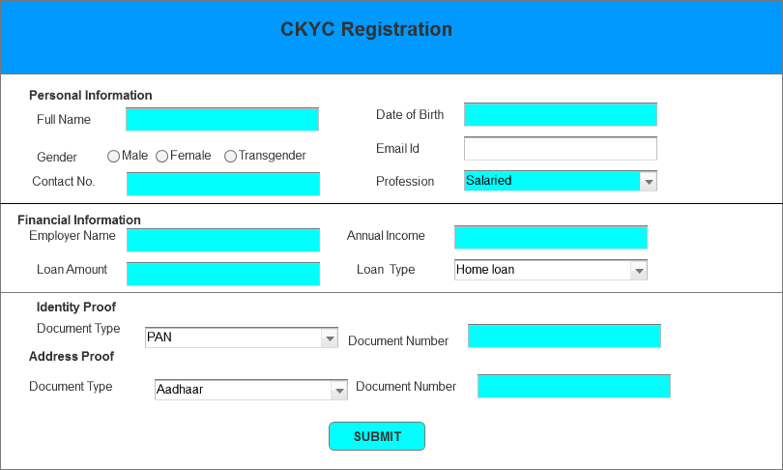
2. Document upload page for uploading all relevant documents in LMS Portal.

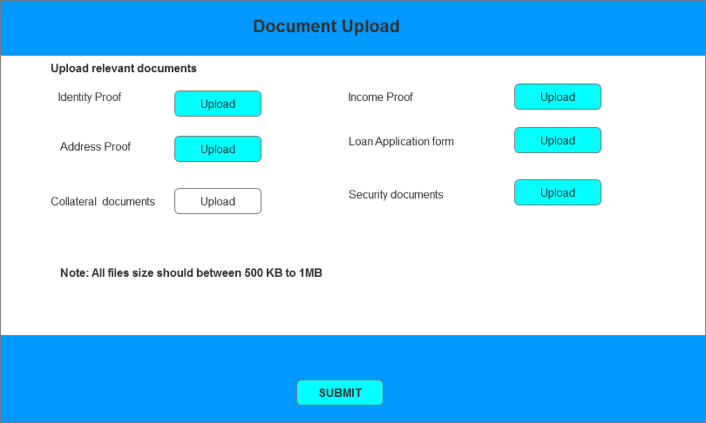
3. Conducting Automated KYC after CKYC registration and document upload.
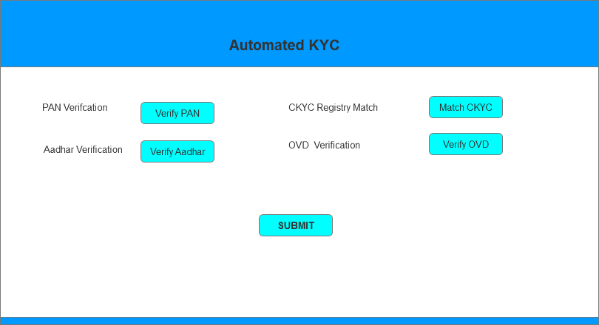

4. After filling all relevant details and performing all steps, Branch Manager forward the application to CPC Cell for further processing.
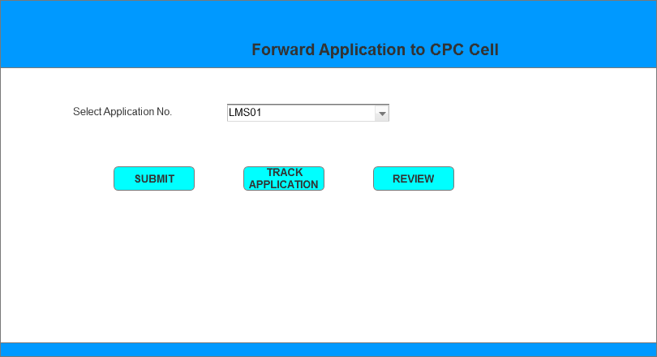

5. Credit Officer screen for further processing and checking the proposal. After checking all relevant details and performing all steps, Credit Officer forwards the application to Approving Authority to approval to Higher Authority.

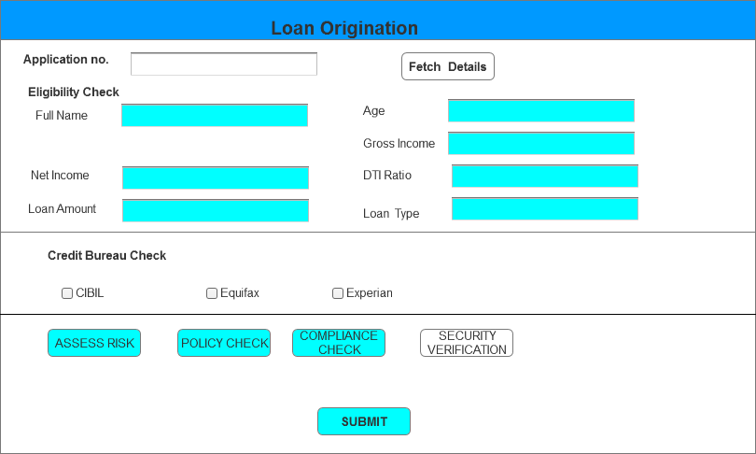
6. Approval Authority screen for sanctioning decision

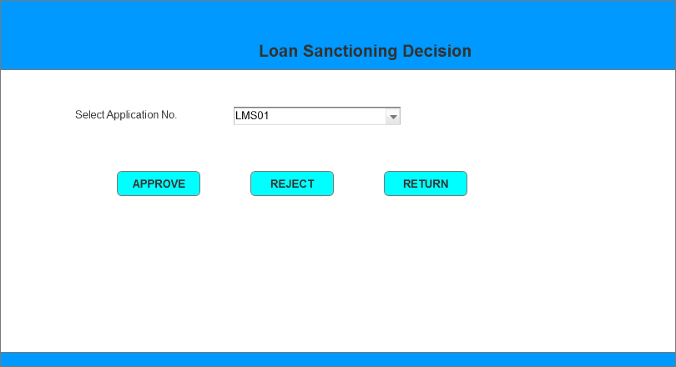

7. Customer access to Disbursement request from online banking portal.
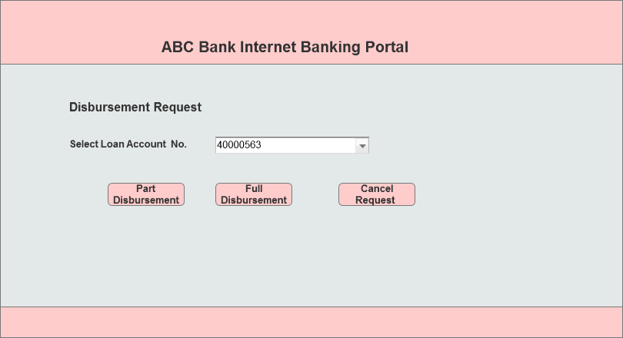

8. Customer access to Loan repayment integration from online banking portal.
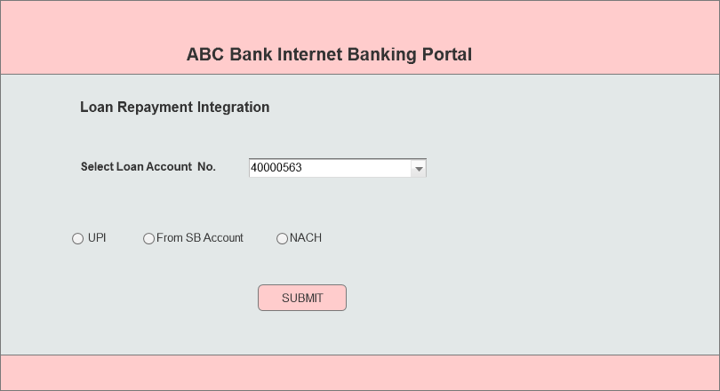

9. Customer access to Manage repayment from online banking portal.

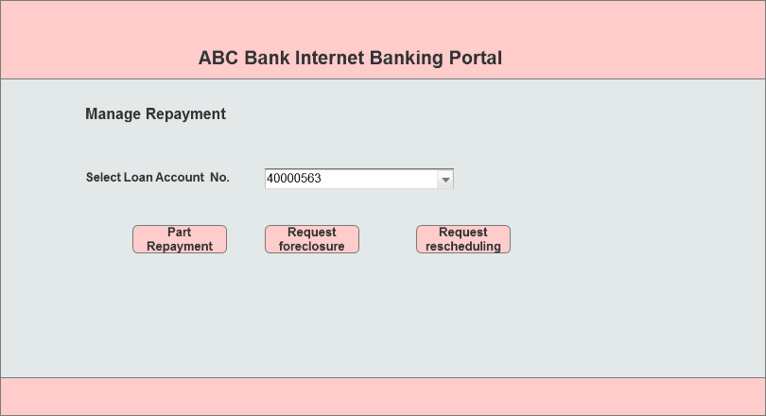

10. Compliance Officer screen to access Regulatory Reports in LMS portal

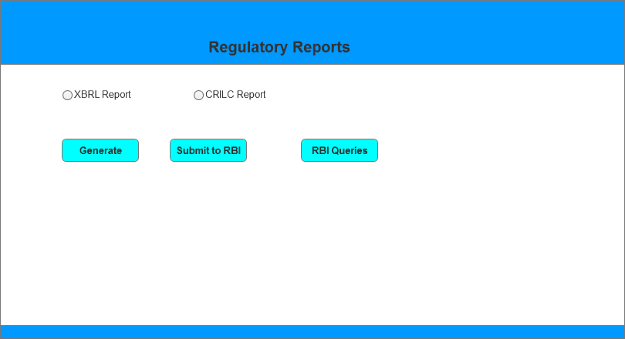

11. Compliance Officer screen for Loan Portfolio Dashboard in LMS portal

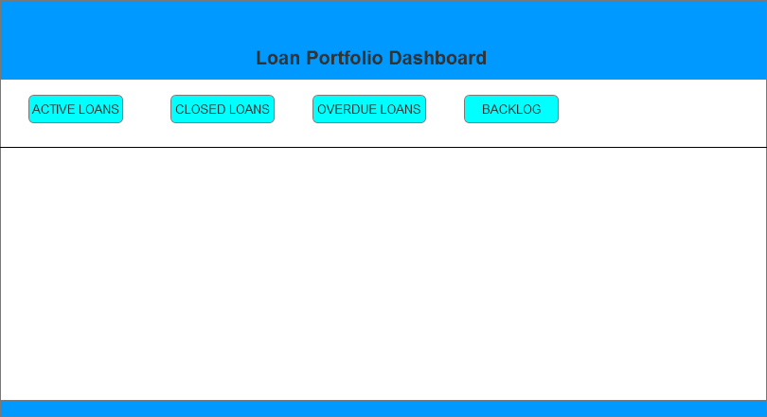

12. Compliance Officer screen for Helpdesk in LMS portal

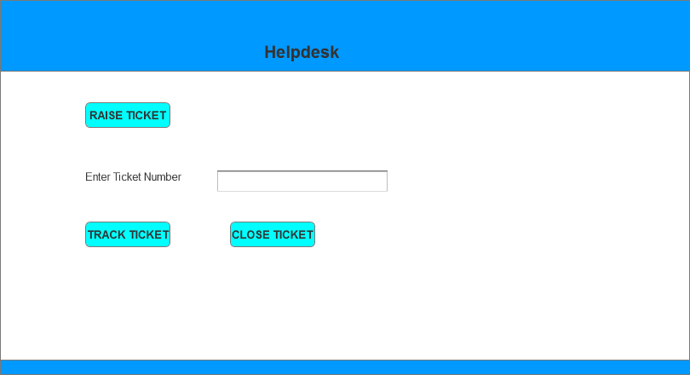

13. Compliance Officer screen for Audit trail and Monitoring in LMS portal

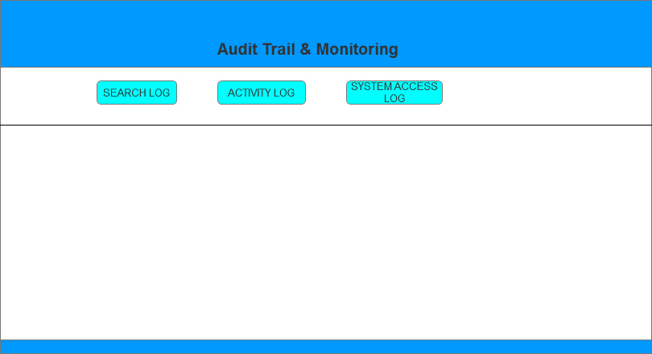

Document 8

Tools – Visio and Axure
Write a paragraph on your experience using Visio and Axure for the project.

Answer:

While working on the Loan Management System enhancement project, I made use of both Ms-Visio and Axure, and I realized that each tool added value in different ways. With Visio, it was much easier to build structured diagrams such as the use case models, activity and process flow diagrams. The predefined UML shapes helped me map out actors interactions for example, showing how compliance officers, credit officers, and approvers access different functionalities. I found Visio especially helpful when preparing diagrams for discussions with stakeholders, since the outputs were clean, formal, and easy to interpret.
Axure, on the other hand, was more engaging because it allowed me to go beyond static diagrams. I used it to create wireframes and small prototypes to simulate how the system would behave once the enhancements were in place. For example, I could show how a compliance officer would generate regulatory reports step by step, or how a loan officer would move through the dashboard options like active loans or overdue loans. This made the project feel more “real,” and it gave me chance to validate user flows before development started.
Overall, I felt the two tools complemented each other well. Visio gave me structure and clarity for documenting the system design, while Axure brought the user perspective to life. Together, they helped bridge the gap between backend logic and front-end experience, which was especially important in an LMS project involving multiple roles and compliance requirements.

Document 9
BA Experience

Business Analyst Experience Document
Project: LMS Enhancement Project
Role: Business Analyst
Project Objective: Enhance the Loan Management System (LMS) with new modules for digital onboarding, straight-through loan processing, regulatory compliance, and customer experience improvements.
Key Modules Covered:
- Customer Onboarding & KYC – Centralized e-KYC, OCR-based document upload, validation workflows.
- Loan Origination & Approval – Straight-through loan workflow, digital sanctioning, multi-level approval.
- Omnichannel Communication – SMS, email, in-app notifications for loan status updates.
- Regulatory Compliance – Data security, RBI-compliant cloud hosting, data localization requirements.

1. Requirement Gathering
- Conducted workshops with client stakeholders to capture needs for digital KYC, OCR-based document upload, and real-time loan approvals.
- Applied MoSCoW prioritization to separate important features e.g., e-KYC, approval workflow from other ancillary features like loan dashboard etc.
- Handled client unavailability by connecting with their IT representative and compliance officers for continuous inputs.
- Validated requirements using FURPS model (e.g., scalability for 10,000 concurrent applications).
- Prototyped digital loan sanctioning screens to elicit feedback and refine usability.

2. Requirement Analysis
- Designed Use Case diagrams for Customer Onboarding, Loan Origination Workflow, Customer service access, Automated Compliance and audit reports.
- Created Activity Diagrams to map process flows such as loan approval hierarchy and automated KYC checks.
- Aligned business requirements with regulatory needs (RBI compliance, data localization).
- Prepared BRD (capturing business needs) and SRS (functional & non-functional requirements).
- Ensured traceability by mapping all functional requirements (FRs) to business requirements (BRs).

3. Design Phase
- Derived test cases from use cases like Digital Loan Sanctioning covering both positive and negative paths (e.g., failed KYC, duplicate applications).
- Prepared test data (dummy PAN, Aadhaar, bank statements) to simulate real onboarding scenarios.
- Collaborated with client’s compliance team to review solution design for data security and encryption.
- Maintained RTM to ensure requirements such as multi-factor authentication and end-to-end encryption were not missed.

4. Development Phase
- Facilitated JAD sessions between business, IT, and compliance teams to finalize workflows like approval of loans.
- Clarified technical queries during coding (e.g., how OCR validation integrates with the centralized KYC system).
- Resolved team conflicts by explaining impact on loan approval timelines if workflows were delayed.
- Guided developers using UML diagrams (e.g., loan approval activity diagram).
- Recorded sprint review meetings to ensure all stakeholders, even those absent, stayed aligned.

5. Testing Phase
- Designed system test cases (Omnichannel Communication) to validate notifications across SMS, email, and app.
- Performed high-level testing for loan workflow automation before QA handover.
- Obtained test data from client’s dummy environment (e.g., masked customer IDs, loan accounts).
- Updated RTM with testing results to show 100% coverage of FRs like multi-factor authentication.
- Coordinated with client to sign-off functional requirements and prepared them for UAT sessions.

6. Deployment & Closure
- Shared final RTM as part of project closure to demonstrate coverage of all requirements.
- Coordinated preparation of end-user manuals for loan officers, credit analysts, and compliance staff.
- Organized training sessions on new workflows such as straight-through processing and digital sanctioning.
- Ensured full participation by scheduling multiple training slots and tracking attendance.
- Facilitated smooth handover to support and ensured regulatory documents were attached to closure reports.

