**Neuria**

**Document 6- Please prepare a use case diagram, activity diagram and a use case specification document.**

1. Use case Name

2. Use case Description

3. Actors Primary Actors Secondary actors

4. Basic Flow

5. Alternate flow

6. Exceptional flows

7. Pre- Conditions

8. post-conditions

9. Assumptions

10. Constraints

11. Dependencies

12. Inputs and Outputs

13. Business Rules

14.Miscellaneous Information

**Use case Diagram-**



**Activity Diagram-**











* **Use case specs for all use cases-**

|  |  |  |  |
| --- | --- | --- | --- |
| Use Case ID | UC001 | | |
| Use Case Name | Book appointment with Developer | | |
| Created by | Nikita Suryawanshi | Last updated by | January 11th 2025 |
| Date Created | December 13th 2024 | Last revision Date | January 11th 2025 |
| Actor | Customer, Developer | | |
| Description | These use case describe how user can register for Neuria app or website | | |
| Pre-Condition | User should have valid email address or mobile | | |
| Post condition | Successfully account is successfully created | | |
| Normal flow of events | 1. Patient/Physician visits the website and clicks on "Register 2. The system displays a registration form 3. User enters details (e.g., name, contact, address, and password) for physician (Education, Licence, Expertise) and submits the form 4. The system validates the information 5. The system creates a farmer account and sends a confirmation email/SMS | | |
| Alternative flow | 1. If validation fails, the system highlights errors and requests corrections | | |
| Expectations | User can successfully Register himself or herself into app. | | |
| Frequency of Use | High | | |
| Assumptions | The Patient/Physician has access to the internet and a valid email address or mobile phone number  The registration form is simple and user-friendly, with mandatory fields clearly marked  The system is accessible via both desktop and mobile device | | |

|  |  |  |  |
| --- | --- | --- | --- |
| Use Case ID | UC002 | | |
| Use Case Name | Book appointment with Developer | | |
| Created by | Nikita Suryawanshi | Last updated by | January 11th 2025 |
| Date Created | December 13th 2024 | Last revision Date | January 11th 2025 |
| Actor | Customer, Developer | | |
| Description | These use case describe how user can log in app and allow user to login into app. | | |
| Pre-Condition | User should have registered account | | |
| Post condition | Successfully login into app | | |
| Normal flow of events | 1. System describe a login or Registered option  2. User can login into app by using user id and password  3. System validate user Id and password  4. System verified user id and password  5. The system displays the user’s homepage  6. The use case end | | |
| Alternative flow | 1. Missing user id and password 2. Maximum 3 attempt exceeded 3. Invalid user id password | | |
| Expectations | User can login successfully into app. While login into app user should enter valid email id and password | | |
| Frequency of Use | High | | |
| Assumptions | It is assumed that the customer is registered  It I assumed that the customer has basic knowledge about use of or handling of mobile and computers | | |

|  |  |  |  |
| --- | --- | --- | --- |
| Use Case ID | UC003 | | |
| Use Case Name | Book appointment with Developer | | |
| Created by | Nikita Suryawanshi | Last updated by | January 11th 2025 |
| Date Created | December 13th 2024 | Last revision Date | January 11th 2025 |
| Actor | Customer, Developer | | |
| Description | These use case describe if user forgot password then how to Rest Password | | |
| Pre-Condition | User should have registered account | | |
| Post condition | Password is successfully updated | | |
| Normal flow of events | 1. User navigates to the "Forgot Password" page 2. The system prompts for the registered email or phone number 3. User submits the information (OTP) 4. The system sends a password reset link or code 5. User resets the password using the link or code | | |
| Alternative flow | 1. Invalid Email/Phone Number: The user enters an email address or phone number that is not associated with any account. User can re-enter the correct email/phone number or contact support 2. Expired or Invalid Reset Link: User clicks on the reset link in the email, but it has expired or is invalid. The user can request another password reset | | |
| Expectations | User can login successfully into app after resetting password Successfully | | |
| Frequency of Use | Medium | | |
| Assumptions | It is assumed that the customer is registered  The email or phone number used during the password recovery process must match the one provided during registration | | |

|  |  |  |  |
| --- | --- | --- | --- |
| Use Case ID | UC004 | | |
| Use Case Name | Book appointment with Designer | | |
| Created by | Nikita Suryawanshi | Last updated by | January 11th 2025 |
| Date Created | December 13th 2024 | Last revision Date | January 11th 2025 |
| Actor | Customer, Designer | | |
| Description | These use case describe how user can Browse the product in app | | |
| Pre-Condition | User must be logged in | | |
| Post condition | User is informed about the available products | | |
| Normal flow of events | 1. User selects a Physician category (e.g., Availability, Expertise, Treatment condition, Location). 2. The system displays available Physician. 3. User filters and sorts Physician based on criteria (e.g., Location, expertise). 4. User views Physician details. | | |
| Alternative flow | 1. No Physician Available in Selected Category 2. View Limited Physician Details (Guest User) 3. The Patient uses the search bar to find a specific Physician for treatment. | | |
| Expectations | User can Browse and view Physician easily on app | | |
| Frequency of Use | High | | |
| Assumptions | Patient/Physician are familiar with basic browsing and filtering operations.  The system has a robust database to handle Physician listings and queries efficiently | | |

|  |  |  |  |
| --- | --- | --- | --- |
| Use Case ID | UC005 | | |
| Use Case Name | Book appointment with Developer, Pay Pal | | |
| Created by | Nikita Suryawanshi | Last updated by | January 11th 2025 |
| Date Created | December 13th 2024 | Last revision Date | January 11th 2025 |
| Actor | Customer, Developer, Paypal | | |
| Description | These use case describe how user can take consultation and do payment | | |
| Pre-Condition | User must be logged in and have selected Physician, book appointment to take treatment | | |
| Post condition | User can Placed order successfully | | |
| Normal flow of events | 1. User adds desired case history on profile 2. User proceeds to Teleconsultation 3. Physician conducted Teleconsultation 4. Physician give prescription to patient 5. User selects payment method 6. The system processes with payment and generates a confirmation | | |
| Alternative flow | 1. If payment fails, the system prompts the user to retry or choose another payment method | | |
| Expectations | User can take consultation and treatment with Physician successfully | | |
| Frequency of Use | High | | |
| Assumptions | The user must be a registered member of the platform to take treatment.  User can first browse Physician properly according to disease condition and then take treatment | | |

|  |  |  |  |
| --- | --- | --- | --- |
| Use Case ID | UC006 | | |
| Use Case Name | Book appointment with Developer | | |
| Created by | Nikita Suryawanshi | Last updated by | January 11th 2025 |
| Date Created | December 13th 2024 | Last revision Date | January 11th 2025 |
| Actor | Customer, Developer | | |
| Description | These use case describe Physician can Track Patient Health | | |
| Pre-Condition | User must have taking treatment. | | |
| Post condition | Physician is informed about the Patient health status | | |
| Normal flow of events | 1. Physician navigates to the order history section 2. User selects a patient treatment view detail 3. Patient uploaded test report file and status of health progress 4. The system displays the Patient health status and tracking information | | |
| Alternative flow | 1. If no reports are available, system displays a message. | | |
| Expectations | User can track their health progress status | | |
| Frequency of Use | High | | |
| Assumptions | The user must be taken treatment and do payment for further health progress.  User should Uploaded Correct reports during treatment. | | |

* **Constrains-**

Fixed Timeline and Budget: The project follows a Waterfall methodology, with a 12-month timeline and a fixed budget of Rs. 9,500,000.

Regulatory Compliance: The platform must adhere to HIPAA, GDPR, and other healthcare laws, which may require additional legal and technical efforts.

Internet Dependency: Teleconsultation, real-time tracking, and data synchronization require a stable internet connection; offline functionality is not supported.

Physician and Patient Adoption: The platform’s success depends on active participation from neurologists and patient engagement.

Data Security Requirements: Strict encryption, access control, and cybersecurity measures must be implemented to prevent breaches.

**- Dependencies-**

Availability of Skilled Medical Experts – The success of the project depends on collaboration between neurologists, healthcare professionals and their availability.

Regulatory Approvals and Compliance – The project must comply with healthcare laws and data protection regulations before launch.

Stable Internet & Infrastructure Support – A reliable cloud environment and IT support are necessary for smooth operations.

Patient Engagement & Adoption – The success of the platform depends on patients actively using the system for appointments, treatment tracking, and consultations.

Multi-Device & OS Compatibility – The app must work smoothly across different devices (smartphones, tablets, desktops) and operating systems (iOS, Android, Windows).

**Inputs and Outputs-**

Input - Providing information by doing market research like who is our competitor company and which medical associations who provide support for app promotion and help in finding specialist. By providing all information about disease and conditions and can also provide information Dosage, side effects, and interactions of prescribed drugs. All language includes in application so Users can choose language as per their preference. Provide trained employee.

Output- The platform will provide a centralized database of doctor information, facilitate seamless communication between doctors and patients, and offer tools for treatment tracking, appointment scheduling, and teleconsultation. Owner of this platform will get profit with all satisfaction of provided help.

**Business Rules-**

1.Organization Policies

- The platform must comply with all healthcare data protection laws (HIPAA, GDPR) to ensure patient confidentiality.

- Only verified and licensed neurologists can register and offer medical consultations on the platform. Physicians must regularly update their availability to avoid scheduling conflicts.

- Patients must provide accurate medical history before booking consultations.

- The platform should operate under strict cybersecurity protocols to prevent data breaches.

- A strict no-misuse policy will be enforced—unauthorized access, sharing, or misuse of patient data will lead to account suspension.

2. Procedures

- User Registration and Verification: Physicians must undergo identity and credential verification before being listed. Patients must provide valid identification to create an account.

- Appointment Booking and Consultation: Patients can book appointments based on doctor availability. Cancellations and rescheduling must be done at least 24 hours in advance, except in emergencies.

-Treatment and Progress Tracking: Physicians must log treatment details securely.

Patients will receive regular updates and reminders for medication and follow-ups.

-Teleconsultation and Communication: All video and chat communications will be encrypted and stored securely. Physicians cannot provide prescriptions for restricted drugs without proper medical assessment.

3. Rules and Regulations

- Legal and Compliance Rules: All healthcare services provided must comply with medical regulations and ethical standards.

-Data collection and storage must follow HIPAA/GDPR-compliant policies.

-The platform must ensure informed consent from patients before any medical consultation or data sharing.

-Financial and Payment Rules: Payment transactions must be secure and follow financial regulations. Refund and cancellation policies should be clearly stated for both physicians and patients.

**Miscellaneous Information-**

Security Measures: Data encryption for patient records.

Multilingual Support: Users can select their preferred language.

Emergency Alerts: Notifications for urgent medical attention.

Integration: Compatible with wearable health devices.

Automated Reminders: The system sends medication and appointment reminders to ensure adherence to treatment plans.

User-Friendly Interface: The app is designed with an intuitive layout for easy navigation, even for users with limited technical knowledge.

**Document 7- Screens and page**

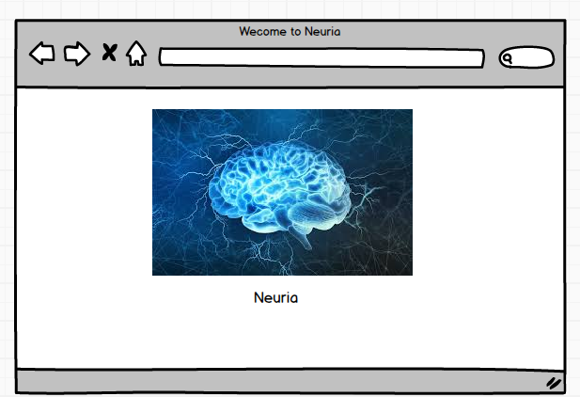**s**

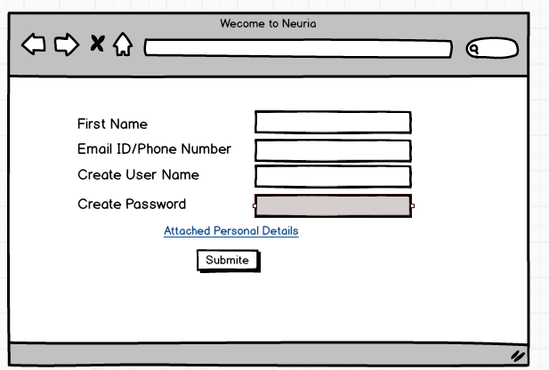

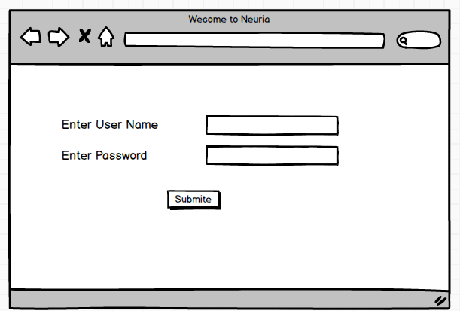

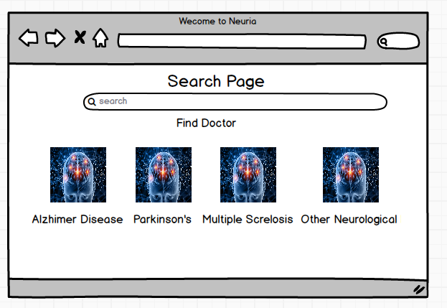

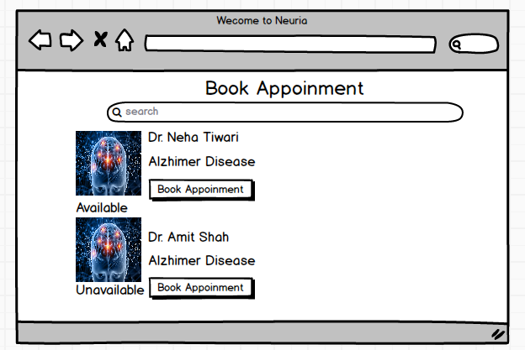

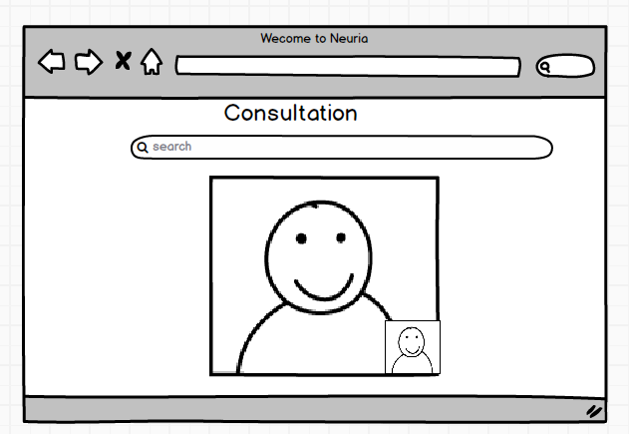

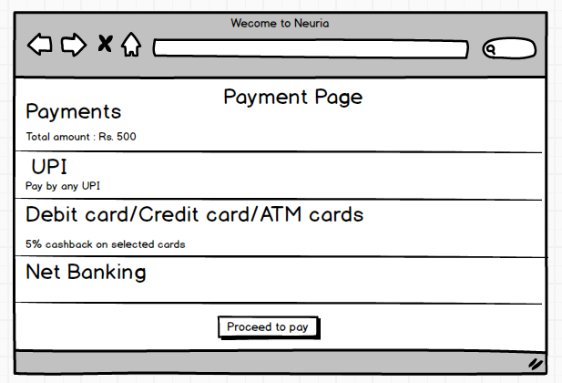

**Document 8- Tools-Visio and Axure**

1. Microsoft Visio- it is diagramming and vector graphics application used to create diagrams, Flowchart, and other visual representation of complex information. Microsoft Visio is a diagramming tool used for creating UML diagrams like Use Case, Activity, and Sequence diagrams. Its integration with Microsoft Office enhances documentation. Visio simplifies complex processes through drag-and-drop features and making it essential for business and technical analysis.
2. Axure- it is more advance prototype tool used to create high-fidelity, interactive wireframes and prototypes for web and mobile application. It supports dynamic panels, conditional logic, and data-driven elements to create realistic user experiences. Axure aids in user flow validation, stakeholder communication, and usability testing, ensuring a well-defined and structured design before development.

**Document 9- BA experience-**

**My experience as BA in following phases:**

1. Requirement gathering:

- To gather requirements, we used MOSCOW technique.

- Client is not available for some period of time during this phase. So as a BA I need to source out point of contacts from his side and get the information ASAP.

- I validate the requirements using FURPS technique

- There are many requirements which are duplicated or repeated. We need to remove them immediately

- Prototyping is used to give more specific requirements

2. Requirement Analysis:

- We need to draw UML diagrams to visually describe the requirements

- Activity diagrams also used to describe the process flow

- Communicate the diagrams to team. Some team members might not agree with them and might make changes. As a BA we need to consider the points and make modifications

- Prepare BRS and SRS

3. Design:

- From the use case diagrams, we prepare test cases

- Communicate with client on design and solution documents

- Write negative test cases as well along with positive test cases.

- Do not miss a single test case. It might have huge impact on project development in later stages

- Prepare test data for testing

- Update RTM. This is just as we need to make sure that all the requirements

are met

4. Development:

- Organized JAD sessions

- Clarifying queries of tech team during coding

- There might be some team members who doesn't agree with the concept or who doesn’t cooperate during JAD session, as a BA I handle the situation gently and had one on one discussion with them. Explained how their actions are going to affect the project. Setup healthy environment within the team.

- Referred diagrams to code the Unit

- Conduct regular meetings with technical team and client which is challenging. Some team members might not be available for the meeting. Recording the session and providing that to missed one and having one to one discussion later with that missed person is all I need to do

5. Testing:

- Prepare test cases from use cases

- Perform high level testing

- Test data is requested by BA from client

- Updated RTM

- Take signoff from client

- Prepare client for UAT

6. Deployment:

- Forwarded RTM to client which should be attached to project closure

document

- Coordinates to complete and share end user manuals

- Plans and organizes training sessions

- Make sure all the candidates attend the meeting