Capstone prep 1 part 3

Online Agriculture Products Store

**Question 1** – Functional Requirements

Identify minimum 20 functional requirements

**Answer 1** -

Functional requirements define the specific functions, behaviours, or operations of a system. They describe what the system should do, outlining the necessary task, actions, or activities it must perform to achieve its objectives.

|  |  |  |  |
| --- | --- | --- | --- |
| Req ID | Req Name | Req Description | Priority |
| FR001 | Farmer Registration | Farmer should be able to register with the application | 9 |
| FR002 | Farmer search for Products | Farmer should be able to search the agriculture products | 9 |
| FR003 | Manufacturer Registration | Manufacturers should be able to register with the application | 8 |
| FR004 | Manufacturer Product Listing | Manufacturers should be able to list their products in the catalogue | 8 |
| FR005 | Product Details Display | The application should display detailed information about each product, including descriptions, specifications and pricing | 7 |
| FR006 | Filter | Farmer should be able to filter and select the products as per brands and price | 6 |
| FR007 | Add to cart | User should be able to add products to their shopping cart for purchase | 9 |
| FR008 | Cart Management | User should be able to view and manage the contents of their shopping cart, including adding or removing products | 8 |
| FR009 | Wish list Management | User should be able to manage their wish list or buy later list, including adding and removing products | 8 |
| FR010 | Multiple Payment Gateways | The platform should be integrate with multiple payment gateways to facilitate secure and convenient transactions | 7 |
| FR011 | Order placement | Users should be able to place orders for selected products, specifying quantity and delivery address | 9 |
| FR012 | Order Confirmation | Users should receive an order confirmation with details such as order ID, products, quantities, total amount and estimated delivery date | 7 |
| FR013 | Order Tracking | User should be able to track the status and location of their orders in real time | 6 |
| FR014 | Order history | User should be able to view their order history, including past orders, order details and statuses | 7 |
| FR015 | Customer Support | Users should have access to customer support, either through live chat, email or phone, for assistance with their orders. | 8 |
| FR016 | User ratings and reviews | User should be able to provide ratings and reviews for products they have purchased | 7 |
| FR017 | Product Recommendations | The Platform should provide personalized product recommendations based on user preferences and browsing history | 7 |
| FR018 | Social Sharing | User should have the option to share products or their purchase experience on social media platforms | 7 |
| FR019 | Secure Transactions | The platform should have ensured secure transactions by implementing appropriate encryption and security measures | 9 |
| FR020 | Product Filtering | User should be able to filter products based on various criteria such ass price range, brand, or product | 8 |
| FR021 | Account Management | User should be able to manage their account setting, including profile information, password changes, and email preferences | 7 |

Non-functional requirements will describe the qualities and attributes of a system, focusing on how the system perform rather than specific behaviours or functions.

|  |  |  |  |
| --- | --- | --- | --- |
| Req ID | Req Name | Req Description | Priority |
| NFR001 | Page loading Time | Each Page load within 3 seconds time | 10 |
| NFR002 | Technical supported System | Application can be used on any OS(Android/IOS) | 6 |
| NFR003 | Time limit for OTP | OTP time should given maximum of 5 minutes for login and registration process | 10 |
| NFR004 | Logout System | If the page is not accessed for more for 5 minutes, the page should log out automatically | 7 |
| NFR005 | Stocke Availability | Stoke availability should be updated on a real time basis | 8 |
| NFR006 | SMS and Mail Confirmation | Automated Email and SMS notification should be sent to users | 6 |
| NFR007 | Backup | All data should get backup automatically | 7 |
| NFR008 | Connectivity | System should be connected with Internet | 8 |
| NFR009 | Stock Alerts | Seller should receive stock alert notifications when Stock is reduced, every week | 6 |
| NFR0010 | Net banking | Bank account should be active in nature for smooth Payment Process | 8 |
| NFR0011 | Check Stock | Once the product is sold. The stock of the product should be reduced | 7 |
| NFR0012 | Email Address | User’s Email address should be active to receive Email notifications | 5 |
| NFR0013 | Taxation System | All Products should be included with additional Tax | 8 |
| NFR0014 | Password | User should receive Password change alert every 30 day | 4 |
| NFR0015 | Payment Receipt | Generation of payment details on white paper receipt of 4”6 | 5 |

**Question 2–** Minimum 5 page designs

Make wireframe and prototypes

**Answer 2 -**

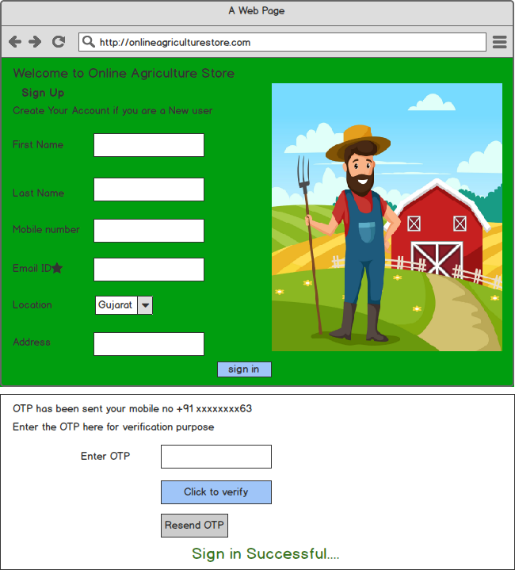

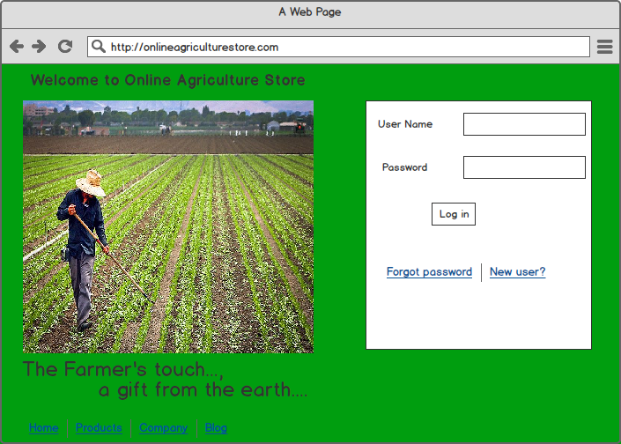

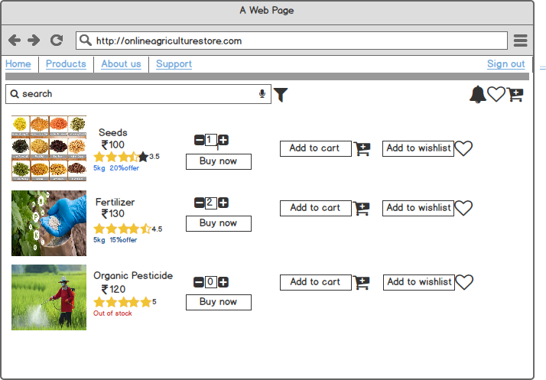

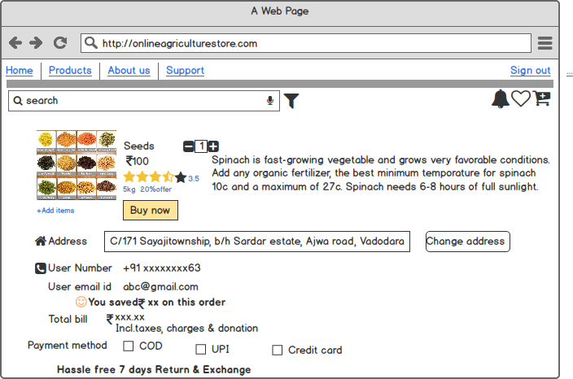

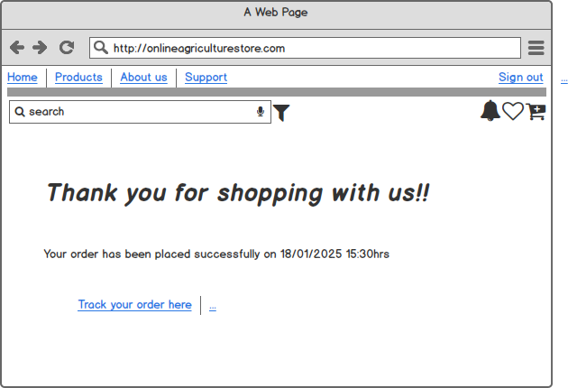

**Question 3 –** Tools (Visio, Balsamiq)

Make a note of the Tools, which you are using for above concepts.

**Answer 3 -**

**Ms Visio:** Microsoft Visio is software for drawing a variety of diagrams. Visio is a diagramming and vector graphics application and is part of the Microsoft Office family. These include flowchart, org charts, Network Diagrams, UML diagrams, Mind maps, building plans, floor plans, data flow diagram, process flow diagram, business process modelling, swim lane diagrams, 3D maps, and many more.

Visio enables users to visually represent complex information with other Microsoft office applications.

Another thing Visio can do is pull in live information from an external source, such as an Excel sheet or Access database. This makes diagrams functional and current. The most recent example I have seen involved using Visio to monitor network status across a localized broadband system.

Mostly used diagram by BA is UML Use Case Diagram and UML Activity Diagram sometimes Sequence Diagram and State Chart Diagram. Unified Modelling Language (UML) is the industry standard language for specifying, visualizing, constructing, and documenting software system. It simplifies software design, and communication about the design.

In MS Visio, UML has 9 diagrams:

5 Static (Use Case, Class, Component, Package, Deployment) and 4 Dynamic (Sequence, Activity, State chart, Collaboration).

In this case, As BA I should use Use Case Diagram and Activity Diagram for easy to explain stakeholders how system works in these application like how to user should log in, Register, Add to cart, Payment, delivered, shipping, exchange, Add to wish list or favourite.

**Balsamiq:** Balsamiq is an effective tool for presenting the software requirements in the form of wireframes. It creates mock-ups and wireframes for websites, webapps, and desktop software. It allows us to picture ideas and concepts through a simple drag and drop interface.

This helps the software development team to visualize how the software project will look like in the very early stages of development. This is a small tutorial where we will cover all the basic steps needed to start with Balsamiq Mock-ups.

Balsamiq Mock-ups allows you to quickly create wireframes with an in-built drag-and-drop interface and large libraries of UI elements. It keeps teams aligned with built-in notes, comments, and collaboration features. The hand-drawn style wireframes in Balsamiq Mock-ups focus discussions on layout and flow, not visuals.

**Features of Balsamiq**

Balsamiq has many useful features for wireframing and prototyping user interfaces.

* Notes and annotations

Ability to add notes, descriptions, and annotations to your wireframes.

* Link between wireframes

You can link two wireframes together to illustrate navigation flows and create flowcharts.

* Responsive wireframing

Offers mobile, tablet, desktop, and web wireframes options. Easily create responsive designs and preview them across various screen sizes.

* Revision history

See an entire version history and track the changes made to your wireframes over time. Any prior version is accessible.

* Import and export

Easily import and export wireframes and UI mock-ups in various formats like PDF, PNG, HTML, and Balsamiq (.bmml) format.

* Team collaboration

You can share wireframing projects with your team for real-time collaboration and feedback. Review colleagues’ work and comment on it which will be visible to the colleague.

* Style guide

Define styles for colours, fonts, and dimensions, and add them to your wireframing UI library and interface elements. This helps ensure UI consistency.

**Question 4 –** RTM

A business analyst’s key responsibilities are to keep track of the requirements and make sure that no requirement is missed.

Mr. Henry and peter have approached you regarding the current status of the project. How will you tackle this situation?

**Answer 4 -**

**Requirement tracing matrix**

It is a document to track the requirements throughout the project lifecycle, ensuring that they are met and that no requirements are over looked.

Prepare RTM

|  |  |  |  |  |  |  |  |  |  |  |  |  |
| --- | --- | --- | --- | --- | --- | --- | --- | --- | --- | --- | --- | --- |
| Req ID | Req Name | Req Description | Design | D1 | T1 | D2 | T2 | D3 | T3 | D4 | T4 | UAT |
| FR0001 | Farmer Registration | Farmers should be able to register with the application | Yes | Y | Y | Y | Y | Y | Y | Y | Y | N |
| FR0002 | Farmer Search for Products | Farmers should be able to search for available products in fertilizers, seeds, pesticides | Yes | Y | Y | Y | Y | Y | Y | Y | Y | N |
| FR0003 | Product not found | Farmer should be notified if the searched product not found | Yes | Y | Y | Y | Y | Y | Y | N | N | N |
| FR0004 | Product Selection | Farmer should be able to select the product | Yes | Y | Y | Y | Y | Y | N | N | N | N |
| FR0005 | Out of Stock | Farmer should be notified, if the product is out of stock | Yes | Y | Y | N | N | N | N | N | N | N |
| FR0006 | Filter | Farmer should be able to filter and select the product as per Brands and Price | Yes | Y | Y | N | N | N | N | N | N | N |
| FR0007 | Similar products | Farmer should be able to select similar products | Yes | Y | Y | N | N | N | N | N | N | N |
| FR0008 | Bought together | Once the product is finalized, farmer should be suggested with related products as a package with the price. | Yes | Y | Y | Y | Y | N | N | N | N | N |
| FR0009 | Add to cart | Farmer should be able to Add the product to the cart for purchase. | Yes | Y | Y | Y | N | N | N | N | N | N |
| FR0010 | Wishlist | Farmer should have an option to Add the product into Wishlist | Yes | Y | Y | N | N | N | N | N | N | N |
| FR0011 | Delivery Address | Farmer should be able to select the delivery address to deliver the product | Yes | Y | Y | N | N | N | N | N | N | N |
| FR0012 | Payment option | Once the delivery address is selected, Application should show the Payment options to the farmer for purchasing the product | Yes | Y | Y | N | N | N | N | N | N | N |
| FR0013 | Payment Confirmation | Farmer should receive the payment confirmation email and SMS | Yes | Y | Y | Y | Y | N | N | N | N | N |
| FR0014 | Order Confirmation | Farmer should receive the order confirmation email and SMS | Yes | Y | Y | N | N | N | N | N | N | N |
| FR0015 | Expected Delivery date | Farmer should also see the expected delivery date of the product | Yes | Y | Y | N | N | N | N | N | N | N |
| FR0016 | Track Delivery | Farmer should have the option to track the delivery on the application | Yes | Y | Y | N | N | N | N | N | N | N |
| FR0017 | Cancel/Replacement/Return | Farmer should be able to cancel/replacement/return the product | Yes | Y | Y | Y | Y | N | N | N | N | N |
| FR0018 | Return Pickup | Farmer should be given Pick up date and time for cancel/return | Yes | Y | Y | N | N | N | N | N | N | N |
| FR0019 | Return confirmation | Farmer should receive SMS and email confirmation for cancellation/return | Yes | Y | Y | N | N | N | N | N | N | N |
|  |  |  |  |  |  |  |  |  |  |  |  |  |

|  |  |  |  |  |  |  |  |  |  |  |  |  |
| --- | --- | --- | --- | --- | --- | --- | --- | --- | --- | --- | --- | --- |
| Req ID | Req name | Req description | Design | D1 | T1 | D2 | T2 | D3 | T3 | D4 | T4 | UAT |
| NFR001 | Page loading | Each Page should load within 3 seconds time | Yes | Y | Y | Y | Y | Y | Y | Y | Y | N |
| NFR002 | Technical supported system | Application can be used on any OS(Android/IOS) | Yes | Y | Y | Y | Y | N | N | N | N | N |
| NFR003 | Time limit for OTP | OTP time limit should be given maximum of 5 minutes for login and registration process | Yes | Y | Y | N | N | N | N | N | N | N |
| NFR004 | Logout System | If the page is not accessed for more for 5 minutes, the page should log out automatically | Yes | Y | Y | N | N | N | N | N | N | N |
| NFR005 | Stock availability | Stock availability should be updated on a real time basis | Yes | Y | Y | N | N | N | N | N | N | N |
| NFR006 | SMS & Mail confirmation | Automated Email and SMS notification should be sent to users | Yes | Y | Y | Y | Y | N | N | N | N | N |
| NFR007 | Back up | All data should get backup automatically | Yes | Y | Y | Y | N | N | N | N | N | N |
| NFR008 | Connectivity | System should be connected with Internet | Yes | Y | Y | Y | Y | N | N | N | N | N |
| NFR009 | Stock alerts | Seller should receive stock alert notifications when stock is reduced, every week | Yes | Y | Y | N | N | N | N | N | N | N |
| NFR010 | Net Banking | Bank account should be active in nature for smooth payment process | Yes | Y | Y | N | N | N | N | N | N | N |
| NFR011 | Check stock | Once the Products is sold, the stock of the product should be reduced | Yes | Y | Y | Y | Y | N | N | N | N | N |
| NFR012 | Email Address | Email Address should be a active Email notification | Yes | Y | Y | N | N | N | N | N | N | N |
| NFR013 | Taxation system | All products should be include with additional Tax | Yes | Y | Y | N | N | N | N | N | N | N |
| NFR014 | Password | User should receive Password change alert every 30 day | Yes | Y | Y | N | N | N | N | N | N | N |

**Question 5 –** 10 Test Case Documents



**Answer 5 -**

A test case document is a detailed outline used by tester to ensure that a software application or system is working as expected.

Test case - 1



|  |  |  |  |  |  |
| --- | --- | --- | --- | --- | --- |
| **Test Case ID** | **TC001** |  | **Test Case Name** | **New User Registration** |  |
| **Project ID** | PRJ001 |  | **Project Name** | Online Agriculture Product Store |  |
| **PM ID** | PM001 |  | **PM Name** | Mr. Vandanam |  |
| **Test Strategy ID** | TS001 |  | **Tester ID** | T001 |  |
| **Test Plan ID** | TP001 |  | **Tester Name** | Mr. Jason |  |
| **Test Schedule ID** | TSCH001 |  | **Date of Test** | 26-12-2024 |  |
|  |  |  |  |  |  |
| **Scenario** | New User Registration through his Name, valid phone number or email id and user will get OTP |  |  |  |  |
| **Example** | The user enters Name, valid phone number or email id and click on the sign in button. then User will get an OTP. User enters the OTP and sign in successfully |  |  |  |  |
|  |  |  |  |  |  |
|  | **Step 1** | **Step 2** | **Step 3** | **Step 4** | **Step 5** |
| **Input Data** | Name: Ramesh Phone number- +91 9979715763, Email ID- abc@gmail.com, OTP- 8209 | Name: Jay Phone number- +91 9979715700, Email ID- bgc@gmail.com, OTP- 2908 | Name: Rohini Phone number- +91 9979715493, Email ID- mbc@gmail.com, OTP- 0098 | Name: Heet Phone number- +91 9979718863, Email ID- kkc@gmail.com, OTP- 5587 | Name: Sachi Phone number- +91 9979740763, Email ID- xyc@gmail.com, OTP- 0970 |
| **Expected Behaviour** | The user should be able to register and redirected to home page |  |  |  |  |
| **Actual Behaviour** | User successfully sign in and redirected to home page |  |  |  |  |
| **Comments** | NA |  |  |  |  |
| **Result Pass/Fail** | Pass |  |  |  |  |

Test case - 2



|  |  |  |  |  |  |
| --- | --- | --- | --- | --- | --- |
| **Test Case ID** | **TC002** |  | **Test Case Name** | **Attempt to sign in invalid details** |  |
| **Project ID** | PRJ001 |  | **Project Name** | Online Agriculture Product Store |  |
| **PM ID** | PM001 |  | **PM Name** | Mr. Vandanam |  |
| **Test Strategy ID** | TS002 |  | **Tester ID** | T002 |  |
| **Test Plan ID** | TP002 |  | **Tester Name** | Mr. Jason |  |
| **Test Schedule ID** | TSCH002 |  | **Date of Test** | 26-12-2024 |  |
|  |  |  |  |  |  |
| **Scenario** | The User enters invalid phone number or email or OTP |  |  |  |  |
| **Example** | If User enters invalid phone number or email or OTP and click on sign in. then the system should display an error message ”Invalid Phone number/Email/OTP |  |  |  |  |
|  |  |  |  |  |  |
|  | **Step 1** | **Step 2** | **Step 3** | **Step 4** | **Step 5** |
| **Input Data** | Phone number- +44 9979715763, Email ID- abc@gmail.com, OTP- 8209 | Phone number- +91 9979718900, Email ID- wku@gmail.com, OTP- 2809 | Phone number- +91 997971546, Email ID- mbc@gmail.com, OTP- 000000 | Phone number- +37 9979715700, Email ID- kkc@gmail.com, OTP- 5587 | Phone number- +91 997971570078, Email ID- xyc@gmail.com, OTP- 0970## |
| **Expected Behaviour** | The system should display an error message ”Invalid phone number” | Invalid Email id | Invalid OTP | Invalid phone number | Invalid OTP |
| **Actual Behaviour** | Error message was displayed |  |  |  |  |
| **Comments** | NA |  |  |  |  |
| **Result Pass/Fail** | Pass |  |  |  |  |

Test case - 3

|  |  |  |  |  |  |
| --- | --- | --- | --- | --- | --- |
| **Test Case ID** | **TC003** |  | **Test Case Name** | **User Login Successfully** |  |
| **Project ID** | PRJ001 |  | **Project Name** | Online Agriculture Product Store |  |
| **PM ID** | PM001 |  | **PM Name** | Mr. Vandanam |  |
| **Test Strategy ID** | TS003 |  | **Tester ID** | T003 |  |
| **Test Plan ID** | TP003 |  | **Tester Name** | Mr. Jason |  |
| **Test Schedule ID** | TSCH003 |  | **Date of Test** | 26-12-2024 |  |
|  |  |  |  |  |  |
| **Scenario** | The User should be successfully log in these application |  |  |  |  |
| **Example** | The User enters correct credential ID and Password then click on log in. |  |  |  |  |
|  |  |  |  |  |  |
|  | **Step 1** | **Step 2** | **Step 3** | **Step 4** | **Step 5** |
| **Input Data** | ID: [user78@mail.com](mailto:user78@mail.com)  Password: Ramesh123 | ID: [user00@mail.com](mailto:user00@mail.com)  Password: Jay110 | ID: [user90@mail.com](mailto:user90@mail.com) Password: rohini766 | ID: [user01@mail.com](mailto:user01@mail.com)  Password: Heet123 | ID: [user89@mail.com](mailto:user89@mail.com)  Password: sachi900 |
| **Expected Behaviour** | The user should be able to login and redirected to home page |  |  |  |  |
| **Actual Behaviour** | User successfully sign in and redirected to home page |  |  |  |  |
| **Comments** | NA |  |  |  |  |
| **Result Pass/Fail** | Pass |  |  |  |  |

Test case - 4

|  |  |  |  |  |  |
| --- | --- | --- | --- | --- | --- |
| **Test Case ID** | **TC004** |  | **Test Case Name** | **Log in unsuccessfully** |  |
| **Project ID** | PRJ001 |  | **Project Name** | Online Agriculture Product Store |  |
| **PM ID** | PM001 |  | **PM Name** | Mr. Vandanam |  |
| **Test Strategy ID** | TS004 |  | **Tester ID** | T004 |  |
| **Test Plan ID** | TP004 |  | **Tester Name** | Mr. Jason |  |
| **Test Schedule ID** | TSCH004 |  | **Date of Test** | 26-12-2024 |  |
|  |  |  |  |  |  |
| **Scenario** | The User enters invalid credential ID or Password |  |  |  |  |
| **Example** | If User enters invalid credential Id or Password and click on log in. then the system should display an error message ”Invalid ID or Password” |  |  |  |  |
|  |  |  |  |  |  |
|  | **Step 1** | **Step 2** | **Step 3** | **Step 4** | **Step 5** |
| **Input Data** | ID: [user078@mail.com](mailto:user078@mail.com)  Password: Ramesh123 | ID: [user000@mail.com](mailto:user000@mail.com)  Password: Jay110 | ID: [user90@mail.com](mailto:user90@mail.com) Password: rohini76690 | ID: [heet01@mail.com](mailto:heet01@mail.com)  Password: Heet123 | ID: [user89@mail.com](mailto:user89@mail.com)  Password: sachi9008 |
| **Expected Behaviour** | The system should display an error message ”Invalid user ID” | Invalid user ID | Invalid credential password | Invalid user ID | Invalid password |
| **Actual Behaviour** | Error message was displayed |  |  |  |  |
| **Comments** | NA |  |  |  |  |
| **Result Pass/Fail** | Pass |  |  |  |  |

Test case - 5



|  |  |  |  |  |  |
| --- | --- | --- | --- | --- | --- |
| **Test Case ID** | **TC005** |  | **Test Case Name** | **Add product to cart** |  |
| **Project ID** | PRJ001 |  | **Project Name** | Online Agriculture Product Store |  |
| **PM ID** | PM001 |  | **PM Name** | Mr. Vandanam |  |
| **Test Strategy ID** | TS005 |  | **Tester ID** | T005 |  |
| **Test Plan ID** | TP005 |  | **Tester Name** | Mr. Jason |  |
| **Test Schedule ID** | TSCH005 |  | **Date of Test** | 26-12-2024 |  |
|  |  |  |  |  |  |
| **Scenario** | The User selects some products and add to the cart |  |  |  |  |
| **Example** | The User selects Organic Spinach seeds & quantity-5kg and click on add to the cart |  |  |  |  |
|  |  |  |  |  |  |
|  | **Step 1** | **Step 2** | **Step 3** | **Step 4** | **Step 5** |
| **Input Data** | Organic Spinach seeds- 5kg , Pesticide- 2lit add | Tomato Seeds- 2kg, Sugarcane seeds-3 kg add | Pesticide -2lit, Fertilizer- 5kg add | Fertilizer-1kg, Pesticide- 5lit | - |
| **Expected Behaviour** | User should able to Click on the product. Select the required quantity and then click on “Add to cart”. The product should be added to the cart with accurate quantity |  |  |  |  |
| **Actual Behaviour** | Product was added to the cart with correct quantity |  |  |  |  |
| **Comments** | NA |  |  |  |  |
| **Result Pass/Fail** | Pass |  |  |  |  |

Test case - 6



|  |  |  |  |  |  |
| --- | --- | --- | --- | --- | --- |
| **Test Case ID** | **TC006** |  | **Test Case Name** | **Remove product from cart** |  |
| **Project ID** | PRJ001 |  | **Project Name** | Online Agriculture Product Store |  |
| **PM ID** | PM001 |  | **PM Name** | Mr. Vandanam |  |
| **Test Strategy ID** | TS006 |  | **Tester ID** | T006 |  |
| **Test Plan ID** | TP006 |  | **Tester Name** | Mr. Jason |  |
| **Test Schedule ID** | TSCH006 |  | **Date of Test** | 26-12-2024 |  |
|  |  |  |  |  |  |
| **Scenario** | The User removes a product from the cart |  |  |  |  |
| **Example** | The user should already selected the product in the cart and user should click on “Minus button” for remove product from the cart |  |  |  |  |
|  |  |  |  |  |  |
|  | **Step 1** | **Step 2** | **Step 3** | **Step 4** | **Step 5** |
| **Input Data** | Remove Pesticide- 2lit | Remove Tomato Seeds | Remove Fertilizer- 5kg | Remove Pesticide- 5lit | - |
| **Expected Behaviour** | The user should be able to click on “Minus button” to remove product from cart |  |  |  |  |
| **Actual Behaviour** | User was remove the product |  |  |  |  |
| **Comments** | NA |  |  |  |  |
| **Result Pass/Fail** | Pass |  |  |  |  |

Test case - 7



|  |  |  |  |  |  |
| --- | --- | --- | --- | --- | --- |
| **Test Case ID** | **TC007** |  | **Test Case Name** | **Add product to favourites or wish list** |  |
| **Project ID** | PRJ001 |  | **Project Name** | Online Agriculture Product Store |  |
| **PM ID** | PM001 |  | **PM Name** | Mr. Vandanam |  |
| **Test Strategy ID** | TS007 |  | **Tester ID** | T007 |  |
| **Test Plan ID** | TP007 |  | **Tester Name** | Mr. Jason |  |
| **Test Schedule ID** | TSCH007 |  | **Date of Test** | 26-12-2024 |  |
|  |  |  |  |  |  |
| **Scenario** | Add to favourite |  |  |  |  |
| **Example** | The user should add to product to favourites or wish list by click on “love symbol” |  |  |  |  |
|  |  |  |  |  |  |
|  | **Step 1** | **Step 2** | **Step 3** | **Step 4** | **Step 5** |
| **Input Data** | Fertilizer  Seeds | Pesticide  Fertilizer | Pesticide | Seeds | Pesticide  Seeds |
| **Expected Behaviour** | The user should be able to add the product to favourite or wishlist |  |  |  |  |
| **Actual Behaviour** | Product was successfully added to favourites |  |  |  |  |
| **Comments** | NA |  |  |  |  |
| **Result Pass/Fail** | Pass |  |  |  |  |

Test case - 8



|  |  |  |  |  |  |
| --- | --- | --- | --- | --- | --- |
| **Test Case ID** | **TC008** |  | **Test Case Name** | **Update product quantity in cart** |  |
| **Project ID** | PRJ001 |  | **Project Name** | Online Agriculture Product Store |  |
| **PM ID** | PM001 |  | **PM Name** | Mr. Vandanam |  |
| **Test Strategy ID** | TS008 |  | **Tester ID** | T008 |  |
| **Test Plan ID** | TP008 |  | **Tester Name** | Mr. Jason |  |
| **Test Schedule ID** | TSCH008 |  | **Date of Test** | 26-12-2024 |  |
|  |  |  |  |  |  |
| **Scenario** | Updates the quantity of the product in cart |  |  |  |  |
| **Example** | User should checkout the cart and change the quantity of the product from 2kg to 5kg.The user should be change the quantity of the product |  |  |  |  |
|  |  |  |  |  |  |
|  | **Step 1** | **Step 2** | **Step 3** | **Step 4** | **Step 5** |
| **Input Data** | Change the quantity from 2kg to 5kg. | Change the quantity from 250kg to 1kg | - | Change the quantity from 1kg to 2kg | - |
| **Expected Behaviour** | User should be able to change the quantity of the product |  |  |  |  |
| **Actual Behaviour** | User was to change the quantity |  |  |  |  |
| **Comments** | NA |  |  |  |  |
| **Result Pass/Fail** | Pass |  |  |  |  |

Test case - 9



|  |  |  |  |  |  |
| --- | --- | --- | --- | --- | --- |
| **Test Case ID** | **TC009** |  | **Test Case Name** | **Display total cost of the products** |  |
| **Project ID** | PRJ001 |  | **Project Name** | Online Agriculture Product Store |  |
| **PM ID** | PM001 |  | **PM Name** | Mr. Vandanam |  |
| **Test Strategy ID** | TS009 |  | **Tester ID** | T009 |  |
| **Test Plan ID** | TP009 |  | **Tester Name** | Mr. Jason |  |
| **Test Schedule ID** | TSCH009 |  | **Date of Test** | 26-12-2024 |  |
|  |  |  |  |  |  |
| **Scenario** | The user can show the total cost of the products |  |  |  |  |
| **Example** | User should be able to click on checkout button and The system should display the total cost of product |  |  |  |  |
|  |  |  |  |  |  |
|  | **Step 1** | **Step 2** | **Step 3** | **Step 4** | **Step 5** |
| **Input Data** | Organic Spinach Seeds- MRP 100 | Pesticide- MRP  Sugarcane seeds- MRP 120 | Fertiliser -MRP 200 | Pesticide- MRP 250 | - |
| **Expected Behaviour** | User should be able to see a display the total cost of product |  |  |  |  |
| **Actual Behaviour** | The cost of the product was successfully displayed including all taxes |  |  |  |  |
| **Comments** | NA |  |  |  |  |
| **Result Pass/Fail** | Pass |  |  |  |  |

Test case - 10



|  |  |  |  |  |  |
| --- | --- | --- | --- | --- | --- |
| **Test Case ID** | **TC0010** |  | **Test Case Name** | **Payment Mode** |  |
| **Project ID** | PRJ001 |  | **Project Name** | Online Agriculture Product Store |  |
| **PM ID** | PM001 |  | **PM Name** | Mr. Vandanam |  |
| **Test Strategy ID** | TS0010 |  | **Tester ID** | T0010 |  |
| **Test Plan ID** | TP0010 |  | **Tester Name** | Mr. Jason |  |
| **Test Schedule ID** | TSCH0010 |  | **Date of Test** | 26-12-2024 |  |
|  |  |  |  |  |  |
| **Scenario** | User should select the payment mode COD |  |  |  |  |
| **Example** | The user should be able to see checkout screen, select payment mode and then click on the order place |  |  |  |  |
|  |  |  |  |  |  |
|  | **Step 1** | **Step 2** | **Step 3** | **Step 4** | **Step 5** |
| **Input Data** | COD | UPI | COD | Credit Card | - |
| **Expected Behaviour** | The user should be able to see checkout screen, select payment mode and click on order place |  |  |  |  |
| **Actual Behaviour** | Payment was successfully done and order was confirmed |  |  |  |  |
| **Comments** | NA |  |  |  |  |
| **Result Pass/Fail** | Pass |  |  |  |  |

Test case - 11



|  |  |  |  |  |  |
| --- | --- | --- | --- | --- | --- |
| **Test Case ID** | **TC0011** |  | **Test Case Name** | **Track the delivery order** |  |
| **Project ID** | PRJ001 |  | **Project Name** | Online Agriculture Product Store |  |
| **PM ID** | PM001 |  | **PM Name** | Mr. Vandanam |  |
| **Test Strategy ID** | TS001 |  | **Tester ID** | T0011 |  |
| **Test Plan ID** | TP0011 |  | **Tester Name** | Mr. Jason |  |
| **Test Schedule ID** | TSCH0011 |  | **Date of Test** | 26-12-2024 |  |
|  |  |  |  |  |  |
| **Scenario** | The Users to track the whereabout of their order |  |  |  |  |
| **Example** | After order placed and receive a confirmation mail/SMS then user should to click on “track your order here” |  |  |  |  |
|  |  |  |  |  |  |
|  | **Step 1** | **Step 2** | **Step 3** | **Step 4** | **Step 5** |
| **Input Data** | Click on “track your order here” |  |  |  |  |
| **Expected Behaviour** | User should able to click on “track your order here” |  |  |  |  |
| **Actual Behaviour** | Order was successfully track and delivered |  |  |  |  |
| **Comments** | NA |  |  |  |  |
| **Result Pass/Fail** | Pass |  |  |  |  |

Test case - 12



|  |  |  |  |  |  |
| --- | --- | --- | --- | --- | --- |
| **Test Case ID** | **TC012** |  | **Test Case Name** | **Cancel the existing order** |  |
| **Project ID** | PRJ001 |  | **Project Name** | Online Agriculture Product Store |  |
| **PM ID** | PM001 |  | **PM Name** | Mr. Vandanam |  |
| **Test Strategy ID** | TS012 |  | **Tester ID** | T012 |  |
| **Test Plan ID** | TP012 |  | **Tester Name** | Mr. Jason |  |
| **Test Schedule ID** | TSCH012 |  | **Date of Test** | 26-12-2024 |  |
|  |  |  |  |  |  |
| **Scenario** | The users should to cancel the existing order process |  |  |  |  |
| **Example** | The users want to cancel order then click on “cancel order” |  |  |  |  |
|  |  |  |  |  |  |
|  | **Step 1** | **Step 2** | **Step 3** | **Step 4** | **Step 5** |
| **Input Data** | Click on Cancel order | - | Cancel order | Cancel order | - |
| **Expected Behaviour** | The user should be able to click on “cancel order” |  |  |  |  |
| **Actual Behaviour** | Order was successfully cancelled |  |  |  |  |
| **Comments** | NA |  |  |  |  |
| **Result Pass/Fail** | Pass |  |  |  |  |

**Question 6 –** DB Design

After the requirements are thoroughly explained to the entire project team by business analyst, the Database architects have decided to do the database design and also to represent the in-flow and out-flow of data. Draw database schema and ER diagram.

**Answer 6 -**

**DB Schema** is a blueprint that outlines the structure of a database, including its tables, fields, relationships, constraints, and other characteristics.

**An Entity-Relationship diagram(ERD)** is a visual representation of the relationships between entities in a database. It depicts the entities (such as table), attributes (Properties or fields), and relationships between them.

|  |
| --- |
| DB Schema + ER Diagram = DB Design |



**Question 7 –** Data Flow Diagram

What is a data flow diagram? Draw a data flow diagram to represent the in-flow and out-flow of data when a Farmer is placing an order for the product.

**Answer 7 - A Data Flow Diagram(DFD)** is a graphical representation of the flow of data within a system. It visually shows how data moves from one process to another, how it’s stored, and where it ends up.

It help analysts and designers understand the flow of data within a system, identify potential bottlenecks or inefficacies and communicate system requirements to stakeholders.



**Question 8 –** Change Request

Due to change in the Government Taxation structure, we should change the Tax structure How do you handle change requests in a project?

**Answer 8 -**

Change requests are when a stakeholder, either a client or an internal team or department, request a change to the processes or deliverables that had already been decided upon in the project scope.

However, In this scenario, this change request has come up due to change in the Govt, Taxation structure. As a BA, I would analyse the request and clarify the stakeholders exactly what the request is asking as to do in the Online Agriculture Product Store. In a normal scenario, as a BA, I would first do the Feasibility Test, to check , how feasible it is to change the current ongoing project with the new change request.

However, In this case, Feasibility study is not required, as its’s a Govt structure which needs to be updated and followed. Therefore, I will follow the below steps to change the project as per the client’s requirements.

* The change request should be documented.
* Look for any supporting materials to assist in the implementation of this change.
* Need to assess, whether the change is an Inside or Outside scope. This is an outside scope, so budget and timeline will both be affected.
* BA and PM should ensure whether the change is a minor or a major change. Government policy changes are major changes, and we must ensure that the change is implemented according to the government's instructions.
* Fill the change request form and get the approval from the Project Manager.
* We also need to ensure that our Team understands the priority of this change request.
* We also need to discuss the change with change control board who will recommend the necessary change on the Project.
* Once this change has been approved, it will be necessary to update the project deliverables. This can include plans and schedules, business process documents, and the requirements documents.
* After these updates have been made, the project manager can communicate the necessary tasks to the people responsible for implementing the new changes.

**Question 9 –** As the project is in process, Ben and Kevin have contacted you. The reason is to inform you that they want the Farmers to sell their crop yields through this application i.e. Farmers should be able to add their crop yields or products and display to general public and should be able to sell them.

They also want to introduce Auction system for their Crop yields. As a BA, what will be your response?

Is this a change request or an enhancement???

**Answer 9 -**

This sound like an enhancement request as it involves adding new features to the existing project.

As a BA, I would first gather more information from Ben and Kelvin about the specific requirements for adding crop yields and implementing an auction system. I should analyse the request and work with development team. I should provide a project plan, requirement, design and testing plans for this request. I would then assess the impact of these enhancement on the project timeline, budget, and other existing requirements.

I must prepare an enhancement request form and decide how much manpower and manhours required for this enhancement request.

If the change are feasible and align with the project goals, I would document the new requirements and update the project plan and relevant stakeholders accordingly.

**Question 10 –** Estimations

Come up with estimations – How many Manhours required

**Answer 10 -**

As per the case study, the duration of the project is 18 months and the current team size around 12.

This will come under medium project. As the trained resources are available, trainers are not required.

Working Hours a day = 8 hrs

Number of Resources = 18 Months= 547 days= 78 weeks

Assuming Weekends = 156

Assuming Public Holidays = 10

Total = 166

547 – 166 = 381

**Estimated Manhours = 8 hours* 12 resources* 381 days = 36,576 hours**

**Question 11 –** UAT

Project has finally completed all the stages i.e., design, development, testing etc. Now, it is the role of a business analyst to contact the client for testing of the final product and have to successfully complete it. How are you going to handle this situation? And once it is done, what will be the process to close the project?

Explain UAT Acceptance process.

**Answer 11-**

User Acceptance Testing(UAT) is the final stage in the software development life cycle where the end-user of the system test the Product to ensure that it meets their requirements and is ready for deployment. The users of the Online Agriculture Product Store participate in Validating that if meets their needs.

As a BA, I will verify all the validations prior to the UAT test, which will cover the functionality of the product, System environment, any possible defects which could arise and how to deal with these defects.

The UAT Acceptance process involves the following steps.

**1. Requirements Analysis**

This step involves analyses of business requirements. The following documents will be considered and studied thoroughly to identify and develop test scenarios:

* Business Use Cases.
* Business Requirements Document (BRD).
* System Requirements Specification (SRS).
* Process Flow Diagrams.

**2. UAT Test Plan Creation**

In this step, a test place is created that will help to outline the test strategy that will be used to verify and ensure that the software meets the expected business requirements. The test plan includes entry criteria, exit criteria, test scenarios, and a test case approach.

**3. Identify Test Scenarios**

This step involves identifying the test scenarios will respect to the business requirements and creating test cases listing the clear test steps. The test cases should cover the UAT test scenarios.

**4. Create UAT Test Cases**

Create UAT test cases in this step that cover most of the test scenarios. Business use cases are the input here to create test cases.

**5. Prepare Test Data**

It is considered a best practice to use live data for UAT testing, UAT testers should be familiar with database flow.

**6. Test Run**

This step involves executing the test cases and reporting the bugs if there are any. Re-test the software once the bugs are fixed. In this step, test management tools can be used for test case execution.

**7. Confirm Business Objectives**

In this step, the UAT testers need to sign off the mail after the UAT testing to ensure that the product is good to go for production. Deliverables here are Test Plan, UAT Test Scenarios, Test Cases, Results Log, and Defect Log.

To close the project, the following steps should be taken:

1. Ensure that all project Deliverables have been completed and accepted by the client.

1. Each project should be documented, along with any lessons learned, to help future projects be more successful.

1. Obtain formal acceptance from clients and stakeholders of the project's completion.
2. Release all resources allocated to the project, including team members, equipment, and software.
3. Make sure all project documents and other relevant materials are stored in a secure location so that they can be accessed in the future.
4. Submit the final documents of the project, including the UAT test cases, test results, and any other documentation that may be relevant, to the client.

1. Celebrate the project's successful completion and recognize all the team members' contributions.

**Question 12 –** Project Closure Document

Explain Project closure document

**Answer 12 –**

|  |  |  |  |
| --- | --- | --- | --- |
| **Srl no.** | **Point to include** | **Details** | **Reference** |
| **1** | **Did the client signed off on the UAT Testing** |  |  |
|  | Date of the signoff | xx/xx/xxxx |  |
|  | Name of the resource | Mr. Henry | Business_Scope.docx |
| **2** | **Objective of the project** |  |  |
|  | User friendliness | Achieved |  |
|  | Customer satisfaction | ROI in 6 months |  |
|  | More categories | Achieved |  |
| **3** | **Functionalities worked on** |  |  |
|  | Secure payment process | Achieved | FRD.docx |
|  | Categories | Achieved |  |
| **4** | **Infrastructure** |  |  |
|  | Software installed |  | Procurement.docx |
|  | Laptop purchased |  |  |
| **5** | **Funding** |  |  |
|  | Amount approved | 2 Crore | FinancialDetails.xlsx |
|  | Amount used | 2 Crore |  |
| **6** | **Overall project information** |  |  |
|  | Escalations | 25 |  |
|  | Customer satisfaction | High |  |
| **7** | **Value of the company** |  |  |
|  | Positive/Negative | Positive 95% |  |
|  |  | Company has successfully made an application to help remote farmers to get the products on doorstep |  |
|  |  | Upcoming projects |  |