**Online Agriculture Products Store**

1. **Audits:**

**What is an Audit**: Audit is the inspection of various books of different departments by an auditor followed by physical checking of inventory, financial statement and several other documents to make sure that all departments are following documented system of recording transactions.

**What is a Project Audit**: A project management audit is a formal review that seeks to evaluate a given project based on specific criteria. Examples of these can include project quality, performance, and adherence to the statement of work.

While doing the Audit of a BA, the auditor needs to check the following details.

|  |  |
| --- | --- |
| Stage | Requirement Gathering Phase-15 weeks (Week 1 to Week 15) |
| Completed | 10 weeks (Week 1 to Week 10) |
| Check List | |
| 1 | BRD Template |
| 2 | Elicitation Results report |
| 3 | Duplicate requirements report |
| 4 | Grouping of functionalities/features-client signoff |
| 5 | Email communication- To, CC, BCC |

|  |  |
| --- | --- |
| Stage | Requirement Analysis Phase-13 weeks (Week 16 to Week 28) |
| Completed | 7 weeks (Week 16 to Week 22) |
| Check List | |
| 1 | UML Diagrams |
| 2 | Business to functional requirements mapping |
| 3 | Client signoff - documents |
| 4 | RTM document version control |
| 5 | Email communication- To, CC, BCC |

|  |  |
| --- | --- |
| Stage | Design Phase-10 weeks (Week 29 to Week 38) |
| Completed | 7 weeks (Week 29 to Week 35) |
| Check List | |
| 1 | Utilization of Tools |
| 2 | Documented evidence on client communication |
| 3 | Stakeholder MOM |
| 4 | Email communication- To, CC, BCC |

|  |  |
| --- | --- |
| Stage | Development-30 weeks (Week 39 to Week 68) |
| Completed | 20 weeks (Week 39 to Week 58) |
| Check List | |
| 1 | JAD Session Report |
| 2 | End user manual preparation Document |
| 3 | BA and Developer MOM |
| 4 | Email communication- To, CC, BCC |

|  |  |
| --- | --- |
| Stage | Testing -20 weeks (Week 58 to Week 77) |
| Completed | 20 weeks (Week 58 to Week 77) |
| Check List | |
| 1 | Test case summary |
| 2 | Training report to end users |
| 3 | BA and Developer MOM |
| 4 | Email communication- To, CC, BCC |

**In Q1 Auditor will check the following details**:

* 1. Understanding of company goals does the BA has.
  2. Work is Planned and Tracked.
  3. Understood the Current as is process.
  4. BA’s understanding of Business Requirements.
  5. BA conducted the Stakeholder Analysis.
  6. Requirement gathering and analysis was done correctly.
  7. What Elicitation techniques has been used to gather requirements.

**In Q2 Auditor will check the following details**:

1. Documents have been prepared by the BA.
2. Has the BA prepared all the required documents like RTM, BPM to understand the requirement correctly.
3. How is BA prepared the Use case and Activity diagram.
4. Were all these documents signed and agreed by the Stakeholders, before the start of the development stage.

**In Q3 Auditor will check the following details**:

1. Requirements were correctly explained to the development team.
2. BA tracking the status of the project.
3. JAD session organized by the BA.
4. Timesheets sent to the reporting manager.
5. BA keeping the Stakeholders updated on the status of the project.

**In Q4 Auditor will check the following details**:

1. BA tracking the Testing of the product.
2. BA assisting the Testing team for Testing the product.
3. BA sending the Test data to the client.
4. BA preparing the End user manual.
5. BA preparing the client for UAT.

**In Q5 Auditor will check the following details**:

1. BA assisting the Delivery manager to implement the product.
2. BA helping the client to do the UAT.
3. BA organizing the training sessions for the users.
4. BA taking signoff document from the client.
5. BA sending the complete timesheet to the reporting manager.
6. **BA Approach Strategy**: The Business Analysis Approach is the plan that the senior or lead business analyst on a project would create describing the way that all the Business Analysis activities will be executed.

This could include:

* 1. Business Analysis resources and their Roles & Responsibilities,
  2. Requirements Gathering Approach for the project (techniques to be used, high level planning),
  3. Stakeholder Engagement,
  4. Requirements Review Process and Approval Cycles,
  5. Change Management approach to requirements and agreed deliverables.
  6. Other elements such as team structure, assumptions and constraints could also be included.

As a Business Analyst, following are the steps which needs to be followed to complete a Project.

* **Elicitation Techniques to apply** – There are several Elicitation techniques to be used to elicit the requirement, however for this project, we are going to use the below Elicitation techniques.
  1. **Brainstorming** – We are going to arrange sessions, where participants are allowed to provide inputs without criticism, discussion, or evaluation. The goal is to be creative and gather as many ideas as possible in a short period of time.
  2. **Interviews** – We will be interviewing every Stakeholder to elicit the requirements needed to complete the project.
  3. **Workshops** – We are going to arrange workshops, which will be a focused event and will be attended by Key Stakeholders and SMEs. The purpose of these workshops will be for Planning, Analysis, Design, Scoping, Requirements elicitation, Modelling, or combination of any of these. This elicitation technique will also be used for generating ideas for new features of the products, to reach consensus on a topic and to review requirements and design.
  4. **Surveys or Questionnaire** – There will be Surveys or Questionnaires sent to all the Stakeholders and SMEs, which will include multiple range of open and closed ended questions, which will extract the information about the desired product, work practices and behavioural attitudes etc.
* **Stakeholder Analysis** – Stakeholder Analysis involves Identifying the Stakeholders who will be directly or indirectly impacted by the change and analysing the information once collected.
  1. **Identifying Stakeholders**:
     + **Internal Stakeholders** –
       - Project Manager – Mr. Vandanam
       - Senior Java Developer - Ms. Juhi
       - Java Developers – Mr. Teyson, Ms Lucie, Mr Tucker, Mr Bravo
       - Network Admin – Mr. Mike
       - DB Admin – Mr. John
       - Testers – Mr. Jason and Ms. Alekya
       - BA – Mr. Sourabh Bhattacharya
     + **External Stakeholders** –
       - Sponsor - Mr. Henry
       - Financial Head – Mr. Pandu
       - Project Coordinator – Mr. Dooku
       - Key stakeholders - Peter, Kevin and Ben
  2. **Prioritizing Stakeholders**: RACI Matrix -

|  |  |  |  |  |  |  |  |  |
| --- | --- | --- | --- | --- | --- | --- | --- | --- |
| **RACI - Responsible (R) - Accountable (A) - Consulted (C)- Informed (I)- Authorize (A*) – Not Available (NA)** | | | | | | | | |
| **Tasks** | **Mr Henry - Project Sponsor** | **Peter, Kevin, Ben -**  **Key Stakeholders** | **Mr. Karthik**  **- DH** | **Mr. Vandanam – PM** | **Ms. Juhi Sr Java**  **Dev** | **Teyson, Lucie, Bravo & Tucker -**  **Java Dev** | **Mr. Jason & Ms.**  **Alekya - Testers** | **Sourabh Bhattacharya**  **- BA** |
| **Requirement**  **Gathering** | A* | C | NA | A/I | NA | A | NA | R |
| **Requirement**  **Analysis** | NA | NA | NA | I | NA | NA | NA | R |
| **Development** | A* | NA | NA | R/A | C/A | R | NA | C |
| **Testing** | NA | NA | NA | R/A | I | NA | R | I |
| **Implementation** | NA | NA | R | I | I | NA | NA | A |
| **UAT** | I | NA | NA | R/A | NA | NA | NA | C |

* **Documents to Write** –
  1. Project vision Document
  2. Business Analysis Plan – Stakeholder Analysis Document (RACI)
  3. Business Requirements Document.
  4. Functional requirement specification (FRS)/ Functional Specification Document (FSD)
  5. System requirement specification (SRS)/ System Requirement Document (SRD)
* **Signing off on the Documents** – Once the above-mentioned documents are prepared, as a BA, I will take the sign off on the above documents via Emails and Physical sign off as well from the respective Stakeholders.
  1. Project Vision Document – Email to – Project Sponsor and CC – Financial Head, Project Coordinator and Project Manager.
  2. Business Requirement Document – Project Sponsor (Email and Physical)
  3. FRS/FSD & SRS/SRD – Email to - Project Sponsor and CC - Financial Head, Project Coordinator and Project Manager.
* **Taking Approvals** – While taking approval for all the above documents, I will call the respective Stakeholders and send them an Email with the details.
* **Communication Channels to establish and implement** – As a BA, I would prefer the below communication channels:
  1. Face to Face communication – for Requirement Gathering stage. For example, Interviews with Stakeholders.
  2. Video conferencing - This communication is also used when the Stakeholder is at a different location.
  3. Phone calls – This communication is used for setting up meetings with Stakeholders and for taking approvals.
  4. Emails - This communication is used for setting up meetings with Stakeholders and for taking approvals.
* **How to handle Change request** -

As a BA I would handle the Change request by understanding the below steps.

1. Understanding the Scope of Change.
2. Determining the Scope of Incorporating the Change request.
3. Understanding the Feasibility of the Change request.
4. Taking the approval for the Change.
5. Communicating and Implementing the Change.

* **Updating the progress of the project** – As a BA, before we update the Project status, we need understand few key areas –
* **Understand Stakeholder needs** – We need to know the stakeholders who we are working with. Stakeholders sometimes prefer to review the date everyday/weekly/biweekly/monthly. Other stakeholders may like to only read descriptive text.
* **Proactively listen to your stakeholders’ concerns** - Stakeholders may want to share specific concerns with us in confidence and will rely on us to address potential issues/risks. As a BA, we need to know how we provide status to our stakeholders. This includes making sure that the project progress status reports or dashboards provide enough detail. Finally, it should also address their concerns without having them ask about it.
* **Develop and execute a communication plan** – Which means, we need to do Stakeholder analysis, an analysis on stakeholders that provides details on who the stakeholder is and the division are they aligned to. This analysis will contain details on how the project will impact them and interest level of the stakeholders. The analysis will also contain details on stakeholder’s ability to influence others, and their stance on the overall project.

Once we understand these key areas, we will now have to focus on sharing the project status with the Stakeholders.

* Utilize online collaboration tools to share regular progress.
* Send out weekly or bi-weekly status reports.
* Develop a follow up meeting with actively involved Stakeholders.
* **Signing off on the UAT- Client Project Acceptance Form** -

|  |  |
| --- | --- |
| **Project Sign-off Sheet** | |
| **Version Date**: **/**/**** | |
| **Project Name**: Online Agriculture Product Store | |
| **Project Goals**:   1. To provide online agriculture facility to farmers, to help farmer with online product store. 2. New application should be able to accept the product (fertilizers, seeds, pesticides) details from the manufacturers and should be able to display them to the Farmers. 3. to build this online store is to facilitate farmers to buy seeds, pesticides, and fertilizers from anywhere through internet connectivity. | |
| **Project Manager** - Mr. Vandanam | **Sponsor** - Mr. Henry |
| **Start Date:** 09th Feb 2025 | **Planned Budget**: INR 2 Crores |
| **Planned Completion Date**: 03rd Aug 2026 | **Actual Budget**: |
| **Actual Completion Date**: | **Variance**: |
| **Variance**: |  |
| **Duration**: 18 months |  |
| **Days Past the Planned Completion Date**: |  |
| **Project Deliverables:** | |
| By signing this document, I acknowledge that I have delivered all the stated deliverables at the agreed to quality levels.  **Project Manager Signature**: **Date**: **/**/**** | By signing this document, I acknowledge that I have received all the stated deliverables at the agreed to quality levels.  **Sponsor Signature**: **Date**: **/**/**** |
| **Remarks:** |  |

1. **3-Tier Architecture**

Three-tier architecture is a hierarchical software architecture with three distinct, independent tiers or layers. Three-tier architecture is comprised of the following tiers: Presentation Tier (Client layer), Business (Business Logic Layer) and Data access (Data layer). The main job of the architecture is to enable software applications to efficiently and quickly respond to user requests or inputs.

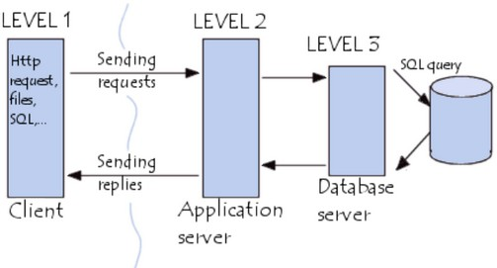

**Presentation Tier**: This layer is also called Client layer and is responsible for accepting inputs or requests from the user and displaying data for the user in a user-friendly format. It accepts inputs and sends the inputs or request to the business logic layer.

**Business Tier:** This layer is also called Business Logic Layer and helps define solutions to complex business problems. It acts as a middle layer between the client and the database server which are used to exchange partially processed data.

**Database layer:** In this layer the data or information is stored. This layer performs operations like insert, update and delete to connect with the database.

|  |  |
| --- | --- |
| Presentation Layer | All user interface will be visible on the screen in the Client layer, Ex: Application Name, Login username and password, Product list, new user registration, new arrivals etc. |
| Business Logic Layer | Reusable components or changing rules and regulations are included in the Business Logic layer, Ex: GST, Multiple payment options etc. |
| Database layer | Storage place for all the information related to Products, Client credentials etc. Ex: Product price, Quality, Quantity, Client details etc. |

1. **BA Approach Strategy for Framing Questions**

* 5W1H – As a BA, the followings points should be kept in mind before framing questions to ask a Stakeholder.
  + What is the Project and what are the objectives?
  + What is the Timeline for the project?
  + Who is the Client and Who are the users?
  + Who will benefit from this project?
  + Where will the product be deployed?
  + How much is the Budget?
  + Why are the clients developing this product?
* SMART - Confirm the requirement is SMART before accepting it for development.
  + Specific - Narrowing the questions, so let every signal question only include one element you can get.
  + Measurable – The questions are better to be quantified and countable. Ex. Multiple Choice questions.
  + Action Oriented – Does the question influence creation of different or new feature packages.
  + Relevant – Does the question identify which features are most required from the customer.
  + Timebound - It can let you or your customer decide priority in a specific time frame.
* RACI Matrix
  + Responsible – The person who does the work to achieve the task. They have responsibility for getting the work done or decision made. The persons responsible are typically working-level project team members, such as the project manager, business analyst and developers.
  + Accountable – The person who is responsible for the correct and through completion of the task. They are responsible for ensuring the work is complete and suitable.
  + Consulted – People from whom feedback and input should be solicited. They are going to provide information for the project and with whom there can be two-way communication.
  + Informed – People kept informed of progress by keeping them in loop. These individuals do not have to be consulted or be a part of the decision making.
* 3 Tier Architecture
  + Presentation layer - This layer display screens, pages, validation on page, company specific logic, functionally.
  + Business logic layer - In a business logic layer all reusable components, frequently changing components, governing body rules, regulation, compliance.
  + Data layer - In this layer the data or information is stored. This layer performs operations like insert, update and delete to connect with the database.
* Use Cases
  + What type of product we will deliver?
  + Where is the location we will deliver the application?
  + When should be the process be completed?
  + Who all are responsible for doing this?
  + Why this product will be used?
  + How will we deliver this project?
* Use Case Specs
  + Who are the Primary and Secondary actors?
  + What are the Actor Goals?
  + What are the main Tasks or functions that are performed by the Actor?
  + What information does the actor desire from the system?
* Activity Diagrams – Activity diagrams are visual representations of a series of actions or flow of control in a System similar to a Data flow diagram. It is basically a flowchart to represent the flow from one activity to another activity. The activity can be described as an operation of the system.

Purpose of an activity diagram can be described as –

* + Draw the activity flow of a system.
  + Describe the sequence from one activity to another.
  + Describe the parallel, branched, and concurrent flow of the system.
* Models
  + Conceptual Model
  + Data Model
  + Physical Model

1. **Elicitation Techniques (BDRFOWJIPQU)**:
   1. **Brainstorming:** This technique is used to generate new ideas and find a solution for a specific issue. The members included for brainstorming can be domain experts, subject matter experts. Multiple ideas and information give us a repository of knowledge and we can choose from different ideas.
   2. **Document Analysis:** During this step of the requirements elicitation process, business analysts review existing documentation at hand, with the intent of identifying requirements for changes or improvements. Examples of document analysis sources include pre-existing project plans, system specifications, process documentation, market research dossiers, customer feedback, meeting minutes, and user manuals. Document analysis is performed before scheduling more in-depth requirements elicitation sessions or interviews with stakeholders.
   3. **Reverse engineering:** In this Technique, any outdated documentation in an existing system, can be reversed to understand what the system does. his is an elicitation technique that can extract implemented requirements from the system. There are two types of reverse engineering techniques.
      1. **Black box reverse engineering**: The system is studied without examining its internal structure (function and composition of software).
      2. **White box reverse engineering**: The inner workings of the system are studied (analysing and understanding of software code).
   4. **Focus Group:** By using a focus group, you can get information about a product, service from a group. The Focus group includes subject matter experts. The objective of this group is to discuss the topic and provide information. A moderator manages this session.
   5. **Observations:** Observation is an excellent elicitation technique that helps understand requirements based on observations related to process flows and work environments of stakeholders. Observation requires a business analyst to go and look at the work – for example, observing the business processes in scope of the project. The elicitation technique observation is an effective means of understanding how a user does their job by assessing their work environment.
   6. **Workshops:** Workshops comprise a group of users or stakeholders working together to identify requirements. A requirement workshop is a structured way to capture requirements. Workshops are used to scope, discover, define, and prioritize requirements for the proposed system.
   7. **JAD (Joint Application Development):** This technique is more process-oriented and formal as compared to other techniques. These are structured meetings involving end-users, PMs, SMEs. This is used to define, clarify, and complete requirements.
   8. **Interviews:** An interview is a systematic approach to elicit information from a person or group of people. This is the most common technique used for requirement elicitation. Interview techniques should be used for building strong relationships between business analysts and stakeholders. In this technique, the interviewer directs the question to stakeholders to obtain information. One to one interview is the most commonly used technique.
   9. **Prototyping:** Prototyping is used to identify missing or unspecified requirements. In this technique, frequent demos are given to the client by creating the prototypes so that client can get an idea of how the product will look like. Prototypes can be used to create a mock-up of sites, and describe the process using diagrams.
   10. **Questionnaire & Surveys:** For Survey/Questionnaire, a set of questions is given to stakeholders to quantify their thoughts. After collecting the responses from stakeholders, data is analysed to identify the area of interest of stakeholders. Questions should be based on high priority risks. Questions

should be direct and unambiguous. Once the survey is ready, notify the participants and remind them to participate.

* 1. **Use case specs:** Use cases are an effective and widely used technique for eliciting software requirements. The use-case approach focuses on the goals that users have with a system, rather than emphasizing system functionality. This technique combines text and pictures to provide a better understanding of the requirements. The use cases describe the ‘what’, of a system and not

‘how’. Hence, they only give a functional view of the system. The components of the use case design include three major things – Actor, use cases, use case diagram.

1. **This project Elicitation Techniques**: For this Project, I would prefer to use the below Elicitation techniques.

* **Brainstorming:** By using this Technique, we can extract several ideas to make the Online store more useful for farmers and other users. Once we have these ideas, we can analyse and select the best ideas to implement. Brainstorming is effective with group of 8 to 12 people it helps to get the good number of ideas from user and stakeholders.
* **Prototype:** Prototyping is a visual technique, where we can create a representation of any ideas and allow us to test our ideas directly with the users before developing into a fully-fledged product. For this project, I would draw down the idea in a paper and share it with the stakeholders. Being a completely new project in the market, for which there are no details or documents available, I would use this technique to find the feasibility of the project, before spending money on the project.
* **Use case specs:** This technique is a combination of text and pictures which will provide me a better understanding of the requirements. This technique shows the behaviour of the system and help to capture the requirement of the system. These diagrams also identify the interactions between the system and its actors.

1. **10 Business Requirements**

**Identify Business Requirements (which includes Stakeholder Requirements)**

* BR001 – Farmers should be able to search for available products in fertilizers, seeds, pesticides.
* BR002 – Manufacturers should be able to upload and display their products.
* BR003 – All users should have Login details with Username and Password.
* BR004 - Once the user’s login to the portal, they should also update their address details, to make sure the delivery happens to their requested address only.
* BR005 - A fresh user should be able to create a new account by submitting their email ID and creating a secure password.
* BR006 – Users should be able to browse through the Product catalogues once they visit the website.
* BR007 – User should have the Buy Now option if they want to purchase the product immediately.
* BR008 - Users can have a Save for Later or Wishlist option, if they want to buy any product later.
* BR009 – Farmers needs to have an easy-to-use payment gateway which should include cash-on delivery (COD), Credit/Debit card and UPI options so that the user’s experience should be better.
* BR010 – User should get an email confirmation regarding their order status.
* BR011 **–** Users should be able to track their order, once placed.
* BR012 – User should be able to cancel or return the product, if not happy with it.
* BR013 – Users should have an option to rate the Product, Delivery and Overall experience.

1. **Assumptions:**

* Users should either have Laptop or Desktop or Mobile.
* They should have an active Email address.
* They should have an active Bank account with active payment modes, like Credit/Debit card, UPI payments or mobile banking facility etc.
* They also should have an active registered mobile number to receive OTPs to pay for the product and accept delivery.
* Does the application have price comparison option for multiple products.
* How much competitive the price of the products is going to be.
* The application should have the Product stock notification.
* The application should have Chat facility to speak to any customer service querying for any product, they want to buy.
* The application should have a delivery tracking facility.

1. **This project Requirements Priority**

|  |  |  |  |
| --- | --- | --- | --- |
| Req. ID | Requirement Name | Requirement Description | Priority |
| BR001 | Farmer Search for Products | Farmers should be able to search for available products in fertilizers, seeds, pesticides | 8 |
| BR002 | Manufacturers upload their Products | Manufacturers should be able to upload and display their products. | 8 |
| BR003 | Username & Password | All users should have Login details with Username and Password | 9 |
| BR004 | User Details | Once the user’s login to the portal, they should also update their address details, to make sure the delivery happens to their requested address only. | 9 |
| BR005 | User Details | A fresh user should be able to create a new account by submitting their email ID and creating a secure password. | 8 |
| BR006 | Browsing through Product catalogues | Users should be able to browse through the Product catalogues once they visit the website. | 7 |
| BR007 | Purchase Options | User should have the Buy Now option if they want to purchase the product immediately. | 6 |
| BR008 | Wishlist | Users can have a Save for Later or Wishlist option, if they want to buy any product later. | 6 |
| BR009 | Payment Gateway | Farmers needs to have an easy-to-use payment gateway which should include cash-on delivery (COD), Credit/Debit card and UPI options so that the user’s experience should be better. | 9 |
| BR010 | Notifications | User should get an email confirmation regarding their order status. | 7 |
| BR011 | Order Tracking | Users should be able to track their order, once placed. | 7 |
| BR012 | Cancel/Return | User should be able to cancel or return the product, if not happy with it. | 9 |
| BR013 | Feedback | Users should have an option to rate the Product, Delivery and Overall experience. | 7 |

1. **Use Case Diagram**

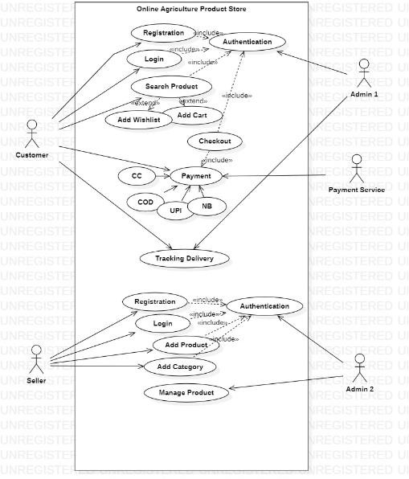

1. **(Minimum 5) Use Case Specs:**

* Use case spec – User buying fertilizers.

|  |  |  |  |  |
| --- | --- | --- | --- | --- |
| **USE CASE SPEC – BUYING FERTILIZER** | | | | |
| **Document Title** | **Buying fertilizers from an Online Agriculture Store.** | | | |
| **Document Owner** | Kumaran Dharmalingam | | | |
| **Version** |  | | | |
| **Status** | In Progress | | | |
| **Date** | 09th Feb 2025 | | | |
|  |  |  |  |  |

|  |  |
| --- | --- |
| **BRIEF DESCRIPTION** | This Use case explains how a Farmer uses the Online Agriculture Product Store to buy Fertilizers. |
| **ACTORS** | 1. Farmers 2. Database/Admin |
| **Pre-Conditions** | * There should be an active Internet connection. * Farmer should have Laptop/Mobile. |
| **Basic Flow** | * Use case Begins with User logs in. * User validation is performed. * Customer begins to search for the Agriculture Product. * Application displays multiple products for the Searched product. * User selects the product and add it to cart. * User selects the Delivery location for product delivery. * User selects the Payment mode to pay. * Order placed and user receives an SMS for Order confirmation. * Use case Ends successfully. |
| **Alternate Flow** | * **Invalid User** – This happens when the user validation fails.   App display message: User validation not completed Successfully. Use case ends with failure condition.   * **Product Out of Stock** – If the user selects the product which is out of stock. App display message: Product out of stock. Select from similar product available. * **Product Out of Stock for selected location**: If the product is not available for the Selected location.   App display message: Product out of stock for selected location. Please try after few days when the product is available / Try selecting from similar products.   * **No response from Payment server**: While making payment, if the server disconnects or there is no response from the server. * **Use Case Ends** |
| **Post Conditions** | * Successful Completion – User bought the fertilizer successfully. * Failure Condition – User couldn’t purchase the product due to some Technical/Financial reason |
| **SUPPLEMENTAL REQUIREMENTS** | * The price of all the agriculture product should be as per the Govt. policy. * The application shall keep a usage detail of all complete and incomplete transactions. |

* Use case spec – User registering in the application.

|  |  |  |  |  |
| --- | --- | --- | --- | --- |
| **USE CASE SPEC – User Registration** | | | | |
| **Document Title** | **User Registering with User details** | | | |
| **Document Owner** | Kumaran Dharmalingam | | | |
| **Version** |  | | | |
| **Status** | In Progress | | | |
| **Date** | 09th Feb 2025 | | | |
|  |  |  |  |  |
| **BRIEF DESCRIPTION** | This Use case describes, how a user registers himself in an Online Agriculture Store | | | |
| **ACTORS** | * Farmer * Admin | | | |

|  |  |
| --- | --- |
| **Pre-Conditions** | * There should be an active Internet connection. * Farmer should have Laptop/Mobile. * The user should have active Email address. * The user should have active mobile number. |
| **Basic Flow** | **Use case Begin**s – When a new user starts register himself with the user details.   1. User enters user details: Name, Address, Mobile number, and Email ID. 2. Application displays option to send OTP to mobile for mobile verification. 3. User sends OTP to the mobile number. 4. User enters OTP received. 5. Application displays OTP verified. 6. User validation performed. 7. Application displays User created successfully.   **Use case Ends.** |
| **Alternate Flow** | 1. **Invalid OTP**: If the user enters the incorrect OTP. Display Msg: Please enter the correct OTP. 2. **Mobile number already used**: In this case, if the user enters the mobile number which is already in use, which means that the user is already a registered user.   Display Msg: Mobile number is already in use. Please enter the correct mobile number.   1. **Email address is already used**: If the user enters the email address which is already used to register, which means that the user has already a registered user.   Display Msg: Email address is already in use. Please enter the correct Email address.   1. **User ID not available**: If the user enters the User ID which is already used, then the application gives the below message.   Display Msg: User ID already used. Please enter another user id.   1. **Server issue**: If the user not able to create the user id, when the server breakdown. Display Msg: Server busy. Please try again later. |
| **Post Conditions** | * Successful completion: The user id has been successfully created. * The details updated in the log accordingly. |
| **SUPPLEMENTAL REQUIREMENTS** | * The application shall keep a log, Including date and time, of all complete and incomplete transactions. |

* Use case spec – User making payment for the order placed.

|  |  |  |  |  |
| --- | --- | --- | --- | --- |
| **USE CASE SPEC – Processing Payment** | | | | |
| **Document Title** | **Payment process for the purchased product** | | | |
| **Document Owner** | Kumaran Dharmalingam | | | |
| **Version** |  | | | |
| **Status** | In Progress | | | |
| **Date** | 09th Feb 2025 | | | |
|  |  |  |  |  |
| **BRIEF DESCRIPTION** | This use case describes, how the user goes through a Payment process after the product selection | | | |
| **ACTORS** | * Farmer * Admin * Bank | | | |

|  |  |
| --- | --- |
| **Pre-Conditions** | * There should be an active Internet connection. * Farmer should have Laptop/Mobile. * User should have an active Bank account. * User should have active mobile number to receive the Bank OTP. |
| **Basic Flow** | **Use case Begins** – when the user initiates the payment after the selection of the product.   1. User validation performed. 2. Application displays multiple options to Pay by Credit card, Debit card, Net Banking, and UPI. 3. User has option to pay by Credit card, Debit card, Net Banking, UPI 4. User selects the Payment mode and fill the details. 5. Application displays Payment completed. 6. User receives email and SMS with the Order completion.   **Use case Ends** |
| **Alternate Flow** | 1. **Incorrect Card details**: If the user enters incorrect Card details. User receives SMS from Bank about Payment failure due to incorrect card details entered.   Display Msg: Payment not completed.   1. **Incorrect OTP**: If the user enters incorrect OTP. Display Msg: Payment declined. Incorrect OTP entered. 2. **Insufficient Funds**: Payment got declined due to insufficient funds.   Display Msg: Payment declined. User receive SMS from Bank confirming the Payment declined due to insufficient funds.   1. **Server Busy**: Payment didn’t complete due to Server busy. Display Msg: Payment not completed. Server Busy. Please try again |
| **Post Conditions** | * Successful Completion: Payment is completed, and the Order is placed successfully |
| **SUPPLEMENTAL REQUIREMENTS** | * The application shall keep a log, Including date and time, of all complete and incomplete transactions |

* Use case spec – Seller adding and updating the products in the portal.

|  |  |  |  |  |
| --- | --- | --- | --- | --- |
| **USE CASE SPEC – Seller Adding/Updating Products** | | | | |
| **Document Title** | **Seller Adding/Updating Products** | | | |
| **Document Owner** | Kumaran Dharmalingam | | | |
| **Version** |  | | | |
| **Status** | In Progress | | | |
| **Date** | 09th Feb 2025 | | | |
|  |  |  |  |  |
| **BRIEF DESCRIPTION** | * This Use case describes how a Seller/Manufacturer adds this product on the portal. | | | |
| **ACTORS** | * Seller / Manufacturer * Database/Admin | | | |
| **Pre-Conditions** | * There should be an active Internet connection. * Seller should have Laptop/Mobile | | | |

|  |  |
| --- | --- |
| **Basic Flow** | **Use case Begins** – When the Seller wants to Add/update any New Agricultural product at Agricultural Product store.   1. Seller selects the Sale option before Login. 2. User validation performed. 3. Application displays different Product selling alternatives. In this case the Seller selects Agricultural product option. 4. Seller chooses product categories. 5. The Seller enters product details i.e., Product Name, Type of the product, Price and Offers on product and Approximate Delivery date. 6. Application displays the new Product detail updated successfully. 7. Seller also receives a receipt by SMS or email.   **Use case Ends**. |
| **Alternate Flow** | * **Region wise product price display to customer**: Seller tries to update the Price as per the region; however, the application throws an error.   Display Msg: Price not matching as per the region. Please enter the correct price.   * **Incorrect product categories**: Seller selects the wrong product category. Display Msg: Incorrect Product category. Please select the correct category |
| **Post Conditions** | * Successful completion - The product has been successfully updated |
| **SUPPLEMENTAL REQUIREMENTS** | * The application shall keep a log, Including date and time, of all complete and incomplete transactions with the admin |

* Use case spec – User cancelling the product.

|  |  |  |  |  |
| --- | --- | --- | --- | --- |
| **USE CASE SPEC – Product cancellation/Return/Refund** | | | | |
| **Document Title** | **Product cancellation/Return/Refund** | | | |
| **Document Owner** | Kumaran Dharmalingam | | | |
| **Version** |  | | | |
| **Status** | In Progress | | | |
| **Date** | 09th Feb 2025 | | | |
|  |  |  |  |  |
| **BRIEF DESCRIPTION** | * This use case describes how user cancel/return the product at online agricultural product store | | | |
| **ACTORS** | * Farmer * Database/Admin * Seller | | | |
| **Pre-Conditions** | * There should be an active Internet connection. * Seller should have Laptop/Mobile. | | | |

|  |  |
| --- | --- |
| **Basic Flow** | **Use case Begins** – When the User wants to cancel/return agriculture product at agricultural product store.   1. User validation performed. 2. Application displays multiple order, which has already been placed. 3. User selects the Order/Product for cancellation/return. 4. Application displays Reason for cancellation/return. 5. User provides reason for cancellation/return. 6. Application displays Product cancellation/return requested. Product will be picked up at certain time and date. 7. Seller receives message or product cancellation/return. 8. Seller arranges the product pick up. 9. Admin issues Refund to User. 10. User receives the Refund.   **Use case Ends**. |
| **Alternate Flow** | * **Cancel Period over**: Application displays this message when the user tried to cancel after the cancellation/return period is over.   Display Msg: Product cannot be returned. |
| **Post Conditions** | * **Successful cancellation/Return**: The product has been successfully cancelled and the internal logs have been updated. * **Refund Initiated**: Refund has been initiated. |
| **SUPPLEMENTAL REQUIREMENTS** | * The application shall keep a log, Including date and time, of all complete and incomplete transactions with the admin |

1. **(Minimum 5) Activity Diagrams**
   1. 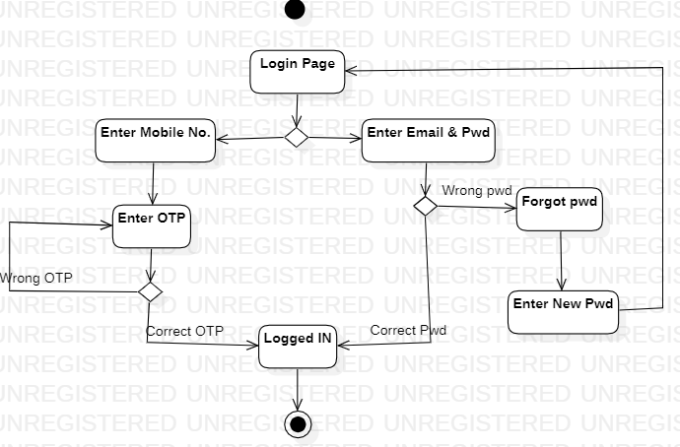**Login Page**

* **Registration Page**

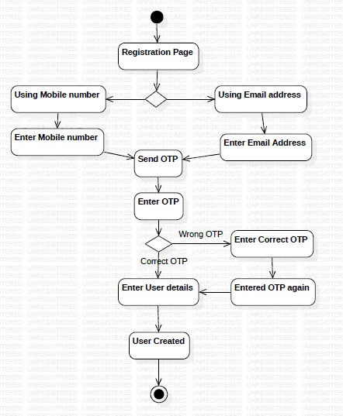

* **Buying fertilizer**

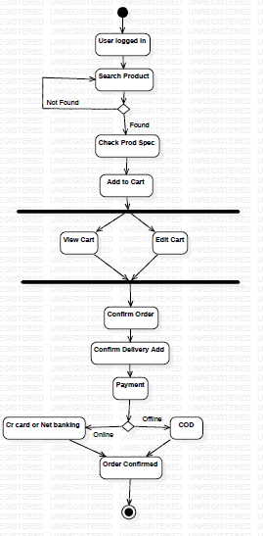

* **Order Cancellation**

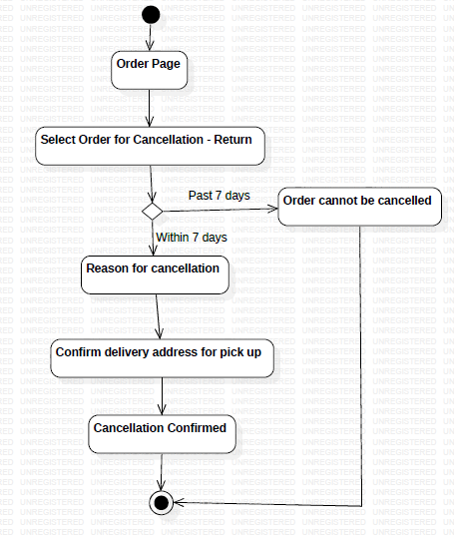

* 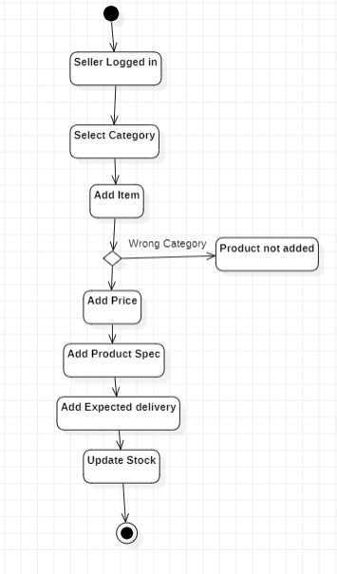**Adding or updating Product**