BA MOCK 4

**Assignment 1:**

1. Please make a BRD which can be presented to the client along with complete development and resource plan.

**Answer:**

**1. Document Revisions**

|  |  |  |  |
| --- | --- | --- | --- |
| **Version Number** | **Date** | **Prepared by** | **Remarks** |
| 1.0 | 14/12/2024 | Initial draft | First draft for review |
| 1.1 | 18/12/2024 | Updated Draft | Added reviewers input |
| 2.0 | 25/12/2024 | Final Draft | Approved and finalized |

**2. Approvals**

|  |  |  |  |  |
| --- | --- | --- | --- | --- |
| Role | Name | Title | Signature | Date |
| Project Sponsor | Rahul | Sponsor | Rahul | 05/11/2024 |
| Project manager | Madhusudhan | Project Manager | Madhusudhan | 05/12/2024 |
| System Architect | Srinivas | System Architect | Srinivas | 13/12/2024 |
| Development lead | Priyanka | Development Lead | priyanka | 23/01/2025 |
| User experience lead | Anusha | User experience lead | Anusha | 22/02/2025 |
| Quality lead | Nagaraj | Quality lead | Nagraj | 15/04/2025 |
| Content lead | Yashwanth | Content Lead | Yashwanth | 29/05/2025 |

**3. RACI Chart for This Document**

RACI matrix is a document that clarifies which individual or groups are responsible for a project’s successful completion, and the roles that each will paly throughout the project. The acronym RACI stands for the different responsibility types: Responsible, Accountable, Consulted, and Informed.

R- Responsible, A- Accountable, C- Consulted, I- Informed

|  |  |  |  |  |
| --- | --- | --- | --- | --- |
| **Task** | **Responsible (R)** | **Accountable (A)** | **Consulted ( c )** | **Informed (I)** |
| **Requirements gathering** | Business Analyst | Product manager | Plant managers and warehouse supervisors | IT Head |
| **Software design** | Solution Architect | Technical lead | Business Analyst | Project sponsor |
| **Inventory management module** | Developers | Technical lead | Plant managers and warehouse supervisors | Product Manager |
| **Logistics and delivery module** | Developers | Technical lead | Business Analyst | Product Manager |
| **System integration** | Integration specialist | Technical lead | Solution Architect | Product manager |
| **User interface design** | UX/UI Designer | Technical lead | Business Analyst | End Users |
| **Testing and quality assurance** | QA team | QA Manager | Technical lead | End users |
| **Deployment and rollout** | DevOps engineers | IT Head | Technical lead | Plant Managers |
| **Monitoring and maintenance** | IT Support team | IT Head | Plant managers and warehouse supervisors | Product manager |

**4. Introduction**

**4.1. Business Goals**

* Monitor and maintain optimal inventory levels across manufacturing plants and warehouses. Reduce wastage of perishable goods like milk and ice cream.

* Facilitate seamless communication between manufacturing plants, distributors. Tracks shipments in real time for better accountability.

* Ensure product availability and timely delivery to meet customer demands. Provide accurate order tracking for customers.

**4.2. Business Objectives**

* Centralize inventory management to minimize wastage and ensure the availability of products.

* Optimize logistics for quick and cost effective delivery to customers.

* Improve operational efficient by integrating manufacturing, storage, and delivery workflows.

* Provide real time insights into inventory levels, product movement, and delivery timelines.

**4.3. Business Rules**

* All manufacturing plants and warehouses must be linked to a centralized system to track real time inventory levels. * Ice cream and milk products must be categorized by type, flavour and size for better inventory organization. * Products close to expiry must be flagged for priority dispatch to reduce wastage. * Orders must be routed to the nearest warehouse or manufacturing plant with sufficient stock. * Clear delivery timeframes must be communicated to customers based on location and inventory. * Use AI driven route optimization to ensure deliveries are made in the shortest possible time.

**4.4. Background**

The Company is a leading manufacturer of ice cream and milk products, operating across various locations in the country. It has a network of manufacturing plants to cater to customer demands efficiently. Given the highly perishable nature of their products, managing inventory effectively and ensuring quick delivery to customers are critical to maintaining quality, reducing wastage, and achieving customer satisfaction.

**4.5. Project Objective**

To develop a robust and scalable software solution for the company to efficiently manage inventory across its manufacturing plants and warehouses, optimize logistics for the quickest delivery of ice cream and milk products to customers, and enhance overall operational efficiency while reducing costs.

* Key Areas to focus:

1. Inventory Management: Real time tracking of stock levels for raw materials, finished goods and packaging materials. Automated alerts for replenishment to avoid shortages or overstocking.

2. Delivery Optimization: Route Optimization for faster and cost effective delivery. Real time tracking of delivery vehicles and customer orders.

**4.6.1. In Scope Functionality**

* Inventory management across manufacturing plants and warehouses. * Order processing and tracking. * Delivery route optimization. * Real time data analytics and reporting. * User roles and permissions for secure access.

**4.6.2. Out Scope Functionality**

* Non ice cream and milk product inventory. * In-House production process automation. * Third party logistics. * Advanced financial management. * Marketing and CRM campaigns. * E commerce features. * Custom Hardware integration

**5. Assumptions**

* The company has historical data to predict customer demand for ice cream and milk products. * All manufacturing plants and warehouses are connected to a centralized inventory management system. * The company has the infrastructure and willingness to adopt software for inventory and delivery management. * The locations of manufacturing plants and warehouses will not change frequently. *The company primarily delivers to wholesalers, retailers and some direct customers.

**6. Constraints**

* Training * Additional features or changes in features and functionalities described in document may require changing the time and costing estimation of the project development. * Timeline for enterprise platform updates will impact execution of testing and delivery plan. * Budget (2 crores). * Schedule (may 28th delivery date)

**7. Risks**

Risks analysis plays a crucial part in the business progress, Risk analysis can be done anytime of the project which helps to be on track and measure the progress, while anticipating and being ready for unseen risks before it occurs.

**In the particular project risk we face are on the following:**

**Political Risks:** Government has changed and introduced new laws and regulations which has impacted our e commerce application like taxation, policies and consumer protection laws.

**Skills Risks:** The team may not have the necessary technical skills to develop, maintain, or use the software properly. Employees at various levels may struggle to learn the new system, affecting productivity and accuracy in managing inventory and deliveries.

**Technological Risks:** The software might experience technical issues or crashes, leading to interruptions in operations and delayed deliveries. The new software may not integrate well with existing systems or hardware at plants and warehouses, causing inefficiencies.

**Requirements Risks:** If the company’s goals or the software’s desired features aren’t clearly defined at the start, the software might not meet the need of the business. As business needs evolve, the software might need continuous updates, and if the software isn’t flexible, it could become obsolete or ineffective.

**Business Risks:** Other companies may develop more advanced software or more efficient processes, giving them an edge in quick deliveries or inventory management. The development or implemented of the software may exceed budget, affecting the financial health of the company.

**8. Business Process Overview**

**8.1. Legacy System (AS-IS)**

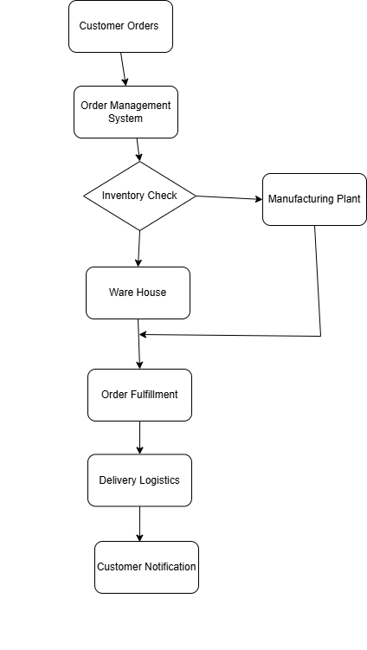

**8.2. Proposed Recommendations (TO-BE)**

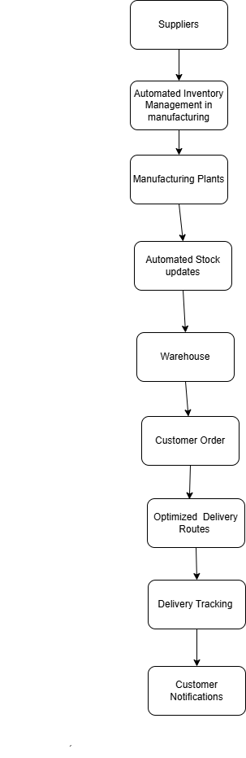

**9. Business Requirements**

|  |  |  |
| --- | --- | --- |
| **REQUIREMENT ID** | **REQUIREMENT NAME** | **REQUIREMENT DESCRIPTION** |
| BR001 | Inventory Management | Track the stock levels of ice creams and milk products at all manufacturing plants and ware houses. |
| BR002 | Order Processing | Enable quick and efficient processing of customer orders for fast delivery. |
| BR003 | Real time stock updates | Automatically update stock levels in real time as sales and deliveries occur |
| BR004 | Route optimization | Determine the most efficient delivery routes to minimize time and cost in transporting products to customers. |
| BR005 | Order prioritization | Prioritize urgent or high value orders to ensures fast delivery to important customers. |
| BR006 | Product Quality Monitoring | Monitor and maintain the quality pf products during storage and transportation to ensure freshness. |
| BR007 | Warehouse Management | Organize inventory in warehouses for easy access and quicker picking pf products for shipping. |
| BR008 | Sales Forecasting | Predict future product demand based on historical sales data to optimize inventory levels. |
| BR009 | Reporting and Analytics | Generate reports to track sales, delivery times, and inventory levels to improve decision making. |
| BR0010 | Customer Notification | Provide customers with updates on order status, delivery time and any potential delays. |

2. Prepare process flow diagram using your imagination.

**Answer:**

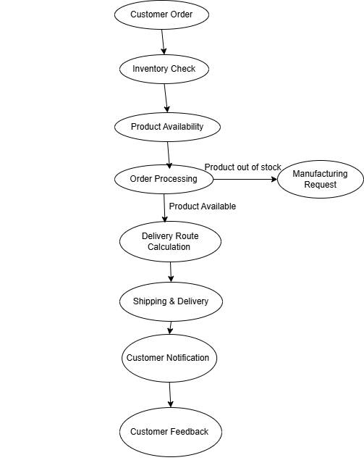

**Assignment 2:**

1. Write an introduction letter to a client introducing yourself as a business analyst in charge of working with the client and his team to start the business understanding process.

**Answer:**

Dear Client,

I hope this message finds you well. My name is Gudupally Achyuth Reddy, and I am pleased to introduce myself as the Business Analyst assigned to collaborate with you and your team. I will be your primary point of contact as we work together to understand your business needs and ensure the success of this project. My primary responsibility is to act as a bridge between your organization and our team, facilitating a through understanding of your business processes, goas, and challenges. I will work closely with you to 1. Gather and analyze your requirements, 2. Translate these requirements into actionable insights for our team. Over the next few weeks, well begin with a detailed business understanding process. This will include discussions, workshops, and reviews to gain a comprehensive understanding of your objectives and expectations. Please feel free to reach out to me directly at [achyuthreddygudupally@gmail.com](mailto:achyuthreddygudupally@gmail.com) or 7075071266 should you have any questions or require assistance.

Looking forward to working with you and achieving great results together.

Best regards, Gudupally Achyuth Reddy, Business Analyst, 7075071266.

2. Prepare a brief BRD and SRS for a project- Horoscope or Ticketing system or online store.

**Answer:**

**Online E Commerce Application**

BRD Template

**1. Document Revisions**

|  |  |  |
| --- | --- | --- |
| **Date** | **Version Number** | **Document Changes** |
| 07/12/2024 | 0.2 | Initial Draft |
| 15/12/2024 | 1.2 | Data Requirements |
| 22/12/2024 | 1.3 | Tools navigation list |
| 27/12/2024 | 1.4 | Typographical updates and formatting |
| 09/01/2025 | 2.0 | Journey History |

**2. Approvals**

|  |  |  |  |  |
| --- | --- | --- | --- | --- |
| Role | Name | Title | Signature | Date |
| Project Sponsor | G. Vishal | Sponsor | Vishal | 05/11/2024 |
| Business owner | Ashwith | Business Owner | Ashwith | 09/11/2024 |
| Project manager | Joel Michael | Project Manager | Joel | 05/12/2024 |
| System Architect | Manush | System Architect | Manush | 27/12/2024 |
| Development lead | Anil | Development Lead | Anil | 28/01/2025 |
| User experience lead | Keshav Naik | User experience lead | Keshav | 18/02/2025 |
| Quality lead | Raj Kumar | Quality lead | Raj kumar | 10/04/2025 |
| Content lead | Sampanth | Content Lead | Sampanth | 23/05/2025 |

**3. RACI Chart for This Document**

RACI matrix is a document that clarifies which individual or groups are responsible for a project’s successful completion, and the roles that each will paly throughout the project. The acronym RACI stands for the different responsibility types: Responsible, Accountable, Consulted, and Informed.

R- Responsible, A- Accountable, C- Consulted, I- Informed

|  |  |  |  |  |  |  |  |  |  |
| --- | --- | --- | --- | --- | --- | --- | --- | --- | --- |
| **RACI** | **Mr Nagraj ( Client BA)** | **Mr. Ahmed**  **(Requirement Stakeholders)** | **Mr Rakesh (Delivery Head)** | **Mr. Joel  (Project manager)** | **Mr. Anil**  **(Senior Java Developer)** | **Mr Jason and Ms Alekya**  **(Testers)** | **Mr Mike (Network Admin)** | **Mr John (DB Admin)** | **Mr Achyuth**  **(Business Analyst)** |
| **Requirements gathering** | C | C | A | A | I |  |  | I | R |
| **Requirements analysis** | C | C | A | A | I |  |  | I | R |
| **Design** | I | I | A | A | I |  |  | I | A |
| **Coding/Unit tests** | I | I | A | A | R |  |  | I |  |
| **Testing** | I | I | A | I | I | R |  | R | R |
| **Deployment & implementation** | I | I | A | A |  | A | R |  | C |

**4. Introduction**

**4.1. Business Goals [This should describe the organization goals& Organization Need]**

Need: Creating a successful online e commerce application involves addressing various organizational needs that span across different departments and functions.

**Goal:**

*To Create a gap between Consumers and manufacture companies so that Consumers can buy their needs directly from the manufacturers

*To develop a Application where Customers can order their products through online.

**Out Puts:**

* Users can purchase their products through this application easily where they cant buy at their local areas

* Manufacturers can directly sell their products to the customers without any broker in between

**4.2. Business Objectives To provide an IT solution for:**

List what the functionalities are going to develop in software

* Licensed Product

* Have to allow users to login

* Debugging and excellent customer service provided

**4.3. Business Rules [List Organization Policies, Procedures, and Rules& Regulations]**

**\*** Ifthe product is unopened and in its original packaging: Offer a full refund to the customer.

* A cancellation, clear refund, return and cancellation policy must be established and followed.

* If the product has been opened or used but is within 30 days of the purchase date: Provide an option for a store credit or exchange.

* Sellers are required to provide tracking information where applicable

* Provide clear customer support channels, such as email, chat or phone.

* Sellers must comply with local, state and national tax regulations.

**4.4. Background**

Website is necessary for simplifying the buying and selling process of apparels. Customers should be able to search the desired items. And can place order by making online payment of the items. Online website will help business owner to streamline his offline business of apparels selling and will grow revenue by making business online.

**4.5. Project Objective**

* Making online e commerce platform for buyers to buy apparels from website. * Customers will be able to search for the various kinds of products for e.g shirts, perfume etc. and will be able to order it from website by making online payment of products. * Customer will be able to track their order shipment. * Business owner will be able to manage his products by category and prices with different sizes and colours. Owner will be able to deliver the items to the buyers on shipping address mentioned by the buyer while placing an order.

**4.6. Project Scope**

The scope of the project is to design and develop an online ecommerce website for products. Customers will be able to use the frontend website for searching the products and place the order by making online payment of the order in advance. Web based admin panel/backend will help admin user i.e. business owner to manage the products, categories, prices and orders placed by the customers.

**4.6.1. In Scope Functionality**

* Buyer

* Login
* Registration
* Search products
* Product listing and search results
* Product details with available variations
* Add to cart
* Add to wishlist
* Checkout and online payment of the orders
* Share products on social media
* Ratings and review on products
* Place the order
* Manage address book
* My account
* Order history
* Order Tracking

* Admin

* Ability to create /edit/ delete products
* Manage product categories and sub categories
* Manage product catalog
* Manage orders
* Manage customers
* Manage shipping
* Manage payments
* Manage roles/permissions
* CMS pages management
* Ratings and review management

**4.6.2. Out Scope Functionality**

* Ordering customized products
* Real time order tracking
* Cash on delivery option for buyers

**5. Assumptions**

* Customer will have various payment options. * Price of the product will be in rupees. * Admin will manage the product catalogue with product codes. * Products with custom size and colours are not going to be sold on website. * Website will accept orders from India only.

**6. Constraints**

* Training * Additional features or changes in features and functionalities described in document may require changing the time and costing estimation of the project development. * Timeline for enterprise platform updates will impact execution of testing and delivery plan. * Budget (2 crores). * Schedule (June30th delivery date)

**7. Risks**

Risks analysis plays a crucial part in the business progress, Risk analysis can be done anytime of the project which helps to be on track and measure the progress, while anticipating and being ready for unseen risks before it occurs.

**In the particular project risk we face are on the following:**

**Skills Risks:** Weak backend development skills which is leading to inefficient data handling, slow load time, and poor integration with third party services. Insufficient Understandings of legal requirements which results in non- compliance, leading to legal penalties and loss of customer trust.

**Political Risks:** Government has changed and introduced new laws and regulations which has impacted our e commerce application like taxation, policies and consumer protection laws.

**Technological Risks:** Technical issue where login access has problem to the website or the checkout will also impact the sales and the customer service.

**Human risk Error:** As the project is more inclined to a human service – oriented Customer service where the focus is all about, provided excellent customer service human error is a common risk happening which can evaluate and avoided.

**Requirements Risks:** Requirements are unclear or open to interpretation, leading to misunderstanding during development. Some essential features or business rules are not identified during the requirement gathering phase. Stakeholders frequently changes requirements after the project has started.

**8. Business Process Overview**

**8.1. Legacy System (AS-IS)**

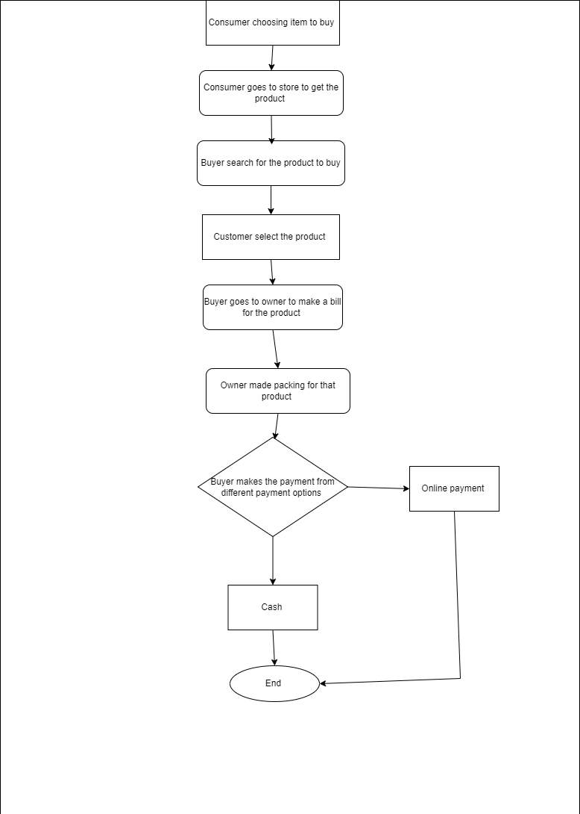

**8.2. Proposed Recommendations (TO-BE)**

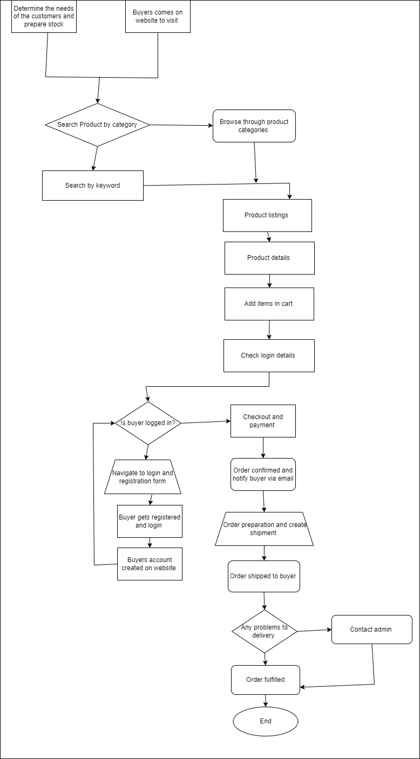

**9. Business Requirements**

|  |  |  |
| --- | --- | --- |
| **REQUIREMENT ID** | **REQUIREMENT NAME** | **REQUIREMENT DESCRIPTION** |
| BR001 | Login | The website should ask the details like email and phone number to login. |
| BR002 | Product catalogue | The website should able to show the variety of products. |
| BR003 | Order status | Users should get the confirmation code to their number regarding their order status. |
| BR004 | Availability | The website should show the availability of products to the Customers. |
| BR005 | Add to cart | Consumers can add their product in to the cart which they want to buy. |
| BR006 | Search option | Consumers should search the product which they need. |
| BR007 | Delivery tracking | Website should show the delivery tracking of product to the Customers. |
| BR008 | Payment options | There should be have multiple payment options to the Customers. |
| BR009 | Pay later | The application should show the pay later option to the Customers where it will be very useful to the farmers. |
| BR0010 | Instalment options | If application should show the instalment options the users can pay the amount for every month. |

**SRS DOCUMENT**

**INTRODUCTION**

The Online E commerce store web application is intended to provide complete solutions for vendors as well as customers through a single gateway using the internet as sole medium. It will enable vendors to sell their products through this website, Customers browse through the shop and purchase them online without having to visit the shop physically. The administration module will enable a system administrator to approve and reject requests for new shops and maintain various lists of shop category.

**GOAL**

*To Create a gap between Consumers and manufacture companies so that Consumers can buy their needs directly from the manufacturers

*To develop a Application where Customers can order their products through online.

**OBJECTIVES**

The purpose of this document is to define the requirements of online shopping system. This document lists the requirements that are not readily captured in the use cases of the use case model. The supplementary specification and use case model together capture a complete set of requirements of the system.

**Project Objectives**

* Making online e commerce platform for buyers to buy apparels from website. * Customers will be able to search for the various kinds of products for e.g shirts, perfume etc. and will be able to order it from website by making online payment of products. * Customer will be able to track their order shipment. * Business owner will be able to manage his products by category and prices with different sizes and colours. Owner will be able to deliver the items to the buyers on shipping address mentioned by the buyer while placing an order.

**Business Objectives**

Creating business objectives for an application involves aligning goals with customer needs, market trends, and the company vision. Below are some key business objectives:

* Increase sales revenue

* Enhance customer experience

* Build brand awareness and trust

* Increase Customer Retention and loyality

* Expand Market Reach

* Optimize operational efficiency

**Business Requirements**

|  |  |  |
| --- | --- | --- |
| **REQUIREMENT ID** | **REQUIREMENT NAME** | **REQUIREMENT DESCRIPTION** |
| BR001 | Search option | Consumers should search the product which they need. |
| BR002 | Add to cart | Consumers can add their product in to the cart which they want to buy. |
| BR003 | Delivery tracking | Website should show the delivery tracking of product to the Customers. |
| BR004 | Payment options | There should be have multiple payment options to the Customers. |
| BR005 | Login | The website should ask the details like email and phone number to login. |
| BR006 | Availability | The website should show the availability of products to the Customers. |
| BR007 | Pay later | The application should show the pay later option to the Customers where it will be very useful to the farmers. |
| BR008 | Order status | Users should get the confirmation code to their number regarding their order status. |
| BR009 | Instalment options | If application should show the instalment options the users can pay the amount for every month. |
| BR0010 | Product catalogue | The website should able to show the variety of products. |
| BR0011 | User Registration and authentication | Allow users to create accounts, login and manage their profiles securely. |
| BR0012 | Customer Service | Users can contach customer support via email or live chat to know about their product and application also. |
| BR0013 | Reviews and ratings | Users can write reviews and rate products. |
| BR0014 | Wishlist | Users can add products to a wishlist. Users can view and manage their wishlist. |
| BR0015 | Security | Secure user data storage and transmission. Compliance with data protection regulations. E.g GDPR |
| BR0016 | Reporting and Analytics | Admins can generate sales and revenue reports. Analytics on customer behavior. |
| BR0017 | Reliability | The system must ensure data integrity and consistency even in case of system failures or crashes. |
| BR0018 | Response time | The average response time for any user request should be under 2 seconds |
| BR0019 | Compatibility | The application should be compatible with various web browsers and mobile devices to reach a wider audience. |
| BR0020 | Availability | The system should make sure that it is available for customers at all times. |

**USE CASE DIAGRAM**

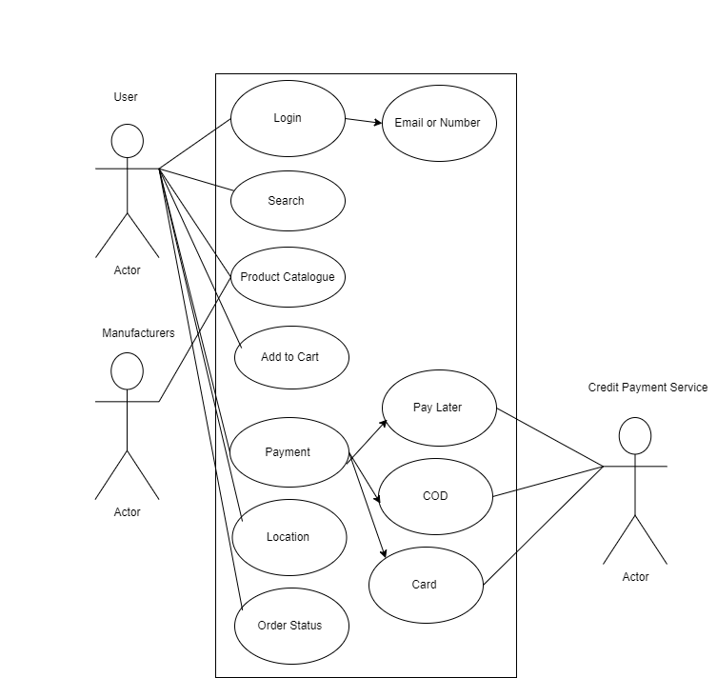

**Use Case Specification Document**

**1. Use Case Specification – Payment**

|  |  |
| --- | --- |
| **Use Case ID:** | PQR_UC1 |
| **Use Case Name:** | Payments |
| **End Objective:** | User can make payment for the product |
| **Actors(primary actor, Secondary actor)** | Consumers , Payment gateway and Bank. |
| **Frequency of Use** | When user wants to buy product should make payment |

|  |
| --- |
| **Use Case Identification** |

|  |
| --- |
| **Preconditions** |
| The User has email id and phone number  The User has internet connection  The User wants to purchase the product/User wants to add product in catalogue |

|  |
| --- |
| **Basic Flow** |
| **Step** | **User actions** | **System actions** |
| 1 | The User opens the website | Display homepage to sign in to account |
| 2 | Fill details and click sign in | Filled details are correct display the website |
| 3 | Click on search option and see the product they required | Display the product which available in catalogue |
| 4 | Select the product they required | Display the entire product details and information like pricing and etc. |
| 5 | Click on payment option+ | Make payment by using different options for product which is selected. |

|  |
| --- |
| **Exceptional Flow** |
| If product is damaged then payment should be refund to the user |

|  |
| --- |
| **Use Case Description** |
| This use case describes the process of handling a payment transaction initiated by a user. It outline how the system will accept, process, and confirm payment through various payment methods (credit card, bank transfer, etc.) |

|  |  |  |
| --- | --- | --- |
| **Step** | **User actions** | **System actions** |
| 1 | The User opens the website | Display homepage to sign in to account |
| 2 | Fill details and click sign in | Filled details are correct display the website |
| 3 | Click on search option and see the product they required | Display the product which available in catalogue |
| 4 | Select the product they required | Display the entire product details and information like pricing and etc. |
| 4 | Select the product they required | Display the entire product details and information like pricing and etc. |

|  |
| --- |
| **Alternate Flow** |

|  |
| --- |
| **Assumptions** |
| The user has a valid payment method  The users payment method has sufficient balance or credit. |

|  |
| --- |
| **Business Rules** |
| 1. Payment must be processed using secure protocols(e.g., SSL/TLS)  2. The system must support a minimum of three payment methods (credit card, bank transfer, and one digital wallet).  3. Payment information should not be stored in the system unless the user has opted for recurring payments. |

|  |
| --- |
| **Constraints** |
| 1. The payment system must comply with country-specific financial regulations, including data privacy laws like GDPR for European countries.  2. Payments made in foreign currencies may be subject to exchange rates and conversion fees, depending on the bank for payment service provider.  3. Any delays in network communication between the payment system, banks could impact transaction times. |

|  |
| --- |
| **Dependencies** |
| 1. The payment processing system depends on third party payment gateways to authorize and process transactions.  2. The payment system relies on a user authentication system to ensure that only authorized users can initiate payments.  3. Payment transactions may depend on real time fraud detection services, which could block or delay transactions if suspicious activity is detected. |

|  |  |
| --- | --- |
| **Inputs** | Payment method details, User account information, Total amount for payment, user confirmation for payment. |
| **Outputs** | Payment confirmation or rejection message, Transaction ID for reference, Payment receipt, Error message. |

|  |
| --- |
| **Post Condition** |
| The website should show the different payment options and make payments easily. |

**2. Use Case Specification – Add to cart**

|  |
| --- |
| **Use Case Identification** |

|  |  |
| --- | --- |
| **Use Case ID:** | PQR_UC2 |
| **Use Case Name:** | Add to cart |
| **End Objective:** | User can add products to catalogue |
| **Actors(primary actor, Secondary actor)** | Consumers, System |
| **Frequency of Use** | When user wants to buy products |

|  |
| --- |
| **Use Case Description** |
| This use case allows a user to add a product to their shopping cart on an e commerce platform. The user selects a product, specifies details(like quantity, size, color etc.) and adds it to the cart to proceed toward checkout. |

|  |
| --- |
| **Basic Flow** |
| **Step** | **User actions** | **System actions** |
| 1 | The User opens the website | Display homepage to sign in to account |
| 2 | Fill details and click sign in | Filled details are correct display the website |
| 3 | Click on search option and see the product they required | Display the product which available in catalogue |
| 4 | Select the product they required | Display the entire product details and information like pricing and etc. |
| 5 | Click on add to cart option | Add the product which is selected in to cart |

|  |
| --- |
| **Preconditions** |
| The User has email id and phone number  The User has internet connection  The User wants to purchase the product/User wants to add product in catalogue |

|  |
| --- |
| **Exceptional Flow** |
| If selected product is not available the website must show the out of stock. |

|  |  |  |
| --- | --- | --- |
| **Step** | **User actions** | **System actions** |
| 1 | The User opens the website | Display homepage to sign in to account |
| 2 | Fill details and click sign in | Filled details are correct display the website |
| 3 | Click on search option and see the product they required | Display the product which available in catalogue |
| 4 | Select the product they required | Display the entire product details and information like pricing and etc. |
| 5 | Click on add to cart option | Add the product which is selected in to cart |

|  |
| --- |
| **Alternate Flow** |

|  |
| --- |
| **Business Rules** |
| 1. Only in stock items can be added to the cart.  2. Discounts, if available, are applied once the item is added to cart.  3. Certain restricted items may require validation before being added.  4. The system must handle concurrent access and inventory reservation to prevent overselling. |

|  |
| --- |
| **Constraints** |
| 1. The system must check inventory in real time to avoid overselling products.  2. The ‘’Add to cart’’ functionality must be fully operational on mobile, tablet, and desktop.  3. If the cart cannot be updated(due to network issues, server errors, etc.,) an appropriate error message should be displayed. |

|  |
| --- |
| **Assumptions** |
| The user will have java script enabled for interactive UI.  The inventory system provides real time updates to the frontend.  Any promotional pricing logic is handled in the backend or through an API call during the cart addition process. |

|  |
| --- |
| **Dependencies** |
| **Product catalog system**: For retrieving product details, options and images.  **Inventory system:** For real time stock levels.  **Session Management:** For storing cart details for guest users. |

|  |  |
| --- | --- |
| **Inputs** | Product ID, Product options, Selected quantity, User ID |
| **Outputs** | Confirmation message showing the item was added to cart, Updated cart count in the UI, Updated inventory in the backend. |

|  |
| --- |
| **Post Condition** |
| The website should take user to product catalogue. |

**3. Use Case Specification – Search Option**

|  |
| --- |
| **Preconditions** |
| The User has email id and phone number  The User has internet connection  The User wants to purchase the product/User wants to add product in catalogue |

|  |  |
| --- | --- |
| **Use Case ID:** | PQR_UC3 |
| **Use Case Name:** | Search |
| **End Objective:** | Search for products |
| **Actors(primary actor, Secondary actor)** | User, System and Search Algorithm |
| **Frequency of Use** | When user wants to Search for products |

|  |
| --- |
| **Use Case Description** |
| The ‘’Search’’ functionality enables users to search for specific information within a database, website, or application by entering keywords, filters or criteria. The search engine will then retrieve and display relevant results based on the input query. |

|  |
| --- |
| **Business Rules** |
| 1. Query Limitation: Queries should be limited to 500 characters.  2. Relevance: Search results should prioritize relevance based on the query.  3. Data Visibility: Users should only see search results they have permission to access.  4. Logging: Search queries and results should be logged for performance tracking and analytics. |

|  |
| --- |
| **Basic Flow** |
| **Step** | **User Actions** | **System Actions** |
| 1 | The User opens the website | Display home page to sign in to account |
| 2 | Fill details and click sign in | Filled details are correct display the website |
| 3 | Click on search option and see the product they required | Display the product which available in catalogue |
| 4 | Select the product they required | Display the entire product details and information like pricing and etc. |

|  |
| --- |
| **Exceptional Flow** |
| If searched product is not in the catalogue then the website shall display the error. |

|  |
| --- |
| **Alternate Flow** |

|  |  |  |
| --- | --- | --- |
| **Step** | **User actions** | **System actions** |
| 1 | The User opens the website | Display homepage to sign in to account |
| 2 | Fill details and click sign in | Filled details are correct display the website |

|  |  |  |
| --- | --- | --- |
| 3 | Click on search option and see the product they required | Display the product which available in catalogue |

|  |
| --- |
| **Assumptions** |
| The user is familiar with using search functionality and can input appropriate search queries.  The Data base or data repository contains sufficient and relevant data for user queries. |

|  |
| --- |
| **Constraints** |
| 1. Time Constraint: The search query must return results within a reasonable time frame. Complex queries with large datasets may affect response times.  2. Scalability: The search function must scale efficiency as the number of users or data grows.  3. Data Integrity: The search function must ensure accurate and relevant data is retrieved. The search results should reflect the most up-to-date information. |

|  |
| --- |
| **Dependencies** |
| **Data Base:** The search functionis dependent on the availability and accessibility of the database that stores the information.  **User Interface(UI):** The search bar and search results page need to be integrated into the user interface. |

|  |
| --- |
| **Post Condition** |
| The website shall show the product which is searched by user. |

|  |  |
| --- | --- |
| **Inputs** | Search keywords, Filters, Advanced search options. |
| **Outputs** | List of search results, suggestions for similar or related queries, Error or notification message in case of invalid input or no results. |

**4. Use Case Specification – Log In**

|  |
| --- |
| **Use Case Identification** |

|  |  |
| --- | --- |
| **Use Case ID:** | PQR_UC4 |
| **Use Case Name:** | Log In |
| **End Objective:** | Log In to Application |
| **Actors(primary actor, Secondary actor)** | User and Authentication Service |
| **Frequency of Use** | When user wants to add to catalogue/Wants to purchase the product |

|  |
| --- |
| **Use Case Description** |
| The user login use case describes the process by which a user authenticates themselves into the system by providing valid credentials. It ensures that only authorized users can access the system by verifying the credentials(e.g., username and password) |

|  |
| --- |
| **Preconditions** |
| The User must be available and accessible to the user.  The user must have a valid account in the system.  The user must be on the login page or screen.  If the system uses a third party authentication service, the external service must be operational. |

|  |
| --- |
| **Basic Flow** |
| **Step** | **User Actions** | **System Actions** |
| 1. | The user opens the website | Display home page login to account |
| 2. | Fill details and click login | Filled details are correct display the website |

|  |
| --- |
| **Exceptional Flow** |
| If Login details are wrong the system should show the error |

|  |
| --- |
| **Alternate Flow** |
| **Step** | **User Actions** | **System Actions** |
| 1. | The user opens the website | Display home page login to account |
| 2. | Fill details and click login | Filled details are correct display the website |

|  |
| --- |
| **Assumptions** |
| The user has an account and knows their credentials.  The systems authentication service is secure and robust.  External dependencies are available if used. |

|  |
| --- |
| **Constraints** |
| 1. The user must have internet access to login.  2. There might be limits on the number of failed login attempts before locking the user out their account.  3. The login functionality must operate across different devices(e.g., mobile, desktop) |

|  |
| --- |
| **Dependencies** |
| The login process depends on a reliable database or external authentication service to store and verify user credentials.  Availability of email service or SMS for two-factor authentication  The system relies on proper network and server availability. |

|  |
| --- |
| **Business Rules** |
| 1. Users must be authenticated before accessing any restricted areas of the system.  2. Passwords must be stored securely  3. Successful login attempts must be logged for security auditing.  4. Users should be automatically logged out after a period of inactivity. |

|  |  |
| --- | --- |
| **Inputs** | Username or Email, Password, CAPTCHA, OTP(one time password) |
| **Outputs** | Success: User is authenticated and redirected to their account or home page.  Failure: Error message are displayed. |

|  |
| --- |
| **Post Condition** |
| The website shall allow user to login |

**5. Use Case Specification – Order Status**

|  |  |
| --- | --- |
| **Use Case ID:** | PQR_UC5 |
| **Use Case Name:** | Order Status |
| **End Objective:** | Status of the Order |
| **Actors(primary actor, Secondary actor)** | Consumers and Manufacturers |
| **Frequency of Use** | When Consumers want to check the status of the order |

|  |
| --- |
| **Use Case Description** |
| The user case allows users to view the current status of an order placed within a system. Users can check whether their order is pending, processed, shipped, delivered or canceled. The system retrieves this information from the database, and displays it to the user in easy-to-understand format. |

|  |
| --- |
| **Preconditions** |
| The User is authenticated and logged in to the system (if required)  The user has previously placed an order. |

|  |
| --- |
| **Basic Flow** |
| 1. Customer logs into the e commerce platform or app. |
| 2. Customer navigates to the ‘’ My Orders ‘’ section. |
| 3. The Customers selects a specific order for which they want to check the status. |
| 4. The system retrieves the order details from the order management system and the database. |
| 5. The System displays the order status along with tracking information, estimated delivery time, and other relevant details. |
| 6. The Customer views the order status. |

|  |
| --- |
| **Exceptional Flow** |
| If Login details are wrong the system should show the error |

|  |
| --- |
| **Alternate Flow** |
| **Invalid Order ID** | **If the system cannot find the order based on the given order ID( e.g., invalid order ID) an error message will be shown: ‘’ Order not found. Please verify order ID.** |
| **Unauthenticated user** | **If the user attempts to access the ‘’ My orders” page without logging in, they are redirected to the login page and asked to authenticate before continuing.** |

|  |
| --- |
| **Assumptions** |
| The order status date is accurate and update in real –time.  The customer has an active internet connection when checking order status. |

|  |
| --- |
| **Constraints** |
| 1. The system must retrieve and display the order status within a predefined time frame.  2. Only authenticated and authorized users can view the order status.  3. The User interface must be intuitive and responsive across devices. |

|  |
| --- |
| **Dependencies** |
| **Order Management System (OMS):** | The system that manages all order-related information. |
| **Shipment Tracking Service:** | An external or internal service that provides shipment tracking information |

|  |
| --- |
| **Business Rules** |
| 1. Order Status Accuracy: The system must ensure that the status information provided is accurate and reflects the current state of the order.  2. Access Control: Only authorized users should be able to access detailed order status information.  3. Logging and Auditing: All requests and responses related to order status queries must be logged for auditing purposes.  4. Error Handling: The system should handle errors gracefully and provide clear, actionable messages to users. |

|  |  |
| --- | --- |
| **Inputs** | User Input: User login credentials, Order selection.  System Input: Order ID, Order status details from the database. |
| **Outputs** | Display of the current order status.  Optional tracking details.  Error or success messages depending on the outcome of the request. |

|  |
| --- |
| **Post Condition** |
| The Customer successfully views the order status and related details, including shipment tracking and estimated delivery time.  If the system encounters any error (e.g., network issues, order date not found), an appropriate error message will be displayed to the customer. |

3. Make an ERD of creating a support ticket/Ticketing life cycle.

**Answer:**

**Database Schema for Online Movie ticket booking system**

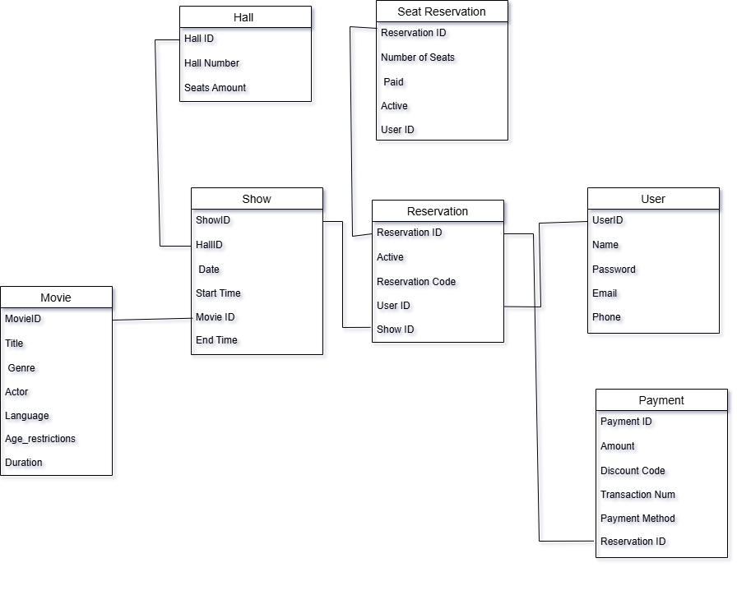

4. User story of shopping from ecommerce.

**Answer:**

|  |  |  |  |
| --- | --- | --- | --- |
| **User Story No:** 01 | **Tasks:** 4 | | **Priority:** Medium |
| As a User  I want to view the order  So that I can cancel it | | | |
| **BV:** 100 | | **CP:** 03 | |
| **Acceptance Criteria:**  The User can access the "View Order" feature from their account. The order details, including items, quantities, and total amount, are displayed accurately. The customer can easily identify the order they wish to cancel. A "Cancel Order" option is clearly visible next to each order. Upon selecting "Cancel Order," the system prompts the customer to confirm the cancellation. Once confirmed, the order status is updated to "Cancelled," and appropriate notifications are sent to the customer and the system administrator. The cancelled order is no longer visible in the customer's order history. | | | |

|  |  |  |  |
| --- | --- | --- | --- |
| **User Story No:** 02 | **Tasks:** 3 | | **Priority:** High |
| As a User  I want to receive notifications  So that I can receive updates | | | |
| **BV:** 200 | | **CP:** 02 | |
| **Acceptance Criteria:**  User receives notifications for relevant updates. Notifications are timely and accurately reflect the updates. User can choose notification preferences (e.g., frequency, type). Notifications are delivered via preferred channels (e.g., push notifications, email). User can easily dismiss or mark notifications as read. Notifications include actionable information or links when appropriate. | | | |

|  |  |  |  |
| --- | --- | --- | --- |
| **User Story No:** 03 | **Tasks:** 2 | | **Priority:** Low |
| As a Customer  I want to view the contact number of delivery boy  So that I can contact delivery boy for the status | | | |
| **BV:** 50 | | **CP:** 01 | |
| **Acceptance Criteria:**  Upon accessing the delivery tracking page, the contact number of the assigned delivery boy must be visible. The contact number should be displayed prominently and clearly labeled as "Delivery Boy Contact." The contact number should be accurate and up-to-date, reflecting the current assigned delivery boy for the order. The contact number should be clickable or easily copyable for convenient use. The contact number should be accessible to the customer without any additional steps or authentication requirements. | | | |

|  |  |  |  |
| --- | --- | --- | --- |
| **User Story No:** 04 | **Tasks:** 6 | | **Priority:** High |
| As a Admin  I want to view revenue generated  So that I can view restaurant revenue | | | |
| **BV:** 200 | | **CP:** 04 | |
| **Acceptance Criteria:**  As a restaurant owner, I can access a dashboard or page specifically dedicated to viewing revenue generated. The revenue displayed should be clear, accurate, and updated in real-time or at regular intervals. I can filter revenue data by date range, allowing me to view revenue for specific time periods. The revenue should be categorized by sources such as dine-in, takeout, delivery, and catering, if applicable. The revenue display should include a breakdown of taxes, discounts, and any other relevant fees. The interface should be user-friendly, allowing easy navigation and understanding of revenue metrics. Access to revenue data should be restricted to authorized personnel only, ensuring confidentiality and security. | | | |
| **User Story No:** 05 | **Tasks:** 3 | | **Priority:** High |
| As a User  I want to log out of the platform  So that I secure my account. | | | |
| **BV:** 100 | | **CP:** 03 | |
| **Acceptance Criteria:**  User can click logout to end the session  User is redirected to the login page. | | | |

|  |  |  |  |
| --- | --- | --- | --- |
| **User Story No:** 06 | **Tasks:** 5 | | **Priority:** Medium |
| As a User  I want to track my order status  So that I can check my status of my order | | | |
| **BV:** 200 | | **CP:** 04 | |
| **Acceptance Criteria:**  User can see order status and tracking information in their account.  Status updates are reflected I real time. | | | |

|  |  |  |  |
| --- | --- | --- | --- |
| **User Story No:** 07 | **Tasks:** 5 | | **Priority:** High |
| As a Delivery boy  I want to login  So that I can accept the orders | | | |
| **BV:** 200 | | **CP:** 04 | |
| **Acceptance Criteria:**  The login screen should have fields for username and password. Upon entering valid credentials, the delivery boy should be able to log in successfully. If the credentials are invalid, an error message should be displayed. Once logged in, the delivery boy should be redirected to a dashboard or order list page. The login session should persist across app restarts until explicitly logged out. Security measures like password encryption and protection against brute force attacks should be implemented. The delivery boy should be able to reset their password if they forget it. The system should have logging capabilities to track login attempts and errors for security and troubleshooting purposes. | | | |

|  |  |  |  |
| --- | --- | --- | --- |
| **User Story No:** 08 | **Tasks:** 1 | | **Priority:** Medium |
| As a User  I want to apply promo codes, coupons and discounts  So that I can order at lower price | | | |
| **BV:** 100 | | **CP:** 04 | |
| **Acceptance Criteria:**  User can input a promo code, coupon, or discount during checkout. The system verifies the validity of the entered code. If the code is valid, the discount is applied to the order total. Only one code can be applied per order. Discount should reflect accurately in the final price before payment confirmation. If the code is invalid or expired, an error message is displayed. Successfully applied discounts are visible in the order summary. Discounts cannot be applied retroactively after the order is confirmed. Discounts apply to eligible items according to promo code terms. Discounts are correctly calculated and applied even when combined with other offers, if applicable. | | | |

|  |  |  |  |
| --- | --- | --- | --- |
| **User Story No:** 09 | **Tasks:** 2 | | **Priority:** High |
| As a Manufacturer  I want to receive and manage orders  So that I can update order status | | | |
| **BV:** 200 | | **CP:** 02 | |
| **Acceptance Criteria:**  As a Manufacturer, I should be able to receive orders through a designated platform or system. The system should allow me to view all incoming orders, including details such as items ordered, customer information, and order time. I should be able to update the status of each order (e.g., received, preparing, ready for delivery, delivered) manually. The system should provide a clear interface for managing orders, including filtering and sorting options. It should be possible to mark orders as complete once they have been delivered or picked up by the customer. The system should support real-time updates to reflect any changes in order status. Orders should be easily searchable by order number, customer name, or any other relevant criteria. There should be a notification system to alert me of new orders and any updates to existing orders. The system should maintain a record of all order status changes for reference and auditing purposes. The interface should be intuitive and user-friendly, requiring minimal training for effective use. | | | |

|  |  |  |  |
| --- | --- | --- | --- |
| **User Story No:** 10 | **Tasks:** 3 | | **Priority:** High |
| As a User  I want to Receive notifications  So that I can receive updates | | | |
| **BV:** 200 | | **CP:** 02 | |
| **Acceptance Criteria:**  User receives notifications for updates. Notifications are delivered in a timely manner. Notifications include relevant information about the updates. User has the option to enable/disable notifications. Notifications are visually and audibly distinguishable. Notifications are supported on all relevant platforms (e.g., web, mobile) | | | |
| **User Story No:** 11 | **Tasks:** 1 | | **Priority:** High |
| As a User  I want to save favourite products  So that I can order from my favourites | | | |
| **BV:** 200 | | **CP:** 02 | |
| **Acceptance Criteria:**  The user should be able to add a restaurant to their list of favorites. The user should be able to remove a restaurant from their list of favorites. The user should be able to view their list of favorite products . The user should be able to view their list of favorite products The list of favorite restaurants and dishes should persist across sessions, so that the user can access them later. The user should receive confirmation when adding products removing from their favorites. The user interface should be intuitive and easy to use for adding, removing, and viewing favorites. | | | |

|  |  |  |  |
| --- | --- | --- | --- |
| **User Story No:** 12 | **Tasks:** 2 | | **Priority:** High |
| As a Customer  I want to track my order  So that I know the time of delivery | | | |
| **BV:** 200 | | **CP:** 02 | |
| **Acceptance Criteria:**  User can view the current status of their order.  User can see the estimated time of delivery for their order.  User receives real-time updates on the status of their order, including any delays or changes. The tracking information is accurate and reflects the actual progress of the order.  User can access the tracking feature through the app or website. The tracking feature is user-friendly and intuitive to use. | | | |

|  |  |  |  |
| --- | --- | --- | --- |
| **User Story No:** 13 | **Tasks:** 1 | | **Priority:** High |
| As a User  I want to add items from wishlist to my cart. | | | |
| **BV:** 200 | | **CP:** 02 | |
| **Acceptance Criteria:**  Items in wishlist can be moved to cart.  Items are successfully removed from wishlist once added. | | | |

|  |  |  |  |
| --- | --- | --- | --- |
| **User Story No:** 14 | **Tasks:** 2 | | **Priority:** High |
| As a user  I want to be notified when an out of stock product is available. | | | |
| **BV:** 200 | | **CP:** 02 | |
| **Acceptance Criteria:**  User can request an email notification.  E mail is sent once the product is back in stock. | | | |

|  |  |  |  |
| --- | --- | --- | --- |
| **User Story No:** 15 | **Tasks:** 2 | | **Priority:** Medium |
| As a Admin  I want to see the regional revenue reports,  So that I can view the regional performance | | | |
| **BV:** 100 | | **CP:** 03 | |
| **Acceptance Criteria:**  As a regional admin, I can access the regional revenue reports from the admin dashboard. The revenue reports display data specific to the region I oversee.  The reports include clear visualization of revenue trends over time. I can filter the reports by date range to analyze revenue performance within specific periods.  The revenue reports provide a breakdown of revenue sources (e.g., product categories, services). The data in the reports is accurate and up-to-date, reflecting the most recent revenue transactions.  The reports are easily exportable for further analysis or sharing with stakeholders. The user interface for accessing and interacting with the revenue reports is intuitive and user-friendly | | | |

|  |  |  |  |
| --- | --- | --- | --- |
| **User Story No:** 16 | **Tasks:** 2 | | **Priority:** High |
| As a user  I want to zoom in on product images. | | | |
| **BV:** 200 | | **CP:** 03 | |
| **Acceptance Criteria:**  User can hover over or click images to see an enlarged view.  Zoom view shows clear product details. | | | |

|  |  |  |  |
| --- | --- | --- | --- |
| **User Story No:** 17 | **Tasks:** 2 | | **Priority:** Low |
| As a Customer  I want to view the contact number of delivery boy  So that I can contact delivery boy for the status | | | |
| **BV:** 50 | | **CP:** 01 | |
| **Acceptance Criteria:**  The customer can access the contact number of the assigned delivery boy. The contact number is clearly displayed on the order tracking page or delivery details section.  The contact number is accurate and up-to-date, reflecting the current delivery assignment. The contact number is clickable or easily copyable for convenient use.  The contact number is accessible both on web and mobile platforms. The feature is tested to ensure it functions correctly across different devices and browsers.  The contact number remains visible throughout the delivery process until completion | | | |

|  |  |  |  |
| --- | --- | --- | --- |
| **User Story No:** 18 | **Tasks:** 1 | | **Priority:** High |
| As a Admin  I want to view the orders  So that I can approve their registration | | | |
| **BV:** 500 | | **CP:** 02 | |
| **Acceptance Criteria:**  As an admin, I can access a list of registered orders.  I can filter the list by registration status (e.g., pending, approved, rejected). I have the ability to approve or reject order registrations directly from the list view.  Approved orders are marked as such and can be distinguished from pending or rejected ones. Rejected orders are removed from the pending list and may have a reason for rejection attached. The list is updated in real-time to reflect any changes in registration status | | | |

|  |  |  |  |
| --- | --- | --- | --- |
| **User Story No:** 19 | **Tasks:** 2 | | **Priority:** Highest |
| As a Customer  I want to Add the address  So that I can get the order to my address | | | |
| **BV:** 500 | | **CP:** 02 | |
| **Acceptance Criteria:**  User can access the address entry screen from the order checkout process.  The address entry form should include fields for street address, city, state/province, postal code, and country. The form should validate that all required fields are filled out before proceeding.  Users should be able to save multiple addresses for future orders. Addresses should be editable and deletable. The system should securely store and retrieve saved addresses for each user. Users should be able to select a saved address for their current order.  Once an order is placed, the selected address should be associated with the order for delivery. Users should receive confirmation that their address has been successfully added/updated. | | | |

|  |  |  |  |
| --- | --- | --- | --- |
| **User Story No:** 20 | **Tasks:** 2 | | **Priority:** Highest |
| As a User  I want to initiate a return for my order.  So that I can buy the product which I want. | | | |
| **BV:** 500 | | **CP:** 02 | |
| **Acceptance Criteria:**  User can request a return for an eligible order.  Admin receives and processes the return request. | | | |
| **User Story No:** 21 | **Tasks:** 1 | | **Priority:** Medium |
| As a User  I want to contact customer support  So that I can submit queries or issues | | | |
| **BV:** 200 | | **CP:** 02 | |
| **Acceptance Criteria:**  User can access the customer support feature from the app's main menu. The customer support feature provides options to submit queries or report issues.  User can input their query or issue through text entry or voice message. Upon submission, the system confirms receipt of the query or issue. User receives a response from customer support within 24 hours.  User can view the history of their submitted queries or issues. | | | |

|  |  |  |  |
| --- | --- | --- | --- |
| **User Story No:** 22 | **Tasks:** 2 | | **Priority:** High |
| As a Admin  I want to access to customer reviews  So that I can view and respond to customer reviews | | | |
| **BV:** 200 | | **CP:** 02 | |
| **Acceptance Criteria:**  The Admin can log in to the platform with their credentials. Upon logging in, the Admin can navigate to a section specifically for viewing customer reviews.  The Admin can filter reviews by date, rating, or other relevant criteria. Each review should display the date, rating, and content left by the customer. The Admin can respond to reviews directly from the platform.  Responses from the Admin should be timestamped and visible to the customer who left the review. The platform should provide notifications to the owner for any new reviews received.  Profile changes are saved and a success message is shown. | | | |

|  |  |  |  |
| --- | --- | --- | --- |
| **User Story No:** 23 | **Tasks:** 7 | | **Priority:** High |
| As a Delivery boy  I want to view the orders  So that I can accept the order | | | |
| **BV:** 200 | | **CP:** 04 | |
| **Acceptance Criteria:**  Delivery boy can log in to the system. Delivery boy can access the "View Orders" section.  Orders are displayed with relevant details (e.g., customer name, delivery address).  Delivery boy can filter orders based on status (e.g., pending, accepted, delivered). Delivery boy can accept an order with a single click.  Once accepted, the order status changes to "Accepted". System updates in real-time to reflect the accepted order. Delivery boy receives a confirmation message upon successful acceptance of an order. | | | |

|  |  |  |  |
| --- | --- | --- | --- |
| **User Story No:** 24 | **Tasks:** 5 | | **Priority:** Medium |
| As a delivery boy  I want to view feed back  So that I can know the customers feedback | | | |
| **BV:** 200 | | **CP:** 02 | |
| **Acceptance Criteria:**  Delivery boy can access a dedicated section for viewing feedback. Feedback is displayed in a clear and organized format, showing date, rating, and comments.  Feedback is sortable by date and rating for ease of access. The system ensures that only feedback related to the delivery boy's orders is displayed.  Delivery boy can view feedback from past orders as well as current ones. The feedback section is accessible via the delivery boy's account on the platform or app. | | | |

|  |  |  |  |
| --- | --- | --- | --- |
| **User Story No:** 25 | **Tasks:** 5 | | **Priority:** Medium |
| As a Admin  I want to view feedback  So that I can know the customers feedback | | | |
| **BV:** 200 | | **CP:** 04 | |
| **Acceptance Criteria:**  As a Admin, I can access a feedback section in the restaurant management system. Feedback should be categorized by date, customer name, and rating. Each feedback entry should include comments or suggestions provided by the customer. The feedback section should be easily accessible from any device with internet connectivity. The feedback should be displayed in a clear and organized manner for easy understanding. | | | |

|  |  |  |  |
| --- | --- | --- | --- |
| **User Story No:** 26 | **Tasks:** 3 | | **Priority:** High |
| As a Regional admin  I want to know the issues  So that I can resolve the system | | | |
| **BV:** 200 | | **CP:** 04 | |
| **Acceptance Criteria:**  As a regional admin, I can view a list of system issues. Each issue entry displays relevant details like title, description, severity, and status. I can filter issues by severity (e.g., low, medium, high). I can filter issues by status (e.g., open, in progress, resolved). Clicking on an issue provides more detailed information. I can mark issues as resolved once addressed. The system updates in real-time to reflect changes in issue status. | | | |

|  |  |  |  |
| --- | --- | --- | --- |
| **User Story No:** 27 | **Tasks:** 2 | | **Priority:** High |
| As a User  I want to checkout as a guest without creating an account | | | |
| **BV:** 200 | | **CP:** 04 | |
| **Acceptance Criteria:**  Guest users can proceed through the checkout process.  Basic shipping and billing information is required. | | | |

|  |  |  |  |
| --- | --- | --- | --- |
| **User Story No:** 28 | **Tasks:** 2 | | **Priority:** Medium |
| As a User  I want to choose from different shipping options to fit my needs. | | | |
| **BV:** 100 | | **CP:** 02 | |
| **Acceptance Criteria:**  User can select standard or expected shipping.  Shipping cost is dynamically updated. | | | |

|  |  |  |  |
| --- | --- | --- | --- |
| **User Story No:** 29 | **Tasks:** 1 | | **Priority:** Medium |
| As a customer  I want to contact customer support  So that I can submit queries or issues | | | |
| **BV:** 200 | | **CP:** 02 | |
| **Acceptance Criteria:**  User can easily locate the "Contact Customer Support" option. Upon clicking, user is presented with various contact methods (phone, email, chat). User can select their preferred method and initiate contact. Contact options are clearly labeled and accessible on all devices. User receives a confirmation or acknowledgment upon submitting their query or issue. If contacting through email or form, user receives a response within a defined timeframe. User has the option to escalate urgent issues or seek further assistance if needed. System logs and tracks user interactions for support team reference and follow-up. | | | |

|  |  |  |  |
| --- | --- | --- | --- |
| **User Story No:** 30 | **Tasks:** 4 | | **Priority:** High |
| As a Admin  I want to track the delivery  So that I can view the status of the delivery | | | |
| **BV:** 100 | | **CP:** 03 | |
| **Acceptance Criteria:**  As a admin, I can access a dashboard to view delivery statuses. The dashboard displays real-time updates on delivery progress. I can filter deliveries by region, date, or status. Each delivery entry includes key information like date, location, and status. The dashboard is accessible via web or mobile interface. The status updates are synchronized across all viewing platforms. The system provides notifications for significant delivery updates. The delivery tracking system is secure and only accessible to authorized regional admins. | | | |
| **User Story No:** 31 | **Tasks:** 2 | | **Priority:** Highest |
| As a Admin  I want to view orders  So that I can view the list of orders | | | |
| **BV:** 200 | | **CP:** 02 | |
| **Acceptance Criteria:**  As a Admin, I can access a dedicated "Orders" section on the restaurant management system.  I can view a list of orders sorted by date and time, showing the most recent orders first. Each order entry displays essential details like order number, items ordered, total amount, and status (e.g., pending, in progress, completed). Orders marked as completed should be visually distinguishable from pending or in-progress orders. The order list should update in real-time or upon manual refresh to reflect any new orders or changes in status. I can click on an individual order to view more detailed information, including customer details and order specifics. The order list is responsive and user-friendly, allowing easy navigation and management of orders on various devices. | | | |

|  |  |  |  |
| --- | --- | --- | --- |
| **User Story No:**32 | **Tasks:** 2 | | **Priority:** Highest |
| As a Customer  I want to Select the payment mode  So that I can Make payment of my choice | | | |
| **BV:** 200 | | **CP:** 03 | |
| **Acceptance Criteria:**  The user should be able to access the payment mode selection screen from the checkout page. The payment mode selection screen should display all available payment options clearly. The user should be able to select only one payment mode at a time. Once a payment mode is selected, it should be visually indicated as chosen. The selected payment mode should be passed on to the payment processing system accurately. Error messages should be displayed if there are any issues with selecting or processing the chosen payment mode. The selected payment mode should remain saved if the user navigates away from the page and returns later. | | | |

|  |  |  |  |
| --- | --- | --- | --- |
| **User Story No:** 33 | **Tasks:** 1 | | **Priority:** Low |
| As a User  I want to view the price  So that I can order the Product | | | |
| **BV:** 50 | | **CP:** 01 | |
| **Acceptance Criteria:**  The price of the product should be displayed on the menu screen. The price should be visible without requiring the user to perform any additional actions such as clicking or tapping. The price displayed should be accurate and up-to-date, reflecting any changes or discounts applied.  If there are variations in pricing due to size or customization options, the user should be able to easily view the different prices available. The price should be displayed in the local currency for the user's region.  The font size and colour of the price should be legible and contrasting enough against the background for easy visibility. The price should remain visible as the user scrolls through the menu items. If there are any additional fees or taxes applied to the order, they should be clearly indicated alongside the price | | | |

|  |  |  |  |
| --- | --- | --- | --- |
| **User Story No: 3**4 | **Tasks:** 2 | | **Priority:** Medium |
| As a user  I want to view products  So I can decide which to purchase. | | | |
| **BV:** 100 | | **CP:** 02 | |
| **Acceptance Criteria:**  Products are displayed with images, names, and prices.  User can filter and sort products by categories. | | | |

|  |  |  |  |
| --- | --- | --- | --- |
| **User Story No:**35 | **Tasks:** 3 | | **Priority:** High |
| As a Registered admin  I want to Manage Products  So that I can track the performance of Orders | | | |
| **BV:** 200 | | **CP:** 03 | |
| **Acceptance Criteria:**  As a registered admin, I can access a dashboard specifically designed for managing orders. I can view a list of all orders along with their relevant performance metrics. I can filter the list of all products performance metrics (such as revenue, customer ratings, etc.), or other relevant criteria. I can add new type of products to the system, providing necessary details such as name, contact information, etc.  I can edit the details of existing orders, including updating performance metrics as necessary. I can deactivate or remove products from the system if needed. Changes made to products details are reflected in real-time on the dashboard. The system provides appropriate feedback or notifications when actions like adding, editing, deactivating, or encounter errors.  The performance metrics displayed for each order are accurate and up-to-date. The dashboard is user-friendly and intuitive, allowing me to efficiently manage order without extensive training or guidance. | | | |

|  |  |  |  |
| --- | --- | --- | --- |
| **User Story No:** 36 | **Tasks:** 2 | | **Priority:** High |
| As a User  I want to chat with registered admin  So that I can Request for Refund | | | |
| **BV:** 200 | | **CP:** 02 | |
| **Acceptance Criteria:**  As a user, I can access a chat feature specifically designated for communicating with registered administrators. Upon initiating the chat, I should be able to clearly identify the administrator I am chatting with, ensuring they are registered personnel. I can articulate my request for a refund clearly within the chat interface.  The registered admin should be able to receive and respond to my refund request promptly. The chat system should maintain a record of the conversation between the customer and the registered admin for future reference. The refund request should be processed according to the company's refund policy and procedures.  The system should provide notifications to both parties regarding the progress and outcome of the refund request, if applicable. The chat system should be accessible and functional on all supported devices and browsers. | | | |

|  |  |  |  |
| --- | --- | --- | --- |
| **User Story No:** 37 | **Tasks:** 2 | | **Priority:** High |
| As a user  I want to add products to my cart  So that I can purchase them later. | | | |
| **BV:** 200 | | **CP:** 02 | |
| **Acceptance Criteria:**  User can add products to the cart from product listings or details pages.  Confirmation message appears after adding an item. | | | |

|  |  |  |  |
| --- | --- | --- | --- |
| **User Story No:** 38 | **Tasks:** 1 | | **Priority:** High |
| As a User  I want to Filter products  So that I can find a better product to order | | | |
| **BV:** 200 | | **CP:** 02 | |
| **Acceptance Criteria:**  The filtering options include cuisine type, price range, distance, and ratings. Users can apply multiple filters simultaneously. Filtered results are displayed in real-time as filters are applied.  The interface clearly indicates which filters are active. Users can easily reset all filters to their default state. The filtered list accurately reflects the user's preferences and requirements. The filtering functionality is accessible and intuitive for all users. The system handles edge cases, such as no results matching the filters, gracefully. | | | |

|  |  |  |  |
| --- | --- | --- | --- |
| **User Story No:** 39 | **Tasks:** 1 | | **Priority:** High |
| As a User  I want to rate and review products  So that I can rate and review the products I have recieved | | | |
| **BV:** 200 | | **CP:** 02 | |
| **Acceptance Criteria:**  User can rate orders on a scale of 1 to 5 stars. User can submit a written review of the order. User can only rate and review order they have received.  Ratings and reviews are visible to other users. User can edit or delete their own ratings and reviews. Ratings and reviews are displayed alongside product details. User can only rate and review a product once. | | | |

|  |  |  |  |
| --- | --- | --- | --- |
| **User Story No:** 40 | **Tasks:** 1 | | **Priority:** High |
| As a User  I want to View past order history  So that I can order again | | | |
| **BV:** 200 | | **CP:** 02 | |
| **Acceptance Criteria:**  The user can access the order history section from the settings. The order history displays a list of past orders, sorted by date. Each past order includes details such as order number, date, items purchased, and total cost. The user can click on a past order to view more detailed information about it.  There is an option to reorder items from a past order directly from the order history page. The user can easily navigate back to the settings or previous screens from the order history section. | | | |