**Question 1 – Functional Requirements**

**Functional requirements:**

Functional requirements define a function that system or system element must be qualified to perform and must be documented in different form. The functional requirement describes the behaviour of the system as it correlates to the systems functionality

Example of functional requirements as follows:

* Authentication
* business rule
* audit tracking
* certification requirements
* transaction correction

|  |  |  |  |
| --- | --- | --- | --- |
| Req_Id | Req_Name | Req_Description | Priority |
| FR01 | User registration | User should be able to create account by providing basic details such as name, email _ID ,Phone number password | 10 |
| FR02 | Product CatLog | The application should be able to display a comprehensive list of all available product including fertilizers,  seeds and pesticides with detailed information | 10 |
| FR03 | Search Functionality | User should be able to search for products based on various criteria like name type brand price range | 9 |
| FR04 | Product details | User should be able to view detailed information about each product including price, quantity, description, image and Revies | 9 |
| FR05 | Shopping cart | User should be able to add product to their cart and view cart detail, including total price and quantity | 8 |
| FR06 | Checkout Process | User should be able to complete the check out process by providing delivery address payment details and confirmation of order | 8 |
| FR07 | Order Tracking | User should be able to track their order status including confirmation, processing shipping and delivery | 7 |
| FR08 | User profile Management | User should be able to manage there profile details such as name, address, phone number and password | 7 |
| FR09 | Order history | User's order history should allow them to view all past purchases, including order details like date, items, quantities, prices, shipping information, payment details, and order status | 6 |
| FR10 | Product Reviews | User should be able to rate and review products they have purchased which will be visible to other users | 6 |
| FR11 | Product Comparison | user should be able to compare products based on various parameters such as a price, quality and features | 5 |
| FR12 | Newsletter Description | User should be able to subscribe to the newsletter to receive update about new product discounts and promotions | 5 |
| FR13 | Wish List | User should be able to add products to their Wishlist for future purchase | 4 |
| FR14 | Product Recommendation | user should be provided with personalized product recommendation based on their search and purchase History | 4 |
| FR15 | Multiple Payment Option | User should be able to pay for their orders through multiple payment options like credit card/debit card net banking | 3 |
| FR16 | Order Cancellation | User should be able to cancel their order and request refund as per the company’s policy | 3 |
| FR17 | Customer Support | User should be able to contact customer support for any queries, complaint or feedback | 2 |
| FR18 | Mobile App | The application should have mobile app version for the users to access it from their mobile devices. | 2 |
| FR19 | Multilingual Support | The application should support multiple languages for users from different regions | 1 |
| FR20 | SE Optimization | The application should be optimised for search engine to improve its visibility and ranking in search results | 1 |

**Nonfunctional Requirements:**

Nonfunctional recruitment are not related to the software’s functional aspect they can be the necessities that specify the criteria that can be used to decide the operation instead of specific behaviour of the system. It describes the qualities and attributes of system, focusing on how the system performs rather than specific behaviour or functions

Example of the non func

tional requirements as follows:

* User ability
* Reliability
* Security Storage
* Cost
* Flexibility
* Performance
* Legal Or Regulatory Requirement

|  |  |  |  |
| --- | --- | --- | --- |
| Req_Id | Req_Name | Req_Description | Priority |
| NFR01 | Loading time | Each page should be load within 2 seconds under normal load condition | 9 |
| NFR02 | Response Time | System actions like product search login or checkout should execute within two to three seconds | 8 |
| NFR03 | Language support | The platform should support multiple languages including regional one to cater to farmers in different areas | 7 |
| NFR04 | Accessibility | The application should be accessible through web browser and mobile devices | 8 |
| NFR05 | Authentication | The system should allow users to log in with correct credentials only | 8 |
| NFR06 | Data protection | All users data should be protected and encrypted during transmission and storage | 9 |
| NFR07 | Maintenance | The system shall be easy to update and maintain | 9 |
| NFR08 | Delivery tracker | The delivery tracking system should update the order status in real time with location updates all transaction | 7 |
| NFR09 | Payment compliance | All transaction must comply with reserve Bank of India RBI regulations for digital payment | 8 |
| NFR10 | scalability | The system shall be able to handle large number of users without performance degradation | 7 |

Question-2: Minimum 5 pages Design (make wireframes Prototype)

1. **Mockup for Login Page**

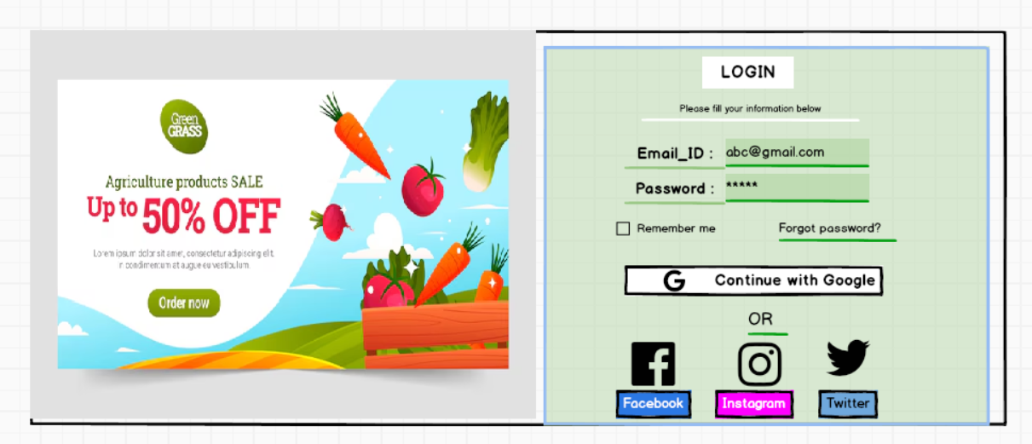

1. **Mockup for Home page**

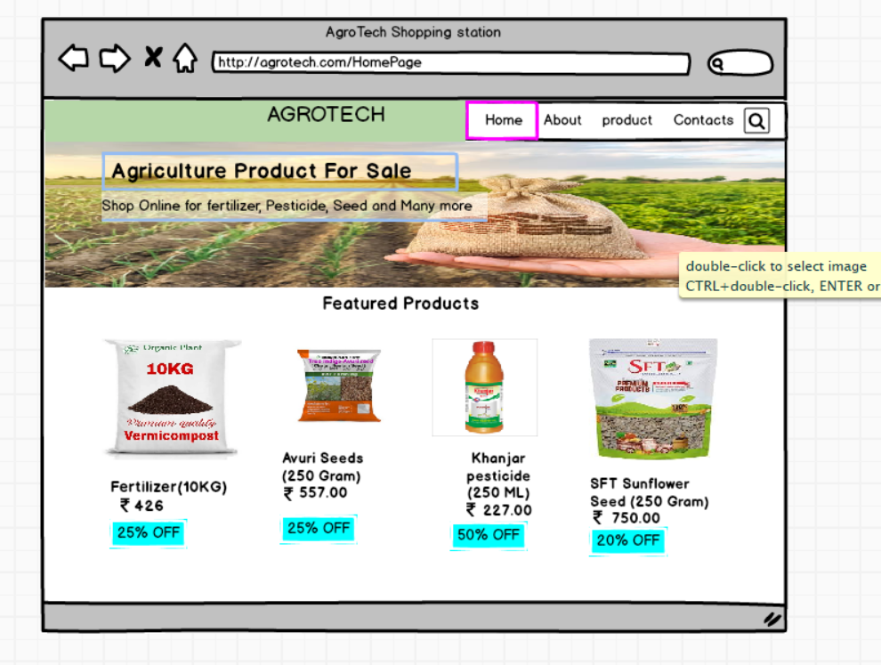

1. **Mockup for Add to Cart Page**

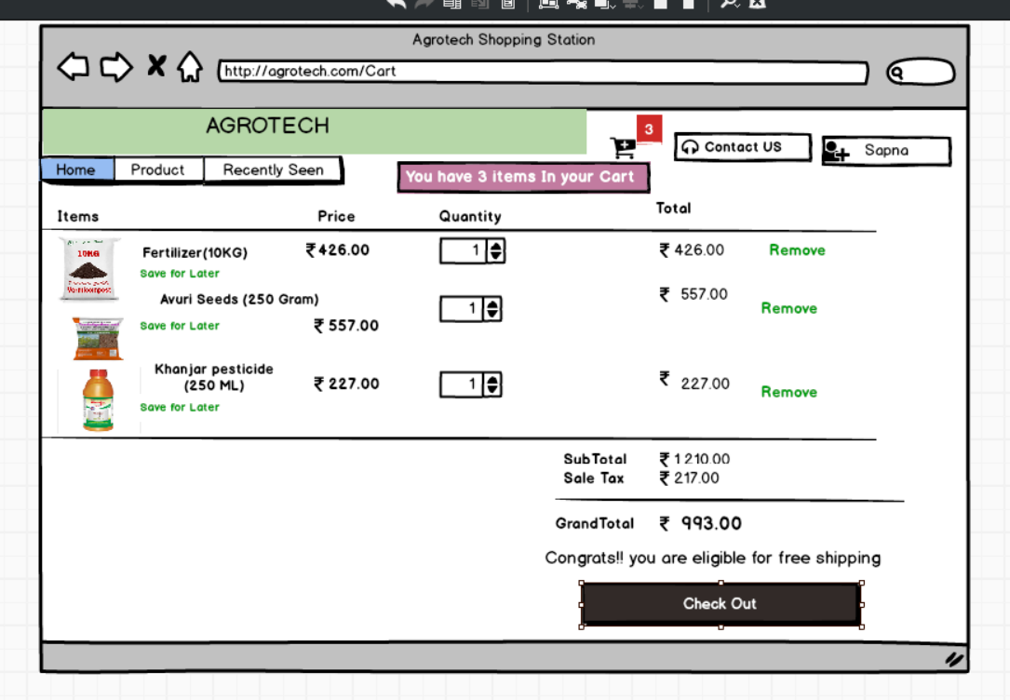

1. **Mockup for payment Page**

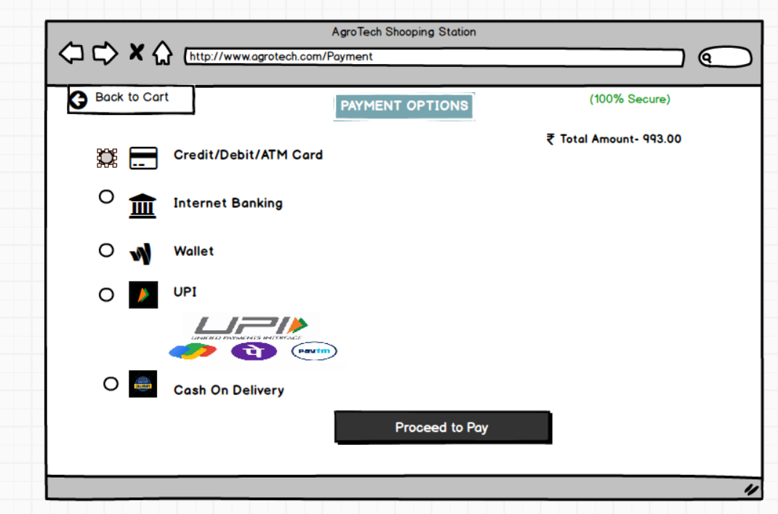

1. **Mockup for Cancel or Return the item Page**

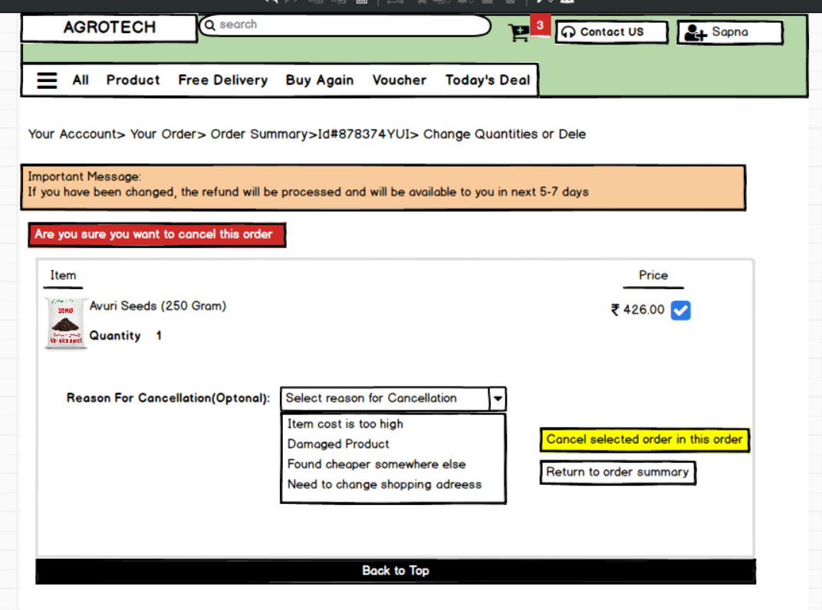

**Question-3: 50 words on the tool you are aware of this in this project?**

1. **Microsoft Visio:**

Microsoft Visio is a versatile diagramming tool that allows user to create a wide range of diagrams including flowchart, organisational chart and network diagram with its extensive Library of shapes and customization options, Visio. It enables users to visually represent complex information and processes it offers collaboration feature data linking capabilities and seamless integration with other Microsoft office application

**key component and features of Microsoft Visio**

**Shapes:**

Visio provides range of three different sets for previous purposes such as flow charts, network diagram, electrical diagram, organisational chart and more. User can drag and drop these shapes onto the canvas to create diagrams.

**Template:**

Visio Offers numerous templates tailored for specific types of diagrams. These templates come with predefined shapes, connector and settings optimized for their respective diagram types, making it easier for users to get started

**Stencil:**

In Visio stencils are collections of relationships group together for easy access. Each template typically comes with its own set of stencil containing shape specific to the diagram type. Users can also create custom stencil to organise their frequently used shapes.

**Connectors:**

Visio Provides various types of connector to link shapes together and illustrate relationship in diagrams. Users can customise the appearance of connect research as a line style arrowheads and endpoints.

**Text and formatting tools:**

Users cannot take two shapes and connectors to provide additional information or labels in their diagram. Visio offers a range of formatting tools for text including font style, sizes, colours and alignment options.

**Grid and guides:**

Visio Provides grid line and guides to help users collect and position shapes precisely on the canvas grid lies can be customised in terms of spacing and visibility while guides can be dragged onto the canvas to serve alignment supports.

**Collaboration and Sharing:**

Visio Supports collaboration features such as commenting, reviewing and co-authoring, allowing multiple users to work on the same diagram simultaneously. Diagrams can also be shared and published in various formats including PDF, image file and web pages.

**Integration with other Microsoft products:**

Visio **Integrate** seamlessly with other Microsoft applications such as Word, Excel, PowerPoint and SharePoint. Users can embed video diagrams into office document or publish them to SharePoint for easy access and sharing.

1. **Balsamiq**:

Balsamiq Is a popular wireframing tool used for creating low fidelity prototypes it focuses on simplicity and page like design to quickly visualise and communicate design ideas with its drag and drop interface and pre built UI element balsamic allows users to rapidly iterate and gather feedback on the basic structure and layout of digital product.

**Mock-up Editor:**

The core component of Balsamiq is its mock-up editor, where users can drag and drop various UI elements such as (buttons, text boxes images and icons) onto the canvas to create wireframes and mock ups of their design. The editor provides simple and intuitive interface for building prototypes quickly.

**UI library:**

Balsamiq Comes with a comprehensive Library of prebuilt UI components and symbols that users can use in their designs this component cover a wide range of UI elements commonly found in web and mobile application.

**Templates:**

Balsamiq Offers a variety of predesigned templates for different types of projects and applications including website mobile app desktop software and many more.

**Export and integration:**

Balsamiq Support exporting mock-ups and prototypes in various formats including PNG, PDF and interactive PDF additionally it integrates popular collaboration and project management tools such as Jira, Confluence and Google Drive.

1. **Axure:**

Axure Is a powerful prototyping tool that enables the creation of interactive and high-fidelity prototypes. It offers a wide range of dynamic and interactive elements such as animation, conditional logic and data driven interactions interaction allows designer to simulate user flows and text complex interaction before the actual development phase supporting in users testing and stakeholder communication.

It is robust tool design for professional needing to create detail and interactive protocols it exists in a complex project with features like conditional logic dynamic content and advanced interactions Axure-RP comprehensive environment support wireframe flow chart mock-ups and specifications.

**Question-4: Prepare RTM**

A requirements traceability matrix (RTM) is a document that describes the relationship between customer requirements and test artifacts, especially test cases.

"RTM" typically stands for Requirements Traceability Matrix, a document that links requirements to their corresponding deliverables, test cases, and other artifacts to ensure all requirements are met and tracked throughout a project's lifecycle.

* **Functionality:**

An RTM provides a detailed mapping of requirements to deliverables, design elements, test cases, and other related artifacts, ensuring that all requirements are linked to their origin and tracked throughout the project lifecycle.

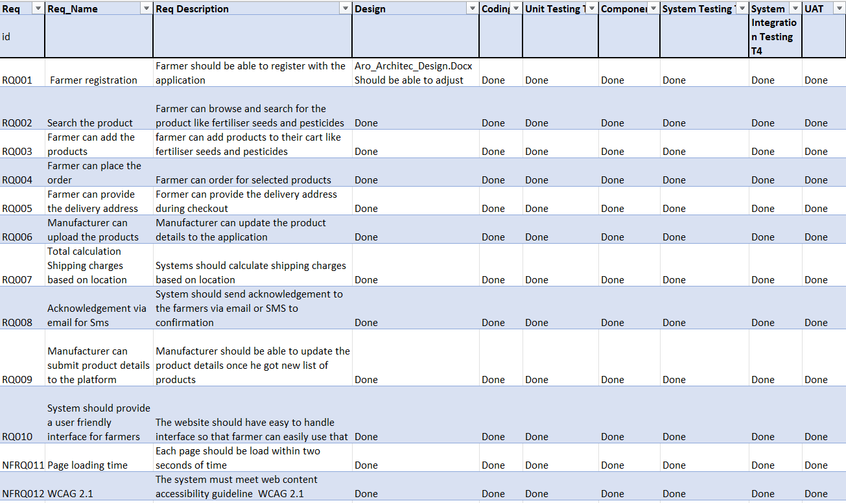

**Question-5: Prepare 10 Test case document**

 Test case document, or test case template, is a structured document that outlines the steps, inputs, and expected results for a specific test scenario, ensuring consistent and organized software testing efforts.

1. **User Login**

|  |  |  |  |  |  |  |
| --- | --- | --- | --- | --- | --- | --- |
| **Test Case ID** | TC01 | | **Test Case name** | | User Login | |
| **Project ID** | PRJ001 | | **Project Name** | | Online Registration Product Store | |
| **PM ID** | PM001 | | **PM Name** | | Mr. Vandanam | |
| **Test Strategy ID** | TS001 | | **Tester ID** | | T001 | |
| **Test Plan ID** | TP001 | | **Tester Name** | | Ms. Alekhya | |
| **Test Schedule ID** | TSCH001 | | **Date Of Test** | |  | |
| **Scenario** | Verify user can Login successfully | | | | | |
| **Link to that Page** | **Login Page** | | | | | |
| **Input Data** | **User Credential 1** | **User Credential 2** | | **User Credential 3** | | **User Credential 4** |
| User1@gmail.com | User1@gmail.com | | User1@gmail.com | | User1@gmail.com |
| Pwd: User1 | Pwd: User1 | | Pwd: User1 | | Pwd: User1 |
| **Expected Behaviour** | User given correct username and password then should be able to login to the page successfully | If user given wrong username and correct password then user should not be able to login to the page successfully | | If user given correct username and wrong password then he should not be to login to the page successfully | | If user given wrong name and password then he should not be able to login to that page |
| **Actual Behaviour** | User able to login to the page successfully | User not able to login to the page successfully | | User not able to login to the page successfully | | User not able to login to the page successfully |
| **Comment** |  |  | |  | |  |
| **Result** | Pass | Pass | | Pass | | Pass |
|  |  |  | |  | |  |

|  |  |  |  |  |  |  |
| --- | --- | --- | --- | --- | --- | --- |
| **Test Case ID** | TC02 | | **Test Case name** | | User Registration | |
| **Project ID** | PRJ002 | | **Project Name** | | Online Registration Product Store | |
| **PM ID** | PM002 | | **PM Name** | | Mr. Vandanam | |
| **Test Strategy ID** | TS002 | | **Tester ID** | | T002 | |
| **Test Plan ID** | TP002 | | **Tester Name** | | Ms. Alekhya | |
| **Test Schedule ID** | TSCH002 | | **Date Of Test** | | 08-04-2025 | |
| **Scenario** | Verify user can register successfully | | | | | |
| **Link to that Page** | **Registration Page** | | | | | |
| **Input Data** | **User Credential 1** | **User Credential 2** | | **User Credential 3** | | **User Credential 4** |
| User1@gmail.com | User1@gmail.com | | User1@gmail.com | | User1@gmail.com |
| Mob_No: 9812345691 | Mob_No: 9812345691 | | Mob_No: 9812345691 | | Mob_No: 9812345691 |
| **Expected Behaviour** | User given correct credential like Gmail or mobile number then should be able to register to the page successfully | If user given wrong Gmail or correct mobile number then user should not be able to register to the page successfully | | If user given correct mobile number and wrong Gmail then he should not be to register to the page successfully | | If user given wrong Gmail and Mobile Number then he should not be able to login to that page |
| **Actual Behaviour** | User able to register to the page successfully | User not able to register to the page successfully | | User not able to register to the page successfully | | User not able to register to the page successfully |
| **Comment** | NO | NO | | NO | | NO |
| **Result** | Pass | Pass | | Pass | | Pass |
|  |  |  | |  | |  |

1. **User registration**
2. **Manufacturer can add product to the cart**

|  |  |  |  |  |  |  |
| --- | --- | --- | --- | --- | --- | --- |
| **Test Case ID** | TC03 | | **Test Case name** | | Updating CatLog | |
| **Project ID** | PRJ003 | | **Project Name** | | Online Registration Product Store | |
| **PM ID** | PM003 | | **PM Name** | | Mr. Vandanam | |
| **Test Strategy ID** | TS003 | | **Tester ID** | | T003 | |
| **Test Plan ID** | TP003 | | **Tester Name** | | Ms. Alekhya | |
| **Test Schedule ID** | TSCH003 | | **Date Of Test** | | 08-04-2025 | |
| **Scenario** | Manufacturer should add product details online successfully | | | | | |
| **Link to that Page** | **CatLog Page** | | | | | |
| **Input Data** | **Product name:** fertA | **Product name:** No name | | **Product name:** fertA | | **Product name:** fertA |
| **Details:** Organic | **Details:** Organic | | **Details:** No Detail | | **Details:** Organic |
| **Price:** INR 500/kg | **Price:** INR 500/kg | | **Price:** INR 500/kg | | **Price:** No Price |
| **Expected Behaviour** | If user add all details correctly then, should be able to upload his product online | If user given not given Product name, then he should not be able to upload his product to the CatLog | | If user given not given Product Details, then he should not be able to upload his product to the CatLog | | If user given not given Product Price, then he should not be able to upload his product to the CatLog |
| **Actual Behaviour** | User is able to upload his product to CatLog | User is able to upload his product to CatLog | | User is able to upload his product to CatLog | | User is able to upload his product to CatLog |
| **Comment** | No | Without Description website will not allow user to upload his product | | No | | No |
| **Result** | Pass | **Fail** | | Pass | | Pass |

1. **Product Search**

|  |  |  |  |  |  |  |
| --- | --- | --- | --- | --- | --- | --- |
| **Test Case ID** | TC04 | | **Test Case name** | | Search Page | |
| **Project ID** | PRJ004 | | **Project Name** | | Online Registration Product Store | |
| **PM ID** | PM004 | | **PM Name** | | Mr. Vandanam | |
| **Test Strategy ID** | TS004 | | **Tester ID** | | T004 | |
| **Test Plan ID** | TP004 | | **Tester Name** | | Ms. Alekhya | |
| **Test Schedule ID** | TSCH004 | | **Date Of Test** | | 08-04-2025 | |
| **Scenario** | Verify that user can search the product | | | | | |
| **Link to that Page** | **Search Page** | | | | | |
| **Input Data** | **Keyword1** | **Keyword2** | | **Keyword2** | | **Keyword2** |
| **Name of Fertilizer or Seed or Pesticide** | **Incorrect Name of**  **Fertilizer or Seed or Pesticide** | | **Incorrect Name of**  **Brand name Fertilizer or Seed or Pesticide** | | **Not added anything to search box** |
| **Expected Behaviour** | If user add all details correctly then, should be able to search product online | If user given not given correct Product name, then he should not be able to search his product | | If user given not given incorrect brand name Product Details, then he should not be able to upload his product to the CatLog | | If user given not given any input to search box, then he should not be able to upload his product to the CatLog |
| **Actual Behaviour** | User is able to upload his product to CatLog | User is able to upload his product to CatLog | | User is able to upload his product to CatLog | | User is able to upload his product to CatLog |
| **Comment** | No | No | | No | | No |
| **Result** | Pass | Pass | | Pass | | Pass |

1. **Applying Search Filter**

|  |  |  |  |  |  |  |
| --- | --- | --- | --- | --- | --- | --- |
| **Test Case ID** | TC05 | | **Test Case name** | | Search Result | |
| **Project ID** | PRJ005 | | **Project Name** | | Online Registration Product Store | |
| **PM ID** | PM005 | | **PM Name** | | Mr. Vandanam | |
| **Test Strategy ID** | TS005 | | **Tester ID** | | T005 | |
| **Test Plan ID** | TP005 | | **Tester Name** | | Ms. Alekhya | |
| **Test Schedule ID** | TSCH005 | | **Date Of Test** | | 08-04-2025 | |
| **Scenario** | Verify user can apply filter on search result | | | | | |
| **Link to that Page** | **Search Result Page** | | | | | |
| **Input Data** | **In filter product type, range or** | **If user doesn’t apply the filter because its optional** | | **While applying filter, filter button should work properly** | | **If user expect impossible filter option** |
| **Expected Behaviour** | If user apply the filter for any categories, then he will retrieve the data accordingly on his page | If user does not apply the filter still, he is able to see the pages not category wise but all generic searches he can do | | If filter Button did not work properly then user will not be able view filter page by categories | | If user given unexpected option to the filter supposes extend price or very high budget then if that result not there then it will not fetch the result |
| **Actual Behaviour** | User is able to filter | User will get generic filter option | | Filter button on this website should be working properly | | User will be unable to get category page |
| **Comment** | No | No | | No | | No |
| **Result** | Pass | Pass | | Pass | | Pass |

1. **View Product Details display correctly**

|  |  |  |  |  |  |  |
| --- | --- | --- | --- | --- | --- | --- |
| **Test Case ID** | TC06 | | **Test Case name** | | Product detail | |
| **Project ID** | PRJ006 | | **Project Name** | | Online Registration Product Store | |
| **PM ID** | PM006 | | **PM Name** | | Mr. Vandanam | |
| **Test Strategy ID** | TS006 | | **Tester ID** | | T006 | |
| **Test Plan ID** | TP006 | | **Tester Name** | | Ms. Alekhya | |
| **Test Schedule ID** | TSCH006 | | **Date Of Test** | | 08-04-2025 | |
| **Scenario** | Verify user can see all product details including price, quantity and description | | | | | |
| **Link to that Page** | **Product Detail Page** | | | | | |
| **Input Data** | **If user double click on the product** | **If user doesn’t double click on the product to see in depth detail** | | **If user double click but not able to see in depth detail** | | **If user selected unwanted product instead of desired product to view information** |
| **Expected Behaviour** | If user double click on the product to see in-depth details like delivery date, description, photos or demo of the item | If user does not double click to see detail then he only get to see what ever information there like price ,quantity and name but not photos, guideline, delivery date and description | | If user click on the product but if website is down then he will not be able to view product information in detail. | | If user selected another product instead of desired one then user will not be able to see information |
| **Actual Behaviour** | User is able see product detail | User will not be able to see product details | | User will be unable to see product details | | User will be unable to see product details |
| **Comment** | No | No | | No | | No |
| **Result** | Pass | Pass | | Pass | | Pass |

1. **Adding product to the cart**

|  |  |  |  |  |  |  |
| --- | --- | --- | --- | --- | --- | --- |
| **Test Case ID** | TC07 | | **Test Case name** | | Add to Cart | |
| **Project ID** | PRJ007 | | **Project Name** | | Online Registration Product Store | |
| **PM ID** | PM007 | | **PM Name** | | Mr. Vandanam | |
| **Test Strategy ID** | TS007 | | **Tester ID** | | T007 | |
| **Test Plan ID** | TP007 | | **Tester Name** | | Ms. Alekhya | |
| **Test Schedule ID** | TSCH007 | | **Date Of Test** | | 08-04-2025 | |
| **Scenario** | Verify user can add product to the cart | | | | | |
| **Link to that Page** | **Add to Cart Page** | | | | | |
| **Input Data** | **If user select Add to cart option** | **If user wish list the product instead of adding to the cart** | | **If selected product is out of stock after adding to the cart** | | **If user added product to cart and suppose some system issue** |
| **Expected Behaviour** | If user select add to cart option then he is able to add that product to the cart | If user wish list the product instead of adding to the cart then user cant checkout for that product | | If user selected product is out of stock then even though user added to the cart company will refund amount | | **If user added product to cart and suppose some system issue then add to cart page will not load but product will remain in the cart** |
| **Actual Behaviour** | User is able see product detail | User will not be able to see add to cart page | | User will be unable to see add to cart page | | User will be unable to see add to cart page |
| **Comment** | No | No | | No | | No |
| **Result** | Pass | Pass | | Pass | | Pass |

1. **Payment Option**

|  |  |  |  |  |  |  |
| --- | --- | --- | --- | --- | --- | --- |
| **Test Case ID** | TC08 | | **Test Case name** | | Pyment_Gateway | |
| **Project ID** | PRJ008 | | **Project Name** | | Online Registration Product Store | |
| **PM ID** | PM008 | | **PM Name** | | Mr. Vandanam | |
| **Test Strategy ID** | TS008 | | **Tester ID** | | T008 | |
| **Test Plan ID** | TP008 | | **Tester Name** | | Ms. Alekhya | |
| **Test Schedule ID** | TSCH008 | | **Date Of Test** | | 08-04-2025 | |
| **Scenario** | Verify user can do payment by various option | | | | | |
| **Link to that Page** | **Payment Gateway Page** | | | | | |
| **Input Data** | **If user select COD option** | **When user first time selecting COD and not able to update the address from the same page** | | **If User select option like Net banking or card** | | **If user select UPI option according to his choice like Gpay,**  **Bhim or Phone pe** |
| **Expected Behaviour** | If user select Cash On Delivery option then he will has to pay at the time of delivery when user get product in hand | When user first time selecting COD and not able to update the address or given blank or wrong address from the same page user will be unable to get product on COD | | If User select option like Net banking or card then it should redirect to the KYC details page first | | If user select particular UPI option then it should redirect to the bank server page for authentication purpose which is mandatory |
| **Actual Behaviour** | User is able get product in COD | User will not be able to get COD | | User is able to redirect to the KYC page and can pay through it | | User is able to get authenticate and pay through UPI |
| **Comment** | No | No | | No | | No |
| **Result** | Pass | Pass | | Pass | | Pass |

1. **Order Confirmation**

|  |  |  |  |  |  |  |
| --- | --- | --- | --- | --- | --- | --- |
| **Test Case ID** | TC09 | | **Test Case name** | | Order_Confirmation | |
| **Project ID** | PRJ009 | | **Project Name** | | Online Registration Product Store | |
| **PM ID** | PM009 | | **PM Name** | | Mr. Vandanam | |
| **Test Strategy ID** | TS009 | | **Tester ID** | | T009 | |
| **Test Plan ID** | TP009 | | **Tester Name** | | Ms. Alekhya | |
| **Test Schedule ID** | TSCH009 | | **Date Of Test** | | 08-04-2025 | |
| **Scenario** | Verify users receive acknowledgement via SMS or via Gmail | | | | | |
| **Link to that Page** | **Order Confirmation Page** | | | | | |
| **Input Data** | **If user checkout then he should receive acknowledgement via SMS or Email** | **If user given Wrong Gmail id** | | **If User given wrong mobile number** | | **If user Not given Gmail id or Mobile number** |
| **Expected Behaviour** | If user given correct Gmail id and Mobile number then user will get order confirmation via SMS or Email | If user given wrong Gmail id then user is unable to get order confirmation via email | | If User given wrong mobile number then he will not get order confirmation via SMS | | If user given Wrong Gmail or Mobile number then he will not receive the order confirmation |
| **Actual Behaviour** | User is getting order confirmation | User is not getting order confirmation | | User is not getting order confirmation | | User is not getting order confirmation |
| **Comment** | No | No | | No | | No |
| **Result** | Pass | Pass | | Pass | | Pass |

1. **Delivery Tracking:**

|  |  |  |  |  |  |  |
| --- | --- | --- | --- | --- | --- | --- |
| **Test Case ID** | TC10 | | **Test Case name** | | Delivery tracking | |
| **Project ID** | PRJ010 | | **Project Name** | | Online Registration Product Store | |
| **PM ID** | PM010 | | **PM Name** | | Mr. Vandanam | |
| **Test Strategy ID** | TS010 | | **Tester ID** | | T010 | |
| **Test Plan ID** | TP010 | | **Tester Name** | | Ms. Alekhya | |
| **Test Schedule ID** | TSCH010 | | **Date Of Test** | | 08-04-2025 | |
| **Scenario** | Verify users should able to track the order | | | | | |
| **Link to that Page** | **Delivery Tracker page** | | | | | |
| **Input Data** | **If user click on delivery tracker option after checkout** | **If user checking tracking order by using correct order id** | | **If User given wrong order id** | | **If user tracking via graph from particular order and it is not moving forward the next step** |
| **Expected Behaviour** | If user click on delivery tracker option, then he should be able to track the order by using order id or graph | If user given correct order id to track order, then he will be able to track the order | | If User given wrong order id to track the order, then user will be unable to track the order | | If user only tracking via graph without order id then there are chances there will be wrong address from user so that it will not move to the next step of the order |
| **Actual Behaviour** | User can track the order via order id | User can not track the order | | User can track the order | | User can fail to see the step of the project |
| **Comment** | No | No | | No | | No |
| **Result** | Pass | Pass | | Pass | | Pass |

**Question 6 – DB Design**

After the requirements are thoroughly explained to the entire project team by business analyst, the Database architects have decided to do the database design and also to represent the in-flow and out-flow of data. Draw database schema and ER diagram

**Ans:**

A database schema is a blueprint that defines the structure, organization, and relationships within a database, including tables, columns, data types, and constraints. It's essentially a plan for how data will be stored and accessed.

The term "schema" refers to the organization of data as a blueprint of how the database is constructed (divided into database tables in the case of relational databases). The formal definition of a database schema is a set of formulas (sentences) called integrity constraints imposed on a database.

Here's a more detailed explanation:

**Key Concepts:**

* **Logical Structure:** A schema describes the logical organization of data, not the physical storage.
* **Data Organization:** It outlines how data is organized into tables, columns, and relationships, including primary and foreign keys.
* **Constraints:** Schemas define rules and constraints that ensure data integrity, such as data types, unique values, and relationships between tables.
* **Data Modelling:** The process of creating a database schema is called data modelling, where designers plan the database structure before implementation.
* **Visual Representation:** Database schemas are often visualized using diagrams to illustrate the relationships between tables and elements.
* **Types of Schemas:**
* **Logical Schema:** Defines the structure of the data and relationships between tables, views, and other objects.
* **Physical Schema:** Describes how data is stored physically on storage systems, such as files and indices.

**For Online Agriculture project following will be the Schema**

* **Table:** User, Product, Orders
* **Column in User:** userId, username, Email, Password
* **Columns in Product:** productid, name, category, price, stock
* **Columns in Order:** orderId, prodId, orderId, quantity, orderDate, price

**ER Diagram:**

An entity relationship diagram is a graphical representation of the database schema. It uses entities, attributes and relationships to visually depict how data is connected. ER diagram make it easier to understand database design and relationship between entities

Key Components:

* **Entities:** A “thing” in real world with independent existence. Entity may be an object with physical existence (ex: house, person) or with a conceptual existence (ex: Course, job). Represented by rectangles, entities are the main subjects or objects of interest in the database.
* **Attributes:** Properties that describe the entities. Represented by ovals, attributes are characteristics or properties of entities.

**Types of Attributes:**

* **Simple Attributes:** Can not be divided into multiple like weight -> cant be divide further it is fixed**.** These are indivisible and cannot be further broken down. For example, "weight" is a simple attribute.
* **Composite Attributes:** Can be divided into multiple like name -> First name, Last name & Middle Name.These are made up of multiple simple attributes. For example, "Address" can be composed of "Street", "City", "State", and "Zip Code".
* **Single-Valued Attributes:** These attributes can only hold one value for each entity instance. For example, "ID" or "Name".
* **Multi-Valued Attributes:** These attributes can hold multiple values for each entity instance. For example, a person can have multiple phone numbers, so "Phone Number" would be a multi-valued attribute.
* **Derived Attributes:** These attributes are calculated or derived from other attributes, rather than being stored directly. For example, "Age" can be derived from "Date of Birth".
* **Key Attributes:** These attributes uniquely identify an entity within an entity set. They are also known as primary keys.
* **Stored Attributes:** These attributes store values in the database, expanding the system tables
* **Relationship:** In an Entity-Relationship Diagram (ERD), relationships are represented as lines or symbols connecting entities, illustrating how they interact and are associated with each other, often depicted as diamonds, and can be one-to-one, one-to-many, or many-to-many.
* **Foreign Key:** n Entity Relationship Diagrams (ERDs), foreign keys, which are attributes in one table that reference the primary key of another table, are typically represented by lines or arrows connecting the related entities, indicating the relationship between them.
* **Primary key:** It must uniquely identify tuples in a table and not be null. The primary key is indicated in the ER model by underlining the attribute.

s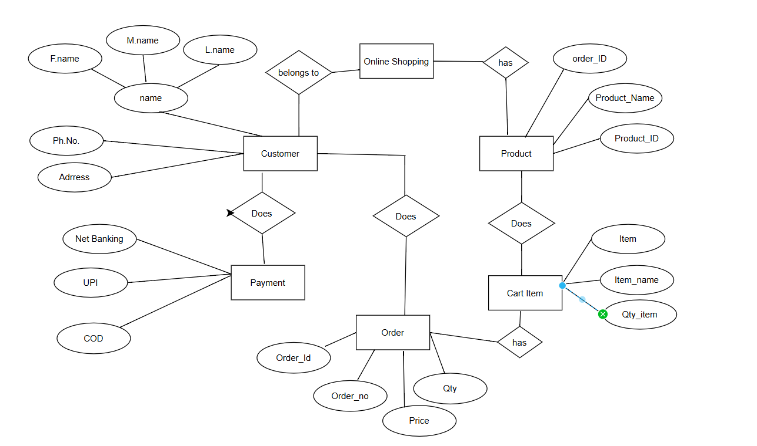

ERD Diagram

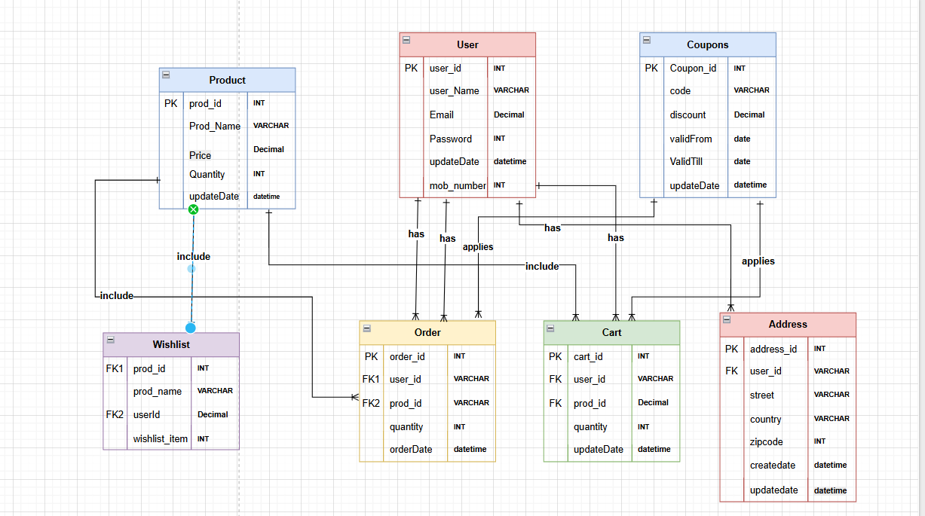

Schema Diagram

Question 7 – Data Flow Diagram

What is a data flow diagram? Draw a data flow diagram to represent the in-flow and out-flow of data when a Farmer is placing an order for the product

**Ans:**

A data flow diagram (DFD) is a visual representation of how data moves through a system or process. DFDs are used to model systems and processes, and to improve efficiency and communication. A data flow diagram (DFD) is a graphical or visual representation that uses a standardized set of symbols and notations to describe a business's operations through data movement.

DFD are often used to analyse and model the structure of the System by illustrating:

* **External Entities:** External source or destination of the data (Farmers)
* **Processes:** The operation or activities performs on the data (Search Product, Place Order, Process Payment and Track delivery)
* **Data stores:** Where data is stored within the system (Product CatLog, Order Database, Payment System)
* **Data Flows:** The movement of data between entities, processes and data stores

Farmers

Product CatLog

Delivery Tracking

Order Database

Payment System

**Question 8 – Change Request**

Due to change in the Government Taxation structure. we should change the Tax structure How do you handle change requests in a project?

**Ans:**

The structure and systematic approach is necessary to deal with change request in a project especially if they are related to something like changing government taxation structure. This ensures that the change is appropriately valuated communicated and implemented without negatively affecting the project budget, timeline or scope.

Here are the steps to respond to the Change Request

* 1. **Change Request received:** Formally receiving the change request by project management team is the first step. The request typically arises because of internal or external situation that calls for a change in the projects budget timeline or scope. In this case, the change request originates due to a modification in government taxation policies. The request is likely initiated by the finance or complex team alerting the project team about the necessity to align with new tax regulation. This project manager acknowledges this request and begins the formal process to address it.
  2. **Change request documented:** Following receipt, the change request is formally recommended in system using structured change request form. The detail of the change are documented thoroughly, including the new taxes rate, effective date and any related government mandates. The documentation may include references to official government notices or circulars. It also specifies how this impacts the project such as modification to the financial system pricing models or invoicing processes.
  3. **Change request Reviewed**: The next step also is involves doing the change request to understand its validity, scope and alignment with the project objectives. The project manager, key stakeholder or project team usually conduct this review. The project team reviews the change request to ensure it is valid and aligned with legal and regulatory requirements. Stakeholder accesses the necessity and urgency of implementing the new taxation structure and discuss the high level impact on the project deliverables.
  4. **Performing Impact Analysis:** An Impact Analysis is conducted to determine how to suggested modification will impact the project after the change request has been examined and accepted as a valid. Impact analysis is conducted to determine how the change in taxation structure will affect different aspects of the project like scope, time budget and risk.
  5. **Updating project document:** The project documents including the scope statement, project plan and risk registered have been updated to reflect the required changes. These updates include adding task for operating tax calculation algorithm popular the financial software and incorporating compliance reviews to ensure adherence to government mandate changes. Additionally, the timeline and budget have been adjusted to account for these additional activities, ensuring that the project remains aligned with its objective while addressing the new requirements.
  6. **Change Control Board (CCB):** Change Control Board (CCB) is responsible for examining and approving project modification in many organisations. The change control board including key stakeholders like finance compliance and IT leads reviews the change. They assess the recommendation and effect analysis then formally approve the change to proceed with implementation. The approval ensures alignment across departments and prevents scope creep
  7. **Communicate the change**: Once change is approved, all relevant teams are promptly informed. Internal teams, such as developers, tester and finance are briefed on the new requirements while external stakeholders, including vendor and customers are updated on changes to pricing invoices or tax display. Clear communication ensures everyone understand their role during implementation.
  8. **Implementing the Change**: Approved changes are implemented by updating financial and billing software to incorporate the new tax rates, adjusting reporting tools to reflect revised tax calculation and conducting system testing to ensure the accurate application of the new tax rules.
  9. **Monitor and track the implementation:** The project team closely monitors the implementation to ensure everything function as intended by running test case to validate text calculations across various scenarios monitoring system performance to prevent disruptions and verifying that all update comply with government requirements.
  10. **Update documentation and Close the Change request:** After successful implementation, the project documentation is updated, including revisions to user manual and text documentations for end users and update the compliance records to reflect the new tax structure. Once verified and validated, the change request is formally closed, and a review is conducted to capture lessons learned.

**Question 9 – Change Request Vs an Enhancement**

As the project is in process, Ben and Kevin have contacted you. The reason is to inform you that they want the Farmers to sell their crop yields through this application i.e. Farmers should be able to add their crop yields or products and display to general public and should be able to sell them. They also want to introduce Auction system for their Crop yields. As a BA, what will be your response? Is this a change request or an enhancement???

**Ans**:

This sounds like an enhancement request as it involves adding new feature to existing project. As a BA, I would first gather more information from Ben and Kevin about specific requirements for adding crop yields and implementing an auction system. I would then measure the impact of these changes on the project timeline, budget and other existing requirements. If the changes are feasible and aligned with the project goals, I would document the new requirement and update the project plan and relevant stakeholders accordingly.

Change request and an enhancement are both terms used in software development and project management, but they refer to slightly different things.

**Change Request:**

* A change request is typically a formal proposal to alter a product, System or project in some way.
* It often arises when there is need to modify something that has already been defined or implemented.
* Change request can involve fixing defects addressing issues or making adjustments to meet new requirements
* They are usually submitted when there is deviation from the initial plan or specification and they often require approval from stakeholders before implementation

**Enhancement:**

* An enhancement on the other hand, refers to an improvement or addition to a product or a system that goes beyond its original specification
* Enhancements are typically intended to add new features, improve existing functionality or enhance user experience
* Unlike change requests, the enhancement are often proactive and driven by a desire to make the product better than fixing something that’s broken.
* While change requests are often reactive, responding to identified problems or changes in requirements, enhancements are more about adding value or staying competitive in the market.

**Question 10 – Estimations**

Come up with estimations – How many Manhours required

**Ans:**

* Estimating a number of man-hours required for developing the online agriculture products store involves breaking down the project into smaller tasks and estimating the effort required for each task here is high level background for tasks and their estimated man hours.
  + 1. **Project planning and requirement gatherings:**
* **Task Breakdown:** Defining project scope requirement gathering and high-level system architecture planning
* **Estimated Man-Hours:** 40-hours
  + 1. **UI/UX Design:**
* **Task Breakdown:** Design user friendly interfaces for the web and mobile applications
* **Estimated Man-Hours:** 90-Hours
  + 1. **Product catalogue management**
* **Task Breakdown:** Development feature for manufacturers to upload product details and images
* **Estimated Man-Hours: 80 hours**

1. **Search and Filter Functionality:**

* **Task Breakdown:** Implement search and philtre option for farmers to easily find products
* **Estimated Man-Hours:** 60 Hours

1. **Front end development**:

* **Task Breakdown**: Implement front end functionalities for browsing products, placing order and marketing payment
* **Estimated Man-Hours:** 150 Hours

1. **Back-end development:**

* **Task Breakdown:** Develop the backend infrastructure, including database design, server setup and API development
* **Estimated Man-Hours:** 150 Hours

1. **Database design and setup**

* **Task Breakdown:** Designing database schema for key entities (products, users, orders) performing data integrity cheks and optimising database performance
* **Estimated Man-Hours:** 40 Hours

1. **Integration:**

* **Task Breakdown:** Integration payment gateways (COD, UPI, Cards) setting up Email and SMS notifications for order update and linking delivery trackers with logistic APIS
* **Estimated Man-Hours:** 80 Hours

1. **Testing:**

* **Task Breakdown:** Conducting unit testing, integration testing, system testing, load testing for high traffic, security testing for vulnerabilities and usability testing with stakeholder feedback.
* **Estimated Man-Hours: 1**40 Hours

1. **Deployment and Maintenance:**

* **Task Breakdown:** Conducting unit testing, integration testing, system testing, load testing for high traffic, security testing for vulnerabilities and usability testing with stakeholder feedback.
* **Estimated Man-Hours:** 140 Hour

1. **Documentation:**

* **Task Breakdown:** Creating user guides for farmer and Manufacturers, preparing technical documentation and drafting FAQs and Troubleshooting guides for SOONY system
* **Estimated Man-Hours:** 30 Hour

1. **Marketing and Awareness Integration:**

* **Task Breakdown:** Designing landing states for commercial campaigns, integrating social media and email marketing tools and setting up analytics to track user acquisitions and behaviour
* **Estimated Man-Hours:** 30 Hour

1. **Training for Stakeholder**

* **Task Breakdown:** Conducting on boarding session for the SOONY team, training farmers on app usability and educating manufacturers on product catalogue management.
* **Estimated Man-Hours:** 50 Hour

1. **Continuous Monitoring**

* **Task Breakdown:** Setting up performance monitoring tools, implementing error reporting systems and performing regular reviews during the warranty period.
* **Estimated Man-Hours:** 30 Hour

**Total estimated 1000 Man-hours.**

**Note:** This estimate may fluctuate depending on factors such as team expertise project complexity and unexpected challenges continuous monitoring and tracking of project progress will allow for adjustment to the estimates as needed during the development process.

**Question 11 – UAT**

Project has finally completed all the stages i.e., design, development, testing etc. Now, it is the role of a business analyst to contact the client for testing of the final product and have to successfully complete it. How are you going to handle this situation? And once it is done, what will be the process to close the project? Explain UAT Acceptance process

**Ans:**

* + 1. **Planning (Prepare for UAT):**
* Identify key stakeholders including farmers, suppliers and business owners for UAT participations
* Review business requirement and ensuring critical functionalities like product search, payment method and delivery tracking are included.
* Develop a UAT plan with defined scope, test cases and timelines and set up a staging environment for testing
  + 1. **Designing (Prepare the Product for the UAT):**
* Align the products UI/UX with client and end user expectations ensuring ease of use for rural and tech-savvy user alike.
* Conduct a walk through of key feature like browsing categories, adding products to the cart and order tracking with stakeholders
* Prepare test cases and realistic datasets for example agriculture product listings or regional pricing for accurate testing scenarios
  + 1. **UAT Testing (Client conducts UAT):**
* End users execute test cases to validate functionality such as searching for fertilisers, placing orders and making payments.
* The BA monitors progress, collects feedback on missing feature or usability issues and logs them for resolution.
* Identify and address any concerns during testing, ensuring the system meets expectations for functionality and performance
  + 1. **Bug fixing (Issue resolution and Retesting):**
* Prioritise and resolve critical issues like payment gateway failures incorrect pricing or slow loading times
* Facilitate retesting of fixed functionalities ensuring all bugs are resolved and no new ones are introduced
* Maintain regular updates with stakeholder on progress and timelines for final delivery
  + 1. **Sign-Off(Final Client Review):**
* Conduct a final review to confirm all requirements such as delivery tracking and product catalogue functionalities are met.
* UAT sign-off from the client signing that the system is ready for the deployment.
* Document feedback, summarise lessons learned and transition to post launch support for ongoing maintenance.

**Note :-** By following a structured approach to UAT planning, designing, testing bug fixing & sign-off. Organization can ensure that the final product meets user expectations , minimise the risk of post deployment issues and maximise user Satisfaction.

**Question 12 – Project Closure Document**

Explain Project closure document

**Ans:**

A project closer document also known as a project closure report document that summarises the key outcomes lesson learned and final details of completed project

It serves as a comprehensive record of the projects accomplishment challenges and overall performance providing valuable insights for stakeholder and future products

**Points to be included in project documents are as follows**

* + 1. **Project Overview:**
* Introduction to the project including its objective scope and key stakeholders
* Overview of project lifecycle, including major milestone and phases
  + 1. **Achievements:**
* Highlight key success and deliverables achieved during the project lifecycle
* Quantitative outcomes such as cost savings, improved efficiency or increased revenue.
* Recognition of team contribution and innovations that added value.
  + 1. **Lessons learned:**
* Insights into what worked well and contributed to the project
* Identification of areas for improvement in process.
* Recommendations for future project based on the challenges and the terminology implemented
  + 1. **Quality assurance:**
* Overview of testing and validation activities to ensure deliverables met quality standards.
* Summary of defects or issues result and their impact on project outcomes.
* Final assessment of adherence to quality benchmark and client satisfaction.
  + 1. **Resource utilization:**
* Analysis of resource allocation and usage for example: human, financial and technical resources.
* Identification of over-utilized or under-utilised resources and their impact on the project.
* Recommendations for optimising resource planning in future project.
  + 1. **Risk management:**
* Summary of risks identified at the beginning of the project and their mitigation plans.
* Evaluation of how effectively risk were managed during the projects.
* New risks encountered and lesson for better risk management in future projects.
  + 1. **Challenges:**
* Key obstacles faced during the project and their impact on timelines or deliverables
* Strategies or actions taken to address challenges and minimise disruptions.
* Evaluation of unresolved challenges and their suggestions for future efforts

The project closure document serves as a formal record of the project’s completion and provides valuable insights and documentation for future reference, ensuring that the project’s outcome is captured and distributed appropriately.

|  |  |  |  |
| --- | --- | --- | --- |
| **S No** | **Point to Include** | **Detail** | **Reference Link** |
| 1. | **Did the client sign off on the UAT testing** |  |  |
|  | Date of sign off | 08-04-2025 | Business_Scope.docx |
|  | Name of resource |  |
| **2.** | **Objectives of the project** |  |  |
|  | User friendliness | Achieved |  |
|  | Customer satisfaction | ROI in 6 months |  |
|  | More categories | Achieved |  |
| **3.** | **Functionalities worked on** |  |  |
|  | Secured payment process | Achieved | FRD.docx |
|  | Categories | Achieved |
| **4.** | **Infrastructure** |  |  |
|  | Software installed | Achieved | Procurement.docx |
|  | Laptop purchased | Achieved |
| **5.** | **Funding** |  |  |
|  | Amount approved | 2 Crores | Financialdetails.xlsx |
|  | Amount used | 2 Crores |
| **6.** | **Overall project information** |  |  |
|  | Escalations | 30 |  |
|  | Customer satisfaction | High |  |
| **7.** | **Value to company** |  |  |
|  | **Positive or negative** | Company has paid successful integration of processes increased turnover by 25% increased deficiency by 20% |  |