Capstone Project: 1

ONLINE AGRICULTURE PRODUCT STORE

Decode the case study:

* Project Idea: To provide online agriculture facilities to farmers, to help farmers with online products.
* Current needs: New application should be able to accept the products fertilizers, seeds, pesticides details from the manufactures and should be able to display to the farmers.
* Over view of the projects: To bulid an online to facilitate farmers to buy seeds, fertilizers and pesticides.

Q1. **Prepare Business Process Model**

* Goal: To build an online store which can facilitate farmers to buy agricultural products through internet.
* Input: farming products and companies manufacturing seeds, fertilizers, Budget (2 crores), best team to resource the project.
* Resources: project managers, BA, testers, coders, developers, E commerce platform , digital marketing tools , system and delivery shipping logistics, mobile phone, computer, internet, farming companies, agricultural products like seeds, plants, fertilizers and pesticides.
* Output: Application where farmers can buy agricultural product and seeds. The complete website.
* Activities: Planning for the project, requirements gathering, budget allocation, coding, testing, implementation of the project

1. Farmers should register themselves with their name and address
2. Use login details to enter the online store.
3. Now select the product that they want to purchase.
4. Farmers should enter payment details like card, online banking or cash on delivery.
5. Order confirmation
6. Delivery estimated date to the address.

* Value: User friendly application which can be understood easily by farmers. Satisfied farmers (customers) who can buy online agriculture products. Providing excellent customer service and support.

Q2. **SWOT:**

Definition: SWOT is an acronym for Strength, Weakness, opportunities and threats. It is a model used to understand influencing factors and how they may affect an company or an initiative.

Strength:

1. Company with talented and trained individuals. Getting the project done by soony company with the success in the previous project
2. Product budget
3. Good interface experience, proven track record and leadership skills.

Weakness:

1. Team handling such project for the first time.
2. Time duration 18 months which seems to be less.
3. Company do not have enough resources to work on the project.

Opportunities:

1. The project is the first kind of project being done by any company.
2. To provide solution to the farmers problem.

Threats:

1. How to deliver the agricultural product in the rural and poor part of the country.
2. Are farmers educated about the online store.
3. Budget seems to be less.
4. Seasonal variants, natural disaster and others.

Q3. **Feasibility Study:**

Definition: Possibility of doing a project within some constraints like technology, Budget and time.

Budget: 2 crores. Various costs involved such as development costs, hardware costs

Time frame: 18 months (plan: 15months to complete the project and 3 months can be kept for change request or for any problems)

Technology:

Based on the data base servers, payment gateways, security and API’s (application interface)

Resources:

* Delivery head
* Project management team
* Senior java Developer
* Java Developers
* Network Admin
* Database admin
* Testers
* BA

Hardware: servers, storage, backup system, network infrastructure

Software – java license, payment gateway software

Q4.**GAP analysis:** GAP analysis is a process typically performed by business analysts and project managers for the delta or difference between the current and future process.

Current state:

* Product limited brands
* Number of product availability
* One payment mode
* Immediate delivery but farmers has to travel without safe packing
* Farmers has to physically move around to know best products

Future state:

* Product with multiple brands
* Collaboration with sellers to maintain product availability
* Multiple payment option in collaboration with multiple banks
* Delivery within week with safe packing
* Farmers can choose best product s from the dropdown.

Q5. **RISK Analysis:**

Definition: An uncertain event or condition which can have impact on cost, time, scope or quality.

BA risk:

* BA missing seller details.
* Due to lack of time BA did not Plan the meeting with stakeholders
* Missing any requirement while stake holders sharing the requirements in a rush.
* Lack of domain knowledge, as it is a new project.

Internal Risk: Risk within the project

* Any fraudulent activities by employees
* Cost risk: as the project may get stalled due to lack of budget, being a new kind of project in the market sponsors may be not aware of the budget the project needed.

External Risk: Any external factors where we don’t have control on.

* Natural disaster : events like earthquakes
* Market Risk : Being a new kind of project the stake holders may miss any delivery of requirement to the BA
* Government Risk: Agriculture is mostly related to government and any new policy may change the whole project completely.

Project Based Risk:

* Scope Creep: When the project scope continuously expands beyond the initial definition, leading to increased costs and timeframes.
* Weather related issues: Adverse weather conditions impacting delivery of products, causing delays.

Q6.**RACI matrix:** is also known as stake holder analysis

Definition: A RACI matrix in risk management is a tool used to clearly define the roles and responsibilities of different stakeholders involved in identifying, analyzing, and mitigating risks within a project or organization.

R- Responsible, A- accountable, C- Consulted, I- informed.

* Requirements gathering - stakeholders are consulted and BA is responsible
* Requirement Analysis – project manager is informed and BA is responsible
* Development – Java Developers are accountable and BA is consulted
* Testing - BA, project manager and java developers are informed, Testers are responsible

Q7. **Business case document:**

The project is initiated because there was demand for pesticides in the farmers and there was no availability. So, this website will act as a felicitator between the manufacturer and farmers.

The current problem is that farmers are facing pest problem because of unavailability of pesticides in the market as the crops get destroyed due to unavailability of pests.

-with this project the problems that could be solved are

a. The pesticides will be available in no time to farmers

b. There will be no middlemen in between so they can get the products at cheaper rates

c. No need for the farmers to go the market in search of pesticides it will delivered to their house.

-The resources required are

a. We need a good set of technical team (developers, testers, designers) for the project.

b. Budget – 2 crores

c. high speed internet facility.

-organizational changes required to adopt this technology are:

There will be no such organizational changes for adopting this technology.

-time frame to recover Return Of Investment will be of 3 years as we are expecting good number of farmers and companies to get enrolled.

Q8.**SDLC Methodologies:**

1. Sequential – waterfall

Waterfall (Sequential): Waterfall methodology is a development process where all the phases flow like a waterfall. Each phases need to be completed before the next phase begins. There are 5 stages in waterfall methodology.

**Requirement**

 Waterfall model depends on all the requirements gathered and understood upfront.

**Design**

 Once the requirement is gathered, the technical team designs the requirement into layouts, data models, prototypes etc.

**Implementation**

 One the design is completed; the technical team starts coding as per the design or prototypes.

**Testing**

Before the product is delivered to the customer, the product/software needs to be tested.

**Deployment/Maintenance**

 Once the software is tested, it gets released to the customer and with that maintenance phase begins

**2. Iterative:** In this development process, each phase builds on the previous one. The development

Takes place in iterations and in small parts at a time. It’s a process of gradual improvement and

Learning from previous iterations, as how to improve the next. There are 4 phases in this methodology

**Requirement:** The Goal needs to set accordingly, as every iteration is different from later ones and there is no previous iterations to work from.

**Design:** In this phase, design needs to be created to solve the requirements, which includes technical designs, process flow diagrams etc.

**Development:** The technical team will create the first iteration which will be informed by analysis and design.

**Testing:** after the iteration, it will be tested to find out the improvement. It can also be checked with project stakeholders.

**Review:** Team will evaluate the success of the iteration and align on anything that needs to be changed.

3. **Spiral Model**: Spiral model is an SDLC methodology which combines Iterative development and Waterfall model. It is used for Risk management. This SDLC model is mostly used for large and complicated projects. The spiral model enables gradual releases and refinement of a product through each phase of the spiral as well as the ability to build prototypes at each phase. It can manage unknown risks once the project is started. The radius of the Spiral model represents the cost of the project, and the angular degree represents the progress made in the current phase. Every phase can be broken into four quadrants:

1. **Identifying and understanding requirements:** Every phase can be broken into four quadrants: identifying and understanding requirements, performing risk analysis, building the prototype and evaluation of the software's performance.
2. **Performing risk analysis:** risk analysis should be performed on all possible solutions to find any faults or vulnerabilities, such as, running over the budget or areas within the software.
3. **Building the prototype:**  Proto type is built and tested. This step includes architectural design, design of modules, physical product design and the final design.
4. **Evaluation of the software's performance:** In the final quadrant, test results of the newest version are evaluated. This analysis allows programmers to stop and understand what Worked and didn’t work before progressing with a new build. At the end of this quadrant, Planning for the next phase begins and the cycle repeats. At the end of the whole spiral, the software is finally deployed in its respective market.

Steps: While the phases are broken down into quadrants, each quadrant can be further broken-down into the steps that occur within each one. The steps in the spiral model can be generalized as follows:

* The new system requirements are defined in as much detail as possible. This usually involves interviewing a number of users representing all the external or internal users and other aspects of existing system.
* A preliminary design has been created for the new system.
* The first prototype of the new system is constructed from the preliminary design. This is usually a scaled-down system and represents an approximation of the characteristics of the final product.
* A second prototype is evolved by a fourfold procedure: (1) evaluating the first prototype in terms of its strengths, weaknesses, and risks; (2) defining the requirements of the second prototype; (3) planning and designing the second prototype; (4) constructing and testing the second prototype.
* The entire project can be aborted if the risk is deemed too great. Risk factors might involve development cost overruns, operating-cost miscalculation and other factors that could result in a less-than-satisfactory final product.
* The existing prototype is evaluated in the same manner as was the previous prototype, and, if necessary, another prototype is developed from it according to the fourfold procedure outlined above.
* The preceding steps are iterated until the customer is satisfied that the refined prototype represents the final product desired.
* The final system is constructed, based on the refined prototype.
* The final system is thoroughly evaluated and tested. Routine maintenance is carried out on a continuing basis to prevent large-scale failures and to minimize downtime.

**4. Agile (Scrum)** : The Agile methodology is a way to manage a project by breaking it up into several

Phases. It’s a process for managing a project that involves constant

Collaboration and working in iterations. Agile project management works off the basis that a project can be continuously improved upon throughout its life cycle, with changes being made quickly and responsively.

Agile's four main values are:

* Individuals and interactions over processes and tools

* Working software over comprehensive documentation

* Customer collaboration over contract negotiation
* Responding to change over following a plan

9Q. **SDLC models:**

* **Waterfall**
* **Iterative**
* **Spiral**
* **Agile**
* **V shaped**

Waterfall:

Waterfall model is the oldest and most structured method. In this model, each phase depends on the outcome of the previous phase and all the phases runs sequentially. This model provides discipline and gives

a tangible output at the end of each phase. However, this model doesn’t work well

When flexibility is a requirement. There is little room for change once a phase is deemed complete, as changes can affect the cost, delivery time, and quality of the software.

Iterative:

In the iterative process, each development cycle produces an incomplete but deployable version of the software. The first iteration implements a small set of the software requirements, and each subsequent version adds more requirements. The last iteration contains the complete requirements set.

Spiral:

Spiral model is an SDLC methodology which combines Iterative development and Waterfall model. It is used for Risk management. This SDLC model is mostly used for large and complicated projects. The spiral model enables gradual releases and refinement of a product through each phase of the spiral as well as the ability to build the prototype at each phase. It can manage unknown risks, once the project is started.

Agile:

The agile methodology produces ongoing release cycles, each featuring small, incremental changes from the previous release. At each iteration, the product is tested. The agile model helps teams identify and address small issues in projects before they evolve into more significant problems. Teams can also engage business stakeholders and get their feedbacks throughout the development process.

V-shaped:

In the V-shaped model, verification phases and validation phases are run in parallel. Each verification phase is associated with a validation phase and the model is run in a V shape, where each phase of development has an associated phase of testing.

10Q. **Differences between V-Model and Waterfall Model:**

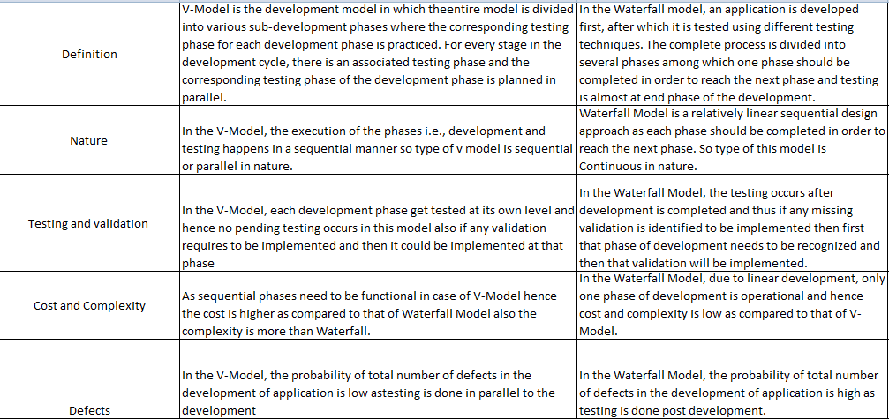

11Q.

Reason for selecting V model:

 As a BA, I would like to choose V model for this project as this is a small project.

V model is based on verification and validation of each stage of development of the online store of the agriculture products.

Also this project is clearly defined and also the requirements are fixed.

Using the model I can complete each step before moving on to the next step, the testing of the developing online store for agriculture products is planned in parallel.

This V model works well in small projects, such as development of an online store for agriculture products where the requirements are well understood.

This V model also helps in the project when in case of changes in the middle, and then it is necessary to update the test documents and requirement document.

In V model test activities like planning, test planning happens well before coding. It saves a lot of time, there is a higher change getting a successful model.

12Q Gantt chart:

Work breakdown structure or the work progress in a project.

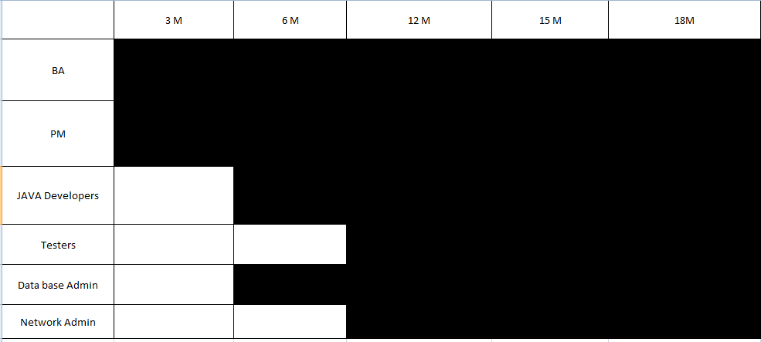

13Q.

**Fixed Bid model Vs Billing model:**

1**.** Fixed Bid project is a project in which the time and scope is fixed within a budget and has a deadline associate with it. In fixed bid model, the client will give all the details, specs and mock-ups and all the requirements upfront, so that vendor can provide a Bid showing the project cost. In this model, vendor should be good in estimating the time and budget, as they need to explain the client, as how much time it would take for them to finish the project and how much it would cost . This model hassles financial risk, however it has no flexibility or room for adjustments, as the budget and time in fixed. This model usually works with smaller projects with limited features and clear requirements.

2. Billing Model (Time and Material) is a project where the project is billed in hourly basis. Vendor will set up a team and presented to the client to bill them for their time spent on development. This model is flexible in nature, as changes can be added in the middle of the project. This model allows client to monitor the progress as developers present reports on work completed.

14Q.

Time Sheet of BA:

Requirements gathering:

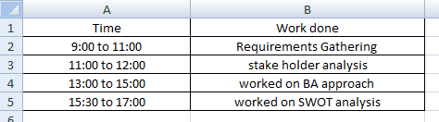

Requirement Analysis:

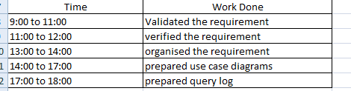

Development stage:

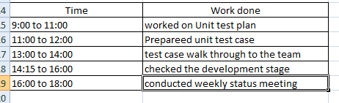

Testing stage:

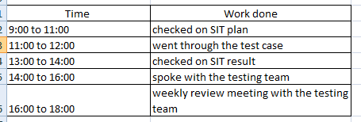

UAT stage:

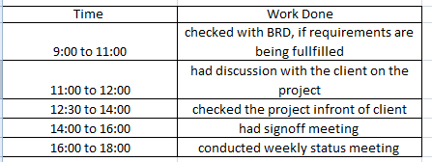

Deployment and implementation:

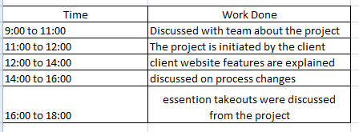

------------------------------------The End of capstone prep 1---------------------------------------------