Contents
Document 1- Definition of Done (DoD) 1
Document 2- Product Vision 1
Document 3- User stories 2
Document 4- Agile PO Experience 5
Document 5- Product and sprint backlog and product and sprint burndown charts 6
Document 6: Sprint meetings 8

Document 1- Definition of Done (DoD)

- A DoD is a set of criteria that a backlog item must meet for the team to consider it complete and ready for customers.
- It is important to note that one person from team does not create the Definition of Done. Instead, it is agreed upon by the entire Scrum team, including developers, testers, product owners, and other stakeholders.
- DoD ensures that there is common understanding between entire team about the expected outcome from the backlog item.
- Everyone from team uses the DoD as a guide before marking an item as complete.
- DoD is usually defined in form of checklist.
- For this project, the DoD checklist for user story will have following points:
  - Acceptance Criteria is mentioned.
  - BV and CP are given.
  - Development is done with no errors
  - Unit testing is done by developer in DEV environment
  - Code is deployed to QA environment
  - QA testing is done and passed with no errors
  - UAT testing is done by business in QA environment with no errors
  - On JIRA ticket, sign-off from business is received to deploy to production.
  - User Story is queued for deployment in Production.
  - Build for production deployment is ready
  - User story is deployed to production.
  - Production validation is done by business.

Document 2- Product Vision

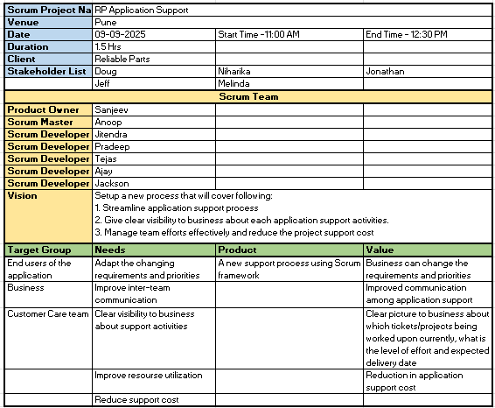

Document 3- User stories

User Story – 1 | Tasks – 3 | Priority – HIGH
AS A USER
I WANT TO POP-UP FOR LOGIN SCREEN
SO THAT I DON’T HAVE TO NAVIGATE TO SEPARATE LOGIN PAGE
BV - 100 | CP - 8 | JIRA Ticket# - MPGL 1217
ACCEPTANCE CRITERIA
For login, show a pop-up screen to allow users to log in without leaving the current page
The pop-up screen can be seen from nay page of the application

Show message window for successful log-in and log-out and window should gets closed automatically after 3 seconds

User Story – 2 | Tasks – 1 | Priority – HIGH
AS A USER
I WANT TO GET CANCEL ORDER NOTIFICATION FOR PICK-UP ORDERS
SO THAT I WILL GET CONFIRMATION OF ORDER CANCELLATION
BV - 500 | CP - 13 | JIRA Ticket# - CVSU 205
ACCEPTANCE CRITERIA
When customer cancels the pick-up order, he should get email/sms notification for the same

User Story – 3 | Tasks – 2 | Priority – HIGHEST
AS A USER
I WANT TO GET SHIP/CANCEL ORDER NOTIFICATION FOR MULTI-LINE MULTI-STATUS ORDER
SO THAT I WILL GET COME TO KNOW WHICH LINES FROM ORDER ARE SHIPPED AND WHICH ONE ARE CANCELLED
BV - 1500 | CP - 20 | JIRA Ticket# - CVSU 204
ACCEPTANCE CRITERIA
From multi-line and multi-status order, customer receive email/sms notification for shipped lines.
From multi-line and multi-status order, customer receive email/sms notification for cancelled lines.

User Story – 4 | Tasks – 1 | Priority – MEDIUM
AS A USER
I WANT TO RECEIVE AM EMAIL WHEN I SUBMIT THE 'Damage Upon Arrival' CLAIM
SO THAT I WILL HAVE CONFIRMATION FOR THE CLAIM SUBMITTED
BV - 500 | CP - 5 | JIRA Ticket# - RTCL 204
ACCEPTANCE CRITERIA
Customers receive an email when the 'Damage Upon Arrival' claim is submitted

User Story – 5 | Tasks – 1 | Priority – HIGH
AS A SYSTEM
ALL CLAIMS THOSE ARE NOT PROCESSED FOR 30 DAYS SHOULD MARKED AS ‘CLOSED’ AUTOMATICLLAY
SO THAT THE CLAIM WILL NOT REMAIN IN ‘SUBMITTED’ STATUS
BV - 1200 | CP - 12 | JIRA Ticket# - RTCL 200
ACCEPTANCE CRITERIA
If the submitted claim in not processed in ASW for 30 days then in NS3 the claim status gets changed to ‘Closed’.

User Story – 6 | Tasks – 1 | Priority – LOW
AS A USER
I SHOULD BE ABLE TO DOWNLOAD THE RMA LABEL
SO THAT I CAN TAKE PRINT OF IT.
BV - 200 | CP - 5 | JIRA Ticket# - MPGL 1305
ACCEPTANCE CRITERIA
When ‘Pre-paid’ RMA is submitted, customer should be able to download the generated label.

User Story – 7 | Tasks – 1 | Priority – MEDIUM
AS A USER
I SHOULD BE ABLE TO SEE THE ‘PAYPAL’ OPTION FOR ‘SUBSCRIBE AND SAVE’ PARTS ORDER
SO THAT I CAN MAKE ORDER PAYMENT USING PAY-PAL
BV - 800 | CP - 9 | JIRA Ticket# - MPGL 1299
ACCEPTANCE CRITERIA
If a ‘subscribe and save’ product is added to the cart, PayPal option becomes available on checkout page.

User Story – 8 | Tasks – 1 | Priority – HIGH
AS A USER
I SHOULD SEE ERROR ON PDP IF SHIPPING ADDRESS IS MISSING
SO THAT I CAN PROVIDE THE SHIPPING ADDRESS BEFORE PLACING THE ORDER
BV - 1300 | CP - 14 | JIRA Ticket# - 94338
ACCEPTANCE CRITERIA
For the customer, If the shipping address is not mentioned in NS3, then while placing the order on PDP, an error message ‘No shipping address found. Please add a valid address in your account settings to continue.’ should get displayed.

User Story – 9 | Tasks – 1 | Priority – LOW
AS A SYSTEM
WHEN EMAIL IS SEND FOR CLAIM SUBMISSION, THE ‘PURCHASE DATE’ SHOULD BE POPULATD FROM ORIGINAL INVOICE
SO THAT THE CUSTOMER WOULD KNOW WHEN THE ITEM WAS PURCHASED
BV - 300 | CP - 2 | JIRA Ticket# - RTCL 198
ACCEPTANCE CRITERIA
In the email generated for claim submission, the ‘Purchase Date’ should get populated from original invoice date.

User Story – 10 | Tasks – 2 | Priority – HIGH
AS A SYSTEM
IF RMA HAS SHIPPING CHARGES INCLUDED THEN IN ASW ORDER ‘RETURN FEE’ LINE SHOULD GET ADDED
BV - 800 | CP - 7 | JIRA Ticket# - 94526
ACCEPTANCE CRITERIA
For 'Drop-off' and 'Self ship' RMAs, the shipping charge is 0 and there is no 'Return Label' line added in the ASW Credit SO.
For 'Pre-paid shipping' RMAs, the shipping charge is non-zero and there is a 'Return Label' line added in the ASW Credit SO.

Document 4- Agile PO Experience

The Product Owner (PO) is primarily responsible for defining and prioritizing the product backlog, ensuring it reflects customer needs and business goals. They act as a voice for the customer, managing communication between stakeholders, development teams, and other relevant parties.

Responsibilities:
- Product Backlog Management – Arrange the product backlog as per business priorities and make sure that it is well understood by all stakeholders.
- Stakeholder Management – Gathering and analysing customer feedback. Manage expectations of stake holders. Being the voice of the customer.
- Collaboration and Communication - Facilitating communication between the team and stakeholders. Participating in Scrum events. Support the development team.
- Other Responsibilities - Analysing product performance data. Check the product releases and ensure quality standards are met. Managing timelines and budgets.

From this project I have learned how to handle sprint meetings such as:
- Sprint planning meeting – To plan the work for upcoming Sprint
- Daily scrum meeting – To get the status of each team member and any issues
- Sprint review meeting – To demonstrate the work done by team in the Sprint.
- Sprint retrospective meeting – To analyse the last completed Sprint for things like Areas to improve, lessons learnt etc.
- Backlog refinement meeting – Re-arrange the product backlog as per business needs/priorities.

I also learnt about User stories creation and what things will be included in user stories such as:
- Story no
- Total number of Tasks in the story
- Priority
- Acceptance criteria
- BV & CP value
- Description

In Scrum, a product owner serves as the connection between multiple areas of an organization. This person communicates with business stakeholders and collaborates closely with Scrum teams to keep all areas of the business informed on a project's development.

The product owner develops a vision of a product's function and operation, which in turn allows the Scrum team member to define product features and break those features into product backlog items.

Document 5- Product and sprint backlog and product and sprint burndown charts

Product backlog: This contains a list of all the user stories that covers entire functionality of the application bug task/enhancement. It is arranged in the order defined by business based on BV and CP.

ID | User Story Description | # of Tasks | Priority | BV | CP | Sprint Number | JIRA ticket#
1 | Show a pop-up screen to allow users to log in. | 1 | High | 1500 | 8 | Sprint 1 | MPGL 1217
2 | Cancel order notifications for pick-up orders. | 1 | High | 1000 | 13 | Sprint 1 | CVSU 205
3 | Get SHIP/CANCEL order notifications for MULTI-LINE MULTI-STATUS order. | 2 | Highest | 800 | 20 | Sprint 1 | CVSU 204
4 | Receive an email when the 'Damage Upon Arrival' claim is submitted | 1 | Medium | 500 | 5 | Sprint 1 | RTCL 204
5 | Not processed claims should get closed after 30 days. | 1 | High | 400 | 12 | Sprint 1 | RTCL 200
6 | download the generated label for ‘Pre-paid’ RMA. | 1 | Low | 400 | 5 | Sprint 2 | MPGL 1305
7 | PayPal option becomes available for ‘subscribe and save’ product on checkout page. | 1 | Medium | 300 | 9 | Sprint 2 | MPGL 1299
8 | If shipping address is not mentioned in NS3, then show error message on PDP. | 1 | High | 250 | 14 | Sprint 2 | 94338
9 | In claim email, ‘Purchase Date’ to be populated from original invoice date. | 1 | Low | 250 | 2 | Sprint 2 | RTCL 198
10 | RMA with Shipping Charges should have Label Fee line in ASW order | 2 | High | 100 | 7 | Sprint 2 | 94526

Sprint backlog: This contains a list of all the user stories that team has agreed to take in current Sprint for development. The items are usually pulled from the product backlog during the sprint planning session.

ID | User Story | # of Tasks | Owner | Status | Estimated Efforts | JIRA Ticket#
1 | Show a pop-up screen to allow users to log in. | 1 | Ajay | Done | 16 Hrs | MPGL 1217
2 | Cancel order notifications for pick-up orders. | 1 | ShriKiran | WIP | 26 Hrs | CVSU 205
3 | Get SHIP/CANCEL order notifications for MULTI-LINE MULTI-STATUS order. | 2 | Omveer | WIP | 40 Hrs | CVSU 204
4 | Receive an email when the 'Damage Upon Arrival' claim is submitted | 1 | Jitendra | ToDo | 10 Hrs | RTCL 204
5 | Not processed claims should get closed after 30 days. | 1 | Ajay | WIP | 24 Hrs | RTCL 200

Product burndown:

A product burndown chart visually represents the overall progress of a project by showing all the remaining work in the product backlog over time. It typically plots the total story/complexity points (unit of work) on the Y-axis against all sprints or time periods on the X-axis. This allows teams to track progress, predict completion dates, and identify potential roadblocks.

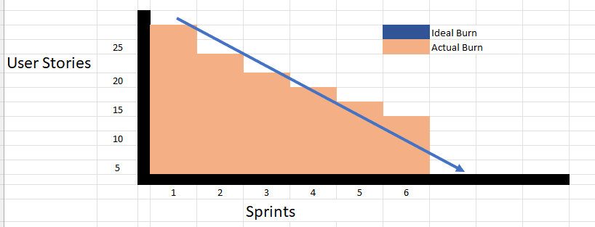
Note: Since the product burndown is not available in the JIRA tool installed on my laptop, I am giving the representation of how it looks.

Sprint burndown:

A Sprint Burndown Chart is a tool used to track the progress of a sprint. It helps teams monitor their progress towards completing the sprint goal and identify any potential roadblocks or delays. The chart displays the amount of work remaining in the sprint over time, allowing teams to see if they are on track to meet their target. On X-axis duration of Sprint is used (i.e. days, weeks) and on Y-axis complexity points is used.

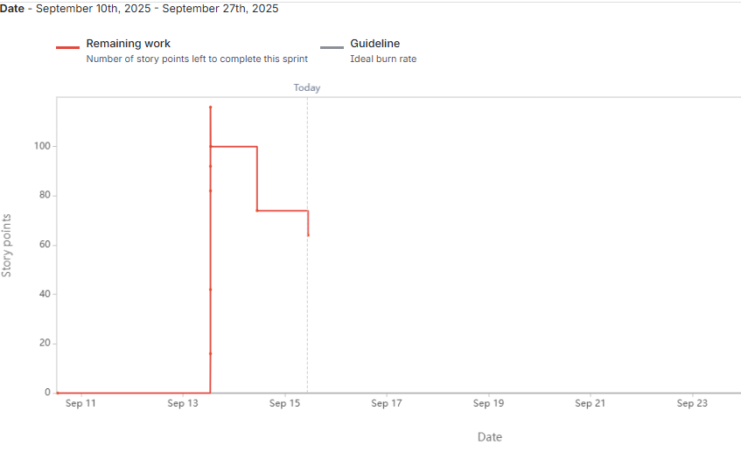

Document 6: Sprint meetings

Meeting Type 1: Sprint Planning meeting

In this meeting, Scrum team discuss and decide what features/user stories they are going to deliver in this sprint. Those user stories/tasks are moved from Product backlog to Sprint Backlog. The selection is based on BV/CP and capacity of the team to deliver in Sprint duration.

Date | 8-Sept-2025
Time | 11 am
Location | Meeting room 1
Prepared By | Uday Hadap
Attendees | Omveer, Pradeep, Umesh, Jitendra, Alankar, Anoop, Sanjeev

Agenda Topics:

Topic | Presenter | Time Allocated
User Stories not completed in last sprint | Omveer | 15 min
Addition of new user stories from product backlog | Anoop | 45 min
Finalize the Sprint backlog | Uday | 15 min
Leave plans in team in next sprint duration | Sanjeev | 15 min

Other Information:

Observers | Niharika, Doug
Resources | AWS and Kount support
Special Notes | Company holiday in next week

Meeting Type 2: Sprint review meeting

At end of Sprint, Sprint Review meeting is conducted at end of Sprint, where team demonstrates the work done in the team to all stakeholder and gather their feedback.

Date | 19-Sept-2025
Time | 4 pm
Location | Meeting room 2
Prepared By | Uday Hadap
Attendees | Omveer, Pradeep, Umesh, Jitendra, Alankar, Anoop, Sanjeev, Doug, Niharika, Jonathan, Jeff

Sprint Status | Things to Demo | Quick Updates | What’s next
Complete | User Story 1  User Story 2  User Story 3  User Story 4  User Story 5 | In User Story 2 i.e. CVSU-205, Niharika has suggested change in UI. | User story 2 will be updated for UI change suggested and will be taken up in next sprint.

Meeting Type 3: Sprint retrospective meeting

This meeting is conducted at the end of Sprint, where Team discusses about how Sprint went, Challenges faced, what went wrong, Areas of improvements etc.

Date | 19-Sept-2025
Time | 6 pm
Location | Meeting room 1
Prepared By | Uday Hadap
Attendees | Omveer, Pradeep, Umesh, Jitendra, Alankar, Anoop

Agenda | What went well | What didn’t do well | Questions | Reference
How was Sprint 1? | All user stories from Sprint backlog are complete | Estimation for User Story 2 was less compared to actual time taken | Can Dev/Test server be available in the morning time for team to work?
How was Sprint 1? | The testing across systems i.e. NS3 and ASW went well | For user story 4, the AWS/Kount dependency was not considered |  | Relationship Manager for Kount
How was Sprint 1? | For user story 2, the Vibes registration worked well

Meeting Type 4: Daily Stand-up meeting

During Sprint, everyday team meet up in Daily Stand-up meeting to discuss the Sprint progress and if anyone is facing any issues/impediments. Each team member also informs about what he worked on yesterday and what he is planning to work on today.

