**Nurturing Process - Capstone Project1 – Part -3/3 V2D2**

**ONLINE AGRICULTURE PRODUCT STORE**

**Question 1 – Functional Requirements - 15 Marks**

Identify minimum 20 functional requirements

**FUNCTIONAL REQUIREMENTS**

|  |  |  |  |
| --- | --- | --- | --- |
| **REQUIREMENT ID** | **REQUIREMENT NAME** | **DESCRIPTION** | **PRIORITY** |
| FR001 | User Registration | User should be able to create an account by providing basic details such as name, email ID, phone number, Password. | 8 |
| ZqFR002 | Product Catalog | The application should be able to display a comprehensive list of all available products including fertilizers, seeds and pesticides with detailed information. | 9 |
| FR003 | Search Functionality | Users should be able to search for products based on various criteria like name, type, brand, price range. | 7 |
| FR004 | Product details | Users should be able to view detailed information about each product, including price, quantity, description, images and reviews. | 10 |
| FR005 | Shopping cart | User details be able to add products to their cart and view their cart details, including total price and quantity. | 8 |
| FR006 | Checkout process | Users should be able to complete the checkout process by providing delivery address, payment details and confirmation of order. | 9 |
| FR007 | Order tracking | Users should be able to track their order status, including confirmation, processing, shipping and delivery. | 6 |
| FR008 | User profile management | Users should be able to manage their profile emails such as name, address, phone number and password. | 9 |
| FR009 | Order History | Users should be able to view their previous order history, including details like order date, order status and product details. | 8 |
| FR010 | Product Reviews | Users should be able to rate and review products they have purchased which will be visible to other users. | 9 |
| FR011 | Product Comparison | Users should be able to compare products based on various parameters such as price, quality and features. | 8 |
| FR012 | Newsletter Subscription | Users should be able to subscribe to the newsletter to receive updates about new products, discounts  and promotions. | 8 |
| FR013 | Wishlist | Users should be able to add products to their wish list for future purchase . | 7 |
| FR014 | Product Recommendation | Users should be provided with personalized product recommendations based on their search and purchase history. | 9 |
| FR015 | Multiple payment options | Users should be able to pay for their orders through multiple payment options such as credit/debit cards, net banking and wallets. | 10 |
| FR016 | Order Cancellation | User should be able to cancel their order and request a refund as per the company's policies. | 7 |
| FR017 | Customer support | Users should be able to contact customer support for any queries, complaints or feedback . | 9 |
| FR018 | Mobile App | The application should have a mobile app version for users to access it from their mobile devices. | 9 |
| FR019 | Multilingual Support | The application should support multiple languages for users from different regions. | 10 |
| FR020 | SE Optimization | The application should be optimized for search engine to improve its visibility and ranking in search results. | 7 |

**NON FUNCTIONAL REQUIREMENTS**

|  |  |  |  |
| --- | --- | --- | --- |
| **REQUIREMENT ID** | **REQUIREMENT NAME** | **DESCRIPTION** | **PRIORITY** |
| NFR001 | Usability | The application should have an initiative and user-friendly | 9 |
| NFR002 | Performance | The application must load pages within 3 seconds | 8 |
| NFR003 | Security | The application must ensure secure user authentication | 9 |
| NFR004 | Compatibility | The application should be compatible with major web browsers | 8 |
| NFR005 | Respose time | The application should respond to user inputs within 2 seconds. | 9 |
| NFR006 | Page loading time | Each Page should load within 2 seconds time | 7 |
| NFR007 | Authentication | Users should be required to authenticate using username and password | 10 |
| NFR008 | Data Encryption | Sensitive data should be encrypted using AES-256 encryption | 9 |
| NFR009 | Access Control | Only authorized users should have access to certain functionalities or data. | 8 |
| NFR010 | Availability | The system should be available 99.9% of the time. | 9 |
| NFR011 | Browser Compatibility | The system should be compatible with the latest versions of popular web browsers (Chrome, Firefox,Safari, Edge). | 9 |
| NFR012 | Efficient resource usage | The system should optimize resource usage to minimize costs. | 10 |
| NFR013 | Traceability | Changes made to the system configuration or code should be logged and traceable to specific users or  Processes. | 8 |
| NFR014 | Consistency | The user interface should have a consistent layout and design across all pages. | 9 |
| NFR015 | Operating system  compatibility | The system should be compatible with Windows, mac OS, and Linux operating systems. | 9 |

**Question 2–Minimum 5 page designs - 15 Marks**

Make wire frame and prototypes

**Answer**

Wire frame and Prototypes are important part of the design process.

**Wire frame:**

The low fidelity skeleton for your design that outlines only the essential UI.

**Benefits:**

* Fast,cheap and easy to make.
* Easy for stakeholders to visualize

**Prototypes:**

High fidelity working model of the final product

**Benefits:**

* Accurate feedback
* Realistic idea
* collaboration

1. **REGISTRATION PAGE**

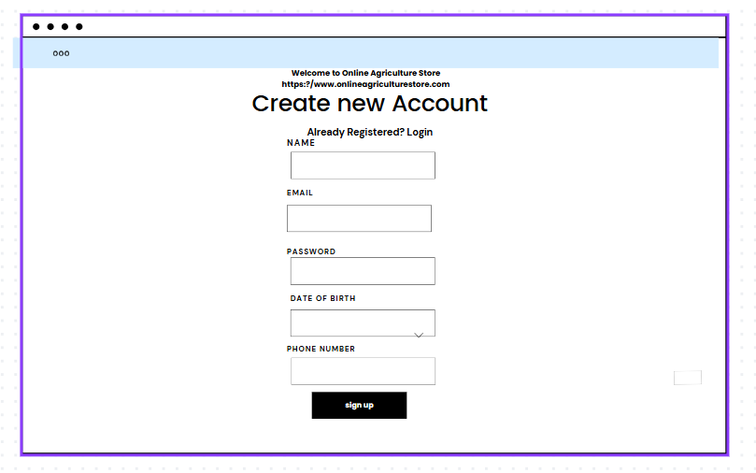

1. **LOGIN PAGE**

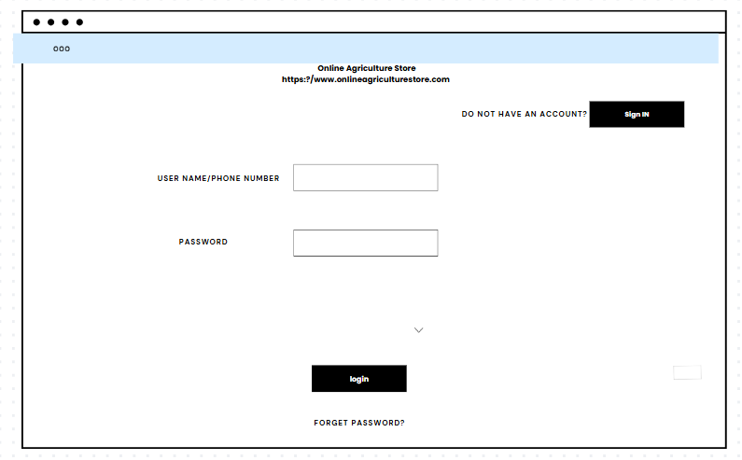

1. **SEARCH PRODUCTS**

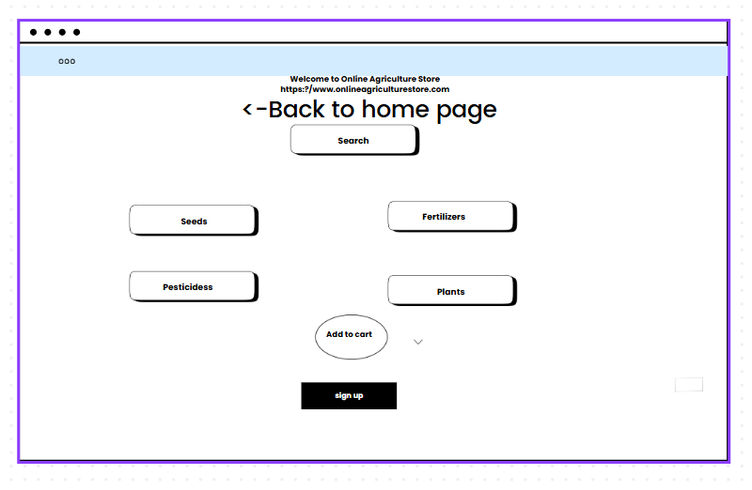

1. **ADD TO CART**

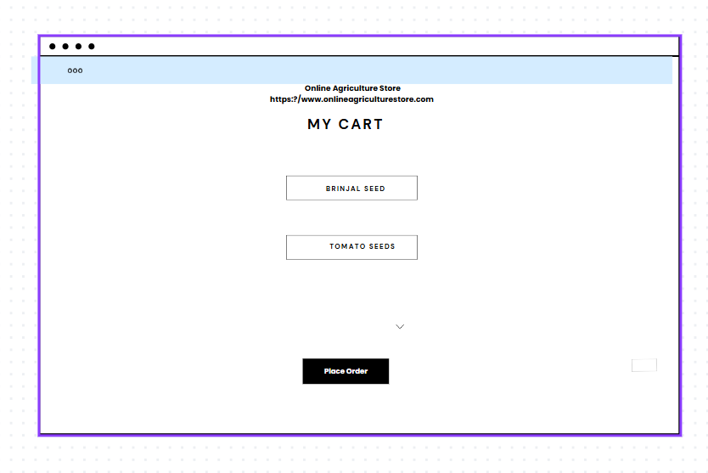

**E .MAKE PAYMENT**

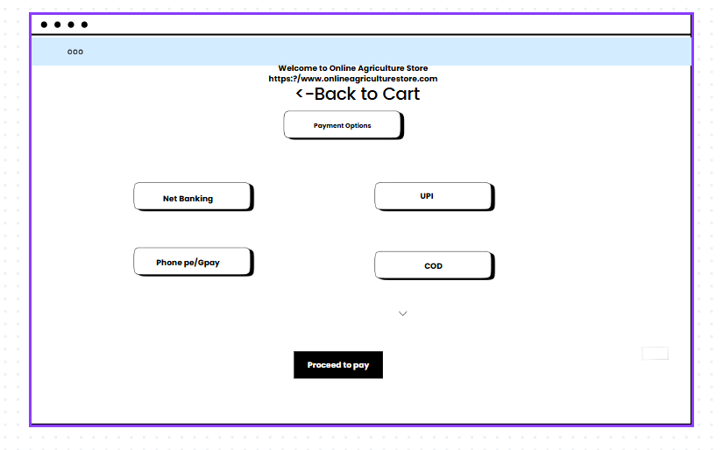

**Question 3 – Tools (Visio, Balsamiq) - 15 Marks**

Make a note of the Tools, which you are using for above concepts.

**Answer**

**Microsoft Visio**

* Microsoft Visio is a versatile diagramming tool that allows users to create a wide range of diagrams, including flowcharts, organizational charts, and network diagrams.
* With its extensive library of shapes and customization options, Visio enables users to visually represent complex information and processes.
* It offers collaboration features, data linking capabilities, and seamless integration with other Microsoft Office applications.

**Key components and features of Microsoft Visio:**

**Shapes:**

Visio provides a wide range of pre-defined shapes for various purposes such as flowcharts, network diagrams, electrical diagrams, organizational charts, and more. Users can drag and drop these shapes onto the canvas to create diagrams.

**Templates:**

* Visio offers numerous templates tailored for specific types of diagrams.
* These templates come with pre-defined shapes, connectors, and settings optimized for their respective diagram types, making it easier for users to get started.

**Stencil:**

* In Visio, stencils are collections of related shapes grouped together for easy access.
* Each template typically comes with its own set of stencils containing shapes specific to the diagram type.
* Users can also create custom stencils to organize their frequently used shapes.

**Connectors:**

* Visio provides various types of connectors to link shapes together and illustrate relationships in diagrams.
* Users can customize the appearance of connectors, such as line style, arrowheads, and endpoints.

**Text and Formatting Tools:**

* Users can add text to shapes and connectors to provide additional information or labels in their diagrams.
* Visio offers a range of formatting tools for text, including font styles, sizes, colors, and alignment options.

**Themes and Styles:**

* Visio allows users to apply themes and styles to their diagrams to enhance visual consistency and appeal.
* Themes can be applied to change the overall look and feel of a diagram, while styles can be used to customize the appearance of individual shapes.

**Grid and Guides:**

* Visio provides grid-lines and guides to help users align and position shapes precisely on the canvas.
* Grid lines can be customized in terms of spacing and visibility, while guides can be dragged onto the canvas to serve as alignment aids.

**Data Linking:**

* Visio offers the ability to link shapes and diagrams to external data sources such as Excel spread sheets, databases, and SharePoint lists.
* This allows users to create dynamic diagrams that update automatically based on changes in the underlying data.

**Collaboration and Sharing:**

* Visio supports collaboration features such as commenting, reviewing, and co-authoring, allowing multiple users to work on the same diagram simultaneously.
* Diagrams can also be shared and published in various formats, including PDF, image files, and web pages.

**Integration with Other Microsoft Products:**

Visio integrates seamlessly with other Microsoft Office applications such as Word, Excel, PowerPoint, and SharePoint. Users can embed Visio diagrams into Office documents or publish them to SharePoint for easy access and sharing.

**Balsamiq**

* Balsamiq is a popular wire framing tool used for creating low-fidelity prototypes.
* It focuses on simplicity and sketch-like designs to quickly visualize and communicate design ideas.
* With its drag-and-drop interface and pre-built UI elements, Balsamiq allows users to rapidly iterate and gather feedback on the basic structure and layout of a digital product.

**Mockup Editor:**

The core component of Balsamiq is its mock up editor, where users can drag and drop various UI elements (such as buttons, text boxes, images, and icons) onto a canvas to create wire frames and mock ups of their designs. The editor provides a simple and intuitive interface for building prototypes quickly.

**UI Library:**

* Balsamiq comes with a comprehensive library of pre-built UI components and symbols that users can use in their designs.
* These components cover a wide range of UI elements commonly found in web and mobile applications, including navigation bars, form controls, tables, and more.

**Customization Options:**

* Users can customize the appearance of UI elements in Balsamiq, such as adjusting colors, fonts, sizes, and styles, to match the desired look and feel of their designs.
* This allows for quick iteration and experimentation during the wire framing process.

**Templates:**

* Balsamiq offers a variety of pre-designed templates for different types of projects and applications,including websites, mobile apps, desktop software, and more.
* These templates provide a starting point for users to kick start their designs and speed up the prototyping process.

**Linking and Interactivity:**

* Balsamiq allows users to create clickable prototypes by linking mock up screens together to simulate user interactions and navigation flows.
* This feature enables stakeholders to experience the user interface firsthand and provide feedback on usability and functionality.

**Version Control and Collaboration:**

* Balsamiq offers built-in version control and collaboration features that allow multiple team members to work on the same project simultaneously.
* Users can share their designs with others, track changes, leave comments, and iterate on designs collaboratively.

**Export and Integration:**

* Balsamiq supports exporting mock ups and prototypes in various formats, including PNG, PDF, and interactive PDF.
* Additionally, it integrates with popular collaboration and project management tools such as Jira, Confluence, Slack, and Google Drive, enabling seamless workflows within development teams.

**Desktop and Web Versions:**

* Balsamiq is available in both desktop and web-based versions, catering to different user preferences and workflow requirements.
* The desktop version offers offline access and a standalone application, while the web version provides browser-based access and real-time collaboration capabilities.

**Axure**

* Axure is a powerful prototyping tool that enables the creation of interactive and high-fidelity prototypes.
* It offers a wide range of dynamic and interactive elements, such as animations, conditional logic, and data-driven interactions.
* Axure allows designers to simulate user flows and test complex interactions before the actual development phase, aiding in user testing and stakeholder communication.

**Question 4 – RTM - 6 Marks**

A business analyst’s key responsibilities are to keep track of the requirements and make sure that no requirement is missed.

Mr. Henry and peter have approached you regarding the current status of the project. How will you tackle this situation?

**Answer**

**RTM(Requirements Traceability Matrix)**

* RTM is a document that links and tracks the requirements throughout the project life cycle to ensure that all requirements are addressed,tested and fulfilled.
* It serves as a mapping document between the requirements,design,development,testing and user acceptance phases.

|  |  |
| --- | --- |
| **TERM** | **DEFINITION** |
| D1 | Development phase 1:Initial coding or development of the requirement begins,focusing on core functionality. |
| T1 | Testing phase 1(**Unit Testing**):Individual components or modules are tested to ensure they meet specifications. |
| D2 | Development phase 2:Enhancements or fixes based on unit testing is applied,extending the functionality further |
| T2 | Testing phase 2(**Component testing**):Testing interactions between components or modules to ensure seamless integration |
| D3 | Development phase 3:Final refinements and fixes after component testing;ensures the requirement is complete. |
| T3 | Testing phase 3(**System testing**):End to end testing of the entire system to ensure it meets business requirements |
| D4 | Development phase 4:Final development or fixes for issues found during system testing before UAT |
| T4 | Testing phase 4(**UAT preparation**):Final validation before presenting to end user for acceptance |
| UAT | User Acceptance Testing:End users validate the functionality and usability of the system against business needs. |

|  |  |  |  |  |  |  |  |  |  |  |
| --- | --- | --- | --- | --- | --- | --- | --- | --- | --- | --- |
| **REQ ID** | **REQ NAME** | **REQ DESCRIPTION** | **PRIORITY** | **DESIGN** | **D1** | **T1** | **T2** | **T3** | **T4** | **UAT** |
| FR001 | Farmer  Registratio | Farmers should be able to register with the application | High | completed | ctd | ctd | ctd | ctd | ctd | ctd |
| FR002 | Farmer  Search for  Products | Farmers should be able to search for available products in fertilizers, seeds, pesticides | High | completed | ctd | ctd | ctd | ctd | ctd | ctd |
| FR003 | Product catalog | Manufacturers list all available products like fertilizers,seeds and pesticides. | High | completed | ctd | ctd | In progress | ctd | ctd | ctd |
| FR004 | Product details | Farmers can view productprice,quantit,description,images and reviews. | High | completed | ctd | ctd | ctd | ctd | In progress | ctd |
| FR005 | Shopping cart | Farmers able to add products to cart,view card details,total price and quantity. | High | completed | ctd | ctd | ctd | ctd | ctd | ctd |
| FR006 | Checkout process | Farmers able to complete checkout process by delivery address,payment details and order confirmation | High | completed | ctd | ctd | In progress | ctd | ctd | ctd |
| FR007 | Order tracking | Farmers able to track order status, confirmation,processing,shipping and delivery | High | completed | ctd | ctd | ctd | ctd | ctd | ctd |
| FR008 | Order history | Farmers able to view order history,order date,status and product details | High | completed | ctd | In progress | ctd | ctd | ctd | ctd |
| FR009 | Product reviews | Farmers able to rate and review products | High | completed | ctd | ctd | ctd | ctd | ctd | ctd |
| FR010 | User profile management | Farmers able to manage name, address,phone number,and password | High | completed | ctd | ctd | ctd | ctd | In progress | ctd |
| NFR01 | Page  Loading  Time | Pageshould  Load within 2  Seconds time | High | completed | ctd | ctd | ctd | ctd | ctd | ctd |
| NFR02 | WCAG  2.1. | The system must  Meet Web Content  Accessibility Guidelines WCAG 2.1. | High | completed | ctd | ctd | ctd | ctd | ctd | ctd |
| NFR03 | Bill Printing | Bill should be printed on page on both sides when order id dispatched | High | completed | ctd | ctd | ctd | ctd | ctd | ctd |
| NFR04 | Security | Application must ensure secure user authentication | High | completed | ctd | ctd | In progress | ctd | ctd | ctd |
| NFR05 | Consistency | UI should have a consistent layout and design | High | completed | ctd | ctd | ctd | ctd | In progress | ctd |

**Question 5 – 10 Test Case Documents - 10 Marks**

Prepare 10 Test Case Documents

**Answer**

1. **USER REGISTRATION**

|  |  |  |  |
| --- | --- | --- | --- |
| Test case ID | **TC001** | Test case name | **User Registration** |
| Project ID | PRJ001 | Project Name | Online Agriculture Product Store |
| PM ID | PM001 | PM Name | MR Vandanam |
| Test strategy ID | TS001 | Tester ID | T001 |
| Test plan ID | TP001 | Tester Name | Jaishree |
| Test schedule ID | TSCH001 | Date of test | 01-04-2025 |
| Scenario |  |  | To authenticate a successful user login on gmail.com |
| Link to that page |  | Registration page |  |
| Input Data | | Name, Contact number, Email ID | |
| Expected Behaviour | | Once username and password are entered, the web page redirects to the user’s inbox, displaying and highlighting new emails at the top. | |
| Actual Behaviour | | As expected | |
| Comments | | NA | |
| Results(Pass/Fail) | | Pass | |

1. **USER LOGIN**

|  |  |  |  |
| --- | --- | --- | --- |
| Test case ID | TC002 | Test case name | **User Login** |
| Project ID | PRJ001 | Project Name | Online Agriculture Product Store |
| PM ID | PM001 | PM Name | Mr. Vandanam |
| Test strategy ID | TS001 | Tester ID | T002 |
| Test plan ID | TP001 | Tester Name | Jaishree |
| Test schedule ID | TSCH002 | Date of test | 02-04-2025 |
| Scenario | | Verify that a user can login to the application successfully. | |
| Link to that page | | Login page | |
| Input Data | | User credentials | |
| Expected Behaviour | | User is able to login to the application successfully | |
| Actual Behaviour | | As expected | |
| Comments | | NA | |
| Results(Pass/Fail) | | Pass | |

**C.ADDING PRODUCT DETAILS BY MANUFACTURER**

|  |  |  |  |
| --- | --- | --- | --- |
| Test case ID | **TC003** | Test case name | **Product uploaded by manufacturer** |
| Project ID | PRJ001 | Project Name | Online Agriculture Product Store |
| PM ID | PM001 | PM Name | MR Vandanam |
| Test strategy ID | TS001 | Tester ID | T003 |
| Test plan ID | TP001 | Tester Name | Jaishree |
| Test schedule ID | TSCH003 | Date of test | 03-04-2025 |
| Scenario | | Seller product creation | |
| Link to that page | | Product upload page | |
| Input Data | | Product,product pictures,product prices | |
| Expected Behaviour | | Authenticated sellers can access authorized product creation panels under authorized categories. | |
| Actual Behaviour | | As expected | |
| Comments | | NA | |
| Results(Pass/Fail) | | Pass | |

**D.PRODUCT SEARCH**

|  |  |  |  |
| --- | --- | --- | --- |
| Test case ID | TC004 | Test case name | Product Search |
| Project ID | PRJ001 | Project Name | Online Agriculture Product Store |
| PM ID | PM001 | PM Name | Mr. Vandanam |
| Test strategy ID | TS001 | Tester ID | T004 |
| Test plan ID | TP001 | Tester Name | Jaishree |
| Test schedule ID | TSCH004 | Date of test | 04-04-2025 |
| Scenario | | Filter Results | |
| Link to that page | | Search page | |
| Input Data | | Product key names, product alternative names | |
| Expected Behaviour | | The user should be able to see results with default search criteria when at least one of the filter parameters isn’t  Mandatory. | |
| Actual Behaviour | | As expected | |
| Comments | | NA | |
| Results(Pass/Fail) | | Pass | |

**E.VIEW PRODUCT DETAILS**

|  |  |  |  |
| --- | --- | --- | --- |
| Test case ID | TC005 | Test case name | View product details |
| Project ID | PRJ001 | Project Name | Online Agriculture Product Store |
| PM ID | PM001 | PM Name | Mr. Vandanam |
| Test strategy ID | TS001 | Tester ID | T005 |
| Test plan ID | TP001 | Tester Name | Jaishree |
| Test schedule ID | TSCH005 | Date of test | 05-04-2025 |
| Scenario | | Product details | |
| Link to that page | | Product details | |
| Input Data | | Product colour alternatives, product quantity, product quality | |
| Expected Behaviour | | Test that all the product details are displayed correctly and that no empty/invalid details are displayed. | |
| Actual Behaviour | | As expected | |
| Comments | | NA | |
| Results(Pass/Fail) | | Pass | |

**F.ADDING PRODUCTS TO CART**

|  |  |  |  |
| --- | --- | --- | --- |
| Test case ID | TC006 | Test case name | Adding products to cart |
| Project ID | PRJ001 | Project Name | Online Agriculture Product Store |
| PM ID | PM001 | PM Name | Mr. Vandanam |
| Test strategy ID | TS001 | Tester ID | T006 |
| Test plan ID | TP001 | Tester Name | Jaishree |
| Test schedule ID | TSCH006 | Date of test | 06-04-2025 |
| Scenario | | Shopping Cart | |
| Link to that page | | Product page | |
| Input Data | | Item price, Item quantity | |
| Expected Behaviour | | Test that all added items have at least a quantity, price, and delete option associated with it. | |
| Actual Behaviour | | As expected | |
| Comments | | NA | |
| Results(Pass/Fail) | | Pass | |

**G.ORDER CONFIRMATION**

|  |  |  |  |
| --- | --- | --- | --- |
| Test case ID | TC007 | Test case name | Order confirmation |
| Project ID | PRJ001 | Project Name | Online Agriculture Product Store |
| PM ID | PM001 | PM Name | Mr. Vandanam |
| Test strategy ID | TS001 | Tester ID | T008 |
| Test plan ID | TP001 | Tester Name | Jaishree |
| Test schedule ID | TSCH007 | Date of test | 07-04-2025 |
| Scenario | | Checkout Page | |
| Link to that page | | Checkout Page | |
| Input Data | | Item price, coupon details, price breakup | |
| Expected Behaviour | | User should be shown the total amount with the necessary breakup as applicable | |
| Actual Behaviour | | As expected | |
| Comments | | NA | |
| Results(Pass/Fail) | | Pass | |

**H.PAYMENT OPTION**

|  |  |  |  |
| --- | --- | --- | --- |
| Test case ID | TC008 | Test case name | payment option |
| Project ID | PRJ001 | Project Name | Online Agriculture Product Store |
| PM ID | PM001 | PM Name | Mr. Vandanam |
| Test strategy ID | TS001 | Tester ID | T008 |
| Test plan ID | TP001 | Tester Name | Jaishree |
| Test schedule ID | TSCH001 | Date of test | 08-04-2025 |
| Scenario | | Payment page | |
| Link to that page | | Payment option | |
| Input Data | | Saved payment method, card numbers, UPI, Customer ID of net banking | |
| Expected Behaviour | | For returning customers, they should be redirected to login for checkout | |
| Actual Behaviour | | As expected | |
| Comments | | NA | |
| Results(Pass/Fail) | | Pass | |

**I.PAGE LOADING**

|  |  |  |  |
| --- | --- | --- | --- |
| Test case ID | TC009 | Test case name | Page loading |
| Project ID | PRJ001 | Project Name | Online Agriculture Product Store |
| PM ID | PM001 | PM Name | Mr. Vandanam |
| Test strategy ID | TS001 | Tester ID | T009 |
| Test plan ID | TP001 | Tester Name | Jaishree |
| Test schedule ID | TSCH009 | Date of test | 09-04-2025 |
| Scenario | | Session log out if page left idle for more than 10 minutes | |
| Link to that page | | Loading page | |
| Input Data | | Timer for page loading | |
| Expected Behaviour | | Maintain a session for each user and test verify the session times out after a while | |
| Actual Behaviour | | As expected | |
| Comments | | NA | |
| Results(Pass/Fail) | | Pass | |

**J.APP DETAILS**

|  |  |  |  |
| --- | --- | --- | --- |
| Test case ID | TC010 | Test case name | App details |
| Project ID | PRJ001 | Project Name | Online Agriculture Product Store |
| PM ID | PM001 | PM Name | Mr. Vandanam |
| Test strategy ID | TS001 | Tester ID | T010 |
| Test plan ID | TP001 | Tester Name | Jaishree |
| Test schedule ID | TSCH010 | Date of test | 10-04-2025 |
| Scenario | | App installation/ uninstallation | |
| Link to that page | | Application details | |
| Input Data | | device details, auto fill up, contact number | |
| Expected Behaviour | | The application is installed and works correctly/ The application is uninstalled. The app’s icon isn’t displayed on  the device’s OS. | |
| Actual Behaviour | | As expected | |
| Comments | | NA | |
| Results(Pass/Fail) | | Pass | |

**Question 6 – DB Design – 8 Marks**

After the requirements are thoroughly explained to the entire project team by business analyst, the Database architects have decided to do the database design and also to represent the in-flow and out-flow of data.

Draw database schema and ER diagram

**Answer**

**DB SCHEMA**

* A DB schema is the logical structure that defines how data is organized in a database.
* It outlines the tables,columns,relationship and constraints like primary keys,foreign keys and data types.
* It acts as a blueprint of the database and ensures consistency and data integrity.

For the online agriculture store database below is the schema examples:

* **Tables**:Users,products,orders
* **Columns in users**:User ID,Name,email,password
* **Columns in products**:Prod ID,Name,Category,Price,stock
* **Columns in orders**:Order ID,User ID,Product ID,Quantity,Order date.

**ER Diagram**

* An ER diagram is a graphical representation of database schema.
* It uses entities(tables),attributes(columns) and relationship to visually depict how data is connected.
* It makes easier to understand DB design and relationship between entities.

**Components of ER diagrams:**

1. **Entities:**It is represented as rectangles
2. **Attributes:** It is represented as Ovals connected to entities

EG:Name,Email

1. **Relationships:** It is represented as Diamonds connecting entities.

EG: Orders connect Users and Products

1. **Primary Key:** Underlined attribute that uniquely identifies a record.
2. **Foreign Key:** Attribute that links to another table**.**



**Question 7 – Data Flow Diagram - 3 Marks**

What is a data flow diagram? Draw a data flow diagram to represent the in-flow and out-flow of data when a Farmer is placing an order for the product.

**Answer**

* A data flow diagram (DFD) maps out the flow of information for any process or system.
* It uses defined symbols like rectangles, circles, and arrows plus short test labels to show data inputs, outputs, storage points and the routes between each destination.
* It is a graphical representation of the flow of data
* DFD is often used to analyze and model the structure of a system by illustrating

**1. External entity** -External sources or destinations of data(Farmers)---Rectangle

**2. Data flow** -The movement of data between entities,processes and data stores---Arrow .

**3. Process or bubble** –The operations or activities performed on the data(Search products,place order,process payment and track delivery)--- circle (process)

**4. Data store** –Where data is stored within the system(Product catalog,order database,payment system and delivery tracking)--Parallel lines (Back end).



**Question 8 – Change Request - 10 Marks**

Due to change in the Government Taxation structure . we should change the Tax structure .

How do you handle change requests in a project?

**Answer**

Handling change requests in a project involves a systematic process to ensure that changes are effectively managed while minimizing disruption to the project's scope,timeline, and resources.

Here are the steps typically followed to handle change requests:

1. **Change Request Identification:** Identify and document the change request,including the specific details of the requested change, the reason for the change,and its potential impact on the project.
2. **Change Impact Analysis:** Assess the impact of the change on various aspects of the project, such as scope, timeline, cost, resources, and risks. Evaluate the feasibility and implications of implementing the change.
3. **Change Evaluation:** Review the change request with key stakeholders, including project sponsors, clients, and relevant team members. Discuss the potential benefits, risks, and trade-offs associated with the change. Consider the project's objectives, constraints, and priorities in the evaluation process.
4. **Change Prioritization:** Prioritize the change request based on its urgency, impact,and alignment with project goals. Determine whether the change is critical and must be implemented immediately or can be scheduled for a future phase or release.
5. **Change Approval:** Obtain formal approval from the appropriate stakeholders,such as project sponsors or change control boards. Ensure that all stakeholders are in agreement regarding the change and its implications.
6. **Change Implementation:** Incorporate the approved change into the project plan,including any necessary adjustments to the scope, schedule, budget, or resources. Communicate the change to the project team and other relevant stakeholders. Update project documentation, such as requirements, design, and test plans, to reflect the approved change.
7. **Change Communication:** Communicate the approved change to all relevant parties, including team members, clients, and other stakeholders. Clearly explain the reasons for the change, its impact on the project, and any adjustments to expectations or deliverable.
8. **Change Tracking and Documentation:** Track and document all approved changes, including the rationale, approvals, and implemented modifications.Maintain a change log or change register to ensure transparency and accountability throughout the project.
9. **Change Control and Monitoring:** Continuously monitor the impact of implemented changes on the project's progress, risks, and quality. Maintain open lines of communication with stakeholders to address any concerns or issues related to the approved changes. Monitor the project's overall alignment with the revised scope, timeline, and objectives.

By following these steps, a project can effectively manage change requests, ensuring that changes are evaluated, approved, and implemented in a controlled manner, while minimizing disruptions and maintaining project success.

**Question 9 – Change Request Vs an Enhancement - 5 Marks**

As the project is in process, Ben and Kevin have contacted you. The reason is to inform you that they want the Farmers to sell their crop yields through this application i.e. Farmers should be able to add their crop yields or products and display to general public and should be able to sell them.

They also want to introduce Auction system for their Crop yields. As a BA, what will be your response?

Is this a change request or an enhancement???

**Answer**

**Change Request**

* A change request is a formal proposal for an alteration to some product or system.
* In project management, a change request often arises when the client wants an addition or alteration to the agreed-upon deliverable for a project.
* Such a change may involve an additional feature or customization or an extension of service, among other things.

**Enhancement**

* An enhancement project is one in which new capabilities are added to an existing system.
* Enhancement projects might also involve correcting defects, adding new reports, and modifying functionality to comply with revised business rules or needs. So, this is an enhancement in the project

As a business analyst, my response to Ben and Kevin's request would be to classify its an enhancement rather than a change request. A change request typically involves modifications to existing functionality or requirements, while an enhancement introduces new features or capabilities that were not initially specified.In this case, the request to allow farmers to add their crop yields, display them to the general public, and enable selling through the application represents an enhancement because it introduces new functionality that goes beyond the initial scope of the project. Additionally, the introduction of an auction system for crop yields adds another layer of functionality to the application.To address this enhancement request, I would follow the standard process for handling new requirements:

1. **Requirement Gathering:** I would meet with Ben and Kevin to gather detailed requirements for the new functionality. This would involve understanding the specific features they envision, such as the process for farmers to add and manage their crop yields, the display of products to the public, and the implementation of the auction system.
2. **Impact Analysis:** I would analyze the impact of these enhancements on the existing project scope, timeline, budget, and resources. This assessment would help determine the feasibility and potential implications of incorporating the requested features.
3. **Stakeholder Analysis:** I would identify and involve relevant stakeholders, such as the project sponsor, development team, and other key personnel, to assess their perspectives and gather their inputs on the potential enhancements.
4. **Documentation and Communication:** I would document the detailed requirements and changes in the project scope, and communicate them to the project team,stakeholders and any other parties involved.

This would ensure everyone is aware of the proposed enhancements and their implications.

1. **Evaluation and Prioritization:** I would work with the project team and stakeholders to evaluate the value and priority of the requested enhancements. This evaluation would consider factors such as the potential benefits, impact on project goals, alignment with business objectives, and available resources.
2. **Planning and Execution:** If the enhancements are deemed feasible and approved, I would update the project plan, schedule, and resources accordingly.I would collaborate with the development team and other stakeholders to incorporate the new features into the application, ensuring proper testing and quality assurance.

By treating this request as an enhancement, the project can effectively manage the additional requirements and deliver the desired functionality while considering the impact on the ongoing project.

**Question 10 – Estimations - 6 Marks**

Come up with estimations – How many Man hours required

Estimating the number of man-hours required for the requested enhancements (adding crop yields, displaying them to the public, and implementing an auction system) would depend on various factors, including the complexity of the features, the size of the existing system, the development team's expertise, and the development methodology used. Without specific details about the project, it's challenging to provide an accurate estimation. However, I can offer a general guideline based on industry standards and experience:

|  |  |  |  |
| --- | --- | --- | --- |
| Best Resource Structure |  |  |  |
| **Types of resources** | **Weeks** | **Number of resources** | **Total weeks** |
| BA | 8 | 1 | 8 |
| Design | 8 | 1 | 8 |
| Angular Back end | 10 | 4 | 32 |
| HTML Front end | 8 | 2 | 16 |
| Testing | 4 | 2 | 8 |
| Devops | 2 | 1 | 2 |
|  |  | Total man weeks | 74 |
|  |  | Total cost in INR | 2000000 |

1. **Requirement Gathering and Analysis:** 10-20 man-hours
2. This includes meetings with stakeholders, gathering detailed requirements,analyzing the impact, and documenting the enhancements.
3. **Design and Architecture:** 20-40 man-hours
4. This involves designing the system components, database structure, and user interface for the new features. It also includes identifying the necessary changes to accommodate the enhancements.
5. **Development and Coding:** 40-80 man-hours
6. The actual development of the new features, including back end and front end coding, integration with existing modules, and implementation of the auction system.
7. **Testing and Quality Assurance:** 20-40 man-hours
8. This phase involves writing test cases, performing unit testing, integration testing,and ensuring the proper functioning and stability of the added features.
9. **Deployment and User Acceptance Testing (UAT):** 10-20 man-hours
10. Deploying the updated system to a testing environment, conducting user acceptance testing, and resolving any issues identified during UAT.
11. **Documentation and Training:** 10-20 man-hours
12. Documenting the new features, updating user manuals or guides, and providing training or support materials for farmers and users.

It's important to note that these estimations are rough figures and can vary significantly depending on the complexity and scale of the enhancements, the team's productivity,and other project-specific factors. It's recommended to involve the development team in the estimation process to get a more accurate assessment based on their expertise and knowledge of the project.

**Question 11 – UAT – 6 Marks**

Project has finally completed all the stages i.e., design, development, testing etc. Now, it is the role of a business analyst to contact the client for testing of the final product and have to successfully complete it. How are you going to handle this situation? And once it is done, what will be the process to close the project?

Explain UAT Acceptance process

**Answer**

**How to handle the situation of testing the final product?**

To handle the situation of testing the final product and successfully completing it, the business analyst can follow these steps:

1. **UAT Planning:** Prepare a plan for User Acceptance Testing (UAT) in consultation with the client. This plan should include the scope of testing, test scenarios, test data, and timelines.
2. **Test Environment Setup:** Ensure that the required test environment is set up and available for the client to perform testing. This may include providing access to the testing environment, necessary test accounts, and any additional resources needed for testing.
3. **Test Execution:** Coordinate with the client to execute the planned test scenarios.Monitor the testing progress, provide support for any questions or issues that arise, and track the test results.
4. **Defect Management:** If any defects are identified during UAT, work closely with the client to understand the issues, document them, and track their resolution.Collaborate with the development team to address the reported defects and verify their fixes.
5. **UAT Sign-off:** Once the client has completed testing and is satisfied with the product's functionality, obtain their formal sign-off or approval. This indicates that the client has accepted the final product and is ready to move forward with its deployment.

**Process to close the project**

Regarding the process to close the project, it typically involves the following steps:

1. **Final Documentation:** Ensure that all project-related documentation is complete,including requirements, design documents, test cases, and user manuals.Review and update these documents to reflect the final product.
2. **Project Review:** Conduct a project review meeting with key stakeholders,including the client, to discuss the overall project performance, achievements,and lessons learned. Gather feedback and suggestions for improvement.
3. **Project Closure Report:** Prepare a project closure report summarizing the project's objectives, deliverable, timeline, budget, and overall success. Include any important metrics or performance indicators.
4. **Handover or Deployment:** Coordinate with the necessary teams, such as deployment or operations, to ensure a smooth transition of the final product to the production environment. Provide any necessary training or documentation to support the deployment process.
5. **Post-Project Evaluation:** After the product is deployed and operational, conduct post-project evaluation to assess its performance, gather user feedback, and identify any areas for further improvement.

**UAT Acceptance Process:**

The User Acceptance Testing (UAT) Acceptance process involves the following steps:

1. **Test Planning:** Define the scope of UAT and identify the key features or functionalities to be tested. Prepare test scenarios and test cases based on user requirements.
2. **Test Execution:** Perform the planned test scenarios, following the test cases provided. Validate the system's behavior against the expected outcomes and verify that it meets the user's acceptance criteria.
3. **Defect Reporting:** If any issues or defects are identified during UAT, document them in a structured manner, including detailed steps to reproduce the problem.Communicate the issues to the development team for resolution.
4. **Defect Resolution:** Collaborate with the development team to address the reported defects. Verify the fixes provided by the development team and retest the affected areas.
5. **Sign-off:** Once all test scenarios have been executed, defects have been resolved, and the system meets the user's acceptance criteria, provide formal sign-off or approval. This signifies that the client accepts the product as meeting their requirements.

**6. UAT Closure:** Document the UAT results, including the test execution summary,any outstanding issues, and the overall assessment of the product.

Communicate the closure of UAT to all stakeholders involved in the testing process.

The UAT Acceptance process ensures that the final product meets the client's expectations and is ready for deployment. It serves as a final validation before the project is considered complete and ready for closure.

**Question 12 – Project Closure Document - 6 Marks**

Explain Project closure document

**Answer**

Project closure document is a comprehensive report that summarizes the entire project's life cycle, outcomes, and lessons learned. It serves as a formal record of the project's completion and provides important information for future reference. The document typically includes the following sections:

1. **Project Overview:** This section provides an overview of the project, including its objectives, scope, and stakeholders involved. It summarizes the project's purpose and sets the context for the closure report.
2. **Project Achievements:** Here, the document highlights the key achievements deliverable of the project. It outlines the successful completion of milestones,tasks, and any significant accomplishments that were achieved.
3. **Project Timeline and Budget:** This section provides an overview of the project timeline, highlighting the start and end dates, major phases, and milestones. It also includes information on the project's budget, including any significant deviations or changes.
4. **Lessons Learned:** The lessons learned section reflects on the project's successes and challenges. It includes a comprehensive analysis of what worked well and what could have been improved. It highlights valuable insights and recommendations for future projects.
5. **Stakeholder Feedback:** This section gathers feedback from key stakeholders involved in the project. It includes their opinions, suggestions, and any concerns they may have expressed. The feedback helps in assessing the overall satisfaction and identifying areas for improvement.
6. **Risks and Issues:** The closure document discusses the risks and issues encountered throughout the project. It outlines the actions taken to mitigate these risks and resolve any issues that arose during the project's life cycle.
7. **Project Performance:** This section evaluates the project's performance against the defined objectives and success criteria. It assesses factors such as scope adherence, timeline adherence, budget performance, quality of deliverable, and customer satisfaction.

|  |  |  |  |
| --- | --- | --- | --- |
| **S .No** | **Points to include** | **Details** | **Reference** |
| 1 | **Did the client sign off on the UAT Testing** | | |
|  | Date of sign off | 05-05-2025 | ABC doc |
|  | Name of resources | Mr.Henry |  |
| 2 | **Objectives of the project** | | |
|  | User friendliness | Achieved |  |
|  | Customer Satisfaction | ROI in 6 months |  |
|  | More categories | Achieved |  |
| 3 | **Functionalities worked on** | | |
|  | Secured payment processing | Achieved |  |
|  | Categories | Achieved |  |
| 4 | **Infrastructure** | | |
|  | Software installed |  |  |
|  | Laptops purchased | 100 |  |
| 5 | **Funding** | | |
|  | Amount approved | 2 Crore | XYZ doc |
|  | Amount used | 2 Crore |  |
| 6 | **Overall project information** | | |
|  | Escalations | 25 |  |
|  | Customer Satisfaction | High |  |
| 7 | **Value to company** | | |
|  | Positive/Negative | Positive 95%  -Company has successfully made an app to help remote farmers to get the  products on doorstep.  - Upcoming projects  - Increased users |  |