AGILE DELIVERABLES

**Project Title: Chemical Equipment Project Management Application**

**Document 1: Definition of Done**

Definition of Done is a technique where the team agrees on, and prominently displays, a list of criteria which must be met before a backlog item is considered done.

**Checklist for DOD:**

|  |  |  |
| --- | --- | --- |
| **Activity** | **Task** | **Checklist** |
| User Story Completion | All user story acceptance criteria met and validated. | Yes |
| Code Development | Code written, reviewed, and committed to the repository. | Yes |
| Unit Testing | All unit tests written and successfully passed. | Yes |
| Integration Testing | All integrated components tested for compatibility. | Yes |
| System Performance | Performance benchmarks met without critical issues. | Yes |
| Regulatory Compliance | Compliance with chemical safety and industry standards validated. | Yes |
| Deployment to Test Environment | Feature deployed in the test environment for validation. | Yes |
| QA Validation | Quality assurance testing completed with no major defects. | Yes |
| Security Compliance | System reviewed for security vulnerabilities and patched. | Yes |
| User Acceptance Testing | End-user testing completed and approved. | Yes |
| Documentation Update | All relevant documentation updated (deployment, system guides). | Yes |
| Sprint Review Approval | Feature demonstrated and accepted by stakeholders. | Yes |
| Automated Alerts | System successfully generates and delivers equipment alerts. | Yes |
| Real-Time Monitoring | IoT-based monitoring system integrated and functional. | Yes |
| Compliance Reporting | Automated compliance reporting enabled and verified. | Yes |
| AI Predictive Maintenance | AI-driven maintenance prediction feature operational. | Yes |
| Mobile Accessibility | System functions properly on mobile devices. | Yes |
| Disaster Recovery | Backup and recovery procedures tested and validated. | Yes |
| Go-Live Approval | Feature ready for deployment in the production environment. | Yes |
| Post-Deployment Monitoring | Performance tracking post-release, ensuring no issues. | Yes |

**Document -2 Product Vision**

|  |  |  |  |
| --- | --- | --- | --- |
| **Scrum Project Name**: Chemical Equipment Project Management Application | | | |
| **Venue:** 3A, Conference Hall, ABC Organization | | | |
| **Date:** 25.02.2025 | **Start time:** 9.00 AM | **End time:** 2.00 PM | **Duration:** 5 hrs |
| **Client:**  Marsan Chemical Company, Ltd | | | |
| **Stakeholder list:**  Rajesh ( Plant Manager), Suresh ( Executive officer), Mantra ( IT infrastructure Lead ), Sophia ( Safety compliance officer), Ganesh (Maintenance Head) | | | |
| **Scrum Team** | | | |
| **Scrum Master:** | Pooja | | |
| **Product owner:** | Kumar | | |
| **Scrum Developer 1:** | Rathore (Front end) | | |
| **Scrum Developer 2:** | Yash (Back end) | | |
| **Scrum Developer 3:** | Yuvaraj (IoT engineer) | | |
| **Scrum Developer 4:** | Shilpa ( AI engineer) | | |
| **Scrum Developer 5:** | Kavya ( QA engineer) | | |

|  |
| --- |
| **Vision**  To develop an Agile based Project management system tailored for chemical equipment installation, maintenance and shutdowns, ensuring real time tracking, compliance and predictive maintenance |
| **Target group**   * **Target Group:** Large Scale Chemical Plants and industrial manufacturing units requiring systematic project management and equipment tracking. * **Market Segment:** Industrial Project management, safety compliance sectors. * **Users & Customers:** PM, Plant engineers, maintenance teams, IT administrators and compliance officers |
| **Needs**   * **Solution:** Eliminates inefficient manual tracking, reduces downtime by optimizing maintenance schedules and automated compliance tracking to prevent regulatory fines. * **Benefits:** Increases Operational efficiency, Enhances Safety Compliance, reduces costs and improves overall project visibility |
| **Product**   * **Product:** A cloud based agile project management system integrated with IoT sensors and AI driven predictive maintenance, providing a centralized platform for managing equipment lifecycles and shutdowns. * **Special Feature:** Real time equipment monitoring, automated shutdown tracking, AI powered maintenance predictions and agile sprint based task execution * **Feasible to develop:** The product is feasible due to advancements in cloud computing, IoT integrations and AI analytics. It can developed using existing methodologies like agile and modern software frameworks |
| **Value**   * **Business Value & Benefits:** Reduces equipment downtime, enhances project efficiency, improves regulatory compliance and foster digital transformation in chemical plant operations * **Business Goals:** Implement an agile based project management system to streamline equipment installation, shutdowns and maintenance, reducing downtime and optimizing workflows. Ensure compliance with industry regulations through automated tracking and reporting. Enhance collaboration between teams with real time data access and AI driven predictive maintenance * **Business Model:**   Implement SaaS subscription model for chemical industries generating revenue through tiered pricing for different features and levels of automation |

**Document 3: User stories**

|  |  |  |  |
| --- | --- | --- | --- |
| **User story No:** 01 | **Tasks:**  Equipment Failure alerts | | **Priority:** High |
| **Value statement:**  As a maintenance engineer, I want to receive real time alerts for equipment malfunctions so that I can take immediate corrective actions and prevent downtime | | | |
| **BV:** 500 | | **CP:** 3 | |
| **Acceptance criteria:**   1. System Generated automated alerts via email, mobile and dashboard notifications 2. Alerts include equipment ID, failure type and urgency level 3. Notifications are received within 5 seconds of fault detection 4. Alert history is logged for review | | | |

|  |  |  |  |
| --- | --- | --- | --- |
| **User story No:** 02 | **Tasks:**  Automated shutdown Tracking | | **Priority:** High |
| **Value statement:**  As a plant manager, I want to tracked planned and emergency shutdowns so that I can minimize downtime and optimize production schedules | | | |
| **BV:** 200 | | **CP:** 3 | |
| **Acceptance criteria:**   1. System record planned and emergency shutdown events 2. Logs Maintenance activities with timestamps 3. Generates automated reports on shutdown impact analysis | | | |

|  |  |  |  |
| --- | --- | --- | --- |
| **User story No:** 03 | **Tasks:**  AI driven predictive maintenance | | **Priority:** Medium |
| **Value statement:**  As a engineer, I want AI driven maintenance suggestions so that I can reduce equipment failures and extend machine life | | | |
| **BV:** 200 | | **CP:** 2 | |
| **Acceptance criteria:**   1. AI system predicts potential failures based on historical data 2. Provides recommended maintenance task and schedule 3. Alerts engineers before a predicted failure occurs | | | |

|  |  |  |  |
| --- | --- | --- | --- |
| **User story No:** 04 | **Tasks:**  Real time equipment status tracking | | **Priority:** High |
| **Value statement:**  As a plant operator, I want to view the real time operational status of all equipment so that I can make informed decisions | | | |
| **BV:** 500 | | **CP:** 3 | |
| **Acceptance criteria:**   1. Dashboard displays live data from IoT sensors 2. Equipment statues are updated every 10 seconds 3. System generated alerts for unexpected operational changes | | | |

|  |  |  |  |
| --- | --- | --- | --- |
| **User story No:** 05 | **Tasks:** Automated Compliance Reporting | | **Priority:** High |
| **Value statement:**  As a Compliance officer, I want automated reports generated for regulatory requirements so that I can ensure compliance | | | |
| **BV:** 200 | | **CP:** 3 | |
| **Acceptance criteria:**   1. System generates compliance reports monthly 2. Reports include timestamps and audit logs 3. Users can export reports in multiple formats (PDF,excel) | | | |

|  |  |  |  |
| --- | --- | --- | --- |
| **User story No:** 06 | **Tasks:**  Inventory management Tracking | | **Priority:** Medium |
| **Value statement:**  As a Inventory manager, I want to track spare parts and material used in equipment maintenance so that I can optimize stock levels | | | |
| **BV:** 100 | | **CP:** 2 | |
| **Acceptance criteria:**   1. System updates inventory levels automatically when parts are used 2. Low stock alerts are generated when parts reach threshold levels 3. Users can generate inventory reports showing usage trends | | | |

|  |  |  |  |
| --- | --- | --- | --- |
| **User story No:** 07 | **Tasks:**  Workflow automation for maintenance request | | **Priority:** High |
| **Value statement:**  As a maintenance supervisor, I want automated maintenance request approvals so that I can expedite necessary repairs | | | |
| **BV:** 500 | | **CP:** 1 | |
| **Acceptance criteria:**   1. Approval workflow routes request to the correct authority 2. System auto assigns maintenance personnel based on availability 3. Request status updates are provided to all relevant stakeholders | | | |

|  |  |  |  |
| --- | --- | --- | --- |
| **User story No:** 08 | **Tasks:**  Risks assessment Integration | | **Priority:** High |
| **Value statement:**  As a safety officer, I want risk assessment tools integrated into the system so that I can ensure hazard mitigation | | | |
| **BV:** 200 | | **CP:** 3 | |
| **Acceptance criteria:**   1. Risk assessment module generates risk scores based on equipment data 2. Users can categorize risks are low, medium or high 3. System suggests mitigation actions for high risk issues 4. Risk logs are maintained for compliance verification | | | |

|  |  |  |  |
| --- | --- | --- | --- |
| **User story No:** 09 | **Tasks:**  Mobile accessibility for field engineers | | **Priority:** Medium |
| **Value statement:**  As a field engineer, I want to access equipment maintenance logs via mobile so that I can work efficiently on site | | | |
| **BV:** 200 | | **CP:** 1 | |
| **Acceptance criteria:**   1. Mobile friendly interface provides full system access 2. Offline mode allows data entry even without internet 3. Push notifications alerts users about urgent maintenance 4. Touch friendly UI for ease of use in field operations | | | |

|  |  |  |  |
| --- | --- | --- | --- |
| **User story No:** 10 | **Tasks:** Integration with SCADA systems | | **Priority:** High |
| **Value statement:**  As a plant manager, I want seamless integration with SCADA so that I can monitor control system effectively | | | |
| **BV:** 500 | | **CP:** 3 | |
| **Acceptance criteria:**   1. System fetches real time data from SCADA and visualizes trends 2. Alerts generated when SCADA reports abnormal conditions 3. Compatibility with major SCADA protocols ensured 4. Historical SCADA data stored for trend analysis | | | |

|  |  |  |  |
| --- | --- | --- | --- |
| **User story No:** 11 | **Tasks:**  Preventive maintenance Scheduling | | **Priority:** High |
| **Value statement:**  As a maintenance engineer, I want scheduler preventive maintenance tasks So that reduce breakdowns | | | |
| **BV:** 500 | | **CP:** 3 | |
| **Acceptance criteria:**   1. System auto generated maintenance schedules based on usage data 2. Alerts sent before scheduled maintenance tasks 3. Maintenance logs stored for future reference 4. Compliance with industry standard maintenance cycles ensured | | | |

|  |  |  |  |
| --- | --- | --- | --- |
| **User story No:** 12 | **Tasks:**  Incident Logging and Resolution tracking | | **Priority:** Medium |
| **Value statement:**  As a plant safety officer, I want a system to log and track equipment incidents so that I can monitor safety trends | | | |
| **BV:** 200 | | **CP:** 1 | |
| **Acceptance criteria:**   1. Incident log tracks date, severity and resolution status 2. Users can attach photos and comments to incident reports 3. Automated escalation for unresolved high priority issues 4. Dashboard provides statistical analysis of incidents | | | |

|  |  |  |  |
| --- | --- | --- | --- |
| **User story No:** 13 | **Tasks:** Remote system diagnostics | | **Priority:** Medium |
| **Value statement:**  As a IT technician, I want remote diagnostic capabilities so that I can troubleshoot issues without being on site | | | |
| **BV:** 200 | | **CP:** 3 | |
| **Acceptance criteria:**   1. System allows remote monitoring and diagnostics of equipment 2. Alerts notify IT of system malfunctions 3. Secure remote access to critical system logs 4. Historical issue data aids in predictive diagnostics | | | |

|  |  |  |  |
| --- | --- | --- | --- |
| **User story No:** 14 | **Tasks:**  AI powered failure root cause analysis | | **Priority:** High |
| **Value statement:**  As a reliability engineer, I want AI to analyze equipment failures so that I can identify root causes faster | | | |
| **BV:** 500 | | **CP:** 3 | |
| **Acceptance criteria:**   1. AI system detects failure patterns based on historical data 2. Suggestions provided for corrective actions 3. Root cause reports generated for stakeholder review 4. Feedback mechanism refines AI predictions over time | | | |

|  |  |  |  |
| --- | --- | --- | --- |
| **User story No:** 15 | **Tasks:**  KPI dashboard for performance monitoring | | **Priority:** High |
| **Value statement:**  As a Plant executive, I want a KPI dashboard so that I can monitor efficiency and Key metrics | | | |
| **BV:** 500 | | **CP:** 1 | |
| **Acceptance criteria:**   1. Dashboard displays KPIs such as uptime, maintenance costs and efficiency 2. Customizable views for different stakeholders 3. Historical performance trends available for review 4. Exportable reports for external presentations. | | | |

|  |  |  |  |
| --- | --- | --- | --- |
| **User story No:** 16 | **Tasks:**  Customizable dashboard for different | | **Priority:** Medium |
| **Value statement:**  As a Executive, I want customizable dashboard so that I can focus on relevant data | | | |
| **BV:** 200 | | **CP:** 3 | |
| **Acceptance criteria:**   1. Users can personalize dashboard views and widgets 2. Filters allows role based data visibility 3. Exportable reports for stakeholders 4. UI adapts based on user preferences | | | |

|  |  |  |  |
| --- | --- | --- | --- |
| **User story No:** 17 | **Tasks:**  Voice Command enabled operations | | **Priority:** Medium |
| **Value statement:**  As a operators, I want voice command functionalities so that I can perform tasks efficiently | | | |
| **BV:** 200 | | **CP:** 1 | |
| **Acceptance criteria:**   1. System executes voice activated commands correctly 2. Voice recognition accuracy above 90% 3. Supports multiple voice commands for navigation 4. Integrates with AI assistance tools | | | |

|  |  |  |  |
| --- | --- | --- | --- |
| **User story No:** 18 | **Tasks:**  Multi Language support | | **Priority:** Medium |
| **Value statement:**  As a team member, I want multi language support so that I can use the system in my preferred language | | | |
| **BV:** 100 | | **CP:** 3 | |
| **Acceptance criteria:**   1. System allows users to switch between different languages 2. Supports translation for key system elements 3. User selected language is stored in preferences 4. Compliance related documentation translated accurately | | | |

|  |  |  |  |
| --- | --- | --- | --- |
| **User story No:** 19 | **Tasks:** Incident root cause analysis | | **Priority:** High |
| **Value statement:**  As a Plant manager, I want root cause analysis for failures so that I can improve reliability | | | |
| **BV:** 200 | | **CP:** 4 | |
| **Acceptance criteria:**   1. AI driven root causes analysis suggests potential failure reasons 2. System recommends corrective measures 3. Detailed reports available for team review 4. Incident data linked to past maintenance history | | | |

|  |  |  |  |
| --- | --- | --- | --- |
| **User story No:** 20 | **Tasks:** Integration with enterprise ERP systems | | **Priority:** High |
| **Value statement:**  As a operations manager, I want ERP integration so that I can sync works orders and inventory | | | |
| **BV:** 500 | | **CP:** 1 | |
| **Acceptance criteria:**   1. System synchronizes with ERP platforms like SAP 2. Real time data sync between systems 3. Work orders automated updates in ERP 4. Inventory transactions reflected accurately | | | |

|  |  |  |  |
| --- | --- | --- | --- |
| **User story No:** 21 | **Tasks:**  Equipment digital twin simulation | | **Priority:** High |
| **Value statement:**  As a engineer, I want a digital twin of equipment so that I can simulate performance and predict failures | | | |
| **BV:** 200 | | **CP:** 3 | |
| **Acceptance criteria:**   1. Virtual model accurately replicates equipment behavior 2. AI predicts potential failures based on simulation data 3. Digital twin syncs with real time sensor data 4. Historical trends influence simulation accuracy | | | |

|  |  |  |  |
| --- | --- | --- | --- |
| **User story No:** 22 | **Tasks:**  Predictive analytics for chemical process deviations | | **Priority:** High |
| **Value statement:**  As a chemical engineer, I want predictive analytics to detect deviations in chemical processes so that I can prevent product quality issues | | | |
| **BV:** 500 | | **CP:** 1 | |
| **Acceptance criteria:**   1. AI detects trends leading to quality deviations 2. Alerts generated when thresholds are exceeded 3. System suggests corrective actions 4. Integration with production control system | | | |

|  |  |  |  |
| --- | --- | --- | --- |
| **User story No:** 23 | **Tasks:**  Smart energy consumption tracking | | **Priority:** Medium |
| **Value statement:**  As a Sustainability officer, I want to track energy consumption trends so that I can optimize resource usage | | | |
| **BV:** 200 | | **CP:** 1 | |
| **Acceptance criteria:**   1. System logs energy usage by equipment 2. Alerts generated for excessive consumption 3. Trends visualized in dashboards 4. Recommendations for energy saving measures | | | |

|  |  |  |  |
| --- | --- | --- | --- |
| **User story No:** 24 | **Tasks:**  Automated anomaly detection in operations | | **Priority:** High |
| **Value statement:**  As a production supervisor, I want automated anomaly detection so that I can prevent unexpected failures | | | |
| **BV:** 500 | | **CP:** 1 | |
| **Acceptance criteria:**   1. AI detects deviations from normal operation conditions 2. Alerts are sent when anomalies are detected 3. System logs incidents for analysis 4. Predictive insights provides for early actions | | | |

|  |  |  |  |
| --- | --- | --- | --- |
| **User story No:** 25 | **Tasks:**  Equipment installation progress tracking | | **Priority:** High |
| **Value statement:**  As a project manager, I want to track the equipment installation progress tracking So that I can ensure timely project executions | | | |
| **BV:** 500 | | **CP:** 3 | |
| **Acceptance criteria:**   1. System logs installation milestones and completion status 2. Progress status are updated my installation teams 3. Alerts generated for delayed installments 4. Dashboard displays real time trackings | | | |

|  |  |  |  |
| --- | --- | --- | --- |
| **User story No:** 26 | **Tasks:**  Audit logging for compliance | | **Priority:** High |
| **Value statement:**  As a compliance auditor, I want a system that logs all user activities so that I can ensure traceability | | | |
| **BV:** 500 | | **CP:** 1 | |
| **Acceptance criteria:**   1. System logs all user activities with timestamps 2. Users with proper roles can review audit logs 3. Logs cannot be modified or deleted 4. Compliance officers receive alerts on suspicious activities | | | |

|  |  |  |  |
| --- | --- | --- | --- |
| **User story No:** 27 | **Tasks:**  Equipment installation safety checklist | | **Priority:** High |
| **Value statement:**  As a safety officer, I want a digital checklist for equipment installation so that I can ensure compliance with safety protocols | | | |
| **BV:** 500 | | **CP:** 1 | |
| **Acceptance criteria:**   1. System provides a standardized safety checklist for installations 2. Checklist submission is recorded for audit purposes 3. Alerts generated if any safety steps are skipps 4. Users must confirms compliance before proceeding to the next step | | | |

**Document 4: Agile PO Experience**

**Market Analysis**

* Conducted market need analysis for an Agile-driven chemical equipment project management system.
* Evaluated the demand for real-time tracking, predictive maintenance, and compliance automation.
* Researched the availability of similar project management tools in the industry and identified gaps in safety compliance and shutdown tracking.

**Enterprise Analysis**

* Performed due diligence to assess business opportunities for Agile adoption in the chemical sector.
* Studied competitor solutions and identified key differentiators, including AI-driven predictive maintenance and IoT-based tracking.
* Assessed ROI potential for digital transformation in equipment project tracking.

**Product Vision and Roadmap**

* **Defined the product vision:** To develop a centralized Agile-driven platform for chemical equipment management.
* Created a product roadmap with high-level features:
  + **Phase 1:** Real-time equipment tracking & automated alerts.
  + **Phase 2:** AI-powered predictive maintenance & compliance reporting.
  + **Phase 3:** Integration with SCADA, ERP, and enterprise solutions.

**Managing Product Features**

* Engaged with stakeholders (plant managers, maintenance teams, compliance officers) to prioritize needs.
* Managed the prioritization of epics, user stories, and features based on criticality and ROI.
* Ensured alignment between business objectives and feature development.

**Managing Product Backlog**

* Regularly prioritized and refined user stories to align with Agile iterations.
* Adjusted backlog based on changing industry regulations and operational needs.
* Ensured epics and sprint planning aligned with business goals and stakeholder expectations.

**Managing Overall Iteration Progress**

* Conducted sprint progress reviews to ensure on-time delivery of features.
* Reprioritized sprints and epics based on ongoing feedback and emerging project constraints.
* Led sprint retrospectives with Business Analysts and development teams to identify process improvements.

**Lessons Learned from this Project**

**Handling Sprint Meetings**

* **Sprint Planning Meeting:** Defined sprint backlog, assigned tasks, estimated story points, and aligned with business priorities.
* **Daily Scrum Meeting:** Facilitated daily stand-ups to track progress, discuss blockers, and ensure collaboration among the team.
* **Sprint Review Meeting:** Demonstrated completed features to stakeholders, collected feedback, and reviewed project goals.
* **Sprint Retrospective Meeting:** Analysed what went well, what could improve, and implemented action items for the next sprint.
* **Backlog Refinement Meeting:** Adjusted backlog based on priority changes, stakeholder needs, and new requirements.

**User Story Creation Process**

Each user story was created with the following elements:

* **Story No:** Unique identifier for tracking progress.
* **Tasks:** Specific actions required to complete the story.
* **Priority:** Importance of the story in the sprint backlog (High/Medium/Low).
* **Acceptance Criteria:** Conditions that must be met for the story to be considered done.
* **BV (Business Value):** Impact on business operations.
* **CP (Complexity Points):** Effort required to implement the story.

**Role of the Product Owner in Scrum**

* Acts as a liaison between business stakeholders and Scrum teams.
* Communicates business objectives, user needs, and feedback to developers and engineers.
* Ensures all areas of the business remain informed on project development progress.
* Develops a clear vision of the product’s functionality to define product features and backlog items.
* Breaks down features into actionable user stories that align with Agile methodologies.

**Document 5: Product and sprint backlog and product and sprint burndown charts**

**Product backlog:**

|  |  |  |  |  |  |  |
| --- | --- | --- | --- | --- | --- | --- |
| **User story ID** | **User story** | **Tasks** | **Priority** | **BV** | **CP** | **Sprint** |
| 01 | Equipment failure alerts | Develop alert system, configure notifications | High | 8 | 5 | Sprint 1 |
| 02 | Automated shutdown tracking | Implement shutdown logging, real-time alerts | High | 7 | 4 | Sprint 1 |
| 03 | AI-driven predictive maintenance | Develop AI model, integrate with sensors | Medium | 6 | 5 | Sprint 2 |
| 04 | Real-time equipment status tracking | IoT integration, dashboard development | High | 8 | 5 | Sprint 2 |
| 05 | Automated compliance reporting | Create reporting module, export options | High | 7 | 4 | Sprint 3 |
| 06 | Inventory management tracking | Implement stock tracking, set alerts | Medium | 6 | 5 | Sprint 3 |
| 07 | Workflow automation for maintenance | Develop approval workflows, automation | High | 8 | 4 | Sprint 4 |
| 08 | Risk assessment integration | Implement risk scoring, mitigation tracking | High | 7 | 5 | Sprint 4 |
| 09 | Mobile accessibility for field engineers | Optimize UI, enable offline mode | Medium | 6 | 5 | Sprint 5 |
| 10 | Integration with SCADA systems | Enable SCADA data sync, real-time monitoring | High | 9 | 5 | Sprint 5 |
| 11 | Preventive maintenance scheduling | Auto-generate schedules, alert notifications | High | 9 | 4 | Sprint 6 |
| 12 | Incident logging and resolution tracking | Develop incident log, resolution status | Medium | 7 | 5 | Sprint 6 |
| 13 | Remote system diagnostics | Enable remote monitoring, troubleshooting tools | Medium | 6 | 4 | Sprint 7 |
| 14 | AI-powered failure root cause analysis | Develop AI model, report insights | High | 9 | 5 | Sprint 7 |
| 15 | KPI dashboard for performance monitoring | Implement KPI tracking, analytics module | High | 9 | 5 | Sprint 8 |
| 16 | Customizable dashboards for different roles | Enable user customization, role-based views | Medium | 7 | 4 | Sprint 8 |
| 17 | Voice-command enabled operations | Implement voice recognition, integrate commands | Medium | 7 | 4 | Sprint 9 |
| 18 | Multi-language support | Enable language switching, translations | Medium | 6 | 3 | Sprint 9 |
| 19 | Incident root cause analysis | AI-driven analysis, mitigation suggestions | High | 8 | 5 | Sprint 10 |
| 20 | Integration with enterprise ERP systems | Enable ERP sync, automated work orders | High | 9 | 5 | Sprint 10 |
| 21 | Equipment digital twin simulation | Develop virtual model, real-time data sync | High | 9 | 5 | Sprint 11 |
| 22 | Predictive analytics for chemical process deviations | AI-driven insights, anomaly detection | High | 9 | 5 | Sprint 11 |
| 23 | Smart energy consumption tracking | Implement energy usage logging, analytics | Medium | 7 | 4 | Sprint 12 |
| 24 | Automated anomaly detection in operations | AI-driven anomaly detection, alerts | High | 8 | 5 | Sprint 12 |
| 25 | Audit trail logging for compliance | Implement activity logging, security controls | High | 9 | 5 | Sprint 13 |
| 26 | Equipment installation progress tracking | Develop tracking module, visual dashboards | High | 9 | 5 | Sprint 13 |
| 27 | Equipment installation safety checklist | Create digital safety checklist, enforce steps | High | 9 | 5 | Sprint 14 |

**Sprint backlog:**

|  |  |  |  |  |  |
| --- | --- | --- | --- | --- | --- |
| **User story ID** | **User story** | **Tasks** | **Owner** | **Status** | **Estimated effort** |
| 01 | Equipment failure alerts | Develop alert system, configure notifications | Developer | In Progress | 5 days |
| 02 | Automated shutdown tracking | Implement shutdown logging, real-time alerts | BA | Pending | 4 days |
| 03 | AI-driven predictive maintenance | Develop AI model, integrate with sensors | Data Scientist | In Progress | 6 days |
| 04 | Real-time equipment status tracking | IoT integration, dashboard development | Developer | Completed | 5 days |
| 05 | Automated compliance reporting | Create reporting module, export options | Compliance Officer | Pending | 4 days |
| 06 | Inventory management tracking | Implement stock tracking, set alerts | IT Admin | Not Started | 3 days |
| 07 | Workflow automation for maintenance | Develop approval workflows, automation | Product Owner | In Progress | 5 days |
| 08 | Risk assessment integration | Implement risk scoring, mitigation tracking | Safety Officer | Not Started | 4 days |
| 09 | Mobile accessibility for field engineers | Optimize UI, enable offline mode | Mobile Developer | In Progress | 6 days |
| 10 | Integration with SCADA systems | Enable SCADA data sync, real-time monitoring | IT Engineer | Completed | 5 days |
| 11 | Preventive maintenance scheduling | Auto-generate schedules, alert notifications | Data Analyst | In Progress | 4 days |
| 12 | Incident logging and resolution tracking | Develop incident log, resolution status | Security Analyst | Completed | 5 days |
| 13 | Remote system diagnostics | Enable remote monitoring, troubleshooting tools | Maintenance Team | Not Started | 4 days |
| 14 | AI-powered failure root cause analysis | Develop AI model, report insights | IT Support | In Progress | 5 days |
| 15 | KPI dashboard for performance monitoring | Implement KPI tracking, analytics module | Executive Manager | Pending | 4 days |
| 16 | Customizable dashboards for different roles | Enable user customization, role-based views | UI/UX Designer | Completed | 3 days |
| 17 | Voice-command enabled operations | Implement voice recognition, integrate commands | AI Engineer | In Progress | 6 days |
| 18 | Multi-language support | Enable language switching, translations | IT Developer | Not Started | 3 days |
| 19 | Incident root cause analysis | AI-driven analysis, mitigation suggestions | Data Scientist | In Progress | 6 days |
| 20 | Integration with enterprise ERP systems | Enable ERP sync, automated work orders | IT Engineer | Completed | 5 days |
| 21 | Equipment digital twin simulation | Develop virtual model, real-time data sync | Process Engineer | Pending | 4 days |
| 22 | Predictive analytics for chemical process deviations | AI-driven insights, anomaly detection | ERP Specialist | In Progress | 5 days |
| 23 | Smart energy consumption tracking | Implement energy usage logging, analytics | Sustainability Officer | Completed | 4 days |
| 24 | Automated anomaly detection in operations | AI-driven anomaly detection, alerts | AI Engineer | In Progress | 5 days |
| 25 | Audit trail logging for compliance | Implement activity logging, security controls | Compliance Officer | Completed | 4 days |
| 26 | Equipment installation progress tracking | Develop tracking module, visual dashboards | Project Manager | Not Started | 4 days |
| 27 | Equipment installation safety checklist | Create digital safety checklist, enforce steps | Safety Officer | In Progress | 5 days |

**Sprint burn down chart**

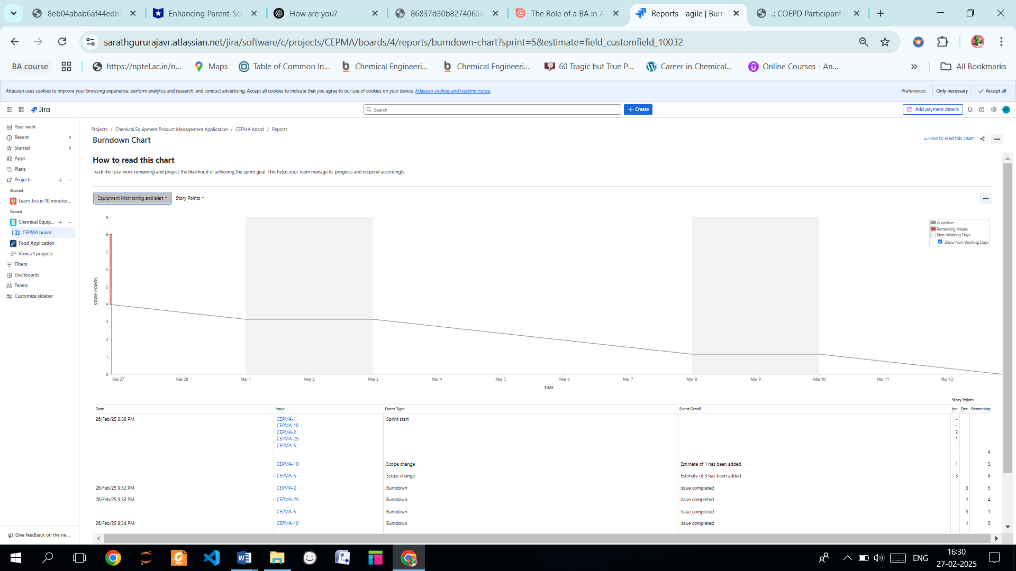

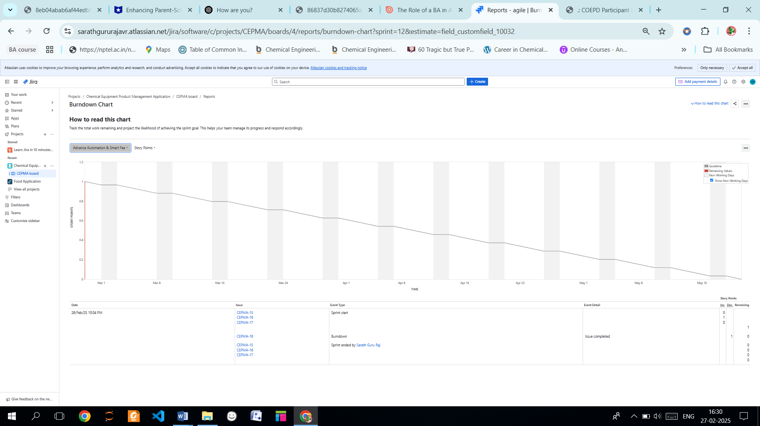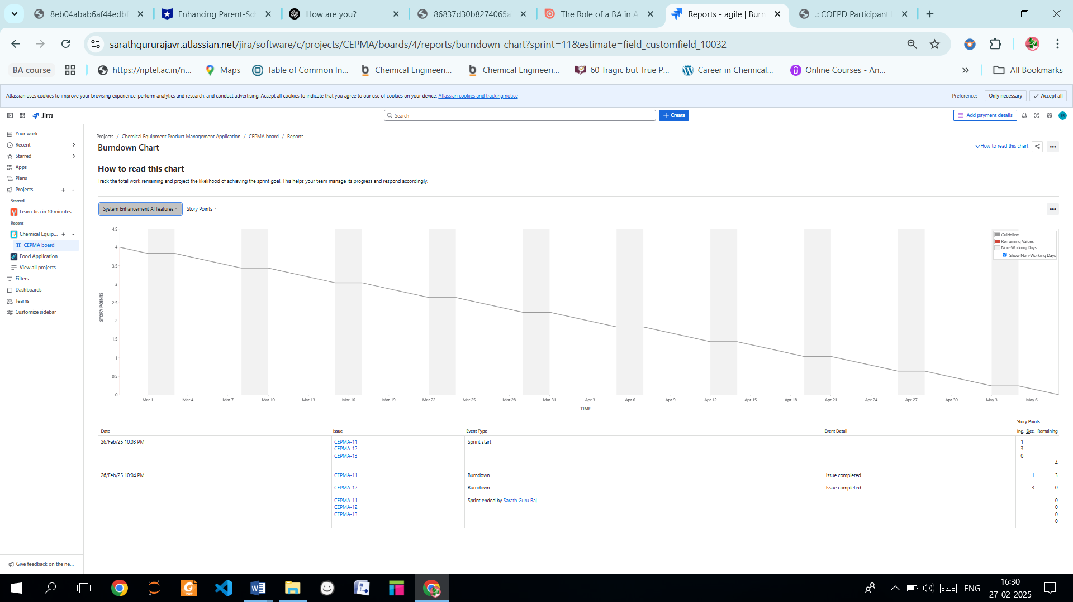

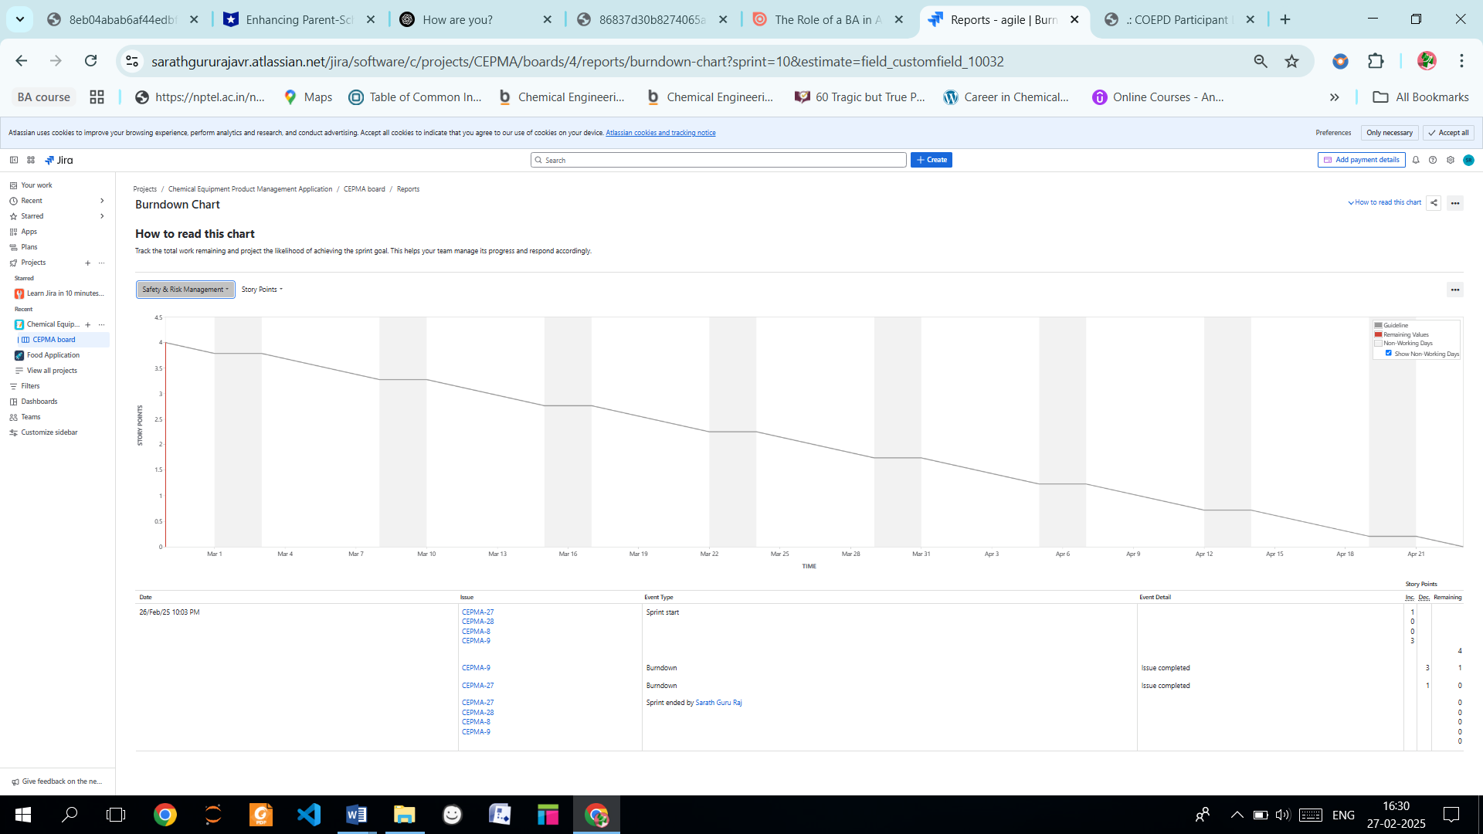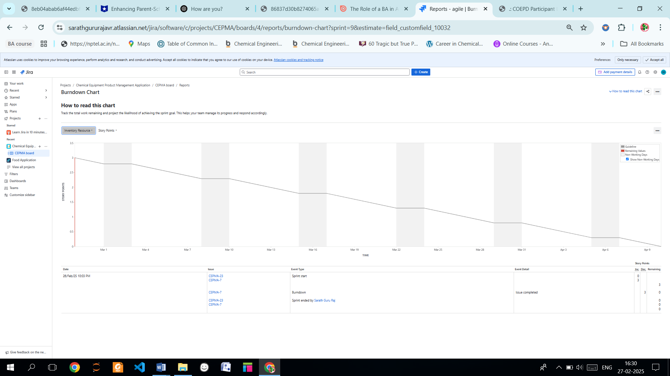

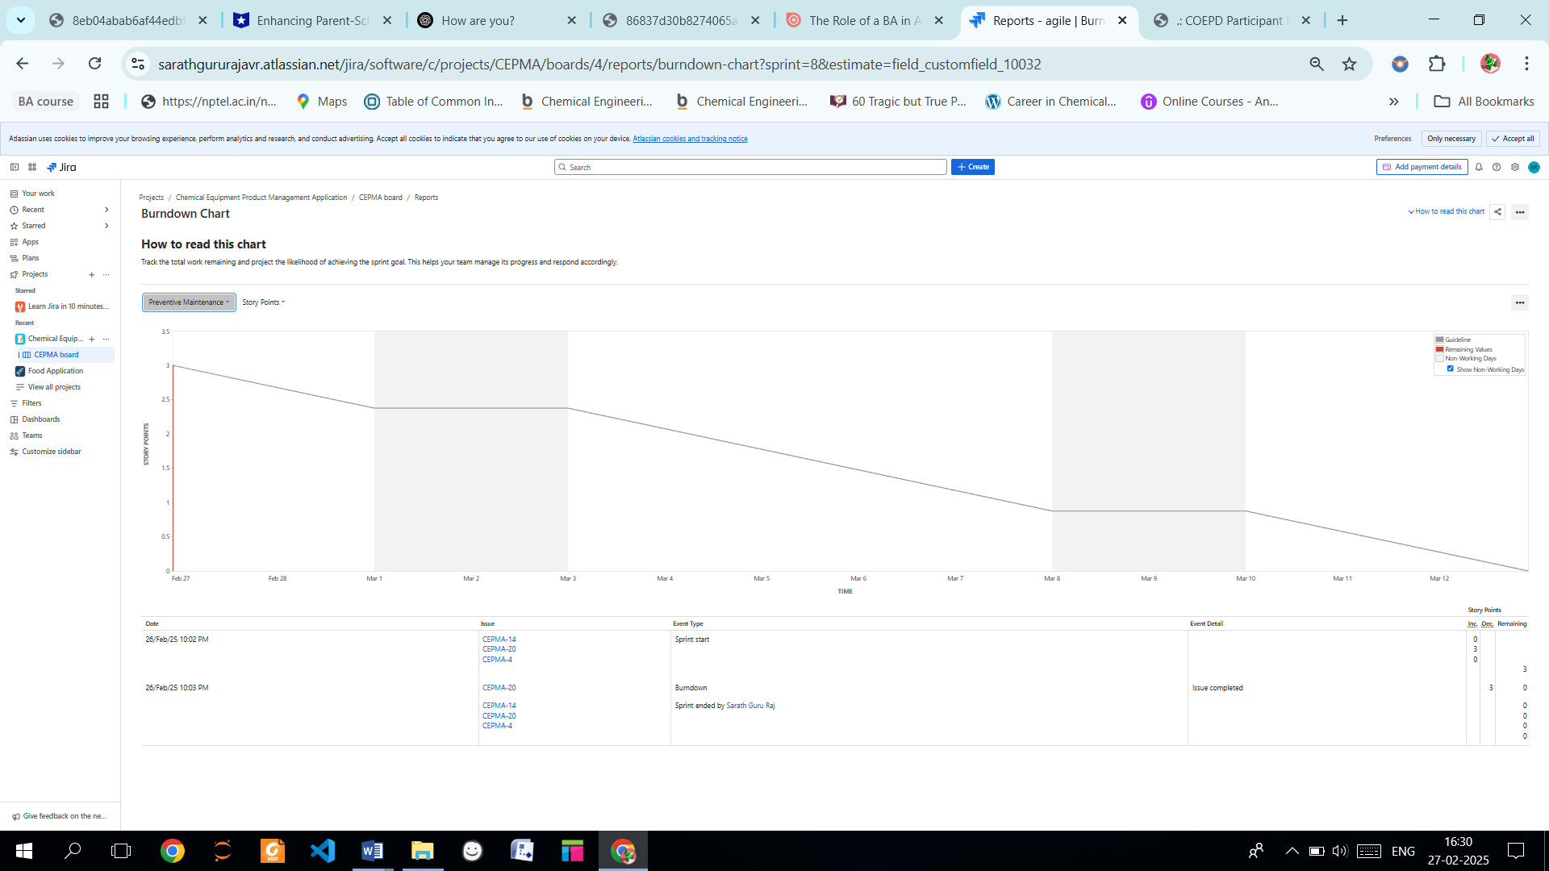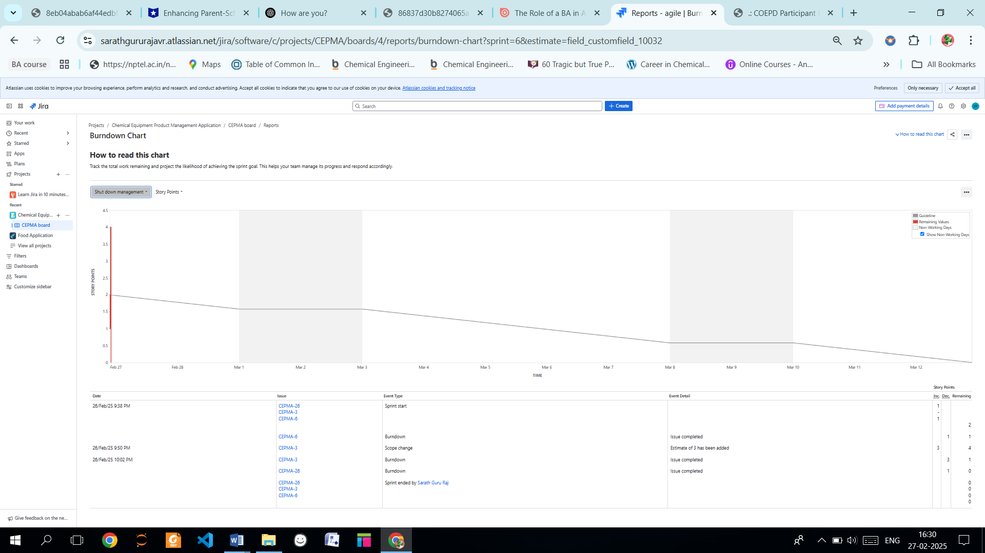

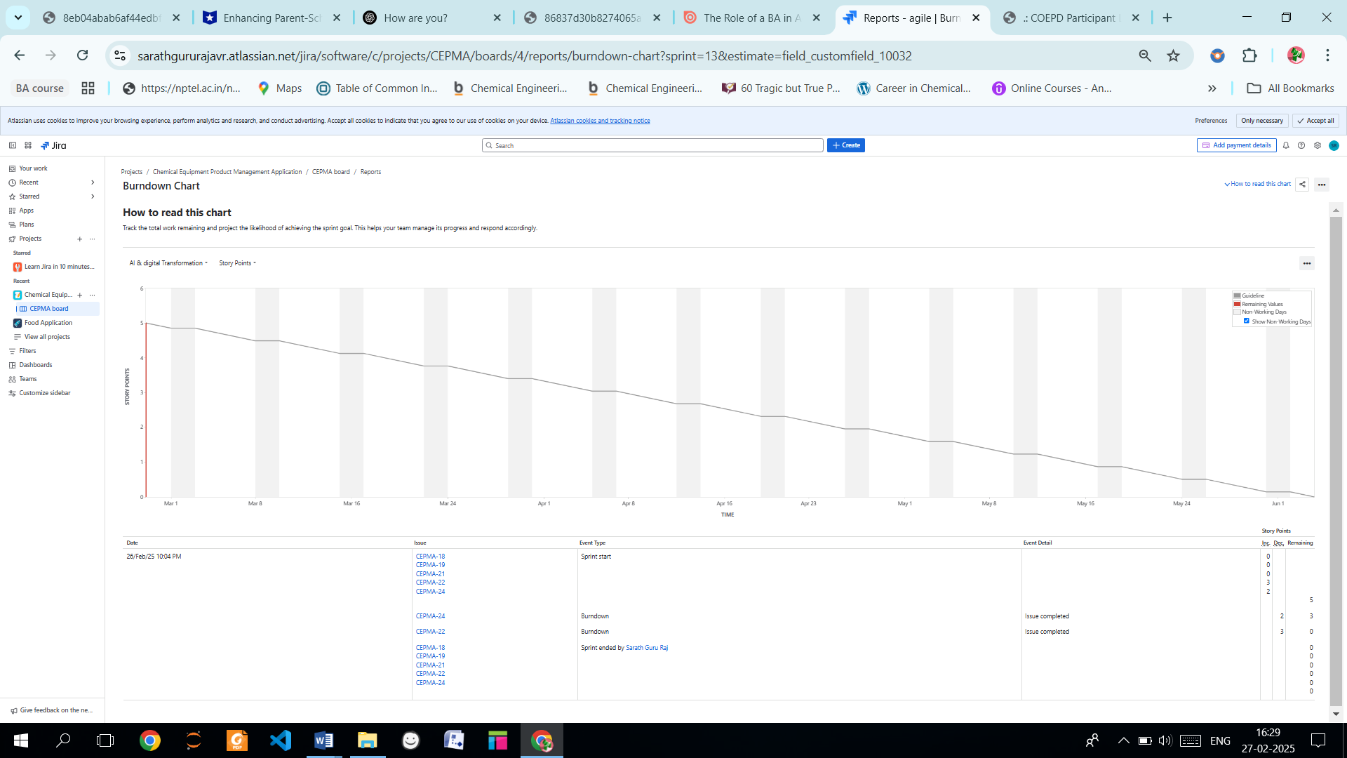

**Document 6: Sprint meetings**

**Meeting Type 1: Sprint Planning meeting**

|  |  |
| --- | --- |
| **Date** | 28/02/2025 |
| **Time** | 10.00 AM – 11.30 AM |
| **Location** | Conference Room, ABC enterprise LTD |
| **Prepared By** | Rajesh ( Scrum Master) |
| **Attendees** | Product Owner (Radha) , Developers(Kumar, and 4 others), BA (Sarath), Compliance officer(Deepak), IT engineers ( Krishnan and 4 others) |

**Agenda Topics**

|  |  |  |
| --- | --- | --- |
| **Topic** | **Presenter** | **Time allotted** |
| Sprint Goal & Scope | Product Owner | 15 min |
| Review of Product Backlog | Scrum Master | 20 min |
| Prioritization of User Stories | Business Analyst | 15 min |
| Task Breakdown & Assignment | Developers | 30 min |
| Sprint Timeline & Dependencies | Scrum Master | 10 min |

**Other Information**

|  |  |
| --- | --- |
| **Observers** | Senior Management, External auditors |
| **Resources** | JIRA board, Sprint Backlog, Compliance documents |
| **Special Notes** | Ensure alignment with safety regulations and industry standards |

**Meeting Type 2: Sprint review meeting**

|  |  |
| --- | --- |
| **Date** | 01/03/2025 |
| **Time** | 2.00 PM – 3.30 PM |
| **Location** | Conference Room, ABC enterprise LTD |
| **Prepared By** | Rajesh ( Scrum Master) |
| **Attendees** | Product Owner (Radha) , Developers(Kumar, and 4 others), BA (Sarath), Compliance officer(Deepak), IT engineers ( Krishnan and 4 others) |

|  |  |  |  |
| --- | --- | --- | --- |
| **Sprint status** | **Things to demo** | **Quick updates** | **What’s next** |
| Completed User Stories | Equipment failure alerts | Issue with SCADA integration | Next sprint goal: Implement predictive maintenance |
| Pending Tasks | AI-driven predictive maintenance | Compliance report automation | Risk assessment integration |
| Challenges | ERP system integration | Security testing pending | Performance enhancements |

**Meeting Type 3: Sprint retrospective meeting**

|  |  |
| --- | --- |
| **Date** | 11/10/2025 |
| **Time** | 10.00 AM – 11.30 AM |
| **Location** | Conference Room, ABC enterprise LTD |
| **Prepared By** | Rajesh ( Scrum Master) |
| **Attendees** | Product Owner (Radha) , Developers(Kumar, and 4 others), BA (Sarath), Compliance officer(Deepak), IT engineers ( Krishnan and 4 others) |

|  |  |  |  |  |
| --- | --- | --- | --- | --- |
| **Agenda** | **What went well** | **What didn’t go well** | **Questions** | **Reference** |
| Sprint Execution | Timely completion of shutdown tracking | Delay in AI integration | How to improve task breakdown? | Sprint Backlog |
| Team Collaboration | Effective communication | Issues with Jira estimates | How to manage unexpected dependencies? | Jira Board |
| Compliance & Safety | Regulatory reporting on track | Performance bottlenecks | How to improve testing automation? | Test Reports |
| Sprint Execution | Timely completion of shutdown tracking | Delay in AI integration | How to improve task breakdown? | Sprint Backlog |

**Meeting Type 4: Daily Stand-up meeting**

|  |  |  |  |  |  |  |  |  |  |  |  |  |
| --- | --- | --- | --- | --- | --- | --- | --- | --- | --- | --- | --- | --- |
| **Question** | **Name/Role** | | | **Week “3” (from 20-03-2025 to 10-04-2025)** | | | | | | | | |
| **Monday** | | | **Tuesday** | **Wednesday** | **Thursday** | **Friday** | **Saturday** | **Sunday** |
| **What did you do yesterday?** |  | **Developer 1** |  | Fixed bug in alert system | | | Developed UI for compliance tracking | Tested ERP sync | Debugged AI model | Performance testing | - | - |
| **Developer 2** | Integrated SCADA data | | | Worked on backend APIs | Unit testing completed | Security audit review | Documentation | - | - |
| **Developer 3** | API development for risk assessment | | | IoT sensor calibration | Dashboard enhancement | User feedback testing | Sprint review preparation | - | - |
|  | | | | | | | | |
|  | | | | | | | | |
| **What will you do today?** |  | **Developer 1** |  | Start mobile UI development | | | Enhance alert configurations | Backend debugging | API performance tuning | Code review | - | - |
| **Developer 2** | Jira backlog refinement | | | Develop security patch | Cloud deployment | Fix test case failures | Sprint retrospective | - | - |
| **Developer 3** | Work on compliance dashboards | | | Implement AI risk analysis | Review UI consistency | Resolve Jira tickets | Demo preparation | - | - |
| **What (if any) is blocking your progress?** |  | **Developer 1** |  | None | | | API endpoint issue | SCADA latency issue | Integration test failure | No blockers | - | - |
| **Developer 2** | Server downtime | | | None | Missing data logs | Backend processing delay | Need approval for changes | - | - |
| **Developer**  **3** |  | Jira estimate missing | | | Compliance data validation | IoT response time slow | Unexpected sprint dependency | Security approval pending | - |  |