**Document 6- Please prepare a use case diagram, activity diagram and a use case specification document.**

**Use case Diagram -**

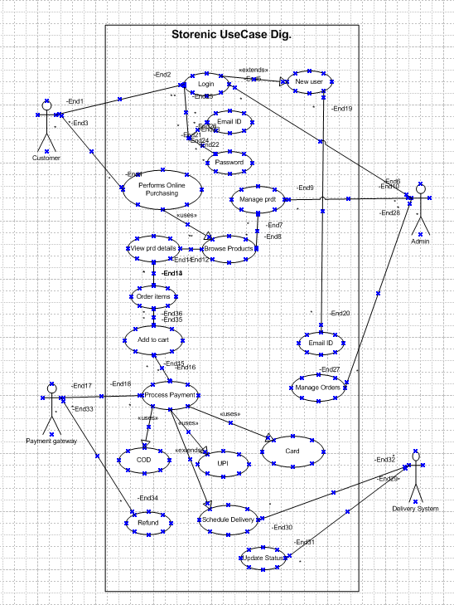

**Activity Diagram -**

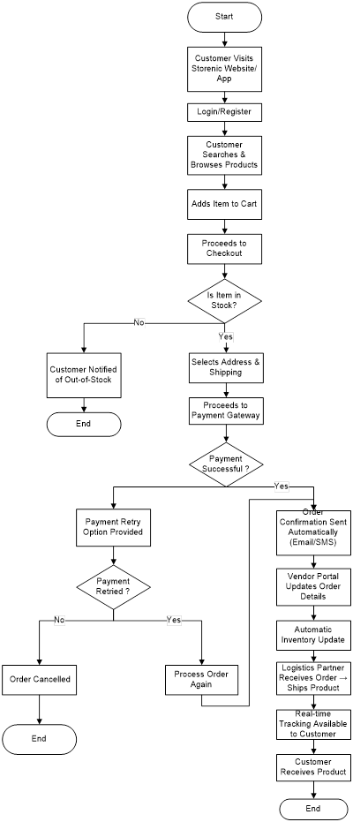

## **Use Case Specifications -**

## **1. User Registration**

|  |  |
| --- | --- |
| Field | Details |
| Use Case Name | User Registration |
| Use Case Description | Allows new users to create an account on Storenic. |
| Actors | **Primary:** Customer  **Secondary:** Admin (for account approvals) |
| Basic Flow | 1. User clicks on "Sign Up".  2. User enters required details (name, email, password, etc.).  3. System validates inputs and creates an account.  4. System sends an email verification link.  5. User verifies email and account is activated. |
| Alternate Flow | If the user does not verify their email, the account remains inactive. |
| Exceptional Flow | If the email is already registered, an error message is displayed. |
| Pre-Conditions | User must have a valid email and internet access. |
| Post-Conditions | Account is created, and the user can log in. |
| Assumptions | Users provide correct information. |
| Constraints | Password must meet security guidelines. |
| Dependencies | Email verification service. |
| Inputs and Outputs | **Input:** User details  **Output:** Account confirmation email |
| Business Rules | Duplicate emails are not allowed. |
| Miscellaneous Information | None |

## **2. User Login**

|  |  |
| --- | --- |
| Field | Details |
| Use Case Name | User Login |
| Use Case Description | Allows registered users to log in. |
| Actors | **Primary:** Customer  **Secondary:** Admin (for account recovery) |
| Basic Flow | 1. User enters email and password.  2. System validates credentials.  3. User is redirected to the home page. |
| Alternate Flow | If the user forgets their password, they can reset it. |
| Exceptional Flow | If credentials are incorrect, an error message is shown. |
| Pre-Conditions | User must be registered. |
| Post-Conditions | User is logged in successfully. |
| Assumptions | Users remember their credentials. |
| Constraints | Password retry limit: 3 attempts. |
| Dependencies | Authentication system. |
| Inputs and Outputs | **Input:** Login credentials  **Output:** User authentication status |
| Business Rules | Locked out after 3 failed attempts. |
| Miscellaneous Information | Two-factor authentication may be required. |

## **3. Product Browsing and Search**

|  |  |
| --- | --- |
| Field | Details |
| Use Case Name | Product Browsing and Search |
| Use Case Description | Users browse categories or search for products. |
| Actors | **Primary:** Customer  **Secondary:** Admin (for product management) |
| Basic Flow | 1. User searches for a product or navigates through categories.  2. System retrieves and displays matching products. |
| Alternate Flow | If no results are found, recommendations are displayed. |
| Exceptional Flow | If database retrieval fails, an error is shown. |
| Pre-Conditions | Product database must be available. |
| Post-Conditions | User finds desired products. |
| Assumptions | Users enter relevant search terms. |
| Constraints | Search results limited to 50 items per page. |
| Dependencies | Product catalog database. |
| Inputs and Outputs | **Input:** Search query  **Output:** Product list |
| Business Rules | Search must be case-insensitive. |
| Miscellaneous Information | Filters and sorting available. |

## **4. Add to Cart**

|  |  |
| --- | --- |
| Field | Details |
| Use Case Name | Add to Cart |
| Use Case Description | Users add items to their shopping cart. |
| Actors | **Primary:** Customer |
| Basic Flow | 1. User selects a product and clicks "Add to Cart".  2. System adds the item to the cart.  3. User can update or remove items. |
| Alternate Flow | If the item is out of stock, a message is displayed. |
| Exceptional Flow | If session expires, cart is cleared. |
| Pre-Conditions | User must be logged in. |
| Post-Conditions | Cart is updated. |
| Assumptions | User selects valid quantities. |
| Constraints | Cart limit: 20 items. |
| Dependencies | Inventory system. |
| Inputs and Outputs | **Input:** Product selection  **Output:** Updated cart |
| Business Rules | Cannot add more than available stock. |
| Miscellaneous Information | Discounts apply at checkout. |

## **5. Checkout and Payment**

|  |  |
| --- | --- |
| Field | Details |
| Use Case Name | Checkout and Payment |
| Use Case Description | Users complete purchases using online payment methods. |
| Actors | **Primary:** Customer  **Secondary:** Payment Gateway |
| Basic Flow | 1. User proceeds to checkout.  2. Enters shipping details.  3. Selects payment method.  4. Completes payment. |
| Alternate Flow | If the payment fails, user can retry. |
| Exceptional Flow | If internet disconnects, transaction is canceled. |
| Pre-Conditions | User must have valid payment details. |
| Post-Conditions | Order is confirmed. |
| Assumptions | Payment gateway is working. |
| Constraints | Payment processing time: < 10 seconds. |
| Dependencies | Payment service provider. |
| Inputs and Outputs | **Input:** Payment details  **Output:** Order confirmation |
| Business Rules | Secure payment required. |
| Miscellaneous Information | Refunds take 7 days. |

## **6. Manage Orders (Admin)**

|  |  |
| --- | --- |
| Field | Details |
| Use Case Name | Manage Orders (Admin) |
| Use Case Description | Allows admins to manage and oversee all orders, including order status updates, cancellations, and issue resolutions. |
| Actors | **Primary:** Admin  **Secondary:** Customer |
| Basic Flow | 1. Admin logs into the system.  2. Admin navigates to the "Manage Orders" section.  3. Admin views a list of all orders.  4. Admin selects an order to update status (e.g., "Processing," "Shipped," "Delivered").  5. If needed, admin can cancel orders or provide refunds.  6. Admin confirms the changes, and the system updates order status. |
| Alternate Flow | If a customer requests cancellation, the admin reviews and approves or denies it. |
| Exceptional Flow | If the order ID is invalid, an error message is displayed.  If the system fails to update order status, an error log is generated. |
| Pre-Conditions | Admin must have the necessary access permissions.  Orders must be available in the system. |
| Post-Conditions | Order status is updated, and customers receive notifications. |
| Assumptions | Admin has accurate order details.  Customers may request order changes. |
| Constraints | Admin cannot modify an order that has already been delivered. |
| Dependencies | Order management system, notification system. |
| Inputs and Outputs | **Input:** Order ID, status update, cancellation request  **Output:** Updated order status, notification to customer |
| Business Rules | Only admins with proper permissions can modify orders.  Order cancellations are not allowed after dispatch. |
| Miscellaneous Information | System logs all admin activities for audit purposes. |

**Document 7- Screens and pages**

1. **Home page of Storenic**

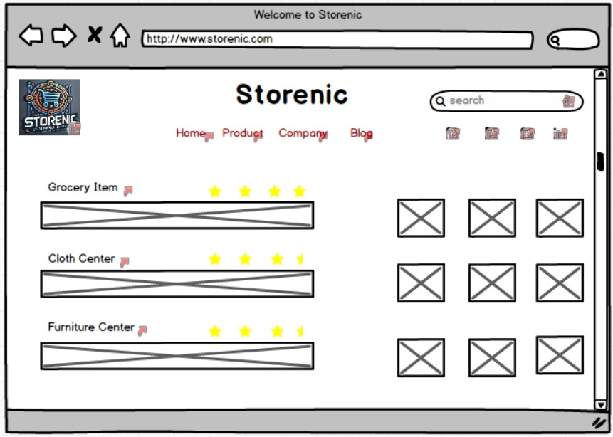

1. **Login Page**

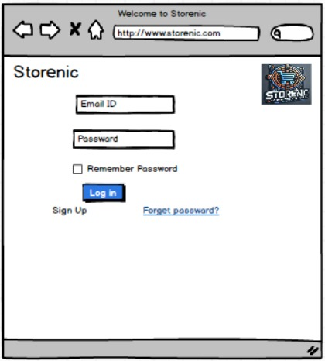

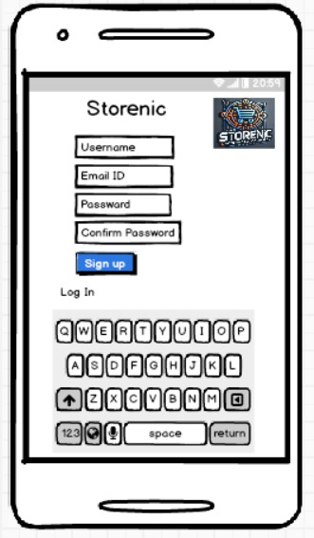

1. **Payment Page**

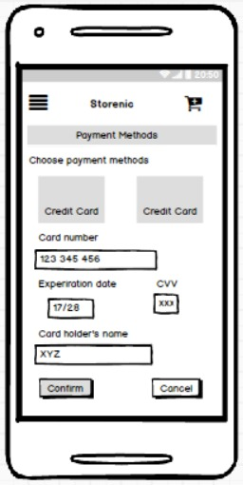

1. Add to Cart Page

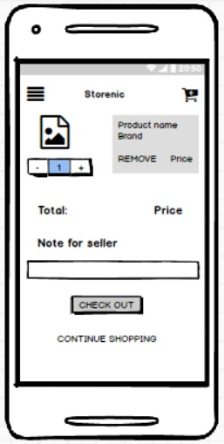

**Document 8- Tools-Visio and Axure**

I used Visio and Axure for the project. Visio helped me draw diagrams and flowcharts. It was easy to put shapes and lines together to show how things work. Axure let me make prototypes of the app. I created screens and buttons that looked real. Both tools were simple to use and made my work easier.

When I am working on a project, tools like Visio and Axure help me a lot. They make it easy to share ideas and plans with others.

**Document 9- BA experience**

**My experience as BA in following phases:**

1. **Requirement gathering:**
2. To gather requirements, we used MOSCOW technique.
3. Client is not available for some period during this phase. So as a BA I need to source out point of contacts from his side and get the information asap.
4. I validate the requirements using FURPS technique
5. There are many requirements which are duplicated or repeated. We need to remove them immediately
6. Prototyping is used to give more specific requirements.
7. **Requirement Analysis:**
8. We need to draw UML diagrams to visually describe the requirements
9. Activity diagrams also used to describe the process flow
10. Communicate the diagrams to team. Some team members might not agree with them and might make changes. As a BA we need to consider the points and make modifications
11. Prepare BRD and FRS
12. **Design:**
13. From the use case diagrams.
14. Communicate with client on design and solution documents
15. Do not miss a single test case. It might have huge impact on project development in later stages
16. Prepare test data for testing
17. Update RTM. This is just as we need to make sure that all the requirements are met
18. **Development:**
19. Organized JAD sessions
20. Clarifying queries of tech team during coding
21. There might be some team members who doesn't agree with the concept or who doesn’t cooperate during JAD sessions. As a BA I handle the situation gently and had one on one discussion with them. Explained how their actions are going to affect the project. Setup healthy environment within the team.
22. Referred diagrams to code the Unit
23. Conduct regular meetings with technical team and client which is challenging. Some team members might not be available for the meeting. Recording the session and providing that to missed one and having one to one discussion later with that missed person is all I need to do
24. **Testing:**
25. Prepare test cases from use cases
26. Perform high level testing
27. Test data is requested by BA from client
28. Updated RTM
29. Take signoff from client
30. Prepare client for UAT
31. **Deployment:**
32. Forwarded RTM to client which should be attached to project closure document
33. Coordinates to complete and share end user manuals
34. Plans and organizes training sessions
35. Make sure all the candidates attend the meeting