Online Agriculture Product Store

# Capstone Project 1- Prep 1/3

Q1. BPM (Business Process Model)

Identify Business Process Model for Online Agriculture Store – (Goal, Inputs, Resources, Outputs, Activities, Value created to the end Customer)

A1. A business process model is basically a structure for action.

* GOAL: - Build an online store to facilitate farmers to buy seeds, pesticides and fertilizers from anywhere (specifically for farmers living in remote villages) through internet.
* INPUTS: - Product details (Seeds, Pesticides, Fertilizer), Payment types & details, Customer information and location, Company information
* RESOURCES: - Mobile/Computer, Internet connectivity, Servers, Products, Shipping parties, Payment gateway API
* OUTPUTS: - Product(s) delivered to the Customers
* ACTIVITIES: -

Customers 🡪Browse the products 🡪Select product and quantity 🡪Add to cart🡪Add Customer details (Name and location)🡪Select Payment type🡪Pay🡪Order Shipped 🡪Product Delivered

Application Login

Manufacturing companies🡪Add their product in the Application🡪Verify products 🡪Product(s) Accepted🡪Display the product in the list for customers to browse

* VALUE created to the END CUSTOMERS: -
* Farmers (mostly living in remote villages) have now easy access to various products
* Product(s) delivered to their location
* Direct communication between Farmers and Manufacturing companies
* Verified quality products ensures quality farming and higher production rates and increased profits.

Q2. SWOT

Mr Karthik is doing SWOT analysis before he accepts this project. What Aspects he should consider as Strengths, as Weaknesses, as Opportunity and as Threats.

A2. SWOT analysis is used to understand influencing factors and how they may affect an initiative.

* Strengths(S): -
* Brand recognition
* Highly experienced and skilled employees
* High quality technology used
* Experience in building Applications for difference industries
* Weaknesses(W)
* Limited resources
* Lack of knowledge on Agricultural domain
* Small size of the company
* Employees engaged with multiple projects
* Opportunity(O)
* The possibility of obtaining higher budget projects
* Entering into Agricultural domain
* Expansion of business from regional to national
* Increasing demand of software products
* Threats (T)
* High competition
* Political changes
* Faster technological progress
* Possible security breaches

**S W**

**(STRENGHTS) (+) (WEAKNESSES) (-)**

**Internal Factors Internal Factors**

**O T**

**(OPPORTUNITIES) (+) (THREATS) (-)**

**External Factors External Factors**

Q3. Feasibility Study

Mr Karthik is trying to do feasibility study on doing this project in Technology (Java), Please help him with points (HW SW Trained Resources Budget Time frame) to consider in feasibility Study.

A3. Feasibility study is the possibility of doing a project within given constraints like Technology (Hardware, Software, Trained Resources) Budget and Time.

* Hardware Requirements
* Computer/Laptops – Mr Karthik needs to verify if there are required number of working systems available to provide for the team to work on this project
* Servers – There must be enough computer servers to store files and share information that are connected on the same network
* Routers – Available for providing internet connectivity
* Hardware configurations of the system based on the Java version: RAM, Disc space and Processor
* Software Requirements
* Operating System – Any operating system supported by other software components
* Web browser – Like IE, Firefox, Chrome, Safari
* Java Applications – JDK / JRE
* Web Applications – Apache Tomcat
* Software Licences – Mr Karthik must calculate the number of software licences required based on number of resources working on this project
* API for Payment gateway
* Database Management Tools
* Testing Tools
* Trained Resources
* Mr Karthik will have to list out the number of resources available for this project from the available talent pool.
* He also needs to look into the project requirements and see if there are resources who have domain knowledge or previous experiences in this domain but are currently engaged with another project
* Look for an SME and provide Domain Knowledge sessions to the team
* As per the information there are total 12 resources in talent pool
* Budget
* 2 Crores INR
* Time frame
* 18 months

Detailed Analysis with Resources, Budget and Time.

Team size: 12; Time Frame: 18 months; Budget: 2 Crores INR

18 months = 1.5 years = 78 weeks

78 weeks x 40 hrs per week = 3120-man hours – 136-man hours (public holidays)

= 2984-man hours

Uncertain time (Employee Leaves = planned, unplanned, sick, half day) = 150 hrs

= 2834-man hours Total Time frame (355 days)



Q4. GAP Analysis

Mr Karthik must submit Gap Analysis to Mr Henry to convince to initiate this project. What points (compare AS-IS existing process with TO-BE future Process) to showcase in the GAP Analysis

A4. A Gap Analysis is the comparison of current state and the future state of an organisation in order to identify differences that need to be addressed.

AS-IS current state

* Farmers are facing problems to buy fertilizers, seeds and pesticides at their local stores due to high prices, lack of available options/alternatives and travel costs

TO-BE future state

* Once an online store is built and available for farmers, they will have access to various product options. This online store will have products from various manufactures so that farmers can choose a product that suits their needs and price. Products are delivered to their door steps and farmers can also have direct contact with the company to discuss about their needs.

Below are the key steps to bridge the GAP

Action Plan

Review

1. Have a discussion with the real farmers who are also stakeholders (Peter, Kevin and Ben)
2. Hear and acknowledge their current problems
3. Document the current state

Develop requirements

1. Discuss with business stakeholders
2. Explain the stakeholders what can be done in best way and guide them with the flow

Comparison

1. Prepare a presentation with before and after the online store
2. Recap the current problem and mention the benefits of using the future app

Implications

1. Give them a hope that based on the analysis this project can be implemented within reasonable time and budget

Give and Take Recommendations

Q5. Risk Analysis

List down different risk factors that may be involved (BA Risks And process/Project Risks)

A5. An uncertain event or condition which can have an impact on either cost, time, scope or quality of the project.

Risk Analysis is done to determine if the proposed project carriers more risk than the organizations capacity to support. Risk should be analysed regularly as the project progresses. We may not be able to avoid every risk but we can limit the risk impact on the project by preparing a beforehand.

Below are the risk factors that may be involved:

* Internal Risks
* Lack of resources
* Miscommunication between the stakeholders
* Inadequate training
* Lack of awareness about the new technologies
* External Risks
* Competitors
* Market fluctuations
* Regulatory changes
* Political instability
* Natural disasters
* Supplier reliability
* BA Risks
* Improper requirement gathering
* Lack of domain knowledge
* Improper planning
* Non availability of stakeholders
* Lack of stakeholder engagement
* Conflicts between stakeholders
* Incomplete stakeholders list
* Inadequate Documentations
* Project based Risks
* Cost Risk
* Schedule Risk
* Performance Risk
* Operational Risk
* Governance Risk
* Strategic Risk
* Legal Risk

Q6. Stakeholder Analysis

Perform stakeholder analysis (RACI Matrix) to find out the key stakeholders who can take Decisions and Who are the influencers

A6. Stakeholder Analysis is based on ILS and RACI matrix

Stakeholder Analysis is the process of (I)Identifying these people before the project begins; Preparing a (L)List by grouping them according to their levels of participation, interest and influence in the project; (S)Summarize how best to involve and communicate each of these stakeholders’ groups throughout the project.

RACI matrix (Responsible, Accountable, Consulted, Informed)

* R (Responsible): Does the work to achieve the task
* Person who performs the task
* Responsibility can be shared
* For Instance: Project manager is the responsible for getting things done and coordinating the project
* A (Accountable): Has authority to approve or disapprove the result
* Person who has ultimate accountability and authority
* Only one accountable person to each task/activity
* For Instance: a project sponsor or executive many be accountable for the success of the project
* C (Consulted): Possesses needed input to the task
* Person be to consulted before a final decision or action is taken
* Refers a tow-way communication
* For Instance: Subject matter experts (SRE) are consulted for feedback or advice
* I (Informed): Needs to be informed of the result
* Person that needs to be informed after the decision or action is taken
* Refers to a one-way communication
* For Instance: Team members inform the project condition to all major stakeholders by regular reports.

|  |  |  |  |  |  |  |  |
| --- | --- | --- | --- | --- | --- | --- | --- |
| **Stage** | **PM** | **Dev Team** | **QA** | **SRE** | **Client** | **BA** | **UI/UX** |
| **Req. Gathering** | **Informed** |  |  | **Consulted** | **Accountable** | **Responsible** |  |
| **Req. Analysis** | **Informed** |  |  | **Consulted** | **Accountable** | **Responsible** |  |
| **Design** | **Accountable** |  |  | **Consulted** |  | **Informed** | **Responsible** |
| **Dev** | **Accountable** | **Responsible** |  | **Consulted** |  | **Informed** |  |
| **QA** | **Accountable** |  | **Responsible** | **Consulted** |  | **Informed** |  |
| **Deployment** |  | **Responsible** |  | **Consulted** | **Accountable** | **Informed** |  |

Q7. – Business Case Document - Help Mr Karthik to prepare a Business Case Doc

|  |  |  |  |  |
| --- | --- | --- | --- | --- |
| **Business Case for Online Agriculture Product Store** | | | | |
| Date of Approval: | 24th Jan 2025 | | | |
| Project Name: | Online Agriculture Product Store | | | |
| Project Proposed by: | SOONY company | |  | | --- | |  | | | Project Initiated by: | APT IT Solutions |
| Sponsor: | Mr. Henry |
| Financial Head: | Mr. Pandu | Delivery Head: | Mr. Karthik |
| Project Coordinator: | Mr. Dooku | Project Manager: | Mr. Vandanam |
| **Project Scope** | | | | |
| Purpose: | Mr. Henry wanted to build an Online Agricultural Product store to facilitate remote area farmers to buy agricultural products | | | |
| Time Period: | 18 Months | | | |
| Budget: | 20 million INR (2 Crores INR) | | | |
| **Executive Summary** | | | | |
| This business case proposes to build an Online Agriculture product store for farmers in remote areas. This online store helps farmers to buy agricultural products at a reasonable price and delivered to their door step. This project is expected to reduce farmer expenditure on buying agricultural products by 20% and increase sales for Manufacturing companies by 20% | | | | |
| **Business Problem** | | | | |
| Famers in remote areas are facing difficulties in procuring fertilizers, buying seeds and lack of pesticides which could help in greatly reducing pests in crops. | | | | |
| **Proposed Solution / Opportunity** | | | | |
| Build an Online Agricultural store to help farmers buy products online and have multiple options to choose according to their need and budget.  Also, products will be delivered to their home steps this helps farmers travelling to urban cities to buy products at higher costs.  This gives an opportunity for manufacturing companies and farmers to communicate directly, which helps the companies to understand farmer needs more clearly | | | | |
| **ROI (Return of Investments)** | | | | |
| This is a CSR initiative project which means a project proposed undertaken by a business to contribute positively to society, the environment, or the economy. | | | | |
| Budget: 2 Crores INR Development and Implementation cost: 1.2 crore Licences: 5 lakhs Maintenance & Support: 5 lakhs /year(Up to 6 years after project implementation ) | | | | |
|  |
|  |
| ROI calculation: (Net Benefit / Total Cost) X 100%  Estimated 1st year Revenue: 20 lakhs; 2nd year Revenue: 30 lakhs;…..;6th year Revenue : 3.5 crores Estimated ROI : 175% | | | | |  |
| **Risk Assessment** | | | | |  |
| Right now, the project looks pretty straight forward but there are still some unknown surroundings implementation. There is also a risk that project doesn't meet the customer needs. It is recommended to involve the business stakeholders who are farmers also the manufacturing companies. New requirements / change requests from stakeholders will eventually increase the budget and time of the project | | | | |  |

Q8. Four SDLC Methodologies

The Committee of Mr. Henry, Mr. Pandu, and Mr. Dooku and Mr. Karthik are having a discussion on Project Development Approach

Mr. Karthik explained to Mr. Henry about SDLC and four methodologies like Sequential iterative Evolutionary and Agile. Please share your thoughts and clarity on Methodologies

A8. A method used to create and evolve a product, service or result during the project life cycle is called a Project Development approach.

A SDLC is a cost effective and time efficient process that development teams use to design and build high-quality software

Mr. Karthik explains about 4 different methodologies in SDLC to the Business Stakeholders

* Sequential
* Iterative
* Evolutionary
* Agile

Let’s see about each Methodology in detail

|  |  |  |  |
| --- | --- | --- | --- |
| **Methodology** | **Definition** | **Key Characteristics** | **Phases** |
| **SEQUENTIAL** | It is a type of SDLC approach where the development process is divided into distinct, linear phrases. Each phase must be completed before the next one begins, and there is little to no overlap between phrases. This methodology is highly structured and follows a step-by-step progression Example of Sequential Methodology is **Waterfall Model** | 1. Linear flow 2. Phrases are Distinct  3. Minimal Flexibility  4. Documentation-Driven  5. Predictable | **WATERFALL MODEL** 1. Requirement Gathering  2. Design  3. Development    4. Testing  5. Deployment  6. Maintenance |
| **Advantages** | **Disadvantages** | **When to Use** |
| 1. Simple and Easy to Understand 2. Clear Milestones 3. Good for Stable Requirements 4. Documentation | 1. Inflexible 2. Late Testing 3. High Risk 4. Not Suitable for Complex or Evolving Projects | 1. Stable Requirements 2. Small to Medium sized- projects 3. Regulated Industries |

|  |  |  |  |
| --- | --- | --- | --- |
| **Methodology** | **Definition** | **Key Characteristics** | **Phases** |
| **ITERATIVE** | It is an SDLC approach where the project is divided into small manageable chunks called I**terations.** Each iteration involves going through a mini-SDLC cycle, including planning, design, development, testing and review. The goal is to produce a working version of the software (an increment) at the end of each iteration, which is refined and improved in subsequent iterations Examples of Iteration Methodology: **Agile, Scrum, RUP, Spiral Model** | 1. Cyclic process 2. Incremental Development 3. Flexibility  4. Continuous feedback 5. Early Delivery 6. Risk Management | 1. Planning  2. Design  3. Development  4. Testing  5. Review |
| **Advantages** | **Disadvantages** | **When to Use** |
| 1. Flexibility 2. Early Delivery 3. Risk reduction 4. Continuous Improvement 5. Stakeholder Involvement 6. Adaptability | 1. Complex Management 2. Higher initial cost 3. Scope creep 4. Documentation challenges | 1. Unclear or Evolving Requirements 2. Large and complex project 3. Stakeholder involvement 4. Innovative Projects |

<<< CONTINUED IN NEXT PAGE >>>

|  |  |  |  |
| --- | --- | --- | --- |
| **Methodology** | **Definition** | **Key Characteristics** | **Phases** |
| **EVOLUTIONARY** | It’s a SDLC approach that focuses on building software incrementally and adapting to changing requirements over time. This methodology is called "evolutionary" because the software evolves multiple versions, with each version adding new features, refining existing ones, and incorporating feedback from stakeholders. This approach is particularly useful when the requirements are not fully understood at the beginning of the project or are expected to change during development Examples of Evolutionary methodology: **Spiral, Prototyping model** | 1. Incremental development 2. Adaptability 3. Continuous feedback  4. Risk Management 5. Prototyping 6. No Fixed Endpoint | 1. Initial Planning  2. Development of an  Increment  3. Testing and Feedback  4. Review and Refinement  5. Next Iteration  6. Repeat (No End Goal) |
| **Advantages** | **Disadvantages** | **When to Use** |
| 1. Flexibility 2. Early Delivery 3. Risk reduction 4. Continuous Improvement 5. Stakeholder Involvement 6. Exploratory Development | 1. Complex Management 2. Higher initial cost 3. Scope creep 4. Documentation challenges | 1. Unclear or Evolving Requirements 2. Long term projects 3. Stakeholder involvement 4. Innovative Projects |

<<< CONTINUED IN NEXT PAGE >>>

|  |  |  |  |
| --- | --- | --- | --- |
| **Methodology** | **Definition** | **Key Characteristics** | **Phases** |
| **AGILE** | It is a Flexible and iterative approach to Software and Iterative approach to software development and project management that focuses on delivering value to customers through collaboration, adaptability and continuous improvement. It emphasizes breaking projects into small, manageable increments called iterations and sprints, allowing teams to respond quickly to changes and deliver working software frequently.  Examples of Agile Methodology: **Scrum, Kanban, XP, Lean** | 1. Iterative and Incremental development 2. Customer-centric 3. Adaptability 4. Cross Functional Teams 5. Continuous feedback  6. Transparency 7. Focus on Delivering Value | 1. Concept /Envisioning  2. Inception / Planning  3. Iteration/ Sprint Execution  4. Release  5. Production/Operation  6. Retirement |
| **Advantages** | **Disadvantages** | **When to Use** |
| 1. Flexibility 2. Faster Delivery 3. Improved Quality 4. Customer Satisfaction 5. Team Collaboration 6. Risk Management | 1. Requires Commitment 2. Not Suitable for all Projects 3. Documentation Challenges 4. Scope Creep | 1. Unclear or Evolving Requirements 2. Complex projects 3. Customer Centric Projects 4. Innovative Projects |

<<< CONTINUED IN NEXT PAGE >>>

Q9. Waterfall, RUP, Spiral and Scrum Models

They discussed models in SDLC like waterfall RUP Spiral and Scrum. You put forth you’re understanding on these models

A9. There are different types of SDLC models and to name a few they are waterfall, RUP, Spiral and Scrum.

Let’s see about each Model in detail

|  |  |  |  |
| --- | --- | --- | --- |
| **Model** | **Definition** | **Key Characteristics** | **Phases** |
| **WATERFALL** | Its is one of the earliest and most traditional approaches to software development. It is a linear and sequential methodology where the development process is divided into distinct phases, and each phase must be completed before the next one begins. The Waterfall model is called so because progress flows steadily downwards (like waterfall) through the phases | 1.Linear and Sequential flow 2. Document-Driven  3. Predictable  4.Rigid structure  5. Clear Milestones | **WATERFALL MODEL** 1. Requirement Gathering  2. Design  3. Development    4. Testing  5. Deployment  6. Maintenance |
| **Advantages** | **Disadvantages** | **When to Use** |
| 1. Simple and Easy to Understand 2. Clear Milestones 3. Good for Stable Requirements 4. Documentation | 1. Inflexible 2. Late Testing 3. High Risk 4. Not Suitable for Complex or Evolving Projects | 1. Stable Requirements 2. Small to Medium sized- projects 3. Regulated Industries |

<<< CONTINUED IN NEXT PAGE >>>

|  |  |  |  |
| --- | --- | --- | --- |
| **Model** | **Definition** | **Key Characteristics** | **Phases** |
| **RUP (Rational Unified Process)** | It is an Iterative and incremental methodology that provides a structured approach to software development. It is known for its flexibility, adaptability and emphasis on best practices in software engineering. RUP is often used for large, complex projects and can be tailored to fit the specific needs of a project or organisation. | 1. Iterative and Incremental  2. Use-case driven 3. Architecture-Centric 4. Risk-Driven 5. Flexible and Adaptable 6. Comprehensive Documentation | 1. Inception  2. Elaboration  3. Construction  4. Transition |
| **Advantages** | **Disadvantages** | **When to Use** |
| 1. Flexibility 2. Risk Management 3. Comprehensive Documentation 4. Iterative Development 5. Focus on Best practices | 1. Complexity 2. Documentation Overhead 3. Learning curve 4. Resource- Intensive | 1. Large, Complex Projects 2. High - Risk projects 3. Regulated Industries |

<<< CONTINUED IN NEXT PAGE >>>

|  |  |  |  |
| --- | --- | --- | --- |
| **Model** | **Definition** | **Key Characteristics** | **Phases** |
| **SPIRAL** | The Spiral Model is a risk-driven software development process model that combines elements of both iterative development and the Waterfall Model. The Spiral Model emphasizes risk analysis and prototyping at each stage of development, allowing teams to identify and mitigate risks early in the process. | 1. Iterative and Incremental  2. Risk-Driven 3.Flexible 4. Prototyping 5. Combines Strengths of Waterfall and Iterative Models | 1. Planning  2. Risk Analysis  3. Engineering (Development and Testing)  4. Evaluation (Customer Feedback) |
| **Advantages** | **Disadvantages** | **When to Use** |
| 1. Flexibility 2. Risk Management 3. Customer Involvement 4. High-Quality Output 5.Suitable for Complex Projects | 1. Complexity 2. Documentation Overhead 3. Cost and Time 4. Not Suitable for Small Projects | 1. Large, Complex Projects 2. High - Risk projects 3. Evolving Requirements 4. Innovative Projects |

<<< CONTINUED IN NEXT PAGE >>>

|  |  |  |  |
| --- | --- | --- | --- |
| **Model** | **Definition** | **Key Characteristics** | **Phases** |
| **SCRUM** | The Scrum Model is an Agile framework used for managing and completing complex projects, particularly in software development. Scrum emphasizes iterative progress, team collaboration, and flexibility to adapt to changing requirements. It is one of the most popular Agile methodologies and is widely used for its simplicity and effectiveness in delivering high-quality products. | 1. Iterative and Incremental development 2. Self-Organizing Teams 3. Roles and Responsibilities 4. Transparency and Inspection 5. Adaptability | The Scrum model is divided into several key phases, known as events or ceremonies, which are repeated in each Sprint (iteration). Here are the primary phases 1. Sprint Planning 2. Daily Scrum 3. Sprint Review 4. Sprint Retrospective 🡪Each of these phases (Sprint Planning, Daily Scrum, Sprint Review, and Sprint Retrospective) occurs within a Sprint, typically lasting 2–4 weeks. 🡪At the end of each Sprint, the cycle begins again with Sprint Planning for the next iteration. 🡪Have Product Backlog and Sprint Backlog |
| **Advantages** | **Disadvantages** | **When to Use** |
| 1. Flexibility 2. Faster Delivery 3. Improved Quality 4. Customer Satisfaction 5. Team Collaboration 6. Risk Management | 1. Requires Commitment 2. Not Suitable for all Projects 3. Documentation Challenges 4. Scope Creep | 1. Unclear or Evolving Requirements 2. Complex projects 3. Customer Centric Projects 4. Innovative Projects |

<<< CONTINUED IN NEXT PAGE >>>

“When the APT IT SOLUTIONS company got the project to make this online agriculture product store, there is a difference of opinion between a couple of SMEs and the project team regarding which methodology would be more suitable for this project. SMEs are stressing on using the V model and the project team is leaning more onto the side of waterfall model. As a business analyst, which methodology do you think would be better for this project?”

Q10. Waterfall Vs V-Model

Write down the differences between waterfall model and V model.

A10.

|  |  |  |
| --- | --- | --- |
| **Aspects** | **Waterfall Model** | **V-Model** |
| **Definition** | The Waterfall Model is a linear and sequential approach to software development. It divides the project into distinct phases, and each phase must be completed before the next one begins. | The V-Model is an extension of the Waterfall Model but emphasizes testing at every stage of development. It is called the "V-Model" because of its V-shaped structure, where each development phase has a corresponding testing phase. |
| **Structure** | Linear and sequential | V-shaped, with development and testing phases aligned. |
| **Testing** | Testing is a separate phase at the end. | Testing is integrated into each development phase. |
| **Flexibility** | Inflexible to changes once a phase is done. | Slightly more flexible but still rigid compared to Agile. |
| **Emphasis** | Focuses on completing phases sequentially. | Focuses on verification and validation at every stage. |
| **Suitability** | Best for small, well-defined projects. | Best for projects with clear and stable requirements. |
| **Documentation** | Heavy documentation at ea  ch phase. | Documentation is critical for both development and testing phases. |
| **Error Detection** | Late-stage | Early-stage |
| **Cost of Fixing Issues** | High | Lower |

Question 11 – Justify your choice

As a BA, state your reason for choosing one model for this project

A11. As a BA, I choose V mode because here

* Project is clearly defined and requirements are stable.
* It requires high quality and rigorous testing because as we have fixed budget so the cost of fixing defects later in development is high.

For this project, the V-model is generally a better choice because it integrates testing early, detects defects sooner, and ensure higher quality.

Question 12 – Gantt Chart

The Committee of Mr. Henry, Mr Pandu, and Mr Dooku discussed with Mr Karthik and finalised on the V Model approach (RG, RA, Design, D1, T1, D2, T2, D3, T3, D4, T4 and UAT)

Mr Vandanam is mapped as a PM to this project. He studies this Project and Prepares a Gantt chart with V Model (RG, RA, Design, D1, T1, D2, T2, D3, T3, D4, T4 and UAT) as development process and the Resources are PM, BA, Java Developers, testers, DB Admin, NW Admin

|  |  |  |  |  |  |  |  |  |  |  |  |  |  |  |  |  |  |  |  |  |
| --- | --- | --- | --- | --- | --- | --- | --- | --- | --- | --- | --- | --- | --- | --- | --- | --- | --- | --- | --- | --- |
|  |  |  |  |  |  |  |  |  |  |  |  |  |  |  |  |  |  |  |  |  |
|  | Week | | | | | | | | | | | | | | | | | | | |
|  |  | 1 | 4 | 10 | 15 | 20 | 24 | 30 | 33 | 37 | 40 | 44 | 49 | 55 | 60 | 65 | 68 | 70 | 75 | 78 |
| Phase | **RG** |  |  |  |  |  |  |  |  |  |  |  |  |  |  |  |  |  |  |  |
| **RA** |  |  |  |  |  |  |  |  |  |  |  |  |  |  |  |  |  |  |  |
| **Design** |  |  |  |  |  |  |  |  |  |  |  |  |  |  |  |  |  |  |  |
| **D1** |  |  |  |  |  |  |  |  |  |  |  |  |  |  |  |  |  |  |  |
| **T1** |  |  |  |  |  |  |  |  |  |  |  |  |  |  |  |  |  |  |  |
| **D2** |  |  |  |  |  |  |  |  |  |  |  |  |  |  |  |  |  |  |  |
| **T2** |  |  |  |  |  |  |  |  |  |  |  |  |  |  |  |  |  |  |  |
| **D3** |  |  |  |  |  |  |  |  |  |  |  |  |  |  |  |  |  |  |  |
| **T3** |  |  |  |  |  |  |  |  |  |  |  |  |  |  |  |  |  |  |  |
| **D4** |  |  |  |  |  |  |  |  |  |  |  |  |  |  |  |  |  |  |  |
| **T4** |  |  |  |  |  |  |  |  |  |  |  |  |  |  |  |  |  |  |  |
| **UAT** |  |  |  |  |  |  |  |  |  |  |  |  |  |  |  |  |  |  |  |

|  |  |  |  |  |  |  |  |  |  |  |  |  |  |  |  |  |  |  |  |
| --- | --- | --- | --- | --- | --- | --- | --- | --- | --- | --- | --- | --- | --- | --- | --- | --- | --- | --- | --- |
| Week | | | | | | | | | | | | | | | | | | |  |
| Resources | 1 | 4 | 10 | 15 | 20 | 24 | 30 | 33 | 37 | 40 | 44 | 49 | 55 | 60 | 65 | 68 | 70 | 75 | 78 |
| **Project Manager** |  |  |  |  |  |  |  |  |  |  |  |  |  |  |  |  |  |  |  |
| **Business Analyst** |  |  |  |  |  |  |  |  |  |  |  |  |  |  |  |  |  |  |  |
| **Java Developers** |  |  |  |  |  |  |  |  |  |  |  |  |  |  |  |  |  |  |  |
| **Testers** |  |  |  |  |  |  |  |  |  |  |  |  |  |  |  |  |  |  |  |
| **DB Admin** |  |  |  |  |  |  |  |  |  |  |  |  |  |  |  |  |  |  |  |
| **NW Admin** |  |  |  |  |  |  |  |  |  |  |  |  |  |  |  |  |  |  |  |

Question 13 – Fixed Bid Vs Billing

|  |  |  |
| --- | --- | --- |
| **Aspects** | **Fixed Bid** | **Billing Projects** |
| **Definition** | A Fixed Bid project has a predetermined price agreed upon before the project starts. The cost remains unchanged regardless of time or effort. | A Billing Project charges the client based on actual time spent and resources used. |
| **Pricing Model** | Fixed cost agreed upfront | Billed based on time spent and materials used |
| **Scope Flexibility** | Rigid, difficult to change | Flexible, can adapt to changing needs |
| **Risk** | Higher for vendor, lower for client | Shared risk between client and vendor |
| **Budget Control** | Predictable, no cost overruns | Variable, can increase over time |
| **Quality** | May suffer if the vendor tries to cut costs | Generally higher due to ongoing optimization |
| **Timeline** | Fixed deadlines | Can be extended if needed |
| **Best For** | Small projects with well-defined requirements Like Waterfall | Long-term, complex, or evolving projects Like Agile |

Explain the difference between Fixed Bid and Billing projects

<<< CONTINUED IN NEXT PAGE >>>

Question 14 – Preparer Timesheets of a BA in various stages of SDLC

* Design Timesheet of a BA

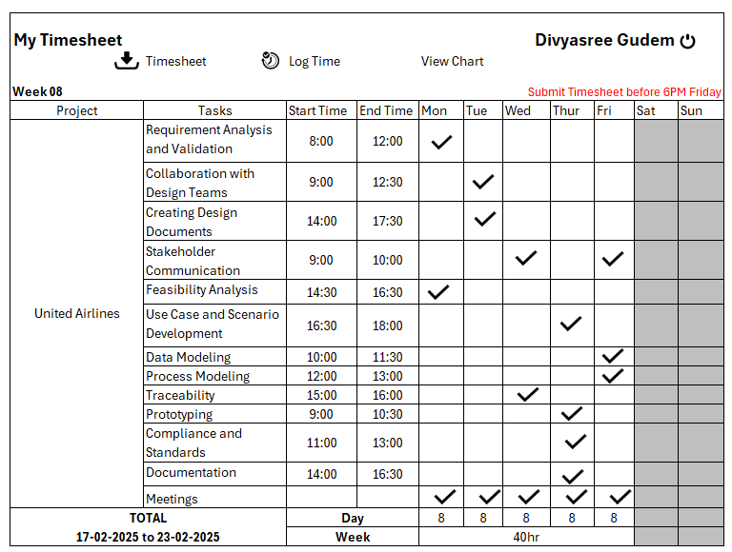

<<< CONTINUED IN NEXT PAGE >>>

* Development Timesheet of a BA

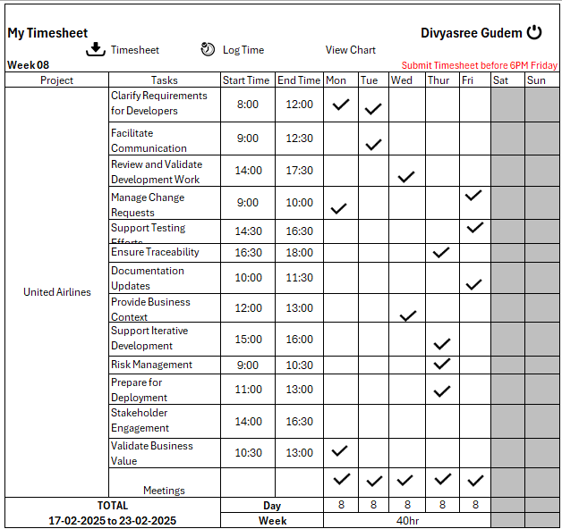

<<< CONTINUED IN NEXT PAGE >>>

* Testing Timesheet of a BA

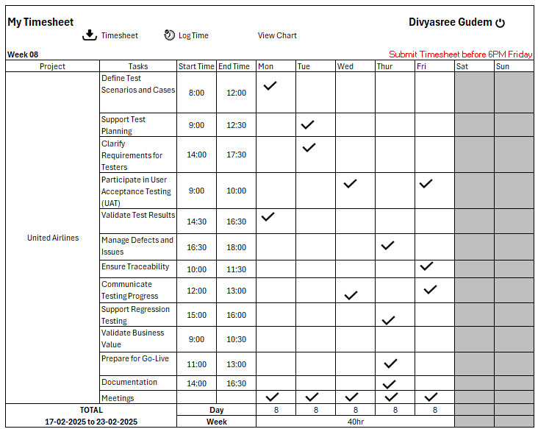

<<< CONTINUED IN NEXT PAGE >>>

* UAT Timesheet of a BA

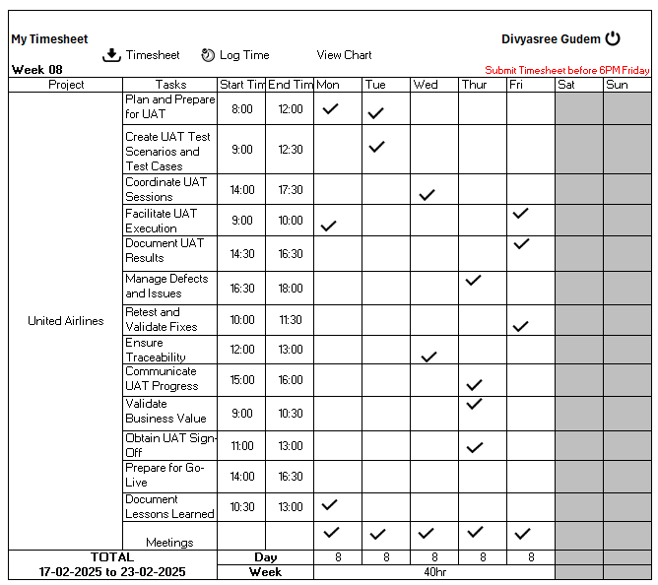

<<< CONTINUED IN NEXT PAGE >>>

* Deployment n Implementation Timesheet of a BA

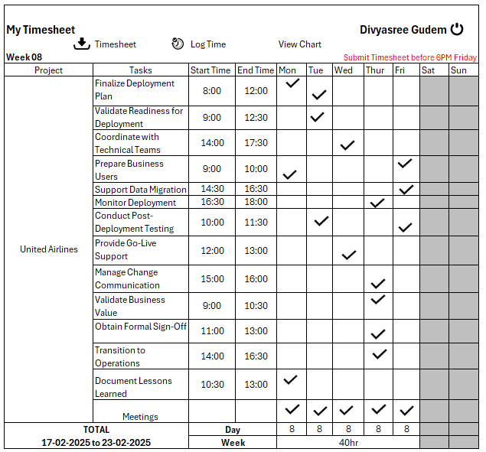

 THE END

* Divyasree Gudem