**Project Name: Ice N Milk Pvt. Ltd**

**Project ID: 2025- Ice N Milk – 001**

**Version ID: 3.0**

**Author: Rohit Salvi**

**Contents**

1. Document Revisions……………………………………………………………………….
2. Approvals……………………………………………………………………………………….
3. RASCI Chart…………………………………………………………………………………….
4. Introduction……………………………………………………………………………………

4.1. Business Goals…………………………………………………………………….

4.2. Business Objectives…………………………………………………………….

4.3. Business Rules…………………………………………………………………….

4.4. Project Goal………………………………………………………………………..

4.5. Project Scope………………………………………………………………………

4.5.1. In Scope Functionality……………………………………………….

4.5.2. Out Scope Functionality…………………………………………….

1. Assumptions……………………………………………………………………………………..
2. Constraints………………………………………………………………………………………
3. Risks………………………………………………………………………………………………..
4. Business Process Overview……………………………………………………………..
5. Development and Resource Plan………………………………………………………
6. Appendices……………………………………………………………………………………..

**Assignment 1**

**Business Requirement Document**

**Project Name: Ice N Milk Pvt Ltd**

**Project ID: 2025- Ice N Milk – 001**

**Version ID: 3.0**

**Author: Rohit Salvi**

1. **Document Revision**

|  |  |  |
| --- | --- | --- |
| **Date** | **Version Number** | **Document Changes** |
| 01.01.2025 | 1.0 | Initial Draft |
| 15.02.2025 | 2.0 | Development and Coding |
| 30.03.2025 | 3.0 | Testing |

1. **Approvals**

|  |  |  |  |  |
| --- | --- | --- | --- | --- |
| **Role** | **Name** | **Title** | **Signature** | **Date** |
| **Project Head** | Ms. Priyanka | SOW |  |  |
| **Project Leader** | Mr. Hanumant | Project sign-off sheet |  |  |
| **Development Lead** | Mr. Gajanan | Coding |  |  |
| **Quality Lead** | Ms. Madhuri | Testing |  |  |
| **Content Lead** | Ms. Sneha | Content Strategy |  |  |

1. **RACI Chart**

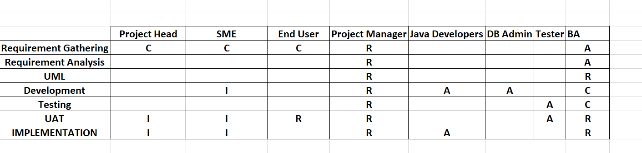

1. **Introduction**
   1. **Business Goals**

This document outlines the requirements for developing software for Ice N Milk Pvt Ltd, a manufacturer of ice cream and milk products having a network of manufacturing plants and warehouses across the country. The proposed system focusses on two primary objectives: effective inventory management and enabling the quickest delivery to customers. By achieving these goals, the company aims to enhance operational efficiency, minimize waste, and improve customer satisfaction.

* **Streamlined Inventory Management:** Ensure real-time monitoring of inventory

levels across all warehouses and plants to reduce spoilage and optimize stock levels.

* **Enhanced Delivery Efficiency:** Implement a system to identify the fastest delivery

routes and automate order allocation based on proximity and inventory availability.

* **Improved Customer Satisfaction:** Minimize order fulfilment time and ensure

product freshness at delivery.

* 1. **Business Objectives**

1. Develop a centralized system to track and manage inventory across all locations.

2. Automate order processing, allocation, and dispatch based on inventory and location.

3. Integrate delivery route optimization with real-time traffic and weather data.

4. Reduce inventory wastage by implementing an expiry-date tracking mechanism.

5. Enable reporting and analytics for better decision-making and demand forecasting.

* 1. **Business Rules**

1. Inventory must be updated in real-time upon receipt, dispatch, or adjustment.

2. Orders should only be fulfilled if the inventory is available

3. Delivery routes must prioritize freshness while minimizing transportation costs.

4. Customer priority orders must be flagged for immediate action.

* 1. **Project Goal**
* Real Time inventory tracking across the locations
* Bulk Order prioritization
* Instant Re-routing in case of delays
* Dashboards / Reports for inventory levels, Order Patterns and Delivery accuracy.

**4.5 Project Scope**

Software to be developed to manage the inventory and quickest delivery to the customer.

**4.5.1. In Scope Functionality**

* Inventory tracking at manufacturing plants and warehouses.
* Order management and allocation.
* Delivery route optimization.
* Analytics and reporting dashboards

**4.5.2. Out Scope Functionality**

* Manufacturing Process and Management
* Customer Relationship Management

1. **Assumptions**
2. All warehouses and plants have internet connectivity for real-time updates.
3. 2. Delivery vehicles are GPS-enabled to support route optimization.
4. 3. Data from external sources (e.g., traffic, weather) is available via APIs.

All warehouses and plants have internet connectivity for real-time updates.

2. Delivery vehicles are GPS-enabled to support route optimization.

3. Data from external sources (e.g., traffic, weather) is available via APIs.

* All warehouses and plants have internet connectivity for real-time updates.
* Delivery vehicles are GPS-enabled to support route optimization.
* Data from external sources (e.g., traffic, weather) is available via APIs

1. **Constraints**

* Budget limitations may restrict the scope of features.
* Integration with legacy systems may pose technical challenges.
* Project timelines must align with the company’s peak season schedules.

1. **Risks**

* Users knowledge expertise
* Resource availability risk
* Improper requirements gathering
* Improper planning
* Scope Creep
* System Integration
* Employees Resistance

1. Improper planning**ss Process Overview**

**8. Business Process Overview**

**Legacy System (AS IS)**

* Inventories are managed manually or using isolated systems.
* Order allocation is manually determined, leading to inefficiencies
* Delivery routes are planned based on experience, not optimized

**Proposed Recommendations (To Be)**

* A centralized system enables automated inventory management.
* Orders are allocated and dispatched through a well-integrated API.
* Delivery routes are optimized dynamically for speed and cost.

1. **Development and Resource Plan**

**Development Strategy**:

**Phase 1:** Requirement gathering, stakeholder workshops, and system design (2 weeks).

**Phase 2:** Development of core modules (Inventory, Order, Delivery) (8 weeks)

**Phase 3:** Integration with external systems (APIs, GPS) and legacy systems (4 weeks)

**Phase 4:** Testing and quality assurance (3 weeks).

**Phase 5:** Deployment, training, and support (3 weeks).

**Resource Count:**

Project Head – 1

Project Manager -1

Business Analyst -1

SME – 1

Developers - 3

1. **Appendices**
   1. **List Of Acronyms**

**GPS –** Global Positing System

**API –** Application Programming Interface

* 1. **Glossary Of Terms**
* GPS **–** Global Positing System **–** Satellite Based Navigation System
* API - Application Programming Interface - Software interface that allows two applications to interact with each other without any user intervention
  1. **Related Documents**
* Market Research for Ice Cream \ Milk Products Industry
* Feasibility Study Report
* Stakeholder requirement documents

**Process Flow Diagram**

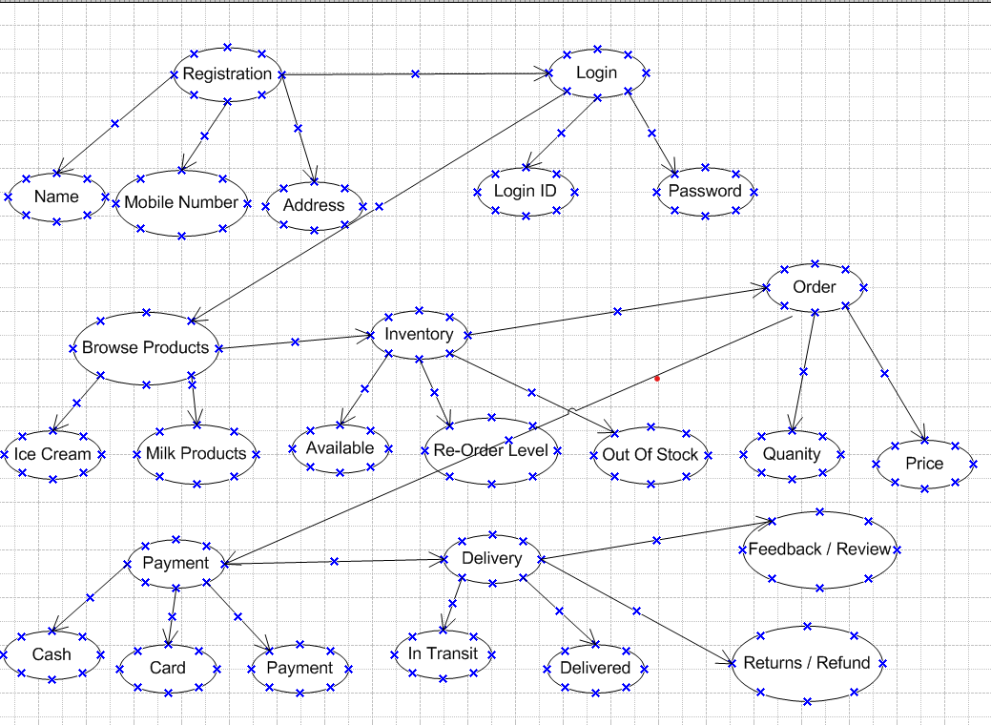

**Assignment 2**

**Introduction Letter**

To,

Ice N Milk Pvt Ltd

Dear Sir/Madam,

Warm Greetings!

My self Rohit Salvi working as a Business Analyst who has been assigned to work with your esteemed organization for this upcoming project.

I bring expertise in warehousing and logistics sector domain concentrating on exceptional customer service, which aligns with your requirements.

With your vision of managing inventory and ensuring the quickest delivery of your ice cream and milk products, I have been assigned the task to shape your goals into realistic and well-curated software application.

I have done an extensive research on your current processes, challenges and futures aspirations regarding your products and customer reach. As a part of your team, I would be delighted to understand your requirements and create a strategic plan to meet your goals and objectives. Your insights and feedback would be very essential to make this software application practical and scalable to match your needs.

I would also be looking forward to meet your team in person to discuss the requirements in details and gather inputs accordingly. I would also request you to share documents, processes or initial walk through to help us start this journey.

I sincerely appreciate for providing me this opportunity to collaborate on this project and I am confident that I would be able to curate a perfect software application that adds value to your business goals.

Please let me know convenient time for further discussion.

Thanks and Regards,

Rohit Salvi

(989031954)

**Project Name: Super Shoppee**

**Project ID: 2025- Super Shopee – 001**

**Version ID: 3.0**

**Author: Rohit Salvi**

**Contents**

1. Document Revisions……………………………………………………………………….
2. Approvals……………………………………………………………………………………….
3. RASCI Chart…………………………………………………………………………………….
4. Introduction……………………………………………………………………………………

4.1. Business Goals…………………………………………………………………….

4.2. Business Objectives…………………………………………………………….

4.3. Business Rules…………………………………………………………………….

4.4. Project Goal………………………………………………………………………..

4.5. Project Scope………………………………………………………………………

4.5.1. In Scope Functionality……………………………………………….

4.5.2. Out Scope Functionality…………………………………………….

1. Assumptions……………………………………………………………………………………..
2. Constraints………………………………………………………………………………………
3. Risks………………………………………………………………………………………………..
4. Business Process Overview……………………………………………………………..
5. Development and Resource Plan………………………………………………………
6. Appendices……………………………………………………………………………………..

**Business Requirement Document**

**Project Name: Super Shoppee**

**Project ID: 2025- Super Shoppee - 01**

**Version ID: 3.0**

**Author: Rohit Salvi**

1. **Document Revision**

|  |  |  |
| --- | --- | --- |
| **Date** | **Version Number** | **Document Changes** |
| 01.01.2025 | 1.0 | Initial Draft |
| 15.02.2025 | 2.0 | Development and Coding |
| 30.03.2025 | 3.0 | Testing |

1. **Approvals**

|  |  |  |  |  |
| --- | --- | --- | --- | --- |
| **Role** | **Name** | **Title** | **Signature** | **Date** |
| **Project Head** | Ms. Priyanka | SOW |  |  |
| **Project Leader** | Mr. Hanumant | Project sign-off sheet |  |  |
| **Development Lead** | Mr. Gajanan | Coding |  |  |
| **Quality Lead** | Ms. Madhuri | Testing |  |  |
| **Content Lead** | Ms. Sneha | Content Strategy |  |  |

1. **RACI Chart**



1. **Introduction**
   1. **Business Goals**

The goal of the project is to develop an online store platform that allows customers to browse, purchase products, and interact with the store via a secure and user-friendly website. The online store will handle user authentication, product management, payments, order processing, and customer support features.

* 1. **Business Objectives**
* To provide an easy-to-use online platform for users to shop from a variety of product categories.
* To offer an intuitive interface for browsing products and managing orders.
* To integrate with a payment gateway for secure transactions.
* To enhance customer satisfaction with order tracking, returns, and responsive support.
  1. **Business Rules**
* Only available products to be reflected on website
* Pre-booking option to made available
* Discounts to applied at check out
* Products to be available in specific currency only
* Minimum predefined quantity / price should be eligible for free shipping
  1. **Project Goal**

To develop an e-commerce platform where customers can browse products, add them to the cart, purchase, and track orders.

* 1. **Project Scope**

Software to be developed to manage an online store with convenience to customer and profitability to vendors.

**4.5.1. In Scope Functionality**

* User registration and login
* Adding, editing, and deleting product listings
* Add to cart, view cart, and modify cart.
* Secure checkout process.
* Multiple payment gateways.
* Order tracking.
* Status updates.
* Order cancellation and returns.
* Live chat support.

**4.5.2. Out Scope Functionality**

* Currency Conversion
* Voice Search
* Referrals Loyalty Program
* International Shipping

1. **Assumptions**

* The platform will initially support web access but may expand to mobile applications in the future.
* All products are stored in the company’s warehouses.
* The business will handle inventory management manually or through an integrated system.

1. All warehouses and plants have internet connectivity for real-time updates.
2. 2. Delivery vehicles are GPS-enabled to support route optimization.
3. 3. Data from external sources (e.g., traffic, weather) is available via APIs.

All warehouses and plants have internet connectivity for real-time updates.

2. Delivery vehicles are GPS-enabled to support route optimization.

3. Data from external sources (e.g., traffic, weather) is available via APIs.

1. **Constraints**

* Budget limitations may restrict the scope of features.
* Integration with legacy systems may pose technical challenges.
* Project timelines must align with the company’s peak season schedules.

1. **Risks**

* Users knowledge expertise
* Resource availability risk
* Improper requirements gathering
* Improper planning
* Scope Creep
* System Integration
* Employees Resistance

1. Improper planning**ss Process Overview**
2. **Business Overview**

**Legacy System (AS IS)**

* Outdated Platform.
* These systems might struggle to integrate with modern third-party services such as payment gateways, shipping providers, or CRM solutions.
* A legacy system may not be optimized for speed, leading to longer page load times, which can negatively affect conversion rates,
* Legacy systems may still rely on manual processes for order fulfillment, customer support, and inventory management, which can slow down operations and increase human error.

**Proposed Recommendations (To Be)**

* Migrate to a modern, scalable e-commerce platform. These platforms offer improved flexibility, speed, and integrations with third-party services.
* Redesign the website with a mobile-first approach to ensure a seamless experience across all devices.
* Integrate automated order fulfilment systems and real-time inventory tracking to reduce manual work and improve accuracy.
* Use modern APIs to integrate with third-party services like CRM ,payment gateways and shipping providers

1. **Development and Resource Plan**

**Development Strategy**:

**Phase 1:** Requirement gathering, stakeholder workshops, and system design (2 weeks).

**Phase 2:** Development of core modules (Inventory, Order, Delivery) (8 weeks)

**Phase 3:** Integration with external systems (APIs, GPS) and legacy systems (4 weeks)

**Phase 4:** Testing and quality assurance (3 weeks).

**Phase 5:** Deployment, training, and support (3 weeks).

**Resource Count:**

Project Head – 1

Project Manager -1

Business Analyst -1

SME – 1

Developers – 3

1. **Appendices**
   1. **List Of Acronyms**
   2. **Glossary Of Terms**
   3. **Related Documents**

* Feasibility Study Report
* Stakeholder requirement documents

**Functional Specifications**

|  |  |
| --- | --- |
| **Project Name** | Online Store |
| **Client Name** | Super Shoppee |
| **Project Version** | 1.0 |
| **Project Sponsor** | Ms. Priyanka – Project Head |
| **Project Initiation Date** | 01.01.2025 |

**Functional Requirement Specifications**

|  |  |  |  |
| --- | --- | --- | --- |
| **Requirement ID** | **Requirement Name** | **Requirement Description** | **Priority** |
| **FR001** | Account Creation | Users must be able to create an account using an email address, username, and password. | 10 |
| **FR002** | Login / Logout | Users should be able to log in using their credentials and log out of their accounts | 10 |
| **FR003** | Password Recovery | Users should be able to reset their passwords through an email link if forgotten. | 10 |
| **FR004** | Product Catalogue | The system must display a list of products that users can browse, categorized by type, price, or other criteria | 10 |
| **FR005** | Product Reviews | Users must be able to leave reviews and rate products they have purchased. | 10 |
| **FR006** | Add to Cart | Users should be able to add products to their shopping cart | 10 |
| **FR007** | View Cart | Users must be able to view the contents of their shopping cart (product name, quantity, price). | 10 |
| **FR008** | Order Summary | Users should be able to review a summary of their order before proceeding to payment. | 10 |
| **FR009** | Order Confirmation | Users should receive an order confirmation email with details of the products purchased, shipping information, and estimated delivery date | 10 |
| **FR010** | Multiple Payment Methods | The system should support multiple payment methods (credit/debit card, PayPal, etc.). | 5 |
| **FR011** | Order Cancellation | Users should be able to cancel an order within a certain time frame after purchase | 5 |
| **FR012** | Refunds/Returns | Users should be able to initiate returns or request a refund within the store’s return policy period | 5 |
| **FR013** | Order Tracking | Users should be able to track the status of their shipped orders with a tracking number | 5 |
| **FR014** | Email Notifications | Users should receive notifications about order confirmations, shipping updates, and delivery status | 5 |
| **FR015** | Coupon Codes | Users should be able to apply discount or promotional codes during checkout | 5 |
| **FR016** | Live Chat | The system should support live chat functionality. | 5 |
| **FR017** | Fraud Prevention | The system should include fraud detection mechanisms, such as payment fraud checks and address verification | 10 |
| **FR018** | Social Media Integration | The online store should allow easy sharing of products on social media platforms | 5 |
| **FR019** | Mobile App Integration | Users should be able to access the store through a dedicated mobile app | 5 |
| **FR020** | Out of Stock Alerts | Users should be notified when a product they are interested in is back in stock | 5 |

**Non - Functional Requirement Specifications**

|  |  |  |
| --- | --- | --- |
| **Requirement ID** | **Requirement Name** | **Requirement Description** |
| **NFR001** | Usability | Application should be user friendly |
| **NFR002** | Performance | Application should load pages within 5 secs |
| **NFR003** | Security | Application must ensure secure user authentication |
| **NFR004** | Availability | Application must ensure minimum down time / outage |
| **NFR005** | Backup/Recovery | System should back up data daily and real time. |
| **NFR006** | Load Balancing | The system should use load balancing to distribute traffic efficiently, ensuring no server is over loaded during high traffic periods |
| **NFR007** | Compatibility | Application must be compatible on various web browsers |

**ERD – Support Ticketing Lifecycle**

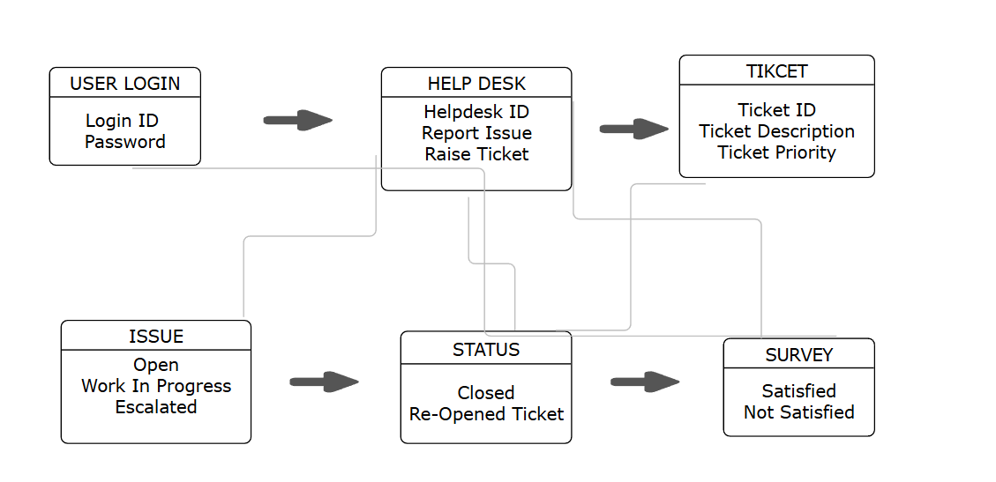

**User Stories**

**SPRINT - 1**

|  |  |  |
| --- | --- | --- |
| **User Story No 1** | Task 2 | Priority - Highest |
| AS A CUSTOMER  I WANT TO REGISTER IN SUPER SHOPPEE  SO THAT I CAN VIEW / BUY PRODUCTS | | |
| **Business Value : 500** | | **CP : 5** |
| **Acceptance Criteria**  Registration screen  Text box for User Name, Password, Name, Address, Email Id and Mobile Number  Click on submit button  Send successful notification to the user | | |

|  |  |  |
| --- | --- | --- |
| **User Story No 2** | Task 2 | Priority - Highest |
| AS A CUSTOMER  I WANT TO VIEW ORDERS BY CATEGORIES  SO THAT I VIEW LIST OF ORDERS | | |
| **Business Value : 500** | | **CP : 8** |
| **Acceptance Criteria**  View order, Display list of orders in tabular form | | |

|  |  |  |
| --- | --- | --- |
| **User Story No 3** | Task 2 | Priority - Highest |
| AS A CUSTOMER  I WANT TO ADD ADDRESS  SO THAT I CAN RECEIVE ORDERS ON MY ADDRESS | | |
| **Business Value : 200** | | **CP : 2** |
| **Acceptance Criteria**  Text Box to enter  Update Address Details | | |

|  |  |  |
| --- | --- | --- |
| **User Story No 4** | Task 2 | Priority - Highest |
| AS A CUSTOMER  I WANT TO SELECT PAYMENT MODE  SO THAT I CAN MAKE PAYEMENT BY MY CHOICE | | |
| **Business Value : 200** | | **CP : 5** |
| **Acceptance Criteria**  Display payment modes, radio button the select payment option, payments button  Business Rules : Can select only one payment mode | | |

|  |  |  |
| --- | --- | --- |
| **User Story No 5** | Task 2 | Priority - Highest |
| AS A CUSTOMER  I WANT TO SEARCH PRODUCT BASED ON PRICE / POPULARITY  SO THAT I CAN MAKE COMPARISON WHILE BUYING | | |
| **Business Value : 500** | | **CP : 5** |
| **Acceptance Criteria**  Products are listed based on price and popularity  Business Rules : Can select only one payment mode | | |

|  |  |  |
| --- | --- | --- |
| **User Story No 6** | Task 2 | Priority - Highest |
| AS A CUSTOMER  I WANT TO REVIEW THE PRODUCT  SO THAT I CAN GIVE FEEDBACK ON THE PRODUCTS | | |
| **Business Value : 500** | | **CP : 5** |
| **Acceptance Criteria**  Review / Ratings Option Available  Products can be viewed based on reviews and ratings | | |

|  |  |  |
| --- | --- | --- |
| **User Story No 7** | Task 2 | Priority - Highest |
| AS A CUSTOMER  I WANT TO VIEW CANCEL ORDER OPTION  SO THAT I CAN CANCEL MY ORDER | | |
| **Business Value : 100** | | **CP : 3** |
| **Acceptance Criteria**  View Order Section  Select Cancel Option | | |

|  |  |  |
| --- | --- | --- |
| **User Story No 8** | Task 2 | Priority - Highest |
| AS A CUSTOMER  I WANT TO MODIFY MY ORDER  SO THAT I CAN ADD/DELETE MY PURCASE | | |
| **Business Value : 100** | | **CP : 3** |
| **Acceptance Criteria**  View Order Section  Select Modify Order  Add / Delete Order | | |

|  |  |  |
| --- | --- | --- |
| **User Story No 9** | Task 2 | Priority - Highest |
| AS A CUSTOMER  I WANT TO TRACK MY ORDER  SO THAT I CAN KNOW CURRENT STATUS OF MY ORDER | | |
| **Business Value : 200** | | **CP : 5** |
| **Acceptance Criteria**  View Order Status  Real Time Update Available  Notifications sent to customer | | |

|  |  |  |
| --- | --- | --- |
| **User Story No 10** | Task 2 | Priority - Highest |
| AS A CUSTOMER  I WANT TO TRACK MY ORDER  SO THAT I CAN KNOW CURRENT STATUS OF MY ORDER | | |
| **Business Value : 100** | | **CP : 3** |
| **Acceptance Criteria**  View Order Status  Real Time Update Available | | |

|  |  |  |
| --- | --- | --- |
| **User Story No 11** | Task 2 | Priority - Highest |
| AS A CUSTOMER  I WANT TO RECEIVE NOTIFICATIONS ON MY ORDER  SO THAT I CAN KNOW THE STATUS INCASE OF DELAY | | |
| **Business Value : 100** | | **CP : 3** |
| **Acceptance Criteria**  View Notifications Tab  Notifications sent to customer | | |

|  |  |  |
| --- | --- | --- |
| **User Story No 12** | Task 2 | Priority - Highest |
| AS A CUSTOMER  I WANT TO ADD MULTIPLE ADDRESS  SO THAT ORDER CAN BE DELIVERED TO ADDRESS OF MY CHOICE | | |
| **Business Value : 100** | | **CP : 3** |
| **Acceptance Criteria**  View Address Section  Update New Addresses  Select Address for delivery | | |
| **User Story No 13** | Task 2 | Priority - Highest |
| AS A CUSTOMER  I WANT TO RETURN THE PRODUCT  SO THAT ORDER RETURN DAMAGE PRODUCT | | |
| **Business Value : 100** | | **CP : 3** |
| **Acceptance Criteria**  View My Order Section  Select Return Option  Select Return Reason | | |

|  |  |  |
| --- | --- | --- |
| **User Story No 14** | Task 2 | Priority - Highest |
| AS A CUSTOMER  I WANT TO APPLY PROMOTIONAL CODE  SO THAT I CAN GET DISCOUNT ON MY AVAILABLE PROMOTIONAL CODE | | |
| **Business Value : 500** | | **CP : 5** |
| **Acceptance Criteria**  View Payment Option  Input Promotional Code  Status : Success / Fail  Final Amount Displayed | | |

|  |  |  |
| --- | --- | --- |
| **User Story No 15** | Task 2 | Priority - Highest |
| AS A CUSTOMER  I WANT TO ADD PRODUCTS TO WISHLIST  SO THAT I CAN BUY THE PRODUCT LATER POINT OF TIME | | |
| **Business Value : 100** | | **CP : 2** |
| **Acceptance Criteria**  View Product List  Add to Wish list | | |

|  |  |  |
| --- | --- | --- |
| **User Story No 16** | Task 2 | Priority - Highest |
| AS A CUSTOMER  I WANT TO ADD VIEW SIMILAR PRODUCTS  SO THAT I CAN COMPARE THE PRODUCTS | | |
| **Business Value : 100** | | **CP : 2** |
| **Acceptance Criteria**  View Product List  Display Similar Products | | |

|  |  |  |
| --- | --- | --- |
| **User Story No 17** | Task 2 | Priority - Highest |
| AS A CUSTOMER  I WANT TO ADD PRODUCTS TO MY FAVOURITES  SO THAT I CAN DIRECTLY BUY FOR FUTURE PURCHASES | | |
| **Business Value : 100** | | **CP : 2** |
| **Acceptance Criteria**  View Product List  Add to Favourites  Make Payment | | |

|  |  |  |
| --- | --- | --- |
| **User Story No 18** | Task 2 | Priority - Highest |
| AS A CUSTOMER  I WANT TO CHAT WITH CSUTOMER CARE  SO THAT I CAN REQUEST FOR REFUND | | |
| **Business Value : 100** | | **CP : 2** |
| **Acceptance Criteria**  Chat Box Field  Order Details  Complaint Details  Submit Button | | |

|  |  |  |
| --- | --- | --- |
| **User Story No 19** | Task 2 | Priority - Highest |
| AS A CUSTOMER  I WANT TO CHAT WITH CSUTOMER CARE  SO THAT I CAN REQUEST FOR REFUND | | |
| **Business Value : 100** | | **CP : 2** |
| **Acceptance Criteria**  Chat Box Field  Order Details  Complaint Details  Submit Button | | |

|  |  |  |
| --- | --- | --- |
| **User Story No 20** | Task 2 | Priority - Highest |
| AS A CUSTOMER  I WANT TO LOG OUT  SO THAT I CAN DISCONTINUE MY LOGIN | | |
| **Business Value : 100** | | **CP : 2** |
| **Acceptance Criteria**  Log Out  Submit Button | | |

|  |  |  |
| --- | --- | --- |
| **User Story No 21** | Task 2 | Priority - Highest |
| AS A CUSTOMER  I WANT TO SCHEDULE MY ORDER DELIVERY  SO THAT I CAN RECEIVE MY ORDER AS PER MY AVAILABLITY | | |
| **Business Value : 100** | | **CP : 2** |
| **Acceptance Criteria**  Select Order Option  Select Delivery Time and Date  Submit Button | | |

|  |  |  |
| --- | --- | --- |
| **User Story No 22** | Task 2 | Priority - Highest |
| AS A CUSTOMER  I WANT TO SCHEDULE MY ORDER DELIVERY  SO THAT I CAN RECEIVE MY ORDER AS PER MY AVAILABLITY | | |
| **Business Value :5100** | | **CP : 2** |
| **Acceptance Criteria**  Select Order Option  Select Delivery Time and Date  Submit Button | | |

|  |  |  |
| --- | --- | --- |
| **User Story No 23** | Task 2 | Priority - Highest |
| AS AN ADMIN  I WANT TO VIEW OFFERS ON PRODUCTS  SO THAT I CAN VIEW BEST OFFERS FOR CLIENTS | | |
| **Business Value : 500** | | **CP : 2** |
| **Acceptance Criteria**  Select Product list  View best offerings for the products | | |

|  |  |  |
| --- | --- | --- |
| **User Story No 24** | Task 2 | Priority - Highest |
| AS AN ADMIN  I WANT TO VIEW PAYMENTS TO VENDORS  SO THAT I CAN VIEW PAYMENT VENDOR WISE | | |
| **Business Value : 100** | | **CP : 2** |
| **Acceptance Criteria**  Select Vendor List  View payment history for vendor wise  Download report | | |

|  |  |  |
| --- | --- | --- |
| **User Story No 25** | Task 2 | Priority - Highest |
| AS AN ADMIN  I WANT TO VIEW CUSTOMER FEEDBACK  SO THAT I CAN TRACK VENDOR / PRODUCT PERFORAMANCE | | |
| **Business Value : 100** | | **CP : 2** |
| **Acceptance Criteria**  View Customer Feedback | | |

|  |  |  |
| --- | --- | --- |
| **User Story No 26** | Task 2 | Priority - Highest |
| AS AN ADMIN  I WANT TO REVIEW CUSTOMER COMPLAINTS  SO THAT I CAN ADDRESS THE COMPLAINTS ISSUE | | |
| **Business Value : 100** | | **CP : 2** |
| **Acceptance Criteria**  View Customer Complaints  Provide Resolution  Customer Satisfaction Confirmation | | |

|  |  |  |
| --- | --- | --- |
| **User Story No 27** | Task 2 | Priority - Highest |
| AS AN ADMIN  I WANT TO REVIEW CUSTOMER COMPLAINTS  SO THAT I CAN ADDRESS THE COMPLAINTS ISSUE | | |
| **Business Value : 500** | | **CP : 5** |
| **Acceptance Criteria**  View Customer Complaints  Provide Resolution  Customer Satisfaction Confirmation | | |

|  |  |  |
| --- | --- | --- |
| **User Story No 28** | Task 2 | Priority - Highest |
| AS AN ADMIN  I WANT TO MANAGE INVENTORY LEVELS  SO THAT PRODUCTS ARE AVAILABLE FOR SALE | | |
| **Business Value : 500** | | **CP : 5** |
| **Acceptance Criteria**  View Inventory List  Re-order Alert  Notification to vendor | | |

|  |  |  |
| --- | --- | --- |
| **User Story No 29** | Task 2 | Priority - Highest |
| AS AN ADMIN  I WANT TO VEIW THE VENDOR LIST  SO THAT I CAN APPROVE THEIR REGISTRATION | | |
| **Business Value : 500** | | **CP : 5** |
| **Acceptance Criteria**  List of vendors, select vendor, verify vendor details, approve button, reject button, notification to the restaurant | | |

|  |  |  |
| --- | --- | --- |
| **User Story No 30** | Task 2 | Priority - Highest |
| AS A VENDOR  I WANT TO VIEW THE REVENUE REPORT  SO THAT I CAN KNOW THE REVENUE STATUS | | |
| **Business Value : 500** | | **CP : 5** |
| **Acceptance Criteria**  Select Reports  Select Revenue Reports  Select from and to date  Generate report  Download report in excel | | |

|  |  |  |
| --- | --- | --- |
| **User Story No 31** | Task 2 | Priority - Highest |
| AS A VENDOR  I WANT VIEW ORDER REPORTS  SO THAT I CAN VIEW MOST OREDER ITEMS | | |
| **Business Value : 200** | | **CP : 5** |
| **Acceptance Criteria**  Reports  List of order reports | | |

|  |  |  |
| --- | --- | --- |
| **User Story No 32** | Task 2 | Priority - Highest |
| AS AN ADMIN  I WANT VIEW DELIVERY BOYS REPORTS  SO THAT I CAN TRACK DELIVERY BOYS LOGIN AND LOGOUT TIME | | |
| **Business Value : 500** | | **CP : 5** |
| **Acceptance Criteria**  Reports  Login  Log Out | | |

|  |  |  |
| --- | --- | --- |
| **User Story No 33** | Task 2 | Priority - Highest |
| AS A VENDOR  I WANT TO VIEW PAYMENT DETAILS  SO THAT I CAN VIEW PAYMENT RECEIVED AGAINST THE ORDER | | |
| **Business Value : 500** | | **CP : 5** |
| **Acceptance Criteria**  Payment Details  Payment Receipt Confirmation | | |

|  |  |  |
| --- | --- | --- |
| **User Story No 34** | Task 2 | Priority - Highest |
| AS A VENDOR  I WANT TO RAISE PAYMENT DISPUTE ISSUE  SO THAT I CAN RAISE DISPUTE ISSUE FOR PAYMENT NOT RECEIVED | | |
| **Business Value : 500** | | **CP : 5** |
| **Acceptance Criteria**  Payment  Raise Dispute  Submit | | |

|  |  |  |
| --- | --- | --- |
| **User Story No 35** | Task 2 | Priority - Highest |
| AS AN ADMIN  I WANT TO CHECK DELIVERY BOYS EXPENSES  SO THAT I CAN REVIEW THEIR SALARY STRUCTURE | | |
| **Business Value : 500** | | **CP : 5** |
| **Acceptance Criteria**  View Delivery Boys Salary List  Review the salary structure | | |

|  |  |  |
| --- | --- | --- |
| **User Story No 36** | Task 2 | Priority - Highest |
| AS AN CUSTOMER  I WANT TO ADD GIFT WRAPPING AND MESSAGE TO MY ORDER  SO THAT I CAN SEND PERSONLAISED GIFT | | |
| **Business Value : 500** | | **CP : 5** |
| **Acceptance Criteria**  Select Gift Wrapping Option  Input Personalized Message upto 300 characters | | |

|  |  |  |
| --- | --- | --- |
| **User Story No 37** | Task 2 | Priority - Highest |
| AS AN CUSTOMER  I WANT TO DELETE MY ACCOUNT  SO THAT I DISCONTINUE THE SERVICE | | |
| **Business Value : 100** | | **CP : 1** |
| **Acceptance Criteria**  Select Login  Delete Account  Confirm Account Deletion  Submit | | |

|  |  |  |
| --- | --- | --- |
| **User Story No 38** | Task 2 | Priority - Highest |
| AS AN ADMIN  I WANT TO SEND PROMOTIONAL ALERTS TO CUSTOMER  SO THAT I CAN DRIVE THE SALES | | |
| **Business Value : 200** | | **CP : 2** |
| **Acceptance Criteria**  Select Promotions  Send To Customers  Submit | | |

|  |  |  |
| --- | --- | --- |
| **User Story No 39** | Task 2 | Priority - Highest |
| AS AN ADMIN  I WANT TO ENABLE TWO FACTOR AUTHENTICATION  SO THAT I CAN SECURE TRANSACTIONS | | |
| **Business Value : 200** | | **CP : 2** |
| **Acceptance Criteria**  Select Transaction  Enable Two Factor Authentication  Submit | | |

|  |  |  |
| --- | --- | --- |
| **User Story No 40** | Task 2 | Priority - Highest |
| AS AN ADMIN  I WANT TO INTEGRATE SOCIAL MEDIA ACCOUNTS  SO THAT USERS CAN LOGIN USING SOCIAL MEDIA ACCOUNT DETAILS | | |
| **Business Value : 200** | | **CP : 2** |
| **Acceptance Criteria**  Select Social Media Account  Login Credentials  Submit | | |