**Question 1 – Audits**

**4 Quarterly Audits are planned Q1, Q2, Q3, Q4 for this Project What is your knowledge on how these Audits will happen for a BA?**

**Answer:**

|  |  |
| --- | --- |
| Stage | Requirements Gathering Phase 13 weeks (week1-week13) |
| Completed | 13 weeks |
| Check List |  |
|  | BRD templets |
|  | Elicitation result Report |
|  | Duplicate Requirements Report |
|  | Grouping of Functionalities |
|  | Email Communication – To, Cc, Bcc |

|  |  |
| --- | --- |
| Stage | Requirements Analysis Phase 13 weeks (week 14-week 26) |
| Completed | 13 weeks |
| Check List |  |
|  | UML Diagrams |
|  | Business to functional requirements mapping |
|  | Client Signoff- documents |
|  | RTM Document version control |
|  | Email Communication – To, Cc, Bcc |

|  |  |
| --- | --- |
| Stage | Develop 8weeks 8 weeks (week 27- week 33) |
| Completed | 8 weeks |
| Check List |  |
|  | Utilization of Tools |
|  | Documented evidence client Communication |
|  | Stakeholder Analysis |
|  | Email Communication – To, Cc, Bcc |

|  |  |
| --- | --- |
| Stage | Development 42weeks (week 34–week 76) |
| Completed | 42 weeks |
| Check List |  |
|  | JAD session report |
|  | End user manual preparation document |
|  | BA and development MOM |
|  | Email Communication – To, Cc, Bcc |

|  |  |
| --- | --- |
| Stage | Testing 42 weeks (week 34-week76) |
| Completed | 42 weeks |
| Check List |  |
|  | Test case Summary |
|  | Training Report to end User |
|  | Lessons Learnt Document |
|  | Email Communication – To, Cc, Bcc |

**Question 2 – BA Approach Strategy**

**Before the Project is going to Kick Start, The Committee asked Mr Karthik to submit BA Approach Strategy Write BA Approach strategy (As a business analyst, what are the steps that you would need to follow to complete a project – What Elicitation Techniques to apply, how to do Stakeholder Analysis RACI/ILS, What Documents to Write, What process to follow to Sign off on the Documents, How to take Approvals from the Client, What Communication Channels to establish n implement, How to Handle Change Requests, How to update the progress of the project to the Stakeholders, How to take signoff on the UAT- Client Project Acceptance Form)**

**Your Team**

**Project Manager - Mr Vandanam**

**Senior Java Developer - Ms. Juhi**

**Java Developers - Mr Teyson, Ms Lucie, Mr Tucker, Mr Bravo**

**Network Admin - Mr Mike**

**DB Admin - Mr John.**

**Testers - Mr Jason and Ms Alekya**

**BA - You**

**Technical Team have assembled to discuss on the Project approach and have finalised to follow 3-tier**

**architecture for this project.**

**Answer:**

* What elicitation techniques to apply?

For Doing Requirements Analysis I will use Prototyping and Brainstorming methods for Requirements analysis. As these are excellent Techniques because they facilitate collaboration, creativity and clarity in the requirements gathering process.

* How to do stakeholder analysis RACI or ILS?

Stakeholder analysis is the process of identifying and evaluating individuals. With the help of RACI, we can understand who will be responsible who will be accountable who has to be consulted and who has to be informed in the project

* Documents to Write in the Project-

Business case BRD- Business Requirement Document

FRD- Functional Requirement Document

FRS- functional requirements specification

SRD- Software Requirement Document

SSD-Supplementary Support Document

RTM-Requirement Traceability Matrix

Solution Document

Design Document

* What process to follow to sign off on the documents?

Take confirmation of sign off over E-mail or take Face to face confirmation etc.

* How to take approvals from the clients?

We will take approvals from client form by contacting the client, talking to them.

* What communication channels to establish and implement?

We will establish Verbal communication channels and Non-verbal communication channels. Verbal communication channels include Oral Communication and Written Communication while Non-verbal communication channels include special expressions, gestures, eye gaze and appearance

* How to handle change requests?

BA has to document and analyse the change request.

The project manager has to provide initial approval for the change requested.

BA will help the stakeholder to understand the impact of a change request

* How to update the process of the project to the stakeholders?

We will update the stakeholders by sharing the timelines and project Status via mail time to time.

* How to take sign off on the UAT client project acceptance form?

We will take the sign off on the UAT client project acceptance form by contacting the client, talking to them and then we will take the sign off.

**Question 3 – 3-Tier Architecture**

**Explain and illustrate 3-tier architecture?**

**Answer:**

-3 Tier ire Architecture is a way to arrange software Application into 3 Layers.  
-Each layer has its own job to make the system easy to use.  
-3 Tier Architecture consists of three layers.  
1. Application Layer  
2.Business Logic Layer  
3.Data Layer

1. Application Layer:

-This is the frontend layer where the user interacts with the system.  
-It is a graphical user interface screen.

-It accepts users request and proceeds it to Business Layer.  
-Examples: Screens, Pages, Validations on page, Functionality

2. Business Logic Layer:

-User's request is processed in this layer.  
-It contains business logics or Rules.  
-It acts as mediator between application layer and data layer. Prevents direct contact of the user from the database.  
-All reusable components, frequent changing components, governing body rules and regulations are present in business application layer.  
-Examples are printers, payment gateways, mail servers, RBI rules for banks, IRDA rules for insurance, etc.

3. Data Layer:

-This is the layer where data is stored and managed.

-Database is provided to user as per his request via business logic layer.

**Question 4 – BA Approach Strategy for Framing Questions**

**Business Analyst should keep What points in his/her mind before he frames a Question to ask to the Stakeholder (5W 1H – SMART – RACI – 3 Tier Architecture – Use Cases, Use case Specs, Activity Diagrams, Models, Page designs)**

**Answer:**

**Question 5 – Elicitation Techniques**

**As a Business Analyst, What Elicitation Techniques you are aware of? (BDRFOWJIPQU)**

**Answer:**

-Requirements elicitation technique is the process of unveiling the hidden needs from the stakeholders.

-There are 10 requirements elicitation techniques.

**1.Brainstorming:**

-Can be done individually or in groups.

-It is the most effective way to generate lots of ideas on specific issues and rate which idea is the best solution.

-It is the most effective with a group of 8-12 people.

-It should be performed in a relaxed environment.

-Brainstorming is generally used in identifying all the possible solutions to problems then prioritisation is done.

-Stages of brainstorming are

i. Prepare for brainstorming:

-Develop the clear and concise definition of area interest and determine the time limit for the group.

-Decide who will be included in the session and their roles.

-Establish the criteria for evaluating and rating the ideas.

ii. Conduct brainstorming session:

-Share the ideas without any criticism and visibly record all the ideas.

-Encourage the participants to be creative.

-Don't limit the number of ideas, as the goal is to elicit as many ideas as possible within the time period.

iii. Wrap-up the brainstorming:

-Once the time limit is reached discuss and evaluate the ideas and eliminate the duplicate ideas.

-Rate the ideas and distribute the final list of ideas to appropriate parties.

-people cannot easily brain storm the ideas and this is the biggest disadvantage of brainstorming.

**2. Document analysis**

-Document analysis is one of the compulsory elicitation techniques for any project

-Documentation about the current system can provide some of the inputs for the new system requirements.

-Evaluating the documentation can assist in making AS-IS of the project and also helps in driving the gap analysis of the project.

Stages for document analysis are-

I. Prepare for document analysis

-Evaluate which existing system and business documentation are relevant.

ii.Analyse the documents

-Study the material and identify the relevant business details.

-Document business details and questions for follow up with SMEs.

iii.Post document analysis wrap up

-Review and confirm the selected details with SMEs and obtain answers to follow up questions.

**3.Reverse Engineering:**

-A situation where software has outdated documentation, there we use reverse engineering elicitation technique to extract implemented Software Code from the System.

-It is generally done for migration projects.

-There are two types of reverse engineering

i. Black box reverse engineering

-System is studied without examining its internal structure

ii. White box reverse engineering

-Inner workings of the system are studied.

**4.Focus groups:**

-It is the means to illicit ideas about a specific product in an interactive group environment.

-Focus group typically has 6 to 12 attendees.

-If more people need to participate then run more than one Focus group.

Focus group can be of two types

i. Homogeneous:

-Group of individuals with similar characteristics.

-The main problem in homogeneous system is that different perspectives will be shared its possible solution is to conduct separate sessions for different homogeneous groups.

ii. Heterogeneous:

-group of individuals with diverse backgrounds.

-Main problem in conducting a heterogeneous focus group is that individuals may feel awkward if not comfortable with the background, resulting in lower quality of Data collection.

**5.Observations:**

-Observing or doing part of their job can provide information of existing processes.

-This method is useful if the user is unable to clearly explain what they do or what are their requirements

-This is relatively slow procedure

-There are two basic approaches for the observation technique

i.Passive

-Business analyst observes the SMEs are working through the business but does not ask questions and stays out of the way, as if he is invisible. He waits until the entire process is completed before asking the questions. -BA should observe the process multiple times to ensure or understand how the process works.

ii. Active

-In This approach BA observes the current process takes notes and may dialogue with the worker.

**6.Questionnaire (Survey):**

-Useful for obtaining limited system requirements details from users who have minor input.

-Questions are designed to get the requirements.

-There are two type of questionnaires

i. Close ended questions

ii. Open ended questions

-Advantages of this technique is questionnaire can be sent to hundreds of users at low cost and good for getting input from users.

The written replies are easier to work with.

-Disadvantages of this system are questionnaires can be slow to create and you may not get a good response from users.

**Question 6 – This project Elicitation Techniques**

**Which Elicitation Techniques can be used in this Project and Justify your selection of Elicitation Techniques?**

**Prototyping**

**Use case Specs**

**Document Analysis**

**Brainstorming**

**Answer:**

-I will prefer **Prototyping and Brainstorming** methods for eliciting techniques for gathering

the requirements of this project.

- Prototype creates a representation of the system making ideas easier to understand to the stakeholder.

- Stakeholders can provide immediate feedback after interaction with the prototype.

- Prototype helps to clarify the requirements of the project, reducing the risk of miscommunication.

- Stakeholders get more engaged in the project when they see the visual representation of the project.

- Brainstorming sessions encourage stakeholders to think freely and come up with innovative ideas.

- Evolving multiple stakeholders helps to create a wide range of ideas.

- Brainstorming is a method of generating many ideas in less time.

- Brainstorming improves open communication between stakeholders.

- Brainstorming identifies the hidden Needs of the Project.

- These both methods encourage active participation from stakeholders.

**Question 7 – 10 Business Requirements**

**Make suitable Assumptions and identify at least 10 Business Requirements.**

**Answer:**

|  |  |  |  |  |
| --- | --- | --- | --- | --- |
| Sr. No. | Requirement Id | Requirement Category | Description | Priority |
| 1. | BR0001 | Login | Customer should be able to login to application. | 1 |
| 2. | BR0002 | Sign In | Customer should be able to Create his login credentials. | 1 |
| 3. | BR0003 | Search | Customer should be able to Search the product. | 2 |
| 4. | BR0004 | Browse | Customer should be able to Browse the product from Product Catalogue. | 1 |
| 5. | BR0005 | Buy Later List | Customer should be able to add product in Buy later List. | 3 |
| 6. | BR0006 | Remove from Buy Later List | Customer should be able to remove the product from Buy later List. | 3 |
| 7. | BR0007 | Filter | Customer should able to set filter while searching a product. | 2 |
| 8. | BR0008 | Cancel order | Customer should be able to cancel order. |  |
| 9. | BR0009 | Payment Option | Customer should be able to de payment via UPI or from Card or COD or from net banking. | 1 |
| 10. | BR0010 | Delivery Tracker | Customer should be able to Track his Product. | 4 |

**Question 8 –Assumptions**

**List your assumptions.**

**Answer-**

**Question 9 – This project Requirements Priority**

**Give Priority 1 to 10 numbers (1 being low priority – 10 being high priority) to these Requirements after discussions with the stakeholders.**

**Once the requirements are finalized, as a business analyst, one of the major roles is to act as a liaison between the client and the project team. To gather the requirements correctly from the client side and then to deliver those requirements to the project team in a way they understand. To make the project team understand the requirements, you need to convert those requirements into UML diagrams and screen mock-ups.**

**Answer:**

**Question 10 – Use Case Diagram**

**Draw use case diagram.**

**Answer:**

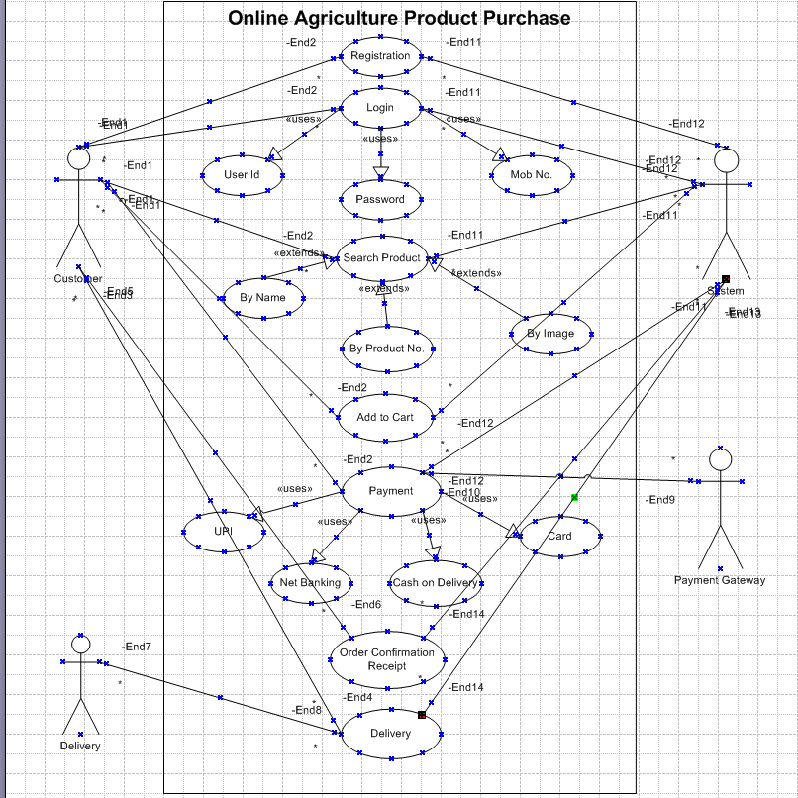

**Question 11 – (minimum 5) Use Case Specs**

**Prepare use case specs for all use cases**

**Question 12 – (minimum 5) Activity Diagrams**

**Activity diagrams**

**Answer:**

**1.Activity Diagram for Login to application:**

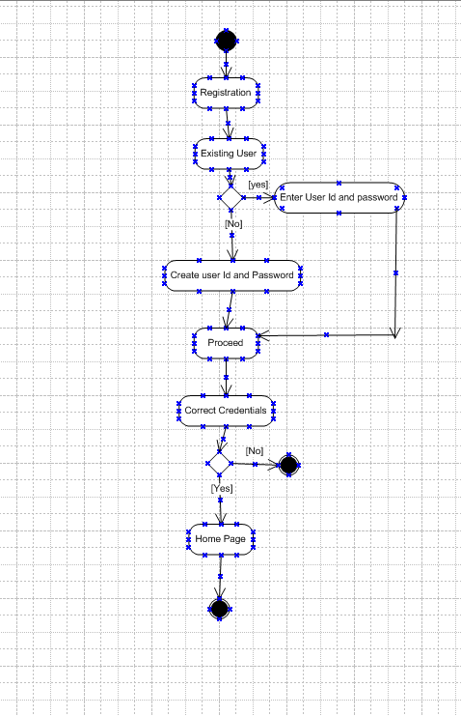

**2.Activity Diagram for Searching a product:**

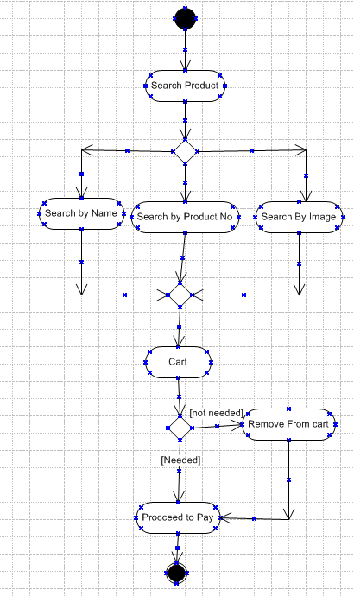

**3. Activity Diagram for Payment:**

