**Document 6- Please prepare a use case diagram, activity diagram and a use case specification document.**

**Use case Diagram:**

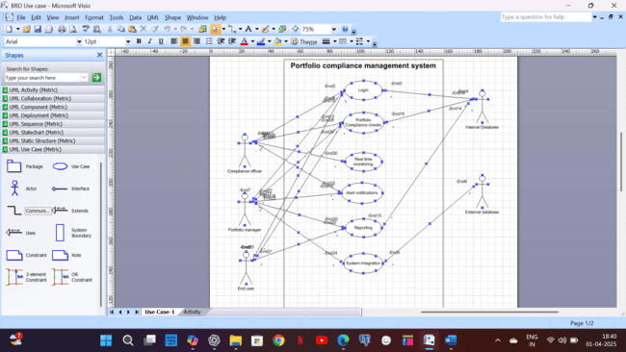

**Activity Diagram:** 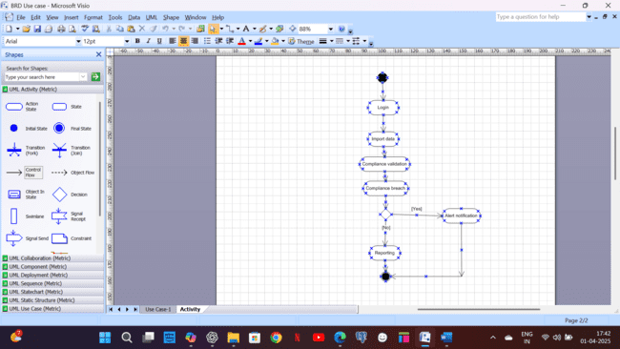

**Use case specification document:**

**Use case 1: User Login**

**1. Use Case Name:** User Login

**2. Use Case Description:** This use case allows registered users to securely log into the Portfolio Compliance Management System and access their respective dashboards based on role-based access control (RBAC).

**3. Actors: Primary -** Portfolio Manager, Compliance Officer, End User, **Secondary -** Internal database.

**4. Basic Flow:**

1. User navigates to the login page.
2. User enters a username and password.
3. System validates the credentials.
4. If valid, the system grants access and redirects the user to the dashboard.

**5. Alternate Flow:**

* **Forgot Password Flow:**
  1. User clicks "Forgot Password."
  2. System prompts the user to enter an email ID.
  3. System sends a password reset link.
  4. User resets the password and logs in successfully.

**6. Exceptional Flows:**

|  |  |
| --- | --- |
| **Exception** | **Handling Strategy** |
| Invalid credentials | Display error message and prompt for retry |
| Account locked due to multiple failed attempts | Notify user and allow password reset |
| System downtime | Display maintenance message |

**7. Pre-Conditions:**

* User must be an employee who must be provided access based on his role.
* System must be available and running.

**8. Post-Conditions:**

* User is successfully logged in.
* If login fails, system records an attempt log.

**9. Assumptions:**

* Users will enter correct credentials.
* Email notifications will work for password resets.

**10. Constraints:**

* Must comply with bank security policies.
* Only employees of bank can access the system.

**11. Dependencies:**

* Authentication service must be operational.

**12. Inputs and Outputs:**

|  |  |
| --- | --- |
| **Inputs** | **Outputs** |
| Username, Password | Dashboard Access |
| Reset Password Request | Email with reset link |

**13. Business Rules:**

* Passwords must be at least 8 characters long and include special characters.
* After 3 failed login attempts, the account is locked.

**14. Miscellaneous Information:**

* Multi-factor authentication (MFA) may be added in future updates.

**Use case 2:**  **Portfolio Compliance Check**

**1. Use Case Name:** Portfolio Compliance Check

**2. Use Case Description:** This use case ensures that portfolio transactions adhere to regulatory compliance rules, reducing non-compliance risks.

**3. Actors: Primary -** Portfolio Manager, Compliance Officer, **Secondary -** Internal Database

**4. Basic Flow:**

1. User uploads portfolio transaction data.
2. System processes the data and applies compliance rules.
3. System generates a validation report.
4. If all transactions pass, a success message is displayed.
5. If violations exist, the system triggers alerts.

**5. Alternate Flow:**

* **Manual Override Flow:**
  1. Compliance Officer reviews flagged transactions.
  2. Officer manually overrides false positives.
  3. System logs the action.

**6. Exceptional Flows:**

|  |  |
| --- | --- |
| **Exception** | **Handling Strategy** |
| Invalid File Format | Reject the file and notify the user |
| Rule Error | Log issue and notify IT support |

**7. Pre-Conditions:** Compliance rules must be predefined in the system.

**8. Post-Conditions:** Compliance status of transactions is recorded.

**9. Assumptions:** Users will provide complete and accurate data.

**10. Constraints:** Must comply with SEBI, RBI, Basel regulations.

**11. Dependencies:** Compliance rule engine must be functional.

**12. Inputs and Outputs**

|  |  |
| --- | --- |
| **Inputs** | **Outputs** |
| Portfolio Data | Compliance Report |

**13. Business Rules:** Threshold-based alerts for policy violations.

**14. Miscellaneous Information:** Future integration with AI-based compliance monitoring.

**Use case 3:**  **Alert Notification**

**1. Use Case Name:** Alert Notification

**2. Use Case Description:** Triggers real-time alerts for portfolio compliance violations.

**3. Actors: Primary -** Compliance Officer, Portfolio Manager.

**4. Basic Flow:**

1. System detects a compliance breach.
2. System generates a risk alert.
3. Compliance Officer receives a notification.
4. Officer reviews and takes necessary action.

**5. Alternate Flow:** If a critical alert is not addressed within 24 hours, the system escalates to higher management.

**6. Exceptional Flows:**

|  |  |
| --- | --- |
| **Exception** | **Handling Strategy** |
| Alert Not Delivered | Resend via alternative method |

**7. Pre-Conditions:** Compliance monitoring must be active.

**8. Post-Conditions:** Alerts are logged and reviewed.

**9. Assumptions:** Compliance Officer actively monitors alerts.

**10. Constraints:** Must meet regulatory reporting requirements.

**11. Dependencies:** Notification service must be active.

**12. Inputs and Outputs**

|  |  |
| --- | --- |
| **Inputs** | **Outputs** |
| Compliance Breach | Risk Alert |

**13. Business Rules:** Critical alerts must be acknowledged within 24 hours.

**14. Miscellaneous Information:** Future implementation of automated corrective actions.

**Use case 4:**  **Reporting**

**1. Use Case Name:** Reporting

**2. Use Case Description:** Generates detailed compliance reports for audits and internal reviews.

**3. Actors: Primary -** Portfolio Manager, Compliance Officer, **Secondary -** Internal database.

**4. Basic Flow**

1. User selects a report type.
2. System compiles compliance data.
3. System generates a report.

**5. Alternate Flow:** User applies custom filters.

**6. Exceptional Flows:**

|  |  |
| --- | --- |
| **Exception** | **Handling Strategy** |
| No Data Available | Show message and suggest alternate parameters |

**7. Pre-Conditions:** Compliance data must be available.

**8. Post-Conditions:** Reports are generated and available for review.

**9. Assumptions:** Users require reports for audits and compliance tracking.

**10. Constraints:** Reports must adhere to industry standards.

**11. Dependencies:** Data warehouse must be accessible.

**12. Inputs and Outputs**

|  |  |
| --- | --- |
| **Inputs** | **Outputs** |
| Report Request | Compliance Report |

**13. Business Rules:** Reports must be retained for 7 years for audits.

**14. Miscellaneous Information:** Future enhancements may include AI-based insights.

**Document 7- Screens and pages Please follow the following steps to create the mock-ups 1. Kindly use balsamic or Axure. 2. Always start with a home page of an application. 3. Take a feature and follow it to the end.**

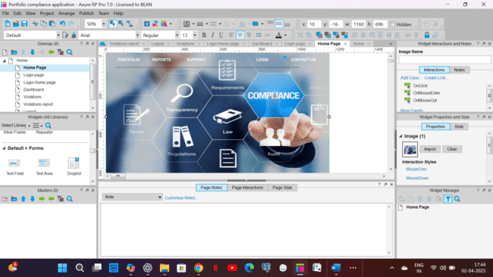

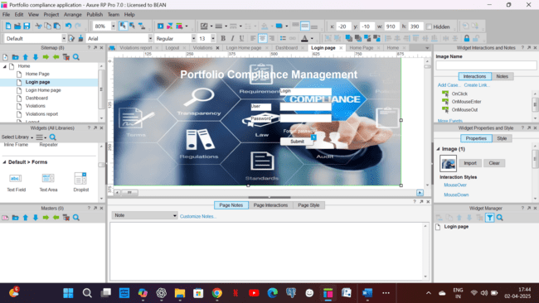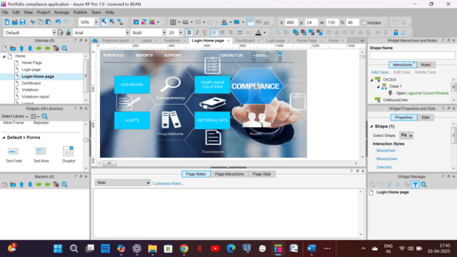

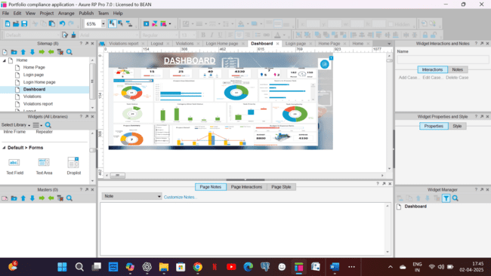

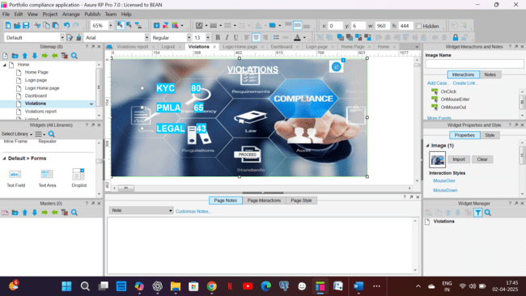

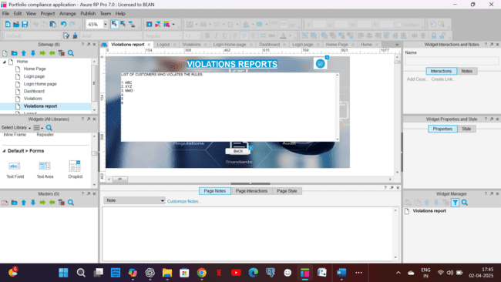

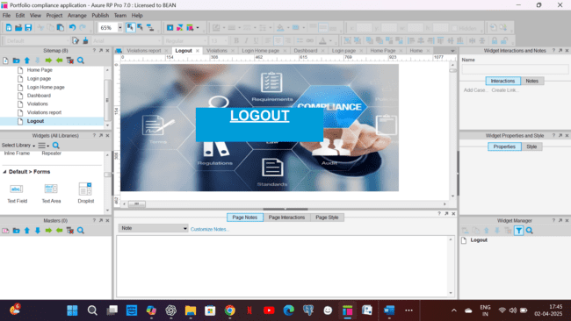

**Document 8- Tools-Visio and Axure Write a paragraph on your experience using Visio and Axure for the project.**

For this project, I used Microsoft Visio and Axure RP to design various diagrams and screen mock-ups for the Portfolio Compliance Management System. Visio was particularly useful for creating structured diagrams like use case diagrams, activity diagrams, and process flow diagrams. Its drag-and-drop functionality and pre-built stencils helped in efficiently designing and organizing visual representations of the system's workflows. Meanwhile, Axure RP was instrumental in building interactive screen mockups for features like Dashboards, Risk Alert Notifications and Compliance Rule Violations etc. Axure's ability to create dynamic prototypes allowed for better visualization of the user interface, making it easier to demonstrate system behaviour to stakeholders. Overall, both tools significantly enhanced the clarity and usability of the project documentation.

**Document 9- BA experience**

**My experience as BA in following phases:**

**1. Requirement gathering:**

* Started with elicitation techniques to gather requirements.
* Used the MoSCoW technique (Must Have, Should Have, Could Have, Won’t Have) to prioritize requirements effectively.
* In case of any client unavailability, I identified and coordinated with alternate stakeholders to ensure timely information gathering.
* Validated requirements using the FURPS technique (Functionality, Usability, Reliability, Performance, Supportability).
* Identified duplicate or conflicting requirements and eliminated them for better clarity.
* Used prototyping to refine requirements, ensuring precise expectations were captured.

**2. Requirement Analysis:**

* Created UML diagrams to visually represent system functionalities and workflows.
* Designed activity diagrams to showcase the end-to-end process flow of compliance management.
* Conducted team discussions to validate and refine diagrams, incorporating feedback for improvements.
* Prepared key documents:
  + Business Requirement Document (BRD)
  + Software Requirement Specification (SRS)

**3. Design:**

* Derived test cases from use case diagrams to cover all functional aspects.
* Regularly communicated with the client on design aspects and solution documentation.
* Developed both positive and negative test cases to ensure comprehensive testing.
* Ensured no test cases were missed, as missing critical scenarios could impact development.
* Prepared test data for different testing scenarios.
* Maintained an RTM (Requirement Traceability Matrix) to map requirements to test cases.

**4.Development:**

* Conducted Joint Application Development (JAD) sessions to facilitate collaboration.
* Assisted the technical team with requirement clarifications during the coding phase.
* Addressed disagreements among team members and handled conflicts through one-on-one discussions, promoting a healthy work environment.
* Provided UML diagrams to developers to help with unit coding.
* Ensured regular meetings were conducted between the tech team and client, and for those who missed discussions, recorded sessions were shared along with individual follow-ups.

**5. Testing**

* Prepared test cases based on use cases to validate business functionality.
* Conducted high-level testing before handing it over for Quality Assurance (QA).
* Coordinated with the client to obtain test data for realistic validation.
* Updated the Requirement Traceability Matrix (RTM) to ensure complete requirement coverage.
* Obtained client sign-off for successful testing completion.
* Provided User Acceptance Testing (UAT) support, guiding the client through the process.

**6. Deployment**

* Shared the final RTM document with the client as part of the project closure.
* Assisted in preparing and distributing end-user manuals for the system.
* Organized and conducted training sessions for the end-users.
* Ensured that all key stakeholders attended the training sessions and understood system functionalities.