**Capstone Project 3-Part-2**

Q1. What is the difference between Brainstorming and JAD Sessions? 3 Marks

Answer-

|  |  |
| --- | --- |
| **Brainstorming** | **JAD Sessions** |
| Brainstorming can be done either individually or in group. | The Joint Application Development techniques is an Extended, Facilitated workshop |
| A creative technique used to generate ideas and solutions for a problem. | A structured meeting where stakeholders collaborate to define system requirements. |
| Encourages free thinking to generate multiple ideas. | Focuses on gathering detailed requirements for system development. |
| Usually includes a diverse group, often without strict roles. | Involves business analysts, developers, users, and subject matter experts (SMEs) with defined roles. |
| Informal, open-ended discussion. | Highly structured with a facilitator guiding the process. |
| A list of ideas or possible solutions. | A well-documented set of system requirements and specifications. |
| It can be an efficient way for users/stakeholders to define their requirements. | This technique provides a forum to explore multiple points of view regarding topic |

Q 2. Why Document Analysis is one of the compulsory technique we use in a Project? Justify – 3 Marks

Answer-

Documentation about current system which could provide some inputs for the system requirement. Such documentation could include interface details, user manuals, and software vendor manuals.

Document analysis is crucial technique used in project management, because it provides valuable insights and information, and context that are essential for project success.

Understanding Requirements- contain valuable information about project objective, scope and expectations.

Quality assurance- Documents include quality standards, guidelines and procedures that define expectations for project deliverable.

Q3. In Which Context we will use Reverse Engineering? - 3 Marks

Answer-

In situation where the software for an existing system has little or outdated documentation and it is necessary to understand what the system actually does, reverse engineering is an elicitation technique that can implemented requirements from the software code.

It is the process of extracting knowledge or design information from anything man-made and re-producing it, re-producing anything based on the extracted information

There are 2 categories in reverse engineering-

Black Box- The system or product is studied without examining its internal structure.

White Box- The inner working of the system or product is studied.

Q4. What is the difference between Brainstorming and Focus Groups? - 3 Marks

Answer-

|  |  |
| --- | --- |
| **Brainstorming** | **Focus Groups** |
| Brainstorming can be done either individually or in group. | A focus group is means to elicit ideas and attitude about specific product, Service or opportunity in an interactive group environment |
| A creative technique used to generate ideas and solutions for a problem. | A moderated discussion used to gather opinions, perceptions, and feedback on a specific topic. |
| Encourages free thinking to generate multiple ideas. | Collects qualitative insights and opinions from participants. |
| Usually includes a diverse group, often without strict roles. | A selected group of target users or stakeholders, moderated by a facilitator. |
| Informal, open-ended discussion. | Semi-Structured discussion with guided questions. |
| A list of ideas or possible solutions. | Deep insights into customer needs, preferences and behaviours. |
| It can be an efficient way for users/stakeholders to define their requirements. | The participant share their impressions, Preferences and needs guided by a moderator. |

Q5. Observation Technique – Explain both Active and Passive approaches - 3 Marks

Answer-

Observing, shadowing users or even doing part of their job, can provide information of existing processes, inputs and outputs.

Observation technique is commonly used in research and requirement gathering to gather the data by directly observing individuals, Process or system.

There are two main approaches to observation-

Active approach - involves direct engagement and interaction with participants, in this approach, while the business analyst observes the current process and take notes he/she may dialog with the worker. In this approach, the business analyst might even participate in the work to gain an immediate appreciation for how the current process work.

Passive Approach – involves indirect engagement and interaction with participants. In this approach the business analyst observes the subject matter expert working trough the business routine but does not ask questions. The Business Analyst writes note about what he/she sees, but otherwise stays out the way, as if he/ she invisible. The business analyst should observe the business process multiple times to ensure he/she understand how the process works today and why it works the way it does.

Q6. How do you conduct the Requirements Workshop- 3 Marks

Answer-

Workshop can comprise 6-10 or more users/ stakeholders, working together to identify requirements. Workshop tends to be of a defined duration, rather than outcome and may need to be briefly repeated in order to clarify or obtain further details.

Requirement workshop is structure approach to capture requirements.

It may used to scope discover, define prioritize and reach closure on requirements for the target system.

Define objectives, identify stakeholders, create an agenda, Collaboratively facilitate the workshop with key stakeholders, Summarize findings, Validate requirements.

Q7. In which context, Interview Technique can be conducted by a BA ? How may approaches are there in conducting Interviews? (Structured – Unstructured) Explain them. Explain the difference between Open Ended Questions and Closed ended Questions – 6Marks

Answer-

Interview of users and stakeholders are important in creating wonderful software. Without knowing the expectations and goal of the stakeholders and users, you are highly unlikely to satiate them.

Interview can be conducted in various context, such as during requirement gathering, stakeholder analysis, Process analysis.

The purpose is to extract valuable insights, expectations and needs from individuals involved on or affected by the project.

Approach to conducting Interview-

Structured interviews-

Follows a predetermined set of questions.

Ensures consistency and comparability across multiple interviews.

Unstructured interview-

Questions are not predetermined, allowing for flexibility.

Allows the interviewee to express thoughts freely.

Open-Ended Questions- Questions that allow detailed, descriptive responses. In this gather detailed insights, opinions, and explanations.

Closed-Ended Questions- Questions that have specific, predefined answers (Yes/No, Multiple Choice). Purpose of Closed-Ended Questions obtain specific, measurable, and comparable responses.

Q8. Questionnaire Technique – Where we will use? Give one example - 6 Marks

Answer-

Questionnaire can be useful for obtaining limited system requirements details from users/stakeholders, who have minor inputs or are geographically remote. The design of questionnaire and type of questions are important and can influence the answer, so care is needed.

The questionnaires technique is method of data collection commonly used in research, surveys and assessments.

It involves presenting set of written questions to respondents and collecting their responses.

Questionnaires can be administered in various way, including paper and pencil, online survey or face to face interview where the questions are read to the participants.

Example of Questionnaire

collecting feedback from restaurant owners for the **Scrum Foods** delivery app to improve service features.

1. How often do you use the Scrum Foods platform for orders?
2. Daily
3. Weekly
4. Monthly
5. **What challenges do you face in managing online orders?**
6. Rate the ease of use of the Scrum Foods app (1 = Difficult, 5 = Very Easy).

Q9. How to Sort the Requirements – Where we will use? Give one example - 5 Marks

Answer-

It is process in which scattered requirements are put together and redundancy is removed. The inter related requirements are linked.

Sorting requirement is crucial step in the requirement management process, helping to organize, Prioritize and categorize them for effective analysis and implementation.

Sorting is often done during the requirement elicitation and documentation phase of project.

Based on functional, and Non- Functional Requirements, Priority Sorting, User Roles Sorting, Time Dependency Sorting we can sort the requirement.

Requirements Sort on the base of dependencies, priority like High, Medium, Low priority based on business impact.

Sorting requirements is crucial in Agile and Waterfall projects to ensure efficient development. It helps in-

Backlog Prioritization

Requirement Traceability

Q10. Prioritise the Requirements –Where we will use? Give one example - 5 Marks

Answer- It is Technique for queuing the requirements for the development process.

Prioritizing requirement is a critical step in the requirement management process, helping teams focus on what is most important for the success of a project.

Prioritizing is typically done based on factors such as business values, impact and dependacies.

One of the most important prioritizing techniques is MOSCOW

Prioritization Techniques- (MOSCOW)-

It is a prioritization technique used in business analysis and software development to reach a common understanding with stakeholders on the importance they place on the delivery of each requirement -also known as MOSCOW prioritization or MOSCOW analysis.

The MOSCOW method can help. MOSCOW stands for must, should, could and would:

M-Must have this requirement to meet the business needs,

S-Should have this requirement if possible, but project success does not rely on it. anything else in the project.

C-Could have this requirement if it does not affect W-Would like to have this requirement later, but it won't be delivered this time.

Q11. Weekly status reporting – How we will drive? 5 Marks

Answer-

Weekly Status report is a summary of all work done during a week and how these activities contribute to the completion of a task or a project or how each one brings the team closer to the achievement of their targets.

How to Drive Weekly Status Reporting?

1. **Schedule Regular Reporting** – Set a fixed day (e.g., every Friday) for report submission
2. **Gather Inputs from Team Members** – Collect updates from developers, testers, and other stakeholders.
3. **Review & Validate** – Ensure accuracy and completeness of the report.

Questions that can be asked in a weekly status report include:

1. What have you been working on recently?
2. What have you accomplished this week?
3. What are your top priorities?
4. What are your challenges going into next week?

Q12. Meeting Minutes Document – prepare one Sample -5 Marks

Answer-

Minutes of Meeting (MOM) is a formal written document that summarize the discussions, decisions and actions taken during a meeting.

It serves as an official record of what transpired during the meeting and help to ensure that everyone is on the same page regarding key points and the action items.

MOM is particularly important for tracking Project Progress, documenting decisions and assigning responsibilities.

|  |  |
| --- | --- |
| Meeting Title: Weekly Project Status Meeting – Online Food App | |
| Date and Time | March 1, 2025, 10:00 AM – 11:00 AM |
| Location | APT IT Solutions – Conference Room / Virtual (MS Teams) |
| Attendees | Delivery Head, Business Analyst, Developers, QA Team, Product Owner, Scrum Master |
| Agenda | 1. Project progress updates  2. Sprint backlog review  3. API integration issues  4. Testing phase updates  5. Deployment plan discussion |
| Discussion Summary | - Developers completed payment gateway integration  - API integration facing delays due to third-party vendor issues  - QA team identified critical bugs in order-tracking module  - Deployment scheduled for March 10, 2025 |
| Decision Made | - API issue escalation to vendor support  - Extended testing timeline by 2 days to fix critical bugs |
| Action Item | **1. Debug API integration issue  2. Retest order tracking module  3. Confirm deployment readiness** |
| Owner | **1. Dev Team  2. QA Team  3. Scrum Master** |
| Due date | March 8, 2025 |
| Agenda Summary | Discussed project status, identified blockers, and planned next steps for deployment. |
| Next meeting | |
| Meeting Title: | Weekly Project Status Meeting – Online Food App |
| Date and time: | March 9, 2025, 10:00 AM – 11:00 AM |
| Location: | APT IT Solutions – Conference Room / Virtual (MS Teams) |
| Expected Attendees: | Delivery Head, Business Analyst, Developers, QA Team, Product Owner, Scrum Master |

Q13. Change Tracker – Document - prepare one Sample -4 Marks

Answer-

Change Tracker Document is used by the Project team to log and track change request made throughout the life of the Project.

|  |  |  |  |  |  |  |
| --- | --- | --- | --- | --- | --- | --- |
| Date | Version Number | Document Changes | Name | Title | Signature | Approved By |
| 01-Mar-2025 | v1.0 | Initial Draft Created | Nikita Surywawnshi | Business Analyst | Karthik | Mr. Karthik (Delivery Head) |
| 04-Mar-2025 | v1.1 | Updated API Integration Details | Harsha gaikwad | Developer | Karthik | (Mr. Karthik)  Delivery Head |
| 06-Mar-2025 | v1.2 | Added Test Case Scenarios | Divya Sharma | QA Lead | Karthik | (Mr. Karthik) Delivery Head |
| 08-Mar-2025 | V.1.3 | Add New Wireframes | Nikita Suryawanshi | Business Analyst | Karthik | (Mr. Karthik) Delivery Head |
| 11-Mar-2025 | v1.3 | Final Review & Approval | Neha Shweale | Project Manager | Karthik | (Mr. Karthik) Delivery Head |

Q14. Difference between Traditional Development Model and Agile Development Models – 8 Marks

|  |  |
| --- | --- |
| Traditional Development Model (Waterfall Model) | Agile Development Models |
| 1. The cost of waterfall model is low. | 1. The cost of Agile development is higher due to continuous iterations and changes |
| 1. Waterfall model is simplicity. | 2. Agile is complex due to frequent iterations and team collaboration |
| 1. Waterfall model is a sequential execution process. | 3. Agile follows an iterative and incremental approach |
| 1. Flexibility of waterfall model is rigid. | 4. Agile is highly flexible and adaptable to changes |
| 1. Waterfall model’s step move in a linear way. | 5. Agile follows a cyclic and iterative approach with feedback loops |
| 1. Reusability of waterfall model is limited | 6. Agile promotes reusability of code and components through iterative sprints |
| 1. User involved in waterfall model is only in beginning | 7. Users are continuously involved throughout the development cycle |
| 1. In waterfall model testing activates start after the development activities are over | 8. In Agile, testing is done parallel to development in every sprint |
| 1. Guarantee of success through waterfall model is low | 9. Agile has a higher success rate due to iterative improvements and stakeholder feedback |
| 1. Waterfall model is continuous process | 10. Agile is a dynamic process with continuous delivery and improvements |
| 1. Requirement specification in waterfall model is necessary in beginning | 11. Agile allows evolving requirements throughout the development cycle |
| 1. Waterfall model is less used now a days in software engineering | 12. Agile is widely used in modern software development methodologies |

Q15. Explain Brainstorming Technique – Where to use? 5 Marks

Answer-

Brainstorming is one of the most important elicitation techniques which I help in generate new ideas about projects. Brainstorming either done in group or individually. In this technique ideas collected can be reviewed, analyzed and relevant ideas included in system requirements. It Encourages free thinking to generate multiple ideas and it usually includes a diverse group, often without strict roles.

Brainstorming is commonly used in:

**Requirement Gathering and Elicitation** - Identifying business needs and features.

**Process Improvement** - Finding inefficiencies in workflows and suggesting optimizations

**Risk Management** - Identifying potential project risks and mitigation strategies

**Product Development** - Generating new product ideas and enhancements

Case study (Q16 – Q20-Q33 Marks)

TTS Company is a multinational Company giving services on Software development in the BFSI Vertical. They have multiple products available. They have Research and Development Wing, which continuously try to improve the Quality of the products and innovation is their USP, this is helping TTS Company to be in Top 10 List. TTS Company came up one initiative to help their Employees with Loans based on their eligibility. To support this cause, they proposed the development of Employees Loan Management System. The Employees Loan Management System will help an organization to manage a loan for its employees online in an efficient way. Employees can request loans, which will be reviewed by the HR and Accounts departments and then loans will be approved or rejected. In case, the loan is rejected, the employee will be informed of the reason for loan rejection. However, in the case of loan approval, Loan approval terms and conditions, the loan repayment schedule will be provided to the employee. If the employee will agree with the loan offer, terms and condition, and repayment schedule, the loan will be granted to the employee and automatic deduction from employee salary will be made.

Q16. What reports Accounts Departments will generate (minimum 5 reports) – 10 Marks

Answer-

The Accounts Department typically generates a variety of reports to ensure the proper tracking and management of financial activities. Here are five key reports they might generate –

**Loan Disbursement Report**-

Details of loans disbursed, including employee details, loan amount, and date of disbursement.

|  |  |  |  |  |
| --- | --- | --- | --- | --- |
| Employee details | Loan amount: | Disbursement Date: | Monthly Deduction: | Loan Status: |
| Harshad Patil | 5,00000 | 21-Feb-2020 | 22,000 | Active |
| Preeti Patil | 3,00,000 | 21-Feb-2021 | 18,500 | Active |
| Priya Sharma | 4,00,000 | 27-01-2025 | 20,000 | Active |

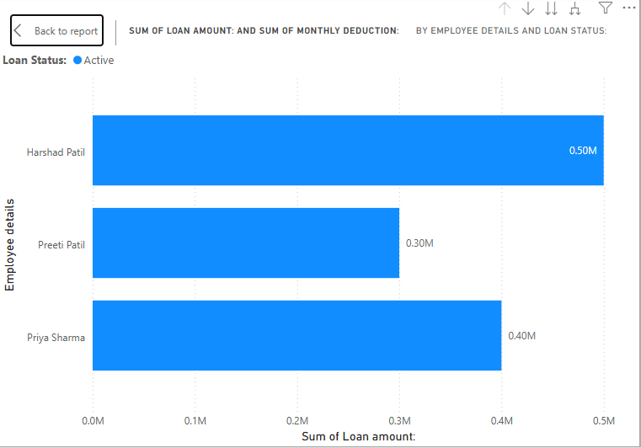

**Loan Repayment Report**-

Tracks loan repayments, including deductions from employee salaries and remaining loan balance.

|  |  |  |  |  |  |  |  |  |
| --- | --- | --- | --- | --- | --- | --- | --- | --- |
| Employee details | Loan amount | Disbursement Date | Monthly Deduction | Total Paid | Remaining Balance | Last Payment Date | Next Payment Date | Loan Status |
| Harshad Patil | 5,00000 | 21-Feb-2020 | 22,000 | 2,50,000 | 2,75,000 | 1-Feb-2025 | -March-2025 | Active |
| Preeti Patil | 3,00,000 | 21-Feb-2021 | 18,500 | 1,48,000 | 1,50,000 | 1-Feb-2025 | -March-2025 | Active |
| Priya Sharma | 4,00,000 | 27-01-2025 | 20,000 | 2,00,000 | 2,00,000 | 1-Feb-2025 | -March-2025 | Active |

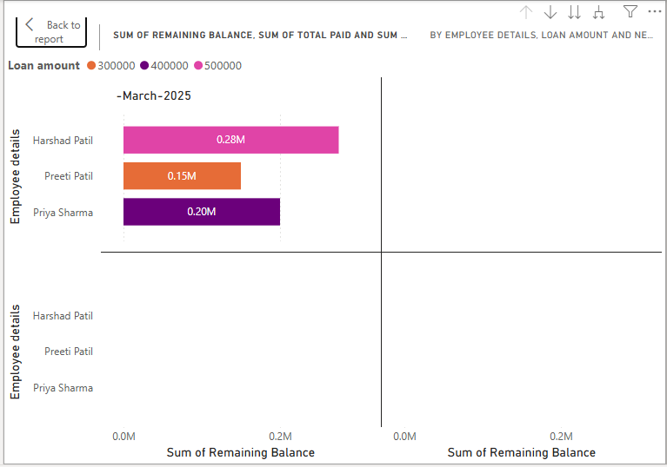

**Outstanding Loan Report-**

Shows the list of employees with pending loan amounts and their repayment status.

|  |  |  |  |  |  |  |  |  |
| --- | --- | --- | --- | --- | --- | --- | --- | --- |
| Employee details | Loan amount | Disbursement Date | Monthly Deduction | Total Paid | Remaining Balance | Overdue Amount: | Due Date | Loan Status |
| Harshad Patil | 5,00000 | 21-Feb-2020 | 22,000 | 2,50,000 | 2,75,000 | 0 | 1-March-2025 | Active |
| Preeti Patil | 3,00,000 | 21-Feb-2021 | 18,500 | 1,48,000 | 1,50,000 | 0 | 1-March-2025 | Active |
| Priya Sharma | 4,00,000 | 27-01-2025 | 20,000 | 2,00,000 | 2,00,000 | 1000 | 1-March-2025 | Active |

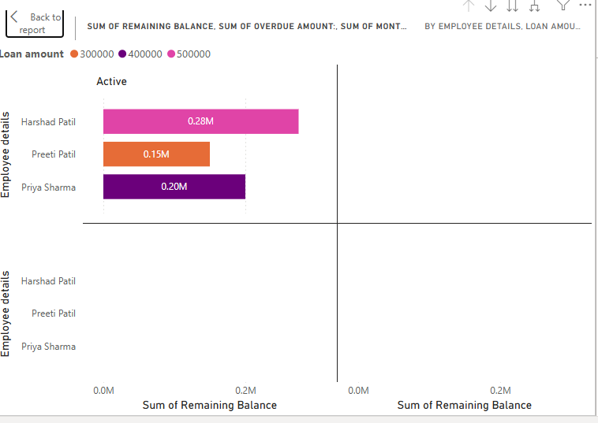

**Loan Approval & Rejection Report**-

Summarizes the number of loans approved/rejected, including reasons for rejection.

|  |  |  |  |  |
| --- | --- | --- | --- | --- |
| Employee details | Requested Loan amount | Approved Loan amount | Approval Status | Rejection Reason (If Any) |
| Harshad Patil | 5,00000 | 5,00000 | Approved | NA |
| Preeti Patil | 3,00,000 | 3,00,000 | Approved | NA |
| Priya Sharma | 4,00,000 | 4,00,000 | Approved | NA |
| Pooja Patil | 7,00,000 | 0 | Rejected | Low Credit Score & Limited Salary |

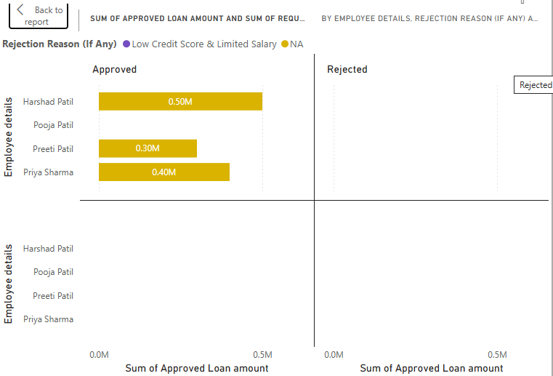

**Salary Deduction Report-**

Details of loan-related salary deductions made for each employee in a given period.

|  |  |  |  |  |  |  |
| --- | --- | --- | --- | --- | --- | --- |
| Employee details | Approved Loan amount | Basic Salary | Monthly Deduction | Remaining Loan Balance | Due Date | Net Salary After Deduction |
| Harshad Patil | 5,00000 | 70,000 | 22,000 | 2,75,000 | 1-March-2025 | 48,000 |
| Preeti Patil | 3,00,000 | 70,000 | 18,500 | 1,50,000 | 1-March-2025 | 52,000 |
| Priya Sharma | 4,00,000 | 60,000 | 20,000 | 2,00,000 | 1-March-2025 | 40,000 |

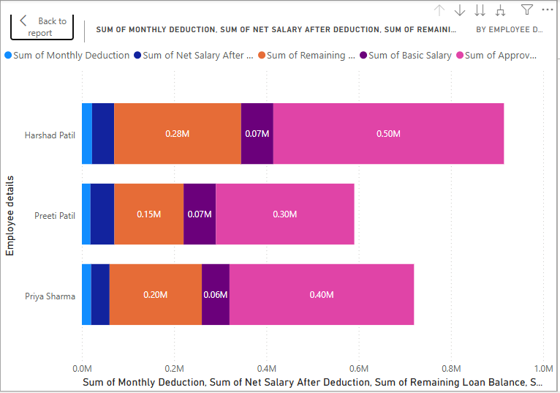

Q17. What is the structure of the message/mail communicated from the HR department to the employee in case the Loan is rejected? – 5 Marks

Answer-

Subject: Notification of Loan Application Rejection – [Loan ID]

Dear Pooja Patil,

We appreciate your interest in the Employee Loan Management System. After careful review of your loan application ([Loan ID: 003]) submitted on 31-01-2025, we regret to inform you that your loan request has been rejected due to the following reasons-

Rejection Reason: You have Low Credit score and Limited Salary.

We understand that this may be disappointing, and we encourage you to review your eligibility criteria before reapplying. If you have any questions or require further clarification, please feel free to reach out to the HR department at [Hr@TTS.com](mailto:Hr@TTS.com) (8685747825).

Thank you for your understanding.

Best regards,

HR. Dipti Naik

HR Department

TTS Company

Q18. What is the structure of the message/mail communicated from the HR department to the employee in case the Loan is approved? – 5 Marks

Answer-

Subject: Loan Approval Confirmation – 002

Dear Neha Shewale,

We are pleased to inform you that your loan application (Loan ID: 002) submitted on 28-12-2024 has been approved as per the Employee Loan Management System policy. Below are the details of your loan:

Loan Details-

Approved Loan Amount: 30,0000

Interest Rate: 8%

Repayment Tenure: 34 Months

Monthly Deduction: 20,000/- EMI

Deduction Start Date: [01-03-2025]

Attached to this email, you will find the Loan Agreement, Terms & Conditions, and Repayment Schedule for your reference. Please review the documents carefully.

To proceed with loan disbursement, kindly reply to this email with "I Accept the Loan Terms" or provide a signed copy of the agreement by 18-02-2025.

If you have any queries, feel free to contact the HR department at [Hr@TTS.com](mailto:Hr@TTS.com) (8685747825).

Best regards,

HR. Dipti Naik

HR Department

TTS Company

Q19. Design a sample report on the Loans applications Received by the accounts department – 8 Marks

Answer-

|  |  |  |  |  |  |  |  |  |  |
| --- | --- | --- | --- | --- | --- | --- | --- | --- | --- |
| Employee Name | Employee ID | Loan ID | CTC (LPA) | Department | Loan Amount | Application Date | Approval Status | Approval/Rejection Date | Rejection Reason |
| Harshad Patil | 1004 | LN101 | 7 | IT | 500000 | 21-02-2020 | Approved | 21-02-2020 | NA |
| Preeti Patil | 1008 | LN102 | 7 | HR | 300000 | 21-02-2021 | Approved | 21-02-2021 | NA |
| Pooja Patil | 1011 | LN103 | 4 | Finance | 700000 | 12-12-2024 | Rejected | 30-12-2024 | Low Credit Score & Limited Salary |
| Nidhi Kasid | 1006 | LN104 | 5 | IT | 200000 | 24-01-2025 | Approved | 26-01-2025 | NA |
| Priya Sharma | 1018 | LN105 | 6 | HR | 400000 | 25-01-2025 | Approved | 27-01-2025 | NA |
| Rohit Verma | 1021 | LN106 | 12 | Finance | 800000 | 01-01-2025 | Approved | 10-01-2025 | NA |

Total Loan Applications Received- 6

Total Loans Approved – 5

Total Loans Rejected- 1

Total Requested Loan Amount – 29,00,000

Total Approved Loan Amount – 22,00,000

Common Rejection Reasons - Low Credit score and Limited Salary

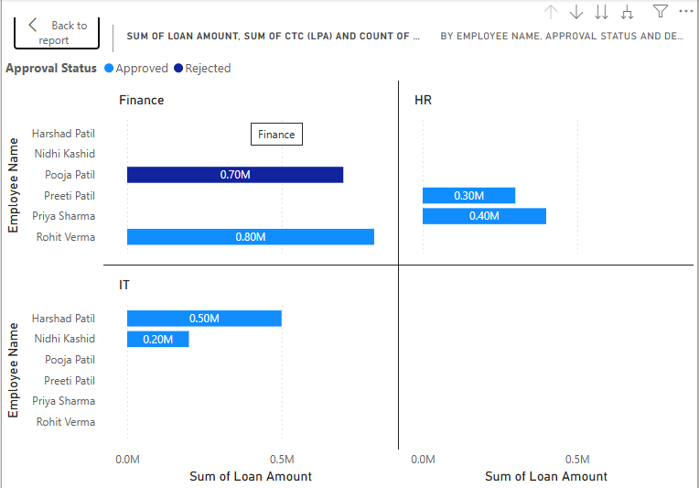

Q20. Which reporting Tools we will use for generating reports. – 5 Marks

Answer-

For generate report we used Power BI and Tubule tool.

Power BI is an interactive data visualization Software Product developed by Microsoft with primary focus on business intelligence.

It is collection of software service, Apps, and connectors that work together to turn your unrelated sources of data into coherent, visually immersive insights.

Power BI is useful to Develop new model in a familiar environment, Publish to organization for data collection with ease

Data Connectivity - Connects to various data sources, including Excel, SQL Server, SharePoint, Azure, Google Analytics, and third-party applications.

Real-Time Data Streaming - Allows live data monitoring for up-to-date business insights.

Tableau – It offers advanced data visualization, real-time reporting, and trend analysis. Tableau is a business intelligence (BI) and data visualization tool that helps organizations analyze and visualize data in an interactive, user-friendly, and dynamic way. It enables businesses to create insightful dashboards, generate real-time reports, and perform deep data analysis without requiring extensive technical expertise.

Data Connectivity - Connects to various data sources, including Excel, SQL Server, SharePoint, Azure, Google Analytics, and third-party applications.

Drag-and-Drop Interface - Simplifies the process of creating **charts, graphs, and dashboards** without coding