Capstone Project 3 part 1
Question 1-Draw the Use case diagram
Answer -
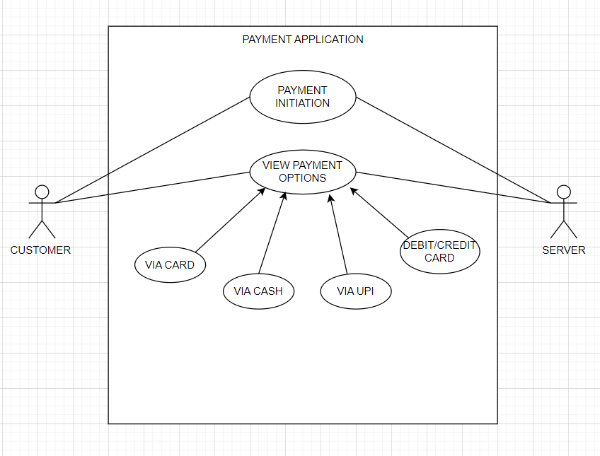

Question 2-Derive Boundary Classes, Controller classes, Entity Classes.
Answer -
Boundary class
Boundary Class used to handle interactions between the system and external actors Boundary Des
Ex: Payment Option Boundary Card Payment Boundary
Controller Class –
act as intermediaries between boundary and entity classes.
Ex: Payment initiated Controller Card Payment Controller
Entity Class –
represent the core data and business logic of the application.
Ex: Customer

Question 3 -Place these classes on a three tier Architecture
Answer -
Application Layer | Customer Registration  Customer Login  Bank Server Login
Business Logic Layer | customer
(Primary actors associated with the Boundary class | Bank server
Data Layer(All the entity classes) | Customer  Bank Server  Cash  Card  Net banking

In this three-tier architecture, the application tier handles the user interface, the
Business Logic Layer
manages the Business logic and coordinates between the other tiers, the data tier handles data storage and retrieval

Question 4- Explain Domain Model for Customer making payment through Net Banking
Answer-
Domain model is like the entity relationship model. The tables are connected to each other. The customer table is connected to bank table, which is why the customer is able to make payment. Customer table is also connected to payment table, because he should make the payment. Now the payment is done by net banking, so payment table is connected to net banking table. The account is in the bank, so the account table is connected to the bank table.
The authentication table is connected to both net banking table and bank table, because authentication is to performed there. Also the authentication table is connected to transaction table, because authentication will be done while transaction.
Difference between ER diagram and domain model-
ER Model – do not have attributes inside the box
Domain Model- do have attributes mentioned inside the box
ER Model – it is a data modelling technique used in database design to represent tables.
Domain Model- it is a conceptual model that represents real world entities.
ER Model – focuses on relationships required for storing and retrieving the data Domain Model- It focuses on capturing the behavior of application

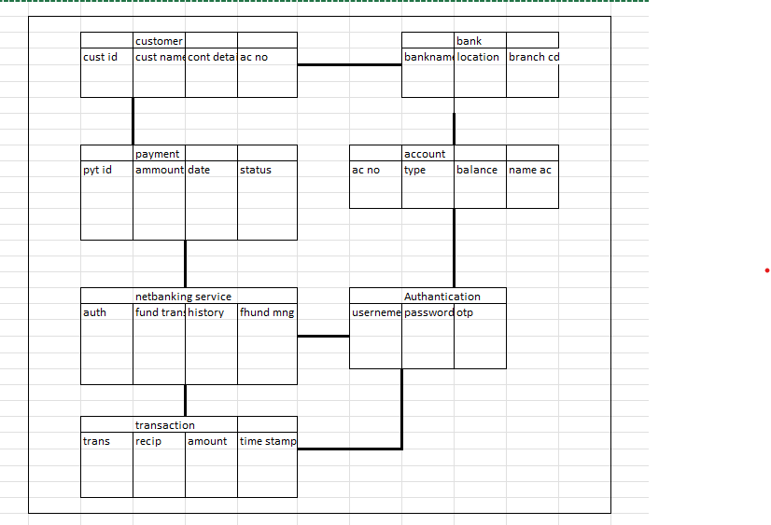

Question 5- Draw a sequence diagram for payment done by Customer Net Banking
Answer-
This diagram shows how the objects in the system interact and communicate with each other with time to achieve specific task. Developer will draw this. It is used to show the flow of messages, events or actions between the objects of the system. This diagram helps to visualize the behavior of the system.This diagram shows the process in detail

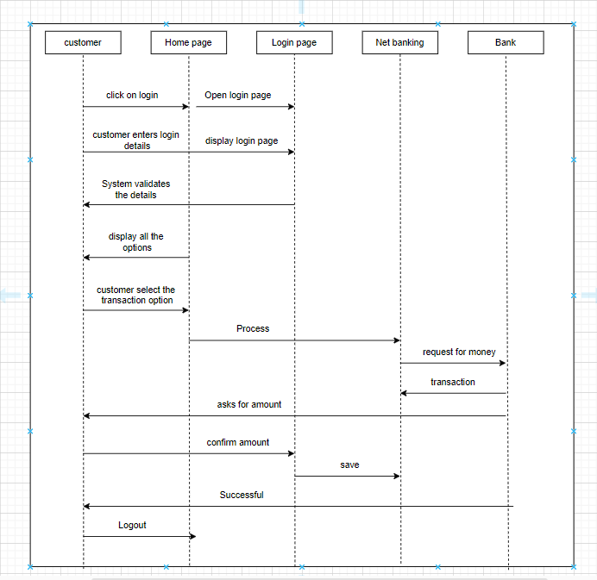

Question 6- Explain Conceptual Model for this Case
Answer -
The conceptual model helps in understanding the key concepts, their relationships, and the overall structure of the net banking payment system.It serves as a foundation for designing the database schema, defining the application architecture, and implementing the necessary functionalities within the system.
The relationships between the entities can be described as follows.
1.customer-this node represents the customers or the users of the net banking services.
2.Service awareness- customer should be aware of the available net banking and net banking services
3.privacy of data- It is important and significant that of this node is to protect the privacy and confidentiality of the customer.
4.trust and support- this node indicated that the bank provides the responsible off erring of the net banking.
5-Technology awareness- customer should be aware and ok with the technology used for the net banking.
6.Bank-this node represents service provider responsible for providing the net banking services.
7-Online information- this aspect highlights the importance of providing accurate and up to date online information about net banking services to customer.
8.security and privacy- the bank should adapt the security policies which will help the customer to keep their data related to the transaction secure and private.
9-Infrastracture- this component suggests that underlaying tech infrastructure including hardware and software systems play an important role in enabling net banking services.
10-Policies- node explains policies and regulations that govern the implementation and operation of net banking services
Question 7- What is MVC architecture? Explain MVC rules to derive classes from use case diagram and guidelines to place classes in 3-tier architecture
Answer -
MVC is a design pattern where, the application is divided into 3 logical parts- Model, View and Controller.
MVC architecture Rules-
1.Combination of one and a use case results in one boundary class.
2.Combination of two actors and use case results in two boundary class.
3.combination of three actors and use case results in three boundary class and so on
Note: only one primary actor is to be considered with a use case
4.use case will result in controller class
5.Each actor will results in on entity class.
Guidelines to place classes in 3-tier architecture
Presentation Layer-This layer is nothing but a user interface. View is inside this layer. These classes interact directly with the user. Presentation layer is responsible for displaying information and also receiving the input from the user.
Application Layer-This layer is nothing but business logic. Model and controller are inside this layer. Controller handles the user input, process the request and co-ordinates interaction between the model and view.
Data Layer- Classes which are responsible for data access and storage are in this layer. It contains the classes which interacts with the database, les and other data sources

Question 8- Explain BA contributions in project
Answer-
Waterfall model is useful in the situation where the project requirements are well detained and the project goals are clear. Waterfall model follows sequential approach.In this model each phase is completed entirely and then only moved to the next phase.Waterfall model relies on documentation to ensure that the project is well detained and project team is working toward clear goals.Ones that particular phase has been completed and ones we move to the next phase, we cannot go back to the previous phase to make changes. This model is stable for the projects when the requirements are clear.
Requirements Gathering-First, the stakeholders are identified. In this phase, all the requirements are gathered from the stakeholder.BA and Project Manager participates in this phase. After completing this phase, BRD will be generated
Requirements Analysis-The requirements are analyzed to understand the scope of the project. Analyzing means the BA will check all the requirements, if he founds conflicting requirements then the BA will talk to the concerned stakeholder to clear it, remove the ambiguous requirements
BA will prepare functional requirement. - The document which contains the functional requirements is called (FRS). [Functional Requirement Specifications]
Technical team will prepare non-functional requirement. - The document which contains the non-functional requirements is called (SSD). [Supplementary Support Document ]
BA will combine FRS and SSD to form SRS. [ Software Requirement Specifications]
BA will prepare RTM by referring SRS.
Design- After the requirements are cleared, Design phase starts.This has a detailed design documentthat outlines the software architecture, user interface, and system components.HDD, ADD and solution document will be generated here. [High level Design Doc.]BA Collaborate with designers, architects, and developers to translate requirements into system design.BA Ensure that the design aligns with the documented requirements and address stakeholder needs.
Development- The Development phase include implementation. It involves coding the software based on the design specifications. Programmers or developer are involved in this phase.Here BA acts as a mediator between the development team and the stakeholders.
BA clarifies the requirements, check if the development is going on right track or not.BA also participates in scrum meetings
Testing-In the testing phase, the software is tested as a whole to ensure that it meets the requirements and is free from defects.Testers are involved in this phaseTest documents are generated here.
BA works with the testing team to ensure that the solution meets the requirements.BA facilitate UAT.BA helps the users to know the functionality of the system and also helps them to use the system
Deployment- Once the software has been tested and approved, it is deployed to the production environment.BA ensures that there is smooth transition from development phase to the production phase.
Implementation- This is the final stage of waterfall model. It involves running the code for the very first time in production phase.Release manager handles this phase.BA will Update documentation and requirements specifications to reflect changes in the system over time
Maintenance- Running the code for second time in the production phase is called maintenance. This is done by support team

Question 9- What is conflict management? Explain using Thomas – Kilmann technique
Answer-
Conflicts can occur due to various reasons, such as differences in goals, values, personalities, resources, or communication breakdowns.Conflict is an inevitable part of any workplace. So it is important to resolve it to promote learning and growth.
Conflict management is nothing but the process of identifying and addressing conflicts in a healthy and constructive manner.It consists of strategies and techniques aimed at resolving disputes, disagreements, or differing perspectives among individuals or groupsBy identifying the conflicts efficiently, it will in turn be helpful to reduce negative impact and increase positive impact. It is a process or skill to find creative ways to handle the disagreement.
Thomas – Kilmann approach is widely used to recognize the approaches for conflict management

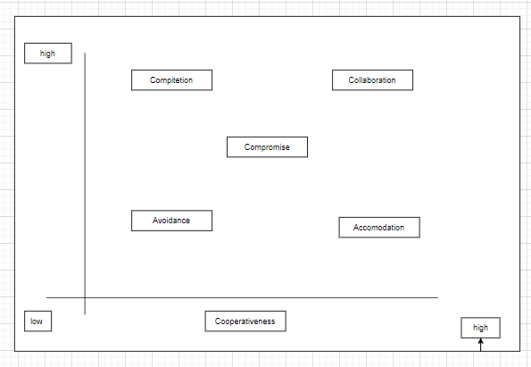

Y axis- assertiveness x axis- cooperativeness
High Assertiveness and High Cooperativeness– Collaboration- means working together to find solution
High Assertiveness and Low Cooperativeness– Competition- means defensive, that is standing for your individual beliefs and trying to win.
Low Assertiveness and High Cooperativeness – Accommodation- stakeholder will prioritize their needs over others.
Low Assertiveness and Low Cooperativeness– Avoidance- means ignoring the conflict
Assertiveness- the extent to which the person attempts to satisfy his own concerns. Cooperativeness- the extent to which the person attempts to satisfy the other persons concerns

Question 10- List down the reasons for project failure
Answer-
Reasons for project failure are:
Improper requirement gathering-
If the requirements of the project are not gathered correctly, then this can lead to project failure
Lack of stakeholder involvement-
A project can fail if the stakeholders are not participating in the process. The stakeholders input and feedback plays very important role to meet the goals.
Ineffective or less communication-
If there are communication issues between stakeholders, team members then this can lead to misunderstandings or delays in project or even can lead to project failure.

Continuous change in the requirement-
if the requirements keep on changing frequently, this can also lead to project failure. Because the scope of the project will also keep on changing which will lead to project failure.
Poor risk management-
Poor risk management can also lead to project failure. The team fails to identify the risks and do the risk mitigation, which can lead to unexpected challenges or delays in project. Lack of user involvement. Lack of executive support.
Unrealistic expectations-
means the goals that cannot be achieved or the goals that are out of scope
Improper planning-
The project can fail if the planning is not done properly.
The milestones, goals should be discussed. If there is no proper planning, then team may face difficulties in addressing the issues or to track the progress.
Insufficient resources-
Insufficient resources can also lead to project failure. The project may fail due to lack of technology knowledge or lack of nances

Question 11- List the Challenges faced in projects for BA
Answer-
Lack of training.
Obtaining sign-off on the requirement.
Change management. - Co-ordination between developers and testers.
Conducting meeting. Making sure status report is effective.
Driving clients for UAT completion. Making sure that the project is going on right track and delivered as per the timelines without any issues.
Gathering clear and unambiguous requirements can be challenging.
Unable to understand what stakeholder is trying to convey.
Scope creep- change in requirement or scope of the project during the project lifecycle can lead to scope creep.
Managing the stakeholder with conflicting interest can be a difficult task for BA.
BA may face difficulties in understanding the requirements if the domain is not familiar to him.
Poor communication between stakeholder and BA can affect the process of gathering the information.
Technical complexity

Question 12- Write about Document Naming Standards
Answer-
[ProjectID][Document Type]V[x]D[y].extention
Example- [PQ777FRDV1D1.docx] or [PQ777FRD1.1.docx]
Question 13- What are the Do’s and Don’ts of a Business analyst
Answer-
DO’s
Never say “NO” to the client.
There is no word called as “BY DEFAULT”.
Never imagine anything in terms of GUI.
Question everything in the world.
Go to the client with plain mind i.e. with no assumptions.
Listen to the client very carefully and after he is done, then ask question.
DONT’S
Don’t interrupt the client.
Never try to give solutions to the client right away.
Try to concentrate only on important and required things.
Be like a lotus in mud- if a client comes with a fancy requirement, then talk to the project manager first.
Requirement hurried project buried.
Never criticize the stakeholder.
Always appreciate the stakeholder even for small efforts

Question 14- Write the difference between packages and sub-systems
Answer-
Packages- it is a group of classes or use cases that are used to organize model elements.Packages can be nested within other packages.These are used as containers to organize elements.It is very useful to represent system architecture

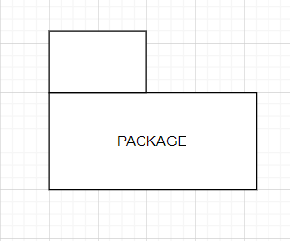
Subsystems- it is logical grouping of related components.
It is collection of classes, packages, libraries and other sub systems that work together to deliver a specific set of functionalities.

Question 15- What is camel-casing and explain where it will be used
Answer-
Camel-casing refers to the naming convention of variable, parameters or properties.
Here, multiple words are combined together.In camel-casing, the starting letter of first word starts with small letter and other words first letter starts with capital letters.
Ex- first Name, last Name
In BA, camel-casing is used in requirements documentation.
In requirement documentation, BA often use camel-casing to name the entities like use case, features, user stories like validate Customer Details, calculate Interest Rate, etc
Business rules, which should be satisfied by the system use camel-casing. While documenting business process or workflows, camel-casing can be used to individual in steps. This will help maintain consistency in the document. The database tables name also uses camel-casing.
Requirement naming- camel casing is used in requirement document also, to name the functional and non-functional requirements. By using camel casing in the documents, it helps to maintain consistency in the entire document and also increases readability
Question 16- Illustrate Development server and what are the accesses does business analyst has?
Answer-
A development server refers to a dedicated environment that is used during the software development process.It provides platform for the developers and the testers to build, test, develop and debug the application.
The accesses a BA has are-Read Only- BA’s may be granted with the read only access to the development server . This will allow them to view the user interface of the application, navigate through the features and also they will be able to observe the behavior of the application.
Limited Access-Depending upon the project needs, the BA’s will be granted limited access to the specific modules in the application.
Limited Configuration Access- Means BA have the authority to make changes in certain areas of application where they have the access.

Question 17- What is Data Mapping.
Answer-
The database contains multiple tables in it.
There may come a scenario, where we need to map the data from one table to another.Data mapping is necessary in cases where we want quick manner.Data mapping is nothing but a process to establish connection between multiple data sources.The purpose of data mapping is to ensure that the data is accurately transferred or converted into different format.
The main purpose of data mapping is-
Data integration-While combining the data from different sources, it ensures that the data is properly matched.
Data Migration-While migrating the data from legacy system(source) to the new system(destination), the data elements are mapped accurately into the new system. Required techniques are applied to covert the data into the format that is required by the new system.
Data Transformation-Data transformation means converting the data from one format to other. In data mapping, data transformation plays very important role which ensures that the data of legacy system(source) is mapped correctly to the data in new system(destination).

Question 18- What is API. Explain how you would use API integration in the case of your application Date format is dd-mm-yyyy and it is accepting some data from Other Application from US whose Date Format is mm-dd-yyyy.
Answer-
API stands for Application Programming Interface.
It is a software intermediary that allows the two applications to communicate with each other.
It is the set of rules, protocols and tools that define how different software application should interact with each other.
API allows sharing of only necessary information and keeps the internal system details hidden, which helps the system security.
For the above scenario,Establish API communication- set up API communication between your application and other application to exchange data.
Do Data forming- while sending the data from one application to other, convert the date format rom dd-mm-yyyy to mm-dd-yyyy.

