**Capstone Prep 2: Online Agriculture Product Store**

**Question 1: Create 5 Quarterly**

|  |  |
| --- | --- |
| **Stage** | **Quarter 1 Audit Report – (Requirement gathering phase)** |
| Completed | 10 weeks |
| Checklist | Conducted interviews and requirement gathering workshop |
|  | Requirements gathered from stakeholders |
|  | Requirement were documented in BRD |
|  | Duplicated documents were reported |

|  |  |
| --- | --- |
| **Stage** | **Quarter 2 Audit Report – (Requirement analysis phase)** |
| Completed | 7 weeks |
| Checklist | Requirements were well -defined and aligned with the project’s scope |
|  | Validated requirements with technical and non-technical teams |
|  | Validated UML and activity diagrams |
|  | Sign off from client |

|  |  |
| --- | --- |
| **Stage** | **Quarter 3 Audit Report – (Design phase)** |
| Completed | 7 weeks |
| Checklist | User friendly design was proposed considering remote area farmers |
|  | Reviewed design artifacts with stakeholders |
|  | Captured evidence on client communication |
|  | Feedback from stakeholder |

|  |  |
| --- | --- |
| **Stage** | **Quarter 4 Audit Report – (Development phase)** |
| Completed | 20 weeks |
| Checklist | Backend APIs and database integration done |
|  | Key features such as login, search, purchase functionalities are done |
|  | BA and developer MOM done |
|  | Critical feature implementation |

|  |  |
| --- | --- |
| **Stage** | **Quarter 4 Audit Report – (Testing phase)** |
| Completed | 20 weeks |
| Checklist | Test case summary |
|  | Test execution |
|  | Test exit report |
|  | High priority defects are promptly addressed |

**Question 2: BA Approach Strategy**

**Elicitation techniques:**

* **Interviews:** One on one discussion with stakeholders to extract insights
* **Workshops:** Group brainstorming sessions to define and prioritize requirements
* **Observation:** Shadowing users to understand real world processes and workflows
* **Surveys/Questionnaires:** Disturbed forms to collect feedback from larger groups
* **Prototyping:** Visual models to validate and refine requirements
* **Document Analysis:** Review existing documentation to extract relevant information

**Stakeholder Analysis:** Identify key stakeholders and classify them based on RACI matrix. The RACI matrix is useful in project management, helping ensure accountability and clear communication among stakeholders

* Responsible(R): Performs the task
* Accountable(A): Owns the outcome
* Consulted(C): Provides the input
* Informed(I): Needs updates

**Documentation:**

Key deliverables include:

* **Business requirement document (BRD):** It’s a document explaining what the business needs or the goal you want to achieve. Outlines functional and non-functional requirements
* **Functional Requirement Document (FRD**): This tells developers how the system should work to meet the needs in the BRD. It’s like a detailed instruction manual for building the software.
* **Use Case Documents:** This document shows how a user interacts with the system to get something done
* **Test Case Document:** Used by testers to check if the system is working correctly. It includes specific tests, what to look for, and whether things pass or fail.
* **Requirement Traceability Matrix (RTM**): Ensures requirements align with deliverables
* **Change Request Log**: Documents and tracks changes requested during the project

**Sign off on the document:**

Business Analyst prepares the SRS based on elicited requirements, then submits the final SRS to Mr.Henry and CSR committee for approval. Stakeholders provides approval via email or project management tool (JIRA, Confluence etc.). Formal sign off is recorded and uploaded to central repository with version.

**Approval from the client:**

* Understand their needs and expectations clearly.
* Present your materials professionally, highlighting key details and aligning with their goals.
* Request feedback and show willingness to adjust based on their input.
* Set a polite deadline for approval to ensure the project stays on track.
* Confirm approval in writing for documentation and clarity.

**Communication channels to establish and implement:**

To facilitate seamless collaboration, need to implement

* **Weekly status report**: Sent via emails or dashboards
* **Stakeholder meetings**: Biweekly virtual calls
* **Project management tools**: Use platforms like Jira or Trello for Tracking progress
* **Instant Messaging Forums**: Teams or Slack for real time discussion

**Handling Change Request:**

* Document change request: Capture details with justification
* Impact analysis: Assess effects on timeline, budget and scope
* Approval workflow: Review with stakeholders before implementation
* Update system and notify stakeholders: Implement the change and communicate updates

**Update the progress of the project to Stakeholders:**

* Dashboard Reports: Real time project insights for transparency
* Monthly progress review meetings: Comprehensive status updates and feedback incorporation

**UAT and Project Acceptance**

* Conduct User Acceptance Testing
* Resolve issues and document feedback
* Obtain sign -ff from stakeholders via the client project acceptance form

**Question 3: Three tire architecture**

This divides the application into 3 logical layers:

1. Application Layer: Topmost layer of the architecture – also known as Presentation layer. It handles user interface components such as screens, pages. E.g.: ecommerce website
2. Business logic layer: middle layer of the architecture – act as intermediary between presentation layer and the data storage layer – layer contains the core logic of the application. E.g.: Payment gateways
3. Database layer: Bottom most layer of the architecture. Responsible for storing and retrieving data. E.g.: MySQL, Oracle database.

**Question 4: Write about the approach strategy for framing questions?**

When framing questions for stakeholders, a business analyst should consider the following key aspects and methodologies to ensure clear, structured and relevant communication:

1. **5W1H Approach:**

* Who: Find out the people involved. E.g.: Who will use this product?
* What: Understand what the scope, features, and functionalities is required. E.g.: What features should the product have?
* When: Clarify timelines and priorities for deliverables E.g.: When should this be completed?
* Where: Address location specific requirements, such as regional customization
* Why: Understand the purpose or reason. E.g.: Why is this product important?
* How: Discuss the process of implementing solutions and any associated challenges. E.g.: How will the product work?

1. **SMART criteria:**

* Specific: Focused and clear about what is needed
* Measurable: Ask about quantifiable goals, such as performance metrics
* Achievable: Verify feasibility based on resources and constraints
* Relevant: Align with business objectives and stakeholder needs
* Time bound: Understand deadlines and delivery expectations

1. **RACI Matrix:**

* Responsible: The person or team who does the work to complete the task
* Accountable: The person who ultimately approves the work and ensures it’s completed successfully. There can only be one accountable person per task
* Consulted: People whose input is needed before the task is completed, these are often subject matter experts
* Informed: People who need to be kept in the loop about progress or results, but don’t contribute directly

1. **3 - Tier Architecture:**

* Presentation layer: Ask about user interface requirements, accessibility and user experience
* Application Layer: Clarify the functionalities and workflows needed
* Database layer: Discuss data storage, retrieval and security needs

1. **Use Case and Use Case Specifications:**

* Frame scenario-based questions to define user interactions with the system.
* Validate use cases with stakeholders to confirm that they meet real world needs.

1. **Activity Diagrams and Models:**

* Activity diagrams is drawn to model how the system should function to achieve business logic, business functionality and business objectives
* Models: Its simplified representation of how something works or is structured. UML diagrams are used to represent system components and relationship.

1. **Page Design:** Discuss layout, navigation and user experience to ensure the design meets stakeholder expectations

**Question 5: Write about the various elicitation techniques you learnt in the workshop?**

* **Brainstorming**: Brainstorming can be done either individually or in groups. Participants share ideas freely, fostering innovation. The ideas collected during the brainstorming session are reviewed or analyzed. Relevant points are included within the system requirement.
* **Document** **analysis**: Document analysis is done through reading a document and understanding the product, process and project. It involves examining existing document, such as project reports, manual and process flows to understand the product, process and project context.
* **Reverse engineering**: It’s also called back engineering. Reverse engineering involves analyzing existing software code to extract implemented requirements. It is useful for understanding legacy systems and documenting their functionalities.
* **Focus groups:** It involves gather key stakeholders and subject matter experts to discuss their perspectives.
* **Observations**: Observing users in their natural environment provides real world insights into their process, challenges and needs. This can be passive (watching) or active (engaging with users).
* **Workshops**: Workshop is a structured way to capture requirements. A workshop may be used to scope, discover, define, prioritize and reach closure on requirements for the target system. It’s one of the most effective way to deliver high quality requirements.
* **JAD**: It’s an extended, facilitated workshop. : It involves collaboration between developers, stakeholders, and business analyst to define and refine requirements. It encourages active participation and minimizes miscommunication
* **Interview:** Conducting one on one or group interviews with stakeholders helps gather detailed information about their needs, expectations and constraints.
* **Prototype**: Creating visual or working prototypes of the system allows users to interact with it and provide feedback. This iterative process ensures alignment between the system and user expectations.
* **Questionnaire**: This involves preparing structured surveys or questionnaires to gather quantitative and qualitative data from a large audience quickly and efficiently
* **Use case spec:** This technique defines user interactions with the system through use cases. It identifies user roles, scenarios and system responses, ensuring all functional aspects are captured.

**Question 6: Which elicitation technique will you use in this project? Justify your opinion?**

* **Workshops**: Highly beneficial for engaging key stakeholders such as farmers, distributors, potential customers and the development team. It allows for collaborative brainstorming on features like product categorization, delivery logistics, payment options, and user-friendly interfaces. This technique also ensures alignment among stakeholders on the overall vision and priorities of the store.
* **Surveys**: Thes are ideal for gathering insights from boarder audience, such as farmers and customers. Surveys can help to identify popular products, preferred payment methods, shipping options, pricing expectations etc.
* **Observations**: Observing existing agricultural markets or competitor platforms could help uncover best practices

**Question 7: Write 10 business requirements?**

* BR001: Farmers should be able to search for agriculture products like fertilizers, seeds and pesticides.
* BR002: Farmers should be able to register and create an account on the platform.
* BR003: Companies should be able to list their products with descriptions and pricing.
* BR004: Farmers should be able to place orders for the products they need
* BR005: The platforms should allow secure payment transactions
* BR006: Farmers should be able to track their orders and delivery status
* BR007: The platform should support communication between farmers and companies
* BR008: Users should be able to provide feedback and rate products they purchase.
* BR009: The platform should provide seasonal recommendations for fertilizers, seeds, and pesticides based on crop type and farming region
* BR010: Stakeholders should be able to access reports on sales and platform performance.

**Questions 8: Write 4 assumptions based on project?**

1. Targeted customers will have stable internet access to browse and place orders
2. The store will have consistent access to agricultural products
3. There will be a consistent demand for agricultural products online
4. The business will adhere to all agricultural trade laws, ecommerce regulations and taxation policies
5. The website or mobile app will operate smoothly, without frequent downtimes or glitches

**Question 9: Project requirement priority**

|  |  |  |  |
| --- | --- | --- | --- |
| Reg ID | Requirement name | Requirement description | Priority |
| BR001 | Product search | Users should be able to search for products | 8 |
| BR002 | User registration | Users should be able to register and create an account | 10 |
| BR003 | Product listing | Companies should be able to list their products with descriptions and pricing | 8 |
| BR004 | Place orders | Users should be able to place orders | 8 |
| BR005 | Payments | Platform should allow secure payments transaction | 10 |
| BR006 | Order tracking | User should be able to track their orders and delivery status | 9 |
| BR007 | Communication | Platform should support communication between farmers and companies | 7 |
| BR008 | Feedback and ratings | User should be able to provide feedback and rate the products they purchase | 7 |
| BR009 | Seasonal recommendations | Platform should provide seasonal recommendations based on crop type and farming region | 6 |
| BR010 | Reports and Analytics | Stakeholders should be able to access reports on sales and platform performance | 7 |

**Question 10: Prepare a use case diagram?**

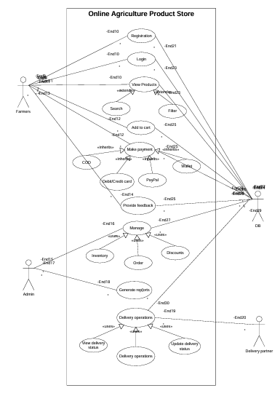

**Question 11: Prepare 5 use case specification document**

**User Registration:**

|  |  |  |
| --- | --- | --- |
| Use case id: | USECASE_01 | |
| Use case name | User Registration | |
| Create by | Shruthi | Date:4/11/2025 |
| Updated by | Shruthi | Date:5/11/2025 |
| Actors involved | Farmers, Companies, Admin | |
| Brief Description | This use case allows new users (farmers and companies) to register on the platform and create an account to access its features | |
| Pre-condition | The user has access to the internet and a compatible device | |
| Post-condition | The user’s account is successfully created, and they can login in | |
| Normal flow | Step 1: Navigate to the registration page  Step 2: Enter required information (name, email, phone number, etc.)  Step 3: Choose account type (Farmer/company)  Step 4: Set a password  Step 5: Submit the registration form | |
| Alternate flow | User may sign up using third party integrations (e.g. social media) | |
| Exceptions | Invalid information entered (e.g. email already registered) | |
| Frequency of use | Once per user | |
| Assumptions | Users have basic literacy and access to personal information | |

**Product Search:**

|  |  |  |
| --- | --- | --- |
| Use case id: | USECASE_02 | |
| Use case name | Search products | |
| Create by | Shruthi | Date:4/11/2025 |
| Updated by | Shruthi | Date:5/11/2025 |
| Actors involved | Farmers, Companies | |
| Brief Description | This use case enables users to search for agriculture products available on the platform | |
| Pre-condition | User must be logged in | |
| Post-condition | Relevant products are displayed based on the search query | |
| Normal flow | Step 1: Navigate to the search bar on the home page  Step 2: Enter product name or category  Step 3: Apply filters if needed (price, brand etc.)  Step 4: Click Search button  Step 5: View the search result | |
| Alternate flow | Use voice search functionality | |
| Exceptions | No matching products found for the query | |
| Frequency of use | Multiple times daily | |
| Assumptions | A comprehensive product database is maintained | |

**Add products to cart:**

|  |  |  |
| --- | --- | --- |
| Use case id: | USECASE_03 | |
| Use case name | Add products to cart | |
| Create by | Shruthi | Date:4/11/2025 |
| Updated by | Shruthi | Date:5/11/2025 |
| Actors involved | Farmers | |
| Brief Description | Users can add products they wish to purchase into their shopping cart | |
| Pre-condition | Users must be logged in and viewing a product page | |
| Post-condition | Selected products are successfully added to the cart | |
| Normal flow | Step 1: Open the product detail page  Step 2: Select quantity and variant (if applicable)  Step 3: Click on Add to cart button  Step 4: Confirm cart addition  Step 5: View updated cart | |
| Alternate flow | User may add products directly from the search results page | |
| Exceptions | Out of stock products cannot be added to the cart | |
| Frequency of use | Daily or as needed | |
| Assumptions | The inventory is updated in real time | |

**Make payment:**

|  |  |  |
| --- | --- | --- |
| Use case id: | USECASE_04 | |
| Use case name | Make a payment | |
| Create by | Shruthi | Date:4/11/2025 |
| Updated by | Shruthi | Date:5/11/2025 |
| Actors involved | Farmers | |
| Brief Description | Users can make payments for products in their cart | |
| Pre-condition | Products must be in cart | |
| Post-condition | Payment is processed and confirmation is provided | |
| Normal flow | Step 1: Navigate to the cart and click “Checkout”  Step 2: Enter the payment details (card/bank information)  Step 3: Review payment summary  Step 4: Confirm payment  Step 5: Receive payment confirmation and invoice | |
| Alternate flow | Use third party payment services (e.g. PayPal, UPI) | |
| Exceptions | Transaction failure due to network issues or incorrect credentials | |
| Frequency of use | Daily or as needed | |
| Assumptions | Secure payment gateways are implemented | |

**Delivery:**

|  |  |  |
| --- | --- | --- |
| Use case id: | USECASE_05 | |
| Use case name | Delivery | |
| Create by | Shruthi | Date:4/11/2025 |
| Updated by | Shruthi | Date:5/11/2025 |
| Actors involved | Farmers, Delivery partners | |
| Brief Description | Products purchased are delivered to the farmer’s location | |
| Pre-condition | Payment has been successfully processed | |
| Post-condition | Products are delivered to the user | |
| Normal flow | Step 1: Confirm delivery address  Step 2: Choose delivery options (standard/express)  Step 3: Track shipment status  Step 4: Receive delivery status  Step 5: Acknowledge receipts of products | |
| Alternate flow | User may reschedule delivery | |
| Exceptions | Delivery delays due to external factors (weather etc.) | |
| Frequency of use | Daily or as needed | |
| Assumptions | Reliable logistics partners are involved | |

**Question 12: Please prepare 5 activity diagrams**

User registration

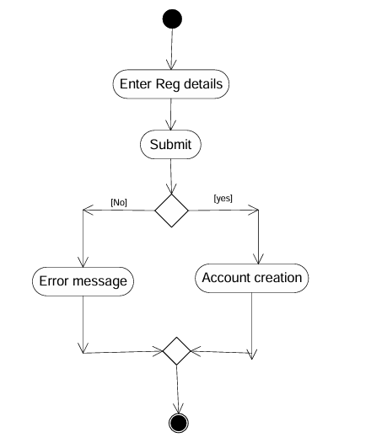

Search products

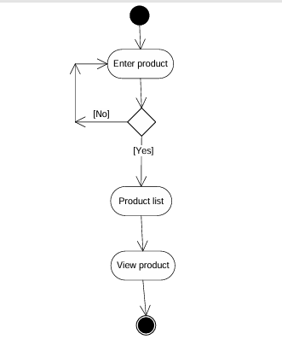

Add product to the cart

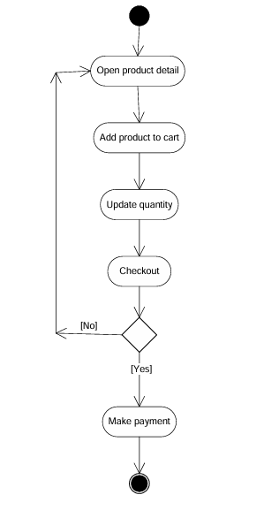

Making a payment

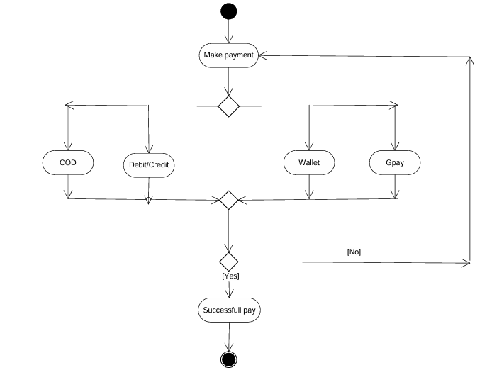

Delivery

