Question 1 – Functional Requirements

Identify minimum 20 functional requirements:

Answer:-

Functional requirement:

Functional requirement define the specific behaviour, functions, or operation of a system. These requirements describe how the system should behave and what it should do in terms of its operations, processes and interactions. They provide detailed guidance for developers, designers and testers to build and evaluate the system.

For this case study, below are the Functional Requirements:-

|  |  |  |  |
| --- | --- | --- | --- |
| Req. ID | Req. name | Req. description | Priority |
| FR0001 | Farmer Registration | Farmer should be able to register themselves for procurement. | 10 |
| FR0002 | Farmer Login | Farmer should have valid user ID and password for login to access the website. | 10 |
| FR0003 | Manufacturer registration | Manufacturer should register themselves for selling their products. | 10 |
| FR0004 | Manufacturer login | Manufacturer should have valid user ID & password for using online agriculture store. | 10 |
| FR0005 | Manufacturer upload the product | Manufacturer should upload the product in product catalogue. | 10 |
| FR0006 | Farmer search product | Farmer can able to search the required product. | 9 |
| FR0007 | Farmer filter out product | Farmer can able to filter out the product from a list of product. | 9 |
| FR0008 | Display product details | Application should display the product details like product description, price, availability, delivery timeline and discount. | 8 |
| FR0009 | Add to wish list | Farmer should be able to add the product in wish list or mark as a favourite. | 8 |
| FR0010 | Add to cart | Farmer should be able to add the required product on cart. | 8 |
| FR0011 | Update the product which are in cart | Farmer can able to update the product quantity, add the product or cancel the product. | 8 |
| FR0012 | Place order | Farmer should be able to place the order successfully. | 10 |
| FR0013 | Various mode of payment | Application should have various payment modes. | 8 |
| FR0014 | Successful order | Farmer can place the order successfully for the selected product and after successful payment and confirming delivery address. | 10 |
| FR0015 | Track delivery | Farmer should be able to track the delivery status online. | 8 |
| FR0016 | Farmer return or exchange product | Farmer should be able to return or exchange the product if it is not as per their requirement. | 8 |
| FR0017 | Farmer give review about product | Farmer should be able to give review on web application about the procured product. | 7 |
| FR0018 | Show order history | Web application should be able to display list of the order has been placed by farmers. | 8 |
| FR0019 | Notify about recommended product & discount | Web application should notify farmers about recommended product and discounts of the agricultural products on time. | 6 |
| FR0020 | Secure transaction details | Web application must have secure farmer’s personal details and it should be encrypted and secured. | 10 |

Non-Functional Requirements:-

Non-Functional requirement: Non-functional requirement will describe the qualities and attributes of system, performance standard and constraints that a system or solution must meet. Unlike functional requirement which specify what the system should do, non-functional requirement describe how the system should perform under certain condition. It ensure that the system operates efficiently, securely and reliably and that it meets various stakeholder expectation related to user experience and operational needs.

|  |  |  |  |
| --- | --- | --- | --- |
| Req. ID | Req. name | Req. description | Priority |
| NFR0001 | Usability | The web application should be easy to navigate. | 9 |
| NFR0002 | Security | The web application must protect sensitive data and secure user authentication. | 10 |
| NFR0003 | Reliability | The web application should run without a critical failure for a given period. | 9 |
| NFR0004 | Performance | The web application must load the page in 3-4 seconds. | 8 |
| NFR0005 | Scalability | The web application must remain stable and maintain performance with more users, data, business processes, or modules. | 8 |
| NFR0006 | Portability | The web application should function properly on multiple devices to improve portability. | 8 |
| NFR0007 | Compatibly | The web application should be compatible with major web browser. | 8 |
| NFR0008 | Availability | The web application should have minimum downtime and ensuring that services are consistently available when needed. | 9 |
| NFR0009 | Maintainability | The web application should take minimum time for a solution if any error found. | 8 |
| NFR0010 | Automatic Log out. | If the page is not accessed for more than 5 minutes, the page should logout automatically. | 8 |

Question 2–Minimum 5 page designs

Make wireframe and prototypes:

Answer:-

What is Wireframe?

Wireframe is a basic skeletal outline of a design. It focus and layout and functionality.

What is Mockups?

More detailed visual representation of design with color, typography and other visual elements to give a realistic impression of product.

What is prototype?

Prototype is more interactive representation of a design, here it will allows the user to interact with the interface, and they can experience its functionality.

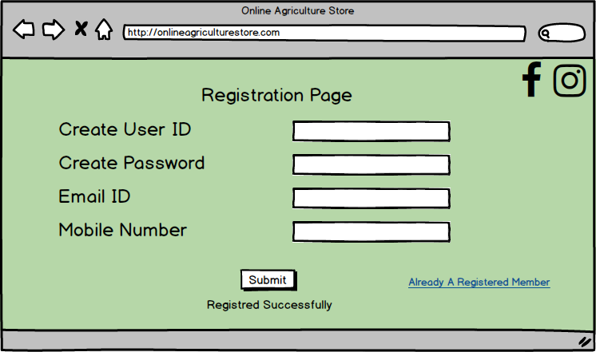

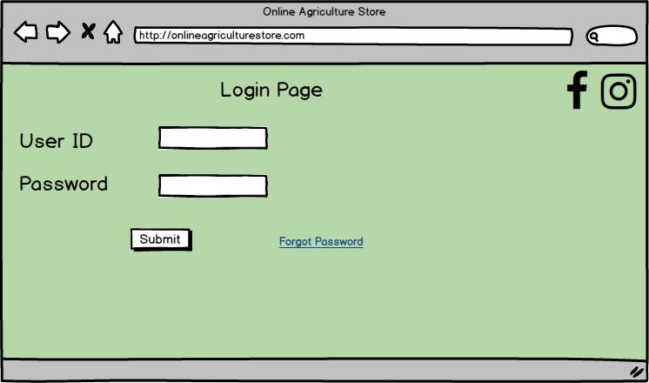

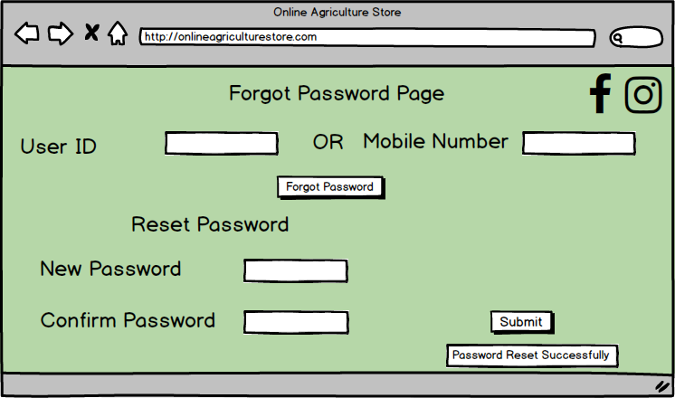

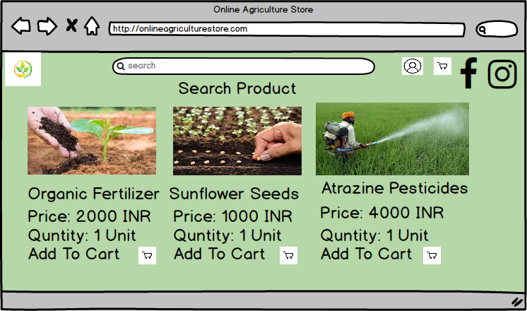

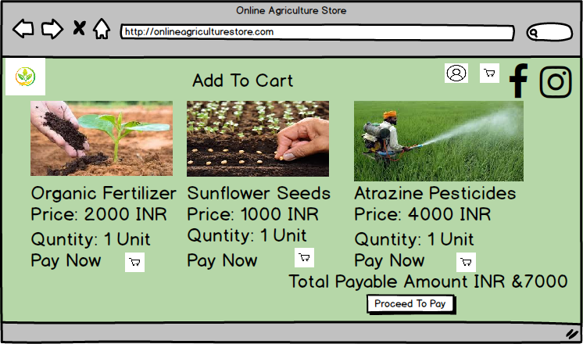

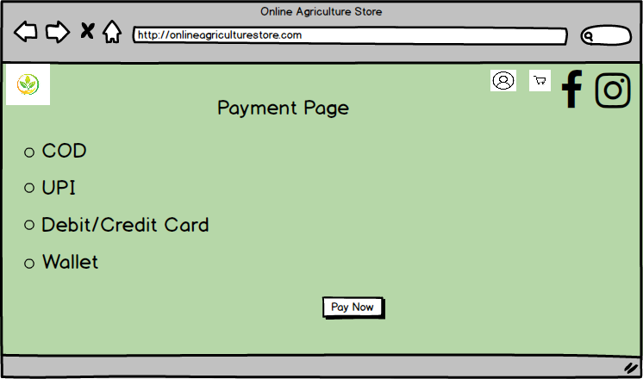

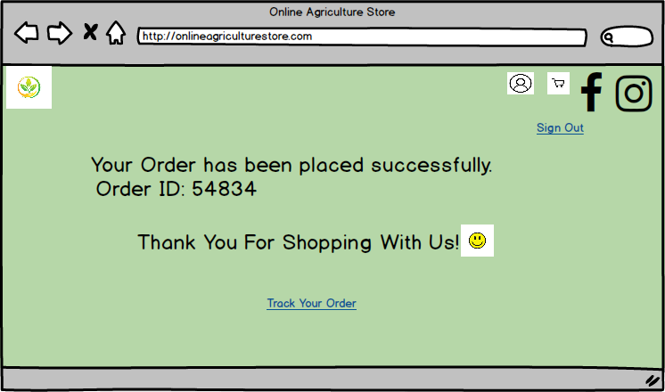

Question 3 – Tools (Visio, Balsamic)

Make a note of the Tools, which you are using for above concepts.

Business analytics tools are essential for visualizing and modeling the requirements and workflows of a project. Tools like MS Visio, Balsamiq, and Axure RP are widely used for creating diagrams and prototypes that help both the business analysts and the stakeholders understand the project's flow, user interaction, and functional requirements.

MS Visio: Microsoft Visio is software for drawing a variety of diagrams. These include flowcharts, org charts, building plans, floor plans, data flow diagrams, process flow diagrams, business process modelling, swimlane diagrams, 3D maps, and many more. Business Analyst can use this tool to represent and communicate complex business process, systems, workflows and organizational structure. It is helpful to analyse various aspects of business operations, enabling stakeholder to better understanding, evaluate and optimize the process.

Balsamiq: Balsamiq Cloud is a web-based user interface design tool for creating wireframes (sometimes called mockups or low-fidelity prototypes). You can use it to generate digital sketches of your idea or concept for an application or website, and to facilitate discussion and understanding before any code is written. The completed wireframes can be used for user testing, clarifying your vision, getting feedback from stakeholders, or getting approval to start development.

Axure RP: Axure RP is a leading wireframing and prototyping software that allows designers, developers, and product managers to create detailed wireframes, mockups, and prototypes. With its powerful features and easy-to-use interface, Axure simplifies the process of designing interactive and responsive web and mobile applications. It is compatible with Windows and macOS, and users can easily collaborate on projects through the Axure Cloud platform. Additionally, the software offers various functionalities, including drag-and-drop widgets, dynamic panels, animations, and conditional logic, thus easing the process of developing and validating complex design concepts.

These tools are key for ensuring that all aspects of the project are thoroughly planned and documented, making it easier to communicate requirements and expectations between the team and stakeholders.

Question 4 – RTM

A business analyst’s key responsibilities are to keep track of the requirements and make sure that no requirement is missed.

The Requirement Traceability Matrix (RTM) is a comprehensive document that links and tracks user requirements with corresponding test cases. It consolidates all client-proposed requirements and their traceability into one document, which is typically finalized at the end of the Software Development Life Cycle. The primary objective of the RTM is to ensure that all specified requirements are covered by test cases, thereby guaranteeing that no functionality is overlooked during the software testing process.

Here I will explain Mr. Henry & Mr. Peter about the status of the project using below RTM.

|  |  |  |  |  |  |  |  |  |  |  |  |  |
| --- | --- | --- | --- | --- | --- | --- | --- | --- | --- | --- | --- | --- |
| Req. ID | Req. name | Req. description | Design | D1 | T1 | D2 | T2 | D3 | T3 | D4 | T4 | UAT |
| FR0001 | Farmer Registration | Farmer should be able to register themselves for procurement. | Yes | Yes | Yes | Yes | Yes | Yes | Yes | Yes | Yes | Yes |
| FR0002 | Farmer Login | Farmer should have valid user ID and password for login to access the website. | Yes | Yes | Yes | Yes | Yes | Yes | Yes | Yes | Yes | Yes |
| FR0003 | Manufacturer registration | Manufacturer should register themselves for selling their products. | Yes | Yes | Yes | Yes | Yes | Yes | Yes | Yes | Yes | Yes |
| FR0004 | Manufacturer login | Manufacturer should have valid user ID & password for using online agriculture store. | Yes | Yes | Yes | Yes | Yes | Yes | Yes | Yes | Yes | Yes |
| FR0005 | Manufacturer upload the product | Manufacturer should upload the product in product catalogue. | Yes | Yes | Yes | Yes | Yes | Yes | Yes | Yes | No | No |
| FR0006 | Farmer search product | Farmer can able to search the required product. | Yes | Yes | Yes | Yes | Yes | Yes | Yes | Yes | No | No |
| FR0007 | Farmer filter out product | Farmer can able to filter out the product from a list of product. | Yes | Yes | Yes | Yes | Yes | No | No | No | No | No |
| FR0008 | Display product details | Application should display the product details like product description, price, availability, delivery timeline and discount. | Yes | Yes | Yes | Yes | Yes | No | No | No | No | No |
| FR0009 | Add to wish list | Farmer should be able to add the product in wish list or mark as a favourite. | Yes | Yes | No | No | No | No | No | No | No | No |
| FR0010 | Add to cart | Farmer should be able to add the required product on cart. | Yes | Yes | Yes | Yes | Yes | No | No | No | No | No |
| FR0011 | Update the product which are in cart | Farmer can able to update the product quantity, add the product or cancel the product. | Yes | Yes | No | No | No | No | No | No | No | No |
| FR0012 | Place order | Farmer should be able to place the order successfully. | Yes | Yes | Yes | Yes | No | No | No | No | No | No |
| FR0013 | Various mode of payment | Application should have various payment modes. | Yes | Yes | Yes | Yes | Yes | No | No | No | No | No |
| FR0014 | Successful order | Farmer can place the order successfully for the selected product and after successful payment and confirming delivery address. | Yes | Yes | Yes | Yes | Yes | Yes | Yes | Yes | No | No |
| FR0015 | Track delivery | Farmer should be able to track the delivery status online. | Yes | Yes | Yes | Yes | No | No | No | No | No | No |
| FR0016 | Farmer return or exchange product | Farmer should be able to return or exchange the product if it is not as per their requirement. | Yes | Yes | No | No | No | No | No | No | No | No |
| FR0017 | Farmer give review about product | Farmer should be able to give review on web application about the procured product. | Yes | Yes | No | No | No | No | No | No | No | No |
| FR0018 | Show order history | Web application should be able to display list of the order has been placed by farmers. | Yes | No | No | No | No | No | No | No | No | No |
| FR0019 | Notify about recommended product & discount | Web application should notify farmers about recommended product and discounts of the agricultural products on time. | No | No | No | No | No | No | No | No | No | No |
| FR0020 | Secure transaction details | Web application must have secure farmer’s personal details and it should be encrypted and secured. | Y | Y | Y | Y | N | N | N | N | N | N |
| NFR0001 | Usability | The web application should be easy to navigate. | Yes | Yes | Yes | No | No | No | No | No | No | No |
| NFR0002 | Security | The web application must protect sensitive data and secure user authentication. | Yes | Yes | Yes | Yes | No | No | No | No | No | No |
| NFR0003 | Reliability | The web application should run without a critical failure for a given period. | Yes | Yes | No | No | No | No | No | No | No | No |
| NFR0004 | Performance | The web application must load the page in 3-4 seconds. | Yes | No | No | No | No | No | No | No | No | No |
| NFR0005 | Scalability | The web application must remain stable and maintain performance with more users, data, business processes, or modules. | Yes | Yes | No | No | No | No | No | No | No | No |
| NFR0006 | Portability | The web application should function properly on multiple devices to improve portability. | Yes | Yes | Yes | No | No | No | No | No | No | No |
| NFR0007 | Compatibly | The web application should be compatible with major web browser. | Yes | Yes | Yes | Yes | Yes | No | No | No | No | No |
| NFR0008 | Availability | The web application should have minimum downtime and ensuring that services are consistently available when needed. | Yes | Yes | Yes | Yes | Yes | Yes | Yes | No | No | No |
| NFR0009 | Maintainability | The web application should take minimum time for a solution if any error found. | Yes | Yes | No | No | No | No | No | No | No | No |
| NFR0010 | Automatic Log out. | If the page is not accessed for more than 5 minutes, the page should logout automatically. | Yes | Yes | No | No | No | No | No | No | No | No |

Question 5 – 10 Test Case Documents

Answer:

A test case is a set of actions that verify whether the software application is working per the client’s requirements. It outlines the steps to follow, the input values to use, and the expected outcomes in order to determine whether the application behaves correctly under various conditions.

|  |  |  |  |
| --- | --- | --- | --- |
| Test Case ID | PQ570TEST01 | Test Case Name | User Registration |
| Project ID | PQ571 | Project Name | Online Agriculture Store |
| PM ID | Mr. Vandanam | Tester ID | 5845 |
| Test Strategy ID | PQ5701 | Tester Name | Mr. Jason |
| Test Plan ID | PQ5701 | Date of Test | 15-11-2024 |
| Test Scheduled ID | PQ5701 |  |  |
| Scenario | New user registration using name, mobile number, email ID and other basic details are required on web application | | |
| Link to that page | [www.onlineagriculturestore.com](http://www.onlineagriculturestore.com) | | |
| Pre-condition | User should have mobile/laptop/desktop computers with having strong internet connection. Website is working appropriately. | | |
| Post condition | Registration successful. Now user ID and password is generated and user can log into the web application. | | |
| Input data | Name, Mobile Number, Mail ID, Gender | | |
| Expected behaviour | Once user enters name, mobile number, mail ID, & create password, system should shows “User Created Successfully” | | |
| Actual behaviour | After entering required details, user clicks on Register button and the system shows “User Created Successfully” | | |
| Comments | NA | | |
| Result (Pass/Fail) | PASS | | |

|  |  |  |  |
| --- | --- | --- | --- |
| Test Case ID | PQ570TEST02 | Test Case Name | Login |
| Project ID | PQ572 | Project Name | Online Agriculture Store |
| PM ID | Mr. Vandanam | Tester ID | 5846 |
| Test Strategy ID | PQ5702 | Tester Name | Ms. Alekya |
| Test Plan ID | PQ5702 | Date of Test | 16-11-2024 |
| Test Scheduled ID | PQ5702 |  |  |
| Scenario | User can login in the web application using valid email ID and password. | | |
| Link to that page | www.onlineagriculturestore.com | | |
| Pre-condition | User should have registered themselves. | | |
| Post condition | After successful login user can search for the required agricultural products like seeds, fertilizer & pesticides. | | |
| Input data | User ID & Password | | |
| Expected behaviour | Once the user enters user ID & password and captcha code, system should show successful login and shows home page of web application. | | |
| Actual behaviour | After entering valid user ID & password, user clicks on login button and system shows login successful. | | |
| Comments | NA | | |
| Result (Pass/Fail) | PASS | | |

|  |  |  |  |
| --- | --- | --- | --- |
| Test Case ID | PQ570TEST03 | Test Case Name | Add To Cart |
| Project ID | PQ573 | Project Name | Online Agriculture Store |
| PM ID | Mr. Vandanam | Tester ID | 5847 |
| Test Strategy ID | PQ5703 | Tester Name | Mr. Jason |
| Test Plan ID | PQ5703 | Date of Test | 18-11-2024 |
| Test Scheduled ID | PQ5703 |  |  |
| Scenario | User should be able to add the selected product into the product cart. | | |
| Link to that page | [www.onlineagriculturestore.com](http://www.onlineagriculturestore.com) | | |
| Pre-condition | Products are available in to inventory stock with required quantity and add to cart option is enabled. | | |
| Post condition | After selecting the product, final price will be displayed for the processing payment and can enter delivery address. | | |
| Input data | Product name, product brand, product ID. | | |
| Expected behaviour | After successful login, user is able to search the required product and add it into the product cart with required quantity. | | |
| Actual behaviour | After selecting the required product and quantity, user can add into the product cart. | | |
| Comments | NA | | |
| Result (Pass/Fail) | PASS | | |

|  |  |  |  |
| --- | --- | --- | --- |
| Test Case ID | PQ570TEST04 | Test Case Name | Offers & discounts |
| Project ID | PQ574 | Project Name | Online Agriculture Store |
| PM ID | Mr. Vandanam | Tester ID | 5848 |
| Test Strategy ID | PQ5704 | Tester Name | Ms. Alekya |
| Test Plan ID | PQ5704 | Date of Test | 20-11-2024 |
| Test Scheduled ID | PQ5704 |  |  |
| Scenario | User should check any offers and discount coupons are displayed on the web application. | | |
| Link to that page | [www.onlineagriculturestore.com](http://www.onlineagriculturestore.com) | | |
| Pre-condition | User should have selected the product and system should displayed valid discount coupons and offer while processing payment. | | |
| Post condition | After selecting offers and discounts, user will see the final payable amount for processing order. | | |
| Input data | Discount details & valid coupon codes. | | |
| Expected behaviour | After selecting product, user can add valid coupons code & discount before payment process. | | |
| Actual behaviour | User has added product into the cart and entered valid discounts & coupon code if available. | | |
| Comments | NA | | |
| Result (Pass/Fail) | PASS | | |

|  |  |  |  |
| --- | --- | --- | --- |
| Test Case ID | PQ570TEST05 | Test Case Name | Payment |
| Project ID | PQ575 | Project Name | Online Agriculture Store |
| PM ID | Mr. Vandanam | Tester ID | 5849 |
| Test Strategy ID | PQ5705 | Tester Name | Mr. Jason |
| Test Plan ID | PQ5705 | Date of Test | 22-11-2024 |
| Test Scheduled ID | PQ5705 |  |  |
| Scenario | System should display various payment modes and then user can select any one payment mode. | | |
| Link to that page | [www.onlineagriculturestore.com](http://www.onlineagriculturestore.com) | | |
| Pre-condition | User needs to added required products and applied any coupons available, added delivery address, then user can able to see final payable amount. | | |
| Post condition | After successful selection of payment mode, system should redirected to payment gateway for payment completion OR customer can select Cash On Delivery option. | | |
| Input data | Net banking, UPI details, Debit/Credit Card/Pin Number/OTP | | |
| Expected behaviour | User should be able to select any one-payment option. | | |
| Actual behaviour | User is able to see various payment methods and selected any one-payment mode. | | |
| Comments | NA | | |
| Result (Pass/Fail) | PASS | | |

|  |  |  |  |
| --- | --- | --- | --- |
| Test Case ID | PQ570TEST06 | Test Case Name | Payment Confirmation |
| Project ID | PQ576 | Project Name | Online Agriculture Store |
| PM ID | Mr. Vandanam | Tester ID | 5850 |
| Test Strategy ID | PQ5706 | Tester Name | Ms. Alekya |
| Test Plan ID | PQ5706 | Date of Test | 23-11-2024 |
| Test Scheduled ID | PQ5706 |  |  |
| Scenario | User should get payment confirmation email or sms. | | |
| Link to that page | [www.onlineagriculturestore.com](http://www.onlineagriculturestore.com) | | |
| Pre-condition | Valid bank details for successful payment. | | |
| Post condition | After successful payment system should display expected delivery date. | | |
| Input data | Valid bank details for successful payment. | | |
| Expected behaviour | After entering correct bank details, payable amount is deducted form user’s account & payment is successfully completed. | | |
| Actual behaviour | User gets payment confirmation email or sms for order confirmation. | | |
| Comments | NA | | |
| Result (Pass/Fail) | PASS | | |

|  |  |  |  |
| --- | --- | --- | --- |
| Test Case ID | PQ570TEST07 | Test Case Name | Order Confirmation |
| Project ID | PQ577 | Project Name | Online Agriculture Store |
| PM ID | Mr. Vandanam | Tester ID | 5851 |
| Test Strategy ID | PQ5707 | Tester Name | Mr. Jason |
| Test Plan ID | PQ5707 | Date of Test | 25-11-2024 |
| Test Scheduled ID | PQ5707 |  |  |
| Scenario | User should get order confirmation details email or SMS. | | |
| Link to that page | [www.onlineagriculturestore.com](http://www.onlineagriculturestore.com) | | |
| Pre-condition | User has to completed payment successful payment. | | |
| Post condition | User should able to track the order status. | | |
| Input data | Product ID, payment details, delivery address | | |
| Expected behaviour | User should get order confirmation email or sms which include Order ID, product details, quantity, and expected delivery date. | | |
| Actual behaviour | After successful payment, user gets order confirmation email or sms, order details and expected delivery date. | | |
| Comments | NA | | |
| Result (Pass/Fail) | PASS | | |

|  |  |  |  |
| --- | --- | --- | --- |
| Test Case ID | PQ570TEST08 | Test Case Name | Delivery tracking |
| Project ID | PQ578 | Project Name | Online Agriculture Store |
| PM ID | Mr. Vandanam | Tester ID | 5852 |
| Test Strategy ID | PQ5708 | Tester Name | Ms. Alekya |
| Test Plan ID | PQ5708 | Date of Test | 26-11-2024 |
| Test Scheduled ID | PQ5708 |  |  |
| Scenario | User should be able to track the delivery status. | | |
| Link to that page | [www.onlineagriculturestore.com](http://www.onlineagriculturestore.com) | | |
| Pre-condition | User has to select any payment method and completed payment successful and having order ID. | | |
| Post condition | User gets product delivery as per expected given date. | | |
| Input data | Order ID | | |
| Expected behaviour | User should track the status of delivery date. | | |
| Actual behaviour | After getting order ID, user is able to track the status of delivery. | | |
| Comments | NA | | |
| Result (Pass/Fail) | PASS | | |

|  |  |  |  |
| --- | --- | --- | --- |
| Test Case ID | PQ570TEST09 | Test Case Name | Return OR Exchange |
| Project ID | PQ579 | Project Name | Online Agriculture Store |
| PM ID | Mr. Vandanam | Tester ID | 5853 |
| Test Strategy ID | PQ5709 | Tester Name | Mr. Jason |
| Test Plan ID | PQ5709 | Date of Test | 15-11-2024 |
| Test Scheduled ID | PQ5709 |  |  |
| Scenario | User should be able to return the product or exchange the product if not meet requirement or found damaged. | | |
| Link to that page | [www.onlineagriculturestore.com](http://www.onlineagriculturestore.com) | | |
| Pre-condition | Product must be delivered to user. | | |
| Post condition | After raising return or exchange request, user gets correct product or return the product. | | |
| Input data | Raise request for return or exchange request on web application. | | |
| Expected behaviour | User should be able to return or exchange product, if found not meeting requirement or found damage or not as per the product details shown on web application. | | |
| Actual behaviour | After product delivery, if product is not meeting user’s requirement or wrong product delivered or damaged product delivered, user can raise a request for return or exchange whatever user wants. | | |
| Comments | NA | | |
| Result (Pass/Fail) | PASS | | |

|  |  |  |  |
| --- | --- | --- | --- |
| Test Case ID | PQ570TEST11 | Test Case Name | Product review |
| Project ID | PQ5780 | Project Name | Online Agriculture Store |
| PM ID | Mr. Vandanam | Tester ID | 5854 |
| Test Strategy ID | PQ5780 | Tester Name | Ms. Alekya |
| Test Plan ID | PQ5780 | Date of Test | 30-11-2024 |
| Test Scheduled ID | PQ5780 |  |  |
| Scenario | User should be able to review or give the feedback of the product experience on web application. | | |
| Link to that page | www.onlineagriculturestore.com | | |
| Pre-condition | Right product should be delivered or exchanged must be completed. | | |
| Post condition | After giving product review or feedback, another user may get information about actual result of product and able to make a decision of procurement. | | |
| Input data | User experience details of procured product. | | |
| Expected behaviour | By viewing reviews or feedback about a product, other users can gather more information about it. | | |
| Actual behaviour | The product review or feedback is available to all users and may assist them in making an informed purchasing decision. | | |
| Comments | NA | | |
| Result (Pass/Fail) | PASS | | |

Question 6 – DB Design

After the requirements are thoroughly explained to the entire project team by business analyst, the Database architects have decided to do the database design and also to represent the in-flow and out-flow of data. Draw database schema and ER diagram.

Answer:

Database Schema: Database Schema is a blueprint that outlines the structure of a database, including tables, fields, relationship, constraints, and other characteristics.

Entity Relationship Diagram: Entity Relationship Diagram is a visual representation of the relationship between entities in a database. It depicts the entities (such as tables), attributes (properties or fields) and relationship between them.



Question 7 – Data Flow Diagram

Answer:

A Data Flow Diagram is a graphical representation of the flow of data within a system. It visually shows how data moves from one process to another, how is transformed, stored, and utilise within a system. Data flow of a system that can be understood by both technical and non-technical users.

It help analysts and designers understands the flow of data within a system, identify potential blocks or inefficiencies and communicate system requirements to stakeholder.



Question 8 – Change Request

Due to change in the Government Taxation structure. We should change the Tax structure.

How do you handle change requests in a project?

Answer:

A change request is a formal request to alter some part of a project, system, business process, or workflow. The management of change requests in a project involves a systematic process to minimize disruption to scope, timeline, and resources.

In this scenario, since the change in government taxation, which is mandatory and non-negotiable, hence typically feasibility study is not necessary. However, as a BA I should have to ensure that the system updates align with the new requirements and work through the necessary steps to implement these changes effectively.

Further, I should do the impact analysis to understand how the new taxation structure will affect our system—such as changes in calculations, reporting, or interfaces with other systems. Ensure all relevant stakeholders (finance, legal, IT, etc.) are aligned on the new changes and their impacts on business processes. It might not be about feasibility, but understanding how it will affect day-to-day operations is crucial.

Fill the change request form and get approval from Mr. Vandanam. We also ensure our team ensure the priority of this change request. Also we need to discuss with change control board. Once the change request is approved, the project deliverable will need to be updated.

Further as a BA I should have to collaborate closely with development teams to ensure the system can accommodate the updated taxation structure and conduct thorough testing to avoid errors when it goes live. Make sure that the system's updates are in full compliance with the new government regulations.

I should have to understand the scope of change request and document the change request. Expecting any supporting materials to help in adding this change. Myself and Mr. Vandanam should ensure the change should be done according to Govt. instruction.

Question 9 – Change Request Vs an Enhancement

As the project is in process, Ben and Kevin have contacted you. The reason is to inform you that they want the Farmers to sell their crop yields through this application i.e. Farmers should be able to add their crop yields or products and display to general public and should be able to sell them. They also want to introduce Auction system for their Crop yields. As a BA, what will be your response? Is this a change request or an enhancement???

Answer:

Change request: A change request is a formal proposal for an alteration to some product or system. In project management, a change request often arises when the client wants an addition or alteration to the agreed-upon deliverables for a project.

Enhancement request: Enhancement Request is defined as a recommendation for a future product enhancement, or a modification to add official support and documentation for an unsupported or undocumented feature, or a feature that does not currently exist in the Software.

Here the request raised by Mr. Ben & Mr. Kelvin is an Enhancement request. Because they want to add the additional feature in the online agriculture store web application. Apart form purchasing agricultural products, they want to sell their corp yields, display to the general public. Also they want to introduce the auction system for selling their products. The idea is great, and as a BA, I would be in favor of it. As a BA is should document the requirements and work with the development team to determine the feasibility and impact of the new features. I also should consider the potential benefits, risks and costs associated with the enhancement before making any recommendation to the client.

To implement this enhancement request, I would have to follow the standard process to handle new requirement like requirement gathering, Impact analysis, Stakeholder analysis, Documentation, communication, evaluation and prioritization, planning and execution.

Question 10 – Estimations

Come up with estimations – How many Manhours required?

Answer:

Estimation: Estimation is a crucial process in software development that revolves around predicting the project’s time and effort, cost, and scope. All this information is necessary for the planning stage and to ensure the project’s success. In software development, manpower estimation refers to estimating the total amount of effort required to complete a task. In most cases, it is expressed in terms of the number of hours an individual or team will dedicate to the project. A project's budget, schedule, and planning all depend on this estimate. This helps to determine the resources required, access project timelines, and evaluate the feasibility of a project.

Below are the type of projects on the basis of Man Hours.

* Small: Upto 500 hours
* Medium: Upto 1000 hours
* Large: Upto 1500 hours

Analysis:-

As per the case study, the duration of the project is 18 months and the current team size is around 11. This will come under medium project.

As the trained resources are available, trainers are not required.

Manpower required: Total hours working per day X total number of members X total number of days worked over the specific period.

|  |  |
| --- | --- |
| **Estimated Required Man Hours** | |
| Duration provided by Client | 18 months (547 days) |
| Number of working days (excluding assumed holidays & weekends) | 379 |
| Number of resources | 11 |
| Number of working hours per day | 8 |
| Estimated man hours | 33352 |

Question 11 – UAT

Project has finally completed all the stages i.e., design, development, testing etc. Now, it is the role of a business analyst to contact the client for testing of the final product and have to successfully complete it. How are you going to handle this situation? And once it is done, what will be the process to close the project? Explain UAT Acceptance process.

Answer:

User Acceptance Testing (UAT) is a crucial phase in software testing where the software is tested in a real-world scenario by end-users to ensure it meets their requirements and functions as expected. Unlike other forms of testing, UAT focuses on validating the software’s user-friendliness, functionality, and performance from the user’s perspective.

Users of the Online Agriculture Product Store participate in User Acceptance Testing, which is a phase in the software development life cycle for validating the product's functionality. In my role as a BA, I will verify all the validations prior to designing UAT test cases, covering the functionality of the system, the environment, and any possible defects.

Below are the steps of UAT testing:-

1. Analysis of Business Requirement and Goals:-

Examine business requirements and objectives to grasp project goals. Develop test scenarios with guidance from essential documents such as Business Use Cases, Process Flow Diagrams, and System Requirements Specification (SRS). These documents inform the creation of tailored test scenarios aligning with your project's requirements.

2 . Creation of a UAT Plan with Assignments:-

Develop the UAT plan, outlining the strategy to ensure the application aligns with its business requirements. This plan includes entry and exit criteria, test scenarios and cases, and testing timelines. Ensure specific test assignments cover all parts of the software, based on real user interactions. Use everyday language in instructions, considering that users may not be developers or business professionals.

3. Identify Test Scenarios and Test Cases:-

Identify test scenarios from business processes and create test cases with clear steps. Concentrate your UAT testing on functional and/or UI/UX concerns. Check if all app buttons, drop-downs, and sliders function properly. Ensure there are no overlapping elements hindering scrolling. Confirm that all CSS styles render correctly and do not impede user navigation within the application.

4. Test Data Preparation:-

It's suggested to use live data for UAT. To maintain privacy and security, scramble the data. Professional software testers are ideal for this task as they represent real users and specialize in testing.

5. Run the Tests and Track the Results:-

Execute test cases and document any encountered bugs. After bugs are fixed, conduct re-tests. It's important to carefully comprehend the testing feedback provided by testers. Expect non-technical language in their responses. Utilize available templates to help craft a UAT feedback form.

6. Confirm Business Objectives Are Met:-

Ensure that the project aligns with its intended business goals and objectives. It's essential to ensure that the created solution effectively achieves the specified business goals.

6. Sign Off:- After the client has completed testing & satisfied with product’s functionality, get formal sign on RTM & project closure document. This indicate that the client has accepted final product and it is ready to move forward with its deployment.

What will be the process to close the project?

Project closure is the last stage of a project. It serves several important purposes and helps properly finalize the project. It typically involves reviewing project objectives to assess whether they were met, confirm all deliverables were completed and do a financial review to make sure the project stick to to the budget.

1. Final documentation: Ensure all the project related documentation is complete, including requirements, design documents, test cases and user manuals. Review and update these documents to reflect the final product.

2. Project review: Conduct a project review meeting with key stakeholders, including the client, to discuss overall project performance, achievements and lesson learned. Gather feedback and suggestions for improvements.

3. Project closure report: Prepare a project closure report summarizing the projects objectives, deliverables, timeline, budget, and overall success.

4. Handover or deployment: Co ordinate with necessary team such as deployment or operations, to ensure a smooth transition of the final product to the production environment. Provide any necessary training or documentation to support the deployment process.

5. Post project evaluation: After the product is deployed and operational, conduct a post-project evaluation to access its performance, gather user feedback and identify any areas for the further improvement.

Question 12 – Project Closure Document

Explain Project closure document

Answer:

A project closure report is a formal document that summarizes the outcomes of a project after it has been completed. It’s a record of the project’s performance, captures lessons learned and provides a final assessment of whether the project met it’s objectives. The project closure report should contain the following elements.

|  |  |  |  |
| --- | --- | --- | --- |
| **Sr. no.** | **Point to include** | **Details** | **Reference link** |
| **1** | **Did the client signed off on the UAT Testing** |  |  |
|  | Date of the signoff | 31/12/2024 |  |
|  | Name of the resource | Mr. Henry | Business_Scope_document.docx |
| **2** | **Objective of the project** |  |  |
|  | User friendliness | Achieved |  |
|  | Customer satisfaction | 100% |  |
|  | More categories | Achieved |  |
| **3** | **Functionalities worked on** |  |  |
|  | Secure payment process | Achieved | FRD.docx |
|  | Categories | Achieved |  |
| **4** | **Infrastructure** |  |  |
|  | Software installed | Achieved | Procurement.docx |
|  | Hardware purchased | Achieved |  |
| **5** | **Funding** |  |  |
|  | Amount approved | 2 Crore | FinancialDetails.xlsx |
|  | Amount used | 2 Crore |  |
| **6** | **Overall project information** |  |  |
|  | Escalations | 35 |  |
|  | Customer satisfaction | High |  |
| **7** | **Value of the company** |  |  |
|  | Positive/Negative | Positive 95% |  |
|  |  | Company has successfully developed an online agriculture store web application which to help farmers to get the agricultural products on their doorstep .  Increase productivity.  Increase client. |  |