**CAPSTONE PROJECT 1- ONLINE AGRICULTURAL PRODUCTS STORE**

Mr. Henry, after being successful as a businessman and has become one of the wealthiest persons in the city. Now, Mr. Henry wants to help others to fulfil their dreams. One day, Mr. Henry went to meet his childhood friends Peter, Kevin and Ben. They live in a remote village and do farming. Mr. Henry asked his friends if they are facing any difficulties in their day-to-day work.

Peter told Mr. Henry that he is facing difficulties in procuring fertilizers which are very important for farm. Kevin said that he is also facing the same problem in-case of buying seeds for farming certain crops. Ben raised his concern on lack of pesticides which could help in greatly reducing pests in crops.

After listening to all his friends’ problems, Mr. Henry thought that this is a crucial problem faced not only by his friends but also by so many other farmers. So, Mr. Henry decided to make an online agriculture product store to facilitate remote area farmers to buy agriculture products. Through this Online Web / mobile Application, Farmers and Companies (Fertilizers, seeds and pesticides manufacturing Companies) can communicate directly with each other.

The main purpose to build this online store is to facilitate farmers to buy seeds, pesticides, and fertilizers from anywhere through internet connectivity. Since new users are involved, Application should be user friendly.

This new application should be able to accept the product (fertilizers, seeds, pesticides) details from the manufacturers and should be able to display them to the Farmers. Farmers will browse through these products and select the products what they need and request to buy them and deliver them to farmers location.

Mr. Henry has given this project through his Company SOONY. In SOONY Company, Mr Pandu is Financial Head and Mr Dooku is Project Coordinator. Mr. Henry, Mr Pandu, and Mr Dooku formed one Committee and gave this project to APT IT SOLUTIONS company for Budget 2 Crores INR and 19 months Duration under CSR initiative. Peter, Kevin and Ben are helping the Committee and can be considered as Stakeholders share requirements for the Project.

Mr Karthik is the Delivery Head in APT IT SOLUTIONS company and he reached out to Mr Henry through his connects and bagged this project. APT IT SOLUTIONS company have Talent pool available for this Project. Mr Vandanam is project Manager, Ms. Juhi is Senior Java Developer, Mr. Teyson, Ms Lucie, Mr Tucker, Mr Bravo are Java Developers. Network Admin is Mr Mike and DB Admin is John. Mr Jason and Ms Alekya are the Tester. And you joined this team as a BA.

**Question 1:** Audits- 4 Quarterly Audits are planned Q1, Q2, Q3, Q4 for this Project What is your knowledge on how these Audits will happen for a BA? **5 marks**

**Answer:** As a Business Analyst (BA) involved in a project with planned quarterly audits (Q1, Q2, Q3, Q4), my role in ensuring the audits is smooth and successful is multifaceted. Below is an outline of how these audits typically happen and the BA's role in each phase:

* **Purpose of Audits** –

Audits in a project are conducted to:

* Ensure compliance with project objectives, scope, timelines, and budget.
* Verify adherence to organizational processes, standards, and regulations.
* Assess the quality of deliverables and progress against milestones.
* Identify risks, issues, and areas of improvement.
* **Types of Audits** in the Context of this Project –
* **Process Audit:** Ensures that all processes (requirements gathering, documentation, communication, etc.) align with standards and best practices.
* **Compliance Audit:** Checks adherence to company policies, industry standards, and CSR requirements.
* **Performance Audit:** Evaluates project progress, delivery milestones, and stakeholder satisfaction.
* **Financial Audit:** Validates if the financial aspects of the project, such as budget utilization, are on track.
* **BA's Role in Each Quarterly Audit** –
* Q1 - Initial Audit: Planning & Setup
* **Focus:** Review initial project setup, requirements gathering, and alignment with business goals.
* BA's Contribution:
* Provide the finalized **Business Requirements Document (BRD)** and other requirement artifacts.
* Ensure traceability of requirements to project objectives.
* Validate that stakeholder inputs (e.g., from farmers and manufacturers) are documented and agreed upon.
* Showcase progress in building foundational elements (use cases, user stories, process flows).
* Q2 - Midway Audit: Progress Check
* **Focus:** Monitor progress in development, risk mitigation, and compliance with timelines.
* BA's Contribution:
* Present updated artifacts like Functional Specification Documents (FSDs) and workflow diagrams.
* Verify alignment of development output with requirements.
* Highlight any changes in requirements or scope, supported by a **Change Request Log**.
* Showcase stakeholder feedback cycles and resolutions.
* Q3 - Pre-Implementation Audit: Readiness Check
* **Focus:** Assess deliverable quality and readiness for testing and deployment.
* BA's Contribution:
* Validate that requirements are fully implemented and accounted for in the system.
* Demonstrate progress on test cases prepared with testers (requirements traceability matrix).
* Provide records of user acceptance testing (UAT) plans and preparation for feedback collection.
* Ensure all stakeholder concerns are addressed.
* Q4 - Final Audit: Post-Implementation Review
* **Focus:** Evaluate final deliverables, project success, and lessons learned.
* BA's Contribution:
* Present evidence of successful delivery of requirements and stakeholder satisfaction.
* Provide reports on post-deployment feedback and issue resolution.
* Highlight measurable outcomes (e.g., farmer adoption rates, feedback from manufacturers).
* Assist in preparing the **Project Closure Report** with lessons learned.
* **General BA Responsibilities in Audits** –
* Documentation:
* Ensure all documentation (BRD, FSD, user stories, meeting minutes) is up-to-date and accessible.
* Provide detailed audit trails for requirement changes, approvals, and test results.
* Stakeholder Communication:
* Act as a liaison between stakeholders and auditors to clarify objectives and resolve discrepancies.
* Ensure stakeholder feedback is reflected in audit discussions.
* Risk Identification:
* Highlight risks identified during requirement gathering or development phases.
* Document and present mitigation strategies.
* Compliance Monitoring:
* Ensure the project adheres to regulatory and CSR guidelines.
* Verify that farmer needs are prioritized as per the CSR goals.
* Audit Support:
* Assist in preparing reports and responses to audit queries.
* Help resolve any gaps identified by auditors.

By actively contributing to each phase of the audits, a BA ensures the project's alignment with business goals, compliance requirements, and successful delivery.

**Question 2:** BA Approach Strategy- Before the Project is going to Kick Start, The Committee asked Mr Karthik to submit BA Approach Strategy Write BA Approach strategy (As a business analyst, what are the steps that you would need to follow to complete a project – What Elicitation Techniques to apply, how to do Stakeholder Analysis RACI/ILS, What Documents to Write, What process to follow to Sign off on the Documents, How to take Approvals from the Client, What Communication Channels to establish n implement, How to Handle Change Requests, How to update the progress of the project to the Stakeholders, How to take signoff on the UAT- Client Project Acceptance Form )

Your Team: Project Manager - Mr Vandanam; Senior Java Developer - Ms. Juhi; Java Developers - Mr Teyson, Ms Lucie, Mr Tucker, Mr Bravo; Network Admin - Mr Mike; DB Admin - Mr John; Testers - Mr Jason and Ms Alekya; BA – You.

Technical Team have assembled to discuss on the Project approach and have finalised to follow 3-tier architecture for this project. **5 marks**

**Answer:** Business Analyst Approach Strategy for the Agriculture Product Store Project is as follows:

**1. Understanding the Project Objectives**

* **Objective:** To create an online agriculture product store that facilitates farmers in remote areas to purchase fertilizers, seeds, and pesticides. The platform will enable direct communication between farmers and manufacturing companies.
* **Key Stakeholders:** Mr. Henry, Mr. Pandu, Mr. Doku, Peter, Kevin, Ben, SUNY committee, and APT IT Solutions’ delivery team.

**2. Steps for Project Completion**

**2.1 Elicitation Techniques**

* **Workshops**: Conduct joint workshops with stakeholders (committee members and farmers) to gather detailed requirements.
* **Interviews**: Conduct one-on-one interviews with key stakeholders, including Peter, Kevin, Ben, and manufacturers.
* **Surveys/Questionnaires**: Distribute surveys to farmers to understand their preferences and technical challenges.
* **Observation**: Observe farmers’ day-to-day processes to identify pain points.
* **Document Analysis**: Review existing systems or similar platforms to identify best practices and gaps.

**2.2 Stakeholder Analysis**

Perform a RACI Analysis:

|  |  |  |  |  |
| --- | --- | --- | --- | --- |
| **Role/Task** | **Responsible** | **Accountable** | **Consulted** | **Informed** |
| Requirements Gathering | BA | Mr. Vandanam | Peter, Kevin, Ben | Committee |
| Budget Management | Mr. Pandu | Committee | BA, Mr. Vandanam | APT IT Team |
| Design & Development | Ms. Juhi & Developers | Mr. Vandanam | Farmers, Committee | Committee |
| Testing | Testers | Mr. Vandanam | Farmers, Committee | Committee |
| Deployment | Mr. Mike, Mr. John | Mr. Vandanam | BA, Committee | Farmers |

**2.3 Documents to Write**

* **Business Requirements Document (BRD)**: Captures all business objectives and requirements.
* **Functional Requirements Specification (FRS)**: Defines detailed functionalities of the platform.
* **Technical Specification Document (TSD)**: Outlines technical details, including the 3-tier architecture.
* **User Stories and Use Cases**: Describes user interactions with the system.
* **Requirements Traceability Matrix (RTM)**: Tracks all requirements throughout the project lifecycle.
* **Test Plan and Test Cases**: Created in collaboration with testers.

**2.4 Process for Document Sign-Off**

1. Share drafts with stakeholders for review.
2. Conduct review meetings to clarify doubts.
3. Incorporate feedback and finalize documents.
4. Obtain formal sign-off via email or digital signature.

**2.5 Approvals from the Client**

* Present milestone-based deliverables.
* Schedule periodic review meetings with Mr. Henry and the committee.
* Use collaborative tools (e.g., email or project management software) to document approvals.

**2.6 Communication Channels**

* **Meetings**: Weekly status meetings with the core team and bi-weekly meetings with the committee.
* **Email**: For formal communication and updates.
* **Project Management Tool**: Use tools like Jira or Trello for task tracking.
* **Instant Messaging**: Establish a group chat for quick updates.

**2.7 Handling Change Requests**

* Implement a **Change Control Process**:
  1. Document the change request.
  2. Analyse the impact on scope, timeline, and budget.
  3. Present the analysis to the committee.
  4. Obtain formal approval or rejection.
  5. Update the project plan if approved.

**2.8 Updating Progress to Stakeholders**

* **Weekly Status Reports**: Share progress, risks, and mitigations.
* **Milestone Reviews**: Present achievements at key project phases.
* **Dashboard**: Use a dashboard for real-time project tracking.

**2.9 UAT and Client Sign-Off**

1. Prepare a UAT Plan with test scenarios and expected results.
2. Train farmers and stakeholders on system usage.
3. Facilitate UAT sessions and collect feedback.
4. Resolve identified issues.
5. Obtain sign-off on the Client Project Acceptance Form.

**3. Implementation Plan**

**3.1 Technical Architecture**

* **3-Tier Architecture:**
  1. Presentation Layer: Web and mobile application interface.
  2. Application Layer: Handles business logic, developed in Java.
  3. Data Layer: Database management with secure storage.

**3.2 Testing Strategy**

* Conduct unit testing, integration testing, and system testing.
* Perform load testing and security testing.
* Involve farmers in beta testing for feedback.

**3.3 Training and Support**

* Develop user manuals and video tutorials.
* Provide helpline support for initial months post-deployment.

This BA approach ensures comprehensive requirement gathering, stakeholder involvement, and a streamlined process for approvals, communication, and delivery. The structured methodology aligns with the project’s objectives and ensures successful execution within the defined budget and timeline.

**Question 3:** 3-Tier Architecture- Explain and illustrate 3-tier architecture? **5 marks**

**Answer:** The 3-tier architecture is a software architecture design pattern that divides an application into three logical and physical layers. This approach separates concerns, enhances scalability, simplifies maintenance, and improves application performance.

**Layers in a 3-tier Architecture**

* Presentation Layer (User Interface Layer)
* **Purpose**: This layer interacts directly with the user. It provides the graphical user interface (GUI) or command-line interface (CLI) for the user to interact with the application.
* **Responsibilities**:
* Display data to users.
* Collect input from users and send it to the business logic layer.
* **Example**: Web browsers, mobile applications, or desktop applications.
* Business Logic Layer (Application Layer)
* **Purpose**: This layer contains the application's core logic and rules. It processes user requests and determines how data should be managed and transferred between the layers.
* **Responsibilities**:
* Validate user inputs.
* Perform computations, enforce business rules, and execute workflows.
* Interact with the database layer to fetch or store data.
* **Example**: APIs, microservices, or application servers that process requests.
* Data Layer (Database Layer)
* **Purpose**: This layer manages the storage, retrieval, and manipulation of data. It interacts with the database to perform operations such as querying, updating, or deleting records.
* **Responsibilities**:
* Store data persistently.
* Ensure data integrity and security.
* Provide an interface for the application layer to access the data.
* **Example**: SQL or NoSQL databases, data warehouses.

**Illustration of 3-Tier Architecture**

Here is how the 3-tier architecture would function in the context of Mr. Henry's online agricultural product store:

* **Presentation Layer**:
* User interfaces like a web browser or mobile app.
* Farmers and manufacturers access the system to browse, upload, or purchase agricultural products.
* **Business Logic Layer**:
* Manages the logic for farmers to register, search for products, add items to their cart, and place orders.
* Handles manufacturer uploads and ensures data consistency.
* Executes payment processing and order tracking.
* **Data Layer**:
* Stores details of products, manufacturers, farmers, orders, and transactions.
* Ensures that the system can retrieve product details, order histories, and other essential data.

**Benefits of 3-Tier Architecture**

* **Scalability:** Each layer can be scaled independently.
* **Modularity:** Code is more organized, making it easier to maintain and update.
* **Security:** Sensitive data is stored in the data layer, isolated from direct user access.
* **Reusability:** The business logic layer can be reused across multiple interfaces (e.g., web and mobile apps).
* **Flexibility:** Changes in one layer do not significantly impact others.

**Question 4:** BA Approach Strategy for Framing Questions - Business Analyst should keep What points in his/her mind before he frames a Question to ask to the Stakeholder (5W 1H – SMART – RACI – 3 Tier Architecture – Use Cases, Use case Specs, Activity Diagrams, Models, Page designs) **10 marks**

**Answer:** As a Business Analyst (BA), framing effective questions to stakeholders is crucial to ensure the requirements gathering process is efficient and thorough. The BA Approach Strategy should consider the following key points before framing questions:

* **5W 1H Approach**
* **Who:** Identify the stakeholders involved. Understand their roles, responsibilities, and expectations.
* Example: Who will be using the application (farmers, manufacturers)?
* **What:** Clarify what the stakeholders need or expect from the project.
* Example: What features should the application include for usability?
* **When:** Determine timelines and any dependencies.
* Example: When do the farmers expect deliveries after placing orders?
* **Where:** Specify where the application will be deployed and used.
* Example: Where will the farmers primarily access the application (remote areas)?
* **Why:** Understand the core problem or reason for the requirement.
* Example: Why is the online platform critical for resolving these issues?
* **How:** Explore how the solution will address the problem.
* Example: How should the communication between farmers and manufacturers work?
* **SMART Approach**
* **Specific:** Ensure questions address a precise requirement or detail.
* **Example:** What specific types of fertilizers, seeds, or pesticides need to be listed?
* **Measurable:** Define metrics or criteria for success.
* **Example:** How many product categories should the application support initially?
* **Achievable:** Confirm if the expectations are feasible within the constraints.
* **Example:** Are real-time updates for product availability achievable?
* **Relevant:** Focus on requirements aligned with project goals.
* **Example:** How relevant is multi-language support for the app users?
* **Time-bound:** Establish clear timelines for implementation.
* **Example:** By when do farmers expect features like payment integration?
* **RACI Framework**
* **Responsible:** Identify stakeholders responsible for each deliverable.
* **Example:** Who will provide data on fertilizers and pesticides?
* **Accountable:** Ensure key decision-makers are involved.
* **Example:** Who approves feature designs (Mr. Henry, the committee)?
* **Consulted:** Collaborate with stakeholders for feedback.
* Example: Consult farmers (Peter, Kevin, Ben) on usability and design.
* **Informed:** Keep all stakeholders updated on progress and decisions.
* **3-Tier Architecture Consideration**
* **Presentation Layer:** What user interface (UI) requirements do farmers and manufacturers have?
* **Example:** Should it be a mobile-first design for remote users?
* **Application Layer:** What business logic must the application handle?
* **Example:** How should orders be routed to manufacturers?
* **Data Layer:** How will data be stored, managed, and retrieved?
* **Example:** What database requirements are critical for scalability and security?
* **Use Cases and Supporting Artifacts**
* **Use Cases:** Define scenarios where stakeholders interact with the system.
* **Example:** A farmer browsing and ordering seeds.
* **Use Case Specifications:** Detail inputs, outputs, and flows for each use case.
* **Example:** Input: Select product; Output: Confirm order with delivery details.
* **Activity Diagrams:** Visualize workflows for clarity.
* **Example:** Illustrate the process from product selection to order placement.
* **Models:** Prepare entity-relationship diagrams (ERDs) or process models.
* **Example:** Map interactions between farmers, manufacturers, and the system.
* **Page Designs:** Create mock-ups or wireframes for the UI.
* **Example:** Draft a homepage design with product categories and search options.

**Question 5:** Elicitation Techniques- As a Business Analyst, What Elicitation Techniques you are aware of? (BDRFOWJIPQU) **6 marks**

**Answer:** As a Business Analyst, elicitation techniques are essential tools to gather requirements, understand stakeholder needs, and ensure project success. Below are some key elicitation techniques, represented by the mnemonic **BDRFOWJIPQU**:

* B - Brainstorming: A collaborative technique used to generate creative ideas and solutions from a group of stakeholders. It is effective in identifying requirements, risks, or innovative features for the project.
* D - Document Analysis: Reviewing existing documentation such as business processes, user manuals, or contracts to gather information about the current system and derive relevant requirements.
* R - Requirements Workshops: Structured meetings involving stakeholders to discuss and finalize requirements collaboratively. This technique promotes consensus and addresses conflicts early.
* F - Focus Groups: A group of selected individuals (e.g., farmers, manufacturers, or other stakeholders) provide feedback on their needs, challenges, and expectations. This is particularly useful for understanding user perspectives.
* O – Observation: Observing stakeholders in their natural work environment to understand their processes and challenges. For example, visiting farms to see how farmers use fertilizers, seeds, and pesticides.
* W - Wireframes/Prototyping: Creating visual models or mock-ups of the application to elicit feedback from stakeholders about the design and functionality of the system.
* J - Job Shadowing: Accompanying stakeholders during their daily activities to gain first-hand insights into their challenges and workflows. For example, observing how farmers currently procure agricultural products.
* I - Interviews: One-on-one or group discussions with stakeholders to gather detailed insights into their needs, challenges, and expectations. This is especially useful for direct communication with farmers and manufacturers.
* P - Process Mapping: Analysing and documenting current business processes to identify gaps, inefficiencies, and areas for improvement that the new system can address.
* Q - Questionnaires/Surveys: Distributing structured forms to a broader audience to gather input on requirements, preferences, or concerns. This is useful for collecting data from farmers and manufacturers in remote areas.
* U - Use Cases/Scenarios: Defining specific interactions between users and the system to understand functional requirements. For example, detailing how a farmer would browse products, place an order, and track delivery.

These techniques can be used independently or in combination, depending on the project's complexity and the stakeholders involved. As a Business Analyst, selecting the right elicitation technique for each scenario ensures a thorough understanding of requirements and aligns the solution with stakeholder needs.

**Question 6:** This project Elicitation Techniques- Which Elicitation Techniques can be used in this Project and Justify your selection of Elicitation Techniques? Prototyping, Use case Specs, Document Analysis, Brainstorming.

Fertilizers, seeds, pesticides details from the manufacturers and should be able to display them to the Farmers.

To gather the business requirements from the client, you went to SOONY and met Mr. Henry. When Mr. Henry was asked about the project and what are they expecting from the project, Mr. Henry stated that he is expecting to have a login for all its users (fertilizers, seeds, pesticides manufacturers and Farmers), a product catalog of fertilizers, seeds, pesticides, a search option to search for products, payment process, and delivery tracking.

After doing the stakeholder analysis, you have found out that Peter, Kevin, Ben are the key stakeholders and you have scheduled an appointment to meet them. After meeting with them and trying to gather the stakeholder requirements, Kevin said that, a Farmer should be able to browse through the products catalog once they visit the website and need to have a search option so that they can search for any product they need. Peter said that, if a farmer wants to buy any product or add them to buy-later list, they need to login first using their email id and password. If it is a new user, then they can create a new account by submitting their email ID and creating a secure password. Ben added saying that, Farmers needs to have an easy-to-use payment gateway which should include cash-on-delivery (COD), Credit/Debit card and UPI options so that the user’s experience should be better. Kevin mentioned that, a user gets an email confirmation regarding their order status. A delivery tracker to track the whereabouts of their order.

Identify Business Requirements (which includes Stakeholder Requirements)

BR001 – Farmers should be able to search for available products in fertilizers, seeds, pesticides

BR002 – Manufacturers should be able to upload and display their products in the application **5 marks**

**Answer:** Here are the suitable elicitation techniques for this project and the justification for their selection:

* **Prototyping:**
* Prototyping involves creating a mock-up or visual representation of the application to help stakeholders understand how the final system will look and work.
* It helps validate the requirements related to user interface (UI) and user experience (UX) for farmers and manufacturers.
* Since the application involves various features (login, product catalog, search, payment gateway, delivery tracker), a prototype can clarify the visual structure and functionality.
* Farmers and manufacturers, who may not be technically inclined, can better express their expectations through feedback on the prototype.
* **Use Case Specification:**
* Use cases describe the interactions between the users (farmers, manufacturers, admin) and the system to achieve specific goals (e.g., searching products, placing orders).
* This clearly outlines functional requirements by focusing on user actions and system responses.
* Use cases are ideal for capturing the details of workflows like login, product browsing, order placement, and payment processing.
* They help ensure all user interactions are mapped and can serve as a reference for developers and testers.
* **Document Analysis:**
* Document analysis involves reviewing existing materials such as reports, policies, or similar systems to gather relevant information.
* It helps understand industry best practices for agricultural product e-commerce platforms.
* It can identify regulatory and compliance requirements for the sale of fertilizers, seeds, and pesticides.
* Provides insight into common challenges and solutions in similar online platforms, ensuring the project aligns with user needs.
* **Brainstorming:**
* Brainstorming sessions involve stakeholders collaboratively generating ideas to address specific challenges or define features.
* It encourages input from diverse stakeholders, including farmers, manufacturers, and the project team, to identify innovative solutions.
* It is useful for discussing features like delivery tracking, payment gateways, and product catalog search options.
* Promotes collaborative ownership of the project, increasing the likelihood of meeting stakeholder expectations.
* Approach to Requirements Gathering
* **Prototyping:** Develop initial wireframes and mock-ups of the application and gather feedback.
* **Use Case Specification:** Define use cases for user registration, product search, payment processing, and delivery tracking.
* **Document Analysis:** Analyse existing agricultural e-commerce platforms for inspiration and compliance.
* **Brainstorming:** Conduct sessions with stakeholders to finalize feature details and address any additional challenges.

**Identified Business Requirements (stakeholder requirements):**

* **BR001:** Farmers should be able to search for available products in fertilizers, seeds, and pesticides.
* **BR002:** Manufacturers should be able to upload and display their products in the application.
* **BR003:** Farmers should be able to browse through the product catalog without logging in.
* **BR004:** Farmers should be able to create accounts and log in securely.
* **BR005:** A secure and user-friendly payment gateway should support multiple payment modes (COD, credit/debit cards, UPI).
* **BR006:** Farmers should receive email notifications regarding their order status.
* **BR007:** A delivery tracker should provide real-time updates on order location.

**Question 7:** 10 Business Requirements- Make suitable Assumptions and identify at least 10 Business Requirements. **10 marks**

**Answer:** Based on the provided scenario, here are 10 Business Requirements derived from the information shared and additional assumptions made:

* **Online Marketplace for Agricultural Products:** The platform must serve as an online marketplace where manufacturers of fertilizers, seeds, and pesticides can list their products, and farmers can browse and purchase them.
* **User Registration and Authentication:** The system must allow manufacturers and farmers to register and create accounts. Authentication mechanisms should ensure secure access to user accounts.
* **Product Management for Manufacturers:** Manufacturers must be able to upload details of their products, including name, type (fertilizer, seed, pesticide), quantity, price, and specifications.
* **Product Search and Filtering:** Farmers should be able to search for products by categories, price range, type (fertilizer, seed, pesticide), and availability.
* **Order Placement and Tracking:** Farmers must be able to place orders for products, make payments, and track the delivery status of their orders.
* **Payment Integration**: The platform must integrate secure payment gateways, supporting multiple payment modes like credit/debit cards, UPI, mobile wallets, and net banking.
* **Multi-Lingual Support:** Considering the target audience includes farmers from remote areas, the platform must support multiple languages for ease of use.
* **Delivery Logistics Integration:** The system must have an integrated delivery logistics module to ensure the products are shipped to farmers' locations efficiently.
* **Customer Support and Chat Assistance:** A customer support feature, including FAQs, live chat, and ticketing systems, must be available for both manufacturers and farmers.
* **Reports and Analytics:** The system must generate reports and analytics for manufacturers (sales trends, product performance) and the SUNY committee (overall impact of the platform).

**Assumptions:**

* Internet connectivity is reasonably accessible in target remote areas.
* Farmers may need assistance with using the platform, so user-friendly design is essential.
* The platform will comply with legal and regulatory requirements for agricultural product transactions.
* Initial launch will focus on fertilizers, seeds, and pesticides, with potential for expansion into other agricultural products.

**Question 8:** Assumptions: List your assumptions **5 marks**

**Answer:** Here are the assumptions for the project based on the provided scenario:

* **Internet Accessibility:** Farmers in remote areas have sufficient internet connectivity to access the online store application.
* **Device Availability:** Farmers have access to internet-enabled devices such as smartphones or computers to use the application.
* **Digital Literacy:** Farmers have basic digital literacy to navigate the application or can easily be guided to use it.
* **Product Catalog Completeness:** Manufacturers will provide comprehensive and accurate details for all their products, including fertilizers, seeds, and pesticides.
* **Logistics Support:** There are sufficient logistics and delivery mechanisms in place to transport agricultural products to remote areas in a timely manner.
* **Payment Gateway Integration:** The application will support multiple payment options (e.g., digital payments, bank transfers, cash-on-delivery) suitable for farmers in rural areas.
* **Compliance and Regulations:** The project complies with all local laws and regulations regarding the sale and transportation of agricultural products.
* **Maintenance and Support:** The application will have ongoing technical support for any issues faced by farmers or manufacturers.
* **Language Support:** The application will support multiple regional languages to cater to farmers across diverse locations.
* **Stakeholder Commitment:** All stakeholders (farmers, manufacturers, and the committee members) will actively participate in sharing feedback and requirements throughout the project lifecycle.
* **Training and Awareness:** Adequate training or help features (such as tutorials or a helpline) will be provided to guide farmers and manufacturers in using the application.
* **Security and Privacy:** The application will have robust security features to protect users' data, including payment and personal information.
* **Budget and Timeline:** The project will be completed within the allocated budget of 2 crores INR and the stipulated 18-month timeline.
* **Scalability:** The application will be designed to handle future scalability, such as an increase in users or product offerings.
* **Feedback Mechanism:** The application will include a feedback mechanism to continuously improve the system based on user inputs.
* **Availability of Resources:** The required talent and technical resources will be consistently available throughout the project duration.

These assumptions ensure clarity in project requirements and identify areas that need validation or additional considerations during planning and execution.

**Question 9:** This project Requirements Priority: Give Priority 1 to 10 numbers ( 1 being low priority – 10 being high priority) to these Requirements after discussions with the stakeholders

|  |  |  |  |
| --- | --- | --- | --- |
| **Req ID** | **Req Name** | **Req Description** | **Priority** |
| BR001 | Farmer Search for Products | Farmers should be able to search for available products in fertilizers, seeds, pesticides | 8 |
| BR002 | Manufacturers upload their Products | Manufacturers should be able to upload and display their products in the application | 8 |
|  |  |  |  |

Once the requirements are finalized, as a business analyst, one of the major roles is to act as a liaison between the client and the project team. To gather the requirements correctly from the client side and then to deliver those requirements to the project team in a way they understand.

To make the project team understand the requirements, you need to convert those requirements into UML diagrams and screen mock-ups. **8 marks**

**Answer:** To address this project systematically, the requirements can be prioritized after discussion with stakeholders, ensuring the features critical to the business and technical success are identified. Below is the detailed priority list based on the requirements mentioned:

|  |  |  |  |
| --- | --- | --- | --- |
| **Req ID** | **Req Name** | **Req Description** | **Priority** |
| BR001 | Farmer Search for Products | Farmers should be able to search for available products in fertilizers, seeds, pesticides | 8 |
| BR002 | Manufacturers upload their Products | Manufacturers should be able to upload and display their products in the application | 8 |
| BR003 | Product Details Display | Products should have detailed descriptions, including price, usage instructions, and availability. | 9 |
| BR004 | Ordering System | Farmers should be able to add products to a cart and place orders for delivery to their location. | 10 |
| BR005 | Secure Payment Gateway | The application should support secure online payment options for the farmers. | 9 |
| BR006 | User-Friendly Interface | The application should have an intuitive and simple interface for easy usage by farmers and manufacturers. | 10 |
| BR007 | Registration and Authentication | Farmers and manufacturers should have a registration and login system for accessing services. | 8 |
| BR008 | Notifications | Notify farmers and manufacturers about order status, new product availability, or other updates. | 7 |
| BR009 | Multilingual Support | The application should support multiple languages to cater to farmers in remote regions. | 6 |
| BR010 | Technical Support System | Provide a help desk or technical support feature for users in case of issues. | 5 |

**Approach for Requirement Gathering and Communication**

As a Business Analyst, translating these requirements into actionable formats for the project team involves:

* **Use Case Diagram**:
* Visualize how farmers, manufacturers, and the admin interact with the system.
* Identify core functionalities like product search, upload, ordering, and notifications.
* **Activity Diagram**:
* Detail workflows such as product search, order placement, and payment processes.
* Show the sequence of actions for key operations.
* **Screen Mock-ups**:
* Design intuitive mock-ups for core screens such as:
* Home page (product browsing and search).
* Registration/Login pages.
* Product upload and detailed view.
* Cart and checkout process.
* **Sequence Diagrams**:
* Map out interactions between users and the system for processes like ordering or uploading products.
* **Communication Plan**:
* Regular stakeholder meetings to refine requirements.
* Weekly updates to the project team through documentation and walkthroughs.

**Question 10:** Use Case Diagram: Draw use case diagram **10 marks**

**Answer:** The key components for use case diagram are:

**Actors**

* **Farmers:** Browse products, place orders, and track deliveries.
* **Manufacturers:** Add products (fertilizers, seeds, pesticides) and manage inventory.
* **Admin (SOONY Team):** Monitor the platform, manage disputes, and oversee operations.

**Use Cases**

* **Farmers:**
* Browse products.
* Place an order.
* Track order delivery.
* Provide feedback or ratings.
* **Manufacturers:**
* Add products.
* Update product details (price, availability).
* View order requests.
* **Admin:**
* Approve/reject manufacturer registrations.
* Monitor orders.
* Resolve disputes.
* Generate reports.



**Relationships**

* **Farmers** are linked to the use cases of browsing, ordering, and tracking products.
* **Manufacturers** are associated with product management and order handling.
* **Admin** oversees the entire workflow and ensures smooth platform operations.

**Question 11:** (minimum 5) Use Case Specs: Prepare use case specs for all use cases **15 marks**

**Answer:** Here are use case specifications for the main functionalities in the online agriculture product store project. Each use case includes essential details to capture user interaction with the system.

**Use Case 1: Add Product by Manufacturer**

|  |  |
| --- | --- |
| **Use Case ID** | UC-01 |
| **Actors** | Manufacturer, System |
| **Description** | A manufacturer adds product details, including fertilizers, seeds, and pesticides, to the online store. |
| **Preconditions** | * Manufacturer must be registered and logged in. * Manufacturer must have the necessary product details and certifications. |
| **Trigger** | Manufacturer chooses the "Add Product" option from their dashboard |
| **Main Flow** | * **Login and Navigate:** * Manufacturer logs into the system with valid credentials. * Manufacturer navigates to the "Add Product" page from their dashboard. * **Enter Product Details:** * Manufacturer fills in the product form, which includes: * Product name * Category (fertilizers, seeds, pesticides) * Price per unit * Quantity available * Product description * Applicable usage instructions (if any) * Expiry date (if applicable) * **Upload Documentation:** * Manufacturer uploads relevant documents (e.g., certification, lab reports, licenses). * **Product Image:** * Manufacturer uploads a clear image of the product. * System validates the image format (JPG, PNG) and resolution (min. 500x500 pixels). * **Product Visibility:** * Manufacturer chooses whether the product should be immediately visible to farmers or saved as a draft. * If visible, the product is made available for browsing by farmers. * **Submit Product:** * Manufacturer submits the product details. * The system validates all input fields and shows a confirmation message if successful. * **System Updates:** * The system stores the product details in the database. * A notification is sent to the manufacturer confirming that the product was added successfully. |
| **Post Conditions** | * The product is stored in the system and displayed in the product catalog for farmers. * Manufacturer is notified via email/SMS about the successful addition of the product. |
| **Alternate Flow** | * **Missing Fields**: * If required fields are missing (e.g., price, product description), the system will highlight the missing fields and ask the manufacturer to fill them in. * **Invalid File Format for Documentation/Image**: * If the file format for images or documents is incorrect, the system will display an error message and prompt the manufacturer to upload the correct file format. * **Product Not Available**: * If the quantity provided is zero or negative, the system will notify the manufacturer and ask them to enter a valid quantity. |

**Use Case 2: Browse Products by Farmers**

|  |  |
| --- | --- |
| **Use Case ID** | UC-02 |
| **Actors** | Farmer, System |
| **Description** | Farmers browse and search for products available in the online store. |
| **Preconditions** | * Farmer must be registered and logged in. * There must be available products in the system. |
| **Trigger** | Farmer navigates to the "Browse Products" section on the homepage. |
| **Main Flow** | * **Login and Navigate:** * Farmers logs into the system with valid credentials. * Farmer navigates to the "Browse Product" section from their homepage. * **Apply Filters:** * Farmer can filter the product catalog by: * Product type (fertilizers, seeds, pesticides) * Price range * Manufacturer * Delivery location (based on the farmer's region) * Rating or reviews * **View Product Details:** * After applying filters, the system displays matching products in a list or grid format. * Farmer clicks on a product to view detailed information, including: * Name * Description * Price * Available quantity * Delivery options * Product ratings * **Add to Cart:** * Farmer can add the product to their shopping cart. * **Return to Browsing:** * Farmer can return to browsing other products or proceed to checkout. |
| **Post Conditions** | * Products are displayed in a searchable and sortable manner. * Farmer can add products to the shopping cart for future purchase. |
| **Alternate Flow** | * **No Products Available:** * If no products are available that match the filters, the system will show a message: "No products found matching your criteria." * Farmer can adjust the filters or browse products without any filters. |

**Use Case 3: Purchase Product by Farmer**

|  |  |
| --- | --- |
| **Use Case ID** | UC-03 |
| **Actors** | Farmer, System, Payment Gateway |
| **Description** | A farmer purchases a selected product from the store and completes the transaction. |
| **Preconditions** | * Farmer must be registered and logged in to the system. * Farmer must have a valid payment method available (credit/debit card, net banking, UPI, etc.). * Product must be in stock. |
| **Trigger** | Farmer clicks on the "Buy" option for a selected product. |
| **Main Flow** | * **Login and Selection**: * Farmer logs into the system using valid credentials. * Farmer browses the product catalog and selects a desired product. * **Initiate Purchase**: * Farmer clicks on the "Buy" button for the selected product. * System displays the product details (price, quantity, delivery date estimate). * **Enter Delivery Details**: * Farmer provides or confirms the delivery address (can add a new address if needed). * Farmer selects a preferred delivery date (if applicable). * **Select Payment Method**: * Farmer chooses a payment method from the available options (e.g., credit card, debit card, UPI, or cash on delivery). * System validates the entered payment details. * **Process Payment**: * System redirects to the secure payment gateway. * Farmer enters the necessary credentials (e.g., card details, UPI PIN). * Payment gateway processes the transaction and sends a success or failure response to the system. * **Order Confirmation**: * If payment is successful, the system generates an order ID and displays an order confirmation page. * An email or SMS notification with order details is sent to the farmer. * The manufacturer is notified about the order for processing. |
| **Post Conditions** | * The order is recorded in the system. * Payment status is updated in the database. * Farmer can view the order in the "Order History" section. |
| **Alternate Flow** | * **Invalid Product Selection:** * If the selected product is out of stock: * System displays a message: "This product is currently unavailable." * Farmer can choose a different product. * **Payment Failure:** * If payment fails due to insufficient funds, incorrect details, or technical issues: * System displays a message: "Payment failed. Please try again or use another payment method." * Farmer can retry the payment process or choose a different method. * **Address Validation:** * If the delivery address is incomplete or invalid: * System prompts the farmer to correct the details before proceeding. * **Session Timeout:** * If the farmer is inactive for too long during the payment process: * System times out and redirects the farmer back to the product page with a message: "Your session has expired. Please log in again." * **Cancellation:** * If the farmer decides to cancel the purchase before completing payment: * System aborts the transaction and redirects to the product page. |

**Use Case 4: Manage Orders by Manufacturer**

|  |  |
| --- | --- |
| **Use Case ID** | UC-04 |
| **Actors** | Manufacturer, System |
| **Description** | Manufacturers manage orders placed by farmers, including updating order status and delivery details. |
| **Preconditions** | * Manufacturer must be registered and logged in. * Orders must be placed by farmers. |
| **Trigger** | Manufacturer clicks on the "Manage Orders" section in the dashboard. |
| **Main Flow** | * **Login and Selection**: * Manufacturer logs into the system using valid credentials. * Manufacturer navigates to the "Manage Orders" page from the dashboard. * **View Orders:** * The system displays a list of all received orders, including order ID, product details, farmer details, and current status (e.g., "Pending", "Shipped", "Delivered"). * **Update Order Status:** * Manufacturer selects an order and updates its status: * Pending → Shipped * Shipped → Delivered * Cancelled * The system records the change and notifies the farmer about the update via email/SMS. * **View Order Details:** * Manufacturer can view more details about the order, including delivery address, payment status, and shipping method. * **Generate Invoices:** * Manufacturer can generate and download invoices for completed orders. |
| **Post Conditions** | * Order statuses are updated. * Notifications are sent to farmers about their order status. |
| **Alternate Flow** | * **Order Status Update Failure:** * If the status update fails (e.g., due to a system error), the system will show an error message and ask the manufacturer to try again. |

**Use Case 5: Feedback and Rating**

|  |  |
| --- | --- |
| **Use Case ID** | UC-05 |
| **Actors** | Manufacturer, System |
| **Description** | Farmers provide feedback and rate manufacturers/products based on their experience. |
| **Preconditions** | * Farmer must have purchased the product and the transaction must be complete. * System must have implemented a rating system. |
| **Trigger** | Farmer navigates to the "My Orders" section and selects a completed order. |
| **Main Flow** | * **Login and Navigate:** * Farmer logs into the system. * Farmer navigates to the "My Orders" section from the dashboard. * **Select Order:** * Farmer selects a completed order for which they wish to provide feedback. * **Rate Product:** * The system prompts the farmer to rate the product on a scale (e.g., 1 to 5 stars). * **Write Feedback:** * Farmer writes additional comments or feedback about the product. * **Submit Feedback:** * The system stores the rating and feedback. * Feedback is displayed on the product's page for other farmers to view. * **System Notifications:** * The manufacturer is notified about the feedback and rating provided. |
| **Post Conditions** | * Rating and feedback are stored in the system. * Feedback is visible on the product page for other farmers to review. |
| **Alternate Flow** | * **No Feedback Option:** * If the order is not marked as completed or delivered, the system does not allow the farmer to leave feedback, displaying a message like: "You can only leave feedback after receiving your order." * **No Rating Given:** * If the farmer chooses not to provide a rating, the system will submit the feedback with a default rating (e.g., 3 stars) or request the farmer to rate the product. |

**Question 12:** (minimum 5) Activity diagram: Draw activity diagram **15 marks**

**Answer:** An activity diagram is used to visualize the flow of control in a system or process, typically representing workflows, actions, and decisions that occur in a particular scenario. Here, we can create an activity diagram for the process where a farmer browses products (seeds, fertilizers, pesticides) through the online platform and places an order for them.

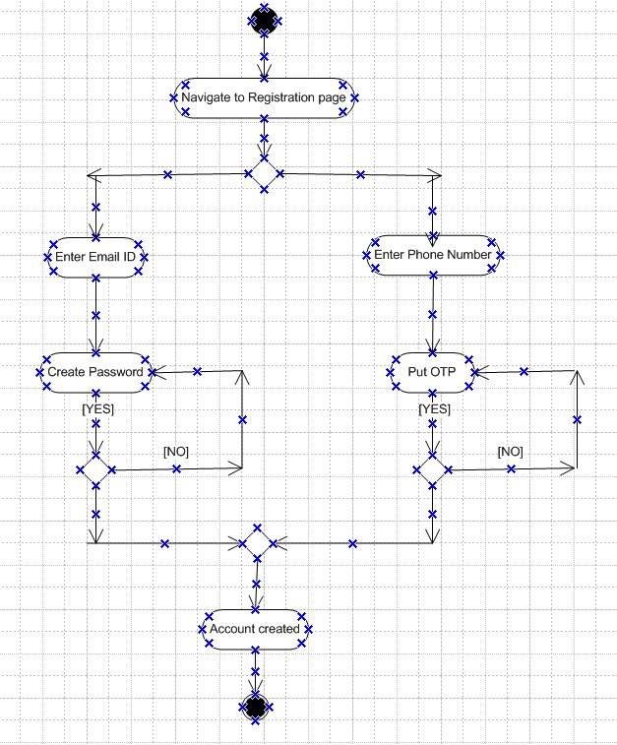

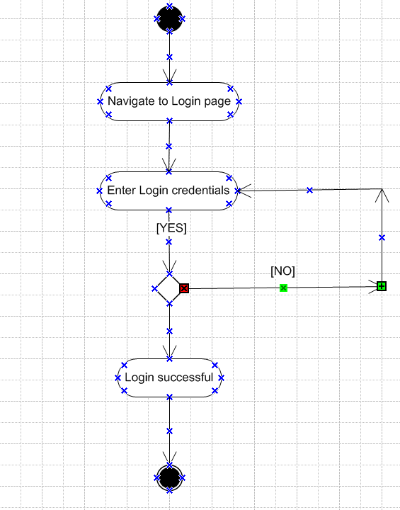

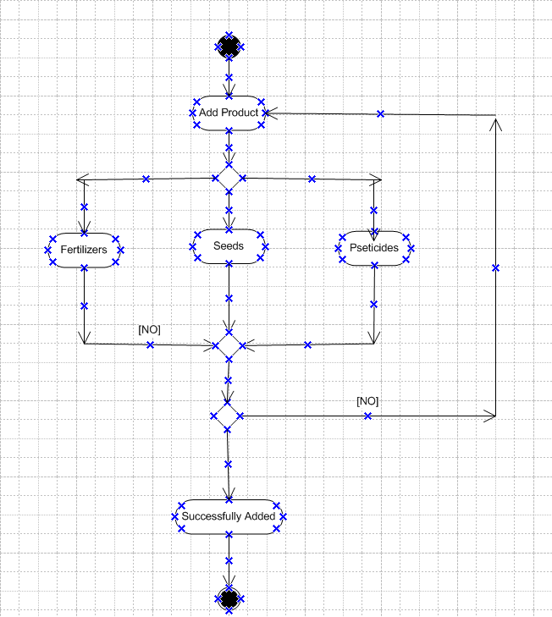

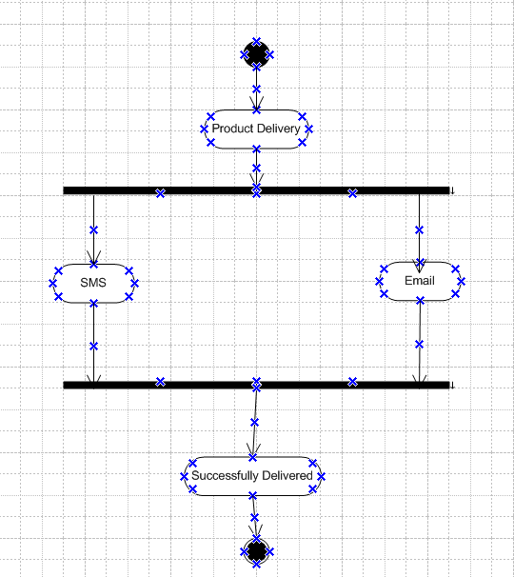

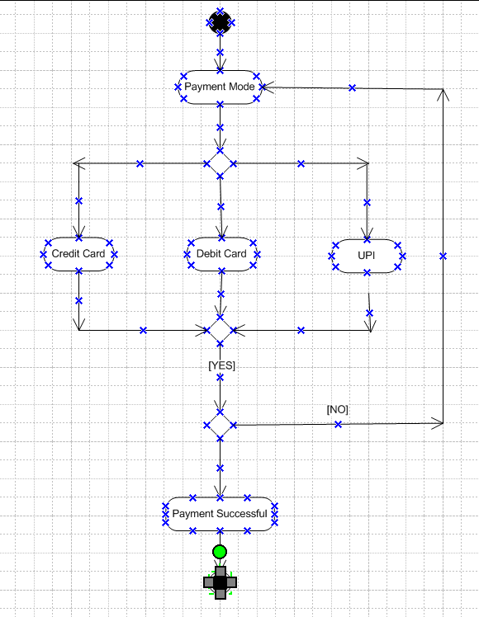

**Steps to be included in the activity diagram:**

* **Farmer Login/Registration:** The farmer must either log in or register if they are new to the system.
* **Browse Products:** After login, the farmer can browse the available products, including fertilizers, seeds, and pesticides.
* **Select Products:** The farmer selects products they wish to purchase.
* **Add to Cart:** After selecting the desired products, the farmer adds them to the cart.
* **View Cart:** The farmer checks the cart for the items they have selected.
* **Confirm Order:** The farmer confirms the items and quantity in the cart.
* **Request to Buy:** The farmer places a request to buy the products.
* **Order Sent to Manufacturer:** The system sends the order to the appropriate manufacturer(s).
* **Manufacturer Process:** The manufacturer processes the order and prepares for delivery.
* **Shipping and Delivery:** The products are shipped to the farmer’s location.
* **Order Confirmation:** The farmer receives the products and confirms the delivery.
* **Order Completed:** Once the products are confirmed, the order is marked as completed.