AGILE DOCUMENTS

Document 1: Definition of Done
The best form of Definition of Done representation is a checklist of activities that has to demonstrate the agreed value and quality of a user story. So, this checklist should include:
- Acceptance criteria (to satisfy customer requirements for a product)
- Quality criteria (to satisfy quality requirements for a product)

Definition of Done may be defined for different levels of project work. For example, in Agile / Scrum framework these levels of work could be user story, sprint, and release.

✅ Definition of Done (DoD) – Financial Statement Audit Software
- Produced code for presumed functionalities
All features related to audit planning, document management, risk assessment, and reporting have been implemented as per the defined user stories.

- Assumptions of User Story met
Every user story’s specific assumption — such as audit workflow roles, data integration logic, or regulatory compliance — are addressed and verified.

- Project builds without errors
The software compiles and builds successfully in the CI/CD pipeline (Continuous Integration and Continuous Delivery or Deployment), ensuring no runtime or dependency errors.

- Unit tests written and passing
Each module (e.g., approval logic, audit evidence tracking) has associated unit tests with a minimum passing threshold (e.g., 90% coverage).

- Project deployed on the test environment identical to production platform
The application is deployed in a mirrored test environment to validate performance, security, and compliance before production rollout.

- Tests on devices/browsers listed in the project assumptions passed
Compatibility testing is completed on all required browsers (e.g., Chrome, Edge) and devices (laptops, tablets) commonly used by auditors.
- Feature ok-ed by UX designer
UX designer has reviewed the user interface for usability, accessibility, and consistency with design standards (e.g., easy navigation of audit modules).

- QA performed & issues resolved
Full QA cycle completed—including functional, regression, and integration testing—and all critical/high-priority issues are resolved.

- Feature is tested against acceptance criteria
Each user story has been validated against predefined acceptance criteria, confirming functional and non-functional requirements.

- Feature agreed by Product Owner
Product Owner (typically an audit or compliance lead) has reviewed and approved the functionality as ready for release.

- Refactoring completed (restructure without altering functionality)
Any redundant or inefficient code has been optimized to meet performance and maintainability standards.

- Any configuration or build changes documented
All changes to deployment configurations, environment variables, and system integrations are documented in the DevOps or release repository.

- Documentation updated
User manuals, configuration guides, and process documents are updated to reflect the latest system behaviour and workflows.

- Peer Code Review performed
Code changes have been reviewed and approved by at least one team member to ensure quality, consistency, and adherence to standards.

Document 2- Product Vision

Scrum Project Name: | Financial Statement Audit Software
Venue: | XYZ Company, Bengaluru
Date: 20/06/2025 | Start Time: 10:00 AM | End time: 11:30 AM | Duration: 1 Hour 30 Minutes
Client: | Audit Engagement Team
Stakeholder list: | Audit Partner | IT Director | Compliance Officer
 | Financial Controller
Scrum Team
Scrum Master | Priya Menon
Product Owner | Sreevidya L N Sharma (Business Analyst)
Scrum Developer 1 | Rahul Nair (Frontend Developer)
Scrum Developer 2 | Aisha Khan (Backend Developer)
Scrum Developer 3 | Vignesh Iyer (QA Engineer)
Scrum Developer 4 | Sumanth Rao (Database Architect)
Scrum Developer 5 | Ritu Sharma (DevOps Engineer)

Vision: To provide a smart, secure, and efficient platform that streamlines financial statement audits and enhances audit quality and compliance.
Target Group | Needs | Products | Value
Which market segment does the product address?  Financial audit teams, risk and compliance departments. | What problem does the product solve?  Manual and disjointed processes in auditing lead to inefficiencies, delays, and errors. | What product is it?  Cloud-based Financial Statement Audit Software | How is the product going to benefit the company?  Enhances audit accuracy, efficiency, and transparency. Reduces audit cycle time.
Who are the target users and customers?  Auditors, Audit Managers, Audit Partners, IT Admins. | Which benefit does it provide?  Automation, centralized workflow, real-time insights, and increased compliance. | What makes it desirable and special?  Smart analytics, document management, role-based dashboards, risk flagging, collaboration tools. | What are the business goals?  Deliver high-quality audits faster, meet regulatory demands, and gain client trust.
 |  | Is it feasible to develop the product?  Yes – aligns with XYZ Company’s digital transformation and supported by IT infrastructure. | What is the business model?  SaaS integration (Software as a service – 3rd party integration like API) for internal global audit teams with scalability.

Document 3: User Stories

User Story No: 01 | Tasks: 03 |  | Priority: HIGH
AS AN AUDITOR,
I WANT TO LOGIN TO THE AUDIT PLATFORM SECURELY
SO THAT I CAN ACCESS MY ASSIGNED AUDITS AND DATA SAFELY

BV: 500 |  | CP: 13
Acceptance Criteria:
  - USER CAN LOG IN USING EMAIL AND PASSWORD
  - TWO-FACTOR AUTHENTICATION (OTP) IS TRIGGERED
  - ERROR MESSAGES SHOWN FOR INCORRECT LOGIN ATTEMPTS
  - ACCOUNT LOCK AFTER 5 UNSUCCESSFUL ATTEMPTS

User Story No: 02 | Tasks: 02 |  | Priority: MEDIUM
AS AN AUDITOR,
I WANT TO SELECT THE CORRECT AUDIT ENGAGEMENT FROM A DROPDOWN
SO THAT I CAN BEGIN WORK ON THE CORRECT CLIENT'S FINANCIALS

BV: 100 |  | CP: 8
Acceptance Criteria:

- DROPDOWN SHOWS ONLY ACTIVE ENGAGEMENTS ASSIGNED TO THE USER
- ENGAGEMENT OPENS ONLY AFTER SELECTION CONFIRMATION
- SYSTEM SAVES LAST SELECTED ENGAGEMENT FOR SESSION CONTINUITY

User Story No: 03 | Tasks: 04 |  | Priority: HIGH
AS AN ENGAGEMENT MANAGER
I WANT TO UPLOAD THE CLIENT'S TRIAL BALANCE IN EXCEL FORMAT
SO THAT I CAN BEGIN MAPPING FINANCIAL ACCOUNTS TO AUDIT AREAS

BV: 1000 |  | CP: 21
ACCEPTANCE CRITERIA:
  - UPLOAD SUPPORTS .XLS, .XLSX, FORMATS
  - VALIDATION ERRORS SHOWN FOR MISSING ACCOUNT CODES OR INCORRECT FORMATS
  - PREVIEW BEFORE FINAL UPLOAD
  - AUTOMATIC MAPPING IF STANDARD CHART OF ACCOUNTS IS DETECTED

User Story No: 04 | Tasks: 03 |  | Priority: MEDIUM
AS AN AUDITOR
I WANT TO VIEW A DASHBOARD WITH AUDIT PROGRESS, MATERIALITY, AND RISKS
SO THAT I CAN MONITOR AND PRIORITIZE AUDIT ACTIVITIES

BV: 500 |  | CP: 13
ACCEPTANCE CRITERIA:
  - DASHBOARD LOADS WITHIN 5 SECONDS
  - DISPLAYS METRICS LIKE % COMPLETION, ISSUES RAISED, AND ASSIGNED TASKS
  - INTERACTIVE FILTERS FOR PERIOD AND ENGAGEMENT

User Story No: 05 | Tasks: 05 |  | Priority: HIGH
AS AN AUDITOR
I WANT TO GENERATE AND DOWNLOAD THE AUDIT REPORT IN PDF FORMAT
SO THAT I CAN SUBMIT IT FOR REVIEW AND CLIENT DELIVERY

BV: 1000 |  | CP: 34
ACCEPTANCE CRITERIA:
- REPORT INCLUDES COVER PAGE, AUDIT SUMMARY, FINDINGS, AND APPENDICES
- USER CAN SELECT SECTIONS TO INCLUDE/EXCLUDE
- PDF FORMATTING FOLLOWS FIRM STANDARDS
- TIMESTAMP AND AUDITOR DETAILS EMBEDDED IN THE FOOTER

Document 4: Agile PO Experience

Sprint Meeting Learnings from the Financial Statement Audit Software Project
From this project, I have learned how to effectively participate in and manage Agile sprint meetings, which are critical for successful project execution. The key meetings I gained experience with include:
- ➢ Sprint Planning Meeting
Learned how to define sprint goals, prioritize backlog items, estimate effort, and break stories into actionable tasks for the upcoming sprint.
- ➢ Daily Scrum Meeting
Understood the importance of regular team synchronization by sharing daily updates on what was done, what is planned, and identifying blockers.
- ➢ Sprint Review Meeting
Gained insight into presenting completed work to stakeholders, gathering feedback, and demonstrating working software or features.
- ➢ Sprint Retrospective Meeting
Experienced the value of reflecting on the sprint, discussing what went well, what didn’t, and how to improve future sprints through actionable steps.
- ➢ Backlog Refinement Meeting
Learned how to continuously groom and clarify user stories, adjust priorities, and ensure the backlog is ready for upcoming sprints.

Document 5: Product and sprint backlog and product and sprint burndown charts

Product backlog:

User story ID | User story | Tasks | Priority | BV | CP | Sprint
01 | AS AN AUDITOR,  I WANT TO LOGIN TO THE AUDIT PLATFORM SECURELY  SO THAT I CAN ACCESS MY ASSIGNED AUDITS AND DATA SAFELY | 03 | HIGH | 500 | 13 | FSA – Sprint 1
02 | AS AN AUDITOR,  I WANT TO SELECT THE CORRECT AUDIT ENGAGEMENT FROM A DROPDOWN  SO THAT I CAN BEGIN WORK ON THE CORRECT CLIENT'S FINANCIALS | 02 | MEDIUM | 100 | 8 | FSA – Sprint 1
03 | AS AN ENGAGEMENT MANAGER  I WANT TO UPLOAD THE CLIENT'S TRIAL BALANCE IN EXCEL FORMAT  SO THAT I CAN BEGIN MAPPING FINANCIAL ACCOUNTS TO AUDIT AREAS | 04 | HIGH | 1000 | 21 | FSA – Sprint 1
04 | AS AN AUDITOR  I WANT TO VIEW A DASHBOARD WITH AUDIT PROGRESS, MATERIALITY, AND RISKS  SO THAT I CAN MONITOR AND PRIORITIZE AUDIT ACTIVITIES | 03 | MEDIUM | 500 | 13 | FSA – Sprint 1
05 | AS AN AUDITOR  I WANT TO GENERATE AND DOWNLOAD THE AUDIT REPORT IN PDF FORMAT  SO THAT I CAN SUBMIT IT FOR REVIEW AND CLIENT DELIVERY | 05 | HIGH | 1000 | 34 | FSA – Sprint 1

Sprint backlog:
User story ID | User story | Tasks | Owner | Status | Estimated effort
01 | AS AN AUDITOR,  I WANT TO LOGIN TO THE AUDIT PLATFORM SECURELY  SO THAT I CAN ACCESS MY ASSIGNED AUDITS AND DATA SAFELY | 03 | Sreevidya L N Sharma | Sprint Completed | 13
02 | AS AN AUDITOR,  I WANT TO SELECT THE CORRECT AUDIT ENGAGEMENT FROM A DROPDOWN  SO THAT I CAN BEGIN WORK ON THE CORRECT CLIENT'S FINANCIALS | 02 | Sreevidya L N Sharma | Sprint Completed | 8
03 | AS AN ENGAGEMENT MANAGER  I WANT TO UPLOAD THE CLIENT'S TRIAL BALANCE IN EXCEL FORMAT  SO THAT I CAN BEGIN MAPPING FINANCIAL ACCOUNTS TO AUDIT AREAS | 04 | Sreevidya L N Sharma | Sprint Completed | 21
04 | AS AN AUDITOR  I WANT TO VIEW A DASHBOARD WITH AUDIT PROGRESS, MATERIALITY, AND RISKS  SO THAT I CAN MONITOR AND PRIORITIZE AUDIT ACTIVITIES | 03 | Sreevidya L N Sharma | Sprint Completed | 13
05 | AS AN AUDITOR  I WANT TO GENERATE AND DOWNLOAD THE AUDIT REPORT IN PDF FORMAT  SO THAT I CAN SUBMIT IT FOR REVIEW AND CLIENT DELIVERY | 05 | Sreevidya L N Sharma | Sprint Completed | 34

Sprint burndown Chart

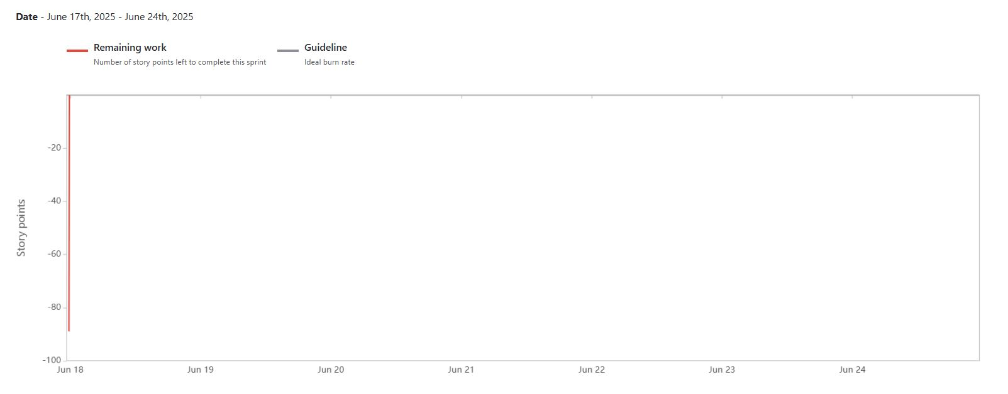

Burnup Chart
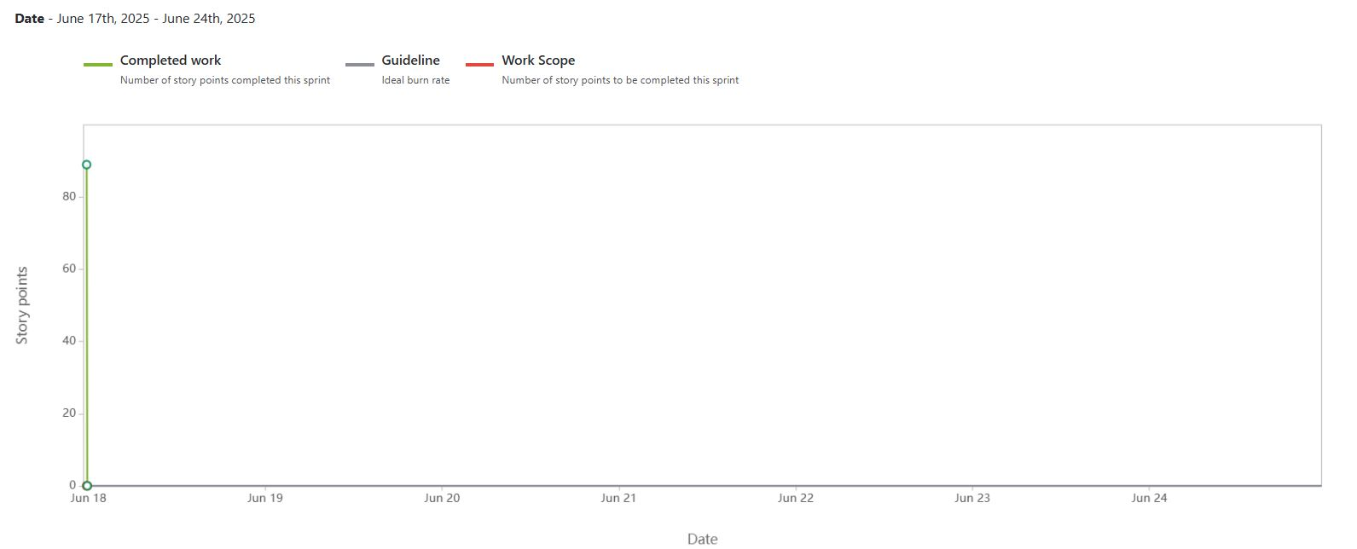

Document 6: Sprint meetings

Meeting Type 1: Sprint Planning meeting

Date | 18 June 2025
Time | 10:00 AM – 11:30 AM
Location | XYZ Company Conference Room / Zoom
Prepared By | Sreevidya L N Sharma (Business Analyst)
Attendees | Product Owner, Scrum Master, Developers, QA Team, Stakeholder Reps

Topic | Presenter | Time Allotted
Sprint Goal & Scope | Product Owner | 20 mins
Backlog Review & Prioritization | Scrum Master | 30 mins
Task Estimation & Assignment | Dev Team Lead | 30 mins
Review of Sprint Capacity | Scrum Master | 10 mins

Observers | Internal Audit Compliance Team
Resources | Sprint Backlog, Jira Board, FRS Document
Special Notes | Ensure UAT readiness is included in scope

Meeting Type 2: Sprint Review meeting

Date | 25 June 2025
Time | 3:00 PM – 4:30 PM
Location | XYZ Company Zoom Room / Meeting Room 4B
Prepared By | Sreevidya L N Sharma (Business Analyst)
Attendees | Product Owner, Scrum Master, Developers, QA Team, Client Stakeholders

Sprint Status | Things to Demo | Quick Updates | What’s Next
Sprint 3 Completed – 90% Stories Done | Audit Dashboard, Report Generation, Client Upload Module | Bug fixes in Entity Setup module | Start Sprint 4 – Focus on UAT preparation & Training
Few low-priority items moved to backlog | Demo of Data Validation Rules and Notifications | Updated RTM (or sprints) and added user documentation draft | Incorporate client feedback from review meeting

Meeting Type 3: Sprint Retrospective meeting

Date | 27 June 2025
Time | 11:00 AM – 12:00 PM
Location | XYZ Company Teams Channel / Conf Room 2C
Prepared By | Sreevidya L N Sharma (Business Analyst)
Attendees | Scrum Master, Product Owner, Dev Team, QA Team

Agenda | What went well | What didn’t go well | Questions | Reference
Sprint 3 Review | Timely completion of client upload and dashboard modules | Delay in finalizing error messages for validation rules | Can we involve QA earlier for test data setup? | Sprint 3 Backlog & JIRA board
Collaboration | Improved communication during daily stand-ups | One developer was unavailable during UAT prep | How to ensure backup resources in critical sprints? | Daily Scrum Notes

Meeting Type 4: Daily Stand-up Meeting

Question | Name/Role | Week “2” (from 16-06-2025 to 22-06 2025)
 |  | Monday | Tuesday | Wednesday | Thursday | Friday | Saturday | Sunday
What did you do yesterday? | Developer 1 | Completed API integration for audit checklist module | Finalized checklist validation logic | Fixed bugs in checklist form validation | Integrated checklist module with dashboard | Created test cases for checklist workflows | N/A | N/A
 | Developer 2 | Worked on UI design for client selection page | Implemented client dropdown linking with backend | Finalized responsive layout and UX review | Added loading states and error messages | Completed UI testing | N/A | N/A
 | Developer 3 | Wrote unit tests for entity data extraction component | Reviewed PRs for audit data import module | Worked on performance tuning for data loading | Assisted QA with regression test issues | Documented test summary for sprint review | N/A | N/A
What will you do today? | Developer 1 | Begin error handling and validation for audit checklist | Conduct integration testing of checklist module | Prepare checklist module demo | Fix feedback from internal UAT | Participate in sprint review meeting | N/A | N/A
 | Developer 2 | Integrate frontend with backend for client selection | Collaborate with QA for usability testing | Tweak layout per feedback | Prepare client selection demo for stakeholders | Update design documentation | N/A | N/A
 | Developer 3 | Conduct peer code review and test coverage reporting | Improve test coverage for audit import pipeline | Test import module with large datasets | Assist in preparing sprint artifacts | Support live demo during review | N/A | N/A
What (if any) is blocking your progress? | Developer 1 | Awaiting clarification on input rules from Product Owner | No blockers | Minor conflicts in dashboard module integration | None | None | N/A | N/A
 | Developer 2 | None | Browser compatibility issues (IE11 – Internet Explorer 11 disapproved) | None | Delay in getting feedback from UX team | None | N/A | N/A
 | Developer 3 | Delay in access to QA environment | Test data not available | Limited access to staging server | No blockers | None | N/A | N/A

