1. **Functional requirements :**

|  |  |  |  |
| --- | --- | --- | --- |
| **Req ID** | **Req Name** | **Req Description** | Priority |
| BR001 | Farmers Registration | Farmers who are new to the website should be able to register themselves before buying the products | 8 |
| BR002 | Farmers search for products | Farmers should be able to search for available products, seeds, fertilizers | 8 |
| BR003 | Selecting the product | Farmers should be able to select the product searched | 10 |
| BR004 | buy the product | Farmers should be able to buy the product selected | 5 |
| BR005 | Manufactures upload their products | Manufactures uploads their product along with description and pics in the website | 8 |
| BR006 | Login option | Farmers should be able to login to the application once they have created an account in the website | 10 |
| BR007 | Product information | Users should be able to see the product details once the product is selected | 5 |
| BR008 | Notify product availability | Farmers should get the option to notify when the product is available in the website | 5 |
| BR009 | Payment option | User should have an option to make payments through netbanking/card or UPI | 8 |
| BR010 | COD option | Farmers should have the option to buy the product through COD | 8 |
| BR011 | Payment confirmation | Farmers should be able to get a confirmation once the payment is done | 8 |
| BR012 | Download invoice | Farmers should be able to download the invoice post making the payment | 8 |
| BR013 | Return/exchange | user should get an option to return/exchange the product is there is any discrepancies | 5 |
| BR014 | provide feedback | user should be able to provide feedback for the product received | 4 |
| BR015 | cancel order | user should have an option to cancel the order | 7 |
| BR016 | contact customer services | user should be able to contact the customer services when he need any help regarding the product purchased/product | 5 |
| BR017 | No limitation | Users should not have any limitation to book the product | 3 |
| BR018 | Offers details | Farmers should get the offers details through mobile or email ID | 3 |
| BR019 | Address details | Farmers should be able to save the address details in the website | 3 |
| BR020 | Edit Address details | Farmers should be able to edit and save the address details in the website | 3 |

1. Page designs:

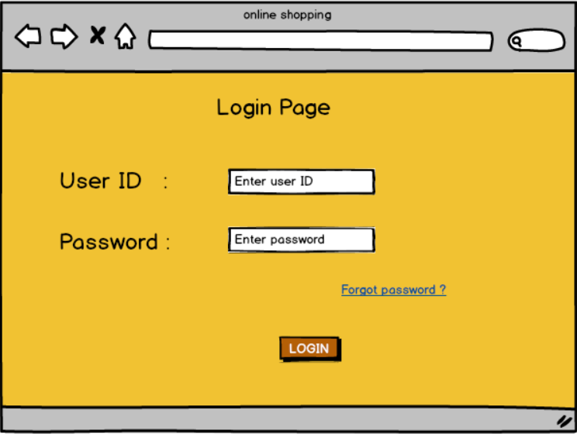

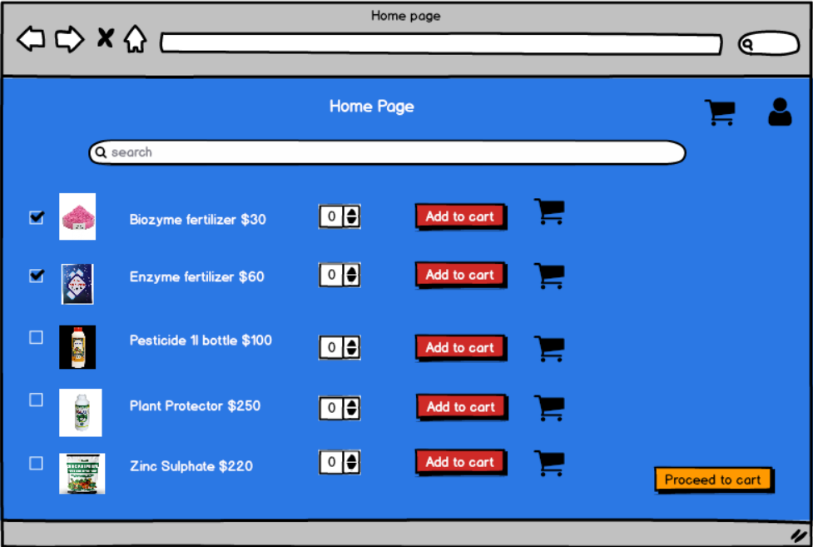

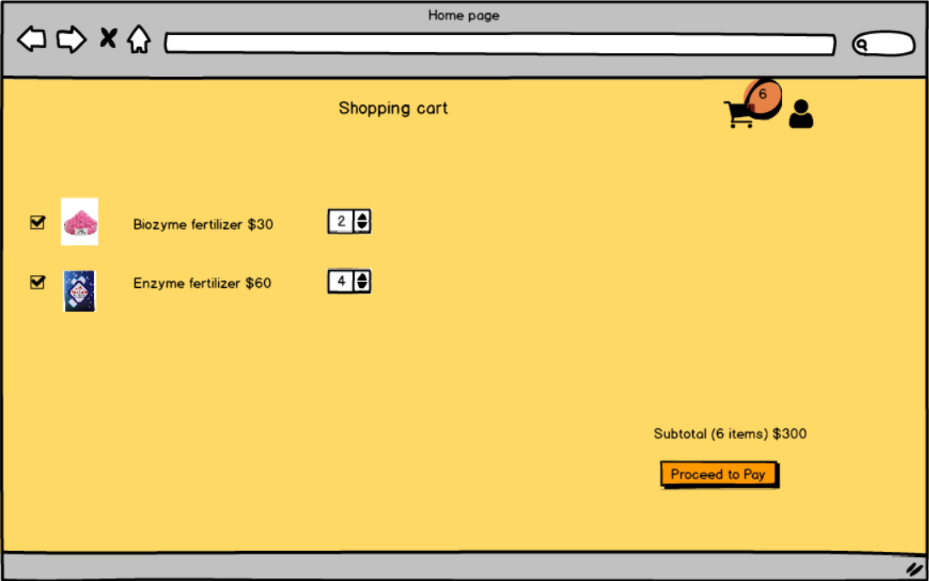

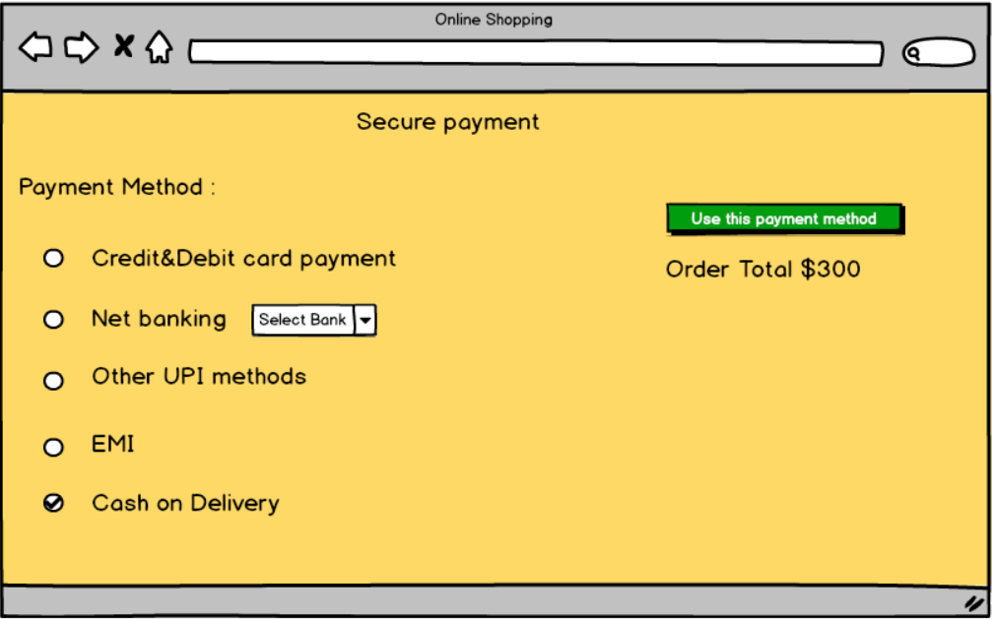

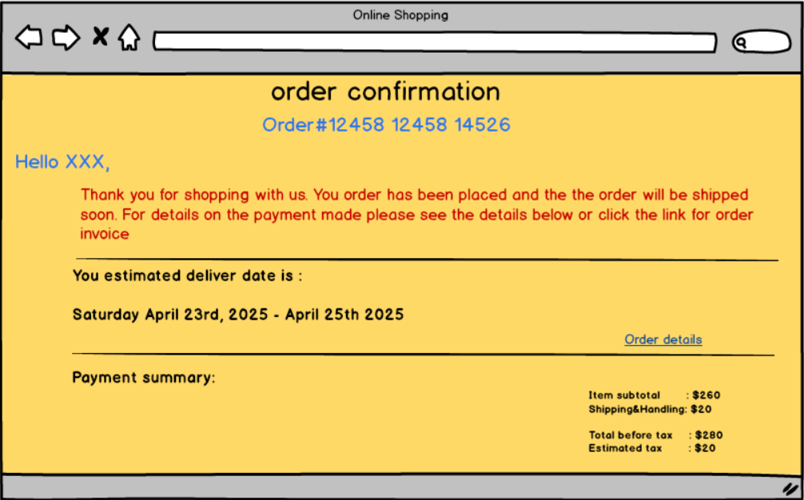

1. **Tools used:**

Tools used for preparing above pages was balasmiq. Where we can actually create a link to pages and see the slideshow. The main drawback of Balasmiq is that you cannot give inputs. Other than that there are so many options available.

1. **Requirement Traceability matrix:**

|  |  |  |  |  |  |  |  |  |  |
| --- | --- | --- | --- | --- | --- | --- | --- | --- | --- |
| **Req ID** | **Req Name** | **Req Description** | Design | D1 | D2 | T1 | T2 | T3 | UAT |
| BR001 | Farmers Registration | Farmers who are new to the website should be able to register themselves before buying the products |  |  |  |  |  |  |  |
| BR002 | Farmers search for products | Farmers should be able to search for available products, seeds, fertilizers |  |  |  |  |  |  |  |
| BR003 | Selecting the product | Farmers should be able to select the product searched |  |  |  |  |  |  |  |
| BR004 | buy the product | Farmers should be able to buy the product selected |  |  |  |  |  |  |  |
| BR005 | Manufactures upload their products | Manufactures uploads their product along with description and pics in the website |  |  |  |  |  |  |  |
| BR006 | Login option | Farmers should be able to login to the application once they have created an account in the website |  |  |  |  |  |  |  |
| BR007 | Product information | Users should be able to see the product details once the product is selected |  |  |  |  |  |  |  |
| BR008 | Notify product availability | Farmers should get the option to notify when the product is available in the website |  |  |  |  |  |  |  |
| BR009 | Payment option | User should have an option to make payments through netbanking/card or UPI |  |  |  |  |  |  |  |
| BR010 | COD option | Farmers should have the option to buy the product through COD |  |  |  |  |  |  |  |
| BR011 | Payment confirmation | Farmers should be able to get a confirmation once the payment is done |  |  |  |  |  |  |  |
| BR012 | Download invoice | Farmers should be able to download the invoice post making the payment |  |  |  |  |  |  |  |
| BR013 | Return/exchange | user should get an option to return/exchange the product is there is any discrepancies |  |  |  |  |  |  |  |
| BR014 | provide feedback | user should be able to provide feedback for the product received |  |  |  |  |  |  |  |
| BR015 | cancel order | user should have an option to cancel the order |  |  |  |  |  |  |  |
| BR016 | contact customer services | user should be able to contact the customer services when he need any help regarding the product purchased/product |  |  |  |  |  |  |  |
| BR017 | No limitation | Users should not have any limitation to book the product |  |  |  |  |  |  |  |
| BR018 | Offers details | Farmers should get the offers details through mobile or email ID |  |  |  |  |  |  |  |
| BR019 | Address details | Farmers should be able to save the address details in the website |  |  |  |  |  |  |  |
| BR020 | Edit Address details | Farmers should be able to Edit and save the address details in the website |  |  |  |  |  |  |  |

1. **Test case document:**

|  |  |  |  |
| --- | --- | --- | --- |
| Test Case ID | T001 | Test case name | login |
| Project ID | PJ001 | Project name | Online agriculture product store |
| Test Plan ID | TP001 | Test ID | TID01 |
|  |  | Date of Testing | 17-04-2025 |

|  |  |
| --- | --- |
|  | Set 1 |
| Scenario | Login to the application |
| Input | Enter user name and password |
| Expected behavior | user should be able to login successfully |
| Actual behavior | user should be able to login successfully |
| comments |  |
| Result pass/fail | pass |

|  |  |  |  |
| --- | --- | --- | --- |
| Test Case ID | T002 | Test case name | registration |
| Project ID | PJ002 | Project name | Online agriculture product store |
| Test Plan ID | TP002 | TestID | TID02 |
|  |  | Date of Testing | 17-04-2025 |

|  |  |
| --- | --- |
|  | Set 1 |
| Scenario | User Registration |
| Input | Enter valid personal details like mail id, mob number and create password |
| Expected behavior | The user should be successfully registered & redirect to login page The user should be successfully registered & redirect to login page |
| Actual behavior | The user should be successfully registered & redirect to login page |
| comments |  |
| Result pass/fail | Pass |

|  |  |  |  |
| --- | --- | --- | --- |
| Test Case ID | T003 | Test case name | Product search |
| Project ID | PJ003 | Project name | Online agriculture product store |
| Test Plan ID | TP003 | TestID | TID03 |
|  |  | Date of Testing | 17-04-2025 |

|  |  |
| --- | --- |
|  | Set 1 |
| Scenario | Searching for the products |
| Input | The user enters product name in search field and clicks on search button |
| Expected behavior | It should display the relevant products |
| Actual behavior | It should display the relevant products |
| comments |  |
| Result pass/fail | Pass |

|  |  |  |  |
| --- | --- | --- | --- |
| Test Case ID | T004 | Test case name | Select the product searched |
| Project ID | PJ004 | Project name | Online agriculture product store |
| Test Plan ID | TP004 | TestID | TID04 |
|  |  | Date of Testing | 17-04-2025 |

|  |  |
| --- | --- |
|  | Set 1 |
| Scenario | The user should be able to click on the product searched and see the detailed view of the product |
| Input | User clicks on the product |
| Expected behavior | It should take the user to the product detailed page |
| Actual behavior | It should take the user to the product detailed page |
| comments |  |
| Result pass/fail | Pass |

|  |  |  |  |
| --- | --- | --- | --- |
| Test Case ID | T005 | Test case name | Add to Cart |
| Project ID | PJ005 | Project name | Online agriculture product store |
| Test Plan ID | TP005 | TestID | TID05 |
|  |  | Date of Testing | 17-04-2025 |

|  |  |
| --- | --- |
|  | Set 1 |
| Scenario | Add product to cart |
| Input | Browse, select the product and press Add to cart button |
| Expected behavior | Product should be seen in the Cart |
| Actual behavior | Product should be seen in the Cart |
| comments |  |
| Result pass/fail | pass |

|  |  |
| --- | --- |
|  | Set 1 |
| Scenario | Select the quantity of the product |
| Input | Click on + icon and add the quantity |
| Expected behavior | The count of the product should increase each time when you click on + |
| Actual behavior | The count of the product should increase each time when you click on + |
| comments |  |
| Result pass/fail | pass |

|  |  |  |  |
| --- | --- | --- | --- |
| Test Case ID | T006 | Test case name | Select the quantity |
| Project ID | PJ006 | Project name | Online agriculture product store |
| Test Plan ID | TP006 | TestID | TID05 |
|  |  | Date of Testing | 17-04-2025 |

|  |  |  |  |
| --- | --- | --- | --- |
| Test Case ID | T007 | Test case name | payment |
| Project ID | PJ007 | Project name | Online agriculture product store |
| Test Plan ID | TP007 | TestID | TID07 |
|  |  | Date of Testing | 17-04-2025 |

|  |  |  |  |
| --- | --- | --- | --- |
| Test Case ID | T006 | Test case name | Select the quantity |
| Project ID | PJ006 | Project name | Online agriculture product store |
| Test Plan ID | TP006 | TestID | TID05 |
|  |  | Date of Testing | 17-04-2025 |

|  |  |  |  |
| --- | --- | --- | --- |
| Test Case ID | T006 | Test case name | Select the quantity |
| Project ID | PJ006 | Project name | Online agriculture product store |
| Test Plan ID | TP006 | TestID | TID06 |
|  |  | Date of Testing | 17-04-2025 |

|  |  |
| --- | --- |
|  | Set 1 |
| Scenario | Payment Process |
| Input | Enter any of the payment details like card or UPI details and click Pay Now Button |
| Expected behavior | Payment should be processed successfully, farmer should receive an order confirmation |
| Actual behavior | Payment should be processed successfully, farmer should receive an order confirmation |
| comments |  |
| Result pass/fail | pass |

|  |  |  |  |
| --- | --- | --- | --- |
| Test Case ID | T008 | Test case name | Order Tracking |
| Project ID | PJ008 | Project name | Online agriculture product store |
| Test Plan ID | TP008 | TestID | TID08 |
|  |  | Date of Testing | 17-04-2025 |

|  |  |
| --- | --- |
|  | Set 1 |
| scenario | Tracking the order |
| input | Enter the order ID and clock on Track order button |
| Expected behavior | Should show the current status along with the location details |
| Actual behavior | Should show the current status along with the location details |
| comments |  |
| Result pass/fail | pass |

|  |  |  |  |
| --- | --- | --- | --- |
| Test Case ID | T009 | Test case name | Order Cancellation |
| Project ID | PJ009 | Project name | Online agriculture product store |
| Test Plan ID | TP009 | TestID | TID09 |
|  |  | Date of Testing | 17-04-2025 |

|  |  |
| --- | --- |
|  | Set 1 |
| Scenario | Cancelling a product |
| Input | Select the product under my orders and click cancel the order button |
| Expected behavior | Should cancel the order processing and should initiate the refund |
| Actual behavior | Should cancel the order processing and should initiate the refund |
| comments |  |
| Result pass/fail | pass |

|  |  |  |  |
| --- | --- | --- | --- |
| Test Case ID | T010 | Test case name | Logout |
| Project ID | PJ010 | Project name | Online agriculture product store |
| Test Plan ID | TP010 | TestID | TID10 |
|  |  | Date of Testing | 17-04-2025 |

|  |  |
| --- | --- |
|  | Set 1 |
| Scenario | User Logg out |
| input | Click Logout Button under My Profile |
| Expected behavior | Should be successfully logged out and redirected to login page |
| Actual behavior | Should be successfully logged out and redirected to login page |
| comments |  |
| Result pass/fail | pass |

1. Database diagram:

|  |
| --- |
| Shopping order |
| Order ID (PK)  Customer ID(FK)  Date |

|  |
| --- |
| Categories |
| Category ID (PK)  Category name  Category type |

|  |
| --- |
| Deliveries |
| Delivery ID (PK)  Customer ID (FK)  Date |

|  |
| --- |
| Customers |
| Customer ID (PK)  name  address |

|  |
| --- |
| Products |
| Product ID (PK)  Category ID (FK)  Product Name |

|  |
| --- |
| Transaction reports |
| Customer ID (FK)  Order ID (FK)  Product ID (FK)  Payment ID (FK) |

|  |
| --- |
| Seller |
| Seller ID (PK)  Product ID(FK)  name |

|  |
| --- |
| Payment |
| Payment ID (PK)  Category ID (FK)  date |

**ER diagram**: Entity Relationship Diagram, is a visual representation of how different entities and their attributes relate to each other within a database or system.

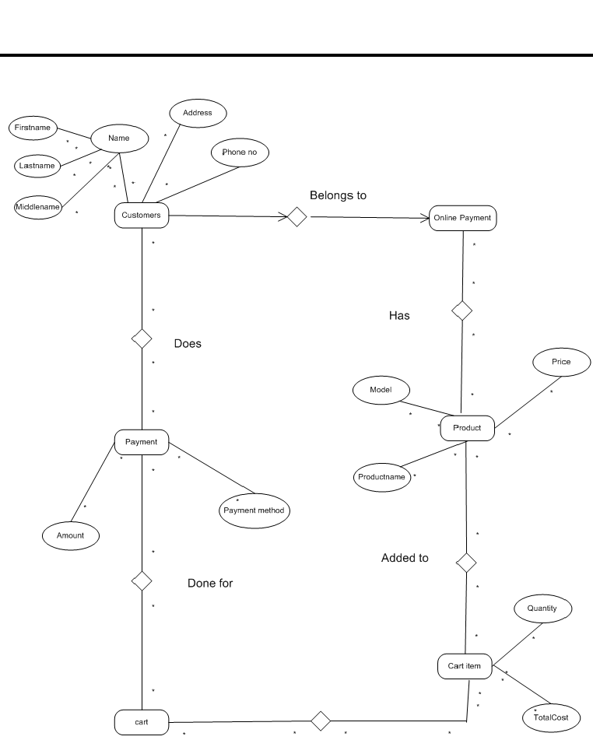

1. **Data Flow diagram:**

A data flow diagram shows the way information flows through a process or system. It includes data inputs and outputs, data stores, and the various subprocesses the data moves through. A data flow diagram has no control flow there are no decision rules and no loops.

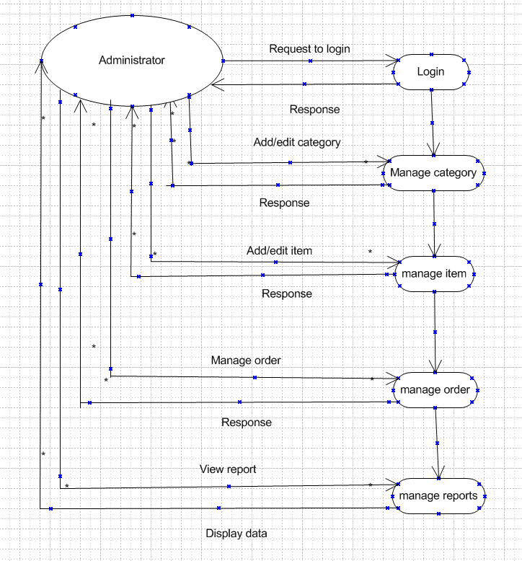

1. **Change request:**

A change request is a formal proposal for an alteration to some product or system. In project management, a change request often comes when the client wants an addition or alteration to the existing and agreed-upon deliverables for a project. It may involve an additional feature or customization or an extension of service. When there is a change in the tax structure by the government, the entire project cost gets effected. We will get into a call with clients, discuss how we are going to tackle the changes. Will discuss the area where we can do the cost cutting, if it’s not feasible, reach out to client and convince him to increase the budget

1. **Change request vs enhancements:**

**Change Request:**

* **Purpose:**

To formally document and manage proposed changes to a project or system.

* **Origin:**

Can be initiated internally (e.g., by a project team) or externally (e.g., by a client).

* **Process:**

Typically involves a formal process for submission, evaluation, approval, and implementation.

* **Examples:**
  + Modifying project deliverables.
  + Adding a new feature to a software product.

**Enhancement:**

* **Purpose:**

To improve or add functionality to an existing product or system.

* **Origin:**

Often initiated by users or stakeholders who have feedback on the product or system.

* **Process:**

Can be submitted as part of a change request, but may also have its own dedicated process for evaluation and implementation.

* **Examples:**
  + Improving user interface elements.
  + Adding a new reporting feature.
  + Optimizing software performance.

1. **Estimations:**

1. Project Overview:

* **Project Name:** online Agriculture Product Store
* **Project Manager:** vandanam
* **Project Sponsor:** Me Henry
* **Project ID:** PR-ID - 23451667.

2. Timeline and Deliverables:

* **Start Date:** 1st feb 2025
* **End Date:** July 31st 2026
* **Project Phases/Deliverables:** 3 phases which happens on every 6 months

3. Effort and Resource Estimation:

* **Estimated Hours:** 1500 hrs.
* **Resources Required:** 18 people.
* **Resource Hourly Rates:** 5dollar

4. Cost Breakdown:

* **Cost per Phase/Task:**
* **Total Project Cost:** 2 crores
* **Contingency:** Include a buffer of 6 resources to complete the project on time

1. **UAT :**

User Acceptance Testing (UAT) is a crucial final phase in the software development lifecycle where real end-users test the software to ensure it meets their needs and business requirements before deployment. It's about validating that the software functions as intended in practical, real-world scenarios, rather than just focusing on technical correctness.

Here's a more detailed breakdown:

**Purpose:**

UAT aims to confirm that the software meets user expectations, addresses their needs, and aligns with business goals.

**Who performs it:**

Typically, UAT involves real end-users, not just developers or testers, to ensure the testing reflects actual usage patterns.

**What it involves:**

UAT involves executing realistic scenarios, identifying and reporting issues, and validating that the software performs as expected in practical use.

**Importance:**

It helps reduce post-launch issues, improves user satisfaction, and ensures the software is ready for production.

**When it happens:**

UAT is usually the final phase of testing, following system testing, functional testing, and regression testing, ut before the software is released to end-users.

**How it's performed:**

UAT involves creating test cases based on real-world scenarios, documenting findings, and providing feedback to the development team.

**Benefits:**

UAT helps identify usability issues, functional gaps, and any discrepancies between the developed software and the user's expectations.

1. **Project closure:**

A project closure document, also known as a project closure report, is a formal document summarizing and evaluating the final outcomes of a project, ensuring all project elements are completed, documented, and evaluated. It's the last deliverable submitted, measuring overall project success and identifying areas for improvement.

Key aspects of a project closure document:

* **Formalization of Completion:**

It officially signals the end of the project and provides a record of its final state.

* **Performance Assessment:**

It analyzes the project's performance against its goals, highlighting successes, failures, and areas for optimization.

* **Lessons Learned:**

It captures key learnings and best practices for future projects, ensuring valuable insights are shared.

* **Stakeholder Communication:**

It communicates the project's final status to key stakeholders, ensuring everyone is aware of the outcome.

* **Resource Management:**

It facilitates the handover of resources and ensures they are properly utilized in future projects.

* **Documentation:**

It serves as a comprehensive record of the project's journey, including deliverables, scope, milestones, and budget.

What a project closure document typically includes:

* **Project Overview:** A summary of the project's objectives, scope, and key milestones.
* **Achievements and Results:** Details on how well the project met its goals and the final deliverables.
* **Challenges and Issues:** Identification of any problems encountered during the project and how they were addressed.
* **Budget and Financial Performance:** A summary of the project's budget, expenses, and financial results.
* **Resource Utilization:** An assessment of how resources were used and whether they were effectively managed.
* **Stakeholder Feedback:** Input from stakeholders, including their satisfaction with the project outcome.
* **Lessons Learned:** Insights and best practices gained from the project that can be applied to future initiatives.
* **Recommendations:** Suggestions for improving future projects based on the lessons learned.
* **Final Sign-Off:** Formal confirmation from stakeholders that the project has been successfully closed.