Document 7- Screens and pages

Login Page

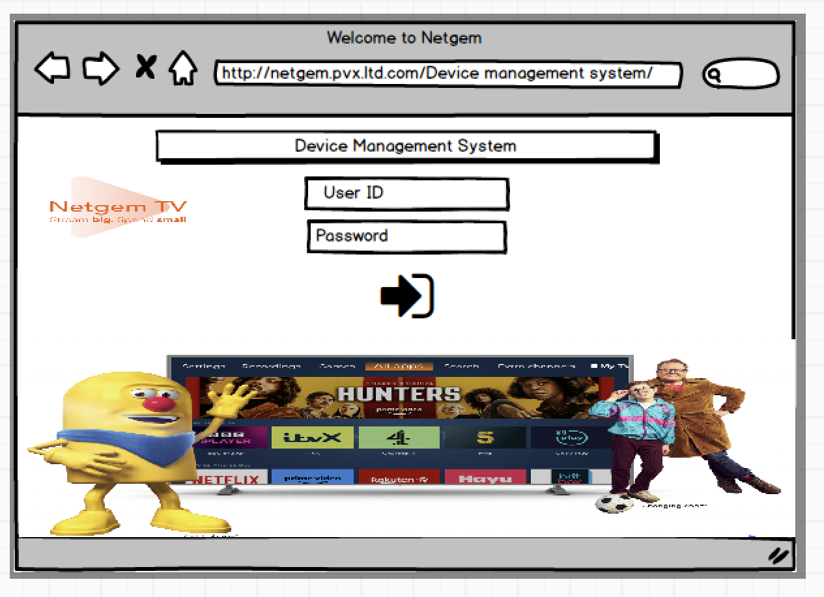

Home Page

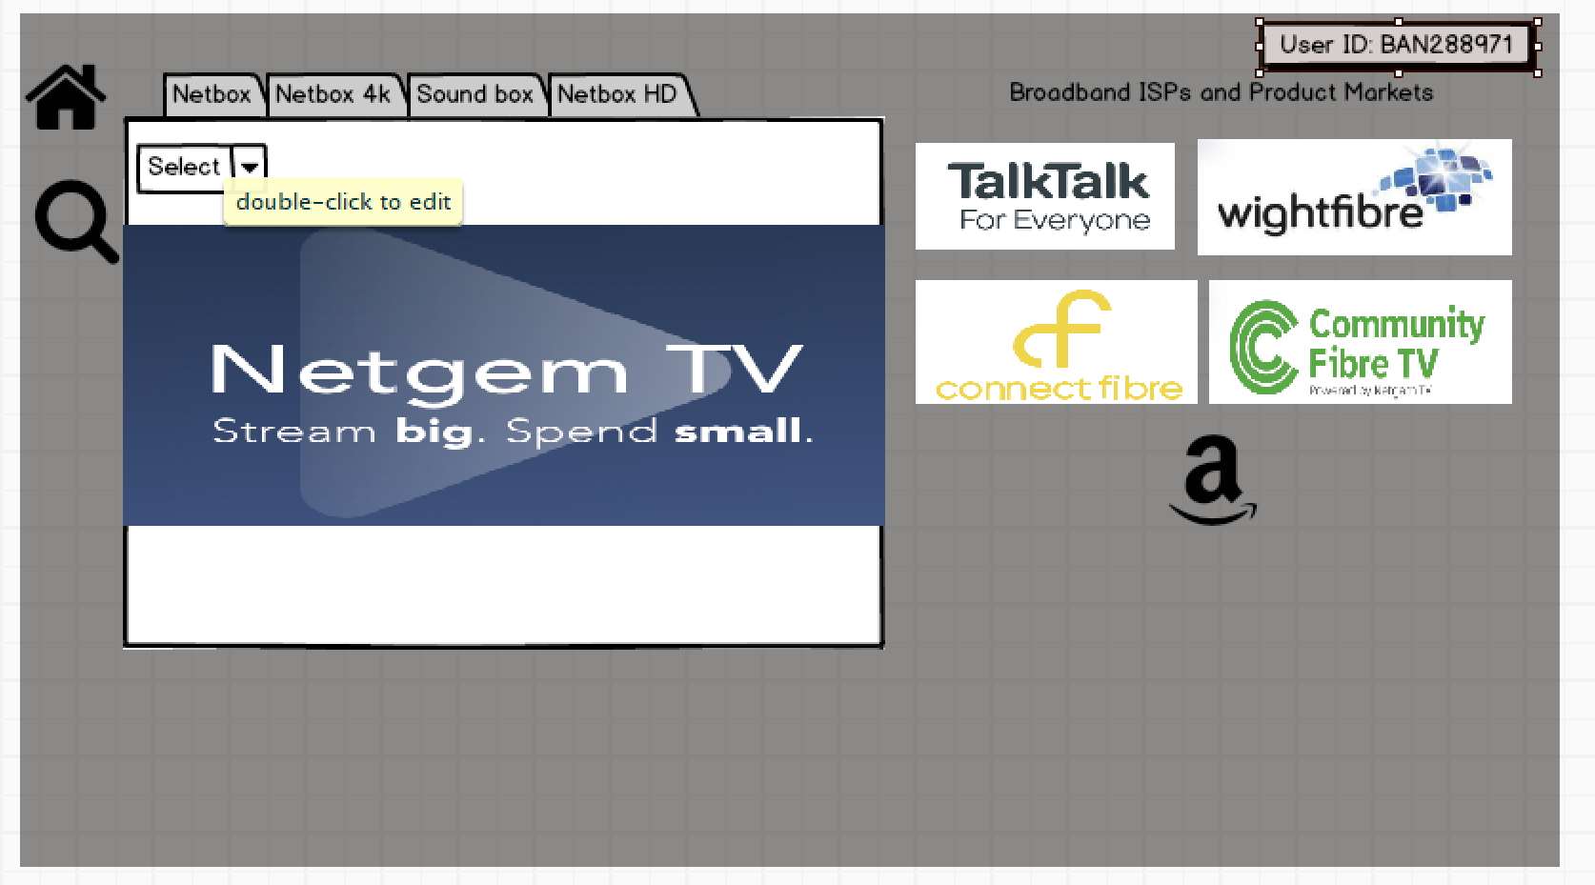

Device details search screen

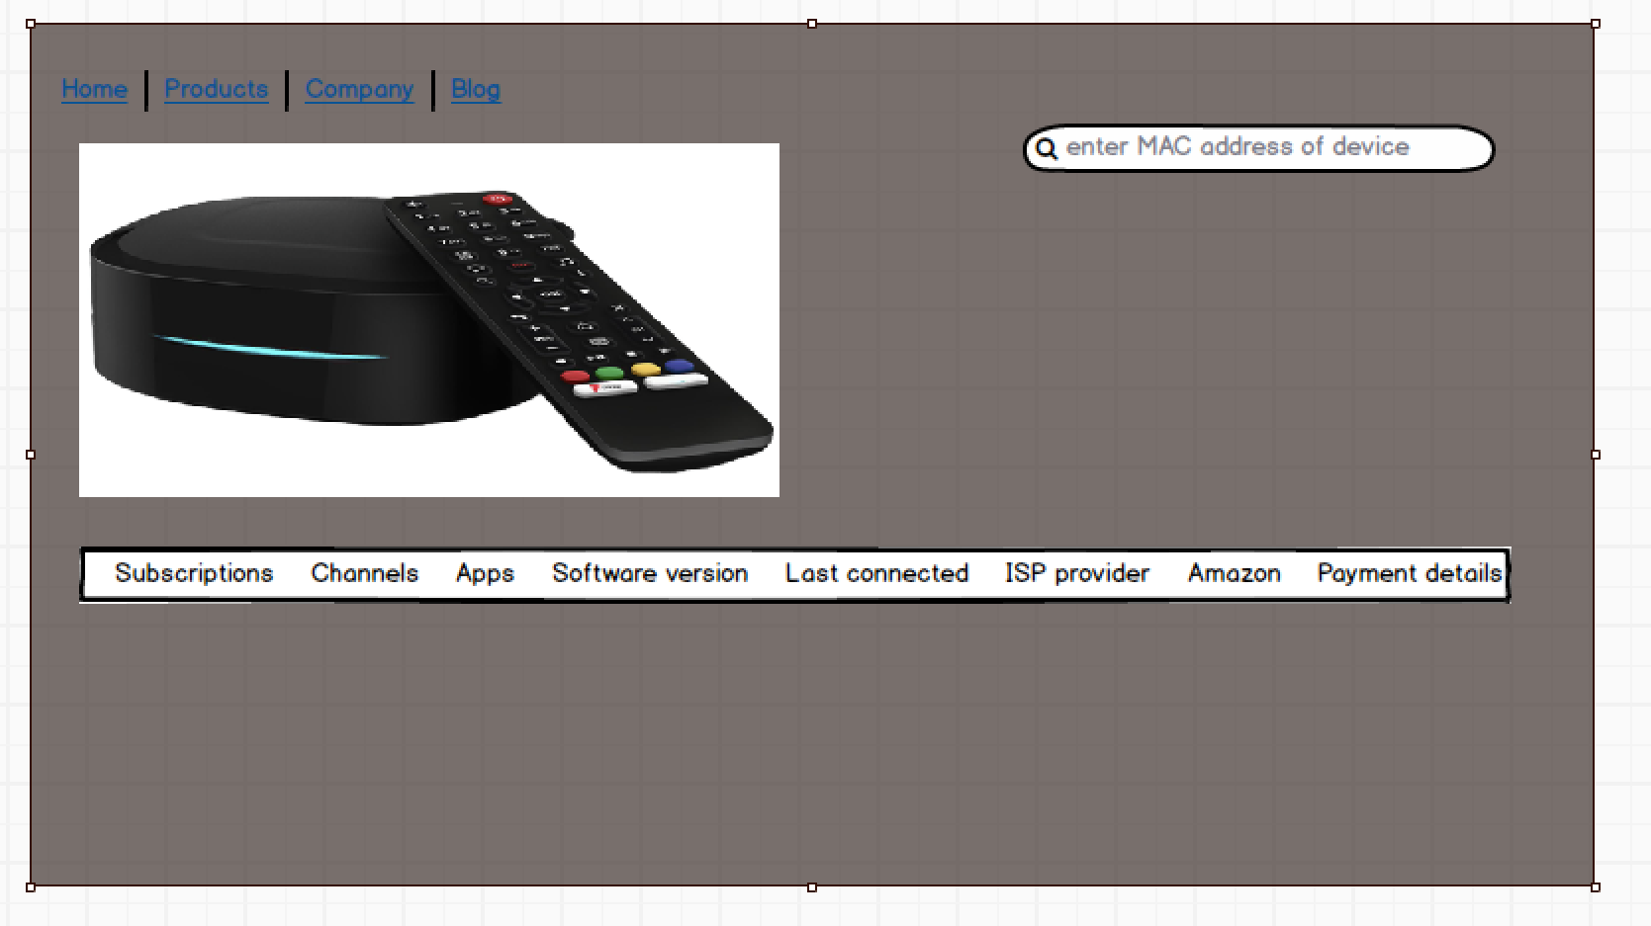

Remote Access screen

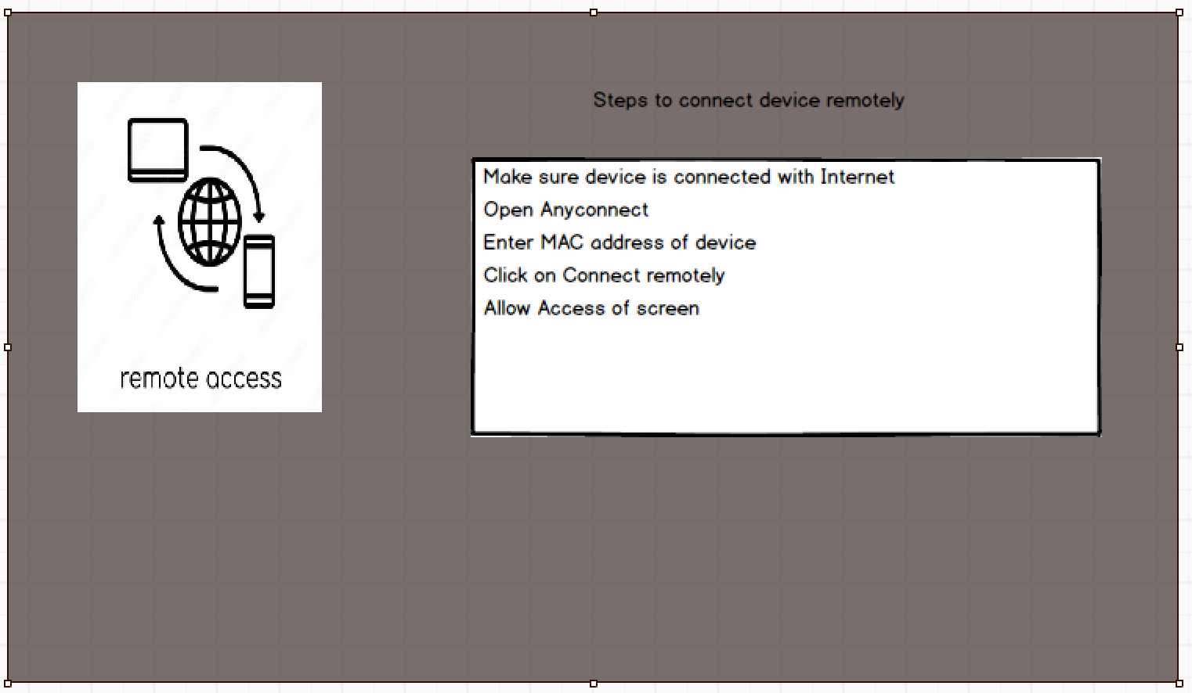

Logout screen

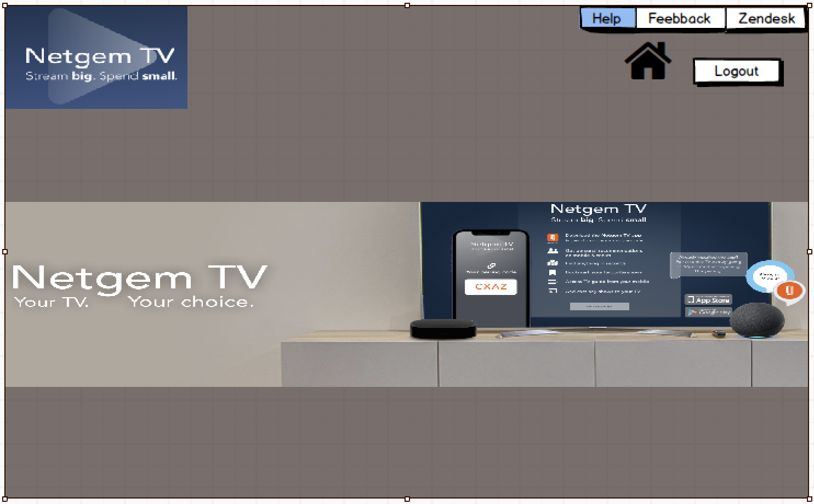

Document 8- Tools-Visio and Axure

Visio is better suited for general diagramming needs like flowcharts, organizational charts, and floor plans, whereas Axure is specifically designed for creating interactive prototypes of websites and applications, allowing for more detailed user interaction simulation and design communication.

Visio: General-purpose diagramming tool for various business processes, workflows, and visual representations of data relationships.

Axure: Primarily used for creating high-fidelity interactive prototypes of software applications, including websites and mobile apps, allowing users to simulate real-world interactions.

Purpose:

Visio: General-purpose diagramming tool for various business processes, workflows, and visual representations of data relationships.

Axure: Primarily used for creating high-fidelity interactive prototypes of software applications, including websites and mobile apps, allowing users to simulate real-world interactions.

Functionality:

Visio: Offers a wide range of pre-built shapes and templates for different diagram types, including flowcharts, network diagrams, mind maps, and org charts.

Axure: Focuses on interactive elements like clickable buttons, dropdown menus, input fields, and transitions to simulate user interactions within a prototype.

User Base:

Visio: Commonly used by business analysts, project managers, and individuals who need to visually represent complex processes.

Axure: Primarily used by UX designers, product managers, and developers to create high-fidelity prototypes for user testing and feedback gathering.

When to use which tool:

Use Visio when:

You need to create basic flowcharts, process maps, or organizational charts.

You want a simple tool for quick visual communication of ideas.

You need to visualize data relationships within a system.

Use Axure when:

You need to create detailed interactive prototypes of web or mobile applications.

You want to simulate user interactions and gather feedback on design elements.

You need to document user flows and detailed specifications for development.

Document 9- BA experience

My experience as BA in following phases:

1. Requirement gathering:

It is a start/initial part of the discussion where requirements arise. Requirement gathering is the process of identifying and documenting the needs and goals of a project. It’s a collaborative process that involved stakeholders, such as clients, users, and subject matter experts.

1.Identified stakeholders who will be the part of project.

2.Deined the Project goals and objective.

3.Collected information from stakeholders about their needs and expectations.

4.Documented the requirements

5. We used MOSCOW method to gather the requirements.

6.Reviewed the requirements with stakeholders and received their approval.

7.Pritorized the requirements based on their importance.

8.We used interviews, brainstorming & Surveys and questionnaires techniques.

9.Based on goals and objectives of the project we have identified required resources and completed requirement gathering discussion even if the client is not available for some time.

10.We have validated the requirements using FURPS technique.

1. Requirement Analysis:

Requirement analysis is a process that involves identifying, analysing, and managing requirements for a project. It's a key part of the software development life cycle (SDLC).

1. Design:
2. From the use case diagrams, we prepared test cases
3. Communicated with client on design and solution documents ● Writtend negative test cases as well along with positive test cases.
4. Do not miss a single test case. It might have huge impact on project development in later stages
5. Prepared test data for testing
6. Updated RTM. This is just as we need to make sure that all the requirements are met
7. Development:
8. Organized JAD sessions
9. Clarifying queries of tech team during coding
10. There might be some team members who doesn't agree with the concept or who doesn’t cooperate during JAD sessions. As a BA I handled the situation gently and had one on one discussion with them. Explained how their actions are going to affect the project. Setup healthy environment within the team.
11. Referred diagrams to code the Unit
12. Conducted regular meetings with technical team and client which is challenging. Some team members might not be available for the meeting. Recording the session and providing that to missed one and having one to one discussion later with that missed person is all I need to do

5. Testing:

1. Prepared test cases from use cases

2.Performed high level testing

3. Test data is requested by BA from client

4.Updated RTM

5.Take signoff from client

6. Prepared client for UAT

6. Deployment:

1. Forwarded RTM to client which should be attached to project closure document

2.Coordinates to complete and share end user manuals

3. Planned and organised training sessions

4. Make sure all the candidates attend the meeting

6. Document 6- Please prepare a use case diagram, activity diagram and a use case specification document.

|  |  |
| --- | --- |
| Use cse ID | UC001 |
| Use case Name | Able to login and search products |
| Created by | BA |
| Created date |  |
| Actors | User/customer |
| Description | This use case involves user/customer to enter details to login and search the products using MAC address |
| Preconditions | Mobile with internet connectivity |
| Postconditions | Users should able to search desired product and leave the website |
| Flows | User should sign in to the app. Able to search the required product and check details of required device |
| Alternative flows | None |
| Exception | None |
| Requirement | R001,R002,R003 |
|  |  |
| Use cse ID | UC002 |
| Use case Name | Search |
| Created by | BA |
| Created date |  |
| Actors | User |
| Description | This use case involves user to search device with MAC address/Purchase bundles/Product name and subscription details |
| Preconditions | Mobile/laptop with internet connectivity |
| Postconditions | Users should able to search desired product and able to check all the device details |
| Flows | User should login to the DMS tool. Able to search the required product and check details of required device |
| Alternative flows | None |
| Exception | None |
| Requirement | R004,R005,R006 |
|  |  |
| Use case ID | UC003 |
| Use case Name | Manage user groups |
| Created by | BA |
| Created date |  |
| Actors | User |
| Description | This use case involves user to to manage the user groups. User will able to create group/update group/delete group. |
| Preconditions | Mobile/laptop with internet connectivity |
| Postconditions | Users should able to create group/update group/delete group as per their subscription details |
| Flows | User should login to the DMS tool. Able to search the required product and check details of required device. User to update/delete/create groups for particular subscriptions |
| Alternative flows | None |
| Exception | None |
| Requirement | R007 |
|  |  |
| Use case ID | UC004 |
| Use case Name | To manage inventory |
| Created by | BA |
| Created date |  |
| Actors | User/DB |
| Description | This use case involves user to to manage and maintain the inventory where the product purchased,subscription details, audits,reports will be handled |
| Preconditions | Mobile/laptop with internet connectivity |
| Postconditions | Users should able to maintain the device inventory data of all products. |
| Flows | User should login to the DMS tool. Maintain inventory audit reports, daily device orders, device susbcription details, device maintainence. |
| Alternative flows | None |
| Exception | None |
| Requirement | R008, R009 |
|  |  |
| Use case ID | UC005 |
| Use case Name | Payments |
| Created by | BA |
| Created date |  |
| Actors | User/DB |
| Description | This use case involves to check the payment details of all customer whether they have paid the subscription amount via cash/UPI/card |
| Preconditions | Mobile/laptop with internet connectivity |
| Postconditions | Users should able to know the payment modes of all customers they have used to pay |
| Flows | User should login to the DMS tool. Need to check the Payment mode to know the pay details of customer |
| Alternative flows | None |
| Exception | None |
| Requirement | R0010 |

