**Nurturing Process - Capstone Project1 – Part -1/3 V2D1- Mar2024**

**Online Agriculture Products Store**

**Question 1 – BPM**

**Answer: Business Process Model:**

**Goal**: The goal is to create a website that will help farmers of the village buy fertilizers via this website directly without any hustle. Considering the lifestyle of the farmers, the website needs to be quite user-friendly and simple so that they can use it very easily.

**Inputs**: Need to create a web-based application, where buyers will be able to search products from across the globe, with detailed information & specification about the product. From searching product to buying the product or adding the product to the wish list or to their cart to making a payment, or returning the product on a single click, every feature a user will get in this App. Based on the search of the user, additional features would be like suggestions of products that will pop up on the screen while the user is browsing.

**Resources**: Team will consist of Business analyst, Java Developers, Network Admin, DB Admin, tester.

**Outputs**: A successful user-friendly working website/Application.

**Activities:**

1st step- user login via email/ phone number or login as a guest

2nd step- user will search for product/ add product in wish list/ add product to cart

3rd step- make the payment/ return of the product

**Values:** User is satisfied and will be happy to buy the product as the application is seamless and hustle free and will keep buying whenever they have a requirement.

**Question 2 – SWOT**

**Answer: SWOT Analysis**

**Strength:** The delivery head is quite resourceful as he got the project through his own company, connection & friends. Having good terms with the stakeholders is an added advantage. IT company is resourceful. All required manpower is available to make the project successful It's a well-established company, to handle and deliver the project on time with an experienced team. Advanced technology and IT hardware to deliver a successful project.

**Weakness:** Have to deal with stakeholders with less understanding of digital apps, which may lead to lots of vague or incorrect information from them. Target customers can be reluctant to use app because of not being familiar with digitization.

**Opportunity:** The budget is 2 crore which is a good amount to continue the project without any obstacle.

**Threats:** Threat of local sellers' objection as the online store will decrease their business. Local influencers like the village head, local politician etc. can negatively influence the farmers in order to get a bribe from us to let us continue the project.

**Question 3 – Feasibility study**

**Answer: Feasibility study**

**Hardware:** Laptop/desktop, printer, scanner, phone, projector

**Software:** Strong broadband connection, Java and other necessary applications, Cloud storage.

**Trained resources:** Java developers, DB administrator, Business analysts, testers, network administrator.

**Budget:** 2 Crore

**Time frame:** 18 months

**Question 4 – Gap Analysis**

**Answer: Gap Analysis**

**AS IS:** Farmers are struggling to get the pesticides easily, they had to travel to the farway city bearing travelling expense and not able to get good dealer in city, due to which they end up buying bad products at high prices. Still many required products or equipment’s are not available in the market.

**TO BE:** Farmers will be able search all kind of agricultural product in just one click across the globe and can make payment instantly via online payment method. Which is really hassle-free, in compare to go to bank and withdraw money. Added benefit is purchased product will be delivered at their door step at 0 delivery charges.

**Question 5 – Risk Analysis**

**Answer: Process/Project Risks**

More budget can be required to maintain the continuity of the project without any obstacle, as old uneducated farmers can oppose the digitization and may influence the young farmers to not support.

**Following are the BA Risks:** Improper information at requirement gathering

The period of project development

Choosing improper elicitation technique

Relevant climate study for crops

Change requests given by stakeholder in the last phase

Multilanguage input for the farmers

Coding and Java developer coordination are important

Easy payment gateway as well proper connection with delivery channel partner

**Projects Risks:**

Farmers are not used to digital thing

Low Internet speed of internet in remote areas, where farmers live

Old farmers prefer to buy from the store only

Farmers return the product, saying not needed, in case of COD

Multiple-time return or exchange of products.

**Internal risk:** High operating expense, technical issue.

**External risk:** Competition from external e com website, change in govt policies affects e com industry.

**Question 6 – Stakeholder Analysis (RACI Matrix)**

**Answer: RACI Matrix**

A RACI chart, also called a RACI matrix, is a type of responsibility assignment matrix (RAM) in project management. In practice, it's a simple spreadsheet or table that lists all stakeholders on a project and their level involvement in each task, denoted with the letters R, A, C or I

|  |  |  |  |  |  |  |
| --- | --- | --- | --- | --- | --- | --- |
| **RACI MATRIX** | | | | | | |
| **Name** | **Position** | **Responsible** | **Accountable** | **Consulted** | **Informed** | **Supporting** |
| Mr. Doku & Mr. Pandu | Business Stakeholders |  |  |  | Yes |  |
| Peter, Kevin, Ben | End users |  |  |  | Yes |  |
| Vishnu E | BA | Yes |  |  |  |  |
| Mr. Vanadam | Project manager |  | Yes |  |  |  |
| Mr. Henry | Finance head |  |  |  |  | Yes |
| Ms. Juhi, Mr. Teyson, Ms. Lucie, Mr. Tucker, Mr. Bravo, Mr. Mike, Mr. John, Mr. Jason, Ms. Alekya | Tech team |  |  | Yes |  |  |

**Question 7 – Business Case Document**

**Answer: Business Case Document**

**Following points are to be covered:**

1. Why is this project initiated?
2. What are the current problems? - GAP analysis
3. What are the resources required? - 14 -15 people
4. How much organizational change is required to adopt this technology? - A percentage how much change can be done
5. With this project how many problems could be solved? - Time frame to recover how to identify stakeholders? Via RACI we can identify.

**Summary:** The whole purpose of this project is to help farmers to buy agricultural products on just one click. To have them a hassle-free experience and to save their time, as they will search the required products from N number of sellers across the country and will be able to place the order in seconds, also the product will be delivered at their door step. All these activities will be done, right from their home. They won’t have to step out of the home.

**Challenges:** Budget could be increased along with the time frame, as this project is demanding in terms of resources. lack of domain knowledge and lack of education of stakeholders could be hinderance in gathering requirement properly and implementing them correctly.,

**Present circumstances:** Farmers are facing difficulties in procuring fertilizers and pesticides, due to the unavailability of products on time, which leads to bad crops.

**Solution:** With the help of the APP, farmers will get all the varieties of the agricultural project on one platform, it will save a lot of time, and orders will be delivered to their doorstep.

**Requirements:** Balsmiq, Visio, Java, Azure, Power BI

In this business case documents. MR. Karthik needs to analyze the things like-

A business case is a package of information, analysis and recommendations.

A business case is prepared by Sr BA, Business Architect & Pre-sales team.

A business case also helps in identifying key stakeholders who are affected by the problem.

14-15 people of dedicated team is required. To complete this project we need PM, BA, Software developers, testers, technical team, DB.

**Changes:** There are chances of 40% -50% changes to be happened in organizational policies, as this project is quiet demanding. Unpredictable changes can be asked at any times. As we can’t expect stability.

**Time frame:** As project is for 18 months. This app would be beneficial for all the farmers, fertilizers and pesticides companies. This time frame for return on investment is possibly after 1 year.

**Cost:** This tells us the cost of the project such as capital, operational and maintenance cost. The cost should be realistic and justifiable.

**Stakeholder identification:** The best way to identify the stakeholders is to prepare RACI matrix based on the functionality of every individual.

**Question 8 – Four SDLC Methodologies**

**Answer: Four SDLC Methodologies**

The Committee of Mr. Henry, Mr Pandu, and Mr Dooku and Mr Karthik are having a discussion on Project Development Approach. Mr Karthik explained to Mr. Henry about SDLC. And four methodologies like Sequential, Iterative, Evolutionary and Agile.

SDLC is a structured approach to developing software products. It consists various stages like planning, analysis, design, development, testing, deployment and maintenance. Each methodology has its strengths and weaknesses. The choice of methodology depends on project requirements.

**Sequential:** The Sequential model is a linear stack of layers that can be created using the waterfall model. In this method, entire project is delivered at the end of the deadline. Client can’t use the application in the midway. This method begins with at the system level and progresses through, analysis, design, coding, testing and support.

**Iterative:** In this method APP is delivered in the modules. Each module is delivered per year in a given frequency of time. Client can start using the part of the application after delivery. Iterative changes result from repeated cycles of change with each cycle contributing to the outcome. The whole process is divided into a particular number of iterations and during each of them developers build a limited number of features.

**Evolutionary:** The overall frame of the module is submitted to the stakeholders. Client freezes on the given module. Slowly the IT team starts adding functionality to the modules. Business analyst gives the look and feel of the project to the stakeholders.

**Agile:** Agile is the most popular method to use. In this methodology, project is getting delivered from the beginning. Clients start using the APP immediately. Continuous support goes on. Change request is possible at each phase during the delivery.

**Question 9 – Waterfall RUP Spiral and Scrum Models**

**Answer: My understanding on Waterfall, RUP, Spiral and Scrum Models.**

**Waterfall:** This is the most common lifecycle mode and is also known as liner sequential model. It is very easy and simple to use. In this model, each phase is entirely completed, before that we can’t move to next phase. Once each phase is completed, review will be done to decide, whether to continue with the project or not. This is just to make sure that the project is on the right path or not. This method is different a bit as each phase is input for the next phase.

**RUP:** Rational unified process. In this method long term application is developed. It allows to track the defects of the project at very early stage. Since it has multiple phases, it requires more budget and resources to execute the same. It also frames step by step explanation describing how specific explanation goals are to be achieved.

**Spiral:** It emphasizes on risk analysis. The spiral model is a risk driven process model generator for software projects It has four phases. Planning, risk analysis, engineering and evaluation. And these process repeats. In planning phase, requirements are gathered during the planning phase. In risk analysis phase a process is undertaken to identify risk and alternate solutions. A prototype is produced at the end of the risk and alternate solutions. Finally, software is produced in the engineering phase. Along with the testing at the end of the phase. In this method angular component represents progress and radius of the spiral component represents cost.

**Agile:** Agile is the most popular method to use. In this methodology, project is getting delivered from the beginning. Clients start using the APP immediately. Continuous support goes on. Change request is possible at each phase during the delivery. It involves customer retention, since there is no documentation.

**Question 10 – Waterfall Vs V-Model**

**Answer:**

|  |  |
| --- | --- |
| **Waterfall Model** | **V-Model** |
| Identifies flaws at outset | Identifies flaws during testing |
| Testing activities initiated following conclusion of  development activities | Next phase begins only after completion of present  phase |
| Processes carried out linearly | Processes not carried out linearly |
| Less flexible | More flexible |
| Lower cost | Higher cost |
| Does not prioritize risk management | Risk management as an integral part of its development  process |

**Question 11 – Justify your choice**

**Answer:**

As a business analyst, my recommendation would be to use the Waterfall model for this project.

The Waterfall model is a linear sequential approach where each phase of the software development process is completed before moving onto the next phase. This model is suitable for projects with clear and well-defined requirements, which is the case for the online agriculture product store project. The project has a clear objective of developing an e-commerce platform for farmers to buy agriculture products, and the requirements for the project have been shared by the stakeholders.

On the other hand, the V model is an extension of the Waterfall model, and it is used for testing and verification. It is useful when the requirements are clear and well-defined. However, it is not an appropriate approach for software development projects as it does not provide a framework for design and development.

Therefore, based on the project's clear requirements, I recommend the Waterfall model for this project.

**Question 12 – Gantt Chart**

**Answer:**

**GANTT Chart:** Its nothing but a progress report prepared by a project manager. it’s a work breakdown structure (WBS). Can prepare 2 GANTT chart:

1. Based on how much time it takes work to be done

2. How many resources are gone be required and their requirement weeks.

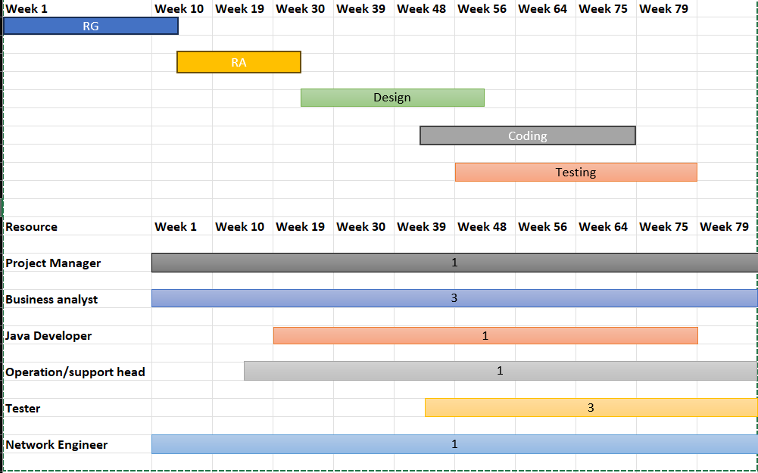

**Question 13 – Fixed Bid Vs Billing**

**Answer:**

**Fixed Bid Model:** In this model, the vendor commits to a set amount of money for a project with defined deliverables. These are usually domestic projects when a company has specific elements in their project, such as predetermined data, a fixed scope, or a strict budget. The fixed bid project is charged as a single, flat fee, irrespective of hours spent. This model features predefined project requirements, fixed time frames, and a fixed budget. As the name implies, this model is about freezing your project requirements and specifications together with the costs before development begins. For any extra work that was not specified in the documentation, client must pay extra. The fixed bid model can be beneficial for companies that have a clear understanding of their project requirements and are looking for cost predictability. However, it can also bring some confusion when it comes to choosing which model is best to handle your business.

**Billing Model:** In this model project is billed based on the number of hours worked, at the hourly, daily, or monthly fixed billing rates assigned for that project. This model is used when there is no restriction on budget, it can be increased, based on the work required by the team.

**Question 14 – Preparer Timesheets of a BA in various stages of SDLC**

**Answer: Timesheet is a breakdown of everyday work**

|  |  |  |  |  |
| --- | --- | --- | --- | --- |
| **RG Timesheet of a BA: requirement gathering** | | | | |
| **Task Description** | **Time Started** | **Time Ended** | **Total Time (mins)** | **Remarks** |
| Had a meeting with stakeholders | 10:45 AM | 11:45 AM | 60 |  |
| Worked on consolidation of raw information received from stakeholders | 12:00 PM | 1:00 PM | 60 |  |
| Discussion on call about summarized data with stakeholders for verification. | 1:15 PM | 2:30 PM | 75 |  |
| High level design document is prepared and analyzed | 3:00 PM | 5:00 PM | 120 |  |

|  |  |  |  |  |
| --- | --- | --- | --- | --- |
| **RA Timesheet of BA: Requirement analysis** | | | | |
| **Task Description** | **Time Started** | **Time Ended** | **Total Time (mins)** | **Remarks** |
| Had a meeting with Internal stakeholders | 10:15 AM | 11:15 AM | 60 |  |
| Review on gathered requirement | 11:45 AM | 1:00 PM | 75 |  |
| Discussion on call about summarized data with stakeholders for verification. | 1:30 PM | 2:45 PM | 75 |  |
| Discussion on how to go further after analysis with Stakeholders | 3:00 PM | 4:30 PM | In Progress |  |

|  |  |  |  |  |
| --- | --- | --- | --- | --- |
| **Timesheet of a BA: Design** | | | | |
| **Task Description** | **Time Started** | **Time Ended** | **Total Time (mins)** | **Remarks** |
| Had a meeting with technical team | 10:30 AM | 11:30 AM | 60 |  |
| Detailed analysis on the progress of the application | 11:45 AM | 12:45 PM | 60 |  |
| The risk and challenges faced in the design phase are covered | 1:15 PM | 2:30 PM | 75 |  |
| High level design document is prepared and analyzed | 3:00 PM | 4:45 PM | 105 |  |

|  |  |  |  |  |
| --- | --- | --- | --- | --- |
| **Testing Timesheet of a BA** | | | | |
| **Task Description** | **Time Started** | **Time Ended** | **Total Time (mins)** | **Remarks** |
| Meeting with testers and responsible stakeholders | 10:45 AM | 11:45 AM | 60 |  |
| Comprehensive assessment of a software as per the client needs | 12:00 PM | 1:30 PM | 90 |  |
| Defects are analyzed and errors are minimized | 2:15 PM | 3:45 PM | 90 |  |
| Test document is prepared | 4:15 PM | 6:00 PM | 105 |  |

|  |  |  |  |  |
| --- | --- | --- | --- | --- |
| **UAT Timesheet of a BA** | | | | |
| **Task Description** | **Time Started** | **Time Ended** | **Total Time (mins)** | **Remarks** |
| Morning meeting with the concerned team | 10:45 AM | 11:45 AM | 60 |  |
| Genuine change request is put under consideration | 12:00 PM | 1:30 PM | 90 |  |
| Functionalities are added as per the given change request | 2:15 PM | 3:45 PM | 90 |  |
| Reporting the possible outcome to the PM | 4:15 PM | 5:15 PM | 60 |  |

|  |  |  |  |  |
| --- | --- | --- | --- | --- |
| **Deployment & Implementation of the BA** | | | | |
| **Task Description** | **Time Started** | **Time Ended** | **Total Time (mins)** | **Remarks** |
| Team meeting to analyse the user readiness of the software | 10:45 AM | 11:45 AM | 60 |  |
| Running the code for the first time | 12:00 PM | 1:30 PM | 90 |  |
| Risk analysis of the given code from the release engineers' perspective. | 2:15 PM | 3:45 PM | 90 |  |
| Training and Documentation and sign off | 4:15 PM | 5:30 PM | 75 |  |

**Nurturing Process - Capstone Project1 – Part -2/3 V2D1- Mar2024**

**Online Agriculture Products Store**

**Question 1 – Audits**

**Answer:**

**What is an Audit:** Audit is the inspection of various books of different departments by an auditor followed by physical checking of inventory, financial statement and several other documents to make sure that all departments are following documented system of recording transactions.

**What is a Project Audit:** A project management audit is a formal review that seeks to evaluate a given project based on specific criteria. Examples of these can include project quality, performance, and adherence to the statement of work.

While doing the Audit of a BA, the auditor needs to check the following details.

|  |  |
| --- | --- |
| **Stage** | **Quarter 1 Audit report** |
| **Time line** | 10 weeks (week 1 to 10) |
| **Check list** | 1. Understanding of company goals does the BA has. 2. Work is Planned and Tracked. 3. Understood the Current as is process. 4. BA’s understanding of Business Requirements 5. BA conducted the Stakeholder Analysis  6. Requirement gathering and analysis was done correctly. 7. What Elicitation techniques has been used to gather requirements. |

|  |  |
| --- | --- |
| **Stage** | **Quarter 2 Audit report** |
| **Time line** | 08 weeks (week 19 to 27) |
| **Check list** | 1. Documents have been prepared by the BA. 2. Has the BA prepared all the required documents like RTM, BPM to understand the requirement correctly. 3. How is BA prepared the Use case and Activity diagram. 4. Were all these documents signed and agreed by the Stakeholders, before the start of the development stage. |

|  |  |
| --- | --- |
| **Stage** | **Quarter 3 Audit report** |
| **Time line** | 09 weeks (week 30 to 39) |
| **Check list** | 1. Requirements were correctly explained to the development team. 2. BA tracking the status of the project. 3. JAD session organized by the BA. 4. Timesheets sent to the reporting manager. 5. BA keeping the Stakeholders updated on the status of the project. |

|  |  |
| --- | --- |
| **Stage** | **Quarter 4 Audit report** |
| **Time line** | 18 weeks (week 41 to 59) |
| **Check list** | 1. BA tracking the Testing of the product. 2. BA assisting the Testing team for Testing the product. 3. BA sending the Test data to the client. 4. BA preparing the End user manual. |

|  |  |
| --- | --- |
| **Stage** | **Quarter 5 Audit report** |
| **Time line** | 18 weeks (week 60 to 78) |
| **Check list** | 1. BA preparing the client for UAT. 2. BA assisting the Delivery manager to implement the product. 3. BA helping the client to do the UAT. 4. BA organizing the training sessions for the users. 5. BA taking signoff document from the client. 6. BA sending the complete timesheet to the reporting manager. |

**Question 2 – BA Approach Strategy**

**Answer:**

1. **Elicitation Techniques-** Elicitation is the process of discovering requirements or business needs. It is important to use a very rigorous process to do elicitation because so often stakeholders do not have a direct view of the problem. There are several elicitation techniques. For this Project i will use brainstorming Techniques.
2. **Stakeholder Analysis-** A stakeholder analysis is a process of identifying these people before the project begins; grouping them according to their levels of participation, interest, and influence in the project; and determining how best to involve and communicate each of these stakeholder groups throughout. We can do this by using RACI Matrix.
   1. Below is the list of Stakeholders. Project Stakeholders
      1. Business Analyst – Vishnu E
      2. Delivery Head – Mr. Karthik
      3. Project Manager – Mr. Vanadanam
      4. Development Team – MS. Juhi, Mr. Teyson, Ms. Lucie, Mr. Tucker, Mr. Bravo
      5. Testing Team – Mr. Jason and Ms. Alekya
      6. Network Admin – Mr. Mike and DB Admin is John
   2. Business Stakeholders - Business Sponcer - Mr. Henry
      1. Influencers - Peter, Kevin and Ben.
      2. Finance team – Mr. Pandu
      3. Project Team – Mr. Dooku
3. **What Documents to Write-**
   1. Scope
   2. In-Scope Features/Services
   3. Out scope Features/Services
   4. Solution Architecture Diagram
   5. Technology Specifications
   6. FRD- Functional and Non-Functional
   7. BRD- Business Requirements Document
   8. Project timeline
   9. Risks and mitigation plan
   10. Change management
   11. Standard terms and conditions
4. **Process to follow to Sign off on the Documents-** Project sign-off is typically executed during the contract closure phase – the company presents the results of the work done to the client and then, after getting the necessary acceptance from them, should get a client statement to verify that the job was completed.
   1. Name of the project.
   2. All relevant dates.
   3. Key roles in the project.
   4. Project deliverables.
5. **Taking Approvals** - While taking approval for all the above documents, I will call the respective Stakeholders and send them an Email with the details.
6. **Communication Channels to establish and implement-** As a BA, I would prefer the below communication channels:
   1. Face to Face communication – for Requirement Gathering stage. For example, Interviews with Stakeholders.
   2. Video conferencing - This communication is also used when the Stakeholder is at a different location.
   3. Phone calls – This communication is used for setting up meetings with Stakeholders and for taking approvals.
   4. Emails - This communication is used for setting up meetings with Stakeholders and for taking approvals
7. **How to handle Change request-** As a BA I would handle the Change request by understanding the below steps.
   1. Understanding the Scope of Change.
   2. Determining the Scope of Incorporating the Change request.
   3. Understanding the Feasibility of the Change request.
   4. Taking the approval for the Change.
   5. Communicating and Implementing the Change.
8. **Updating the progress of the project-** As a BA once we understand these key areas, we will now have to focus on sharing the project status with the Stakeholders.
   1. Utilize online collaboration tools to share regular progress.
   2. Send out weekly or bi-weekly status reports.
   3. Develop a follow up meeting with actively involved Stakeholders.
9. **Signing off on the UAT- Client Project Acceptance Form-** User Acceptance Testing (UAT) is a type of testing performed by the end user or the client to verify/accept the software system before moving the software application to the production environment.
   1. UAT is done in the final phase of testing after functional, integration and system testing is done.
   2. Deliverables for UAT testing are Test Plan, UAT Scenarios and Test Cases, Test Results and Defect Log.
   3. Once execution is over, and as many defects as possible are resolved, it is time to sign off on UAT and go live.
   4. The sign-off approval indicates that the change meets business requirements and is ready for deployment.
   5. Business Analysts or UAT Testers needs to send a sign off mail after the UAT testing.
   6. After sign-off, the product is good to go for production.

**Question 3 – 3-Tier Architecture**

**Answer-**

Three-tier architecture is a hierarchical software architecture with three distinct, independent tiers or layers. Three-tier architecture is comprised of the following tiers: Presentation Tier (Client layer), Business (Business Logic Layer) and Data access (Data layer). The main job of the architecture is to enable software applications to efficiently and quickly respond to user requests or inputs.

**Presentation Tier:** This layer is also called Client layer and is responsible for accepting inputs or requests from the user and displaying data for the user in a user-friendly format. It accepts inputs and sends the inputs or request to the business logic layer.

**Business Tier:** This layer is also called Business Logic Layer and helps define solutions to complex business problems. It acts as a middle layer between the client and the database server which are used to exchange partially processed data.

**Database layer:** In this layer the data or information is stored. This layer performs operations like insert, update and delete to connect with the database.

|  |  |
| --- | --- |
| Presentation Layer | All user interface will be visible on the screen in the Client layer, Ex: Application Name, Login username and password, Product list, new user registration, new arrivals etc. |
| Business Logic Layer | Reusable components or changing rules and regulations are included in the Business Logic layer, Ex: GST, Multiple payment options etc. |
| Database layer | Storage place for all the information related to Products, Client credentials etc. Ex: Product price, Quality, Quantity, Client details etc. |

**Question 4 – BA Approach Strategy for Framing Questions**

**Answer-**

**5W1H-** As a BA, the followings points should be kept in mind before framing questions to ask a Stakeholder.

1. What is the Project and what are the objectives?
2. What is the Timeline for the project?
3. Who is the Client and Who are the users?
4. Who will benefit from this project?
5. Where will the product be deployed?
6. How much is the Budget?
7. Why are the clients developing this product?

**SMART-** Confirm the requirement is SMART before accepting it for development.

1. Specific - Narrowing the questions, so let every signal question only include one element you can get.
2. Measurable – The questions are better to be quantified and countable. Ex. Multiple Choice questions.
3. Action Oriented – Does the question influence creation of different or new feature packages.
4. Relevant – Does the question identify which features are most required from the customer.
5. Timebound - It can let you or your customer decide priority in a specific time frame.

**RACI Matrix**

1. Responsible – The person who does the work to achieve the task. They have responsibility for getting the work done or decision made. The persons responsible are typically working-level project team members, such as the project manager, business analyst and developers.
2. Accountable – The person who is responsible for the correct and through completion of the task. They are responsible for ensuring the work is complete and suitable.
3. Consulted – People from whom feedback and input should be solicited. They are going to provide information for the project and with whom there can be two-way communication.
4. Informed – People kept informed of progress by keeping them in loop. These individuals do not have to be consulted or be a part of the decision making.

**3 Tier Architecture**

1. Presentation layer - This layer display screens, pages, validation on page, company specific logic, functionally.
2. Business logic layer - In a business logic layer all reusable components, frequently changing components, governing body rules, regulation, compliance.
3. Data layer - In this layer the data or information is stored. This layer performs operations like insert, update and delete to connect with the database.

**Use Cases**

1. What type of product we will deliver?
2. Where is the location we will deliver the application?
3. When should be the process be completed?
4. Who all are responsible for doing this?
5. Why this product will be used?
6. How will we deliver this project?

**Use Case Specs**

1. Who are the Primary and Secondary actors?
2. What are the Actor Goals?
3. What are the main Tasks or functions that are performed by the Actor?
4. What information does the actor desire from the system?

**Activity Diagrams-** Activity diagrams are visual representations of a series of actions or flow of control in a System similar to a Data flow diagram. It is basically a flowchart to represent the flow from one activity to another activity. The activity can be described as an operation of the system.

Purpose of an activity diagram can be described as-

1. Draw the activity flow of a system.
2. Describe the sequence from one activity to another.
3. Describe the parallel, branched, and concurrent flow of the system.

**Modelling & page design-** It's a very important part of the question for requirement getting where BA needs to ask a stakeholder about.

1. In what way do you want functioning to look like?
2. The web page functions look like?
3. Functional activity?
4. Payment gateway Complaint and function update

**Question 5 – Elicitation Techniques**

**Answer- 12 techniques (BDRFOWJIPQU)**

1. **Brainstorming:** This technique is used to generate new ideas and find a solution for a specific issue. The members included for brainstorming can be domain experts, subject matter experts. Multiple ideas and information give us a repository of knowledge and we can choose from different ideas.
2. **Document Analysis:** During this step of the requirements elicitation process, business analysts review existing documentation at hand, with the intent of identifying requirements for changes or improvements. Examples of document analysis sources include pre-existing project plans, system specifications, process documentation, market research dossiers, customer feedback, meeting minutes, and user manuals. Document analysis is performed before scheduling more in-depth requirements elicitation sessions or interviews with stakeholders.
3. **Reverse engineering:** In this Technique, any outdated documentation in an existing system, can be reversed to understand what the system does. This is an elicitation technique that can extract implemented requirements from the system. There are two types of reverse engineering techniques.
   1. Black box reverse engineering: The system is studied without examining its internal structure (function and composition of software).
   2. White box reverse engineering: The inner workings of the system are studied (analyzing and understanding of software code).
4. **Focus Group:** By using a focus group, you can get information about a product, service from a group. The Focus group includes subject matter experts. The objective of this group is to discuss the topic and provide information. A moderator manages this session.
5. **Observations:** Observation is an excellent elicitation technique that helps understand requirements based on observations related to process flows and work environments of stakeholders. Observation requires a business analyst to go and look at the work – for example, observing the business processes in scope of the project. The elicitation technique observation is an effective means of understanding how a user does their job by assessing their work environment.
6. **Workshops:** Workshops comprise a group of users or stakeholders working together to identify requirements. A requirement workshop is a structured way to capture requirements. Workshops are used to scope, discover, define, and prioritize requirements for the proposed system.
7. **JAD (Joint Application Development):** This technique is more process-oriented and formal as compared to other techniques. These are structured meetings involving end-users, PMs, SMEs. This is used to define, clarify, and complete requirements.
8. **Interviews:** An interview is a systematic approach to elicit information from a person or group of people. This is the most common technique used for requirement elicitation. Interview techniques should be used for building strong relationships between business analysts and stakeholders. In this technique, the interviewer directs the question to stakeholders to obtain information. One to one interview is the most commonly used technique.
9. **Prototyping:** Prototyping is used to identify missing or unspecified requirements. In this technique, frequent demos are given to the client by creating the prototypes so that client can get an idea of how the product will look like. Prototypes can be used to create a mock-up of sites, and describe the process using diagrams.
10. **Questionnaire & Surveys:** For Survey/Questionnaire, a set of questions is given to stakeholders to quantify their thoughts. After collecting the responses from stakeholders, data is analyzed to identify the area of interest of stakeholders. Questions should be based on high priority risks. Questions should be direct and unambiguous. Once the survey is ready, notify the participants and remind them to participate.
11. **Use case specs:** Use cases are an effective and widely used technique for eliciting software requirements. The use-case approach focuses on the goals that users have with a system, rather than emphasizing system functionality. This technique combines text and pictures to provide a better understanding of the requirements. The use cases describe the ‘what’, of a system and not ‘how’. Hence, they only give a functional view of the system. The components of the use case design include three major things – Actor, use cases, use case diagram.

**Question 6 – This project Elicitation Techniques**

**Answer-**

Brainstorming technique will be the right choice, when the BA is getting a chance to connect with the stakeholders, who are experienced and can share their knowledge. By using brainstorming techniques, we can generate a large number of ideas in a short amount of time.

* **Brainstorming:** By using this Technique, we can extract several ideas to make the Online store more useful for farmers and other users. Once we have these ideas, we can analyze and select the best ideas to implement. Brainstorming is effective with group of 8 to 12 people it helps to get the good number of ideas from user and stakeholders.
* **Prototype:** Prototyping is a visual technique, where we can create a representation of any ideas and allow us to test our ideas directly with the users before developing into a fully-fledged product. For this project, I would draw down the idea in a paper and share it with the stakeholders. Being a completely new project in the market, for which there are no details or documents available, I would use this technique to find the feasibility of the project, before spending money on the project.
* **Use case specs:** This technique is a combination of text and pictures which will provide me a better understanding of the requirements. This technique shows the behavior of the system and help to capture the requirement of the system. These diagrams also identify the interactions between the system and its actors.

As per my judgement, Business Requirements which include Stakeholder Requirements:

BR001 - Farmers should be able to search for available products in fertilizers, seeds, pesticides

**Question 7 – 10 Business Requirements**

**Answer-**

Identify Business Requirements (which includes Stakeholder Requirements)

* BR001- Farmers should be able to search for available products in fertilizers, seeds, pesticides.
* BR002- Manufacturers should be able to upload and display their products.
* BR003- All users should have Login details with Username and Password.
* BR004- Once the user’s login to the portal, they should also update their address details, to make sure the delivery happens to their requested address only.
* BR005- A fresh user should be able to create a new account by submitting their email ID and creating a secure password.
* BR006- Users should be able to browse through the Product catalogues once they visit the website.
* BR007- User should have the Buy Now option if they want to purchase the product immediately.
* BR008- Users can have a Save for Later or Wishlist option, if they want to buy any product later.
* BR009- Farmers needs to have an easy-to-use payment gateway which should include cash-on delivery (COD), Credit/Debit card and UPI options so that the user’s experience should be better.
* BR010- User should get an email confirmation regarding their order status.
* BR011- Users should be able to track their order, once placed.
* BR012- User should be able to cancel or return the product, if not happy with it.
* BR013- Users should have an option to rate the Product, Delivery and Overall experience.

**Question 8 –Assumptions**

**Answer- List of my assumptions:**

* Users should either have Laptop or Desktop or Mobile.
* They should have an active Email address.
* They should have an active Bank account with active payment modes, like Credit/Debit card, UPI payments or mobile banking facility etc.
* They also should have an active registered mobile number to receive OTPs to pay for the product and accept delivery.
* Does the application have price comparison option for multiple products.
* How much competitive the price of the products is going to be.
* The application should have the Product stock notification.
* The application should have Chat facility to speak to any customer service querying for any product, they want to buy.
* The application should have a delivery tracking facility.

Question 9 – This project Requirements Priority

Answer-

|  |  |  |  |
| --- | --- | --- | --- |
| **Req ID** | **Business requirement** | **Req Description** | **Priority** |
| BR001 | Farmer Search for Products | Farmers should be able to search for available products in fertilizers, seeds, pesticides | 8 |
| BR002 | Manufacturers upload their Products | Manufacturers should be able to upload and display their products. | 8 |
| BR003 | Username &Password | All users should have Login details with Username and Password | 9 |
| BR004 | User Details | Once the user’s login to the portal, they should also update their address details, to make sure the delivery happens to their requested address only. | 9 |
| BR005 | User Details | A fresh user should be able to create a new account by submitting their email ID and creating a secure password. | 8 |
| BR006 | Browsing through Product catalogues | Users should be able to browse through the Product catalogues once they visit the website. | 7 |
| BR007 | Purchase Options | User should have the Buy Now option if they want to purchase the product immediately. | 6 |
| BR008 | Wishlist | Users can have a Save for Later or Wishlist option, if they want to buy any product later. | 6 |
| BR009 | Payment Gateway | Farmers needs to have an easy-to-use payment gateway which should include cash-on delivery (COD), Credit/Debit card and UPI options so that the user’s experience should be better. | 9 |
| BR010 | Notifications | User should get an email confirmation regarding their order status. | 7 |
| BR011 | Order Tracking | Users should be able to track their order, once placed. | 7 |
| BR012 | Cancel/Return | User should be able to cancel or return the product, if not happy with it. | 9 |
| BR013 | Feedback | Users should have an option to rate the Product, Delivery and Overall experience. | 7 |

**Question 10 – Use Case Diagram**

**Answer-**

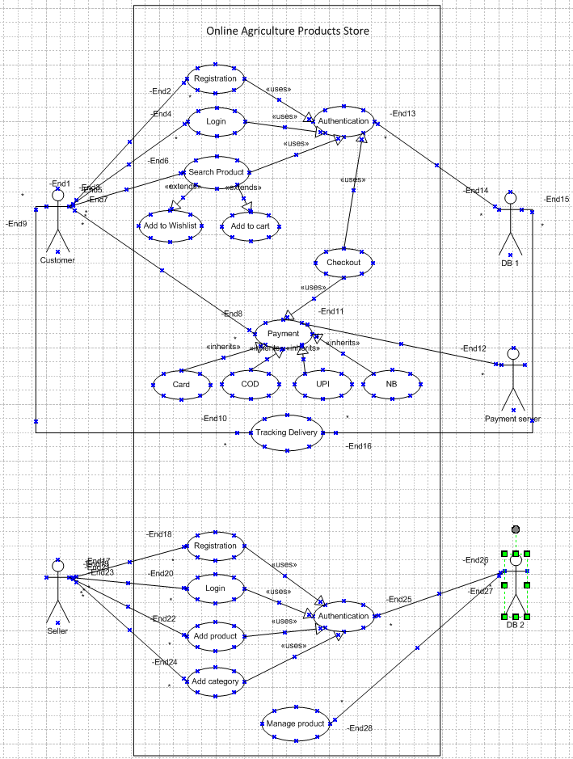

**Question 11 – (minimum 5) Use Case Specs**

**Answer-**

|  |  |
| --- | --- |
| **Use case ID** | **UC001** |
| **Use case name** | Buying a Product |
| **Actors** | Customer, seller |
| **Description** | This use case describes how users can make purchase via App |
| **Pre - Condition** | User should have been registered into the application |
| **Post - Condition** | Successfully able to login the Account |
| **Basic Flow** | Step 1: User create and account and login Step  2: User search for a product from the search bar.  Step 3: same product and related product option from different manufacture will be appeared on the screen.  Step 4: User select one product, selects the size and quantity of the product and click on "buy now option".  Step 5: System will take to another page, where total price calculation will be displayed along with the products added to cart.  Step 6: User click on "Place order button".  Step 7: User need to choose the mode of the payment.  Step 8: User need to enter the banking details and make payment.  Step 9: User will receive order confirmation on email along with the tracking id.  Step 10: Basic flow end here. |
| **Alternate Flows** | Step 1: User is not able to login and redirected to forgot "Username/Password" page.  Step 2: If you user is not able to get the right information, he can request for a call from customer care.  Step 3: once he gets connected with the customer care he will explain the issue to the customer care representative,  Step 4: Customer care will send a link to reset password to his email account.  Step 5: User will go to that link and system will take to new page, where user will be able to change new password  Step 6: User will be put a new password.  Step 7: System will ask to reconfirm the password.  Step 8: User will be able to login the account now. |
| **Exceptions** | If internet connectivity lost while doing this use case, system displays " check with your internet connectivity " |
| **Frequency of use** | High |
| **Assumptions** | It is assumed that the customer is registered  It is assumed that the customer has the computer knowledge  It is assumed that the customer has a suitable device to use the APP. |

|  |  |
| --- | --- |
| **Use case ID** | **UC002** |
| **Use case name** | Exchange of Product |
| **Actors** | Customer, seller |
| **Description** | This use case describes how users can exchange a purchased product. |
| **Pre - Condition** | User should have purchased a product before in order to make a exchange. |
| **Post - Condition** | Successfully able to exchange the product |
| **Basic Flow** | Step 1: User login to account via credentials.  Step 2: User click on "Account".  Step 3: System takes to different page with other details.  Step 4: User select option "Exchange" among those options.  Step 5: System will take to another page, where recently ordered products will be displayed on the screen.  Step 6: User has to choose the product which he wants to exchange.  Step 7: User will get another option where he will be asked- "different size in same product" or "want to buy another product"  Step 8: User need to choose one of the options and take action according to chosen option.  Step 9: Once the product is chosen, user will have to click on button "Exchange".  Step 10: User will get the confirmation on email. |
| **Alternate Flows** | Step 1: User couldn't find the size which he wanted.  Step 2: User call customer care agent to get a solution  Step 3: Agent suggested to wait for the size to be restocked and gave a tentative date or go for similar products.  Step 4: Agent shares the link of similar products to the registered email of the customer. Step 5: User choose the product  Step 6: User will be put a new password.  Step 7: System will ask to reconfirm the password.  Step 8: User will be able to login the account now. |
| **Exceptions** | If internet connectivity lost while doing this use case, system displays " check with your internet connectivity " |
| **Frequency of use** | High |
| **Assumptions** | It is assumed that the customer is registered  It is assumed that the customer has the computer knowledge  It is assumed that the customer has a suitable device to use the APP. |

|  |  |
| --- | --- |
| **Use case ID** | **UC003** |
| **Use case name** | Return of Product |
| **Actors** | Customer, seller |
| **Description** | This use case describes how users can return a purchased product. |
| **Pre - Condition** | User should have purchased a product before in order to make a return. |
| **Post - Condition** | Successfully able to exchange the product |
| **Basic Flow** | Step 1: User login to account via credentials.  Step 2: User click on "Account".  Step 3: System takes to different page with other details.  Step 4: User select option "Return" among those options.  Step 5: System will take to another page, where recently ordered products will be displayed on the screen.  Step 6: User has to choose the product which he wants to return.  Step 7: User will get another option where he will be asked to provide the bank account number for amount of the returned product to be credited.  Step 8: User need to enter the account number and submit.  Step 9: User will get the confirmation on email. |
| **Alternate Flows** | Step 1: User didn't get the amount in his account within the TAT. Step 2: User call customer care agent to ask payment status.  Step 3: Payment was stuck due to a technical glitch.  Step 4: User was shared complaint form to be filled.  Step 5: Once form submitted, user received another TAT on the email of amount to be credited.  Step 6: User get the payment id in registered email |
| **Exceptions** | User put the incorrect bank account. |
| **Frequency of use** | High |
| **Assumptions** | It is assumed that the customer has a valid bank account number.  It is assumed that the customer has good internet connectivity.  It is assumed that the customer has computer knowledge. |

|  |  |
| --- | --- |
| **Use case ID** | **UC004** |
| **Use case name** | Update the delivery address |
| **Actors** | Customer, seller |
| **Description** | This use case describes how users can update address. |
| **Pre - Condition** | User should have a valid deliverable postal address. |
| **Post - Condition** | Successfully able to update address. |
| **Basic Flow** | Step 1: User login to account via credentials.  Step 2: User click on "Account".  Step 3: System takes to different page with other details.  Step 4: User select option "Update" among those options.  Step 5: System will take to another page, where mandatory fields like; Apt number, landmark, pin code, city name will be displayed and has to be field.  Step 6: User need to click on "submit" button.  Step 7: User can use the updated address for products delivery. |
| **Alternate Flows** | Step 1: User is not able to update the address. Step 2: User will refresh the page.  Step 3: User gets error again while submitting details.  Step 4: User use live chat box  Step 5: User is asked to not leave blank any star marked field.  Step 6: after updating all mandatory field, address was successfully submitted. |
| **Exceptions** | User put the incorrect address details like; pin exceeds the maximum number of digits |
| **Frequency of use** | High |
| **Assumptions** | It is assumed that the customer has a valid postal address  It is assumed that the customer has good internet connectivity.  It is assumed that the customer has computer knowledge.  It is assumed, customer understands, what details has to be put in every field. |

|  |  |
| --- | --- |
| **Use case ID** | **UC005** |
| **Use case name** | Update the new contact number |
| **Actors** | Customer, seller |
| **Description** | This use case describes how users can update/ change new phone number |
| **Pre - Condition** | User should have a new contact number. |
| **Post - Condition** | Successfully able to change contact number. |
| **Basic Flow** | Step 1: User login to account via credentials.  Step 2: User click on "Account".  Step 3: System takes to different page with other details.  Step 4: User select option "Manage your Account" among those options.  Step 5: System will take to another page, where personal details will be displayed.  Step 6: User has to click Mobile number  Step 7: User will get a red popup button "CHANGE".  Step 8: OTP will be sent to existing updated number  Step 9: once number is verified with the OTP user put. User can update new contact number.  Step 10: New contact number is successfully updated. |
| **Alternate Flows** | Step 1: User didn't get the OTP in registered existing number.  Step 2: User restarts the phone.  Step 3: User raised a ticket with the customer care  Step 4: User was shared issue ticket number in the registered email.  Step 5: Issue got fixed with the help of support team  Step 6: contact number is successfully changed. |
| **Exceptions** | User put the incorrect phone number. |
| **Frequency of use** | Low |
| **Assumptions** | It is assumed that the customer has a valid phone number.  It is assumed that the customer has good phone network to receive OTP.  It is assumed that the customer has checked the message inbox for OTP. |

**Question 12 – (minimum 5) Activity Diagrams**

**Answer-**

1. **Login Page**

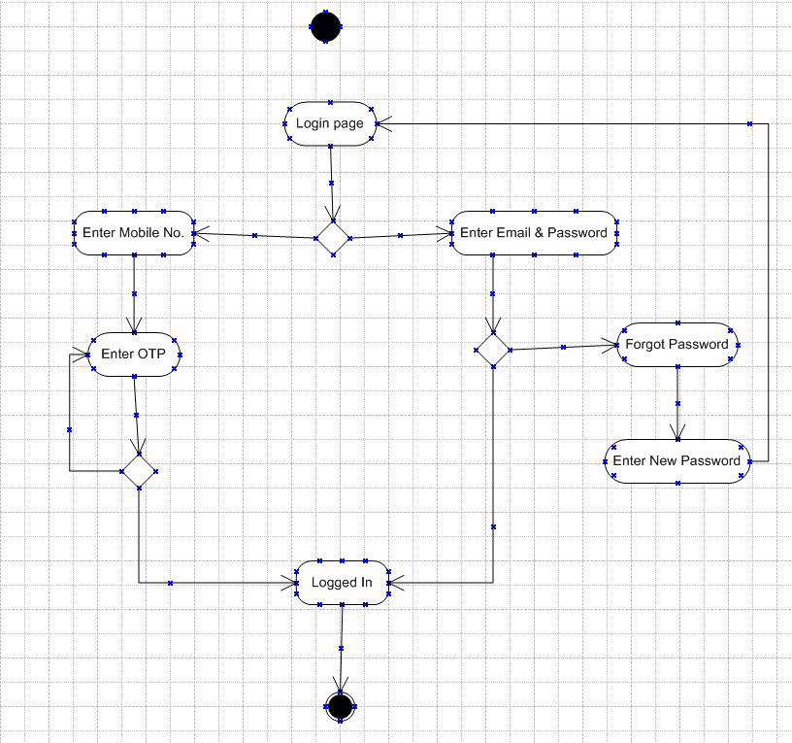

1. **Registration Page**

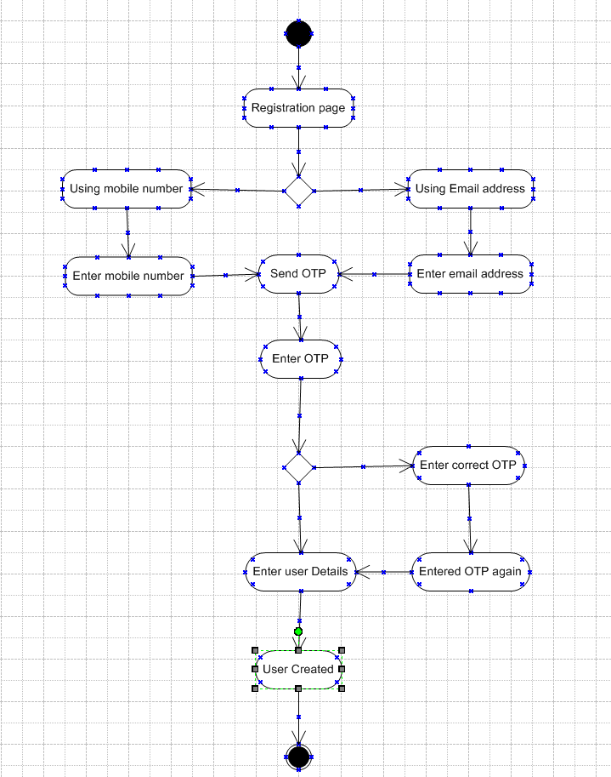

1. **Buying fertilizer**

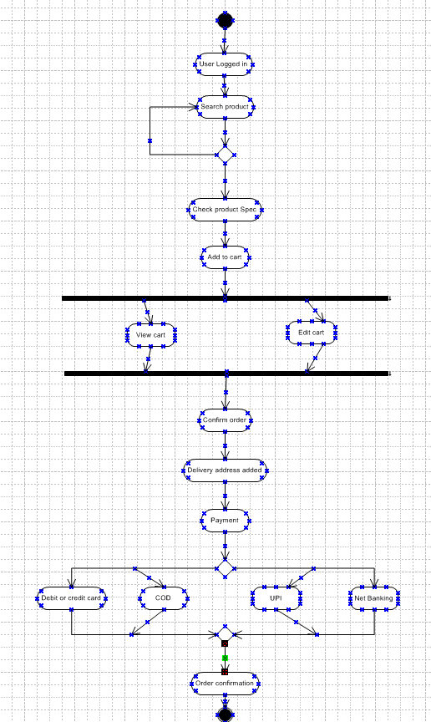

1. **Order Cancellation**

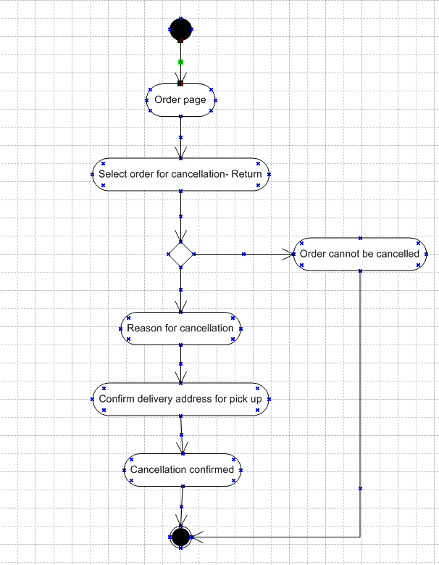

1. **Adding or Updating product**

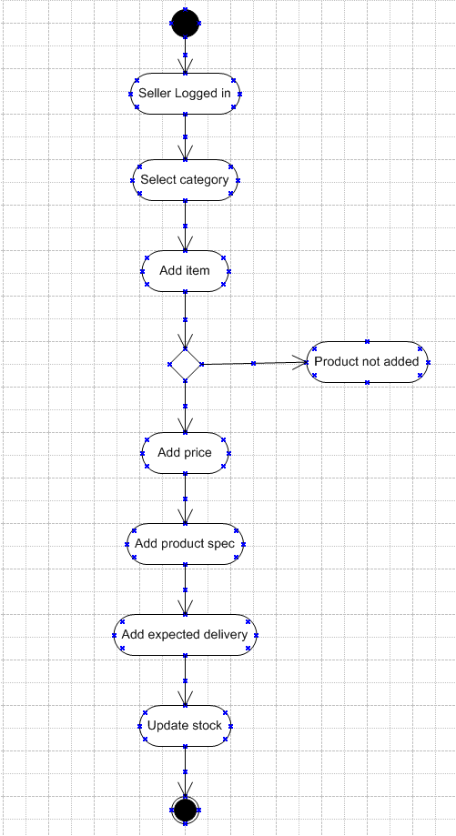

**Nurturing Process - Capstone Project1 – Part -3/3 V2D1- Mar2024**

**Online Agriculture Products Store**

**Question 1 – Functional Requirements**

**Answer-**

|  |  |  |  |
| --- | --- | --- | --- |
| **Req ID** | **Req Name** | **Req Description** | **Priority** |
| FR0001 | Farmer Registration | Farmer should be able to register with the application | 9 |
| FR0002 | Farmer Search for Products | Farmer should be able to search for available products in fertilizers, seeds, pesticides | 8 |
| FR0003 | No matching Product | Farmer should be notified if the searched product not found | 5 |
| FR0004 | Product Selection | Farmer should be able to select the product | 7 |
| FR0005 | Out of Stock | Farmer should be notified, if the product is out of stock | 7 |
| FR0006 | Filter | Farmer should be able to filter and select the product as per Brands and Price | 7 |
| FR0007 | Similar products | Farmer should be able to select similar products, if the searched product is out of stock | 6 |
| FR0008 | Bought together | Once the product is finalized, farmer should be suggested with related products as a package with the price | 6 |
| FR0009 | Add to Cart | Farmer should be able to Add the product to the Cart for purchase | 8 |
| FR0010 | Wishlist | Farmer should have an option to Add the product into Wishlist | 6 |
| FR0011 | Save it Later | Farmer should be able to see the option for Save it Later, to purchase later | 7 |
| FR0012 | Delivery Address | Farmer should be able to select the Delivery address to deliver the product | 8 |
| FR0013 | Payment options | Once the delivery address is selected, Application should show the Payment options to the Farmer for purchasing the product. | 8 |
| FR0014 | Payment Confirmation | Farmer should receive the Payment confirmation email and SMS | 10 |
| FR0015 | Order Confirmation | Farmer should receive the Order confirmation email and SMS | 9 |
| FR0016 | Expected Delivery date | Farmer should also see the Expected Delivery date of the product. | 9 |
| FR0017 | Track Delivery | Farmer should have the option to Track the delivery on the application | 8 |
| FR0018 | Cancel/Return/Replacement | Farmer should be able to Cancel/Return/Replacement the product | 9 |
| FR0019 | Return Pick up | Farmer should be given Pick up date and time for cancel/return | 7 |
| FR0020 | Return Confirmation | Farmer should receive SMS and Email confirmation for cancellation/return | 7 |

|  |  |  |  |
| --- | --- | --- | --- |
| **Req ID** | **Req Name** | **Req Description** | **Priority** |
| NFR001 | Page Loading Time | Each Page should load within 2 seconds time | 9 |
| NFR002 | Technical supported system | Application can be used on any OS (Android/IOS) | 9 |
| NFR003 | Time limit for OTP | OTP time limit should be given maximum of 5 minutes for Login and Registration process | 4 |
| NFR004 | Logout System | If the page is not accessed for more for 5 minutes, the page should log out automatically. | 4 |
| NFR005 | Stock Availability | Stock availability should be updated on a real time basis | 8 |
| NFR006 | SMS & Mail confirmation | Automated Email and SMS notification should be sent to Users | 8 |
| NFR007 | Back up | All data should get backup automatically | 9 |
| NFR008 | Connectivity | System should be connected with Internet | 10 |
| NFR009 | Stock alerts | Seller should receive Stock alert notifications when Stock is reduced, every week. | 8 |
| NFR010 | Net Banking | Bank account should be active in nature for smooth payment process | 9 |
| NFR011 | Check Stock | Once the Product is sold, the stock of the product should be reduced. | 7 |
| NFR012 | Email Address | Email Address should be a active to receive Email notifications | 3 |
| NFR013 | Taxation system | All products should be included with additional Tax | 8 |
| NFR014 | Password | User should receive Password change alert every 30 day | 5 |

**Question 2–Minimum 5-page designs**

**Answer-**

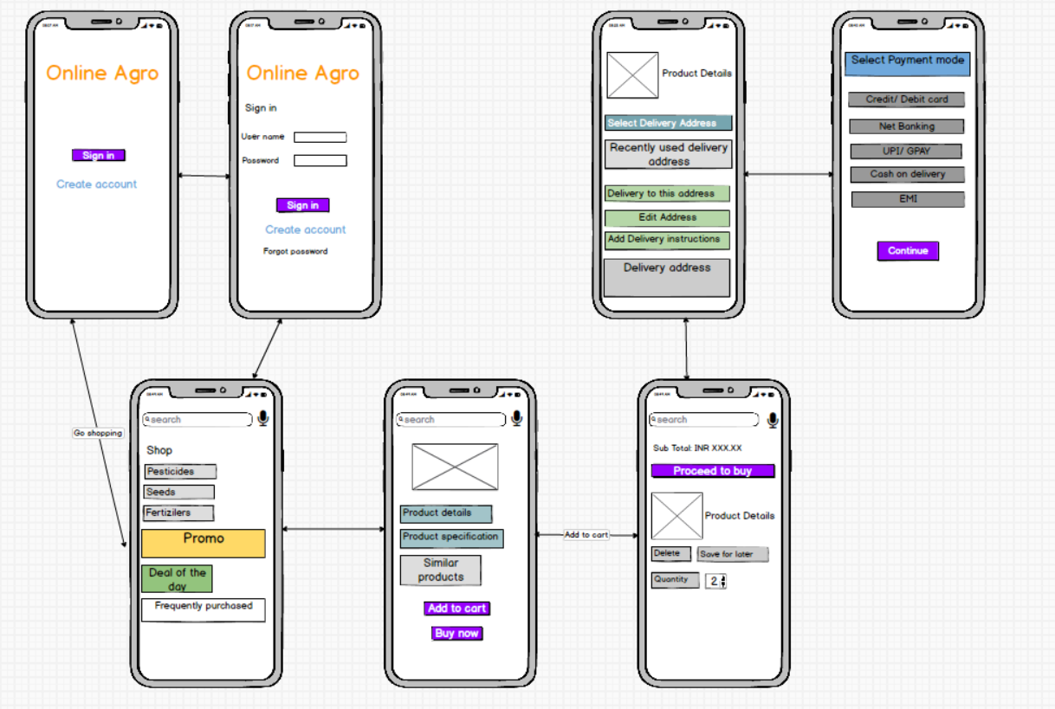

**Question 3 – Tools (Visio, Balsamiq)**

**Answer-**

**Microsoft Office Visio**

Microsoft Visio is a diagramming and vector graphics application and is part of the Microsoft Office family. It is used to create diagram types such as Flowcharts, Org Charts, Floor Plans, Network Diagrams, UML Diagrams, Mind maps and more. It is also commonly used for scenarios such as Process Mapping and Visual Collaboration. The latest version of Visio also has data visualization that allows users to create diagrams from Excel data and also embed Visio diagrams in Power BI dashboards.

Microsoft Office Visio is a tool that eases the process of making complex diagrams. Especially for business purposes. It can help in the making of presentations, floor plans, org charts, etc. Listed below are some uses of Visio:

Followings things can draw BA by using MS Office Visio.

* Flowchart: A flowchart is helps to show the steps in sequential order. These are steps that need to be taken to complete a certain process. It is effective in conveying information. Thus, it can be used in various other fields too
* Organization Chart: An org chart displays the roles and reporting relationships in a business organization. It can be used in also any other organization. It depicts the names and positions of employees in a company. In short, we can say it shows the structure of an organization.
* Floor Plan: A floor plan is the structure of a room or a floor. Architects use floor plans to place doors, windows, and other objects. Visio also offers a floor plan template.
* Business Process Modelling Notation: BPMN is a flowchart method of displaying all the processes in a business that is to be taken. In other words, it is helps in give a clear understanding of the processes in a particular business through visual representation.

**Balsamiq**

Balsamiq Mock ups is an effective tool for presenting the software requirements in the form of wireframes. This helps the software development team to visualize how the software project will look like in the very early stages of development. This is a small tutorial where we will cover all the basic steps needed to start with Balsamiq Mock ups.

It is a user interface design tool that can be used to generate wireframes, also known as mock ups or low-fidelity prototypes. Balsamiq offers sketch-style controls for users to quickly sketch and brainstorm ideas. It is available as a desktop application and as a web-based tool called Balsamiq Cloud.

**Question 4 – RTM**

**Answer- (Requirements Traceability Matrix)**

It’s a document to track the requirements throughout the project lifecycle, ensuring that they are met and that no requirements are overlooked.

UT- Unit testing

CT- Component testing

ST- System testing

SIT- System integrated testing

UAT- User acceptance testing

|  |  |  |  |  |  |  |  |  |  |
| --- | --- | --- | --- | --- | --- | --- | --- | --- | --- |
| **Req ID** | **Req Name** | **Req Description** | **Design** | **Code** | **UT** | **CT** | **ST** | **SIT** | **UAT** |
| FR0001 | Farmer Registration | Farmer should be able to register with the application | Y | Y | Y | Y | Y | Y | N |
| FR0002 | Farmer Search for Products | Farmer should be able to search for available products in fertilizers, seeds, pesticides | Y | Y | Y | Y | Y | Y | N |
| FR0003 | No matching Product | Farmer should be notified if the searched product not found | Y | Y | Y | Y | Y | Y | N |
| FR0004 | Product Selection | Farmer should be able to select the product | Y | Y | Y | Y | Y | Y | N |
| FR0005 | Out of Stock | Farmer should be notified, if the product is out of stock | Y | Y | Y | N | N | N | N |
| FR0006 | Filter | Farmer should be able to filter and select the product as per Brands and Price | Y | Y | Y | N | N | N | N |
| FR0007 | Similar products | Farmer should be able to select similar products, if the searched product is out of stock | Y | Y | Y | N | N | N | N |
| FR0008 | Bought together | Once the product is finalized, farmer should be suggested with related products as a package with the price | Y | Y | Y | Y | Y | N | N |
| FR0009 | Add to Cart | Farmer should be able to Add the product to the Cart for purchase | Y | Y | Y | Y | N | N | N |
| FR0010 | Wishlist | Farmer should have an option to Add the product into Wishlist | Y | Y | Y | N | N | N | N |
| FR0011 | Save it Later | Farmer should be able to see the option for Save it Later, to purchase later | Y | Y | Y | N | N | N | N |
| FR0012 | Delivery Address | Farmer should be able to select the Delivery address to deliver the product | Y | Y | Y | N | N | N | N |
| FR0013 | Payment options | Once the delivery address is selected, Application should show the Payment options to the Farmer for purchasing the product. | Y | Y | Y | N | N | N | N |
| FR0014 | Payment Confirmation | Farmer should receive the Payment confirmation email and SMS | Y | Y | Y | Y | Y | N | N |
| FR0015 | Order Confirmation | Farmer should receive the Order confirmation email and SMS | Y | Y | Y | N | N | N | N |
| FR0016 | Expected Delivery date | Farmer should also see the Expected Delivery date of the product. | Y | Y | Y | N | N | N | N |
| FR0017 | Track Delivery | Farmer should have the option to Track the delivery on the application | Y | Y | Y | N | N | N | N |
| FR0018 | Cancel/Return/Replacement | Farmer should be able to Cancel/Return/Replacement the product | Y | Y | Y | Y | Y | N | N |
| FR0019 | Return Pick up | Farmer should be given Pick up date and time for cancel/return | Y | Y | Y | N | N | N | N |
| FR0020 | Return Confirmation | Farmer should receive SMS and Email confirmation for cancellation/return | Y | Y | Y | N | N | N | N |

|  |  |  |  |  |  |  |  |  |  |
| --- | --- | --- | --- | --- | --- | --- | --- | --- | --- |
| **Req ID** | **Req Name** | **Req Description** | **Design** | **Code** | **UT** | **CT** | **ST** | **SIT** | **UAT** |
| NFR001 | Page Loading Time | Each Page should load within 2 seconds time | Y | Y | Y | Y | Y | Y | N |
| NFR002 | Technical supported system | Application can be used on any OS (Android/IOS) | Y | Y | Y | Y | Y | N | N |
| NFR003 | Time limit for OTP | OTP time limit should be given maximum of 5 minutes for Login and Registration process | Y | Y | Y | N | N | N | N |
| NFR004 | Logout System | If the page is not accessed for more for 5 minutes, the page should log out automatically. | Y | Y | Y | N | N | N | N |
| NFR005 | Stock Availability | Stock availability should be updated on a real time basis | Y | Y | Y | N | N | N | N |
| NFR006 | SMS & Mail confirmation | Automated Email and SMS notification should be sent to Users | Y | Y | Y | Y | Y | N | N |
| NFR007 | Back up | All data should get backup automatically | Y | Y | Y | Y | N | N | N |
| NFR008 | Connectivity | System should be connected with Internet | Y | Y | Y | Y | Y | N | N |
| NFR009 | Stock alerts | Seller should receive Stock alert notifications when Stock is reduced, every week. | Y | Y | Y | N | N | N | N |
| NFR010 | Net Banking | Bank account should be active in nature for smooth payment process | Y | Y | Y | N | N | N | N |
| NFR011 | Check Stock | Once the Product is sold, the stock of the product should be reduced. | Y | Y | Y | Y | Y | N | N |
| NFR012 | Email Address | Email Address should be a active to receive Email notifications | Y | Y | Y | N | N | N | N |
| NFR013 | Taxation system | All products should be included with additional Tax | Y | Y | Y | N | N | N | N |
| NFR014 | Password | User should receive Password change alert every 30 day | Y | Y | Y | N | N | N | N |

**Question 5 – 10 Test Case Documents**

**Answer-**

|  |  |  |  |
| --- | --- | --- | --- |
| **Test case id** | ABCD0001 | **Test case name** | **Search query** |
| **Project id** | ABCD | **Project name** | Online agriculture shop |
| **Test strategy** | ABCD00S1 | **Tester id** | T12345 |
| **Test plan id** | ABCD00P1 | **Date of test** |  |
| **Test schedule id** | ABCD0S1 |  |  |
|  |  |  |  |
|  | **Set 1** | **Set 2** |  |
| **Input Data** | Pesticides | Seeds |  |
|  | Organic pesticides | Soya been |  |
|  | 1 quantity | 1 Kg |  |
|  | 200 Rs is cost | 550 Rs/kg |  |
| **Expected behaviour** | 100 farmers should visit and order for above data |  |  |
| **Actual behaviour** | 75 farmers visited and orders successfully |  |  |
| **Comment** | Tester tested and UAT Completed Updated comment. |  |  |
| **Result- Pass/Fail** | Pass |  |  |

|  |  |  |  |
| --- | --- | --- | --- |
| **Test case id** | ABCD0002 | **Test case name** | **Registration** |
| **Project id** | ABCD | **Project name** | Online agriculture shop |
| **Test strategy** | ABCD00S2 | **Tester id** | T12345 |
| **Test plan id** | ABCD00P2 | **Date of test** |  |
| **Test schedule id** | ABCD0S2 |  |  |
|  |  |  |  |
|  | **Set 1** | **Set 2** |  |
| **Input Data** | Mail id | First name |  |
|  | Mobile number | Last name |  |
|  | Password | Password |  |
|  |  |  |  |
| **Expected behaviour** | Mandatory fields are marked with * Against the field. Password masking. |  |  |
| **Actual behaviour** | After entering all the mandatory details register button will appear below and then press register yourself |  |  |
| **Comment** | You have been successfully registered |  |  |
| **Result- Pass/Fail** | Pass |  |  |

|  |  |  |  |
| --- | --- | --- | --- |
| **Test case id** | ABCD0003 | **Test case name** | **Order placement** |
| **Project id** | ABCD | **Project name** | Online agriculture shop |
| **Test strategy** | ABCD00S3 | **Tester id** | T12345 |
| **Test plan id** | ABCD00P3 | **Date of test** |  |
| **Test schedule id** | ABCD0S3 |  |  |
|  |  |  |  |
|  | **Set 1** | **Set 2** |  |
| **Input Data** | Image or images of the product |  |  |
|  | Price of the product |  |  |
|  | Product specifications |  |  |
|  |  |  |  |
| **Expected behaviour** | Select the required product |  |  |
| **Actual behaviour** | After selecting the product to buy, the page will take you to the payment page to select the mode of payment. |  |  |
| **Comment** | Order Placed |  |  |
| **Result- Pass/Fail** | Pass |  |  |

|  |  |  |  |
| --- | --- | --- | --- |
| **Test case id** | ABCD0004 | **Test case name** | **Payment step** |
| **Project id** | ABCD | **Project name** | Online agriculture shop |
| **Test strategy** | ABCD00S4 | **Tester id** | T12345 |
| **Test plan id** | ABCD00P4 | **Date of test** |  |
| **Test schedule id** | ABCD0S4 |  |  |
|  |  |  |  |
|  | **Set 1** | **Set 2** |  |
| **Input Data** | Check different payment options | Receives OTP |  |
|  | Enter card details | Check total amount |  |
|  | Payment details |  |  |
|  |  |  |  |
| **Expected behaviour** | Text confirmation with the order number generated |  |  |
| **Actual behaviour** | While making payment, farmer can select their preferred mode of payment after entering the valid payment details press the pay button. |  |  |
| **Comment** | Payment done. Order has successfully placed |  |  |
| **Result- Pass/Fail** | Pass |  |  |

|  |  |  |  |
| --- | --- | --- | --- |
| **Test case id** | ABCD0005 | **Test case name** | **Shipment step** |
| **Project id** | ABCD | **Project name** | Online agriculture shop |
| **Test strategy** | ABCD00S5 | **Tester id** | T12345 |
| **Test plan id** | ABCD00P5 | **Date of test** |  |
| **Test schedule id** | ABCD0S5 |  |  |
|  |  |  |  |
|  | **Set 1** | **Set 2** |  |
| **Input Data** | Check placed order is reflected in page | Check order status |  |
|  | Name and delivery address is correct | Check delivery status |  |
|  | Item ordered is same as showing in order page |  |  |
|  |  |  |  |
| **Expected behaviour** | Item is shipped and will be deliver on date |  |  |
| **Actual behaviour** | We have input that is selection of one order id at a time after selecting Order id press track button. |  |  |
| **Comment** | Page will display the shipment status |  |  |
| **Result- Pass/Fail** | Pass |  |  |

|  |  |  |  |
| --- | --- | --- | --- |
| **Test case id** | ABCD0006 | **Test case name** | **Delivery step** |
| **Project id** | ABCD | **Project name** | Online agriculture shop |
| **Test strategy** | ABCD00S6 | **Tester id** | T12345 |
| **Test plan id** | ABCD00P6 | **Date of test** |  |
| **Test schedule id** | ABCD0S6 |  |  |
|  |  |  |  |
|  | **Set 1** | **Set 2** |  |
| **Input Data** | Link provided by delivery partner is correct or not | Tracking id number page in any browser |  |
|  | Link is reachable or not |  |  |
|  |  |  |  |
|  |  |  |  |
| **Expected behaviour** | If the farmer clicks on the tracking links, provided by the delivery partner it should be able to open the tracking page |  |  |
| **Actual behaviour** | Page should display the correct tracking details |  |  |
| **Comment** | Page will display the delivery status |  |  |
| **Result- Pass/Fail** | Pass |  |  |

|  |  |  |  |
| --- | --- | --- | --- |
| **Test case id** | ABCD0007 | **Test case name** | **Cancel or return step** |
| **Project id** | ABCD | **Project name** | Online agriculture shop |
| **Test strategy** | ABCD00S7 | **Tester id** | T12345 |
| **Test plan id** | ABCD00P7 | **Date of test** |  |
| **Test schedule id** | ABCD0S7 |  |  |
|  |  |  |  |
|  | **Set 1** | **Set 2** |  |
| **Input Data** | Cancel the order | Replacement |  |
|  | Return |  |  |
|  |  |  |  |
|  |  |  |  |
| **Expected behaviour** | Testing of relevant option available after the order is placed change the order. |  |  |
| **Actual behaviour** |  |  |  |
| **Comment** | If any option is selected then next page will display the text confirmation. |  |  |
| **Result- Pass/Fail** | Pass |  |  |

|  |  |  |  |
| --- | --- | --- | --- |
| **Test case id** | ABCD0008 | **Test case name** | **FAQ Page** |
| **Project id** | ABCD | **Project name** | Online agriculture shop |
| **Test strategy** | ABCD00S8 | **Tester id** | T12345 |
| **Test plan id** | ABCD00P8 | **Date of test** |  |
| **Test schedule id** | ABCD0S8 |  |  |
|  |  |  |  |
|  | **Set 1** | **Set 2** |  |
| **Input Data** | Have all the questions and answers covered? | Search option is working or not |  |
|  | Alphanumeric keywords can be entered in the search bar. |  |  |
|  |  |  |  |
|  |  |  |  |
| **Expected behaviour** | Testing of questions and answers available related to product or service can be searched or not |  |  |
| **Actual behaviour** | Farmers are searching for a different type of Q&Ans |  |  |
| **Comment** | When any Q & Ans is searched then this FAQ page should be able to display the result on the same page. |  |  |
| **Result- Pass/Fail** | Pass |  |  |

|  |  |  |  |
| --- | --- | --- | --- |
| **Test case id** | ABCD0009 | **Test case name** | **Customer care** |
| **Project id** | ABCD | **Project name** | Online agriculture shop |
| **Test strategy** | ABCD00S9 | **Tester id** | T12345 |
| **Test plan id** | ABCD00P9 | **Date of test** |  |
| **Test schedule id** | ABCD0S9 |  |  |
|  |  |  |  |
|  | **Set 1** | **Set 2** |  |
| **Input Data** | Email & phone number of customer care team | Registered office address |  |
|  | Escalation team contact details |  |  |
|  |  |  |  |
|  |  |  |  |
| **Expected behaviour** | Testing of have all the Q & Ans has been covered in the example |  |  |
| **Actual behaviour** | Any escalation or any query farmer will contact to the customer care team through this page. |  |  |
| **Comment** | This page will display the available option to contact the customer care team. |  |  |
| **Result- Pass/Fail** | Pass |  |  |

|  |  |  |  |
| --- | --- | --- | --- |
| **Test case id** | ABCD00010 | **Test case name** | **Bill view/download** |
| **Project id** | ABCD | **Project name** | Online agriculture shop |
| **Test strategy** | ABCD00S10 | **Tester id** | T12345 |
| **Test plan id** | ABCD00P10 | **Date of test** |  |
| **Test schedule id** | ABCD0S10 |  |  |
|  |  |  |  |
|  | **Set 1** | **Set 2** |  |
| **Input Data** | Product name & and other details | Total amount |  |
|  | Amount paid | Bill is prepared or COD |  |
|  | Delivery address of farmers |  |  |
|  | Seller address & and GST number |  |  |
| **Expected behaviour** | Testing of invoice generation process |  |  |
| **Actual behaviour** | Amount paid by farmer and invoice generation |  |  |
| **Comment** | This page will display the invoice & there is an option to download the invoice |  |  |
| **Result- Pass/Fail** | Pass |  |  |

**Question 6 – DB Design**

**Answer-**

DB Diagram for Existing table

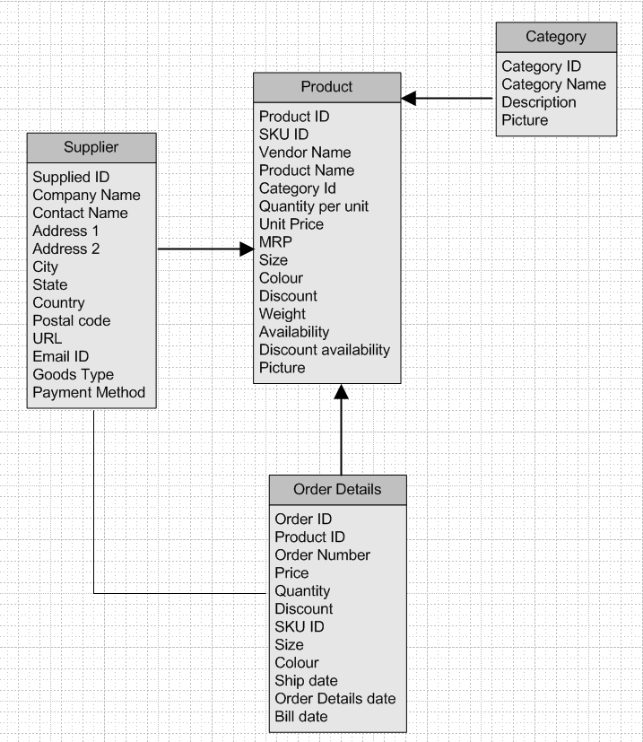

DB Diagram for New table

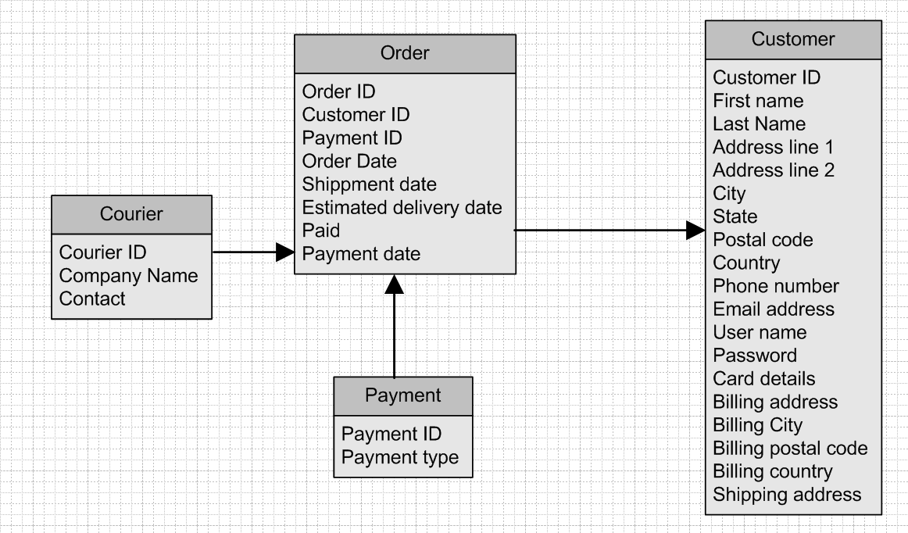

ER Diagram-

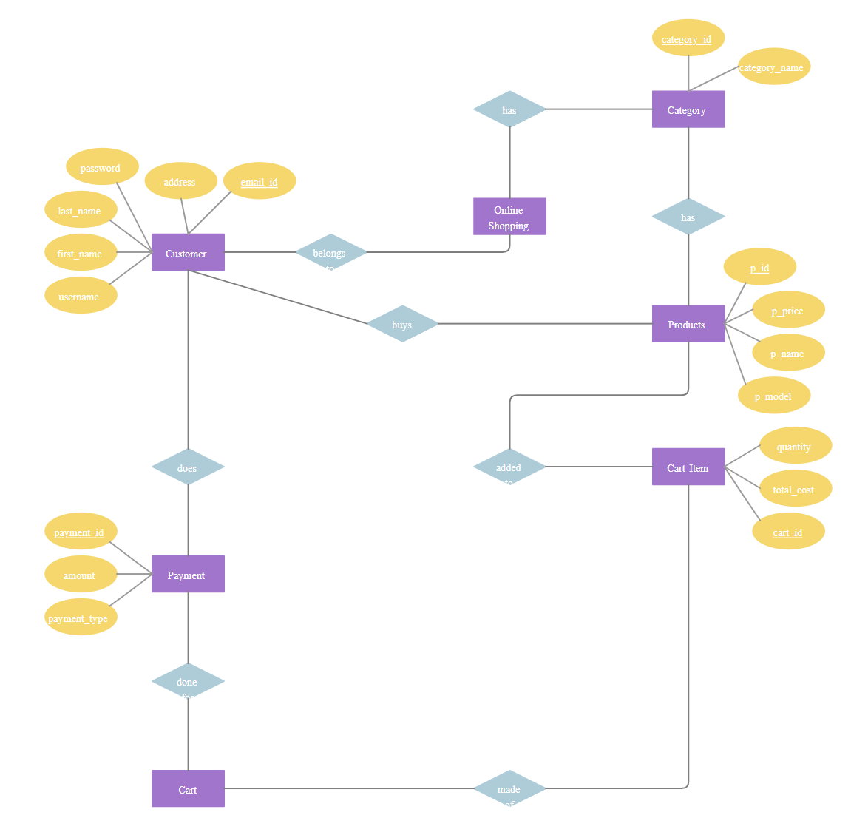

**Question 7 – Data Flow Diagram**

**Answer-**

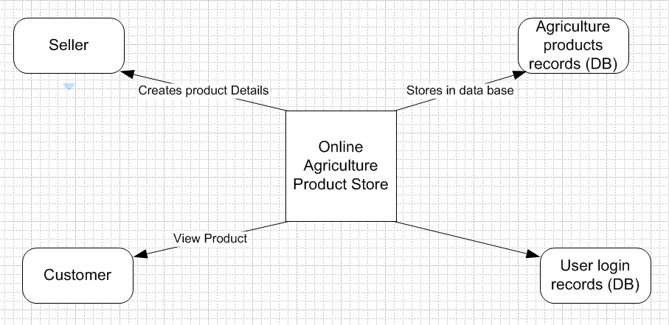

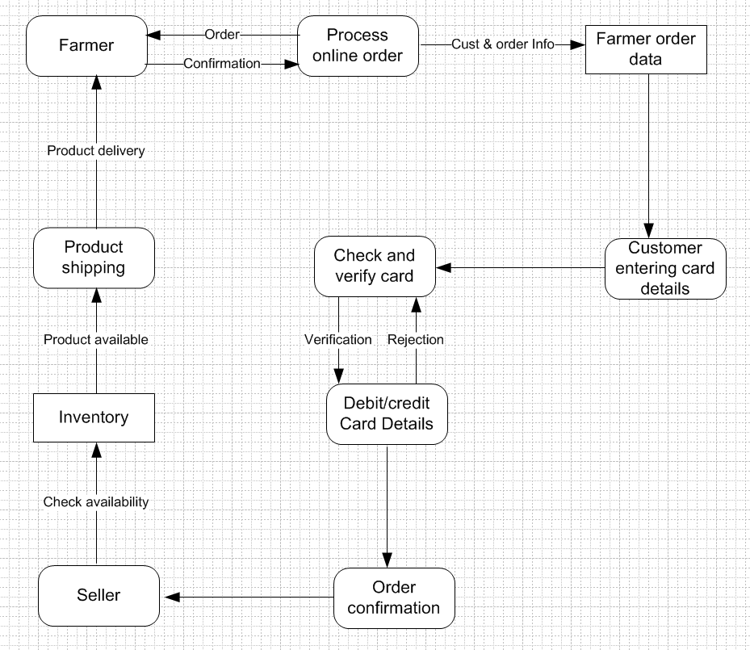

**Question 8 – Change Request**

**Answer-**

What is a Change request - Change requests are when a stakeholder, either a client or an internal team or department, requests a change to the processes or deliverables that had already been decided upon in the project scope.

However, in this scenario, this change request has come up due to change in the Govt. Taxation structure. As a BA, I would analyze the request and clarify the stakeholders exactly what the request is asking us to do in the Online Agriculture Product Store. In a normal scenario, as a BA, I would first do the Feasibility Test, to check, how feasible it is to change the current ongoing project with the new change request.

However, in this case, Feasibility study is not required, as it’s a Govt structure which needs to be updated and followed. Therefore, I will follow the below steps to change the project as per the client’s requirements.

* Document the Change request.
* Look for any Supporting materials to help in adding this Change.
* Need to assess, whether the Change is an Inside or Outside scope. As it’s an outside scope, the Budget and time will get impacted.
* BA and PM should ensure whether the change is a minor or a major change. Policy changes by Govt is a major change request and we need to ensure that the change should be done according to the Govt. instruction.
* Fill the Change request Form and get the approval from the Project Manager.
* We also need to ensure that our Team understands the priority of this change request.
* We also need to discuss the change with Change Control Board who will recommend the necessary change on the Project.
* Once this change is approved, the project deliverables will need to be updated. This can include plans and schedules, business process documents, and the requirements documents.
* Once these updates have been made, the project manager can communicate the new course of action to everyone who will be impacted. Now you can delegate the necessary tasks to the people in charge of implementing these new changes.

**Question 9 – Change Request Vs an Enhancement**

**Answer-**

As business analyst, we can identify whether a request is a change request or an enhancement by keeping in mind a few points:

1. Understand the Request: Understand the nature of the request and the reason behind it. Is the request asking for a modification to an existing feature or a new feature altogether?
2. Analyze the Impact: Analyze the impact of the request on the project. Will the request require significant changes to the project's scope, timeline, or budget?
3. Evaluate the Priority: Evaluate the priority of the request. Is the request critical to the project's success, or can it be deferred to a later phase?
4. Determine the Type: Based on the above analysis, determine whether the request is a change request or an enhancement. A change request is a request to modify an existing feature, while an enhancement is a request to add a new feature.

By following the above-mentioned points, it is a change request situation as a new requirement has been introduced after 3 to 4 months and there is no change in the existing requirement so it is not a case of enhancement, for that, we should process ahead with the change request.

**Question 10 – Estimations**

**Answer- Estimations - Manhours required.**

Manhours Required = Total hours working per day x Total number of members x Total numbers of days worked over the specific period.

Number of Working Hours a day = 8 hours

Number of Resources = 12

Time period provided = 18 months = 547 days = 78 weeks (Including Weekends and Public Holidays)

Assuming Weekends = 156

Assuming Public Holidays = 10

Total = 166

547-166 = 381 working days

Hence, Estimated Manhours = 8 hours * 12 resources * 381 days = 36,576 hours required.

**Question 11 – UAT**

**Answer-**

User Acceptance Testing (UAT) is a phase in the software development life cycle where the users of the Online Agriculture Product Store participate in validating that if meets their needs. As a BA, I will verify all the validations prior to design the UAT Test cases, which will cover the functionality of the product, System environment, any possible defects which could arise and how to deal with these defects.

Steps for UAT

* Analysis of Business Requirements: One of the most important activities in the UAT is to identify and develop test scenarios. These test scenarios are derived from the following documents:
  + Business Use Cases
  + Process Flow Diagrams
  + Business Requirements Document (BRD)
  + System Requirements Specification (SRS)
* Creation of UAT Plan: The UAT test plan outlines the strategy that will be used to verify and ensure an application meets its business requirements. It documents entry and exit criteria for UAT, Test scenarios and test cases approach and timelines of testing.
* Identify Test Scenarios and Test Cases: Identify the test scenarios with respect to high-level business process and create test cases with clear test steps. Test Cases should sufficiently cover most of the UAT scenarios. Business Use cases are input for creating the test cases.
* Preparation of Test Data: It is best advised to use live data for UAT. Data should be scrambled for privacy and security reasons. Tester should be familiar with the database flow.
* Run and record the results: Execute test cases and report bugs if any. Re-test bugs once fixed. Test Management tools can be used for execution.
* Confirm Business Objectives met: Business Analysts or UAT Testers needs to send a sign off mail after the UAT testing. After sign-off, the product is good to go for production. Deliverables for UAT testing are Test Plan, UAT Scenarios and Test Cases, Test Results and Defect Log.

**Question 12 – Project Closure Document**

**Answer-**

Project closure is a formal written assessment of a project. The purpose of the project closure document is to formally close a project and authorize the handoff. It is a crucial document that helps to ensure that all project stakeholders are aware of the project's completion and that all necessary steps have been taken to close the project.

Revision Date: MM/DD/YYYY

Submit the document to the Project Sponsor, Business Owner, and PPMO/PMO Division Director; and archive this closure document with the project artifacts once completed.

|  |  |  |  |
| --- | --- | --- | --- |
| **Approver Name** | **Title/Role** | **Signature/ Remarks** | **Date** |
| Peter and Ben | Project Stakeholder * | Ok | xx/xx/xxxx |
| Mr. Henry | Exec Sponsor (AVP or Exec. Dir) * | Ok | xx/xx/xxxx |
| Mr. Pandu | Financial Head | Ok | xx/xx/xxxx |
| Mr. Vandanam | Project Manager | Ok | xx/xx/xxxx |
| Mr. Kartik | Delivery head | Ok | xx/xx/xxxx |
| Mr. Dooku | Project Coordinator | Ok | xx/xx/xxxx |

*By authorizing this Project Closure, the Project Stakeholder(s), and Executive Sponsor agree to all terms within this document.

**Revision History**

Identify document changes.

|  |  |  |  |
| --- | --- | --- | --- |
| **Version** | **Date** | **Name** | **Description** |
| 1.0 | xx/xx/xxxx | Mr. Henry | Ok to process |

**Section 1. General Information**

|  |  |
| --- | --- |
| **Project Activity** | **Date** |
| Project Start | 13th Feb 2023 |
| Project Closure* | 14th Aug 2024 |

*Date of Project Closure refers to the project finish date, meaning all project tasks have been completed

**Section 2. Business Objectives**

As identified in section 2.2 of the Business Case.

|  |  |  |  |
| --- | --- | --- | --- |
| **Business Case Ref#** | **Business Objectives** | **Met/Not Met** | **Comments** |
| BI0001 | Farmer should be able to buy and sell agricultural product online. | Met | Ok |

**Section 3. Customer Expectation Management**

|  |  |  |  |
| --- | --- | --- | --- |
| **Item** | **Question** | **Description** | **Comments** |
| 1 | Were all expected benefits and business outcomes realized? | Yes | ok |
| 2 | Were all expected performance standards satisfied? | Yes | ok |

**Section 4. Outstanding Actions Items and Issues**

|  |  |
| --- | --- |
| **Action Item** | **Transition and/or Resolution** |
|  |  |

**Section 5. Project Office Checklist**

|  |  |
| --- | --- |
| **Deliverable** | **Remarks (Yes/No)** |
| Risk Assessment completed and posted on suitable shared storage. | Yes |
| Business Case completed and posted on suitable shared storage. | Yes |
| Project Charter completed and posted on suitable shared storage. | Yes |
| Meeting Notes completed and posted on suitable shared storage. | Yes |
| Additional project documentation and artifacts posted on suitable shared storage, including Requirements Template, Project Change Requests, Milestone Timeline, Work Breakdown Structure, etc. | Yes |
| Lessons Learned documented. | Yes |
| Project folder moved completed projects on suitable shared storage. | Yes |
| Support Handover Document completed and archived. | Yes |
| Comments Ok to process. Application running properly. | |