**Proj Prep 1 Case Part 2**

**QUESTION 1 :** 4 Quarterly Audits are planned Q1 , Q2, Q3, Q4 for this Project What is your knowledge on how these Audits will happen for a BA ?

**ANSWER 1 :** During these audits, Business analyst role would be more of a supporting role wherein, he might be required to provide the requisite documentation for the samples selected for audit purpose. Business analyst would be responsible for providing relevant information and documentation pertaining to project requirements, design, development, testing and deployment. The major purpose of these audits is to ascertain the progress of the project, ensuring that it is on track with the timelines and goal objectives. Also to identify if any potential issues or risks that needs to be looked upon. Additionally, he may be asked to participate in meetings or discussions relating to the audits, answering any questions the auditors may have and providing updated on current project status. The auditors may also ask for recommendations for improvement or changes in the project based on its current status. An Audit for a BA will take into consideration mainly four aspects-

1. Is the project progressing with company objectives or not?
2. Whether various risks are managed effectively by the BA?
3. Whether suggestions are provided for areas of improvement in the process?
4. Whether various processes followed by the BA?

Since Audit, is planned for four quarters and total 6 quarters are expected in 18 months duration which is the time allotted by Mr.Henry, BA could be required to provide below documents and data as and when required by the audit team.

|  |  |
| --- | --- |
| **STAGE** | **REQUIREMENTS GATHERING PHASE** |
| STATUS | COMPLETED |
| CHECKLIST | BUSINESS REQUIREMENTS DOCUMENT(BRD) TEMPLATE |
| ELICITATION RESULT REPORT |
| DUPLICATE REQUIREMENTS REPORT, IF ANY |
| GROUPING OF FUNCTIONALITIES/FEATURES – CLIENT SIGN OFF. |

|  |  |
| --- | --- |
| **STAGE** | **REQUIREMENT ANALYSIS PHASE** |
| STATUS | COMPLETED |
| CHECKLIST | UML DIAGRAM DETAILS |
| BUSINESS TO FUNCTIONAL REQUIREMENTS MAPPING |
| RTM DOCUMENT CONTROL FOR VERSION |
| CLIENT SIGNOFF |

|  |  |
| --- | --- |
| **STAGE** | **DESIGN PHASE** |
| STATUS | COMPLETED |
| CHECKLIST | UTILIZATION OF TOOLS FOR DESIGN PURPOSE |
| DOCUMENTED EVIDENCE FOR CLIENT COMMUNICATION HAPPENED |
| MINUTES OF MEETING(MOM) DONE BY STAKEHOLDERS |

|  |  |
| --- | --- |
| **STAGE** | **DEVELOPMENT PHASE** |
| STATUS | COMPLETED |
| CHECKLIST | CREATING TIMELINES AND TASKS WITH THE LIST OF DELIVERABLES |
| MEETINGS WITH PROJECT DEVELOPMENT TEAM AND ITS MOM |

|  |  |
| --- | --- |
| **STAGE** | **TESTING PHASE** |
| STATUS | COMPLETED |
| CHECKLIST | MEETING WITH TESTER AND CHECK FOR POSSIBLE OUTCOMES |
| DISCUSSION WITH THE QUALITY ASSURANCE(QA) TEAM |

**QUESTION 2 :**

Before the Project is going to Kick Start, The Committee asked Mr Karthik to submit BA Approach Strategy

Write BA Approach strategy (As a business analyst, what are the steps that you would need to follow to complete a project – What Elicitation Techniques to apply, how to do Stakeholder Analysis RACI/ILS, What Documents to Write, What process to follow to Sign off on the Documents, How to take Approvals from the Client, What Communication Channels to establish n implement, How to Handle Change Requests, How to update the progress of the project to the Stakeholders, How to take signoff on the UAT- Client Project Acceptance Form )

|  |
| --- |
| **Your team** |
| Project Manager – Mr. Vandanam |
| Senior Java Developer – Ms.Juhi |
| Java Developers – Mr.Teyson, Ms.Lucie, Mr.Tucker, Mr.Bravo |
| Network Admin – Mr.Mike |
| DB Admin – Mr.John |
| Testers – Mr.Jason and Ms.Alekya |
| BA – You |

Technical Team have assembled to discuss on the Project approach and have finalised to follow 3-tier architecture for this project.

**ANSWER 2 :**

**Elicitation Techniques:** We can organize focus group sessions for understanding the needs of the remote area farmers. We will review existing systems and documents for gathering additional information. We will conduct interviews with the stakeholders (Mr. Henry, Mr. Pandu, Mr. Dooku, Peter, Kevin, Ben) for gathering the requirements. Also, we could conduct surveys and questionnaires for gathering a wider perspective.

**Stakeholder Analysis:** We will be identifying the key stakeholders and prioritizing their requirements. We can conduct RACI (Responsible, Accountable, Consulted, Informed) or ILS (Involved, Lead, Support) analysis for determining the roles and responsibilities of each stakeholder. We will establish effective communication channels with the stakeholders for keeping them informed about the progress of the project.

**Documents:** We will create a Business Requirements Document (BRD) for providing a detailed description of the project's objectives, scope, and deliverables. We will write a Requirements Document (RD) to outline the functional and non-functional requirements of the project. We will develop a Use Case Document for describing the processes and workflows involved in the project. We will prepare a Project Charter for defining the project's goals, deliverables, timeline, and budget.

**Sign Off:** We will obtain sign-off from the stakeholders on the Business Requirements Document, Requirements Document, Use Case Document and the Project Charter. It is to be ensured that the stakeholders understand and agree with the objectives, requirements and scope of the project.

**Approvals:** We will obtain the client's approval on the project timeline, deliverables, budget and approach. We will ensure that the client's expectations are in line with the project's goals and objectives.

**Communication Channels:** We will create a communication plan for outlining the channels and methods of communication. We will establish a regular communication schedule with the stakeholders for keeping them informed about the project's progress. We will schedule regular status meetings with the stakeholders for discussing the project's progress and address any issues or concerns.

**Change Requests:** We will obtain approval from the stakeholders before implementing the change request.

We can handle change requests in a structured and systematic manner. We will evaluate the impact of each change request on the project's scope, timeline, and budget.

**Progress Updates:** We will keep the stakeholders informed about the project's progress through regular progress meetings and status reports. We will provide regular progress updates to the stakeholders and seek their feedback. We will highlight any issues or risks that need to be addressed.

**UAT Sign-off:** We will conduct User Acceptance Testing (UAT) to validate the project's deliverables. We will obtain sign-off from the client on the UAT results and the Project Acceptance Form. This is to be ensured that the project meets the client's expectations and requirements.

**QUESTION 3 :**

Explain and illustrate 3-tier architecture?

**ANSWER 3 :**

**3 TIER ARCHITECTURE**

Three-tier architecture is a software architecture that consists of three layers: presentation layer, application layer, and database layer. Here is an explanation and illustration of each layer:

**Presentation Layer:** The presentation layer is the top layer of the architecture and is responsible for presenting the user interface to the end-users. This layer handles the interaction between the user and the system. It is also known as the user interface layer or the client layer.

**Application Layer:** The application layer is the middle layer of the architecture and contains the business logic of the system. It communicates with the presentation layer and the database layer. It is also known as the logic layer or the server layer. This layer manages the application logic, data validation, and data processing.

**Database Layer:** The database layer is the bottom layer of the architecture and is responsible for managing the data storage and retrieval. This layer is responsible for storing and retrieving data from a database management system (DBMS). It is also known as the data layer or the server layer. The database layer provides an interface for the application layer to access and manipulate data.

**QUESTION 4 :**

Business Analyst should keep What points in his/her mind before he frames a Question to ask to

the Stakeholder

( 5W 1H – SMART – RACI – 3 Tier Architecture – Use Cases, Use case Specs, Activity Diagrams, Models, Page designs)

**ANSWER 4 :**

Below is the summary of points a Business Analyst should consider before framing questions to be asked to the stakeholders.

1. 5W1H : Ask about Who, What, When, Where, Why, and How of the project.
2. SMART : This is to be ensured that questions relating to the project should be Specific, Measurable, Achievable, Relevant and Time-bound.
3. RACI : Understand the responsibilities and roles of various stakeholders in the project.
4. 3-TIER ARCHITECTURE : This helps to understand the system architecture and how the data flows between different layers of the application.
5. USE CASES : This helps in developing deeper understanding as to how various users will be using the application.
6. USE CASE SPECS : It helps in developing detailed documentation outlining expected behaviour and specific requirements for each use case.
7. ACTIVITY DIAGRAMS : These help in creating visual representation for how different activities and processes flow within the application.
8. MODELS : Various models like data models and sequence diagrams helps the stakeholders to understand the system better.
9. PAGE DESIGNS : These help in better understand the user needs and preferences by helping in creating mock-ups and wireframes of the user’s interface in the application.

Out of above mentioned points, we will use SMART approach here for the following reasons :

It provides a framework achieving and setting up goals which are Specific, Measurable, Achievable, Relevant, and Time-Bound. By using this approach, a Business Analyst could ensure the questions they ask the stakeholders are :

1. SPECIFIC : Requirements should be clear and concise, focussing on key issues in hand first.
2. MEASURABLE : Requirements should be able to provide quantifiable results such as metrics or KPIs(Key performance indicators) for measuring the progress.
3. ACHIEVABLE : Requirements should be realistic and achievable taking into consideration the resources and constraints of the project.
4. RELEVANT : They should address stakeholders concerns and needs, and should be aligned with objectives and goals of the project.
5. TIME-BOUND : To ensure the project completion on time, there should be a specific deadline or timeline attached to it.

**QUESTION 5 :** As a Business Analyst, What Elicitation Techniques you are aware of? ( BDRFOWJIPQU)

**ANSWER 5 :** As a Business analyst, I am aware about below elicitation techniques :

1. Brainstorming : This refers to collecting views/ideas from various stakeholders and filtering out most valuable points. For example, For a new sales campaign, generating new ideas through a brainstorming session wherein, everyone puts up their opinions/views/ideas etc.
2. Document Analysis : Analysing previous documents for understanding important information. For example, previous project reports and plans to have an insight about requirements and scope of new project.
3. Reverse Engineering : Understanding a project by going from end to beginning of it. For example, analyzing a product by competitors for understanding its functionality/features.
4. Focus Groups : Obtaining reviews/information from a particular group for understanding target audience and the project requirements. For example, creating and conducting focus group of customers to understand their requirements and preferences pertaining to a particular product.
5. Observations : Observing particular set of target audience and customers for getting an insight for improving the product. For example, observing how customers interact with a particular mobile application/website for identifying areas of improvement.
6. Workshops : Gathering requirements in a collaborative setup with stakeholders. For example, conducting a requirements gathering workshop with the project team and stakeholders for identifying key requirements for a new software application development.
7. JAD(Joint application development) session : Process where customers/clients are the end users are involved in application development for high inputs and minimal errors. For example, holding a JAD session with clients and end-users for gathering requirements for new farmer’s application.
8. Interview : Asking a fixed set of questions with the stakeholders for evaluating requirements and gathering insights. For example, conducting interviews with stakeholders to understand their needs and requirements for new product/application.
9. Prototyping : A prototype/sample model is prepared for understanding project requirements and desired outcomes. For example, developing an application prototype to test its interface and functionality.
10. Questionnaire/Survey : Set of fixed questions are asked with targeted audience with an objective of gathering multiple outputs and evaluate further. For example, conducting a survey to understand customer satisfaction for a particular product.
11. Use Case Specs : Understanding input from the user and the desired output from the system to identify potential issues/problems.

**QUESTION 6 :** Which Elicitation Techniques can be used in this Project and Justify your selection of Elicitation Techniques?

Prototyping

Use case Specs

Document Analysis

Brainstorming

Fertilizers, seeds, pesticides details from the manufacturers and should be able to display them to the Farmers.

To gather the business requirements from the client, you went to SOONY and met Mr. Henry. When Mr. Henry was asked about the project and what are they expecting from the project, Mr. Henry stated that he is expecting to have a login for all its users (fertilizers, seeds, pesticides manufacturers and Farmers) , a product catalogue of fertilizers, seeds, pesticides, a search option to search for products, payment process, and delivery tracking.

After doing the stakeholder analysis, you have found out that Peter, Kevin, Ben are the key stakeholders and you have scheduled an appointment to meet them. After meeting with them and trying to gather the stakeholder requirements, Kevin said that, a Farmer should be able to browse through the products catalogue once they visit the website and need to have a search option so that they can search for any product they need. Peter said that, if a farmer wants to buy any product or add them to buy-later list, they need to login first using their email id and password. If it is a new user, then they can create a new account by submitting their email ID and creating a secure password. Ben added saying that, Farmers needs to have an easy-to-use payment gateway which should include cash-on-delivery (COD), Credit/Debit card and UPI options so that the user’s experience should be better. Kevin mentioned that, a user gets an email confirmation regarding their order status. A delivery tracker to track the whereabouts of their order.

Identify Business Requirements (which includes Stakeholder Requirements)

BR001 – Farmers should be able to search for available products in fertilizers, seeds, pesticides

BR002 – Manufacturers should be able to upload and display their products in the application

**ANSWER 6 :**

I will use brainstorming elicitation technique to find the solution on the issues observed for completing this project, I will arrange the session with SME, Software developer and will select the better idea.

In brainstorming 8 to 12 people come together and give their best idea on the specific problem through which we can resolve the issue at once. It is utilized in requirement elicitation to gather a good number of ideas from a group of people. Usually, brainstorming is used in identifying all possible solutions to problems as it simplifies the details pertaining to the available opportunities.

In the application development process, brainstorming will serve as a stepping stone wherein farmers themselves will be involved and providing the insights about the requirements which will be incorporated by the developers in the application the way it is required. Since, farmers are involved in the process, they will give their best suggestion for the products which can help in choosing the offers to be kept at bay in the application.

**QUESTION 7 :** Make suitable Assumptions and identify at least 10 Business Requirements.

**ANSWER 7 :** Business requirement is also know as stakeholder requirements. They describe the characteristics of proposed system from the view point of the system’s end user. It also defines the business necessity and success criteria for a project.

Below are few Business requirements

BR001 : Farmers should be able to search for available products like seeds, pesticides and fertilizers etc

BR002 : A farmer should be able to browse through products catalogueue once they visit the website

BR003 : Manufacturers should be able to display and upload their products in the website with their detailed description.

BR004 : Everyone should be able to login to the website as users.

BR005 : Any new user should be able to create their profile by submitting their email ID and creating strong password.

BR006 : There should be a product catalogueue of seeds, fertilizers and pesticides from various manufacturers and a search option for products.

BR007 : Users should be able to make payment through various payment modes and also track it.

BR008 : Users should be able to place orders post selecting the desired product, its quantity in KGs and number of packets required and be able to trace it post placing.

BR009 : The application should have a fast and responsive interface to ensure a smooth user experience.

BR010 : The application should have a robust security system to protect user data and prevent unauthorised access.

**QUESTION 8 :** List your assumptions

**ANSWER 8 :**

1. The project is a web-based application accessible through desktop and mobile devices.
2. The product catalogue will contain only details of fertilizers, seeds, and pesticides.
3. The application will not store any financial information of the users.
4. The delivery of the products will be outsourced to a third-party logistics company.
5. The application will not have any social media integration.
6. Application built for the project will deliver the products to farmers quickly.
7. The manufacturers will be able to look for frequently ordered items and they can replenish the same in stock and make it available online.
8. The website would require less maintenance.

**QUESTION 9 :**  Give Priority 1 to 10 numbers ( 1 being low priority – 10 being high priority) to these Requirements after discussions with the stakeholders

|  |  |  |  |
| --- | --- | --- | --- |
| Req ID | Req Name | Req Description | Priority |
| BR001 | Farmer Search for Products | Farmers should be able to search for available products in fertilizers, seeds, pesticides | 8 |
| BR002 | Manufacturers upload their Products | Manufacturers should be able to upload and display their products in the application | 8 |

Once the requirements are finalized, as a business analyst, one of the major roles is to act as a liaison between the client and the project team. To gather the requirements correctly from the client side and then to deliver those requirements to the project team in a way they understand.

To make the project team understand the requirements, you need to convert those requirements into UML diagrams and screen mock-ups.

**ANSWER 9 :**



**QUESTION 10**

Draw use case diagram

**ANSWER 10**



**QUESTION 11 :**

Prepare use case specs for all use cases

**ANSWER 11 :**

1. **Use case spec :** Login

**Description :** User Name, Password

**Actors :** Farmers, Website.

**Pre-conditions :** Active internet connection, Compatible browser

**Post conditions :** Home page should be displayed post login

**Basic flows :** User name and password are correct

**Alternate flows :** User name and Password are wrong

**Exceptional flow :** Forgot password, forgot username

**Assumptions :** Users have limited or no knowledge of computer, difficult to understand English.

**Constraints :** Username cannot have a special character.

**Dependents :** User should be registered to login the website, registration should be complete.

**Inputs :** Username and Password

**Output :** Status flag or error code for wrong password entered.

**Business rules :** Username should use a valid email id, password should contain a special character.

**MIS Information :** Interactive design, compatible browser.

1. **Use case spec :** Order Items.

**Description :** Add to cart, purchase.

**Actors :** Farmers, Website, Manufacturers

**Pre-conditions :** Active internet connection, browse through various items.

**Post conditions :** Able to add items to cart, Directed to payment page on checkout.

**Basic flows :** Items selected are correctly captured while adding to the cart.

**Alternate flows :** Items doesn’t add while trying to add to cart.

**Exceptional flow :** While adding items, on checkout not directing to the payments page.

**Assumptions :** Users should know how to add items to the cart.

**Constraints :** Atleast 2 products should be added to the cart.

**Dependents :** Product to be added should be available with the company/manufacturers.

**Inputs :** The chosen product

**Output :** The order gets through to the payments site.

**Business rules :** VISA, MASTERCARD, and MAESTRO cards for payment

**MIS Information :** Good looking attractive payment page.

1. **Use case spec :** New user

**Description :** Email verification and registration

**Actors :** Farmers, Website

**Pre-conditions :** Active internet connection, active valid email Id

**Post conditions :** User should be able to register and login to the website.

**Basic flows :** OTP validation and email verification done for authenticity.

**Alternate flows :** OTP not getting sent to the Email/mobile number.

**Exceptional flow :** mobile number not reachable, Email invalid.

**Assumptions :** Users have a valid email id, users have basic computer knowledge.

**Constraints :** Both mobile and email needs to be verified for completing the registration.

**Dependents :** User should have email and a mobile number to be linked for registration.

**Inputs :** OTP on mobile/email, email ID.

**Output :** User able to register themselves and login to the website.

**Business rules :** Username should use a valid email id, password should contain a special character.

**MIS Information :** Interactive design, compatible browser.

1. **Use case spec :** Upload products

**Description :** Track Item, Refill stock

**Actors :** Website, Manufacturers

**Pre-conditions :** Website can be controlled easily, Stock replenishment data to be generated.

**Post conditions :** Requisite stock is available for all products demanded by the users.

**Basic flows :** Stock information should be provided correctly.

**Alternate flows :** Stock information not provided correctly.

**Exceptional flow :** No control on data, taking more time to show stock data.

**Assumptions :** Manufacturer gets notified for stock of products

**Constraints :** Stock couldn’t be refilled just for one product and there had to be multiple products to be replenished.

**Dependents :** If there is any order, stock are being met.

**Inputs :** Refilling stock signal sent to the manufacturer.

**Output :** Product is either available or not available.

**Business rules :** Once old stock is finished, then only stock can be replenished for multiple items at once.

**MIS Information :** Interactive design, compatible browser.

1. **Use case spec :** Payment

**Description :** Card details, multiple payment options

**Actors :** Farmers, Website, Manufacturers

**Pre-conditions :** Active internet connection, Compatible browser, payment gateway, item should be in the cart for making payment pertaining to it.

**Post conditions :** User should be able to make payment through card, UPI, Cash on delivery, other payment modes.

**Basic flows :** Users should be able to make payment.

**Alternate flows :** Users unable to make payment/select relevant mode of payment.

**Exceptional flow :** Card blocked, UPI not registered, internet banking blocked/not registered.

**Assumptions :** Users should have basic knowledge to make online payment, select various payment options.

**Constraints :** Users cannot make payment through GooglePay application.

**Dependents :** Users need to add the items to the cart before making payment.

**Inputs :** Card details/UPI details.

**Output :** Payment gateway or error page.

**Business rules :** Card should be VISA/MASTERCARD/Maestro, UPI Id should be active.

**MIS Information :** Interactive design, compatible browser.

**QUESTION 12 :**

Activity diagrams

**ANSWER 12 :**

Activity diagrams describe dynamic aspects of a system through pictorial representation. These are basically flowcharts for representing the flow from one activity to another.

1. **Registered user login :**

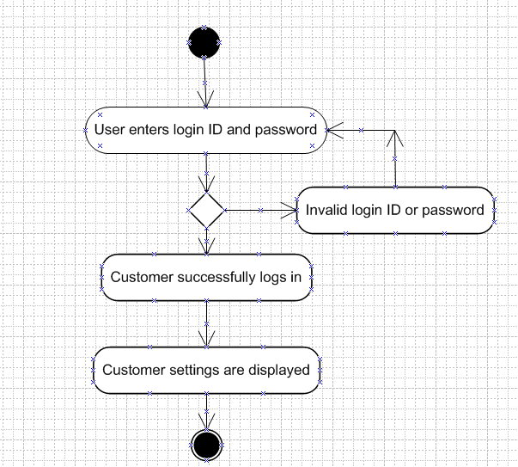

1. **Add to cart :**

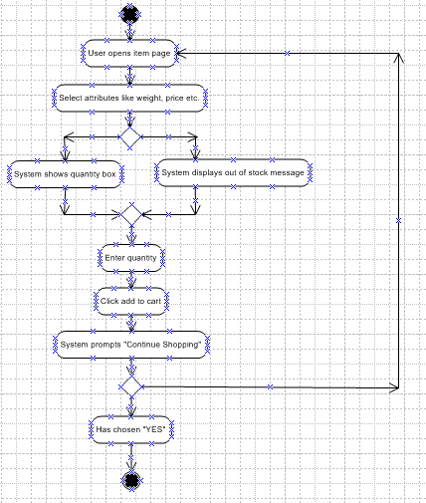

1. **Making payment :**

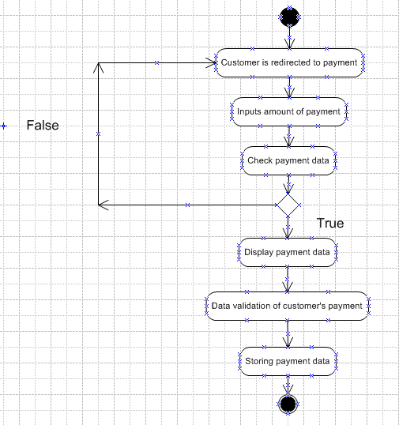

1. **Delivery of order :**

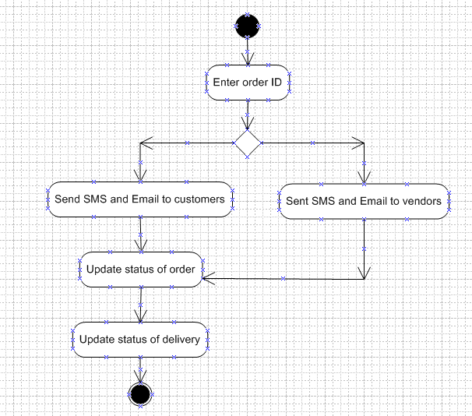

1. **Return a product :**

