**Capstone Project3– Part -1/2**

**Question 1- Draw a Use Case Diagram**

Answer-

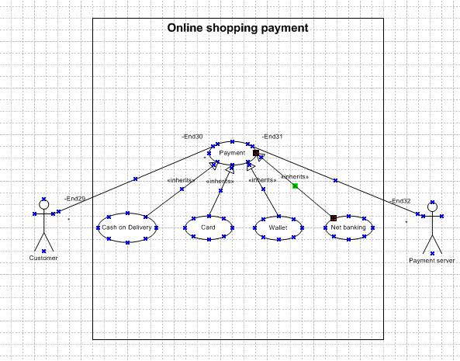

**Question 2- Derive Boundary Classes, Controller classes, Entity Classes.**

**Answer-**

**Boundary Classes:** Is a class that is the boundary of the system which interacts between the system and other system or user (which is actor in the use case diagram). The followings are the feature of the Boundary class:

1.This class is easier to be changed than the Entity and Control class.

2.The attribute of this class and screen layout are defined at the basic design.

3.In a class diagram, there are cases that the stereotype(<<boundary>>) is added.

4.In a class diagram, there are cases that is shown by the following icon.

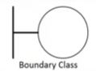

**Controller classes:** Refers to classes that manage the flow of data and user interactions within a software application, also acts as intermediaries between boundary and entity classes. The followings are the feature of the Control class:

1.This class has a few attributes.

2.In a class diagram, there are cases that the stereotype (<<control>>) is added.

3.This class responsibility are Handling User Input, Interacting with the Model, Processing Data, Updating the View and Separation of Concerns.

4.In a class diagram, there are cases that is shown by the following icon.



**Entity Classes:** In object-oriented programming and database contexts, an "entity class" is a class that represents a table in a database, with its attributes mapping to columns in that table. The "E" of the ER diagram means "Entity" too, if you know the ER diagram, you easily understand. The followings are the feature of the Entity class:

1.There are many cases that these objects of this class are perpetuated in the DB.

2.The extraction of the class is like ER diagram.

3.This class is related to the DOA (Data-oriented approach).

4.The module cohesion of this class is high, and is not easy to be changed.

5.In a class diagram, there are cases that the stereotype (<<entity>>) is added.

6.In a class diagram, there are cases that is shown by the following icon.

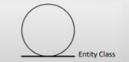

**Question 3- Place these classes on a three tier Architecture.**

**Answer-**

As per below flow diagram please be depicted as follows-

1. Presentation Tier- As actors are interacting with the system which is set under a certain boundary. Example- Payment method boundary, wallet payment, etc
2. Business Tier- As the controller class says it connects boundary and entity class, as the final outcome of the use case is successful only when a developer provides a better logic (in terms of coding language) for the performing the task in hand.
3. Database layer- So entity class in the database of the whole system as it represents the core business logics and keeps intact with the system for a better outcome.

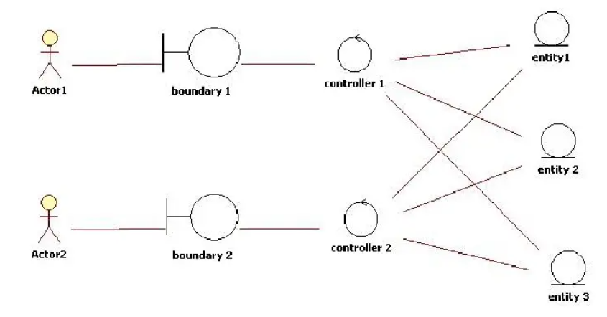

**Question 4- Explain Domain Model for Customer making payment through Net Banking.**

**Answer-**

A domain model is a visual representation of the key concepts, entities, and relationships within a specific domain or area of interest, serving as a blueprint for understanding and building software or systems that interact with that domain.

Difference between ER diagram and domain model-

ER Model –

1. Do not have attributes inside the box.
2. It is a data modelling technique used in database design to represent table.
3. Focuses on relationships required for storing and retrieving the data.
4. Primarily used in database design.

Domain Model-

1. Do have attributes mentioned inside the box.
2. It is a conceptual model that represents real world entities.
3. It focuses on capturing the behaviour of application.
4. Used throughout the software development lifecycle.

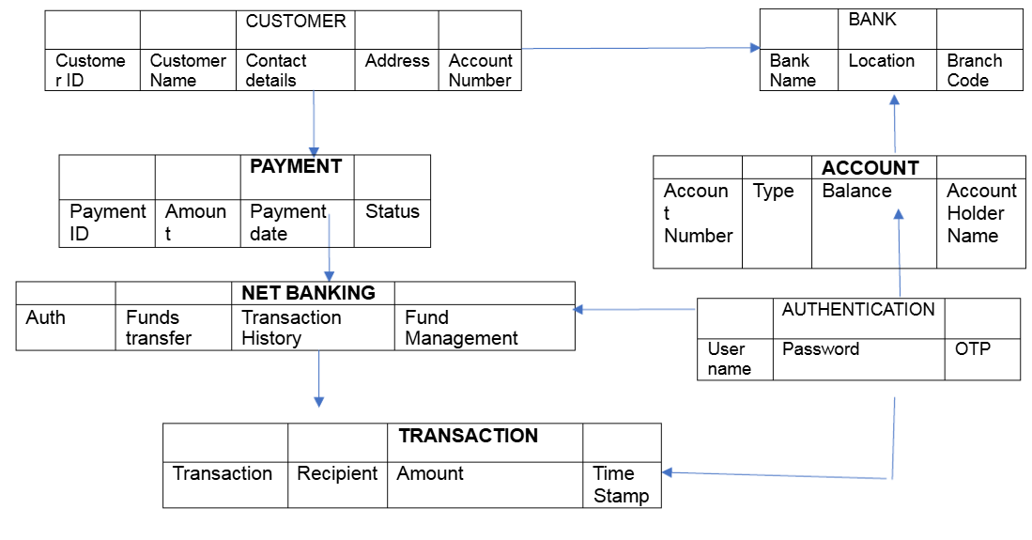

**Question 5- Draw a sequence diagram for payment done by Customer Net Banking**

**Answer-**

A sequence diagram, a type of Unified Modelling Language (UML) diagram, visually illustrates the sequence of interactions and messages between objects during a specific use case or scenario.

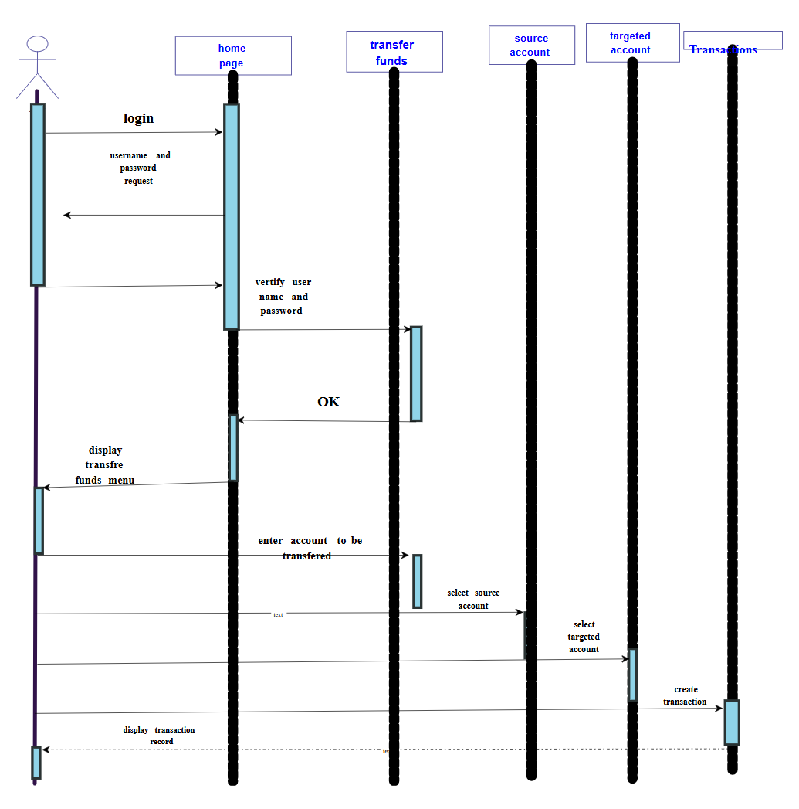

**Question 6- Explain Conceptual Model for this Case.**

**Answer-**

Concept modelling is a technique to create a visual representation of the concepts and relationships within a domain, focusing on the semantic and linguistic aspects of the business, rather than technical details or data structures.

A conceptual model helps in understanding the key concepts, their relationships, and the overall structure of a particular use case, however in this case net banking payment system.

Policies

Infrastructure

Security & Privacy

Online Info

Bank

Trust & Support

Technology

Privacy of data

Service

Customer

Net Banking

**Question 7- What is MVC architecture? Explain MVC rules to derive classes from use case diagram and guidelines to place classes in 3-tier architecture.**

**Answer-**

Model-View-Controller (MVC) is an architectural design pattern that organizes an application's logic into distinct layers, each of which carries out a specific set of tasks.

**Model-**

The Model represents the data and the business logic of the application. Model is responsible for multiple tasks like managing the application's data, performing data validation, implementing business rules, and handling data access operations. Model does not depend on how the data is presented or how the user interacts with the application.

The model class is known about all the data that is needed to be displayed. This layer corresponds to the data-related logic that the user works with. It represents the data that is being transferred between View and Controller. It can add or retrieve the data from the database.

**View-**

The View is responsible -for presenting the data to the user for handling the user interface. The View can be a web page, a desktop application window, or any other form of user interface. It receives input from the user and passes it to the Controller for processing.

It represents the presentation of the application. View refers to the model.

It takes the data from the Model and renders it in a way that is suitable for the user's display or interaction.

**Controller-**

The Controller acts as an intermediary between the Model and the View. It receives input from the user (via the View), processes the input by invoking the appropriate methods in the Model, and then updates the View with the new data or state.

The Controller handles user interactions, interprets user input, and translates it into instructions for the Model or the View. It coordinates the flow of data between the Model and the View, ensuring that they remain separated and independent of each other.

Controller cannot directly get the data from the database. So, controller interacts with the model.

**Advantages of MVC-**

1. MVC has the feature of scalability, which in turn helps the growth of application.
2. The components are easy to maintain.
3. A model can be used by multiple views that provide reusability of code.
4. By using MVC, the application becomes more manageable.
5. As all the three layers are different and independent, they are maintained separately.

Consider the example of Online shopping application with the following use case:

Model Classes-Customer, Payment, Net Banking, Card, Cash.

View Classes-Login View, Payment Option View, Net Banking View, Bank Selection View, Credentials View, Payment Amount View, Payment Confirmation View, Logout View.

Controller Classes-Login Controller, Payment Option Controller, Net Banking Controller, Bank Selection Controller, Credentials Controller, Payment Amount Controller, Payment Confirmation Controller, Logout Controller.

**Guidelines to place classes in 3-tier architecture-**

Three-tier architecture, which separates applications into three logical and physical computing tiers, is the predominant software architecture for traditional client-server applications. This architecture has 3 layers:

-Application layer

-Business logic layer

-Data base layer

Data Tier

Data base

Controller

Logic Tier

Server

Model

Presentation Tier

Client

View

**Question 8- Explain BA contributions in project (Waterfall Model – all Stages).**

**Answer-**

A waterfall model is very old and traditional model in IT industries. Itis a progressive implementation of the projects which is divided into different phrases of SDLC.

The business analyst will verify the product is delivered as per the requirements and it is meeting the business need. Maintenance: Once the implementation is done the team has to give support by installing patches, handling change requests, etc.

Stages in Waterfall Model.

**Requirement Gathering and Analysis:**

This is the initial stage of the project where is an involvement of the BA. BA is responsible for preparing BRD document (Business Requirement Document)

Artifacts: Functional Specification document. Business Requirement Document.

**Designing:**

In this phase the architect will start designing the system based on the business analyst inputs and requirement documents. The BA helps him to clear the doubts about the requirements.

Artifacts: Design Documents and UML diagrams get ready in this phase.

**Coding:**

This phase is quite lengthy as the core development starts in this phase. Developer start product development based on the requirement document prepared by the BA. Developer may ask questions to BA regarding the requirement and he needs to answer the questions as and when required.

**Testing:**

After coding, the testing phase will start, In this phase BA helps the testing team to understand the requirements so that they will build proper functional test cases. BA has to review whether the test cases covering the whole functionality.

Artifacts: Test Cases and test results.

**Deployment:**

Once the code is developed and tested, It is ready to deploy in the production environment. The BA will verify the product is delivered as per the requirements and it is meeting the business needs.

Artifacts: Implementation Review document.

**Maintenance:**

Once the implementation is done the team has to give support by installing patches, Handling changes requests, Etc. A BA is the person who knows every nook and corner of the project. So, every change request has to be reviewed by him and based on his inputs and reports the team will respond.

Artifacts: User Satisfaction review and change request review.

**Question 9- What is conflict management? Explain using Thomas – Kilmann technique**

**Answer-**

In the 1970s, researchers Kenneth Thomas and Ralph Kilmann developed a model for conflict resolution. It was called the Thomas-Kilmann model after them. Under this model, the term ‘conflict’ is described as the condition in which people’s concerns can’t be compared with the others. If two or more people or groups care about things that are contradictory to each other, then the outcome is conflict.

This model describes the two core dimensions while choosing a code of conduct in a situation of conflict: ‘assertiveness’ and ‘cooperativeness’. Assertiveness is the extent to which you try to solve and resolve for your preferred outcomes. Think of this as the factor on the Y-Axis of a graph. On the other hand, Cooperativeness is the level to which you try to resolve the other party’s problems. This is the factor on the X-Axis of the graph.

Thomas-Kilmann’s Five Modes for Handling Conflicts

From the correlation of these two and the scale of implementation, Thomas-Kilmann gave us the following five modes for handling the presented conflicts:

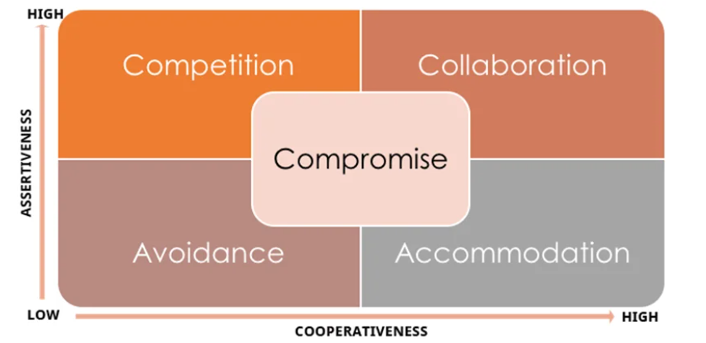

**1. Competing:** The first Thomas-Kilmann conflict mode is assertive and non-cooperative. It refers to addressing only one’s own concerns at the cost of the concerns of the other. It is a power-oriented mode—one uses whatever power dynamic seems appropriate to get a favourable outcome for oneself. An individual’s ability to debate, their position in the hierarchy, or their financial power matters the most. Competing is defensive—it strictly means standing up for your individual beliefs and simply trying to win.

**2. Accommodating:** According to the Thomas-Kilmann model, the Accommodating mode is both accepting and cooperative. It is the opposite of competing. While accommodating, the individual in question neglects their own problems or beliefs to address the problems of the other party. The element of self-sacrifice is highlighted in this mode. Accommodating typically involves selfless understanding, generosity, or charity. At times, accommodating would require you to follow the other person’s orders when you would not like to do so, or submit to the other’s perspective or decisions.

**3. Avoiding:** In the Thomas-Kilmann model, avoiding is both unassertive and uncooperative. The individual wants to neither address their own problems nor the problems of others. This ultimately means that they do not want to engage in the conflict at all. Avoiding might be seen at times as a diplomatic move involving bypassing or ignoring the issue. It could also involve putting off the issue until the time is favourable, or simply stepping back from an uncomfortable or hazardous situation.

**4. Collaborating:** The most beneficial outcome in the Thomas-Kilmann conflict model. is both assertive and cooperative. This mode is the complete opposite of avoiding. Collaborating includes a voluntary effort to work alongside the opposition to find a perfect solution that wholly addresses the collective problem. Collaborating involves deep-diving into an issue to locate the critical demands of the concerned individuals or parties. Collaborating between two or more people might take the form of a quest to understand the ‘why’ of the disagreement. It involves striving to look for creative answers to interpersonal issues and enriching yourself from the other person’s insights.

**5. Compromising:** The last outcome in the Thomas-Kilmann conflict model falls on the average point on both the assertiveness and cooperativeness scales. The goal here is to find a mutually acceptable and robust solution that, in some ways, satisfies both the individuals. It comes midway between competing and accommodating. It addresses an issue more directly than avoiding but falls short of investigating it with as much depth and rigor as collaborating. In certain situations, compromising might involve seeking middle-ground solutions, providing concessions, or looking for a quick solution that provides some way forward from the impasse.

**Question 10- List down the reasons for project failure.**

**Answer-**

**1. Poor planning:** Although sometimes overlooked in importance, lack of planning can make a project fail.Having a successful project depends on properly defining in detail the scope, the time frame, and each member’s role. This way, you’ll have a route laid out to follow.

**2. Inconsistently defined resources:** Let’s be clear: planning shouldn’t be limited to agendas, meetings, and responsibilities. It should also include human, intellectual, financial, or structural resources. If these are not consistently determined, deadlines can’t be met, which can jeopardize the project’s conclusion.

**3. Unclear objectives:** Objectives should be clearly defined, so as time goes by, you’ll know if you’re doing what’s right or not. Remember that choosing measurable goals helps you better visualize your progress and helps you see how close you are to achieving your results.

**4. Lack of detail control:** Monitoring is essential for successful projects, even knowing the details of many projects simultaneously can be very challenging. As a result, it’s important to know how your project is going, if it is on schedule and if the budget is under control. This way, if there are any divergences from the initial plan, you can still correct them.

**5. Lack of transparency:** It’s essential that everyone involved in the projects have complete project visibility so that it doesn’t fail – not only the project manager, but other team members too. This includes clear communication, good document management, and transparency about tasks’ status, all of which can be achieved with centralized, all-digital files.

**6. Lack of communication:** Communication is the key to good project management. Without the right tools and processes to allow interaction among team members and the project manager from the beginning, efficient communication can seldom be achieved.

**7. Change of direction:** Among the ways projects fail, a very common one is scope creep. This concept refers to changes requested when the project has already started which had not been planned before. This is very common when projects are not appropriately documented and defined beforehand.

**8. Unrealistic expectations:** When you want to do something fast, with a limited budget, and a reduced team, it can really make your project fail. You should be realistic when it comes to your teams’ capabilities, deadlines, and the resources available – only then can you obtain the results you want.

**9. Lack of monitoring:** Providing a schedule to the team is not enough for a project to be successful. You should also make sure everything goes as planned. This means having frequent progress checks or meetings, as well as making adaptations, when necessary, is essential.

**10. Unrealistic due dates:** Planning co Unrealistic due dates impex tasks for short due dates is definitely one of the causes for project failure. It is vitally important to carefully consider how long each project phase will take, in addition to extra time for unexpected events. This is the only way to develop a quality project.

**11. Poorly assigned roles:** When each team member receives their responsibilities clearly, they will know what, when, and how to perform their activities without someone needing to constantly ask for it.

**Question 11- List the Challenges faced in projects for BA**

**Answer-**

A BA is responsible for multiple tasks at the same time. From handling the projects, maintaining client relationships, interacting with stakeholders, and managing project deadlines, Business Analysts got a lot on their plate. Read below to find out the challenges faced by business analysts and a possible solution to them.

**1. Lack Of Domain Knowledge:**

A Business Analyst needs to collaborate with the business users to understand the requirements. Domain knowledge plays a vital role in having a clear and complete understanding of the requirements. It is challenging for Business Analysts to be assigned to a wide variety of projects as learning new domains needs time and energy.

**Possible solution:** Whenever you are assigned a new project, sit with the responsible person and understand the project requirements. Take notes whenever necessary and understand them thoroughly. It is challenging to learn new domains sometimes, but you must make mistakes. Hence, go on a loop until you make a very bit of your knowledge count on your fingertips. It will help you while implementing and processing the outcome of the project.

**2. Lack of Up-to-Date Process:**

The success of a project does not happen overnight. First, much effort and mental exhaustion are poured in to bring results. Following this, the lion’s share is the up-to-date process of maintaining and evolving the project. The biggest challenge is the lack of up-to-date techniques and documentation. In most cases, the Project Documentation is incomplete, which hampers productivity.

**Possible solution:** Testing a system is the most remarkable technique to learn about an existing project. It may seem odd, but it has been used for a long time. To further understand the flow, request a demo from a staff member or SME. Afterward, conduct extensive testing.

**3. Changing Business Needs or Requirements:**

Business stakeholders frequently request revisions to requirements even after they have been finalized and approved, as experienced by Business Analysts.

It might happen more once, even for the exact requirement, making it one of the most frequent issues. These adjustments could have an impact on the Business Analysis effort as well as the total project effort, cost, and schedule.

**Possible solution:** A change in the implementation cycle might impact the delivery process even if there are approaches that, like Agile, accept change. Business Analysts and other essential stakeholders must therefore determine how the difference may be implemented in the best way.

**4. Inadequate Stakeholder Involvement:**

One of the essential success criteria for every project is stakeholder involvement. You might encounter any of the following as a Business Analyst:

**Lack of crucial stakeholders:** If this occurs, there will be multiple problems since they will not be up to date on discussions about the most recent requirements. Either they won’t be able to express their ideas, or they will subsequently propose revisions.

**Stakeholders’ Lack of Cooperation:** Occasionally, you may encounter one or more stakeholders who are unwilling to cooperate. It could cause delays, sign-off problems, and even approval problems.

**Possible solution:** Business analysts may record the requirement discussions, particularly significant decisions made, and distribute them to all stakeholders in the meeting minutes. Before the scheduled requirements sessions, they may ask everyone who wasn’t present to review the points. This will reduce the likelihood of miscommunication and reopening requirements items that have already been closed.

**5. Unrealistic Timelines:**

As a Business Analyst, you may find yourself in a problematic situation where timelines might be the concern. In that case, pressure is created, which might hamper your work. In that case, understand how to tackle such a situation while maintaining the quality of the work.

**Possible solution:** Sales Team may be forced to accept a difficult situation for tactical reasons. As a Business Analyst, you cannot change the terms of the agreement, but you can evaluate its effects and inform management of the probable costs and losses. You have the option of starting over. Unrealistic Expectations from stakeholders are widespread. It’s crucial to manage these expectations balanced without permanently damaging the relationships.

**6. Technical Skills:**

When it comes to Business Analysts, it’s a myth that they don’t require technical skills. On the contrary, most of them are champions in coding, know how to maintain business processes, and have a knack for technically undertaking the requirements. Moreover, Business Analysts are involved in every step of the product development cycle; hence, they must understand the technical and functional side of the business as well.

**Possible solution:** Working with multiple clients, customers, and stakeholders is not easy. It requires a lot of skills to put in to bring the best results. Therefore, develop your skills over time. Whenever you are available, read, take courses and understand the technicality of the Project and the business. This will help you in developing better Project documents and will help in multiple ways.

**7. Professionalism:**

Business analysts are one of the most underappreciated, underpaid and ignored members of the IT world. They frequently serve as the binding agent between a project’s technical and business aspects. They are the one who contributes to the development of the project plan and who supports the project from beginning to end. They will collaborate with developers to ensure the project is constructed following the most current standards and satisfies the business’ expectations.

**8. Managing Communication:**

When you communicate effectively, you aid developers in understanding the needs, limits, and requirements of the business. You contribute to the development of solutions that benefit the client as well as the company. You guarantee the work is completed on schedule and to the required standards. But communicating the point is difficult. It involves a variety of abilities and trade secrets.

**Possible solution:** Soft skills are part of better work opportunities and personality. Try to communicate your views clearly and confidently to your team so they can understand them easily. It will help incur the communication gap between the team. While intersecting with the stakeholders, try to break the idea into pointers and explain the leads to them.

**9. Conflict with Users:**

Sometimes, you might find yourself in a situation where you cannot understand the user’s complaint. It happens during the product release stage and might come as rude feedback. Even conflict between stakeholders and business analysts may arise when a team suggests a new strategy pertinent to the existing business process.

**10. Mindset:**

Business analysts must be prepared to deal with various difficulties throughout their work, from limitations of the technologies they employ to push back from stakeholders and other team members. But how one approaches their task can significantly alter if they are ready for the most typical obstacles.

**Question 12- Write about Document Naming Standards**

**Answer-**

1. **Keep file names short, but meaningful.**

Example-

Correct-/…/Orientation/20181105SchdlVlntrs.pdf

Incorrect - The_schedule_and_volunteers_for_Orientation_Nov_18.pdf

1. **Avoid unnecessary repetition and redundancy in file names and folder names/file paths.**

Example-

Correct-/…/Doe/Events/KidsNSibs/20181105BnceHsRsrvtn.pdf

Incorrect - /…/Doe/Events/KidsNSibs/20181105KidsNSibsBounceHouseReservation.pdf

**3. The most preferred is title case (Filename).**

Less preferable are, no separation (filename), underscores (file_name), dashes (file-name), or spaces (File Name).

Correct/Preferred – PSYCSyllabus.docx

Incorrect/Not Preferred – PSYC_syllabus.docx, psych syllabus.docx

**4. When including a number, use leading zeros to ensure files sort properly, i.e., “001, 002…101” instead of “1, 2…101”.**

Correct – (In alphanumeric sort order) Image01.jpg, Image02.jpg, Image03.jpg, Image10.jpg, Image11.jpg, Image20.jpg

Incorrect – (In alphanumeric sort order) image1.jpg, image10.jpg, image11.jpg

**5. Date format should be YYYYMMDD (or YYMMDD) so years of files sort in chronological order.**

**6. When including a personal name in a file name give the family name first followed by the initials.**

Example-

Correct - DoeJL20180421.jpg

Incorrect -John-L-Doe20180421.jpg

**7. Avoid using common words such as “draft” or “letter” at the start of file names. Avoid using common words such as “draft” or “letter” at the start of file names.**

Example-

Correct – SyllabusV02Draft.docx, SyllabusV03Final.docx, TestV01Draft.docx, TestV04Final.docx

Incorrect - DraftSyllabusV02.docx, DraftTestV01.docx, FinalSyllabusV03.docx, FinalTestV04.docx

**8. Order the elements in a file name in the most appropriate way to retrieve the record.**

**9. The file names of records relating to recurring events should include the date and a description of the event, except where the inclusion of either of these elements would be incompatible with rule 2.**

Example-

Correct - KidsNSibs20181012.docx, KidsNSibs20191016.pdf, Orientation20180810.pptx

Incorrect – SibsWeekend.docx, WeekendWithTheKids.docx, 20180810.pptx

**10. Avoid using special characters, i.e.,** ~ ! @ # $ % ^ & * ( ) ` ; < >? , [ ] { } ‘ “

**Question 13- What are the Do’s and Don’ts of a Business analyst**

**Answer-**

|  |  |
| --- | --- |
| **Do’s** | **Don’ts** |
| Conduct Thorough Research | Ignore the Human Element |
| Engage Key Stakeholders | Overlook Communication |
| Use Appropriate Analysis Tools | Resist Process Improvement |
| Develop Clear and Measurable Objectives | Make Decisions in Isolation |
| Prioritize Continuous Learning | Underestimate the Power of Documentation |

Additional Tips for Successful Business Analysis

Besides the dos and don'ts, there are additional tips that can enhance your effectiveness as a business analyst:

**Adaptability:** Be flexible and ready to adapt your approach as project requirements and conditions change.

**Leadership:** Even without formal authority, your influence can guide teams to success. Refine leadership skills to inspire others and drive change.

**Customer-**Centric Focus: Prioritize customer needs and expectations when developing solutions.

In conclusion, effective business analysis requires a blend of analytical skills, effective communication, and strategic thinking. By following the dos and don'ts outlined in this guide, business analysts will be better equipped to drive success and innovation in modern enterprises. Continuous improvement, engagement, and clear documentation form the foundation of successful business analysis, leading to improved processes and user satisfaction.

**Question 14- Write the difference between packages and sub-systems.**

**Answer-**

**Packages:**

A package is a grouping and organizing element in which other elements reside, which must be uniquely named. In the UML, packages are used in a manner similar to the way directories and folders in an operating system group and organize files. It may contain many structural things like classes, components and other packages in it. It can be used to:

* Group semantically related elements.
* Define a semantic boundary in the model.
* Provide units for parallel working and configuration management.
* It is used to provide encapsulated namespace within which all names must be unique.

**Sub-Systems:**

In UML models, subsystems are a type of stereotyped components that represent independent, behavioural units of a system. They are widely used in class, component, use case diagrams to represent large-scale components that are to be modelled. Recall that a system is an organized collection of elements that maybe recursively decomposed into smaller subsystems and eventually into non decomposable primitive elements. For example, the project management system may be decomposed into the following:

* A user interface subsystem responsible for providing a user interface through which users may interact with the system.
* A business processing subsystem responsible for implementing business functionality.
* A data subsystem responsible for implementing data storage functionality.

While a package simply groups elements, a subsystem groups elements that together provide services such that other elements may access only those services and none of the elements themselves. A subsystem is shown as a package marked with the subsystem keyword.

**Question 15- What is camel-casing and explain where it will be used.**

**Answer-**

Camel-case is a naming convention for writing file or object names using compounded or joined words with at least of those words beginning in a capital letter.

Camel-case is used in programming language to name different files and functions without violating the naming laws of the underlying language.

Camel-case is also known as medial capitals and Pascal case.

The term camel-case is derived from its appearance, which can resemble a camel's back. It is used in many programming languages that doesn't allow spaces in file names. Camel-case enables the creation of names that are more unique and have more meaning for the developer.

For example, file names Bigball, BigBall and bigBall can be read much more easily than bigball.

Camel-Case is a way to separate the words in a phrase by making the first letter of each word capitalized and not using spaces. It is commonly used in web URLs, programming and computer naming conventions.

**Question 16- Illustrate Development server and what are the accesses does business analyst has?**

**Answer-**

A development server is a type of server that is designed to facilitate the development and testing of programs, websites, software or applications for software programmers. It provides a run-time environment, as well as all hardware/software utilities that are essential to program debugging and development.

A development server is the core tier in a software development environment, where software developers test code directly. It is comprised of the essential hardware, software and other components used to deploy and test the software underdevelopment, including bulk storage, development platform tools and utilities, network access and a high-end processor. Upon testing completion, the application is moved either to a staging server or production/live server.

Develop stage: The business analyst’s responsibility in this stage is to ensure that the development aligns with the previously approved business values and criteria.

* Setting up preparation activities. The BA monitors the pre-development phase to ensure that each sprint adheres to the agreed-upon requirements and objectives.
* Tracking the development process. Although the BA does not work directly with developers, they attend daily Scrum and Standup sessions to ensure that they meet all business needs.

Business Analyst has the visualizing access in development server. BA has the access to all the functional servers and not to the technical servers.

**Question 17- What is Data Mapping.**

**Answer-**

Data mapping is the process of connecting and transforming data fields from one or more source systems to corresponding fields in a target system, ensuring data integrity and consistency during data integration or migration.

Data mapping bridges the differences between two systems, or data models, so that when data is moved from a source, it is accurate and usable at the destination.

Data mapping has been a common business function for some time, but as the amount of data and sources increase, the process of data mapping has become more complex, requiring automated tools to make it feasible for large data sets.

Data mapping is an essential part of many data management processes. If not properly mapped, data may become corrupted as it moves to its destination. Quality in data mapping is key in getting the most out of your data in data migrations, integrations, transformations, and in populating a data warehouse.

Data mapping is an essential part of ensuring that in the process of moving data from a source to a destination, data accuracy is maintained. Good data mapping ensures good data quality in the data warehouse.

**Data migration:** Data migration is the process of moving data from one system to another as a one-time event. Generally, this is data that doesn't change over time. After the migration, the destination is the new source of migrated data, and the original source is retired. Data mapping supports the migration process by mapping source fields to destination fields.

**Data integration:** Data integration is an ongoing process of regularly moving data from one system to another. The integration can be scheduled, such as quarterly or monthly, or can be triggered by an event. Data is stored and maintained at both the source and destination. Like data migration, data maps for integrations match source fields with destination fields.

**Data transformation:** Data transformation is the process of converting data from a source format to a destination format. This can include cleansing data by changing data types, deleting nulls or duplicates, aggregating data, enriching the data, or other transformations. For example, "Illinois" can be transformed to "IL" to match the destination format. These transformation formulas are part of the data map. As data is moved, the data map uses the transformation formulas to get the data in the correct format for analysis.

**Data warehousing: If** the goal is to pool data into one source for analysis or other tasks, it is generally pooled in a data warehouse. When you run a query, a report, or do analysis, the data comes from the warehouse. Data in the warehouse is already migrated, integrated, and transformed. Data mapping ensures that as data comes into the warehouse, it gets to its destination the way it was intended.

**Question 18- What is API. Explain how you would use API integration in the case of your application Date format is dd-mm-yyyy and it is accepting some data from Other Application from US whose Date Format is mm-dd-yyyy?**

**Answer-**

An API, is Application Programming Interface, is a software-to-software interface. APIs provide a secure and standardized way for applications to work with each other and deliver the information or functionality requested without user intervention.

An API, or application programming interface, is a set of defined rules that enable different applications to communicate with each other. It acts as an intermediary layer that processes data transfers between systems, letting companies open their application data and functionality to external third-party developers, business partners and internal departments within their companies.

**How API Works?**

An API is a set of programming codes that enables data transmission between one software product and another.

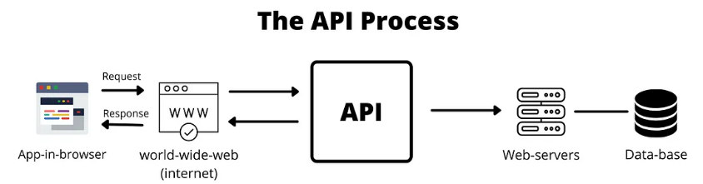

When you use an application on your mobile phone, the application connects to the Internet and sends data to a server. The server then retrieves that data, interprets it, performs the necessary actions, and sends it back to your phone. The application then interprets that data and presents you with the information you wanted in a readable way. This is what an API is — all of this happens via API.

Here's a breakdown of how APIs handle date format changes:

**1. API-Side Handling:**

Standard Format Internally: The API can store and process dates in a standard format (e.g., ISO 8601) for consistency and efficiency.

Format Conversion: The API can offer the ability to convert the standard format to different formats requested by the client.

Parameter for Format: Clients can specify the desired date format as a parameter in their API request.

Example: Client requests data with a date in "DD-MM-YYYY" format.

API receives the request and retrieves data, which is stored in "MM/DD/YYYY" format.

API converts the date to the format requested by the client (e.g., "DD-MM-YYYY") before sending the response.

**2. Client-Side Handling:**

Standard Format from API: The API consistently returns dates in a standard format, like ISO 8601.

Client-Side Conversion: The client application (e.g., a web app, mobile app) handles the conversion of the date format to the desired display format.

Example: Client requests data from the API.

The API returns dates in "DD-MM-YYYY" format. However, the client application uses its programming language's date formatting functions to convert the date to "MM/DD/YYYY" for display.

**3. Case Study Example:**

Scenario: A web application needs to display dates in a specific format (e.g., "DD/MM/YYYY") to users in Pune, India.

API: The API returns dates in US format ("MM/DD/YYYY").

Solution:

The API doesn't need to change its internal format.

The client-side application uses a date formatting library (e.g., moment.js in JavaScript) to convert the date from " MM/DD/YYYY" to "DD/MM/YYYY" before displaying it to the user.

This approach ensures that the API remains consistent and the client can handle the specific display requirements.