**Waterfall Project2 – Part -2/2**

**Question 1 Document 6**

Please prepare a use case diagram, activity diagram and a use case specification document.

**Answer**

*Use case diagram*

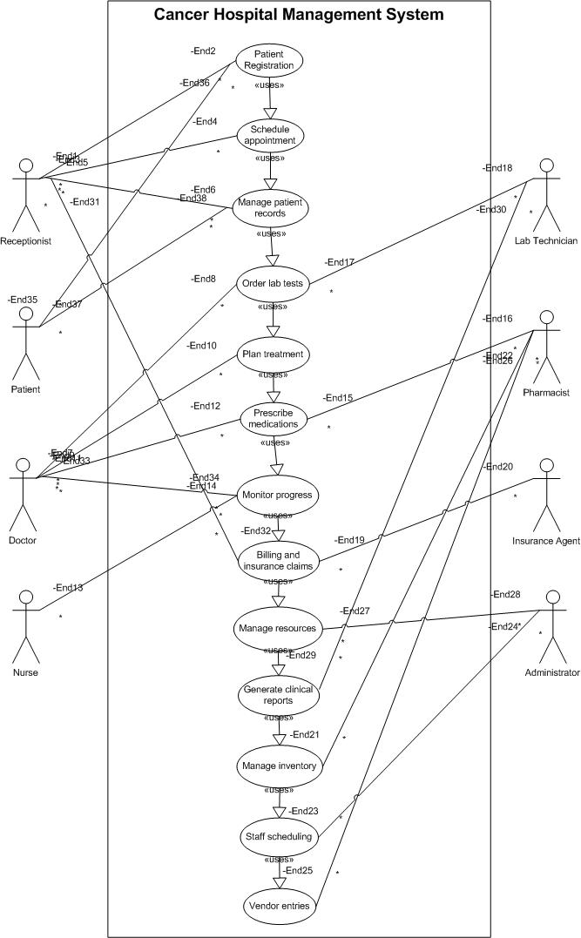

*Activity Diagram*

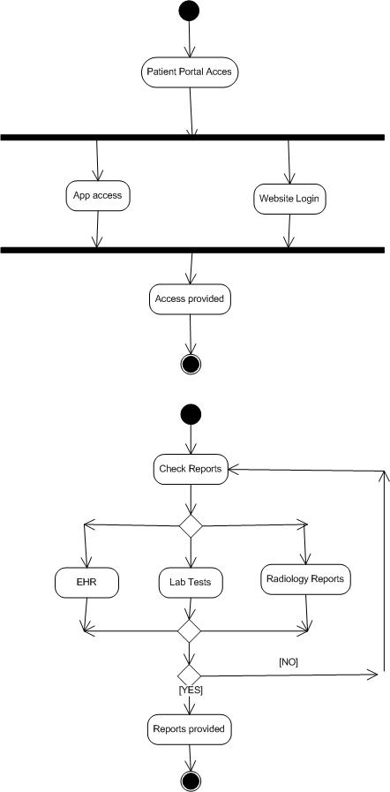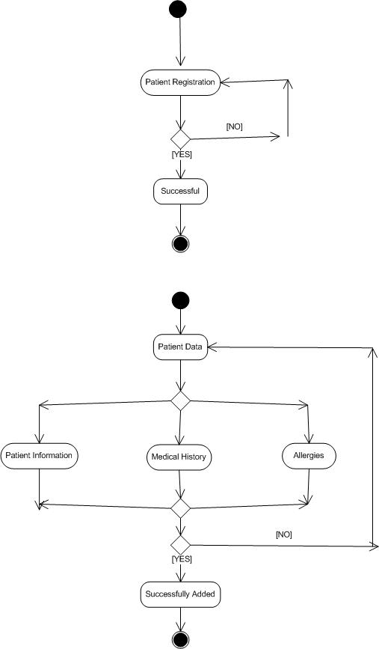

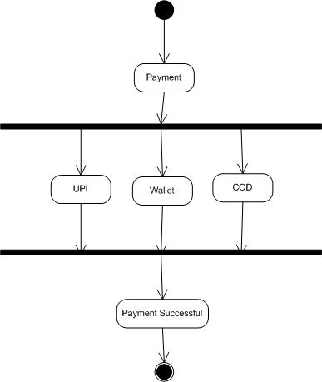

*Use Case Specification: Patient Registration*

1. Use Case Name

Patient Registration

2. Use Case Description

This use case describes the process of registering a new patient in the Cancer Hospital Management System. It includes capturing patient demographics, medical history, insurance information, assigning a unique patient ID, and scheduling the initial consultation with an oncologist.

3. Actors

*Primary Actors:*

- Registration Staff

- Patient

*Secondary Actors:*

- Insurance Verification System

- Electronic Medical Records (EMR) System

- Appointment Scheduling System

- Oncologist

4. Basic Flow

1. Patient arrives at the registration desk with required documentation

2. Registration staff initiates a new patient registration in the system

3. Registration staff enters patient demographic information (name, DOB, gender, contact details, address)

4. Registration staff enters patient's medical history including:

- Family history of cancer

- Previous cancer diagnoses and treatments

- Current medications

- Allergies

- Comorbidities

5. Registration staff captures insurance information

6. System validates insurance eligibility through integration with insurance verification system

7. System generates a unique patient ID

8. Registration staff collects required consent forms and uploads scanned copies to the system

9. Registration staff schedules initial consultation with appropriate oncologist based on cancer type/symptoms

10. System generates a patient information packet with hospital information, appointment details, and patient portal access instructions

11. System sends confirmation email/SMS to patient with appointment details

12. Registration staff provides the patient with physical copies of appointment details and patient information packet

5. Alternate Flows

*5.1 Patient is a Referral*

- At step 1, if patient is referred from another healthcare facility:

1. Registration staff enters referring physician information

2. System requests medical records from referring facility (if electronic sharing is available)

3. Resume at step 2 of basic flow

*5.2 Incomplete Documentation*

- At step 1, if patient has incomplete documentation:

1. Registration staff records available information

2. System flags the patient record as incomplete

3. Registration staff provides patient with list of required documentation

4. Patient is given provisional registration status

5. Resume at step 3 of basic flow

*5.3 Insurance Verification Failure*

- At step 6, if insurance verification fails:

1. System notifies registration staff of verification failure

2. Registration staff informs patient of verification failure

3. Registration staff provides patient with self-pay options or financial assistance programs

4. If patient agrees to proceed, resume at step 7 of basic flow

5. If patient cannot proceed, registration is saved as incomplete and process ends

6. Exceptional Flows

*6.1 System Failure During Registration*

1. If system crashes during registration:

1. System automatically saves data entered up to the point of failure

2. Registration staff informs IT support

3. Registration staff completes registration using paper forms

4. When system is restored, registration staff enters remaining information

5. Resume at appropriate step based on completion status

*6.2 Emergency Registration*

1. If patient requires immediate medical attention:

1. Registration staff initiates expedited registration process

2. System generates temporary patient ID

3. Only critical information is captured (name, DOB, emergency contact)

4. Patient is immediately directed to emergency oncology department

5. Complete registration is performed after patient is stabilized

7. Pre-Conditions

1. Registration staff has valid system credentials and appropriate access rights

2. System integration with insurance verification system is operational

3. Appointment scheduling system has up-to-date oncologist availability

4. Registration terminals are operational and connected to the hospital network

5. Patient has appropriate identification documents

8. Post-Conditions

1. Patient is successfully registered in the system with a unique patient ID

2. Patient has an initial consultation appointment scheduled

3. Patient record is accessible to authorized healthcare providers

4. Patient is registered in the patient portal system

5. Initial appointment is visible in the oncologist's schedule

9. Assumptions

1. Registration staff is trained in using the Cancer Hospital Management System

2. Patients can provide accurate personal and medical history information

3. Hospital has established protocols for different types of cancer cases

4. System has predefined templates for different cancer types

5. Hospital has sufficient oncologists to accommodate new patient appointments within a reasonable timeframe

10. Constraints

1. System must comply with HIPAA regulations for patient data privacy and security

2. Registration process should be completed within 30 minutes for standard cases

3. System must maintain 99.9% uptime during hospital operating hours

4. Patient data must be encrypted both in transit and at rest

5. System must support concurrent registration processes during peak hours

11. Dependencies

1. Integration with insurance verification system

2. Integration with electronic medical records system

3. Integration with appointment scheduling system

4. Integration with patient portal system

5. Integration with hospital billing system

6. Availability of scanning equipment for document digitization

12. Inputs and Outputs

*Inputs:*

1. Patient demographic information

2. Patient medical history

3. Insurance information

4. Referring physician information (if applicable)

5. Scanned identification documents

6. Scanned insurance cards

7. Signed consent forms

*Outputs:*

1. Unique patient ID

2. Patient information packet

3. Appointment confirmation

4. Patient portal access credentials

5. Registration confirmation in EMR system

13. Business Rules

1. All cancer patients must be assigned to an oncologist specializing in their specific cancer type

2. New patients must be scheduled for initial consultation within 5 business days

3. Patients with suspected aggressive cancers must be flagged for expedited appointments

4. All patients must sign informed consent for treatment and privacy forms

5. Insurance verification must be completed before finalizing registration

6. Patient IDs must follow the established format: YYYY-NNNNN-CC (Year-Sequential Number-Check Digits)

7. Complete medical history must be captured before initial consultation

8. Patients without insurance must be informed of financial assistance programs

14. Miscellaneous Information

1. This use case is part of the Patient Management module of the Cancer Hospital Management System

2. Future system enhancements will include integration with national cancer registries

3. The registration process will be reviewed quarterly for efficiency improvements

4. Patient satisfaction surveys regarding the registration process will be conducted monthly

5. Registration process metrics (time to complete, accuracy, patient satisfaction) will be tracked and reported

*Use Case Specification: Treatment Plan Management*

1. Use Case Name

Treatment Plan Management

2. Use Case Description

This use case describes the process of creating, reviewing, approving, and executing a comprehensive treatment plan for cancer patients. It includes documenting the diagnosis, determining appropriate treatment protocols, scheduling treatment sessions, monitoring patient progress, and making necessary adjustments to the plan based on patient response.

3. Actors

*Primary Actors*:

- Oncologist

- Oncology Nurse

- Radiation Therapist

- Medical Physicist

*Secondary Actors*:

- Patient

- Pharmacy System

- Laboratory System

- Radiology System

- Scheduling System

- Billing System

4. Basic Flow

1. Oncologist reviews patient diagnostic information (lab reports, imaging results, pathology reports, genetic testing)

2. Oncologist determines cancer type, stage, grade, and other clinical parameters

3. Oncologist documents official diagnosis in the system

4. Oncologist creates a treatment plan based on established protocols and guidelines

5. Oncologist specifies treatment modalities (chemotherapy, radiation therapy, surgery, immunotherapy, etc.)

6. For each modality, the oncologist defines:

- Medication/procedure details

- Dosage information

- Frequency and duration

- Expected outcomes

- Potential side effects

7. System validates the treatment plan against established protocols and clinical guidelines

8. Oncologist submits plan for tumour board review (if required based on cancer type/complexity)

9. After approval, system generates treatment schedule

10. Oncologist reviews and finalizes the treatment plan with the patient

11. System sends treatment orders to respective departments (pharmacy, radiation therapy, surgery)

12. System schedules all required treatment sessions

13. Treatment plan is executed according to schedule

14. Oncologist and care team document treatment progress, side effects, and patient response

15. Oncologist reviews treatment efficacy at predefined intervals

16. System generates reports on treatment progress

5. Alternate Flows

*5.1 Clinical Trial Eligibility*

- At step 4, if patient meets criteria for clinical trial:

1. Oncologist reviews available clinical trials matching patient profile

2. System displays eligibility criteria and trial protocols

3. Oncologist discusses trial options with patient

4. If patient consents to trial participation:

- Oncologist completes trial enrolment documentation

- System integrates trial protocol into treatment plan

- Resume at step 5 of basic flow

*5.2 Treatment Plan Modification Required*

- At step 7, if system identifies protocol deviations:

1. System flags potential issues and suggests alternatives

2. Oncologist reviews flagged issues

3. Oncologist adjusts plan or provides justification for deviation

4. System records justification and allows plan to proceed

5. Resume at step 8 of basic flow

*5.3 Tumour Board Recommendation for Plan Modification*

- At step 8, if tumour board recommends changes:

1. Tumour board notes are documented in the system

2. Oncologist reviews recommendations

3. Oncologist modifies treatment plan accordingly

4. Modified plan is resubmitted for approval

5. Resume at step 9 of basic flow

6. Exceptional Flows

*6.1 Patient Condition Deteriorates During Treatment*

1. Care team documents decline in patient condition

2. System alerts oncologist of significant changes

3. Oncologist reviews patient status and treatment response

4. Oncologist modifies treatment plan (reduction in dosage, change in medications, treatment pause)

5. System updates all relevant departments about plan changes

6. Modified treatment continues with increased monitoring

*6.2 Severe Adverse Reaction to Treatment*

1. Care team documents adverse reaction in the system

2. System immediately alerts oncologist and pharmacy

3. Current treatment is suspended

4. Oncologist assesses patient and determines appropriate intervention

5. Oncologist updates treatment plan to address adverse reaction

6. System records adverse event for reporting purposes

7. Treatment resumes with modified approach after patient stabilizes

7. Pre-Conditions

1. Patient is registered in the system with complete demographic information

2. Patient has completed all required diagnostic tests

3. Test results are available in the system

4. Patient has had initial consultation with oncologist

5. Patient insurance/payment information is verified

6. Patient has signed informed consent for treatment

8. Post-Conditions

1. Comprehensive treatment plan is documented in the system

2. Treatment schedule is created and visible to all relevant departments

3. Required medications/resources are allocated

4. Patient is scheduled for all initial treatment sessions

5. Billing codes are generated for insurance claims

6. Patient receives treatment plan summary and schedule

9. Assumptions

1. Diagnostic information is accurate and complete

2. Hospital has resources (equipment, staff, medications) to execute the treatment plan

3. Clinical guidelines and protocols are up-to-date in the system

4. Patient will adhere to the treatment schedule

5. Multidisciplinary team members have appropriate system access

6. System integrations with pharmacy, laboratory, and radiology are functional

10. Constraints

1. Treatment plan must comply with clinical practice guidelines

2. Significant deviations from standard protocols require documented justification

3. High-risk treatments require secondary oncologist approval

4. System must maintain complete audit trail of all treatment plan changes

5. Treatment plans must be documented using standardized terminology

6. Medication orders must include dose calculation methodology

11. Dependencies

1. Integration with electronic medical records system

2. Integration with pharmacy management system

3. Integration with laboratory information system

4. Integration with radiology information system

5. Integration with scheduling system

6. Integration with clinical decision support system

7. Integration with billing system

12. Inputs and Outputs

*Inputs*:

1. Patient diagnostic information

2. Pathology reports

3. Laboratory results

4. Imaging studies

5. Genetic testing results

6. Patient medical history

7. Current medications

8. Allergies

9. Performance status assessment

10. Clinical practice guidelines

*Outputs*:

1. Documented cancer diagnosis (type, stage, grade)

2. Comprehensive treatment plan

3. Treatment schedule

4. Medication orders

5. Procedure orders

6. Patient education materials

7. Expected outcome documentation

8. Follow-up appointment schedule

9. Treatment summary reports

13. Business Rules

1. All treatment plans must follow evidence-based clinical guidelines for the specific cancer type

2. Deviations from standard protocols require oncologist justification and documentation

3. Complex cases must be reviewed by tumor board before treatment initiation

4. Treatment plans must be finalized within 5 business days of completed diagnostics

5. High-toxicity chemotherapy regimens require pharmacy verification

6. Radiation therapy plans require medical physicist approval

7. All treatment plans must include symptom management protocols

8. Treatment efficacy must be assessed at predefined intervals based on cancer type

9. Significant treatment modifications require documented patient consent

10. End-of-treatment summaries must be completed within 7 days of treatment completion

14. Miscellaneous Information

1. This use case is part of the Clinical Management module of the Cancer Hospital Management System

2. Integration with national cancer treatment databases is planned for future releases

3. AI-assisted treatment planning features will be added in future versions

4. Treatment plan compliance with guidelines will be audited quarterly

5. System will eventually support genomics-driven personalized treatment planning

6. Remote monitoring capabilities for outpatient treatment management will be incorporated in future releases

**Question 2 Document 7**

Screens and pages

**Answer**

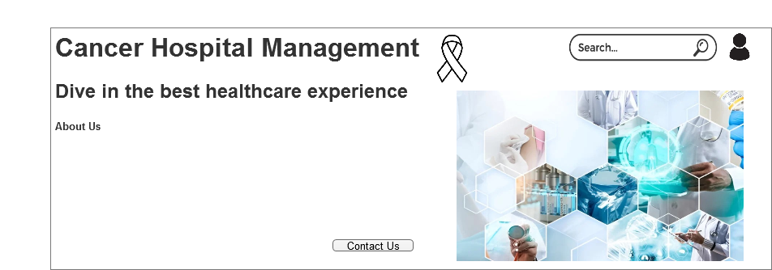

Home Page

Services

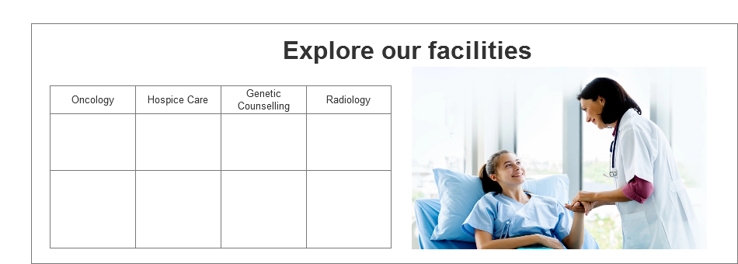

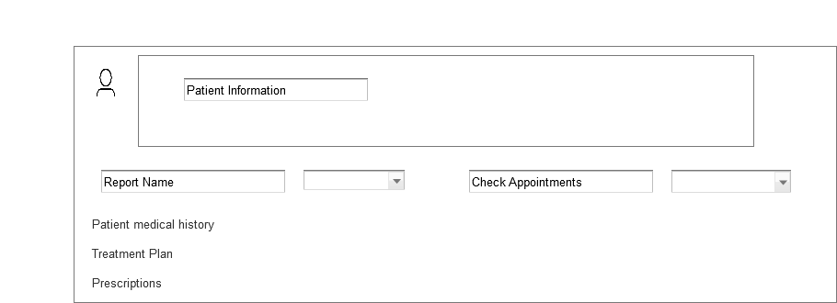Patient Portal

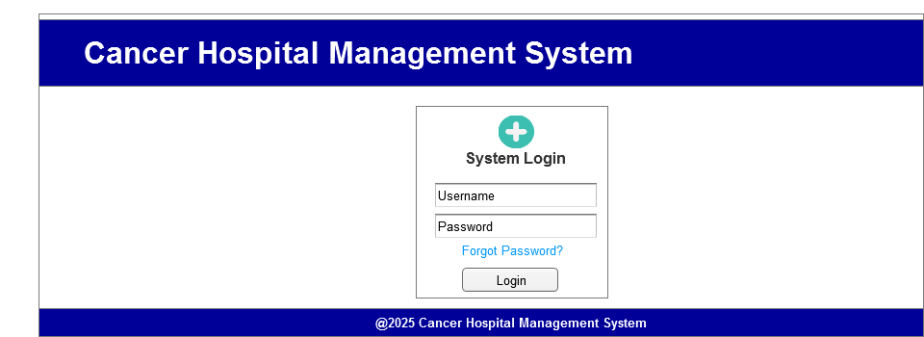

Login Page

**Question 3 Document 8**

Tools Visio and Axure

**Answer**

In my experience working on the cancer hospital management system project using the waterfall model, both Visio and Axure proved to be invaluable tools with distinct strengths. Visio excelled at creating detailed use case diagrams, and activity diagrams during the requirements and design phases, providing clear visual documentation that stakeholders could easily understand and approve before development began. The tool's precision in creating standardized UML diagrams was particularly helpful when mapping out the complex relationships between various hospital departments and patient care workflows.

Meanwhile, Axure transformed our static wireframes into interactive prototypes that simulated the actual user experience, allowing me to test complex interactions for critical processes like patient registration, treatment plan management, and payment processing. The ability to create master components in Axure significantly streamlined my work when designing consistent UI elements across multiple screens.

The combination of both tools enables thorough document requirements and validate user interfaces before coding began, adhering to the waterfall methodology's emphasis on complete documentation and sequential development. This approach minimized costly changes during later development stages and ensured that the final system accurately reflected the detailed specifications we had meticulously documented.

**Question 4 Document 9**

BA Experience

**Answer**

My experience as a Business Analyst for the cancer hospital management system was both challenging and rewarding.

-During requirement gathering, I applied the MoSCoW technique to prioritize features and used FURPS for validation, though client unavailability periodically forced me to work with alternative stakeholders to maintain momentum.

-In the analysis phase, creating UML and activity diagrams proved invaluable for visualizing complex workflows specific to cancer care. When team members disagreed with certain aspects, I facilitated focused discussions to incorporate their insights, ultimately strengthening the solution architecture.

-The design phase involved translating requirements into detailed test cases and working extensively with clinical experts to create realistic test scenarios that accurately reflected oncology care complexities. Developing negative test cases proved particularly valuable for safety-critical features like medication management.

-During development, I found my role as translator between technical and clinical stakeholders to be crucial. JAD sessions helped resolve implementation challenges, though managing resistant team members required diplomatic one-on-one conversations to address underlying concerns.

-Testing demanded meticulous attention to healthcare-specific validation requirements, and I worked closely with oncology staff to obtain appropriate test data while continuously updating the RTM to ensure complete coverage.

-Throughout deployment, coordinating end-user training while accommodating hospital staff's demanding schedules was particularly challenging. Creating role-specific documentation and organizing multiple training sessions helped ensure successful adoption.

The waterfall methodology's structured approach proved appropriate for this healthcare project, where patient safety and regulatory compliance necessitated thorough documentation and systematic validation at each stage.