# Online Agriculture Products Store

Mr. Henry, after being successful as a businessman and has become one of the wealthiest persons in the city. Now, Mr. Henry wants to help others to fulfil their dreams. One day, Mr. Henry went to meet his childhood friends Peter, Kevin and Ben. They live in a remote village and do farming. Mr. Henry asked his friends if they are facing any difficulties in their day-to-day work.

Peter told Mr. Henry that he is facing difficulties in procuring fertilizers which are very important for farm. Kevin said that he is also facing the same problem in-case of buying seeds for farming certain crops. Ben raised his concern on lack of pesticides which could help in greatly reducing pests in crops.

After listening to all his friends’ problems, Mr. Henry thought that this is a crucial problem faced not only by his friends but also by so many other farmers. So, Mr. Henry decided to make an online agriculture product store to facilitate remote area farmers to buy agriculture products. Through this Online Web / mobile Application, Farmers and Companies (Fertilizers, seeds and pesticides manufacturing Companies) can communicate directly with each other.

The main purpose to build this online store is to facilitate farmers to buy seeds, pesticides, and fertilizers from anywhere through internet connectivity. Since new users are involved, Application should be user friendly.

This new application should be able to accept the product (fertilizers, seeds, pesticides) details from the manufacturers and should be able to display them to the Farmers. Farmers will browse through these products and select the products what they need and request to buy them and deliver them to farmers location.

Mr. Henry has given this project through his Company SOONY. In SOONY Company, Mr Pandu is Financial Head and Mr Dooku is Project Coordinator. Mr. Henry , Mr Pandu , and Mr Dooku formed one Committee and gave this project to APT IT SOLUTIONS company for Budget 2 Crores INR and 18 months Duration under CSR initiative. Peter, Kevin and Ben are helping the Committee and can be considered as Stakeholders share requirements for the Project.

Mr Karthik is the Delivery Head in APT IT SOLUTIONS company and he reached out to Mr Henry through his connects and Bagged this project. APT IT SOLUTIONS company have Talent pool Available for this Project. Mr Vandanam is project Manager, Ms. Juhi is Senior Java Developer, Mr Teyson, Ms Lucie, Mr Tucker, Mr Bravo are Java Developers. Network Admin is Mr Mike and DB Admin is John. Mr Jason and Ms Alekya are the Tester. And you joined this team as a BA.

Fertilizers, seeds, pesticides details from the manufacturers and should be able to display them to the Farmers.

To gather the business requirements from the client, you went to SOONY and met Mr. Henry. When Mr.

Henry was asked about the project and what are they expecting from the project, Mr. Henry stated that he is expecting to have a login for all its users (fertilizers, seeds, pesticides manufacturers and Farmers) , a product catalog of fertilizers, seeds, pesticides, a search option to search for products, payment process, and delivery tracking.

After doing the stakeholder analysis, you have found out that Peter, Kevin, Ben are the key stakeholders and you have scheduled an appointment to meet them. After meeting with them and trying to gather the stakeholder requirements, Kevin said that, a Farmer should be able to browse through the products catalog once they visit the website and need to have a search option so that they can search for any product they need. Peter said that, if a farmer wants to buy any product or add them to buy-later list, they need to login first using their email id and password. If it is a new user, then they can create a new account by submitting their email ID and creating a secure password. Ben added saying that, Farmers needs to have an easy-to-use payment gateway which should include cash-on-delivery (COD), Credit/Debit card and UPI options so that the user’s experience should be better. Kevin mentioned that, a user gets an email confirmation regarding their order status. A delivery tracker to track the whereabouts of their order.

**Question 1 – Functional Requirements - 15 M**

Identify minimum 20 functional requirements

Example:

Functional requirement: When an order is fulfilled, the local printer shall print a packing slip. Non-Functional Requirement: Packing slips shall be printed on both sides of 4”x 6” white paper, the standard size for packing slips used by local printers.

|  |  |  |  |  |
| --- | --- | --- | --- | --- |
| Functional Requirements | | | | |
| Req ID | Req Name | Requirement Description | | Priority |
| FR001 | Farmer Registration | Farmer should be able to register with the application | | 9 |
| FR002 | Farmer search for products | Farmer should be able to search for available products fertilizers, seeds, pesticides | | 9 |
| FR003 | Manufacturer registration | Manufacturer should be able to register with the application | | 8 |
| FR004 | Manufacturer product listing | Manufacturer should be able to list their products in the catalogue | | 8 |
| FR005 | Product details display | The application should display detailed information about each product, including descriptions, specifications and pricing | | 7 |
| FR006 | Filter | Farmer should be able to apply filter and select the product as per the brand and price | | 6 |
| FR007 | Add to Cart | User should be able to add products to their shopping cart for purchase | | 9 |
| FR008 | Cart Management | User should be able to view and manage the content of their shopping cart for purchase | | 8 |
| FR009 | Wishlist management | User should be able to manage their wishlist or buylater list, including adding or removing products | | 9 |
| FR010 | Multiple payment gateway | The platform should integrate with the multiple payment gateway to facilitate secure and convenient transactions | | 10 |
| FR011 | Order placement | User should be able to place orders for selected products, specifying the quantity and delivery address | | 9 |
| FR012 | Order confirmation | User should receive and order confirmation with details such as order number, products, quantities, total amount, and estimated delivery date | | 7 |
| FR013 | Order tracking | User should be able to track the status and location of their orders in real-time | | 6 |
| FR014 | Order history | User should be able to view their order history, including past orders, order details and statuses | | 7 |
| FR015 | Customer support | User should have access to customer support, either through live chat, email, or phone, for assistance with their orders or inquiries | | 8 |
| FR016 | User ratings and reviews | User should be able to provide ratings and reviews for products they have purchased | | 7 |
| FR017 | Product recommendations | The platform should provide personalized product recommendations based on user preferences and browsing history | | 7 |
| FR018 | Social sharing | User should have options to share products or their purchase experience on social media platforms | | 7 |
| FR019 | Secure transactions | The platform should ensure secure transactions by implementing appropriate encryption and security measures | | 9 |
| FR020 | Product filtering | User should be able to filter products based on various criteria such as price range, brand, or product | | 8 |
| FR021 | Account management | User should be ablet to manage their account settings, including profile information, password changes and email preferences | | 7 |
| Non - Functional Requirements | | | | |
| Req ID | Req Name | | Requirement Description | Priority |
| NFR001 | Page loading time | | Each page should load within 2 sec time | 10 |
| NFR002 | Technical support system | | Application can be used in any OS | 6 |
| NFR003 | Time limit for OTP | | OTP time limit should be given max of 5 min. for Login and Registration process | 9 |
| NFR004 | Logout system | | If the page is not accessed for more than 5 minutes, the page should log-out automatically | 7 |
| NFR005 | Stock availability | | Stock available should be updated on a real time basis | 8 |
| NFR006 | SMS & mail confirmation | | Automated email and SMS notification should be sent to users | 6 |
| NFR007 | Backup | | All data should be backed up automatically | 7 |
| NFR008 | Connectivity | | System should be connected with internet | 8 |
| NFR009 | Stock alerts | | Seller should receive stock alert notification when stock is reduced, every week | 8 |
| NFR010 | Net banking | | Bank account should be active in nature for smooth payment process | 10 |
| NFR011 | Check stock | | Once the product is sold the stock should be reduced | 7 |
| NFR012 | Email Address | | Email address should be active to receive updates | 5 |
| NFR013 | Taxation system | | All products should be included with add. Tax | 8 |
| NFR014 | Password | | User should receive password change alert every 30 days | 4 |
| NFR015 | Payment receipt | | Generation of payment details | 5 |

**Question 2–Minimum 5 page designs - 15 M**

Make wireframe and prototypes

**Answer:**

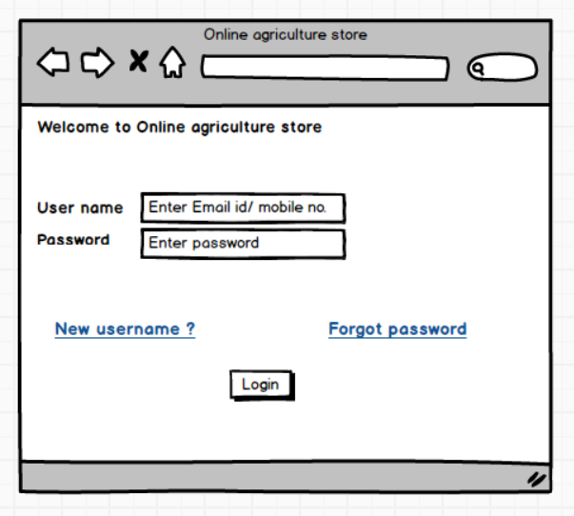

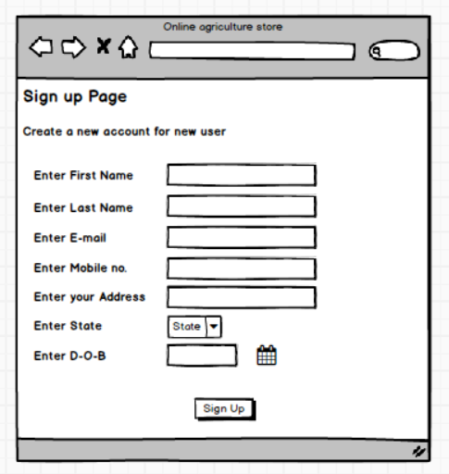

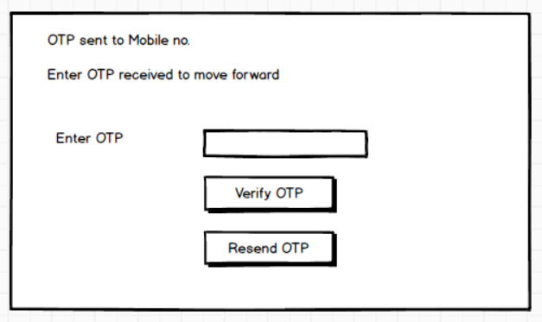

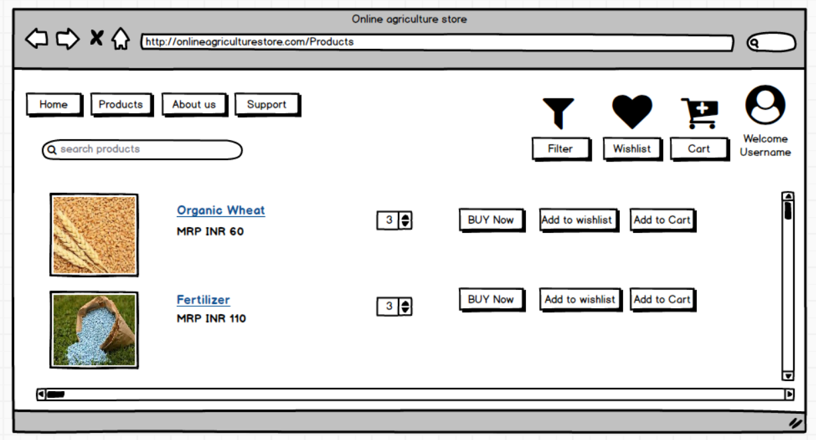

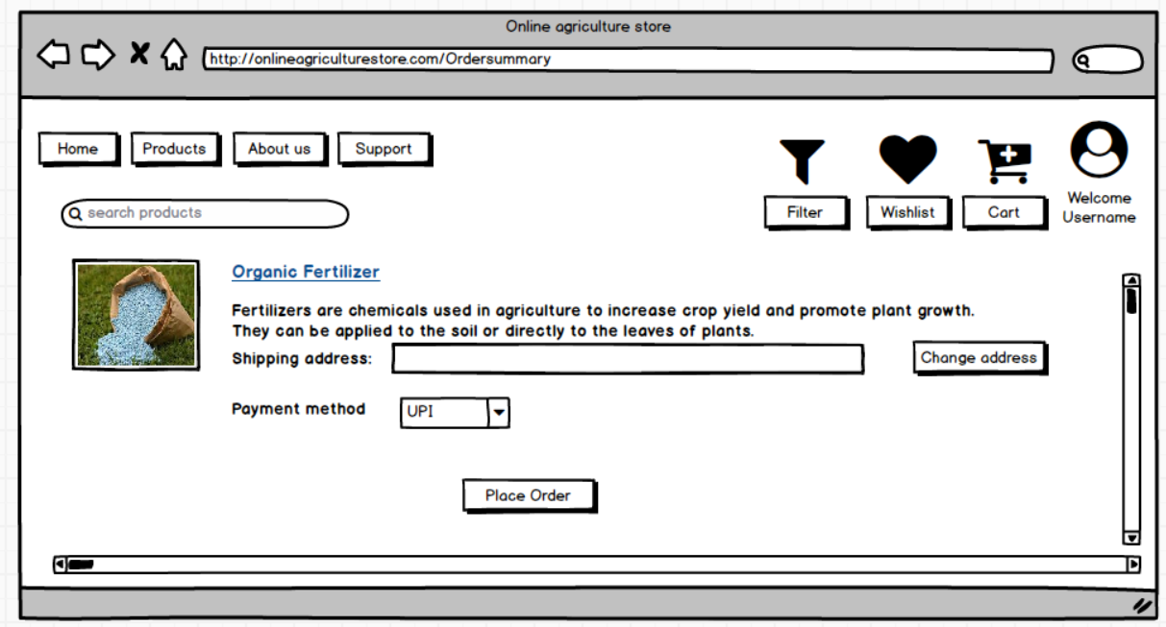

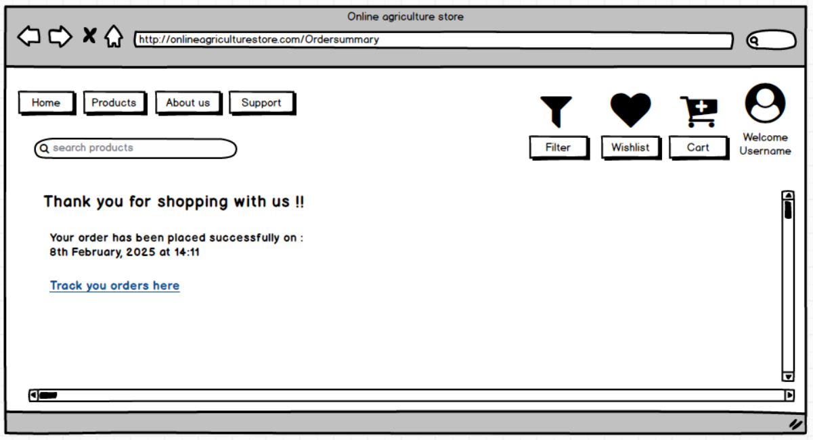

**Question 3 – Tools (Visio, Balsamiq) - 15 M**

Make a note of the Tools, which you are using for above concepts.

**Answer:**

Ms Visio is a diagramming and vector graphics application and is part of the Ms Office family. It is used to create diagram types such as flowcharts, org charts, floor plans, network diag., UML diagrams, mind maps and more. It is also commonly used for scenarios such as Process Mapping and Visual Collaboration. The latest version of Visio also has data visualization that allows users to create diagrams from excel data and also embeded visio diagrams in Power BI dashboards.

**Ms Office Visio** is a tool that eases the process of making complex diagrams. Especially for business purposes. It can help in the making of presentations, floor plans, org charts, etc. Listed below are some uses of Visio:

Following things can draw BA by using MS Office Visio:

* **Flowchart:** A flowchart helps to show the steps in sequential order. These are steps that need to be taken to complete a certain process. It is effective in conveying information. Thus, it can be used in various other fields too.
* **Organization chart:** An org chart displays the roles and reporting relationships in a business org. It depicts the name of the employees in the organization and their position
* **Business process modelling notation:** It is a flowchart method of displaying all the processes in a business that is to be taken. It helps in giving a clear understanding of the process in a particular business through visual representation.

**Balsamiq**: It is an effective tool for presenting the software requirements in the form of wireframes. This helps the software development team to visualize how the software project will look like the early stages of development.

**Question 4 – RTM - 6 M**

A business analyst’s key responsibilities are to keep track of the requirements and make sure that no requirement is missed.

Mr. Henry and peter have approached you regarding the current status of the project. How will you tackle this situation?

Prepare RTM

**Answer:**

|  |  |  |  |  |  |  |  |  |  |  |  |  |
| --- | --- | --- | --- | --- | --- | --- | --- | --- | --- | --- | --- | --- |
| **Req ID** | **Req Name** | **Req Description** | **Design** | **D1** | **T1** | **D2** | **T2** | **D3** | **T3** | **D4** | **T4** | **UAT** |
| FR001 | Farmer Registration | Farmer should be able to register with the application | Y | Y | Y | Y | Y | Y | Y | Y | Y | N |
| FR002 | Farmer search for product | Farmer should be able to search for available products in fertilizers, seeds, etc. | Y | Y | Y | Y | Y | Y | Y | Y | Y | N |
| FR003 | No matching product | Farmer should be notified if the searched product not found | Y | Y | Y | Y | Y | Y | Y | N | N | N |
| FR004 | Product selection | Farmer should be able to select the product | Y | Y | Y | Y | Y | Y | N | N | N | N |
| FR005 | Out of stock | Farmer should be notified, if the product us out of stock | Y | Y | Y | N | N | N | N | N | N | N |
| FR006 | Filter | Farmer should be able to filter and select the product as per brands and price | Y | Y | Y | N | N | N | N | N | N | N |
| FR007 | Similar products | Farmer should be able to select similar products, if the searched product | Y | Y | Y | N | N | N | N | N | N | N |
| FR008 | Bought together | Once the product is finalized, farmer should be suggested withrelated products as a package with the price | Y | Y | Y | Y | Y | N | N | N | N | N |
| FR009 | Add to cart | Farmer should be able to add the product to the cart for purchase | Y | Y | Y | Y | N | N | N | N | N | N |
| FR010 | Wishlist | Farmer should have an option to add the product into wishlist | Y | Y | Y | N | N | N | N | N | N | N |
| FR011 | Save it later | Farmer should be able to see the option for save it later, to purchase later | Y | Y | Y | N | N | N | N | N | N | N |
| FR012 | Delivery address | Farmer should be able to select the deliver address to the deliver the product | Y | Y | Y | N | N | N | N | N | N | N |
| FR013 | Payment options | Once the delivery address is selected, application should show the payment options to the farmer for purchasing the product | Y | Y | Y | N | N | N | N | N | N | N |
| FR014 | Payment confirmation | Farmer should receive the payment confirmation email and SMS | Y | Y | Y | Y | N | N | N | N | N | N |
| FR015 | Order confirmation | Farmer should receive the order confirmation email and SMS | Y | Y | Y | N | N | N | N | N | N | N |
| FR016 | Expected delivery date | Farmer should be able to see the date of delivery | Y | Y | Y | N | N | N | N | N | N | N |
| FR017 | Track delivery | Farmer should have the option to track the delivery | Y | Y | Y | N | N | N | N | N | N | N |
| FR018 | Cancel/return/replacement | Farmer should be able to cancel/return/ replace the products | Y | Y | Y | Y | N | N | N | N | N | N |
| FR019 | Return pickup | Farmer should be given pick up date and time for the cancelled order | Y | Y | Y | N | N | N | N | N | N | N |
| FR020 | Return confirmation | Farmer should receive SMS or email confirmation for the cancellation/return | Y | Y | Y | N | N | N | N | N | N | N |

|  |  |  |  |  |  |  |  |  |  |  |  |  |
| --- | --- | --- | --- | --- | --- | --- | --- | --- | --- | --- | --- | --- |
| **Req ID** | **Req Name** | **Req Description** | **Design** | **D1** | **T1** | **D2** | **T2** | **D3** | **T3** | **D4** | **T4** | **UAT** |
| NFR001 | Page loading time | Each page should load within 2 sec time | Y | Y | Y | Y | Y | Y | Y | Y | Y | N |
| NFR002 | Tech support system | App can be used on any OS | Y | Y | Y | Y | Y | N | N | N | N | N |
| NFR003 | Time limit for OTP | OTP time limit should be a max of 5 min for Login process | Y | Y | Y | N | N | N | N | N | N | N |
| NFR004 | Logout system | If the page is not accessed for 5 mins then auto logout | Y | Y | Y | N | N | N | N | N | N | N |
| NFR005 | Stock availability | Stock availability should be updated on a real time basis | Y | Y | Y | N | N | N | N | N | N | N |
| NFR006 | SMS & Mail confirmation | Automated email and SMS notification should be sent to user | Y | Y | Y | Y | Y | N | N | N | N | N |
| NFR007 | Backup | All data should be backed up automatically | Y | Y | Y | Y | N | N | N | N | N | N |
| NFR008 | Connectivity | System should be connected with internet | Y | Y | Y | Y | Y | N | N | N | N | N |
| NFR009 | Stock alert | Seller should receive alert when the stock is reduced | Y | Y | Y | N | N | N | N | N | N | N |
| NFR010 | Net Banking | Bank account should be active for smooth payment process | Y | Y | Y | N | N | N | N | N | N | N |
| NFR011 | Check Stock | Onec the product is sold, the stock of the products is reduced | Y | Y | Y | Y | Y | N | N | N | N | N |
| NFR012 | Email ID | Email add. To receive email notification | Y | Y | Y | N | N | N | N | N | N | N |
| NFR013 | Taxation system | All products should be included with add. Tax | Y | Y | Y | N | N | N | N | N | N | N |
| NFR014 | Password | User should receive password change alert every 30 days | Y | Y | Y | N | N | N | N | N | N | N |

**Question 5 – 10 Test Case Documents - 10 M**

Prepare 10 Test Case Documents

**Answer:**

1. **Test case for user login details:**

Pre-condition: User needs a valid user name and password for login

**Test scenario: Verify the login of the Online store:**

* + Test case 1: Enter valid username and password.
  + Expected result: Successful Login
  + Actual result: Successfully logged in
  + Status: Pass
  + Test case 2: Enter valid username and invalid password.
  + Expected result: Username or password is wrong. Kindly enter correct details
  + Actual result: Pop up shows “Invalid details”
  + Status: Fail
  + Test case 3: Enter invalid username and valid password.
  + Expected result: Username or password is wrong. Kindly enter correct details
  + Actual result: Pop up shows “Invalid details”
  + Status: Fail
  + Test case 2: Enter invalid username and invalid password.
  + Expected result: Username or password is wrong. Kindly enter correct details
  + Actual result: Pop up shows “Invalid details”
  + Status: Fail

1. **Test case for Cash on Delivery/ Pay on Delivery:**

Pre-condition: User should have an active bank account for this payment method

**Test scenario: Verify the availability of COD**

* Test case 1: Select COD payment method
* Expected result: Order placed
* Actual result: Order placed
* Status: Pass
* Test case 2: COD not available
* Expected result: Choose another payment method
* Actual result: COD not available
* Status: Fail

1. **Test case for Debit card:**

Pre-condition: User should have an active bank account for this payment method

**Test scenario: Verify the selection of debit card as payment method**

* Test case 1: Enter card details and OTP correctly
* Expected result: Payment successful
* Actual result: Order placed successfully
* Status: Pass
* Test case 2: Entered card no. correct, but expiry date incorrect
* Expected result: Enter correct expiry date
* Actual result: Enter correct expiry date
* Status: Fail
* Test case 3: Entered card details correctly, but incorrect OTP
* Expected result: Enter correct OTP
* Actual result: Enter correct OTP
* Status: Fail

1. **Test case for Credit card:**

Pre-condition: User should have an active bank account for this payment method

**Test scenario: Verify the selection of credit card as payment method**

* Test case 1: Enter card details and OTP correctly
* Expected result: Payment successful
* Actual result: Order placed successfully
* Status: Pass
* Test case 2: Entered card no. correct, but expiry date incorrect
* Expected result: Enter correct expiry date
* Actual result: Enter correct expiry date
* Status: Fail
* Test case 3: Entered card details correctly, but incorrect OTP
* Expected result: Enter correct OTP
* Actual result: Enter correct OTP
* Status: Fail

1. **Test case for product availability for the selected address:**

Pre-condition: User should have a valid postal address with postal code

**Test scenario: Verify the product delivery on the selected postal code**

* Test case 1: Enter valid postal code to check the delivery
* Expected result: Product is available to this postal code
* Actual result: Page accepts the postal code for product selection
* Status: Pass
* Test case 2: Entered incorrect postal code to check the delivery
* Expected result: Product is not available in this postal code
* Actual result: Pop up banner shows “Currently out-of-stock for this postal code”
* Status: Fail

1. **Test case for product cancellation for selected address:**

Pre-condition: User should have valid order processed

**Test scenario: Testing the product cancellation/return**

* Test case 1: Select the product for cancellation/return within the return period
* Expected result: Product cancellation/return successful
* Actual result: Product cancellation/return successful
* Status: Pass
* Test case 2: Select the product for cancellation/return within cancellation/return period
* Expected result: Product is not available for cancellation as its out of cancellation period
* Actual result: Pop-up shows “Cancellation/return not available”
* Status: Fail

1. **Test case for Applying coupon code:**

Pre-condition: User should be a registered customer

**Test scenario: Test that the user should be able to add coupons**

* Test case 1: Entering the correct coupon code in checkout page
* Expected result: Coupon code accepted and price adjusted
* Actual result: Pop-up shows “Coupon code applied”
* Status: Pass
* Test case 2: Entering the incorrect coupon code in checkout page
* Expected result: Coupon code not accepted
* Actual result: Pop-up shows “Coupon code not applicable”
* Status: Fail

1. **Test case for seller adding product within limit:**

Pre-condition: Seller should be registered seller

**Test scenario: Test the maximum product adding limit**

* Test case 1: Seller adding product within limit
* Expected result: Product added successfully
* Actual result: Pop-up shows “product added successfully”
* Status: Pass
* Test case 2: Seller adding product over the limit
* Expected result: Duplicate product already available
* Actual result: Pop-up shows “Product already available, upload new product”
* Status: Fail

1. **Test case for Product search:**

Pre-condition: User should have an Online application installed

**Test scenario: Test if user is able to Search the product**

* Test case 1: Enter the name of the product user want to search
* Expected result: Product lists up successfully
* Actual result: Pop-up shows “Item available”
* Status: Pass
* Test case 2: Enter the name of the product user want to search which is not available
* Expected result: Product searched not available
* Actual result: Pop-up shows “Item not available”
* Status: Fail

**Question 6 – DB Design – 8 M**

After the requirements are thoroughly explained to the entire project team by business analyst, the Database architects have decided to do the database design and also to represent the in-flow and out-flow of data.

Draw database schema and ER diagram

**Answer:**

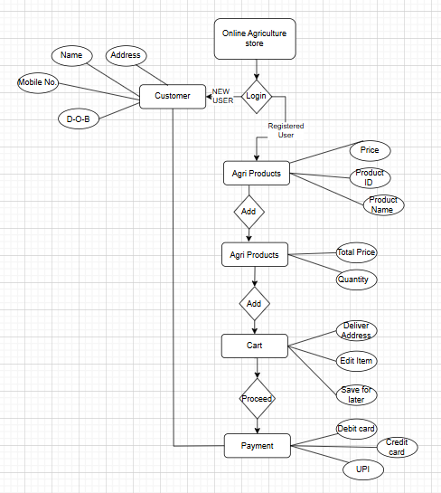

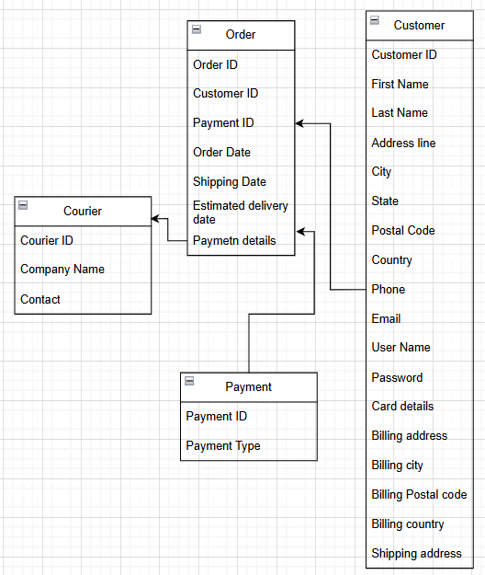

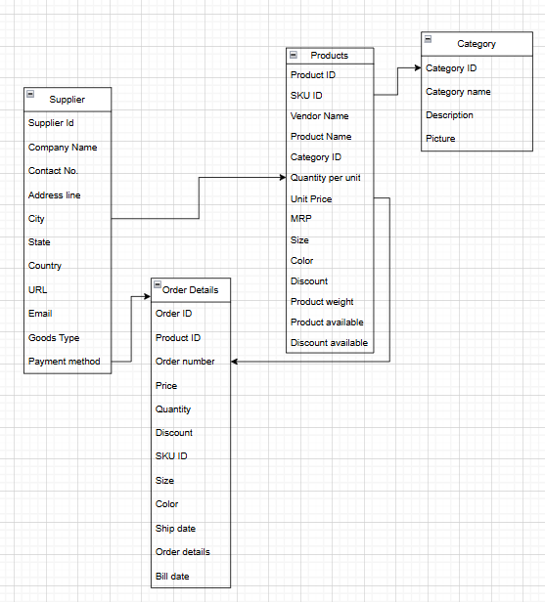

**Question 7 – Data Flow Diagram - 3 M**

What is a data flow diagram? Draw a data flow diagram to represent the in-flow and out-flow of data when a Farmer is placing an order for the product

**Answer:** A Data Flow Diagram (DFD) is a graphical representation of how data moves within a system, including inputs, outputs, data stores, and processing steps. It helps visualize how information is processed and transferred between different components of a system.

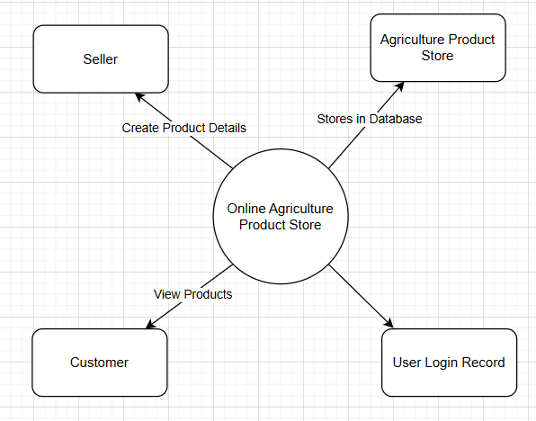

**Question 8 – Change Request - 10 M**

Due to change in the Government Taxation structure . we should change the Tax structure How do you handle change requests in a project?

**Answer:** Change requests are when a stakeholder, either a client or an internal team or department, requests a change to the process or deliverarbles that alreadybeen decided upon the project scope.

However, in this scenario, this change request has come up due to change in Govt. taxation structure. As a BA, I would analyze the request and clarify the stakeholder exactly what the request is asking us to do in the Online store. In a normal scenario, as a BA, I would first of all do a feasibility test, to check the effect of the changes the change request would create in the project.

However, in this case, feasibility study is not required, as it’s Govt structure which needs to be updated and followed. Therefore, I will follow the below steps to change the project as per the clients requirements.

* Document the change request
* Look for any supporting materials to help in adding this change
* Need to assess, whether the change is an inside or outside scope. As its an outside scope, the Budget and time will get impacted
* Policy changes by Govt. is a major change request and we need to ensure that the change should be done according to the Govt. instruction
* Fill the change request form and get the approval from the PM
* We also need to ensure that our team understands the priority of this change request
* We also need to discuss the change with change control board who will recommend the necessary change on the project
* Once this change is approved, the project deliverables will need to be updated. This can include plans and schedules, business process documents, and the requirements documents
* Once these updates have been made, the project manager can communicate the new course of action to everyone who will be impacted. Now we can delegate the necessary tasks to the people in charge of implementing these new changes

**Question 9 – Change Request Vs an Enhancement - 5 M**

As the project is in process, Ben and Kevin have contacted you. The reason is to inform you that they want the Farmers to sell their crop yields through this application i.e. Farmers should be able to add their crop yields or products and display to general public and should be able to sell them. They also want to introduce Auction system for their Crop yields. As a BA, what will be your response? Is this a change request or an enhancement?

**Answer:** The request from Ben and Ken is an Enhancement request, as they want to add another feature in the current Online store. This will help the farmers to sell their yield from the farm directly on the Online store, apart from buying the agriculture related products.

This request would add a totally new module rather than adjusting the current implementation. We would have to analyze this request by conducting feasibility studies, updating the BRD, impacting the deadline, and involving the stakeholders in this issue.

Thus, this request should be logged as an Enhancement, requiring additional business analysis, development, and stakeholder approvals before proceeding.

**Question 10 – Estimations - 6 M**

Come up with estimations – How many Manhours required

**Answer:**

**Manhours required = Total hrs working per day x Total no. of members x Total no. of days worked over the specified period**

No. of working hrs in a day = 8hrs

No. of resources = 12

Time period provided = 18 months = 547 days = 78 weeks

Assuming weekends = 156

Assuming public holidays = 10

Total non-working days = 166

Thus total working days = 547-166 = 381 days

**Estimated manhours** = 8 hrs x 12 resources x 381 days = **36,576 hours required**

**Question 11 – UAT – 6 M**

Project has finally completed all the stages i.e., design, development, testing etc. Now, it is the role of a business analyst to contact the client for testing of the final product and have to successfully complete it. How are you going to handle this situation? And once it is done, what will be the process to close the project? Explain UAT Acceptance process

**Answer:** User Acceptance Testing (UAT) is a phase in the software development life cycle where the users of the Online Agriculture Product Store participate in validating their expectations. As a BA, I will be verifying all the validations prior to design the UAT test cases, which will cover the functionality of the product, system environment, any possible problems which could arise and how to solve these problems.

Steps for implementing the UAT:

* Analysis of Business requirements: One of the most important activities in UAT is to identify and develop test scenarios. These test scenarios are derived from the following documents:
  + Business use case
  + Process flow diagram
  + Business requirements document (BRD)
  + System requirements specification (SRS)
* Creation of UAT plan: The UAT test plan outlines the strategy that will be used to verify and ensure an application achieves its business requirement. It documents entry and exit criteria for UAT, test scenarios and test cases approach and timelines of testing
* Identify test scenarios and test cases: Identify the test scenarios with respect to high level business process and create test case with clear test steps. Test cases should sufficiently cover most of the UAT scenarios. Business use case are input for creating the test cases.
* Preparation of test Data: It is best advised to use live data for UAT. Data should be scrambled for privacy and security reasons. Tester should be familiar with the flow of the database.
* Run and record the results: Execute test cases and report bugs if any. Re-test the bugs once fixed. Test management tools can be used for execution
* Confirm business objectives met: BA or UAT tester needs to send a sign off mail after the UAT testing. After this the product is good to go for production.

By following this structured approach, we ensure a smooth transition from development to client acceptance and final closure. It also helps in establishing long-term client satisfaction and trust.

**Question 12 – Project Closure Document - 6 M**

Explain Project closure document

**Answer:** A Project Closure Document is a formal report that marks the completion of a project. It is prepared by the PM or BA and signed off by key stakeholders, confirming that all project deliverables have been met.

Project closure

Online Agriculture Product Store

|  |  |  |  |
| --- | --- | --- | --- |
| Revision Date: DD/MM/YYYY | | Version: | |
| **Approvers Name** | **Title/role** | **Sign** | **Date** |
| Peter and Ben | Project Stakeholder | OK |  |
| Mr. Henry | Project sponsor | OK |  |
| Mr. Pandu | Financial head | OK |  |
| Mr Vandanam | Project manager | OK |  |
| Mr. Kartik | Delivery head | OK |  |
| Mr Dooku | Project coordinator | OK |  |

**Section 1: General information**

|  |  |
| --- | --- |
| **Project activity** | **Date** |
| Project Start | 18th Dec 2024 |
| Project End | 17th May 2026 |

**Section 2: Business Objectives**

|  |  |  |  |
| --- | --- | --- | --- |
| **Business case** | **Business objectives** | **Met/not met** | **Comment** |
| BI0001 | Farmer should be able to buy and sell agricultural product online | Yes | Ok |

**Section 3: Customer expectations management**

|  |  |  |  |
| --- | --- | --- | --- |
| **Item** | **Question** | **Description** | **Comments** |
| 1 | Were all the expected benefits and business outcomes realized? | Yes | Ok |
| 2 | Were all expected performance standards satisfied? | Yes | Ok |

**Section 4: Project office checklist**

|  |  |
| --- | --- |
| **Deliverables** | **Description** |
| Risk assessment completed and posted on suitable shared storage | Yes or No |
| Business case completed and posted on suitable shared storage | Yes or No |
| Meeting notes completed and posted on suitable shared storage | Yes or No |
| Additional project documentation shared on suitable shared storage, | Yes or No |
| Lesson learned documented | Yes or No |
| Support handover document for future projects stored in suitable storage | Yes or No |
| Comments : Ok to process. Application running propoerlys | |