Online Agriculture Products Store

Mr. Henry, after being successful as a businessman and has become one of the wealthiest persons in the city. Now, Mr. Henry wants to help others to fulfil their dreams. One day, Mr. Henry went to meet his childhood friends Peter, Kevin and Ben. They live in a remote village and do farming. Mr. Henry asked his friends if they are facing any difficulties in their day-to-day work. Peter told Mr. Henry that he is facing difficulties in procuring fertilizers which are very important for farm. Kevin said that he is also facing the same problem in-case of buying seeds for farming certain crops. Ben raised his concern on lack of pesticides which could help in greatly reducing pests in crops. After listening to all his friends’ problems, Mr. Henry thought that this is a crucial problem faced not only by his friends but also by so many other farmers. So, Mr. Henry decided to make an online agriculture product store to facilitate remote area farmers to buy agriculture products. Through this Online Web / mobile Application, Farmers and Companies (Fertilizers, seeds and pesticides manufacturing Companies) can communicate directly with each other. The main purpose to build this online store is to facilitate farmers to buy seeds, pesticides, and fertilizers from anywhere through internet connectivity. Since new users are involved, Application should be user friendly. This new application should be able to accept the product (fertilizers, seeds, pesticides) details from the manufacturers and should be able to display them to the Farmers. Farmers will browse through these products and select the products what they need and request to buy them and deliver them to farmers location. Mr. Henry has given this project through his Company SOONY. In SOONY Company, Mr Pandu is Financial Head and Mr Dooku is Project Coordinator. Mr. Henry, Mr Pandu, and Mr Dooku formed one Committee and gave this project to APT IT SOLUTIONS company for Budget 2 Crores INR and 18 months Duration under CSR initiative. Peter, Kevin and Ben are helping the Committee and can be considered as Stakeholders share requirements for the Project. Mr Karthik is the Delivery Head in APT IT SOLUTIONS company and he reached out to Mr Henry through his connects and Bagged this project. APT IT SOLUTIONS company have Talent pool Available for this Project. Mr Vandanam is project Manager, Ms. Juhi is Senior Java Developer, Mr Teyson, Ms Lucie, Mr Tucker, Mr Bravo are Java Developers. Network Admin is Mr Mike and DB Admin is John. Mr Jason and Ms Alekya are the Tester. And you joined this team as a BA. Your Team

|  |
| --- |
| Project Manager - Mr Vandanam Senior Java Developer - Ms. Juhi |
| Java Developers - Mr Teyson, Ms Lucie, Mr Tucker, Mr Bravo Network Admin - Mr Mike | | |
| DB Admin - Mr John. |
| Testers - Mr Jason and Ms Alekya |
| BA - You |

Fertilizers, seeds, pesticides details from the manufacturers and should be able to display them to the Farmers. To gather the business requirements from the client, you went to SOONY and met Mr. Henry. When Mr. Henry was asked about the project and what are they expecting from the project, Mr. Henry stated that he is expecting to have a login for all its users (fertilizers, seeds, pesticides manufacturers and Farmers), a product catalog of fertilizers, seeds, pesticides, a search option to search for products, payment process, and delivery tracking. After doing the stakeholder analysis, you have found out that Peter, Kevin, Ben are the key stakeholders and you have scheduled an appointment to meet them. After meeting with them and trying to gather the stakeholder requirements, Kevin said that, a Farmer should be able to browse through the products catalog once they visit the website and need to have a search option so that they can search for any product they need. Peter said that, if a farmer wants to buy any product or add them to buy-later list, they need to login first using their email id and password. If it is a new user, then they can create a new account by submitting their email ID and creating a secure password. Ben added saying that, Farmers needs to have an easy-to-use payment gateway which should include cash-on-delivery (COD), Credit/Debit card and UPI options so that the user’s experience should be better. Kevin mentioned that, a user gets an email confirmation regarding their order status. A delivery tracker to track the whereabouts of their order. Identify Business Requirements (which includes Stakeholder Requirements) BR001 – Farmers should be able to search for available products in fertilizers, seeds, pesticides BR002 – Manufacturers should be able to upload and display their products in the application Make suitable Assumptions and identify at least 10 Business Requirements. List your assumptions Give Priority 1 to 10 numbers ( 1 being low priority – 10 being high priority) to these Requirements after discussions with the stakeholders

|  |  |  |  |
| --- | --- | --- | --- |
| Req ID | Req Name | Req Description | Priority |
| BR001 | Farmer Search for Products | Farmers should be able to search for available products in fertilizers, seeds, pesticides | 8 |
| BR002 | Manufacturers upload their Products | Manufacturers should be able to upload and display their products in the application | 8 |

Once the requirements are finalized, as a business analyst, one of the major roles is to act as a liaison between the client and the project team. To gather the requirements correctly from the client side and then to deliver those requirements to the project team in a way they understand.

To make the project team understand the requirements, you need to convert those requirements into UML diagrams and screen mock-ups.

You will draw use case diagram

Prepare use case specs for all use cases

And you will all Activity diagrams required

Question 1 – Functional Requirements - 15 Marks

Identify minimum 20 functional requirements

Example : Functional requirement: When an order is fulfilled, the local printer shall print a packing slip. Non-Functional Requirement: Packing slips shall be printed on both sides of 4”x 6” white paper, the standard size for packing slips used by local printers.

Answer- Functional Requirement

|  |  |  |  |
| --- | --- | --- | --- |
| Req ID | Req Name | Req Description | Priority |
| FR001 | Farmer  Registration | Farmers should be able to register with the  application | 1 |
| FR002 | Farmer  Login | Farmers shall be able to log in using their registered email/User ID and password | 2 |
| FR003 | Farmer browse the product | The system shall allow farmers to browse the product catalog for fertilizers, seeds, and pesticides | 4 |
| FR004 | Farmer search the product | Farmers should be able to search for available  products in fertilizers, seeds, pesticides | 5 |
| FR005 | Farmer search the product by catagory | Farmers shall be able to search for specific products by name or category using a search bar | 6 |
| FR006 | manufacturers to upload their products | The system shall allow manufacturers to upload their products with details (name, category, price, description, and availability) | 12 |
| FR007 | Farmer add product- buy later | The system shall allow farmers to add products to their "Buy Later" list. | 10 |
| FR008 | Manufacturers update details, stock availability | Manufacturers shall be able to update product details, such as stock availability. | 13 |
| FR009 | System provide payment gateway | The system shall provide a payment gateway supporting Credit/Debit Card, UPI, and Cash-on-Delivery (COD) options. | 8 |
| FR010 | Farmers add product in cart as immediate Purchase | Farmers shall be able to add products to the shopping cart for immediate purchase. | 9 |
| FR011 | System valid user credential | The system shall validate and authenticate user credentials during login | 3 |
| FR012 | Farmers notify about delivery status | The system shall enable farmers to track the delivery status of their orders. | 14 |
| FR013 | Farmers notify about Product delivery updates | The system shall notify farmers about product delivery updates through email. | 15 |
| FR014 | Farmers view order history | The system shall allow farmers to view their order history. | 16 |
| FR015 | Famers delete Product from buy later | Farmers shall have the ability to delete products from the "Buy Later" list or shopping cart. | 11 |
| FR016 | System Provide filter | The system shall provide filters (e.g., price range, brand) to refine product searches. | 17 |
| FR017 | System categorize Product | The system shall categorize products based on type (fertilizers, seeds, pesticides) for better navigation. | 7 |
| FR018 | System allow Manufactures to do analytics on sales and demand | The system shall allow manufacturers to view analytics on product sales and demand. | 19 |
| FR019 | System allow administrator to manage user accounts | The system shall allow the administrator to manage user accounts and product listings. | 20 |
| FR020 | Manufacturers view and manage order | Manufacturers shall be able to view and manage the orders placed for their products. | 19 |

Non-Functional Requirement-

|  |  |  |  |
| --- | --- | --- | --- |
| Req ID | Req Name | Req Description | Priority |
| NFR0101 | App should be User-friendly | The application should have a user-friendly interface for farmers and manufacturers. | 4 |
| NFR0102 | Page Loading Time | Each Page should load within 2 seconds time. | 9 |
| NFR0103 | accessible 24/7 | The system shall be accessible 24/7 with 99.9% uptime. | 1 |
| NFR0104 | WCAG 2.1. | The system must meet Web Content Accessibility Guidelines WCAG 2.1. | 8 |
| NFR0105 | secure protocols for all transactions | All transactions shall be encrypted using secure protocols (e.g., HTTPS, SSL) | 2 |
| NFR0106 | Order confirmation email | The system shall send order confirmation emails within 30 seconds of order placement. | 6 |
| NFR0107 | App support for 10,000 concurrent user | The application shall support up to 10,000 concurrent users without performance degradation | 3 |
| NFR0108 | web browsers and mobile devices. | The system shall be compatible with both web browsers and mobile devices. | 5 |
| NFR0109 | Order, user account backup daily | The data related to user accounts and orders shall be backed up daily. | 7 |
| NFR0110 | Multi-language functionality | The application shall support multi-language functionality to cater to diverse users. | 10 |
| NFR0111 | Response Time | Payment gateway transactions must process within 5 seconds. |  |
| NFR0112 | Browser Compatibility | The application must function seamlessly on all major browsers, including Chrome, Firefox, Edge, and Safari. |  |
| NFR0113 | Audit Trail | The application must maintain an audit trail of all user activities for at least six months. |  |
| NFR0114 | Data Security | User data (login credentials, payment details) must be encrypted using AES-256 encryption. |  |
| NFR0115 | Order Tracking Accuracy | The delivery tracker must refresh every 30 minutes with the latest shipment status. |  |
| NFR0116 | Load Handling | The application must handle peak traffic loads during seasonal sales without downtime. |  |
| NFR0117 | Error Handling | The system must provide clear and user-friendly error messages, including steps to resolve common issues. |  |
| NFR0118 | System Updates | All system updates and patches must be deployed with zero downtime using a rolling deployment strategy. |  |
| NFR0119 | Energy Efficiency | The server infrastructure must be optimized for energy efficiency to align with CSR goals. |  |
| NFR0120 | Legal Compliance | The application must comply with local e-commerce regulations and data protection laws like GDPR. |  |

Question 2–Minimum 5 page designs - 15 Marks

Make wireframe and prototypes

Answer-

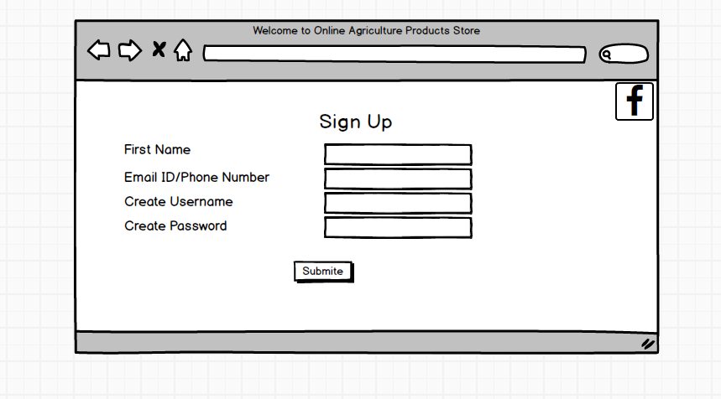

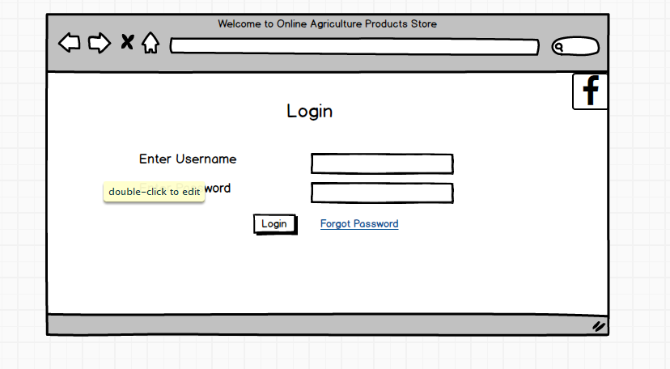

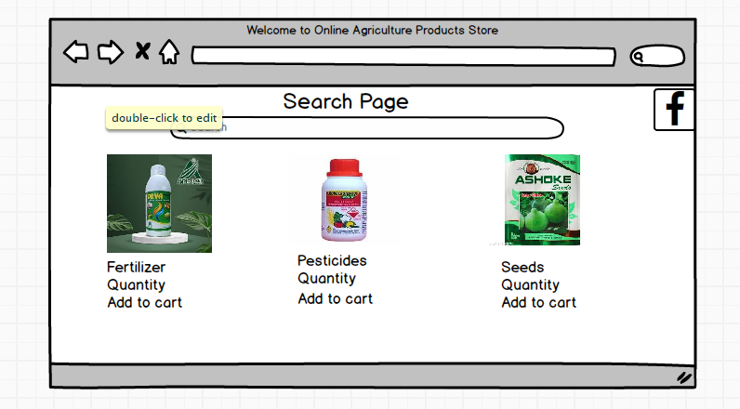

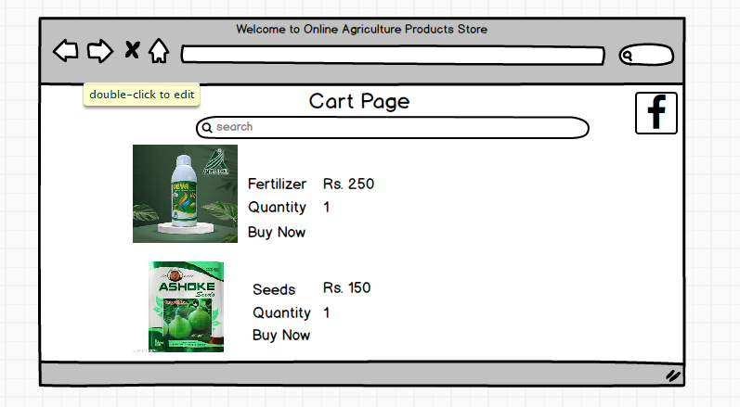

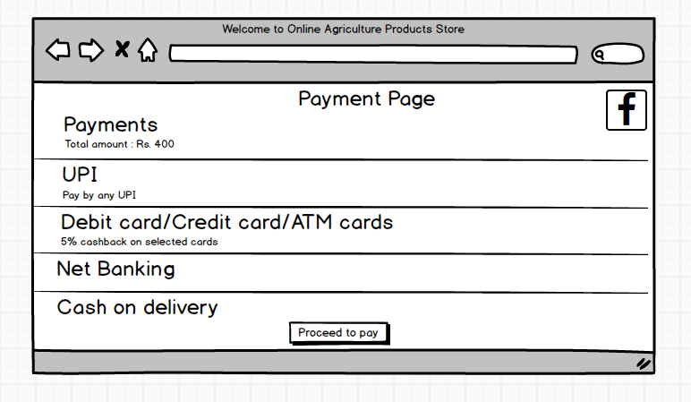

Question 3 – Tools (Visio, Balsamiq) - 15 Marks

Make a note of the Tools, which you are using for above concepts.

Answer-

1. Microsoft Visio- it is diagramming and vector graphics application used to create diagrams, Flowchart, and other visual representation of complex information. Microsoft Visio is a diagramming tool used for creating UML diagrams like Use Case, Activity, and Sequence diagrams. Its integration with Microsoft Office enhances documentation. Visio simplifies complex processes through drag-and-drop features and making it essential for business and technical analysis.
2. Balsamiq- it is rapid Wireframing tool used to create mock-up’s and prototype of user interface. It provides a simple, low-fidelity sketching approach to create mock-up’s quickly. With a drag-and-drop interface, it helps Business Analysts and designers visualize UI layouts, gather feedback, and refine designs before moving to high-fidelity prototypes, reducing development risks.
3. Axure- it is more advance prototype tool used to create high-fidelity, interactive wireframes and prototypes for web and mobile application. It supports dynamic panels, conditional logic, and data-driven elements to create realistic user experiences. Axure aids in user flow validation, stakeholder communication, and usability testing, ensuring a well-defined and structured design before development.

Question 4 – RTM - 6 Marks

A business analyst’s key responsibilities are to keep track of the requirements and make sure that no requirement is missed.

Mr. Henry and peter have approached you regarding the current status of the project. How will you tackle this situation?

Answer-

|  |  |  |  |  |  |  |  |  |  |
| --- | --- | --- | --- | --- | --- | --- | --- | --- | --- |
| Req ID | Req Name | Req Description | Design | code | UT (Unit Testing) | CT (Component Testing) | ST (System Testing) | SIT | UAT (User Acceptance Testing) |
| FR001 | Farmer  Registration | Farmers should be able to register with the  application | Complete | Complete | Complete | Complete | Complete | Complete | Incomplete |
| FR002 | Farmer  Login | Farmers shall be able to log in using their registered email/User ID and password | Complete | Complete | Complete | Complete | Incomplete | Incomplete | Incomplete |
| FR003 | Farmer browse the product | The system shall allow farmers to browse the product catalog for fertilizers, seeds, and pesticides | Complete | Complete | Complete | Complete | Incomplete | Incomplete | Incomplete |
| FR004 | Farmer search the product | Farmers should be able to search for available  products in fertilizers, seeds, pesticides | Complete | Complete | Complete | Complete | Incomplete | Incomplete | Incomplete |
| FR005 | Farmer search the product by catagory | Farmers shall be able to search for specific products by name or category using a search bar | Complete | Complete | Complete | Complete | Incomplete | Incomplete | Incomplete |
| FR006 | manufacturers to upload their products | The system shall allow manufacturers to upload their products with details (name, category, price, description, and availability) | Complete | Complete | Complete | Complete | Incomplete | Incomplete | Incomplete |
| FR007 | Farmer add product- buy later | The system shall allow farmers to add products to their "Buy Later" list | Complete | Complete | Complete | Complete | Incomplete | Incomplete | Incomplete |
| FR008 | Manufacturers update details, stock availability | Manufacturers shall be able to update product details, such as stock availability | Complete | Complete | Complete | Complete | Incomplete | Incomplete | Incomplete |
| FR009 | System provide payment gateway | The system shall provide a payment gateway supporting Credit/Debit Card, UPI, and Cash-on-Delivery (COD) options. | Complete | Complete | Complete | Complete | Incomplete | Incomplete | Incomplete |
| FR010 | Farmers add product in cart as immediate Purchase | Farmers shall be able to add products to the shopping cart for immediate purchase | Complete | Complete | Complete | Complete | Incomplete | Incomplete | Incomplete |
| FR011 | System valid user credential | The system shall validate and authenticate user credentials during login | Complete | Complete | Complete | Complete | Incomplete | Incomplete | Incomplete |
| FR012 | Farmers notify about delivery status | The system shall enable farmers to track the delivery status of their orders. | Complete | Complete | Complete | Complete | Incomplete | Incomplete | Incomplete |
| FR013 | Farmers notify about Product delivery updates | The system shall notify farmers about product delivery updates through email. | Complete | Complete | Complete | Complete | Incomplete | Incomplete | Incomplete |
| FR014 | Farmers view order history | The system shall allow farmers to view their order history. | Complete | Complete | Complete | Complete | Incomplete | Incomplete | Incomplete |
| FR015 | Famers delete Product from buy later | Farmers shall have the ability to delete products from the "Buy Later" list or shopping cart. | Complete | Complete | Complete | Complete | Incomplete | Incomplete | Incomplete |
| FR016 | System Provide filter | The system shall provide filters (e.g., price range, brand) to refine product searches. | Complete | Complete | Complete | Complete | Incomplete | Incomplete | Incomplete |
| FR017 | System categorize Product | The system shall categorize products based on type (fertilizers, seeds, pesticides) for better navigation. | Complete | Complete | Complete | Complete | Incomplete | Incomplete | Incomplete |
| FR018 | System allow Manufactures to do analytics on sales and demand | The system shall allow manufacturers to view analytics on product sales and demand. | Complete | Complete | Complete | Complete | Incomplete | Incomplete | Incomplete |
| FR019 | System allow administrator to manage user accounts | The system shall allow the administrator to manage user accounts and product listings. | Complete | Complete | Complete | Complete | Incomplete | Incomplete | Incomplete |
| FR020 | Manufacturers view and manage order | Manufacturers shall be able to view and manage the orders placed for their products. | Complete | Complete | Complete | In Progress | Incomplete | Incomplete | Incomplete |

|  |  |  |  |  |  |  |  |  |  |
| --- | --- | --- | --- | --- | --- | --- | --- | --- | --- |
| Req ID | Req Name | Req Description | Design | code | UT (Unit Testing) | CT (Component Testing) | ST (System Testing) | SIT | UAT (User Acceptance Testing) |
| NFR0101 | App should be User-friendly | The application should have a user-friendly interface for farmers and manufacturers. | Complete | Complete | Complete | Complete | Complete | Complete | Incomplete |
| NFR0102 | Page Loading Time | Each Page should load within 2 seconds time. | Complete | Complete | Complete | Complete | Incomplete | Incomplete | Incomplete |
| NFR0103 | accessible 24/7 | The system shall be accessible 24/7 with 99.9% uptime. | Complete | Complete | Complete | Complete | Incomplete | Incomplete | Incomplete |
| NFR0104 | WCAG 2.1. | The system must meet Web Content Accessibility Guidelines WCAG 2.1. | Complete | Complete | Complete | Complete | Incomplete | Incomplete | Incomplete |
| NFR0105 | secure protocols for all transactions | All transactions shall be encrypted using secure protocols (e.g., HTTPS, SSL) | Complete | Complete | Complete | Complete | Incomplete | Incomplete | Incomplete |
| NFR0106 | Order confirmation email | The system shall send order confirmation emails within 30 seconds of order placement. | Complete | Complete | Complete | Complete | Incomplete | Incomplete | Incomplete |
| NFR0107 | App support for 10,000 concurrent user | The application shall support up to 10,000 concurrent users without performance degradation | Complete | Complete | Complete | Complete | Incomplete | Incomplete | Incomplete |
| NFR0108 | web browsers and mobile devices. | The system shall be compatible with both web browsers and mobile devices. | Complete | Complete | Complete | Complete | Incomplete | Incomplete | Incomplete |
| NFR0109 | Order, user account backup daily | The data related to user accounts and orders shall be backed up daily. | Complete | Complete | Complete | Complete | Incomplete | Incomplete | Incomplete |
| NFR0110 | Multi-language functionality | The application shall support multi-language functionality to cater to diverse users. | Complete | Complete | Complete | Complete | Incomplete | Incomplete | Incomplete |
| NFR0111 | Response Time | Payment gateway transactions must process within 5 seconds. | Complete | Complete | Complete | Complete | Incomplete | Incomplete | Incomplete |
| NFR0112 | Browser Compatibility | The application must function seamlessly on all major browsers, including Chrome, Firefox, Edge, and Safari. | Complete | Complete | Complete | Complete | Incomplete | Incomplete | Incomplete |
| NFR0113 | Audit Trail | The application must maintain an audit trail of all user activities for at least six months. | Complete | Complete | Complete | Complete | Incomplete | Incomplete | Incomplete |
| NFR0114 | Data Security | User data (login credentials, payment details) must be encrypted using AES-256 encryption. | Complete | Complete | Complete | Complete | Incomplete | Incomplete | Incomplete |
| NFR0115 | Order Tracking Accuracy | The delivery tracker must refresh every 30 minutes with the latest shipment status. | Complete | Complete | Complete | Complete | Incomplete | Incomplete | Incomplete |
| NFR0116 | Load Handling | The application must handle peak traffic loads during seasonal sales without downtime. | Complete | Complete | Complete | Complete | Incomplete | Incomplete | Incomplete |
| NFR0117 | Error Handling | The system must provide clear and user-friendly error messages, including steps to resolve common issues. | Complete | Complete | Complete | Complete | Incomplete | Incomplete | Incomplete |
| NFR0118 | System Updates | All system updates and patches must be deployed with zero downtime using a rolling deployment strategy. | Complete | Complete | Complete | Incomplete | Incomplete | Incomplete | Incomplete |
| NFR0119 | Energy Efficiency | The server infrastructure must be optimized for energy efficiency to align with CSR goals. | Complete | Complete | Complete | Incomplete | Incomplete | Incomplete | Incomplete |
| NFR0120 | Legal Compliance | The application must comply with local e-commerce regulations and data protection laws like GDPR. | Complete | Incomplete | Incomplete | Incomplete | Incomplete | Incomplete | Incomplete |

Question 5 – 10 Test Case Documents - 10 Marks

Prepare 10 Test Case Documents

Answer-

|  |  |  |  |  |  |  |  |
| --- | --- | --- | --- | --- | --- | --- | --- |
| Test Case ID | PQ786TS003 | | Test Case Name | | Registration | | |
| Project ID | PQ786 | | Project Name | | Online Agriculture Products Store | | |
| PM ID | 4869 | | PM Name | | Mr Vandanam | | |
| Test Strategy ID | PQ786TS001 | | Tester ID | |  | | |
| Test Plan ID | PQ786TS001 | | Tester Name | | Mr Jason and Ms Alekya | | |
| Test Schedule ID | PQ786TS001 | | Date of Test | | 31-01-2024 | | |
| Scenario | User registers with valid details | | | | | | |
| Link to that Page: | /register | | | | | | |
| Input Data | Set1  Name: Akansha powar  Email Id: akanshaP@gmail.com  Phone No.: 8866995467 | Set 2  Name: priti patil  Email Id: pritiP@gmail.com  Phone No.: 8463995467 | | Set 3  Name: pooja joshi  Email Id: pooja j@gmail.com  Phone No.: 8876995468 | | Set 4  Name: pratiksha kad  Email Id: Pratiksha k@gmail.com  Phone No.: 8766955469 | Set 5  Name: Isha jog  Email Id: isha J@gmail.com  Phone No.: 8867996467 |
| Expected behaviour | User account created successfully |  | |  | |  |  |
| Actual behaviour | User account created successfully |  | |  | |  |  |
| Comments | No issue found |  | |  | |  |  |
| Result (Pass/fail) | Pass |  | |  | |  |  |

|  |  |  |  |  |  |  |  |
| --- | --- | --- | --- | --- | --- | --- | --- |
| Test Case ID | PQ786TS004 | | Test Case Name | | LogIn | | |
| Project ID | PQ786 | | Project Name | | Online Agriculture Products Store | | |
| PM ID | 4869 | | PM Name | | Mr Vandanam | | |
| Test Strategy ID | PQ786TS001 | | Tester ID | |  | | |
| Test Plan ID | PQ786TS002 | | Tester Name | | Mr Jason and Ms Alekya | | |
| Test Schedule ID | PQ786TS002 | | Date of Test | | 02-02-2024 | | |
| Scenario | User Login with valid details | | | | | | |
| Link to that Page: | /register/Login | | | | | | |
| Input Data | Set1  (User) Email Id: akanshaP@gmail.com  Password: Akansh@123 | Set 2  (User) Email Id: pritiP@gmail.com  Password: Priti@123 | | Set 3  (User) Email Id: pooja j@gmail.com  Password: Pooja@123 | | Set 4  (User) Email Id: Pratiksha k@gmail.com  Password: Pratiksha@123 | Set 5  (User) Email Id: isha J@gmail.com  Password: Isha@123 |
| Expected behaviour | User account Login successfully |  | |  | |  |  |
| Actual behaviour | User account Login successfully |  | |  | |  |  |
| Comments | No issue found |  | |  | |  |  |
| Result (Pass/fail) | Pass |  | |  | |  |  |

|  |  |  |  |  |  |  |  |
| --- | --- | --- | --- | --- | --- | --- | --- |
| Test Case ID | PQ786TS005 | | Test Case Name | | Browse Product | | |
| Project ID | PQ786 | | Project Name | | Online Agriculture Products Store | | |
| PM ID | 4869 | | PM Name | | Mr Vandanam | | |
| Test Strategy ID | PQ786TS001 | | Tester ID | |  | | |
| Test Plan ID | PQ786TS003 | | Tester Name | | Mr Jason and Ms Alekya | | |
| Test Schedule ID | PQ786TS003 | | Date of Test | | 04-02-2024 | | |
| Scenario | User Browse Product | | | | | | |
| Link to that Page: | /register/Login/Browse | | | | | | |
| Input Data | Set1  **Category: Seeds** | Set 2  **Category: Fertilizers** | | Set 3  **Category: Pesticides** | | Set 4 | Set 5 |
| Expected behaviour | User Browse Product successfully |  | |  | |  |  |
| Actual behaviour | User Browse Product successfully |  | |  | |  |  |
| Comments | No issue found |  | |  | |  |  |
| Result (Pass/fail) | Pass |  | |  | |  |  |

|  |  |  |  |  |  |  |  |
| --- | --- | --- | --- | --- | --- | --- | --- |
| Test Case ID | PQ786TS006 | | Test Case Name | | Search Product | | |
| Project ID | PQ786 | | Project Name | | Online Agriculture Products Store | | |
| PM ID | 4869 | | PM Name | | Mr Vandanam | | |
| Test Strategy ID | PQ786TS001 | | Tester ID | |  | | |
| Test Plan ID | PQ786TS004 | | Tester Name | | Mr Jason and Ms Alekya | | |
| Test Schedule ID | PQ786TS004 | | Date of Test | | 06-02-2024 | | |
| Scenario | User Search Product | | | | | | |
| Link to that Page: | /register/Login/Browse/search | | | | | | |
| Input Data | Set1  **Category: Seeds**  **Search Key Word:**  Wheat | Set 2  **Category: Fertilizers**  **Search Key Word:**  Organic | | Set 3  **Category: Pesticides**  **Search Key Word:**  Neem | | Set 4 | Set 5 |
| Expected behaviour | User Search Product successfully |  | |  | |  |  |
| Actual behaviour | User Search Product successfully |  | |  | |  |  |
| Comments | No issue found |  | |  | |  |  |
| Result (Pass/fail) | Pass |  | |  | |  |  |

|  |  |  |  |  |  |  |  |
| --- | --- | --- | --- | --- | --- | --- | --- |
| Test Case ID | PQ786TS007 | | Test Case Name | | Search Product Category wise | | |
| Project ID | PQ786 | | Project Name | | Online Agriculture Products Store | | |
| PM ID | 4869 | | PM Name | | Mr Vandanam | | |
| Test Strategy ID | PQ786TS001 | | Tester ID | |  | | |
| Test Plan ID | PQ786TS005 | | Tester Name | | Mr Jason and Ms Alekya | | |
| Test Schedule ID | PQ786TS005 | | Date of Test | | 06-02-2024 | | |
| Scenario | User Search Product Category wise | | | | | | |
| Link to that Page: | /register/Login/Browse/search/Categories | | | | | | |
| Input Data | Set1  **Category: Seeds**  Price- Low to High  Brand-  Discounts- | Set 2  **Category: Fertilizers**  Price- Low to High  Brand-  Discounts- | | Set 3  **Category: Pesticides**  Price- Low to High  Brand-  Discounts- | | Set 4 | Set 5 |
| Expected behaviour | User Search Product Category wise successfully |  | |  | |  |  |
| Actual behaviour | User Search Product Category wise successfully |  | |  | |  |  |
| Comments | No issue found |  | |  | |  |  |
| Result (Pass/fail) | Pass |  | |  | |  |  |

|  |  |  |  |  |  |  |  |
| --- | --- | --- | --- | --- | --- | --- | --- |
| Test Case ID | PQ786TS008 | | Test Case Name | | Search Product into cart | | |
| Project ID | PQ786 | | Project Name | | Online Agriculture Products Store | | |
| PM ID | 4869 | | PM Name | | Mr Vandanam | | |
| Test Strategy ID | PQ786TS001 | | Tester ID | |  | | |
| Test Plan ID | PQ786TS006 | | Tester Name | | Mr Jason and Ms Alekya | | |
| Test Schedule ID | PQ786TS006 | | Date of Test | | 06-02-2024 | | |
| Scenario | User Search Product Category wise | | | | | | |
| Link to that Page: | /register/Login/Browse/search/Categories/Cart | | | | | | |
| Input Data | Set1  **Product Name:**  Wheat Seeds  **Category: Seeds**  **Quantity**- 1 | Set 2  **Product Name:**  Organic Urea  **Category: Fertilizers**  **Quantity**- 2 | | Set 3  **Product Name:**  Neem Pesticide  **Category: Pesticides**  **Quantity**- 1 | | Set 4 | Set 5 |
| Expected behaviour | User Add Product into cart successfully |  | |  | |  |  |
| Actual behaviour | User Add Product into cart successfully |  | |  | |  |  |
| Comments | No issue found |  | |  | |  |  |
| Result (Pass/fail) | Pass |  | |  | |  |  |

|  |  |  |  |  |  |  |  |
| --- | --- | --- | --- | --- | --- | --- | --- |
| Test Case ID | PQ786TS009 | | Test Case Name | | Make Payment | | |
| Project ID | PQ786 | | Project Name | | Online Agriculture Products Store | | |
| PM ID | 4869 | | PM Name | | Mr Vandanam | | |
| Test Strategy ID | PQ786TS001 | | Tester ID | |  | | |
| Test Plan ID | PQ786TS007 | | Tester Name | | Mr Jason and Ms Alekya | | |
| Test Schedule ID | PQ786TS007 | | Date of Test | | 08-02-2024 | | |
| Scenario | User Make Payment | | | | | | |
| Link to that Page: | /register/Login/Browse/search/Categories/Cart/Payment | | | | | | |
| Input Data | Set1  **Pay By:** UPI | Set 2  **Pay By:** Debit/Credit card | | Set 3  **Pay By:** COD | | Set 4 | Set 5 |
| Expected behaviour | User Pay successfully |  | |  | |  |  |
| Actual behaviour | User Pay successfully |  | |  | |  |  |
| Comments | No issue found |  | |  | |  |  |
| Result (Pass/fail) | Pass |  | |  | |  |  |

|  |  |  |  |  |  |  |  |
| --- | --- | --- | --- | --- | --- | --- | --- |
| Test Case ID | PQ786TS010 | | Test Case Name | | Track Order Status | | |
| Project ID | PQ786 | | Project Name | | Online Agriculture Products Store | | |
| PM ID | 4869 | | PM Name | | Mr Vandanam | | |
| Test Strategy ID | PQ786TS001 | | Tester ID | |  | | |
| Test Plan ID | PQ786TS008 | | Tester Name | | Mr Jason and Ms Alekya | | |
| Test Schedule ID | PQ786TS008 | | Date of Test | | 08-02-2024 | | |
| Scenario | User Track Order Stustus | | | | | | |
| Link to that Page: | /register/Login/Browse/search/Categories/Cart/Payment | | | | | | |
| Input Data | Set1  **Order ID:**  ORD12345  **User ID: US001**  **Status:**  Shipped | Set 2  **Order ID:**  ORD12346  **User ID: US002**  **Status:**  In Transit | | Set 3  **Order ID:**  ORD12347  **User ID: US003**  **Status:**  Out for Delivery | | Set 4  **Order ID:**  ORD12348  **User ID: US004**  **Status:**  Delivered | Set 5  **Order ID:**  ORD12349  **User ID: US005**  **Status:**  Cancelled |
| Expected behaviour | User track order successfully |  | |  | |  |  |
| Actual behaviour | User track order successfully |  | |  | |  |  |
| Comments | No issue found |  | |  | |  |  |
| Result (Pass/fail) | Pass |  | |  | |  |  |

|  |  |  |  |  |  |  |  |
| --- | --- | --- | --- | --- | --- | --- | --- |
| Test Case ID | PQ786TS011 | | Test Case Name | | Order delivered | | |
| Project ID | PQ786 | | Project Name | | Online Agriculture Products Store | | |
| PM ID | 4869 | | PM Name | | Mr Vandanam | | |
| Test Strategy ID | PQ786TS001 | | Tester ID | |  | | |
| Test Plan ID | PQ786TS009 | | Tester Name | | Mr Jason and Ms Alekya | | |
| Test Schedule ID | PQ786TS009 | | Date of Test | | 10-02-2024 | | |
| Scenario | User Order delivered | | | | | | |
| Link to that Page: | /register/Login/Browse/search/Categories/Cart/Payment/Order Status/Delivered | | | | | | |
| Input Data | Set1  **Order ID:**  ORD12345  **User ID: US001**  **Product Name:**  Wheat Seeds  **Quantity: 1**  **Delivery Status:**  Delivered | Set 2  **Order ID:**  ORD12346  **User ID: US002**  **Product Name:**  Organic Urea  **Quantity: 2**  **Delivery Status:**  Delivered | | Set 3  **Order ID:**  ORD12347  **User ID: US003**  **Product Name:**  Neem Pesticide  **Quantity: 3**  **Delivery Status:**  Delivered | | Set 4 | Set 5 |
| Expected behaviour | User order delivered successfully |  | |  | |  |  |
| Actual behaviour | User order delivered successfully |  | |  | |  |  |
| Comments | No issue found |  | |  | |  |  |
| Result (Pass/fail) | Pass |  | |  | |  |  |

|  |  |  |  |  |  |  |  |
| --- | --- | --- | --- | --- | --- | --- | --- |
| Test Case ID | PQ786TS011 | | Test Case Name | | User  Feedback Submission | | |
| Project ID | PQ786 | | Project Name | | Online Agriculture Products Store | | |
| PM ID | 4869 | | PM Name | | Mr Vandanam | | |
| Test Strategy ID | PQ786TS001 | | Tester ID | |  | | |
| Test Plan ID | PQ786TS009 | | Tester Name | | Mr Jason and Ms Alekya | | |
| Test Schedule ID | PQ786TS009 | | Date of Test | | 10-02-2024 | | |
| Scenario | User  Feedback Submission  successfully | | | | | | |
| Link to that Page: | /register/Login/Browse/search/Categories/Cart/Payment/Order Status/Delivered/Feedback | | | | | | |
| Input Data | Set1  **User ID:** US001  **Feedback Type:**  Product  **Feedback Message:**  Very good quality  **Rating (1-5):** 5 | Set 2  **User ID:** US002  **Feedback Type:**  Delivery  **Feedback Message:**  Fast and reliable  **Rating (1-5):** 4 | | Set 3 | | Set 4 | Set 5 |
| Expected behaviour | User Submit Feedback successfully |  | |  | |  |  |
| Actual behaviour | User Submit Feedback successfully |  | |  | |  |  |
| Comments | No issue found |  | |  | |  |  |
| Result (Pass/fail) | Pass |  | |  | |  |  |

Question 6 – DB Design – 8 Marks

After the requirements are thoroughly explained to the entire project team by business analyst, the

Database architects have decided to do the database design and also to represent the in-flow and

out-flow of data. Draw database schema and ER diagram

Answer:

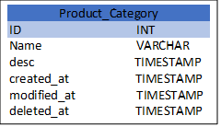

User Address

ID INT

User_ID INT

Address_line1 VARCHAR

Address_line2 VARCHAR

city VARCHAR

postal code VARCHAR

country VARCHAR

telephone VARCHAR

mobile VARCHAR

User

ID INT

user name VARCHAR

password text

first_name Decimal

last_name VARCHAR

telephone INT

created_at TIMESTAMP

modified_at TIMESTAMP

Product

ID INT

Name VARCHAR

desc TIMESTAMP

SKU VARCHAR

Category_ID INT

Inventary_ID INT

Price DECIMAL

Discount_ID INT

created_at TIMESTAMP

modified_at TIMESTAMP

deleted_at TIMESTAMP

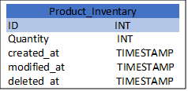

User Payment

ID INT

user_ID INT

payment_type VARCHAR

provider VARCHAR

account_no. INT

expiry date

Shopping Session

ID INT

User_ID VARCHAR

Total DECIMAL

created_at TIMESTAMP

modified_at TIMESTAMP

Order details

ID INT

User_ID VARCHAR

Total DECIMAL

Payment ID INT

created_at TIMESTAMP

modified_at TIMESTAMP

Discount

ID INT

Name VARCHAR

desc TIMESTAMP

discount_Percent DECIMAL

created_at TIMESTAMP

modified_at TIMESTAMP

deleted_at TIMESTAMP

Payment_details

ID INT

Order_ID INT

amount INT

provider VARCHAR

Status VARCHAR

Created_at TIMESTAMP

Cart_item

ID INT

Session_ID INT

Product_ID INT

Quantity INT

created_at TIMESTAMP

modified_at TIMESTAMP

deleted_at TIMESTAMP

Order_items

ID INT

order_ID INT

Product_ID INT

Quantity INT

Created_at TIMESTAMP

created_at TIMESTAMP

modified_at TIMESTAMP

Question 7 – Data Flow Diagram - 3 Marks

What is a data flow diagram? Draw a data flow diagram to represent the in-flow and out-flow of data when a Farmer is placing an order for the product

Answer: A Data Flow Diagram is graphical representation of the flow of the data within a system. It visually shows how data moves from one process to another, how its stored, and where it ends.



Question 8 – Change Request - 10 Marks

Due to change in the Government Taxation structure. we should change the Tax structure How do you handle change requests in a project?

Answer: A change request is formal Proposal to alter system, Product or Project.

1. Understand the scope of change request and Document the change. The change request is initiated by stakeholders, such as the Project Manager, Business Analyst, or Compliance Team.
2. **Change Request Document (CRD)** should include: a) **Reason for change**: Government regulation update b) Impact areas: Pricing calculations, invoices, financial reports, and database schema.

Do the Impact Analysis: Affects product pricing, It could impact on customer invoices and financial statements, Resources and schedule also affected like Development effort estimation and Additional testing effort for financial accuracy. Modifications in the **Database Schema** to update tax rates. Changes in **Reports & Billing System**, changes in the Backend Logic for tax calculations, updates to the UI where tax information is displayed.

1. Prioritize change request based on its urgency, importance and impact on Project.

Implement the Change- Update **tax configuration tables** in the database, Modify pricing and invoice logic, Validate correct tax calculations on different products, Check for **compliance with government regulations,** Ensure **invoice accuracy** with updated tax

1. Seek approval from the project sponsor for change request. after approval, a **Change Implementation Plan** is created.
2. Communicate the change request and its potential impact to all relevant stakeholders, include project team, Finance team etc.

Question 9 – Change Request Vs an Enhancement - 5 Marks

As the project is in process, Ben and Kevin have contacted you. The reason is to inform you that they want the Farmers to sell their crop yields through this application i.e. Farmers should be able to add their crop yields or products and display to general public and should be able to sell them. They also want to introduce Auction system for their Crop yields. As a BA, what will be your response? Is this a change request or an enhancement??

Answer:

In this case, introduce Auction System of Farmers and Farmer Selling in application would be consider an Enhancement as it involved adding new features to the system.

As BA I Should Document the requirements and work with the development team to determine feasibility and impact of the new features. I should also consider the potential benefits, risks and cost associated with the enhancement before making any recommendation to the client. It does not modify existing functionalities but expands the platform’s capabilities.

Question 10 – Estimations - 6 Marks

Come up with estimations – How many Manhours required

Answer:

Man hours are the required effort of the resources to complete a project. There are 3 types of Projects.

1. Small: Upto 500 hours
2. Medium: Upto 1000 hours
3. Large: Upto 1500 hours

Analysis: As per the case study, the duration of the project is 18 months and current team size around 15. This will come under medium Project.

As the trained resources are available so trainers are not required

As structure of the Project is available, New and enhancement infrastructure is not required.

Question 11 – UAT – 6 Marks

Project has finally completed all the stages i.e., design, development, testing etc. Now, it is the role of a business analyst to contact the client for testing of the final product and have to successfully complete it. How are you going to handle this situation? And once it is done, what will be the process to close the project? Explain UAT Acceptance process

Answer:

1. Planning- In this step Blue Prints are made to implement UAT Testing for every feature that needs to test and minimum standard for acceptance the test.
2. Designing- Here the Test cases are design to hide all possibilities of software packages in a real-world environment.
3. UAT Testers- A Testers team consists of a end users that meet the criteria for implement testing, they should know the test cases to run and understand the functionalities.
4. Bug Fixing- Whatever Bugs are found in the UAT Testing, the development team should work on them and make it software error free.
5. Sign off- After removing all bugs, the testing team indicates acceptances of the completion of the bugs, In this phase, all stakeholders come to a conclusion that the Software is ready to GO LIVE and Sign it off.

Question 12 – Project Closure Document - 6 Marks

Explain Project closure document

Answer:

. A Project closure document, also known as a project closure report- its is formal documents that summarizes the key outcome lessons learned and final details of the completed project.

. Its serve as a comprehensive record of the project accomplishments, Challenges and overall performance and provide valuable insights for stakeholder and future projects.

. Points included in the Project Closure document are:

Project Overview

Achievements

Lessons learned

Quality Assurance

Resource Utilization

Risk Management

Challenges

|  |  |  |  |  |  |  |  |  |
| --- | --- | --- | --- | --- | --- | --- | --- | --- |
| Sr. No. | Point to be include | | | | | | | Business Scope document.docx |
| 1 | Did the client Signoff on the UAT Testing | | | | | | |
|  | Date of Sign off: | | | 31-01-2025 | | | |
|  | Name of the source: | | | Nikita Suryawanshi | | | |
| 2. | Object of the project | | | | | | |  |
|  | User friendliness | | | Achieved | | | |  |
|  | Customer satisfaction | | | ROI in 6 Months | | | |  |
|  | More categories | | | Achieved | | | |  |
| 3. | Functionalities worked on | | | | | | |  |
|  | Secured payment processing | | | | | | Achieved |  |
|  | Categories | | | | | | Achieved |  |
| 4 | Infrastructure | | | | | | |  |
|  | Software Installed | | Achieved | | | | |  |
|  | Laptop Purchased | | Achieved | | | | |  |
| 5. | Funding | | | | | | |  |
|  | Amount Approved | Rs. 1 Crore | | | | | | Finance breakdown.docx |
|  | Amount Used | Rs. 95 Lakhs | | | | | |
| 6. | Overall Project Information | | | | | | |  |
|  | Escalation | | | | | 50 | |  |
|  | Customer Satisfaction | | | | | High | |  |
| 7. | Value to the Company | | | | | | |  |
|  | Achievements | | | | Positive 90%  1) Company has gained an edge over the Customers  2) Increased Clients  3) New Project In Pipelines | | |  |
|  | Challenges | | | | 1) **Adapting to Change Requests:** Midway through the project, the **tax structure was changed**, requiring system modifications.  2) **Connectivity Constraints:** Ensuring smooth operation in **rural areas with limited internet access.** | | |  |