Capstone Project2 –Agile-Scrum

**Question 1 - write Agile Manifesto.**

Answer 1 – Agile methodology is one where there is continuous delivery of the project deliverables. In traditional models, there were issues related to change requests, time consumption. To overcome all such issues and removing unnecessary activities, Agile model is introduced. In Agile there is direct contact of client with technical team. Scrum works on Agile methodology. In Scrum model, project is break down into various phases known as Sprints. After every sprint, team review and check back the work in order to see what could be avoided, improved for the next sprint. It is less time consuming as no middleman is required. Working software is proof of functionality, no documentation so less costly and quick delivery is there.

Agile Manifesto has 4 values and 12 principles which are as follows:

1. Individuals and Interactions over Processes and Tools.
2. Working Software over Comprehensive Documentation.
3. Customer Collaboration over Contract Negotiation
4. Responding to Change over Following a Plan.

**12 principles are:**

1. Satisfy the customer through early and continuous delivery of valuable software.
2. Welcome changing requirements even late in development. Agile processes harness change for the customer’s competitive advantage.
3. Delivery working software frequently from a couple of weeks to a couple of months, with a preference to the shorter timescale.
4. Business profile and developers must work together daily throughout the project.
5. Build projects around motivated individuals. Give them the environment and support they need and trust them to get the job done.
6. The most efficient and effective method of conveying information to and within a development team is face to face conversation.
7. Working software is the primary measure of progress.
8. Agile processes promote sustainable development. The sponsors, developers, and users should be able to maintain a constant pace indefinitely.
9. Continuous attention to technical excellence and good design enhance agility.
10. Simplicity- the art of maximising the amount of work not done is essential.
11. The best architectures, requirements, and design emerge from self-organising teams.
12. At regular intervals, the team reflects on how to become more effective, then tunes and adjust its behaviour accordingly.

**Question 2 - Write minimum 40 User stories and their Acceptance Criteria along with their BV and CP**.

Answer 2 – User stories are short, simple descriptions of feature or functionality from user’s perspective. User stories are used to capture the requirements in agile project and help the development team to understand the needs and explanation of the users.

|  |  |  |  |
| --- | --- | --- | --- |
| User story No. 1 | Tasks 1 | | Priority HIghest |
| AS A CUSTOMER  I WANT TO REGISTER IN SCRUM FOODS  SO THAT I CAN ORDER FOOD | | | |
| BV: 500 | | CP: 03 | |
| Acceptance Criteria  Registration screen  Text boxes for User Name, Password, Mobile Number, Email Address, OTP  Click on continue  Send Successful notification to the user | | | |

|  |  |  |  |
| --- | --- | --- | --- |
| User story No. 2 | Tasks 1 | | Priority: HIghest |
| AS A CUSTOMER  I WANT TO LOGIN IN SCRUM FOODS  SO THAT I CAN VIEW RESTAURANT MENU FOOD | | | |
| BV: 500 | | CP:02 | |
| Acceptance Criteria  Registration screen  Text boxes for User Name, Mobile phone number, OTP  Click on continue  Send Successful notification to the user | | | |

|  |  |  |  |
| --- | --- | --- | --- |
| User story No. 3 | Tasks 1 | | Priority: HIghest |
| AS A CUSTOMER  I WANT TO SEARCH AND VIEW RESTAURANTS  SO THAT I CAN ADD FOOD IN CART | | | |
| BV: 500 | | CP:01 | |
| Acceptance Criteria  List of restaurants, Text box to enter Food name, cuisine type  Click on select | | | |

|  |  |  |  |
| --- | --- | --- | --- |
| User story No. 4 | Tasks 1 | | Priority: HIghest |
| AS A CUSTOMER  I WANT TO VIEW RESTAURANT’S MENU  SO THAT I CAN SELECT THE FOOD | | | |
| BV: 100 | | CP:01 | |
| Acceptance Criteria  List of Restaurant, Restaurant’s menu, | | | |

|  |  |  |  |
| --- | --- | --- | --- |
| User story No. 5 | Tasks 2 | | Priority: LOW |
| AS A CUSTOMER  I WANT TO VIEW THE CONTACT NUMBER OF DELIVERY BOY  SO THAT I CAN CONTACT HIM FOR THE STATUS | | | |
| BV: 100 | | CP:02 | |
| Acceptance Criteria  Display delivery boy contact number, delivery boy name | | | |

|  |  |  |  |
| --- | --- | --- | --- |
| User story No. 6 | Tasks 2 | | Priority: LOW |
| AS A CUSTOMER  I WANT TO CANCEL FOOD  SO THAT IT WONT GET DELIEVERD | | | |
| BV: 50 | | CP:01 | |
| Acceptance Criteria  Access the order list, Click on cancel order | | | |

|  |  |  |  |
| --- | --- | --- | --- |
| User story No. 7 | Tasks 2 | | Priority: LOW |
| AS A CUSTOMER  I WANT TO GIVE FEEDBACK AND RATING TO THE FOOD  SO THAT IT SHOWS IN THE APP | | | |
| BV: 100 | | CP:03 | |
| Acceptance Criteria  Text box to enter the feedback in words, access to camera to click food picture, select the number of stars to add to the food, Click on submit | | | |

|  |  |  |  |
| --- | --- | --- | --- |
| User story No. 8 | Tasks 2 | | Priority: MEDIUM |
| AS A CUSTOMER  I WANT TO EDIT THE ADDRESS  SO THAT NEW ADDRESS GET UPDATED IN APP | | | |
| BV: 100 | | CP:02 | |
| Acceptance Criteria  Text box to enter the new address  Click on Submit  Business Rule: within the radius of 5 km. | | | |

|  |  |  |  |
| --- | --- | --- | --- |
| User story No. 9 | Tasks 2 | | Priority: HIghest |
| AS A CUSTOMER  I WANT TO SELECT THE PAYMENT MODE  SO THAT CAN MAKE THE PAYMENT OF MY CHOICE | | | |
| BV: 500 | | CP:04 | |
| Acceptance Criteria  Payment mode screen, Radio buttons to select the payment mode, OTP on phone number, Click on continue  Business Rule: can select only one payment mode. | | | |

|  |  |  |  |
| --- | --- | --- | --- |
| User story No. 10 | Tasks 2 | | Priority: HIghest |
| AS A CUSTOMER  I WANT TO TRACK THE DELIVERY IN APP  SO THAT I CAN KNOW ABOUT THE TIMING OF DELIVERY | | | |
| BV: 500 | | CP:3 | |
| Acceptance Criteria  Shows order acceptance, order ETA, order tracker shows how order moves | | | |

|  |  |  |  |
| --- | --- | --- | --- |
| User story No. 11 | Tasks 2 | | Priority: HIghest |
| AS A CUSTOMER  I WANT TO SAVE FAVOURITE RESTAURANTS AND DISHES  SO THAT I CAN ORDER FROM MY FAVOURITES | | | |
| BV: 500 | | CP:3 | |
| Acceptance Criteria  Order tab, Access my favourite food easily | | | |

|  |  |  |  |
| --- | --- | --- | --- |
| User story No. 12 | Tasks 2 | | Priority: HIghest |
| AS A CUSTOMER  I WANT TO RECEIVE NOTIFICATIONS  SO THAT I CAN SEE UPDATES | | | |
| BV: 200 | | CP:1 | |
| Acceptance Criteria  Notifications for order status, payments, dispatch | | | |

|  |  |  |  |
| --- | --- | --- | --- |
| User story No. 13 | Tasks 3 | | Priority: LOW |
| AS A CUSTOMER  I WANT TO ADD TIP AND REVIEW TO THE DELIVERY BOY  SO THAT AMOUNT AND APPRECIATION ADDS TO HIS SERVICE | | | |
| BV: 100 | | CP:4 | |
| Acceptance Criteria  Amount to add as tip, text box to give review | | | |

|  |  |  |  |
| --- | --- | --- | --- |
| User story No. 14 | Tasks 2 | | Priority: MEDIUM |
| AS A CUSTOMER  I WANT TO CONTACT CUSTOMER SUPPORT  SO THAT I CAN RAISE ISSUES AND TICKET | | | |
| BV: 200 | | CP:2 | |
| Acceptance Criteria  Customer support section to contact via phone, text box to contact via chat, | | | |

|  |  |  |  |
| --- | --- | --- | --- |
| User story No. 15 | Tasks 2 | | Priority: HIghest |
| AS A RESTAURANT OWNER  I WANT TO RECEIVE AND MANAGE ORDERS  SO THAT I CAN UPDATE ORDER STATUS | | | |
| BV: 500 | | CP:3 | |
| Acceptance Criteria  Manage order status, Order management | | | |

|  |  |  |  |
| --- | --- | --- | --- |
| User story No. 16 | Tasks 2 | | Priority: HIghest |
| AS A RESTAURANT OWNER  I WANT TO CHECK REVIEWS BY CUSTOMER  SO THAT I CAN VIEW AND RESPOND THEM | | | |
| BV: 200 | | CP:5 | |
| Acceptance Criteria  Feedback section to view, text box to enter responses | | | |

|  |  |  |  |
| --- | --- | --- | --- |
| User story No. 17 | Tasks 23 | | Priority: HIghest |
| AS A DELIVERY BOY  I WANT TO VIEW THE ORDERS  SO THAT I CAN DELIVER THEM | | | |
| BV: 500 | | CP:5 | |
| Acceptance Criteria  Number of order receives, order details, Order map view, contact the customer via app number, order completion, review the rating | | | |

|  |  |  |  |
| --- | --- | --- | --- |
| User story No. 18 | Tasks 3 | | Priority: LOW |
| AS A DELIVERY BOY  I WANT TO REGISTER TO THE APP  SO THAT I CAN START DELIVERING THE ORDERS | | | |
| BV: 200 | | CP:5 | |
| Acceptance Criteria  Email id/ phone number, Password, OTP, | | | |

|  |  |  |  |
| --- | --- | --- | --- |
| User story No. 19 | Tasks 3 | | Priority: MEDIUM |
| AS A DELIVERY BOY  I WANT TO LOGIN TO THE APP  SO THAT I CAN VIEW THE ORDERS | | | |
| BV: 100 | | CP:2 | |
| Acceptance Criteria  Email id/ password, OTP, order list | | | |

|  |  |  |  |
| --- | --- | --- | --- |
| User story No. 20 | Tasks 3 | | Priority: LOW |
| AS A DELIVERY BOY  I WANT TO VIEW THE FEEDBACK  SO THAT I CAN CHECK MY RATING AND FEEDBACK | | | |
| BV: 100 | | CP: 1 | |
| Acceptance Criteria  Access the feedback section, support system, Sorting and filtering feature | | | |

|  |  |  |  |
| --- | --- | --- | --- |
| User story No. 21 | Tasks 3 | | Priority: HIGH |
| AS A ADMIN  I WANT TO KNOW THELOGIN TO THE APP  SO THAT I CAN VIEW THE ISSUES LOG | | | |
| BV: 1000 | | CP:4 | |
| Acceptance Criteria  Employee id, password, issue log list | | | |

|  |  |  |  |
| --- | --- | --- | --- |
| User story No. 22 | Tasks 3 | | Priority: LOW |
| AS AN ADMIN  I WANT TO KNOW THE ISSUES  SO THAT I CAN RESOLVE THEM | | | |
| BV:500 | | CP:1 | |
| Acceptance Criteria  View issues log, sorting and filtering, box to add comments related to issues, editing and modifying them | | | |

|  |  |  |  |
| --- | --- | --- | --- |
| User story No. 23 | Tasks 3 | | Priority: LOW |
| AS AN REGIONAL ADMIN  I WANT TO VIEW CUSTOMER FEEDBACK  SO THAT I CAN APPROVE THEM | | | |
| BV: 10 | | CP:4 | |
| Acceptance Criteria  Customer feedback section access, sorting and filtering of feedbacks, check feedback authenticity and customer authenticity, approve them | | | |

|  |  |  |  |
| --- | --- | --- | --- |
| User story No. 24 | Tasks 4 | | Priority: LOW |
| AS A BUSINESS OWNER  I WANT TO VIEW RESTAURANT REVENUE REPORT  SO THAT I CAN VIEW THE RESTAURANT’S REVENUE | | | |
| BV: 100 | | CP:5 | |
| Acceptance Criteria  Access sales report, revenue reports, selection of months, region, dates, generate reports, download it | | | |

|  |  |  |  |
| --- | --- | --- | --- |
| User story No. 25 | Tasks 1 | | Priority: HIGHEST |
| AS A RESTAURANT OWNER  I WANT TO PROVIDE TIME SLOTS  SO THAT I CAN CUSTOMER CHECK OPEN AND CLOSE TIME | | | |
| BV: 500 | | CP:1 | |
| Acceptance Criteria  Restaurant dashboard, add timings, click on submit | | | |

|  |  |  |  |
| --- | --- | --- | --- |
| User story No. 26 | Tasks 4 | | Priority: HIGHEST |
| AS AN ADMIN  I WANT TO VIEW THE RESTAURANTS  SO THAT I CAN APPROVE THEIR REGISTERATION | | | |
| BV: 500 | | CP: 4 | |
| Acceptance Criteria  View restaurant’s request for registration, check details, approve | | | |

|  |  |  |  |
| --- | --- | --- | --- |
| User story No. 27 | Tasks 2 | | Priority: HIGHEST |
| AS A REGIONAL ADMIN  I WANT TO MANAGE REGIONAL RESTAURANTS  SO THAT I CAN THE PERFORMANCE OF THEM | | | |
| BV: 200 | | CP:5 | |
| Acceptance Criteria  Regional restaurant list, click on restaurant performance, generate report, select date, ids, details, click on submit, download | | | |
| User story No. 28 | Tasks 4 | | Priority: LOW |
| AS A CUSTOMER  I WANT TO APPLY PROMOCODES  SO THAT I CAN GET THE ODRER AT LOWER RATES | | | |
| BV: 100 | | CP:1 | |
| Acceptance Criteria  Text box to enter promocodes | | | |

|  |  |  |  |
| --- | --- | --- | --- |
| User story No. 29 | Tasks 4 | | Priority: LOW |
| AS A REGIONAL ADMIN  I WANT TO TRACK THE DELIVERY  SO THAT I CAN VIEW THE STATUS OF ORDER | | | |
| BV: 50 | | CP: 4 | |
| Acceptance Criteria:  Rael time tracking,  Security and data privacy  User friendly interface | | | |
| User story No. 30 | Tasks 5 | | Priority: HIGHEST |
| AS A DELIVERY BOY  I WANT TO GET ACCESS OF THE PAYMENT QRs or NUMBER  SO THAT I CAN RECEIVE THE ONLINE PAYMENT | | | |
| BV: 200 | | CP:5 | |
| Acceptance Criteria  View order details, amount, mode of payment selected, scan QRs, get notification of payment made. | | | |

|  |  |  |  |
| --- | --- | --- | --- |
| User story No. 31 | Tasks 5 | | Priority: HIGHEST |
| AS A RESTAURANT ONWER  I WANT TO KNOW DELIVERY BOY  SO THAT I CAN VERIFY HIM | | | |
| BV: 200 | | CP:5 | |
| Acceptance Criteria  ID proof, punctuality, registration on portal | | | |

|  |  |  |  |
| --- | --- | --- | --- |
| User story No. 33 | Tasks 5 | | Priority: LOW |
| AS A RESTURANT ONWER  I WANT TO CONTACT THE ADMIN  SO THAT I CAN RAISE ISSUES RELATED TO ORDER | | | |
| BV: 100 | | CP:3 | |
| Acceptance Criteria  Order detail, order id, contact admin, raise ticket related to order | | | |

|  |  |  |  |
| --- | --- | --- | --- |
| User story No. 34 | Tasks 6 | | Priority: HIGHEST |
| AS A BUSINESS OWNER  I WANT TO VIEW THE SALES AND ORDERS UPDATE  SO THAT I CAN PROCESS THE PAYMENT TO RESTAURANT OWNERS AND DELIVERY BOY | | | |
| BV: 500 | | CP:5 | |
| Acceptance Criteria  Orders list, sales report, restaurant’s list with orders and region, delivery boy’s list with performance and tips information, payment mode radio buttons, make payments,click on submit | | | |

|  |  |  |  |
| --- | --- | --- | --- |
| User story No. 35 | Tasks 6 | | Priority: LOW |
| AS A REGIONAL ADMIN  I WANT TO VIEW THE REFUND REQUESTS  SO THAT I CAN APPROVE OR REJECT IT | | | |
| BV: 100 | | CP:1 | |
| Acceptance Criteria  Login, refund requests list, Amount requested, issues raised against refund, refund authenticity, approve or reject it. | | | |

|  |  |  |  |
| --- | --- | --- | --- |
| User story No. 36 | Tasks 2 | | Priority: LOW |
| AS A DELIVERY BOY  I WANT TO REGISTER TO THE APP  SO THAT I CAN START DELIVERING THE ORDERS | | | |
| BV: 200 | | CP:5 | |
| Acceptance Criteria  Email id/ phone number, Password, OTP, | | | |

|  |  |  |  |
| --- | --- | --- | --- |
| User story No. 37 | Tasks 6 | | Priority: LOW |
| AS A CUSTOMER  I WANT TO VIEW THE PRICE  SO THAT I CAN ORDER FOOD | | | |
| BV: 50 | | CP1 | |
| Acceptance Criteria  Display price in the list of menulist | | | |

|  |  |  |  |
| --- | --- | --- | --- |
| User story No. 38 | Tasks 7 | | Priority: LOW |
| AS A CUSTOMER  I WANT TO CHAT WITH REGIONAL ADMIN  SO THAT I CAN REQUEST A REFUND | | | |
| BV: 200 | | CP:3 | |
| Acceptance Criteria  Br-all mandatory, text box fields, display order id, text box for description,  Submit button, generate issue id, display successful | | | |

|  |  |  |  |
| --- | --- | --- | --- |
| User story No. 39 | Tasks 7 | | Priority: MEDIUM |
| AS A REGIONAL ADMIN  I WANT TO SEE THE REGIONAL REVENUE REPORTS  SO THAT I CAN VIEW THE REGIONAL PERFORMANCE | | | |
| BV: 100 | | CP:3 | |
| Acceptance Criteria  Select regional dropdown, view performance of each rest of that region in tabular form, revenue generated tab, click on download | | | |

|  |  |  |  |
| --- | --- | --- | --- |
| User story No. 40 | Tasks 7 | | Priority: MEDIUM |
| AS AN ADMIN  I WANT TO VIEW THE RESTAURANTS  SO THAT I CAN APPROVE REGISTERATION | | | |
| BV: 500 | | CP:5 | |
| Acceptance Criteria  List of restaurant, select restaurants, verify restaurant details, approve/ reject button, notification to restaurant | | | |

**Question 3 - What is epic? Write 2 epics.**

Answer 3 – User stories are simple, sort description of the function user perspective who wants to add that functionality or feature into the system. If user stories are big and complex then it takes the form of epics. That means epics are none other than collection of user stories but in long and complex statement which defines the system functionality and feature in detailed form.

1. epics are:
2. List of Restaurant in app

* As a Customer I want to have list of restaurants in application so that I can choose among them the best and the one which has lower prices of food with good quality.
* As a Customer I want to have list of restaurants so that I can filter and sort them on the basis of ratings, cuisine types, distance.

Acceptance criteria:

* Customer can view the list of restaurants according to the cuisines, ratings.
* Customer can view and read the ratings given on the feedback section of the restaurants
* Customer can view the menu list of restaurants to check the prices and quantity they are giving
* Customer can sort and filter the restaurants as per the distance, rating
* Customer can view the location or address of the restaurants

1. Order tracking system

* As a customer I want to check the status of the order so that I can know about it’s arrival time, preparation time, out of delivery status
* As a customer I want to track the order so that I can know about it’s location
* As a customer I want to contact delivery boy so that I can guide him through the location
* As a customer I want to receive the order updates so that I can track the order live, view the contact details of the delivery boy
* As a Delivery boy I want to see the delivery location so that I can deliver the order
* As a restaurant owner I want to see the order status so that I can check if the order is delivered.

Acceptance criteria:

* The order tracking system should be updated and bug free to provide real time status of the order.
* The system should provide accurate ETA.
* The system should have masked contact details of the customer so that delivery boy I can contact them.
* The system should disclose the route which delivery boy is taking to deliver the order.
* The system should provide the payment mode used by the customer.

**Question 4 –What is the difference between BV and CP.**

Answer 4 – Business value signifies how important the user story is to the business. It is being estimated by scrum currency notes. Basically, this estimation is being done by the stakeholders, in case of multiples values being selected, then discussion would happen and have to agree on one BV.

Whereas the Complexity Point is the effort required by the Scrum developers to develop the users story using technology. Here efforts mean time required, codes to write. It is also known as Story points. It is being estimated by developers using poker cards.

**Question 5 –Explain about Sprint.**

Answer 5 – Sprint is the timeframe under which the team delivers specified set of user stories and working features of the product. Normally it is of 2 weeks but can be extended to 4 weeks. The business customer and product owner give the priority to the user stories according to which development team starts working on, all these are being decided in sprint planning meeting. During Sprint, user stories can be removed but can not be added, this allows team to focus more and deliver the product rapidly.

The sub unit of sprint is Scrum which is of 1 day duration.

During sprint various meetings are being conducted like Sprint Planning Meeting, Sprint Review Meeting, Daily Scrum Meeting, Sprint Retrospective Meeting.

Cycle of sprint- Once the user stories are being decided and refined, they go to the product backlog. After having sprint planning meeting, developers will move the user stories to sprint backlog and from there works are being assigned. Once the sprint period is over, if the product is completed it will go to the release stage. And if the other set of user stories is pending then again same process.

After the sprint is completed, sprint review and sprint retrospective meetings are held before new sprint, so that lessons learnt from previous sprint can be applied to new sprints.

**Question 6 - Explain Product backlog and sprint back log.**

Answer 6 – Product Backlog means All user stories or requirements that team has to fulfill. Once the acceptance criteria and business values are decided by stakeholders for the user stories and complexity points are being given by developers then all the users stories are moved to product backlog.

So, it means it has list of work to be done by the developers within specified time period.

Sprint Backlog – It consists of product backlog items, tasks, WIP and Done status columns. It means items that are in Product backlog are divided into smaller units known as Tasks, varies from company to company and depends on total user stories. Tasks are the unit of work done by 1 developer in 1 day.

WIP – It shows at given point of time how many developers are there on the task developers will pick the task and assigned their name against it.

Done – Once the task is completed it is moved from WIP column to Done column by developers.

**Question 7 - What is impediments log?**

Answer 7 – Impediments means hindrance, obstruction. So, impediments log is a document consisting of any type of problem, challenges faced by team during sprint in developing the product that could delay the team’s performance.

The Scrum master is responsible for tracking, monitoring and removing of impediments with team effort.

|  |  |
| --- | --- |
| S.No | Impediment description |
|  | Server down – User stories in WIP could not be completed due to server down for 1 day. |
|  | Shortage of team member - Due to emergency and sick leave of 2 team members, testing progress got delayed |

**Question 8 - Explain Velocity of the Team.**

Answer 8 – Velocity means how many hours a development team can spend on scrum. During scrum, development team works on multiple sprints parallely, collective hours by developers spend on these multiple sprints is known as Velocity of team. It is being calculated by Scrum master.

Velocity point of the sprint is - 30

**Question 9 - – Draw Sprint Burn Charts and Product Burn Down Charts.**

Answer 9 – Sprint burn charts

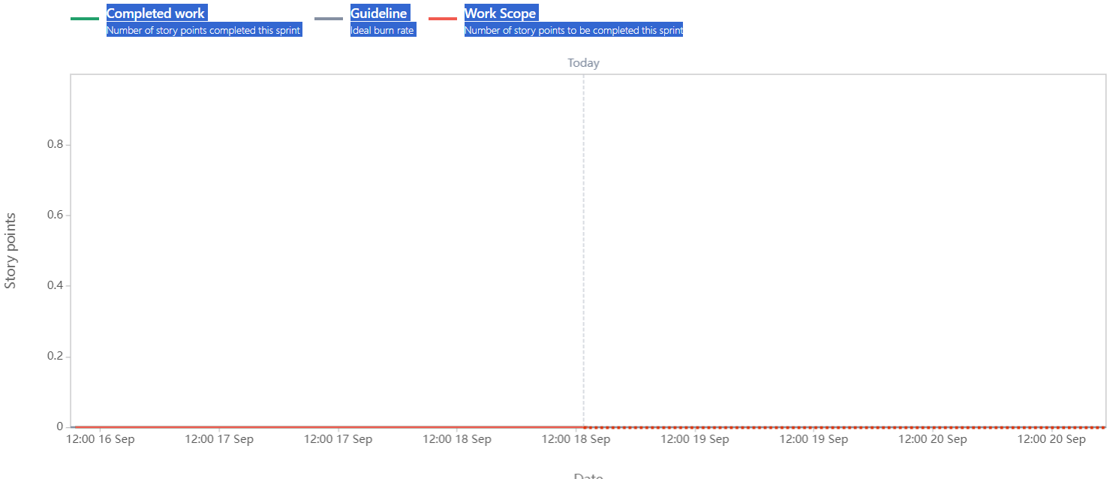

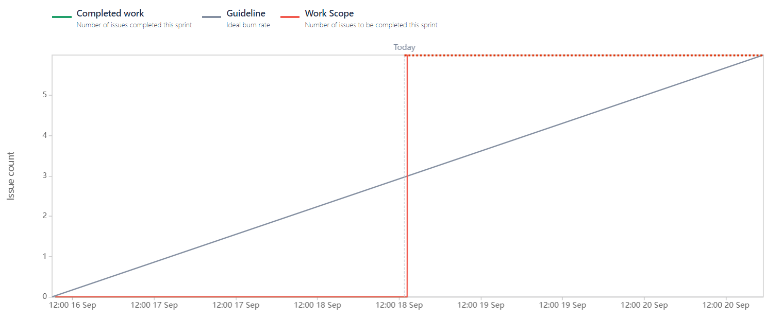

Burn Down chart

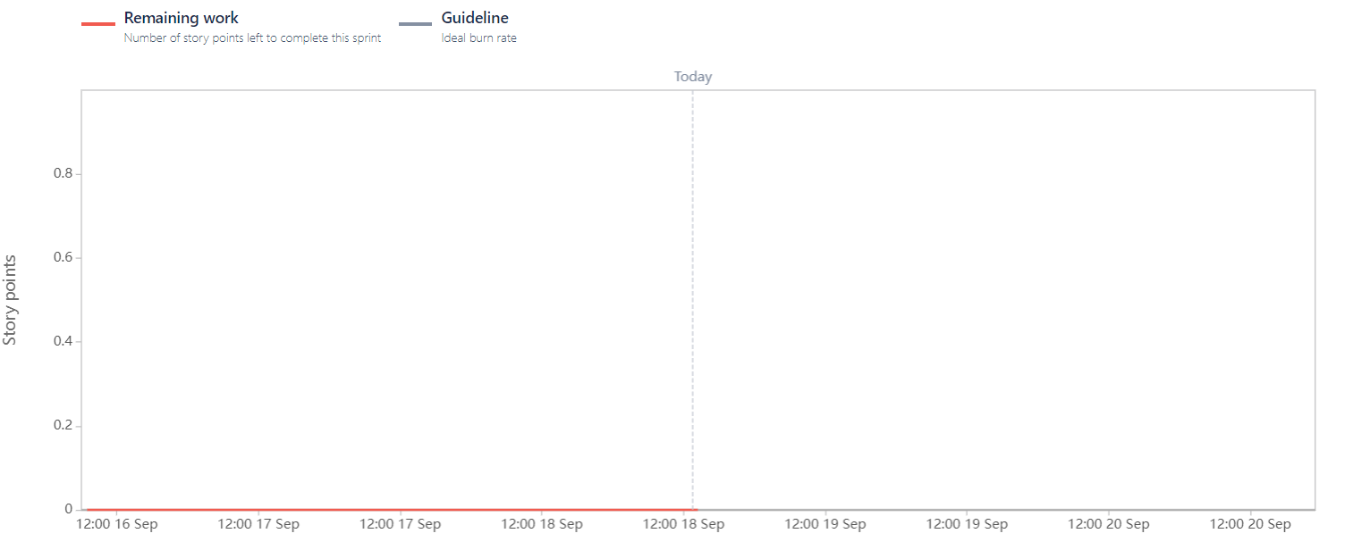 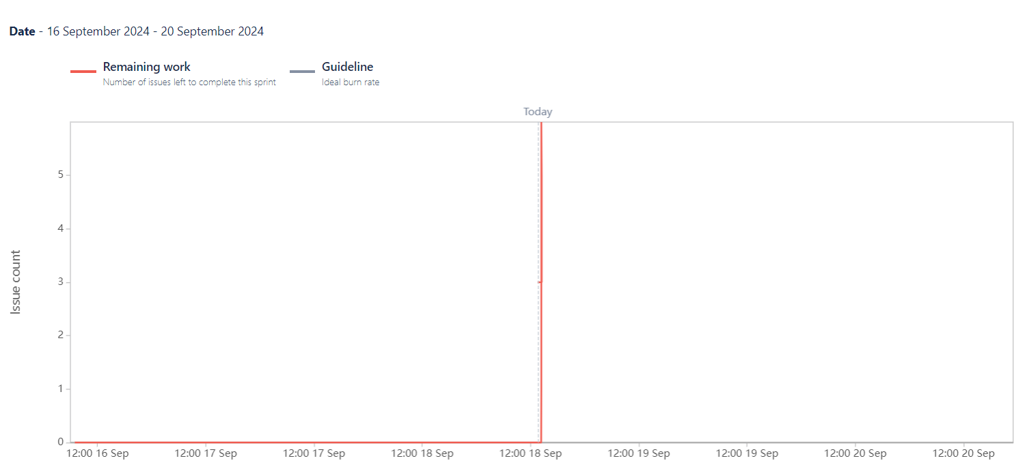

**Question 10 - Explain about Product Grooming.**

Answer 10 – Product Grooming is the meeting where requirements, which are in product backlog, are being refined and priortised. It is also known as Product Refinement Meeting. Product owner is responsible for taking all the requirements in the product backlog. The stakeholders must be clear about product vision for refining the requirements.

**Question 11 - Explain the roles of Scrum Master and Product Owner.**

Answer 11 – Product owner is the person who is responsible to decide how the product will be, what needs to be in the product. He will regularly interact with business owners and Bas. Mostly BAs play this role but can be anyone who is working with end users for a long time or can be customer himself.

Scrum master is the person who is responsible for monitoring the team performance during the sprint. Any concern, or queries being raised by team are solved by Scrum Master. Anyone within the team can play this role but usually it is BA. Project Manager is equivalent to Scrum master.

**Question 12 - Explain all Meetings Conducted in Scrum Project.**

Answer 12 – In scrum we have many meetings:

* Product Refine meeting – It is being done to refine, prioritize the requirements in the product backlog which are later on converted into user stories. Stakeholders, Product owner and development team is the part of this meeting.
* Sprint Planning Meeting - It is conducted at the beginning of the sprint where it is being decided what needs to be deliver in the sprint. The Scrum team is the part of this meeting.
* Daily Scrum Meeting- It is like daily standup meeting which is conducted on daily basis by team to know about daily working plans, what item we are carrying forward on tomorrow, is there any issue or concern need to be addressed which slows down the work progress. This is a kind of short meeting to have quick communication within the team to keep everyone informed about the progress and challenges.
* Sprint Review Meeting- It is being conducted at the end of sprint, where team showcases the completed stories to stakeholders, product owner, customers and get it cleared after gathering any feedback. All the interested people, who has interest in the project can be the part of this meeting.
* Sprint Retrospective Meeting – It is also conducted at the end of sprint and before new sprint to start, only scrum developers are the part of this meeting. It is being done in order to find out what went well in previous sprint, what issues and challenges team had, what could be the area of improvement in next sprint. Basically, this meeting is held to analyse what and how the work is being done in the sprint to enhance the efficiency and effectiveness for the next sprint.

**Question 13 -Explain Sprint Size and Scrum Size.**

Answer 13 – Sprint Size basically means how many user stories are involved in the sprint. It is of duration in between 2 to 4 weeks whereas Scrum size means the number of optimal resources is required in the project to complete the user stories. It is in between 7 to 11 members.

**Question 14 - Explain DOR and DOD**

Answer 14 – DOR – Definition of ready consists of the conditions that should meet by the product backlog items before it enters to development in sprint, it should be well defined and understood by the team. It should be discussed and review before the sprint.

DOD- Definition of done consists of the conditions that backlog item should meet before they are shippable. Here all the development work is completed now. It is reviewed in sprint review meeting.

**Question 15 -Explain Prioritization Techniques and MVP**

Answer 15 – Priortization techniques means queuing the tasks, items to be considered in the project. These techniques help the team to focus on what needs to be done first. Some techniques are :

MoSCoW- This means Must have, Should have, Could have, and Would have features.

100 dollars test, top 10 items, Numerical assignments.

MVP – Minimum Viable product which means the main feature required to develop in order to sell the product at market

**Question 16 - Difference between Business Analyst n Product Owner.**

Answer 16 – Product owner is the person who is responsible to decide how the product will be, what needs to be in the product. He will regularly interact with business owners and Bas. He is the one who defines product features, collaborates with the development team, stakeholders, and customers.

Whereas the Business Analyst is the person who understands the business model, processes, requirements. It is the one who gather the requirements prioritize them and prepares documentations related to workflows, business rules, identifies problems, analyses them and suggest measures to eradicate them. It acts a bridge between stakeholders and development team.

**Question 17 - Prepare a sample Resume of 3yrs exp Product Owner**

Answer 17 –

**Nilam Dongre**

**Address: xyz Road, Mumbai**

**Contact Details: 9876543210**

**Email-nilam121123@gmail.com**

**PRODUCT OWNER**

* Experienced Product Owner with demonstrated history of working on transformative initiatives and achieving results. Proven track record of leadership skills with an ability to develop high-performing team and team members.
* Multi-sector product expertise, with experience working with users across publishing, financial, technical, and consumer sectors.
* Proficient at leveraging key data from stakeholders through guided workshops on Miro.
* Dedicated to meeting and exceeding expectations for product launches and sprint updates.
* Expertise in executing A/B testing and drafting Technical User Stories for product development.

**Education**

* Bachelor of Mass Media -Mumbai University
* Business Analyst certification COEPD, Mumbai

**Key Skills**

* User Centred Design process Attention to Details
* Design Quality Standard
* Agile and Scrum
* Product Design Methodology

**EMPLOYMENT HISTORY**

**Netomi, Mumbai 2022-2024**

**Product Owner**

* Facilitated project meetings to capture testing and project updates within credit risk reporting processes.
* Created project plans/timelines in Microsoft Projects, resolved issues to promote efficient and successful project releases across multiple teams.
* Led multiple tasks to implement best practices by documenting, tracking end-to-end life cycle review and signoff processes.
* Collaborated closely with technology, business partners to develop business requirement documents, and test scripts during multiple release phases.

**Impetus. Pune 2020-2022**

**Product Owner**

* Provided roadmap baseline, prioritized projects, implemented requirements change control, and synchronized cross functional teams.
* Provided market analysis, design recommendations.
* Managed Quarterly releases of the product, supported strategic planning, designing, and delivering new features within the product.
* Oversaw the product team and guided them on issues related to product development.
* Served as liaison between customers and multiple teams to establish requirements and create functional specifications.

**Languages**

**English| Hindi | Marathi**