**Q.1 Agile Manifesto**

Answer: Agile manifesto includes four main value and twelve principles of Agile Software.

**Four Main Values:**

1. Individuals & Interactions over Processes & Tools
2. Working Software over Comprehensive Documentation
3. Customer Collaboration over Contract Negotiation
4. Responding to Change Over following plan

**Twelve Principles:**

1. **Customer Satisfaction:** Satisfy customer through early and continuous delivery of software.
2. **Change in Requirements:** Welcome changing requirements, even late in development. Agile process harness change for customer’s competitive advantage.
3. **Frequent Delivery:** Deliver working software frequently from weeks to months with preference to timescale.
4. **Team Work:** Business people and developers must work together throughout project.
5. **Motivation:** Build projects around motivated individuals. Provide support they need & trust to get the job done.
6. **Face to Face Conversation:** The most convenient method to communicate information to development team is face to face conversation.
7. **Progress measure:** Working software is primary measure of progress.
8. **Constant Pace:** Agile process promote continuous development. The sponsers, developers and users maintain constant pace.
9. **Excellence & Design:** Continuous attention to technical excellence and good design.
10. **Simplicity:** The art of maximizing amount of work not done is essential.
11. **Self-Organizing Teams:** The best architectures, requirements and design will emerge from self-organizing teams.
12. **Adjusting as per Environment:** After specific intervals, teams should reflects on how to become more effective & adjust behavior accordingly.

**Q. 2 User Stories- Acceptance Criteria-BV-CP (40)**

**Answer:** Use stories is information for developers which gives purpose and benefit.

|  |  |  |  |
| --- | --- | --- | --- |
| User Story: 1 | Tasks: Login | | Priority: High |
| As a  Customer  I want to  Login in scrum food app  So that  I will able to login. | | | |
| BV: 200 | | CP: 3 | |
| Acceptance Criteria: Login screen, User name, password, search menu, search button | | | |

|  |  |  |  |
| --- | --- | --- | --- |
| User Story: 2 | Tasks: Merchant Login | | Priority: High |
| As a  Merchant  I want to  Login in scrum food app  So that  I am able to upload login and update food items. | | | |
| BV: 200 | | CP: 5 | |
| Acceptance Criteria: Login screen for merchant, text for user ID of merchant, password, upload button | | | |

|  |  |  |  |
| --- | --- | --- | --- |
| User Story: 3 | Tasks: Visit food items | | Priority: High |
| As a  Customer  I want to  Visit all available food items  So that  **I** can order. | | | |
| BV: 200 | | CP: 3 | |
| Acceptance Criteria: Food items screen, all restaurants screen, ratings for food | | | |

4

|  |  |  |  |
| --- | --- | --- | --- |
| User Story: 4 | Tasks: Add to cart | | Priority: High |
| As a  Customer  I want to  Add food in cart  So that  I can order it later. | | | |
| BV: 200 | | CP: 5 | |
| Acceptance Criteria: text box for add to cart option, selected items visible under add to cart menu | | | |

|  |  |  |  |
| --- | --- | --- | --- |
| User Story: 5 | Tasks: Mark as Favorite | | Priority: High |
| As a  Customer  I want to  Make food mark as favorite  So that  Easy to order. | | | |
| BV: 200 | | CP: 3 | |
| Acceptance Criteria: text box for mark as favorite, selected items visible under favorite menu | | | |

|  |  |  |  |
| --- | --- | --- | --- |
| User Story: 6 | Tasks: Make Payment | | Priority: High |
| As a  Customer  I want to make payment  So that  I can make advance online payment | | | |
| BV: 200 | | CP: 5 | |
| Acceptance Criteria: Login, show payment options (net banking, cards payment) | | | |

|  |  |  |  |
| --- | --- | --- | --- |
| User Story: 7 | Tasks: Ratings | | Priority: High |
| As a  Merchant  I want to show ratings to my food  So that  Customer will eat it. | | | |
| BV: 200 | | CP: 5 | |
| Acceptance Criteria: | | | |

|  |  |  |  |
| --- | --- | --- | --- |
| User Story: 8 | Tasks: Status | | Priority: Medium |
| As a  Merchant  I want to show food status  So that  I will not get any calls from customers to know status of food. | | | |
| BV: 200 | | CP: 5 | |
| Acceptance Criteria: Login, food status | | | |

|  |  |  |  |
| --- | --- | --- | --- |
| User Story: 9 | Tasks: Tracking | | Priority: High |
| As a  Merchant  I want to track my order  So that  I will get order status. | | | |
| BV: 200 | | CP: 3 | |
| Acceptance Criteria: Login, tracking status | | | |

|  |  |  |  |
| --- | --- | --- | --- |
| User Story: 10 | Tasks: Update tracker | | Priority: High |
| As a  Delivery agent  I want to update tracker  So that  I will inform merchant about delivery. | | | |
| BV: 200 | | CP:3 | |
| Acceptance Criteria: text box of delivery updation and feedback | | | |

|  |  |  |  |
| --- | --- | --- | --- |
| User Story: 11 | Tasks: Registration | | Priority: High |
| As a  Customer  I want to register in scrum food  So that  I will login in scrim foods application | | | |
| BV: 500 | | CP: 5 | |
| Acceptance Criteria: Registration screen, Login screen, Login ID, Password, Mobile No., Email ID, Address, Click on registration button, Send registered notification to user | | | |

|  |  |  |  |
| --- | --- | --- | --- |
| User Story: 12 | Tasks: Food Selection | | Priority: High |
| As a  Customer  I want to select food from listed restaurants  So that  I can select food from restaurants to order | | | |
| BV: 500 | | CP: 3 | |
| Acceptance Criteria: Login, list of available restaurants, show available menu cards | | | |

|  |  |  |  |
| --- | --- | --- | --- |
| User Story: 13 | Tasks: Food tracking | | Priority: High |
| As a  Customer  I want to track my food  So that  I can track my order status | | | |
| BV: 500 | | CP: 5 | |
| Acceptance Criteria: status of delivery, location details, expected time for delivery | | | |

|  |  |  |  |
| --- | --- | --- | --- |
| User Story: 14 | Tasks: Order cancellation | | Priority: Medium |
| As a  Customer  I want cancel option  So that  I can cancel my order in case any reason. | | | |
| BV: 200 | | CP: 3 | |
| Acceptance Criteria: text box for cancel button, text box for reason of order cancellation, confirmation about cancellation | | | |

|  |  |  |  |
| --- | --- | --- | --- |
| User Story: 15 | Tasks: Feedback | | Priority: Medium |
| As a  Customer  I want feedback option  So that  I can give feedback about food. | | | |
| BV: 200 | | CP: 3 | |
| Acceptance Criteria: text box for feedback option, option to give rating delivery agent | | | |

|  |  |  |  |
| --- | --- | --- | --- |
| User Story: 16 | Tasks: Delivery agent registration | | Priority: High |
| As a  Delivery agent  I want to register  So that  I can accept order and delivery | | | |
| BV: 500 | | CP: 5 | |
| Acceptance Criteria: register screen, text box for mobile no., password, Email, Address | | | |

|  |  |  |  |
| --- | --- | --- | --- |
| User Story: 17 | Tasks: Delivery agent Login | | Priority: High |
| As a  Delivery agent  I want to login  So that I can accept food delivery from app. | | | |
| BV: 500 | | CP: 3 | |
| Acceptance Criteria: login screen, user name, password, mobile no. | | | |

|  |  |  |  |
| --- | --- | --- | --- |
| User Story: 18 | Tasks: Payment updation | | Priority: High |
| As a  Delivery agent  I want to update payment status  So that  I will update payment status if payment is cash on delivery. | | | |
| BV: 500 | | CP: 3 | |
| Acceptance Criteria: login, screen for payment updation | | | |

|  |  |  |  |
| --- | --- | --- | --- |
| User Story: 19 | Tasks: View Orders | | Priority: Medium |
| As a  Delivery agent  I want to view orders  So that  I can view orders in app | | | |
| BV: 200 | | CP: 3 | |
| Acceptance Criteria: login, text box for view order, display all orders | | | |

|  |  |  |  |
| --- | --- | --- | --- |
| User Story: 20 | Tasks: Addition and removal of hotels | | Priority: Medium |
| As a  Admin  I want to add or remove restaurants  So that  Admin can add or remove restaurants as per ratings.  Acceptance Criteria: | | | |
| BV: 200 | | CP: 3 | |
| Acceptance Criteria: Login, text box for add or remove | | | |

|  |  |  |  |
| --- | --- | --- | --- |
| User Story: 21 | Tasks: Admin Login | | Priority: High |
| As a  Admin  I want login  So that  Admin can login to view all details. | | | |
| BV: 500 | | CP: 3 | |
| Acceptance Criteria: Login screen, mobile no, email id, password | | | |

|  |  |  |  |
| --- | --- | --- | --- |
| User Story: 22 | Tasks: Report Generation | | Priority: High |
| As a  Admin  I want to generate reports  So that  I will know delivery status | | | |
| BV: 500 | | CP: 3 | |
| Acceptance Criteria: login, id for report generation | | | |

|  |  |  |  |
| --- | --- | --- | --- |
| User Story: 23 | Tasks: Searching | | Priority: High |
| As a  Customer  I want to search all food items  So that  I will order food items. | | | |
| BV: 500 | | CP: 5 | |
| Acceptance Criteria: Login, visible all food items | | | |

|  |  |  |  |
| --- | --- | --- | --- |
| User Story: 24 | Tasks: Order repeating | | Priority: Medium |
| As a  Customer  I want to repeat my order option  So that  It will be easy to reorder from same restaurant. | | | |
| BV: 200 | | CP: 1 | |
| Acceptance Criteria: login, previous order details, text box for repeat order | | | |

|  |  |  |  |
| --- | --- | --- | --- |
| User Story: 25 | Tasks: Order History | | Priority: Medium |
| As a  Customer  I want to view order history  So that  I can view ordered food.  Acceptance criteria: | | | |
| BV: 200 | | CP: 3 | |
| Acceptance Criteria: login, all previous details | | | |

|  |  |  |  |
| --- | --- | --- | --- |
| User Story: 26 | Tasks: Location addition | | Priority: Medium |
| As a  Customer  I want to add location  So that  If any change in location, will change and order on other location. | | | |
| BV: 200 | | CP: 5 | |
| Acceptance Criteria: login, text box for add location | | | |

|  |  |  |  |
| --- | --- | --- | --- |
| User Story: 27 | Tasks: Profile updation | | Priority: Medium |
| As a  Customer  I want to update my profile  So that  I will update my required details | | | |
| BV: 200 | | CP: 5 | |
| Acceptance Criteria: login, new tab for update profile | | | |

|  |  |  |  |
| --- | --- | --- | --- |
| User Story: 28 | Tasks: View offers | | Priority: Medium |
| As a  Customer  I want to view offers  So that  I will order food and get discounts | | | |
| BV: 200 | | CP: 2 | |
| Acceptance Criteria: login, view all food items and offers on it | | | |

|  |  |  |  |
| --- | --- | --- | --- |
| User Story: 29 | Tasks: Add and remove food items | | Priority: Medium |
| As a  Customer  I want to add or remove food items  So that  I will add or remove items as per requirement.  Acceptance criteria: | | | |
| BV: 200 | | CP: 3 | |
| Acceptance Criteria: Login, text box for add or remove items, view list of to be ordered items | | | |

|  |  |  |  |
| --- | --- | --- | --- |
| User Story: 30 | Tasks: Add Note | | Priority: Medium |
| As a  Customer  I want to add note for restaurants  So that  I will add suggestion for restaurant to make food. | | | |
| BV: 200 | | CP: 5 | |
| Acceptance Criteria: Login, text box for any special suggestion | | | |

|  |  |  |  |
| --- | --- | --- | --- |
| User Story: 31 | Tasks: Restaurant owner Profile | | Priority: High |
| As a  Restaurant owner  I want to make profile  So that  I can fill required details of restaurant | | | |
| BV: 500 | | CP: 3 | |
| Acceptance Criteria: Login, profile update button | | | |

|  |  |  |  |
| --- | --- | --- | --- |
| User Story: 32 | Tasks: Restaurant owner Profile Updation | | Priority: Medium |
| As a  Owner  I want to update profile  So that  I can add various updated food items. | | | |
| BV: 200 | | CP: 3 | |
| Acceptance Criteria: login, profile, update button | | | |

|  |  |  |  |
| --- | --- | --- | --- |
| User Story: 33 | Tasks: Delivery agent profile updation | | Priority: Medium |
| As a  Delivery agent  I want to update profile  So that  I can update in profile about recent orders. | | | |
| BV: 200 | | CP: 3 | |
| Acceptance Criteria: Login, Profile option | | | |

|  |  |  |  |
| --- | --- | --- | --- |
| User Story: 34 | Tasks: Region – report generation | | Priority: Medium |
| As a  admin  I want to view reports  So that  I can view regional revenue | | | |
| BV: 200 | | CP: 3 | |
| Acceptance Criteria: generate reports region wise | | | |

**Q. 3 What is epic? Write 2 epics (5)**

Answer: Epic are the biggest user stories where you can divide into smaller parts. Epic can be set of small user stories to achieve one task.

Registration: As a customer I want to register in scrum food app so I can register myself.

Login: As a customer I am able to login in scrum food app.

**Q.4 What is difference between BV and CP? (2)**

Answer: BV is Business Complexity given as per importance of task. It is estimated by scrum currency notes. Ex. Rs. 10, Rs. 20, Rs. 50, Rs.100, Rs. 200, Rs. 500, Rs. 1000.

CP is complexity points are given by developers by as efforts taken to complete task. The CP estimated by Poker Cards like ?,1,2,3,5,8,13,20,40,100,BIG.

Business complexity numbers decided on business point of view while Complexity points decided on basis of effort taken by developer team.

**Q.5 Explain about Sprint. (5)**

Answer: A sprint is scrum based agile methodology concept which is similar to iteration. A sprint is time boxed to deliver a specific set of user stories and produce working features within set period time. During sprint planning, customer or product owner specifies priority of user story and development team commits to complete for given sprint. During sprint, user stories can be removed from sprint but new user stories cannot get added. Non addition of user stories can help developing team to get more focus on accomplishing goal.

Srint can ranges from 2 weeks but it may extend up to 4 weeks. It could not go longer than a month. Sprint more focuses on delivering goal, determining right team size to get optimal sprint length.

What is sprint Duration: 2weeks to 4 weeks.

Scrum is subunit of sprint.

**Q.6 Product backlog & Sprint Backlog (5)**

Answer:

**Product backlog:**

* It is list of all item that need to complete so product can be developed.
* Product owner is responsible for product backlog items.
* Product backlog specific to entire goal of product.
* It not dependent on sprint backlog.
* Until new product developed, product backlog remains same i.e unchanged.

**Sprint Backlog:**

* It is list of items taken from product backlog and completed to complete sprint.
* The developer is responsible for sprint backlog items.
* Sprint backlog specific for particular sprint.
* Sprint backlog dependent on product backlog.
* For every new sprint, a new sprint backlog prepared.

Product backlog shows project tasks and user stories, their deadlines, who’s assigned to complete them priority level and completion percentage.

Sprint backlog is subset of product backlog. The complexity of project determines complexity of sprint. Sprint backlog remains unchanged during sprint period. It can be changed during Sprint Planning Meeting.

**Q.7 What is impediments log? Write 2 impediments (5)**

Answer: Impediments are blockers which prevent scrum team to complete work which impact velocity of team. Impediments are obstacles which are recorded in impediments log. They are preventing scrum tem to complete work and recorded in impediments log. All challenges faced by scrum team recorded in impediments log.

Ex. Lack of system knowledge

Lack of Management support

**Q. 8 Explain velocity of team. (1)**

Answer: Velocity is amount of work team can done during specific time. It is used to set plans, improve efficiency and set expected goals.

**Q.9 Draw sprint burn charts & product burn down charts (3)**

**Answer:** Sprint Burn down Chart shows how much work needs to complete to complete sprint while product burn down chart shows he much left to complete project.

**Sprint Burn Down Chart:**

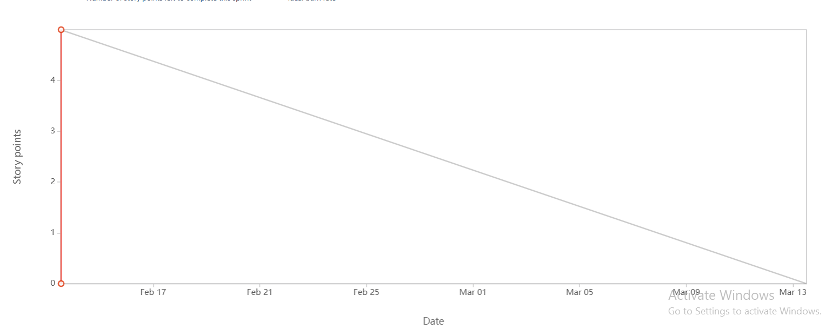

**Product Burn Down Chart:**

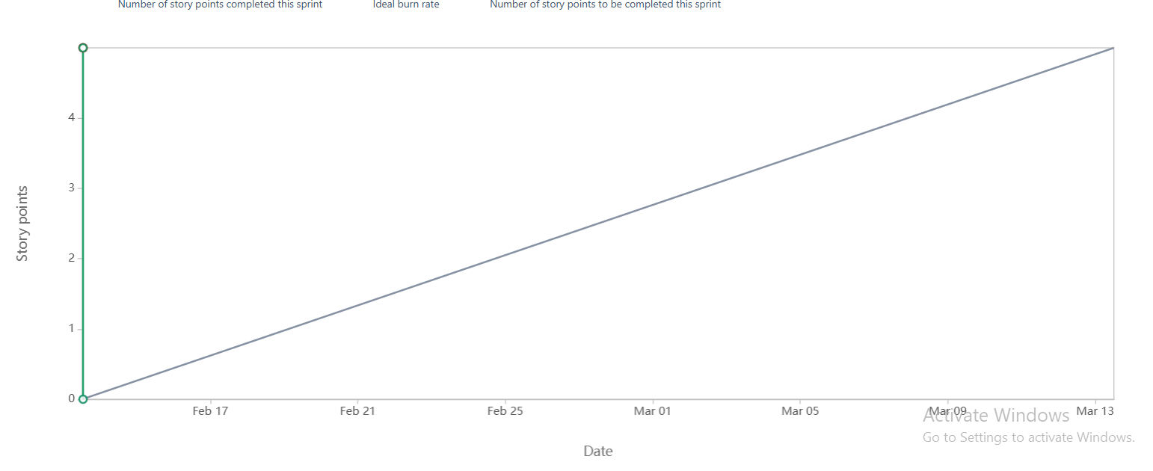

**Q.10 Explain about Product Grooming (2)**

Answer: Product grooming is session where team reviews product backlog items, make it well organized and ensure that they are ready to move for next sprint.

It will allow team to discuss requirements and prioritize work and make backlog items ready for next sprint.

**Q.11 Explain roles of Scrum Master & Product Owner (3)**

**Answer:** Product owner is responsible for product completion. Main job of product owner is to ensure about meeting needs of stakeholders as per requirements. He is also responsible for:

* Product vision
* Requirements questions
* Stakeholders Interest
* He can decides whether to:

1. Accept project
2. Reject the project increment
3. Continue or discontinue with product development
4. Deliver product or not

* Market analysis
* SWOT analysis
* Similar products availability in market

Scrum Master will facilitate scrum process by resolving issues, create environment for team self-organization and capture data to adjust forecast.

**Q.12 Explain all meetings conducted in scrum project. (8)**

Answer: In scrum there are four meetings conducted to get understanding of what is going on in project and is there any difficulty in project. The names of meetings are as below:

1. **Sprint Planning Meeting:** This meeting happen at the beginning of each project. In this meeting sprint team decides what will team is going to achieve during sprint.
2. **Daily Scrum Meeting:** Daily Scrum Meeting happen on daily basis to check –
   * + What did you today?
     + What will you do tomorrow?
     + Are there any impediments that are slowing you or stopping you?

3. **Sprint Review Meeting:** Sprint review meeting will conduct at the end of each sprint where team shows completed stories to product owner and get it cleared.

4. **Sprint Retrospective Meeting**: Sprint Retrospective Meeting happen at end of sprint where team will answers questions:

* + - What went well in the sprint?
    - What did not go well?
    - What are required areas of improvements in the next sprint?

**Q.13 Explain Sprint size and Scrum size. (2)**

Answer: Sprint Size is the time period which team decides to achieve their outcomes. Normally, sprint period will be of 2 weeks but may be extend upto 4 weeks.

Scrum size consists of BAs, Developers, Tester. Each scrum team will be average size of 7- 8 team members.

**Q.14 Explain DOD and DOR. (2)**

Answer: **DOD** – Definition of Done – DOD is criteria which shows when product is complete. DOD ensures about consistency and quality of product.

**DOR** – Definition of Ready – DOR is criteria where it shows product backlog items are ready for sprint. DOR ensures about right product working and team is prepared to work.

**Q.15 Explain prioritization techniques and MVP.**

Answer: Prioritize requirements are requirements which used to sort out as per priority of requirements. They helps to get urgency of requirements and sort accordingly. Factors influenced for priority are: Risk, Cost, Time, Benefits and strategy.

MoSCoW is a prioritization technique which includes Must do, Should do, Could d and would do requirements.

Must do – These are mandatory requirements to meet business/stakeholders need.

Should do – These are requirements where we can proceed for that but product is not dependent on them.

Could do – These are requirements where they will not affect anything in project.

Would do – These are requirements do proceed later, not necessary to deliver at the time of product delivery.

MVP is Minimum Viable Product is technique which shows product has enough features to satisfy early need of stakeholder and ask them to provide feedback for future product.

**Q.16 Difference – Business Analyst and Product Owner**

Answer: Product owner is responsible for product completion. Main job of product owner is to ensure about meeting needs of stakeholders as per requirements. He is also responsible for:

* Product vision
* Requirements questions
* Stakeholders Interest
* He can decides whether to:

1. Accept project
2. Reject the project increment
3. Continue or discontinue with product development
4. Deliver product or not

* Market analysis
* SWOT analysis
* Similar products availability in market

Business Analyst are problem solvers, facilitators and communicator between stakeholders and scrum team. They get requirements from stakeholders by asking questions, accessing needs, find gaps and understand all requirements using elicitation techniques.

**Q.17 Sample resume for 3 years exp. Product Owner.**

**Answer:**

Krishna Babhulgaonkar

[kdb997@gmail.com](mailto:kdb997@gmail.com)

Mob. 8149700461

**Objective:**

Motivated and forward thinker with experience of 3 years. Always eager to support with leadership and guidance over wide range of product development efforts.

**Work Experience:**

Agile Product Owner

HDFC Bank Ltd, Aurangabad

* Acted as mediator between sales, business and IT teams to complete product and features as per market demands.
* Partnered with IT and product leadership to manage solution development process and ensure completion of project
* Collaborated with teams to get best solution in market provided by product team.
* Create and maintain solution vision, roadmap and backlog of work through project life cycle
* Translated features into user stories within team’s backlog and manage, rank and prioritize stakeholder’s requirements.

**Education**:

* B.E in Computer Science and Engineering

**Key Skills:**

* Conceptual Skills
* User centered design process
* Design quality standards
* Agile and scrum
* Conduct sprints
* Analytical skills
* Teamwork