**WAREHOUSE MANAGEMENT SYSTEM (WMS)**

**Business Case Document**

1. **Executive Summary**

Efficient warehouse operations are crucial for optimizing supply chain performance. This business case presents the need for a **Warehouse Management System (WMS) software application** to improve inventory accuracy, reduce operational costs, and enhance order fulfilment efficiency. The proposed WMS will replace manual or outdated systems, leading to improved productivity, real-time tracking, and better decision**-**making.

1. **Current Problems**  
   Current warehouse operations face multiple challenges, including:

* **Inefficient inventory tracking**, leading to stock discrepancies.
* **Manual processes**, increasing errors in order picking and fulfilment.
* **Lack of real-time visibility** of stock levels and warehouse performance.
* **High operational costs** due to excessive labour and poor space utilization.

A WMS application will streamline warehouse operations, improve accuracy, and boost efficiency through automation and real-time monitoring.

1. **Objectives and Benefits**

**Objectives**

* Automate inventory tracking and reduce stock discrepancies.
* Improve order fulfilment speed and accuracy.
* Enable real-time monitoring and reporting.
* Optimize warehouse space utilization.
* Reduce operational costs through efficiency improvements.

**Benefits**

| **Benefit** | **Description** |
| --- | --- |
| Cost Savings | Reduced labour costs and inventory losses due to improved accuracy. |
| Real-Time Visibility | Livestock tracking and reporting for better decision-making. |
| Enhanced Order Accuracy | Reduction in order fulfilment errors, leading to improved customer satisfaction. |
| Scalability | Adaptability to future business growth and warehouse expansions. |
| Compliance | Ensures adherence to industry regulations and standards. |

1. **Proposed Solution**

The WMS software will include the following **key features**:

* Inventory Management – Barcode/RFID tracking for real-time stock monitoring.
* Order fulfilment Optimization – AI-driven picking, packing, and shipping.
* Warehouse Space Utilization – Smart algorithms for efficient storage allocation.
* Automated Reporting & Insights – Custom dashboards for performance tracking.
* Multi-Channel Integration – Connectivity with ERP, e-commerce, and third-party logistics (3PL) providers.
* User-Friendly Web & Mobile Interface – Easy-to-use application for warehouse staff.

1. **Resources Required for WMS Application Development**

Developing a Warehouse Management System (WMS) application using the Waterfall methodology requires various resources across technology, human expertise, infrastructure, and financial aspects. Below is a structured breakdown of the essential resources.

**1.Human Resources (Project Team & Key Roles)**

| **Role** | **Responsibilities** | **Resource Requirement** |
| --- | --- | --- |
| **Project Manager** | Oversees the project, defines milestones, and ensures adherence to the Waterfall process. | 1 |
| **Business Analyst** | Gathers and documents requirements, translates business needs into functional specifications. | 1 |
| **UI/UX Designers** | Designs user-friendly interfaces for desktop & mobile WMS applications. | 1 |
| **Solution Architect** | Defines the system architecture, database design, and overall technical strategy. | 1 |
| **Backend Developers** | Develop core functionalities like inventory tracking, order management, and integrations. | 3 |
| **Frontend Developers** | Develops user interfaces for warehouse staff, managers, and mobile applications. | 3 |
| **Database Administrators** | Designs and optimizes the database for real-time inventory tracking. | 1 |
| **QA & Testing Team** | Conducts unit testing, system testing, and user acceptance testing (UAT). | 2 |
| **DevOps Engineers** | Handles cloud deployment, CI/CD pipelines, and server management. | 2 |
| **Cybersecurity Experts** | Ensures system security, data encryption, and compliance with security standards. | 1 |
| **Technical Support & Maintenance** | Provides post-deployment support, bug fixes, and system upgrades. | 2 |

**2. Technological Resources**

| **Technology** | **Purpose** | **Examples** |
| --- | --- | --- |
| **Programming Languages** | **Backend & frontend development** | **Python, Java, .NET, JavaScript (React, Angular, Vue.js)** |
| **Database Management System (DBMS)** | **Storing and managing inventory, order, and warehouse data** | **MySQL, PostgreSQL, Oracle, MongoDB** |
| **Cloud Infrastructure** | **Hosting WMS application, ensuring scalability & uptime** | **AWS, Microsoft Azure, Google Cloud** |
| **Web Frameworks** | **Developing web-based WMS portals** | **Django, Spring Boot, ASP.NET** |
| **Mobile App Development** | **Warehouse staff can access WMS via mobile devices** | **React Native, Flutter, Swift (iOS), Kotlin (Android)** |
| **RFID & Barcode Integration** | **Scanning and tracking inventory** | **Zebra, Honeywell, GS1 Standards** |
| **AI & Analytics Tools** | **Predictive analytics for warehouse optimization** | **Power BI, Tableau, Apache Spark** |
| **API & Integration Services** | **Connecting WMS with ERP, CRM, and logistics platforms** | **REST APIs, GraphQL, SAP Integration, EDI** |
| **Version Control & CI/CD** | **Managing codebase & deployment** | **GitHub, GitLab, Jenkins, Docker** |
| **Security Tools** | **Ensuring cybersecurity & compliance** | **SSL/TLS encryption, OAuth, IAM, Firewalls** |

**3. Infrastructure & Hardware Resources**

| **Infrastructure** | **Requirement** |
| --- | --- |
| **Server Infrastructure** | **Cloud-based or on-premise servers for hosting the WMS.** |
| **Network Infrastructure** | **High-speed internet, routers, VPN for secure access.** |
| **Storage Solutions** | **Cloud storage or on-premise storage for handling large datasets.** |
| **Barcode/RFID Scanners** | **Devices for tracking inventory movements.** |
| **IoT Sensors & Smart Devices** | **For automated warehouse monitoring.** |
| **Workstations & Mobile Devices** | **Computers & tablets for warehouse staff and managers.** |

1. **Cost Analysis**

**Estimated Costs**

| **Expense** | **Estimated Cost (INR)** | |
| --- | --- | --- |
| Software Development | ₹30,00,000 | |
| Hardware (Scanners, Servers, etc.) | ₹18,00,000 | |
| Implementation & Training | ₹1,50,000 | |
| Maintenance & Support (Annual) | ₹50,000 | |
| **Total Estimated Cost** | | **₹50,00,000** |

1. **Return on Investment (ROI)**

* **Break-even period**: 12-18 months.
* **Annual cost savings**: Reduction in labour costs by 25%, inventory losses by 30%, and operational expenses by 20%.

1. **Identify Stakeholders for WMS Application Development**

Identifying stakeholders is crucial for ensuring that the Warehouse Management System (WMS) application meets business needs, integrates seamlessly, and gains the necessary support for successful implementation. Stakeholders can be internal (within the organization) or external (outside the organization) and will have different levels of involvement in the project. Here in this WMS Project, we can find the below Stakeholders.

**A. Primary Stakeholders (Directly Impacted Users & Decision-Makers)**  
1. Project Sponsor / Senior Management  
2. Warehouse Managers / Supervisors  
3. IT Team (Developers, Architects, Security Experts, Database Admins)  
4. Operations / Supply Chain Managers  
5. Finance & Accounting Team

**B. Secondary Stakeholders (Indirectly Impacted Users & Support Teams)**  
1. End Users (Warehouse Staff, Pickers, Packers, Inventory Controllers)  
2. Customers (Retailers, E-commerce Platforms, B2B Clients)  
3. Vendors / Suppliers  
4. HR & Training Team

**C. Secondary Stakeholders (Indirectly Impacted Users & Support Teams)**  
1. Third-Party Logistics (3PL) Providers  
2. Government & Compliance Authorities  
3. ERP & E-commerce Integration Partners

**Steps to Identify Stakeholders for WMS Development**

**Step 1: Conduct Stakeholder Analysis**

* List all **departments, teams, and external parties** affected by the WMS.
* Identify **who will use, manage, and support** the system.

**Step 2: Categorize Stakeholders by Influence & Interest**

* **High Influence, High Interest** → Key Decision-Makers (Senior Management, IT, Warehouse Managers).
* **High Influence, Low Interest** → Finance Team, Compliance Authorities.
* **Low Influence, High Interest** → Warehouse Staff, Customers, Suppliers.
* **Low Influence, Low Interest** → General IT Support, HR Training Team.

**Step 3: Engage Stakeholders Early**

* Conduct **interviews, surveys, and meetings** with key stakeholders.
* Gather **requirements and pain points** before system design.

**Step 4: Maintain Continuous Communication**

* Provide **regular project updates** to all stakeholders.
* Involve **end users (warehouse staff, pickers, packers)** in **user testing** to ensure usability.

1. **Organizational Change Required for WMS Adoption**

Implementing a Warehouse Management System (WMS) is a significant change that impacts multiple areas within an organization, including processes, people, and technology. The level of change required depends on the organization's existing warehouse operations, technology maturity, and workforce adaptability. Below is a detailed analysis of the organizational change required for WMS adoption.

1. Key Areas of Organizational Change
   1. Process Changes
   2. Workforce & Role Changes
   3. Technology Adoption & Infrastructure Changes
   4. Cultural & Mindset Shift
   5. Change in Performance Metrics & KPIs

2. Change Management Strategy

| **Change Management Aspect** | **Implementation Strategy** |
| --- | --- |
| Leadership Support | Assign a change champion (Warehouse Manager/Operations Head). |
| Employee Training & Upskilling | Conduct hands-on training & workshops for all WMS users. |
| Pilot Testing & Phased Rollout | Implement WMS in a small warehouse unit first, then scale. |
| Feedback & Continuous Improvement | Collect weekly feedback and refine processes. |
| Technical Support & Helpdesk | Set up a dedicated IT support team for WMS issues. |

3. Estimated Timeline for Change Implementation

| **Phase** | **Activities** | **Duration** |
| --- | --- | --- |
| Planning & Stakeholder Alignment | Define scope, process mapping, identify key users | 2-3 Weeks |
| Training & Pilot Testing | Conduct training, test WMS in a small warehouse section | 4-6 Weeks |
| Full-Scale Deployment | Roll out WMS across all warehouses | 8-12 Weeks |
| Post-Go-Live Support | Monitor system performance, resolve issues | Ongoing |

1. **Implementation Plan**

| **Phase** | **Timeline** | **Key Activities** |
| --- | --- | --- |
| **Requirement Analysis** | Month 1 | Gather business needs and define system requirements. |
| **Design & Development** | Months 2-5 | Develop WMS software and integrate necessary hardware. |
| **Testing & Validation** | Month 6 | Conduct system testing and user acceptance testing (UAT). |
| **Deployment & Training** | Month 7 | Implement software and train warehouse staff. |
| **Go Live & Support** | Month 8+ | Full-scale implementation and continuous monitoring. |

1. **Risks & Mitigation Strategies**

| **Risk** | **Mitigation Strategy** |
| --- | --- |
| System Downtime | Implement backup systems and disaster recovery plans. |
| Resistance to Change | Provide proper training and change management support. |
| Integration Challenges | Ensure compatibility with existing systems and perform rigorous testing. |

1. **Conclusion**

Implementing a WMS software application will significantly **improve warehouse efficiency, reduce costs, and enhance operational visibility**. The investment in this system will lead to long-term savings, better customer satisfaction, and a competitive advantage in the market.

**Key Takeaways:**

✅ **Clear project scope and cost predictability** due to Waterfall’s structured process.  
✅ **Efficient warehouse operations** through automation and real-time inventory tracking.  
✅ **Scalability for future expansions** with multi-location warehouse support.  
✅ **Better decision-making** with AI-driven analytics and reporting.

By following this approach, businesses can **achieve cost efficiency, operational excellence, and a strong competitive advantage** in warehouse management.

**Business Analyst (BA) Approach Strategy for WMS Application Development**

As a Business Analyst (BA), my key responsibilities include gathering requirements, analysing stakeholder needs, documenting processes, facilitating approvals, and ensuring a smooth implementation of the Warehouse Management System (WMS) application. I follow the below structured approach and outlines the step-by-step strategy to successfully complete the project using the Waterfall methodology.

**1. Steps to Follow for Project Completion**

**Phase 1: Requirement Elicitation & Stakeholder Analysis**

* Identify and engage key stakeholders (warehouse managers, IT team, finance team, logistics, suppliers, customers).
* Use Elicitation Techniques to gather and validate business needs.
* Perform Stakeholder Analysis using RACI/ILS frameworks.
* Document Business Requirements Document (BRD) and get sign-off.

**Phase 2: Requirement Documentation & Approval Process**

* Convert business needs into Functional Requirement Specification (FRS) and Software Requirement Specification (SRS).
* Get formal approvals from stakeholders and clients using documented sign-off processes.
* Define a Requirement Traceability Matrix (RTM) to track requirements through development.

**Phase 3: Design & Development Collaboration**

* Work closely with Solution Architects & UI/UX Designers for system architecture and interface design.
* Define Use Cases, Data Flow Diagrams (DFDs), and Process Flows.
* Conduct requirement walkthroughs with the development team.

**Phase 4: Testing & UAT Readiness**

* Develop Test Scenarios & Test Cases based on the signed-off requirements.
* Support User Acceptance Testing (UAT) by defining UAT Test Cases.
* Conduct UAT sessions with stakeholders and record test results.

**Phase 5: Deployment & Change Management**

* Facilitate Client Project Acceptance Form and obtain formal sign-off.
* Handle change requests through an organized Change Control Process.
* Establish communication channels for project status updates and escalations.

**2. Elicitation Techniques to Apply  
 Here we have used below Elicitation Techniques used for the Requirement Gathering**

| **Technique** | **Description** | **When is Used** |
| --- | --- | --- |
| **Stakeholder Interviews** | One-on-one meetings to gather business needs. | Initial requirement gathering. |
| **Workshops** | Group discussions with multiple stakeholders. | Aligning business processes and system functionalities. |
| **Surveys & Questionnaires** | Collect input from a larger audience. | Gathering feedback from warehouse staff and suppliers. |
| **Document Analysis** | Reviewing existing warehouse reports, SOPs, and workflows. | Understanding current pain points. |
| **Observation (Job Shadowing)** | Watching warehouse staff perform tasks. | Identifying real-time challenges. |
| **Prototyping** | Creating wireframes/mockups. | Validating UI/UX and workflows. |

**3. Stakeholder Analysis using RACI & ILS**

**RACI Matrix (Responsible, Accountable, Consulted, Informed)**

Defines roles & responsibilities for WMS development.

| **Task** | **Project Manager** | **BA** | **IT Team** | **Warehouse Staff** | **Client** |
| --- | --- | --- | --- | --- | --- |
| Requirement Gathering | A | R | C | C | I |
| System Design | C | A | R | C | I |
| Development | I | C | R | I | I |
| Testing & UAT | C | A | R | R | C |
| Deployment | A | I | R | I | C |
| Change Requests | A | R | C | C | I |

**Influence-Interest (ILS) Analysis**

Categorizes stakeholders based on their **interest** in the project and **influence** over decisions.

| **Stakeholder** | **Influence** | **Interest** | **Action** |
| --- | --- | --- | --- |
| Senior Management | High | Medium | Regular updates & approvals. |
| Warehouse Managers | High | High | Deep engagement in requirement gathering & testing. |
| IT Team | High | High | Involved in all development & testing phases. |
| End Users (Warehouse Staff) | Low | High | Training & UAT participation. |
| Suppliers & Vendors | Low | Medium | Limited engagement. |

**4. Key Documents to Prepare**

**As a Business Analyst Below Documents I have prepared in this Project**

| **Document** | **Purpose** | **Approval Needed From** |
| --- | --- | --- |
| **Business Requirements Document (BRD)** | Captures high-level business needs. | Client, Senior Management |
| **Functional Requirement Specification (FRS)** | Details functional requirements. | IT Team, Business Teams |
| **Software Requirement Specification (SRS)** | Defines technical requirements. | Solution Architects, Developers |
| **Requirement Traceability Matrix (RTM)** | Tracks requirements from inception to implementation. | Project Team, QA Team |
| **User Acceptance Test (UAT) Plan** | Outlines UAT test cases & criteria. | Warehouse Managers, Clients |
| **Change Request Document (CRD)** | Manages change approvals. | Project Sponsor, IT Team |
| **Client Project Acceptance Form** | Formal client sign-off. | Client, Senior Management |

**5. Sign-Off & Approval Process**

**Requirement Approval**

* Conduct requirement walkthroughs and capture feedback.
* Obtain formal email or digital signatures from key stakeholders.

**UAT & Client Acceptance**

* Conduct UAT with real warehouse data.
* Address defects & ensure all UAT cases pass.
* Obtain Client Project Acceptance Form sign-off to proceed with deployment.

**6. Communication Strategy for Stakeholder Engagement**

| **Channel** | **Purpose** | **Stakeholders** | **Frequency** |
| --- | --- | --- | --- |
| **Emails & Reports** | Formal updates, approvals | Senior Management, Clients | Weekly |
| **Meetings & Workshops** | Requirement discussions, feedback | Warehouse & IT Teams | Bi-Weekly |
| **Project Dashboard (JIRA, Trello)** | Task tracking | Internal Project Team | Daily |
| **Slack/Teams Chat** | Quick communication | Developers, Testers | As needed |
| **Stakeholder Review Calls** | Status updates, risk discussions | Clients, Project Sponsor | Monthly |

**7. Handling Change Requests (CRs)**

**Change Request Process**

1. **Document Change Request** → Define impact on timeline & cost.
2. **Stakeholder Review** → Discuss with business teams & IT.
3. **Impact Analysis** → Assess feasibility with development team.
4. **Approval Process** → Obtain sign-off from project sponsor.
5. **Implementation & Testing** → Develop changes & conduct regression testing.

**Change Control Board (CCB) for Major CRs**

* **Board Members:** Project Sponsor, Business Analyst, IT Lead.
* **Meeting Frequency:** Bi-weekly or as needed.

**8. Project Progress Reporting & Monitoring**

| **Reporting Method** | **Purpose** | **Frequency** |
| --- | --- | --- |
| **Status Reports** | Track project health (budget, scope, risks). | Weekly |
| **Risk Logs** | Document project risks & mitigation. | Ongoing |
| **Milestone Reports** | Highlight key achievements. | Monthly |
| **Client Review Meetings** | Provide high-level project insights. | Bi-Monthly |

**9. UAT Sign-Off & Client Acceptance Process**

1. **UAT Execution** → Ensure stakeholders complete all UAT test cases.
2. **Defect Resolution** → Fix bugs & retest.
3. **Final Approval Meeting** → Client reviews test results.
4. **Sign-Off on Client Project Acceptance Form** → Client formally approves project closure.

**Conclusion**

I Follow this structured BA approach ensures clear documentation, stakeholder alignment, risk mitigation, and successful delivery of the WMS application.

**3.Functional Specifications**

|  |  |
| --- | --- |
| Project name: Warehouse Management System (WMS) Development |  |
| Customer name: SOONY |  |
| Project Version: Develop a WMS Application |  |
| Project Sponsor: Mr. Hendry |  |
| Project Manager: Mr Vandanam |  |
| Project Initiation date: 03/03/2025 |  |

**1.Purpose of the Document**

The Functional Specification Document (FSD) provides a detailed description of the functional requirements for the Warehouse Management System (WMS). It outlines system features, workflows, business rules, user roles, and integrations to ensure clarity in development and testing.

**2. System Overview**

The Warehouse Management System (WMS) will enable businesses to efficiently manage inventory, order fulfilment, warehouse operations, and reporting.

**Key Features:**

✅ Inventory Management  
✅ Order Processing & Fulfilment  
✅ Warehouse Operations & Tracking  
✅ Barcode & RFID Integration  
✅ Reports & Analytics  
✅ Integration with ERP & E-commerce Systems

**3. Functional Requirements**

**3.1 User Roles & Access Control**

| **Role** | **Permissions** |
| --- | --- |
| **Admin** | Full access to all modules & settings |
| **Warehouse Manager** | Manage inventory, process orders, generate reports |
| **Warehouse Staff** | Pick, pack, scan barcodes, update order status |
| **Customer Service** | View order status, assist customers |
| **Supplier/Vendor** | Manage incoming stock, track shipments |

| **Req ID** | **Function Req Module** | **Fun. Req Description** | **Priority** |
| --- | --- | --- | --- |
| FR0001 | **Login** | User should be able to login to the application to do inventory operations | 10 |
| FR0002 | **Inventory Management** | Real-time stock tracking  Add, update, and delete inventory items  Barcode & RFID scanning integration  Low-stock alerts & notifications | 9 |
| FR0003 | **Order Processing & Fulfilment** | Order creation, modification, and cancellation.  Order picking, packing, and shipping  Order tracking with real-time updates  Generate invoices and shipping labels | 10 |
| FR0004 | **Warehouse Operations & Tracking** | Warehouse zone & bin location management  Track incoming & outgoing shipments  Assign storage locations dynamically | 8 |
| FR0005 | **Barcode & RFID Integration** | Barcode scanning for inventory updates  RFID tracking for automated stock movement | 8 |
| FR0006 | **Reports & Analytics** | Inventory valuation reports  Order fulfilment status reports  Warehouse efficiency analysis | 7 |
| FR0007 | **Integration with ERP & E-commerce Systems** | Sync inventory data with ERP (SAP, Oracle, etc.)  Connect with e-commerce platforms (Shopify, Amazon, etc.) | 7 |

**4. Non-Functional Requirements**

| **Requirement** | **Description** |
| --- | --- |
| **Performance** | System should support **100+ concurrent users**. |
| **Security** | Implement **role-based access control (RBAC)**. |
| **Scalability** | Support multi-warehouse operations **without performance lag**. |
| **Availability** | System uptime should be **99.9%**. |
| **Compliance** | Adhere to **GDPR & ISO 27001** standards. |

**5. User Interface Mockups (Optional)**

* Login Page
* Dashboard for Admin & Warehouse Manager
* Order Processing Screen
* Inventory Management Screen

**6. API & Integration Requirements**

📌**External Systems:**

* ERP System (SAP, Oracle)
* E-commerce (Amazon, Shopify)
* Payment Gateway (Stripe, PayPal)

📌 **API Functionalities:**

* GET Inventory Details /api/inventory/{sku}
* POST New Order /api/order/create
* PUT Update Order Status /api/order/update/{id}

**7. Workflow Diagrams**

* Order Processing Flow
* Inventory Movement Flow
* Warehouse Staff Workflow

**8. Assumptions & Constraints**

✅ System will be **cloud-based** (AWS/Azure).  
✅ Barcode scanners & RFID readers **must be compatible**.  
✅ Internet connectivity is **required** for real-time updates.

**9. Sign-Off**

| **Role** | **Name** | **Signature** | **Date** |
| --- | --- | --- | --- |
| **Business Analyst:** | Kumaran | Dharmalingam |  |
| **Project Manager:** | Mr. Vandanam |  |  |
| **Client Representative** | : Mr. |  |  |

**Conclusion**

This FSD ensures all functional aspects of WMS development are well-defined, structured, and approved.

Requirement Traceability Matrix (RTM)

**Document Overview**

* **Project Name:** Warehouse Management System (WMS)
* **Prepared By:** Kumaran Dharmalingam (BA)
* **Reviewed By:** Mr. Vandanam (PM)
* **Version:** 1.0
* **Date:** 03/03/3035

**Purpose of the Document**

The Requirement Traceability Matrix (RTM) ensures that all functional and non-functional requirements are tracked throughout the Software Development Life Cycle (SDLC). It maps each requirement to its corresponding design, development, testing, and validation phases to ensure complete implementation.

**Functional Requirements**

| **Requirement ID** | **Requirement Description** | **Business Objective** | **Design Specification** | **Development Status** | **Test Case ID** | **Testing Status** | **UAT Status** |
| --- | --- | --- | --- | --- | --- | --- | --- |
| FR001 | User Login with Role-Based Access | Secure access control | UI Login Page, Database Authentication | ✅ Completed | TC001 | ✅ Passed | ✅ Approved |
| FR002 | Inventory Management (Add, Update, Delete) | Real-time stock tracking | Inventory Module, DB Schema | ✅ Completed | TC002, TC003 | ✅ Passed | ✅ Approved |
| FR003 | Barcode & RFID Scanning for Stock Update | Automate inventory tracking | API Integration, Hardware Compatibility | ✅ Completed | TC004 | 🔄 In Progress | ❌ Pending |
| FR004 | Order Processing (Picking, Packing, Shipping) | Streamline order fulfilment | Order Workflow Design | ✅ Completed | TC005 | ✅ Passed | ✅ Approved |
| FR005 | Generate Inventory Reports | Data-driven decision-making | Reports Module, Dashboard UI | 🔄 In Progress | TC006 | ❌ Not Started | ❌ Pending |
| FR006 | Integration with ERP System | Sync inventory & orders with ERP | API Development | 🔄 In Progress | TC007 | ❌ Not Started | ❌ Pending |

**Non-Functional Requirements**

| **Requirement ID** | **Requirement Description** | **Business Objective** | **Design Specification** | **Development Status** | **Test Case ID** | **Testing Status** | **UAT Status** |
| --- | --- | --- | --- | --- | --- | --- | --- |
| NFR001 | System should support 100+ concurrent users | High system performance | Cloud-based Architecture | ✅ Completed | TC008 | ✅ Passed | ✅ Approved |
| NFR002 | Data Encryption for Security | Secure sensitive data | AES-256 Encryption | ✅ Completed | TC009 | ✅ Passed | ✅ Approved |
| NFR003 | Role-Based Access Control (RBAC) | Restrict unauthorized access | User Management Module | ✅ Completed | TC010 | ✅ Passed | ✅ Approved |
| NFR004 | System Availability 99.9% | Ensure uptime | AWS/Azure Deployment | 🔄 In Progress | TC011 | ❌ Not Started | ❌ Pending |
| NFR005 | API Response Time < 2 sec | Improve performance | REST API Optimization | 🔄 In Progress | TC012 | ❌ Not Started | ❌ Pending |

✅ Completed & Approved: 7 Requirements  
🔄 In Progress: 5 Requirements  
❌ Not Started: 3 Requirements

I have created this RTM and used for Tracking and Monitoring the Requirements and status communication purpose.

# **Business Requirements Document (BRD)**

**Contents**

1. Document Revisions .............................................................................................................18

2. Approvals ............................................................................................................................. 18

3. RASCI Chart for This Document ............................................................................................ 18

Codes Used in RASCI Chart .............................................................................................19

RASCI Chart ...................................................................................................................19

4. Introduction .........................................................................................................................19

4.1. Business Goals ..............................................................................................................19

4.2. Business Objectives .......................................................................................................9

4.3. Business Rules ............................................................................................................. 10

4.4. Background ................................................................................................................. 10

4.5. Project Objective......................................................................................................... 10

4.6. Project Scope .............................................................................................................. 10

4.6.1. In Scope Functionality .......................................................................................... 10

4.6.2. Out Scope Functionality ....................................................................................... 10

5. Assumptions ...................................................................................................................... 10

6. Constraints ......................................................................................................................... 10

7. Risks ................................................................................................................................... 10

Technological Risks .................................................................................................... 11

Skills Risks ................................................................................................................. 11

Political Risks ............................................................................................................ 11

Business Risks ........................................................................................................... 11

Requirements Risks ................................................................................................... 11

Other Risks ................................................................................................................ 11

8. Business Process Overview ................................................................................................ 11

8.1. Legacy System (AS-IS) .................................................................................................. 11

8.2. Proposed Recommendations (TO-BE) ......................................................................... 11

9. Business Requirements ...................................................................................................... 11

10. Appendices ..................................................................................................................... 12

10.1. List of Acronyms ...................................................................................................... 12

10.2. Glossary of Terms .................................................................................................... 12

10.3. Related Documents ................................................................................................. 12

**1. Document Revisions**

|  |  |  |
| --- | --- | --- |
| **Date** | **Version Number** | **Document Changes** |
| 05/02/20xx | 0.1 | Initial Draft |

**2. Approvals**

|  |  |  |  |  |
| --- | --- | --- | --- | --- |
| **Role** | **Name** | **Title** | **Signature** | **Date** |
| Project Sponsor: Mr. Hendry | | | | |
| Business Owner: Mr. Hendry | | | | |
| Project Manager: Mr. Vandanam | | | | |
| **System Architect: ARUN** | | | | |
| **Development Lead:** Mr. Suresh | | | | |
| **User Experience Lead:** Mr. Gopi | | | | |
| **Quality Lead: Mr**. Mohan | | | | |
| **Content Lead:** Ms. Tamilselvi | | | | |

**3.RACI Chart**

| **Project Activity** | **Business Owner** | **Project Manager** | **Business Analyst** | **Developers** | **QA Team** | **IT Team** | **Warehouse Manager** | **End Users** | **Finance Team** |
| --- | --- | --- | --- | --- | --- | --- | --- | --- | --- |
| 1. Requirements Gathering | A | R | R | C | C | I | C | I | I |
| 2. Business Case Approval | A | R | C | I | I | I | I | I | C |
| 3. UI/UX Design | I | R | C | R | C | I | C | I | I |
| 4. Development | I | R | C | R | C | C | I | I | I |
| 5. Integration with ERP | I | R | C | R | C | R | I | I | C |
| 6. System Testing | I | R | C | I | R | I | I | I | I |
| 7. UAT (User Acceptance Testing) | I | R | C | I | R | I | R | R | I |
| 8. Deployment & Go-Live | I | R | C | R | R | R | I | I | I |
| 9. Training & Change Management | I | R | C | C | I | R | R | R | I |
| 10. Post-Go-Live Support | I | R | I | R | R | R | I | I | I |

**R-Responsible, A-Accountable, C-Consulted, I-Informed**

**Codes Used in RACI Chart**

R -Responsible: Responsible for creating this document.

A -Accountable: Accountable for accuracy of this document (for example, the project manager)

C- Consulted: Provides input (such as an interviewee).

I -Informed Must be informed of any changes.

**4. Introduction**

**4.1 Business Goals**

The Project aims to deliver a scalable, secure, and user-friendly system that enables businesses to manage their warehouses more effectively. The key objectives include:

* Improve Warehouse Efficiency & Productivity
* Enhance Inventory Accuracy & Visibility
* Optimize Order Processing & Reduce Errors
* Seamless Integration with ERP & Other Systems
* Improve Decision-Making with Analytics & Reporting
* Ensure Compliance & Data Security

**4.2 Business Objectives**

✅ Improve warehouse efficiency by 30% through automation.  
✅ Reduce order processing time and minimize errors in stock management.  
✅ Ensure real-time inventory tracking via barcode/RFID scanning.  
✅ Enable seamless integration with ERP systems for data synchronization.  
✅ Provide role-based access control for security and compliance.

**4.3 Business Rules**

Business rules define the operational guidelines, constraints, and policies that the Warehouse Management System (WMS) must follow to ensure efficiency, accuracy, and compliance. These rules govern inventory management, order processing, user access, reporting, and system integration.

**1. Inventory Management Rules**

Rule 1: Every item in the warehouse must have a unique SKU (Stock Keeping Unit) or barcode/RFID tag for identification.

Rule 2: The system must trigger a low-stock alert when inventory falls below a predefined reorder level.

Rule 3: FIFO (First In, First Out) or FEFO (First Expired, First Out) methods must be followed for perishable goods.

Rule 4: The system should restrict manual stock updates, allowing only authorized users (Warehouse Manager/Admin) to make inventory adjustments.

Rule 5: Damaged or defective stock must be quarantined, and a return/replacement request must be initiated before further action.

Rule 6: Stock movement (inbound and outbound) should be logged automatically, including timestamps and user details.

Rule 7: Physical stock audits must be conducted monthly/quarterly, and any discrepancies should be flagged for investigation.

**2. Order Processing & fulfilment Rules**

Rule 8: Orders must be processed only if inventory is available; partial fulfilment is allowed based on business policy.

Rule 9: Orders must be picked and packed according to the warehouse layout optimization strategy to reduce handling time.

Rule 10: The system must assign warehouse staff automatically to pick orders based on workload distribution.

Rule 11: The system must validate scanned items during picking to prevent order mismatches.

Rule 12: Orders must be shipped only after quality checks are completed.

Rule 13: The system should provide real-time shipment tracking for customers and warehouse staff.

Rule 14: Returns and refunds must follow a predefined approval workflow, requiring validation by the Warehouse Manager.

**3. User Roles & Access Control Rules**

Rule 15: Only authorized personnel (Warehouse Manager/Admin) can perform manual stock adjustments.

Rule 16: Warehouse staff can access only assigned tasks (picking, packing, stock checking, etc.) based on their role.

Rule 17: The system must implement Role-Based Access Control (RBAC) to restrict access to sensitive data.

Rule 18: Every system login and action must be logged for audit purposes, and logs must be retained for a minimum of 1 year.

Rule 19: Users must change passwords every 90 days, and passwords must meet security standards (minimum 8 characters, mix of uppercase, lowercase, numbers, special characters).

**4. Reporting & Analytics Rules**

Rule 20: Real-time reports must be generated for inventory levels, order status, warehouse efficiency, and sales trends.

Rule 21: Daily, weekly, and monthly performance reports must be automatically emailed to Warehouse Managers and Business Owners.

Rule 22: The system should provide dashboard analytics for quick decision-making.

Rule 23: Historical data must be archived after 3 years but should be accessible if needed.

**5. Integration & Compliance Rules**

Rule 24: The WMS must integrate seamlessly with ERP, CRM, and third-party logistics (3PL) providers through secure APIs.

Rule 25: The system must comply with ISO 27001 & GDPR to ensure data security and privacy.

Rule 26: All system data must be backed up daily to prevent data loss.

Rule 27: Data transmission between WMS and other systems must be encrypted (SSL/TLS) for security.

Rule 28: Any change request to modify business rules must go through a structured approval process before implementation.

**4.4 Background**

In today’s fast-paced logistics and supply chain environment, businesses require efficient warehouse management solutions to optimize inventory tracking, order fulfilment, and resource utilization. Traditional manual warehouse operations lead to delays, errors, and increased operational costs, which negatively impact business performance and customer satisfaction.

To overcome these challenges, this project focuses on developing a Warehouse Management System (WMS) to automate and streamline warehouse operations, ensuring real-time inventory control, faster order processing, and seamless integration with existing enterprise systems.

**Current Challenges in Warehouse Management**  
**Manual Stock Tracking:** Paper-based records and spreadsheets lead to inaccurate inventory data. **High Order Processing Time:** Inefficient picking and packing processes result in delayed deliveries.  
**Stock Discrepancies:** Mismatched stock levels lead to lost sales and overstocking issues.  
**Limited Visibility:** Lack of real-time insights into stock movements and warehouse performance.  
**Integration Issues:** Difficulty in synchronizing data with ERP, CRM, and logistics systems.

**4.5. Project Objective**

The WMS Development Project aims to deliver a scalable, secure, and user-friendly system that enables businesses to manage their warehouses more effectively. The key objectives include:

**Increase warehouse efficiency** by at least **30%** through process automation.  
 **Improve inventory accuracy** to **99.5%** with real-time tracking.  
 **Reduce order fulfilment time** by **40%** through optimized workflows.  
 **Enhance system interoperability** by integrating with ERP and logistics solutions.  
 **Provide robust analytics** for better decision-making.

**4.6. Project Scope**

**4.6.1 In Scope Functionality**

* Inventory Management
* Order Processing & fulfilment
* Warehouse Operations & Workflow Optimization
* System Integrations
* User Management & Security
* Reporting & Analytics
* Compliance & Data Security

**4.6.2 Out Scope Functionality**

🚫 Warehouse robotics automation.  
🚫 Direct customer-facing e-commerce order processing.  
🚫 Hardware Procurement & Maintenance  
🚫 Marketplace & E-Commerce Order Management  
🚫 Non-Warehouse Logistics Operations  
🚫 AI-based predictive analytics (Phase 2 development).

**5. Assumptions**

* The organization has stable internet connectivity for cloud-based WMS.
* Barcode/RFID scanning devices are available and compatible with the system.
* Users will receive training before system deployment.

**6.Constraints**

* The system must be developed within a **6-month timeframe**.
* The budget for development is **fixed** and cannot exceed [amount].
* Any additional feature requests will be **considered in future phases**.

**7.Risks**

A risk is something that could affect the success or failure of a project. Analyse risks regularly as the project progresses.

For each risk, I’ll note the likelihood of its occurrence, the cost to the project if it does occur, and the strategy for handling the risk. Strategies include I am the following for the Risk handling.

**Risk Analysis & Mitigation Plan**

| **Risk** | **Impact** | **Mitigation Strategy** |
| --- | --- | --- |
| Employee resistance to new system | High | Conduct training & change management programs. |
| System downtime affecting operations | High | Ensure cloud-based deployment with failover mechanisms. |
| Integration issues with ERP | Medium | Conduct API testing & pilot deployment before full rollout. |
| Data security concerns | High | Implement role-based access & encryption for sensitive data. |

**8.Business Process Overview**   
 Warehouse operations are crucial for ensuring efficient inventory management, order fulfilment, and seamless supply chain operations. However, the current (As-Is) warehouse management process relies on manual workflows, leading to delays, errors, and inefficiencies. This project focuses on developing a Warehouse Management System (WMS) to automate and optimize warehouse operations.

**8.1. Legacy System (AS-IS)**   
 The existing warehouse management process involves manual stock handling, outdated tracking methods, and inefficient order fulfilment, leading to:

* Stock discrepancies due to manual data entry.
* Slow order fulfilment with manual picking and packing.
* No real-time inventory visibility, causing stockouts or overstocking.
* High operational costs due to inefficient resource utilization.
* Limited reporting & decision-making due to reliance on spreadsheets.

**Process Flow Diagram (As-Is)  
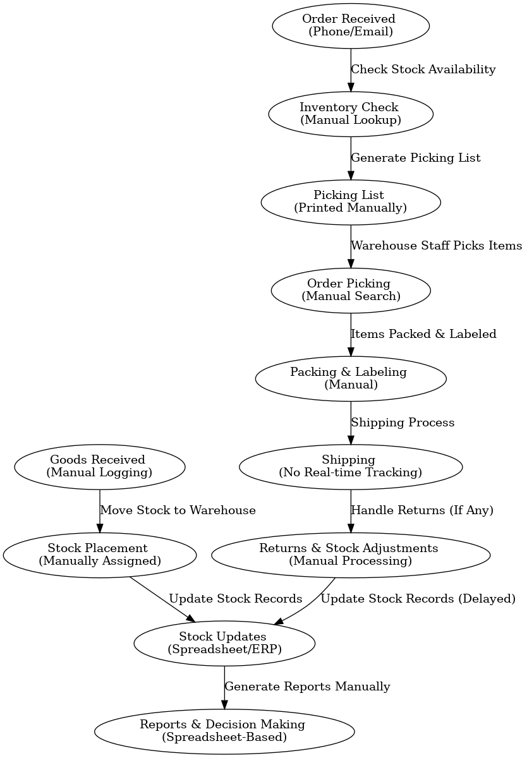**

**8.2. Proposed Recommendations (TO-BE)**

The new WMS-enabled process will introduce automation, real-time tracking, and system integration, leading to:

* Automated stock tracking with barcode/RFID scanning.
* Faster order fulfilment with optimized picking & packing.
* Real-time inventory visibility, preventing stockouts.
* Optimized warehouse layout for efficient storage.
* Automated reporting & analytics for better decision-making.

**Process Flow Diagram (To-Be)**

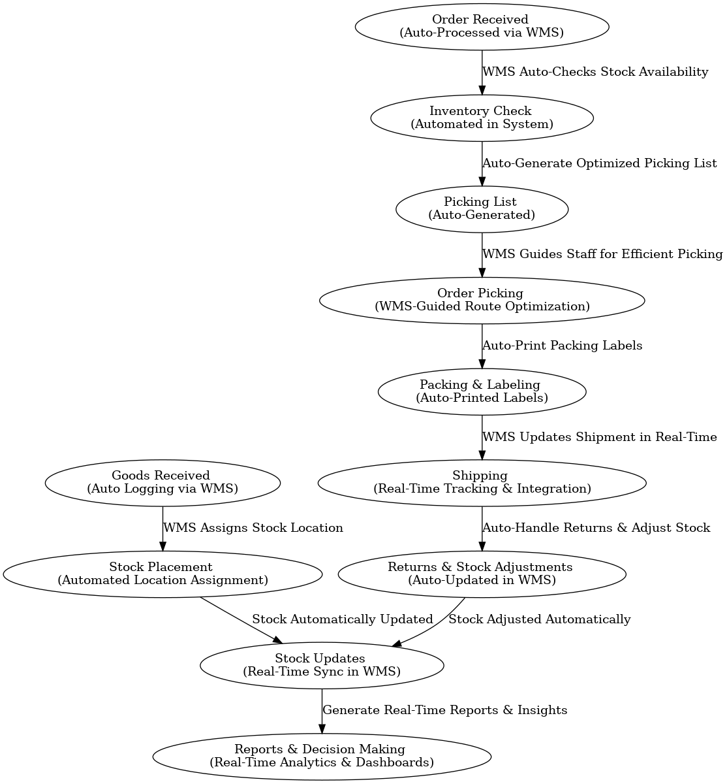

**9. Business Requirements**

The following are the key business requirements categorized into functional and non-functional needs:

| **ID** | **Requirement** | **Description** |
| --- | --- | --- |
| BR-01 | Goods Receiving Automation | Automate inbound stock logging using barcode/RFID scanning. |
| BR-02 | Inventory Tracking | Enable real-time stock tracking and movement updates. |
| BR-03 | Order Processing | Automate order verification and fulfilment workflows. |
| BR-04 | Picking & Packing Optimization | Provide system-guided picking routes and automatic packing label generation. |
| BR-05 | Shipping & Logistics | Integrate with carriers for real-time tracking and shipment status updates. |
| BR-06 | Returns Management | Automate returns processing and stock adjustments. |
| BR-07 | Reporting & Analytics | Generate real-time reports on inventory, order status, and warehouse performance. |

**9.1 Non-Functional Requirements**

| **ID** | **Requirement** | **Description** |
| --- | --- | --- |
| NFR-01 | System Performance | WMS should handle high transaction volumes with minimal latency. |
| NFR-02 | Security & Access Control | Implement role-based access and data encryption. |
| NFR-03 | System Integration | WMS must integrate with ERP, CRM, and logistics partners. |
| NFR-04 | Scalability | The system should support future expansion to multiple warehouse locations. |
| NFR-05 | User Experience | The interface must be user-friendly with minimal training required. |

**10. Appendices**

**10.1 List of Acronyms**

| **Acronym** | **Definition** |
| --- | --- |
| WMS | Warehouse Management System |
| ERP | Enterprise Resource Planning |
| RFID | Radio Frequency Identification |
| BRD | Business Requirements Document |
| FSD | Functional Specifications Document |
| SRS | System Requirement Specification |
| USD | Use case Document |
| UAT | User Acceptance Testing |
| KPI | Key Performance Indicator |
| SKU | Stock Keeping Unit |
| API | Application Programming Interface |
| SLA | Service Level Agreement |

**10.2 Glossary of Terms**

| **Term** | **Definition** |
| --- | --- |
| Warehouse Management System (WMS) | A software application that helps manage warehouse operations, including inventory tracking, order fulfilment, and shipping. |
| Order fulfilment | The process of receiving, processing, and delivering customer orders. |
| Inventory Tracking | The method used to monitor stock levels and movement within the warehouse. |
| Picking & Packing | The process of selecting items from inventory and preparing them for shipment. |
| Barcode Scanning | A technology used to quickly capture product details for tracking. |
| RFID | A technology that uses electromagnetic fields to automatically identify and track tags attached to objects. |
| ERP Integration | Connecting the WMS with an ERP system for seamless data exchange. |
| User Acceptance Testing (UAT) | The final phase of testing where end-users validate the system before deployment. |

**10.3 Related Documents**

* **Business Requirements Document (BRD)** – Defines business needs and high-level requirements.
* **Functional Specifications Document (FSD)** – Outlines detailed functional requirements and system design.
* **System Architecture Document** – Describes the technical architecture of the WMS application.
* **Test Plan & Test Cases** – Defines the testing strategy and cases for validating the system.
* **User Manual & Training Guide** – Provides instructions for warehouse staff on using the WMS.