# **Waterfall Model Documents**

**Document 6** - Please prepare a use case diagram, activity diagram and a use case specification document

1. **Use case Diagram**

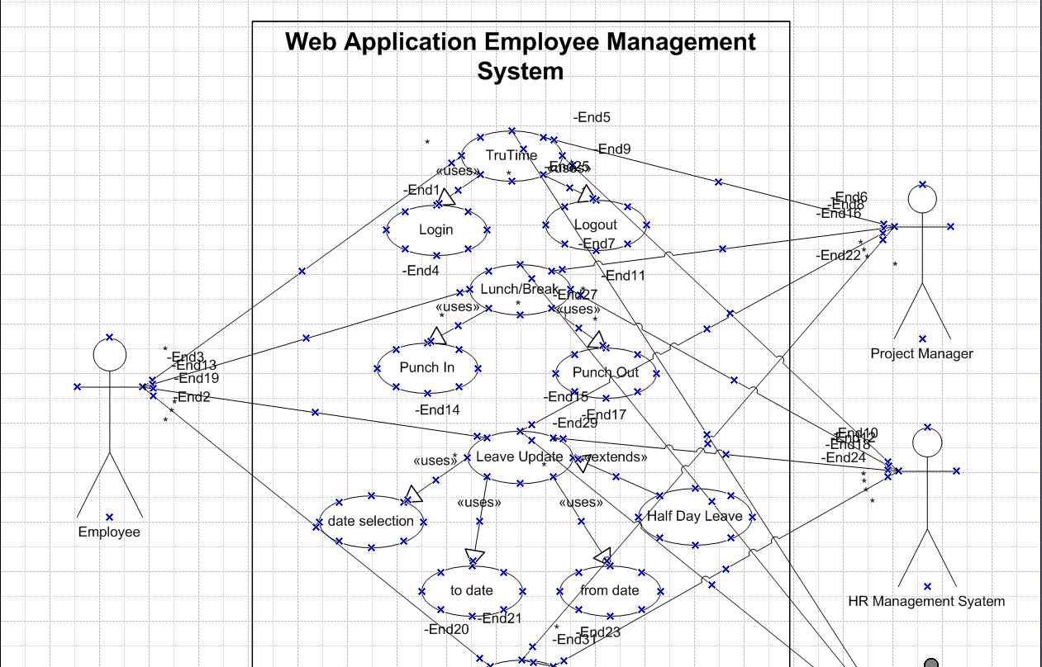

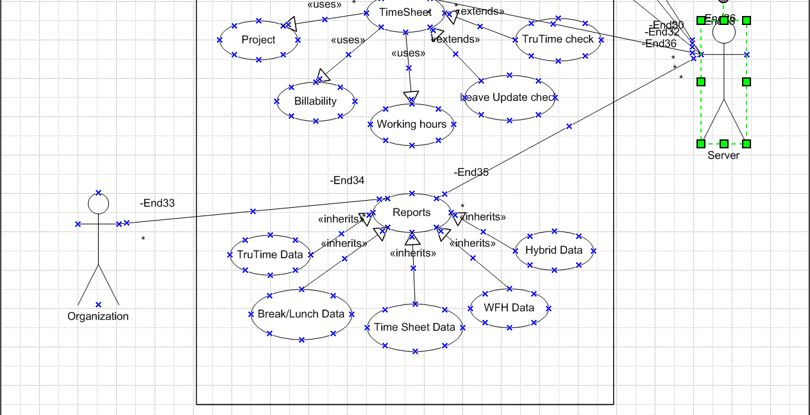

1. **Activity Diagram**
   1. **Login/Logout (TruTime)**

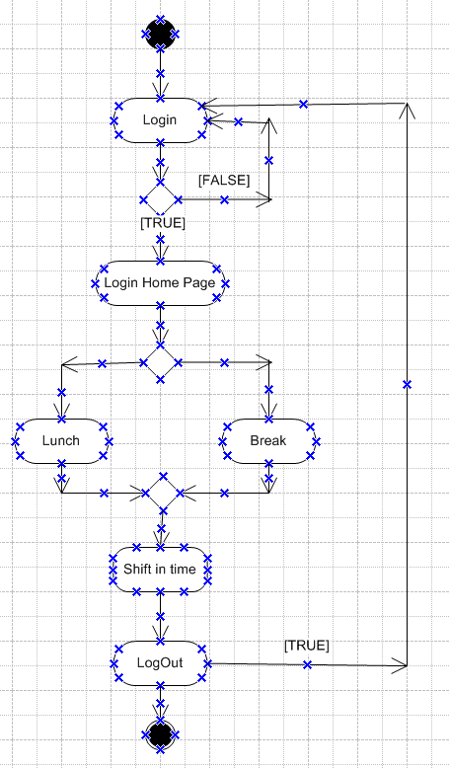

* 1. **Leave Request**

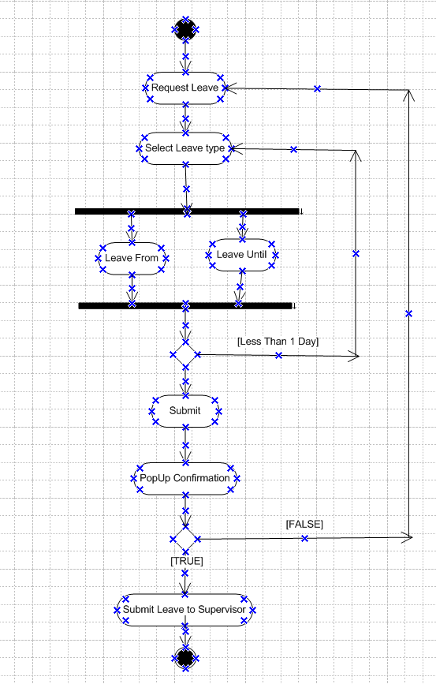

* 1. **Submit Timesheet**

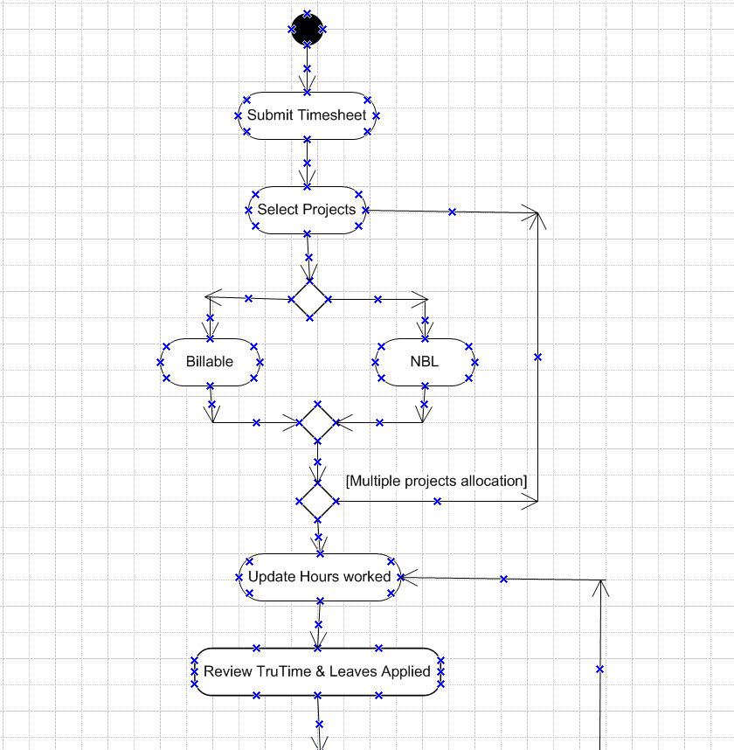

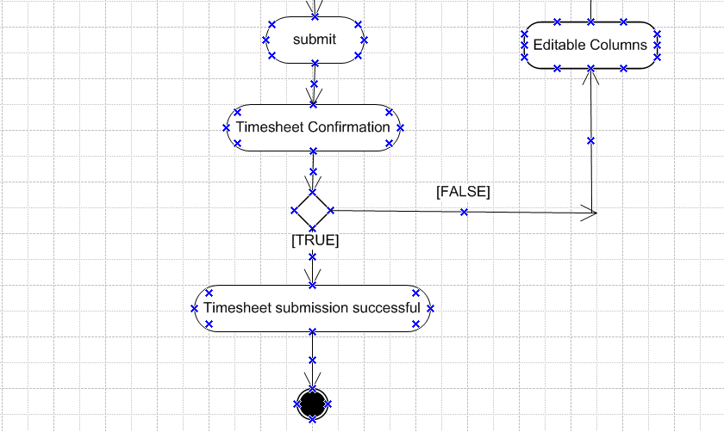

1. **Use case specs:**

|  |  |  |  |
| --- | --- | --- | --- |
| Use Case ID | DC001 | | |
| Use Case Name | User Login Process Flow | | |
| Created by | Mr. Arihant | Created On: | 03-03-2025 |
| Last Updated By | Mr. Arihant | Las Updated On: | 08-03-2025 |
| Actor | Existing Employees | | |
| Description | User be able to login to the portal | | |
| Pre Condition | Valid Employee ID and Password | | |
| Post Condition | User will land in to TruTime Page | | |
| Normal process flow/Basic Flow/Happy Path | **Step 1:** User to Login : https://onecognizant.com **Step 2:** User enters the user ID/Employee ID **Step 3:** User Updates Password **Step 4:** User clicks on Submit button  **Step 5:** User lands to the login page and TruTime starts calculating | | |
|  |
|  |
|  |
| Alternate Flow | Step 1: User to Login : https://onecognizant.com Step 2: User enters the user ID/Employee ID Step 3: User Updates Password Step 4: User clicks on Submit button Step 5: For invalid Password, User to click forgot password button | | |  |
|  |
|  |
|  |
|  |
| Exceptions | If the user is new, then user cannot login, they need to reach HR | | |  |
| Frequency | High | | |  |
| Assumptions | Standard Internet connection , Laptop and Desktop | | |  |
| Dependencies | Cannot relogin without logout in another systems | | |  |

|  |  |  |  |
| --- | --- | --- | --- |
| Use Case ID | DC002 | | |
| Use Case Name | Request Leave | | |
| Created by | Mr. Arihant | Created On: | 03-03-2025 |
| Last Updated By | Mr. Arihant | Las Updated On: | 08-03-2025 |
| Actor | Existing Employees/User | | |
| Description | User be able to submit leave request to the supervisor thru the portal | | |
| Secondary Actor | User’s Supervisor, Server, HR management system | | |
| Pre Condition | User should have logged in to the portal already | | |
| Post Condition | Supervisor should have received email notification post leave request submission | | |
| Normal process flow/Basic Flow/Happy Path | **Step 1:** User to Click button next to "Request Leave" **Step 2:** User to choose the type of leave he/she is taking from the leave type dropdown **Step 3:** User to choose from and to date rage **Step 4:** User clicks on Submit button  **Step 5:** User get confirmation popup on leave request and actions it.  **Step 6:** A notification will be sent to supervisor on leave request from user | | |
|  |
|  |
|  |
| Alternate Flow | Step 1: User to Click button next to "Request Leave" Step 2: User to choose the type of leave he/she is taking from the leave type dropdown Step 3: User to choose from and to date rage Step 4: User clicks on Submit button  Step 5: User get confirmation popup on leave request and actions it.  Step 6:A notification will be sent to supervisor on leave request from user | | |  |
|  |
|  |
|  |
|  |
| Exceptions | If the user wants to take half day leave, then they can check in the box with the date selected | | |  |
| Frequency | Medium | | |  |
| Assumptions | Standard Internet connection, Laptop and Desktop, user must have leave balance | | |  |
| Dependencies | NA | | |  |

|  |  |  |  |
| --- | --- | --- | --- |
| Use Case ID | DC003 | | |
| Use Case Name | Submit Timesheet | | |
| Created by | Mr. Arihant | Created On: | 03-03-2025 |
| Last Updated By | Mr. Arihant | Las Updated On: | 08-03-2025 |
| Primary Actor | Existing Employees/User | | |
| Secondary Actor | Server, HR Management System | |  |
| Description | User be able to submit timesheet for approval | | |
| Pre Condition | User should have logged in to the portal already User's TruTime and Approved Leave (if any for the week) will be populated automatiucally | | |
| Post Condition | User should have submitted timesheet for the week for approval | | |
| Input | Updating the number of hours worked for the week | | |
| Output | Maximum tally of 45 hours per week on time sheet submission | | |
| Business Rule | User cannot exceed more then 9 hours of time per day | | |
| Normal process flow/Basic Flow/Happy Path | **Step 1:** User to Click button next to "Submit Timesheet" from home page **Step 2:** User to choose the project he/she is allocated to from the dropdown **Step 3:** User to choose Billable/NBL accordingly from the check box **Step 4:** User update the hours worked per day in each input box **Step 5:** User to submit the timesheet **Step 6:** User will confirm the time sheet submission from the popup box **Step 7:** User will get timesheet submission confirmation | | |
|  |
|  |
|  |
| Alternate Flow | Step 1: User to Click button next to "Submit Timesheet" from home page Step 2: User to choose the project he/she is allocated to from the dropdown Step 3: User can click + button if they are allocated to multiple projects Step 4: User to choose Billable/NBL accordingly from the check box Step 5: User update the hours worked per day in each input box Step 6: User to submit the timesheet Step 7: User will confirm the time sheet submission from the popup box Step 8: User will get timesheet submission confirmation | | |  |
|  |
|  |
|  |
|  |
| Exceptions | User cannot undo if time sheet is submitted | | |  |
| Frequency | High | | |  |
| Assumptions | Standard Internet connection , Laptop and Desktop, TruTime Compliance | | |  |
| Dependencies | Fetching the TruTime and Leave data to auto populate and tally the hours | | |  |

**Document 7** - Screens and pages

1. Home page / Login Page

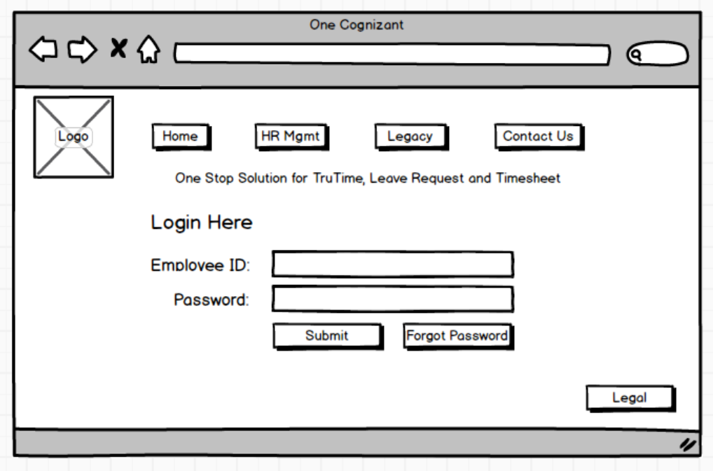

1. TruTime Page

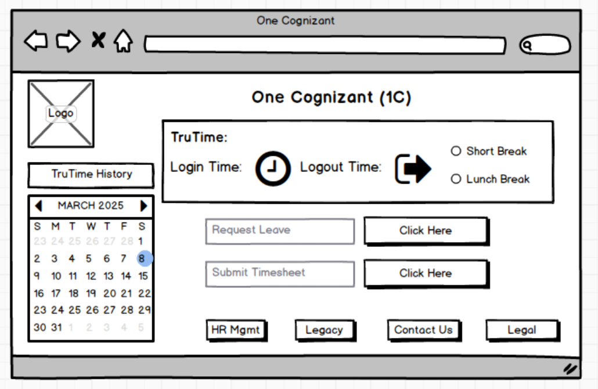

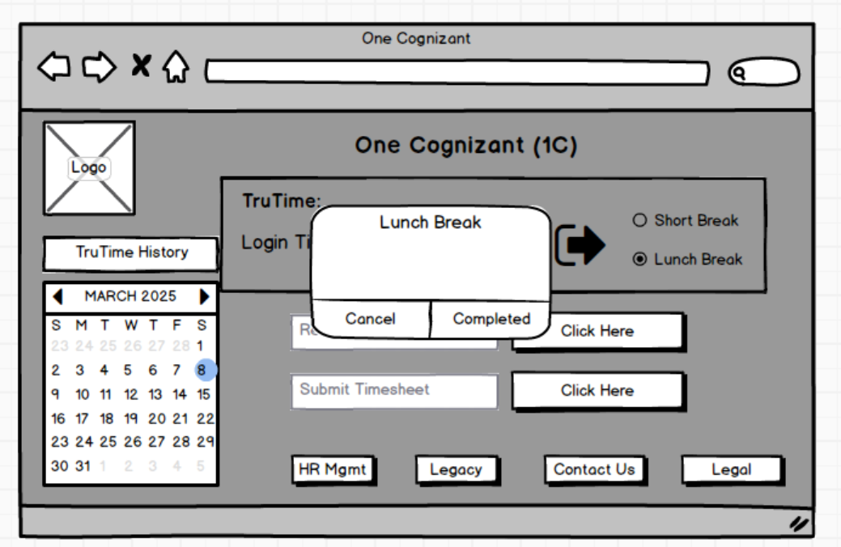

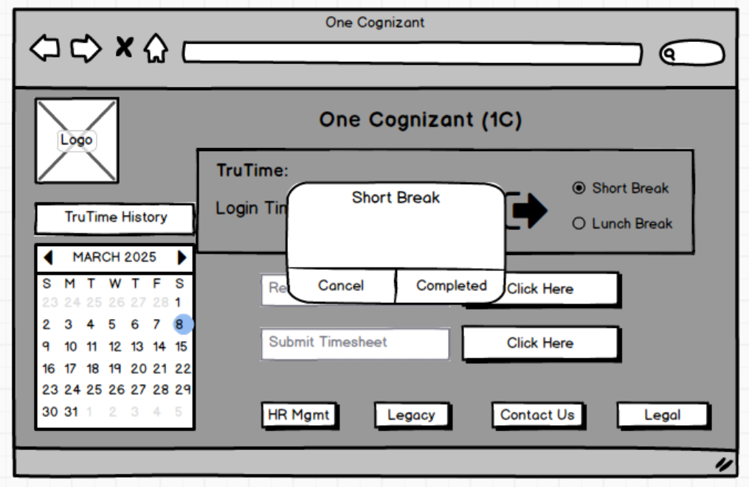

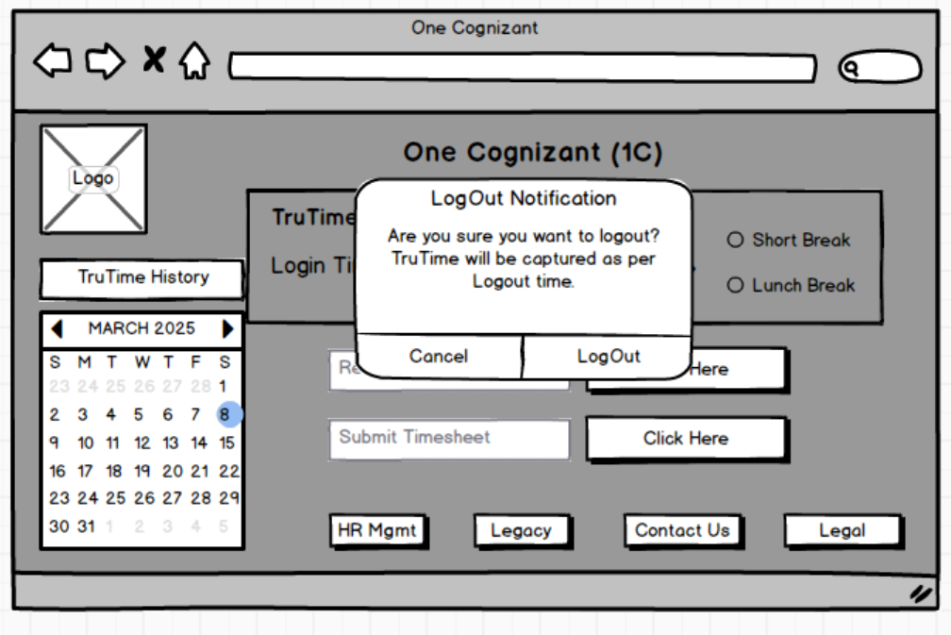

1. Request Leave Page

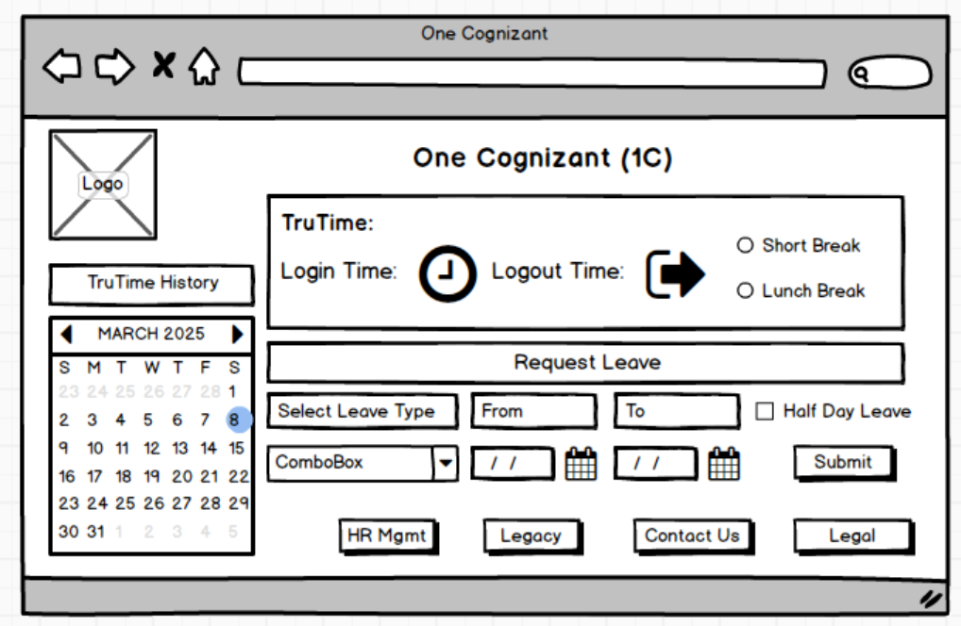

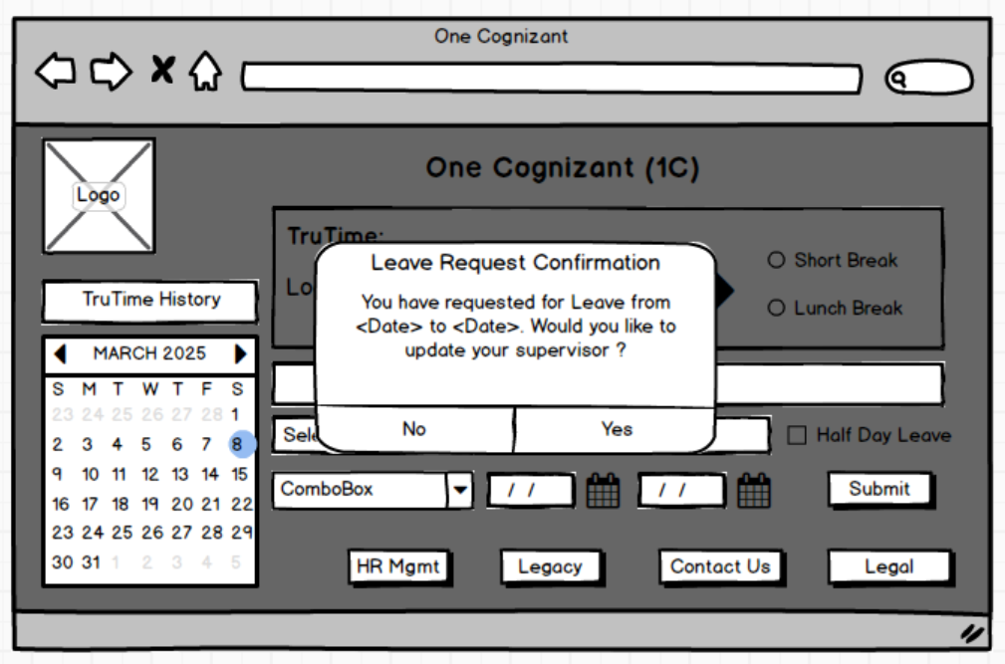

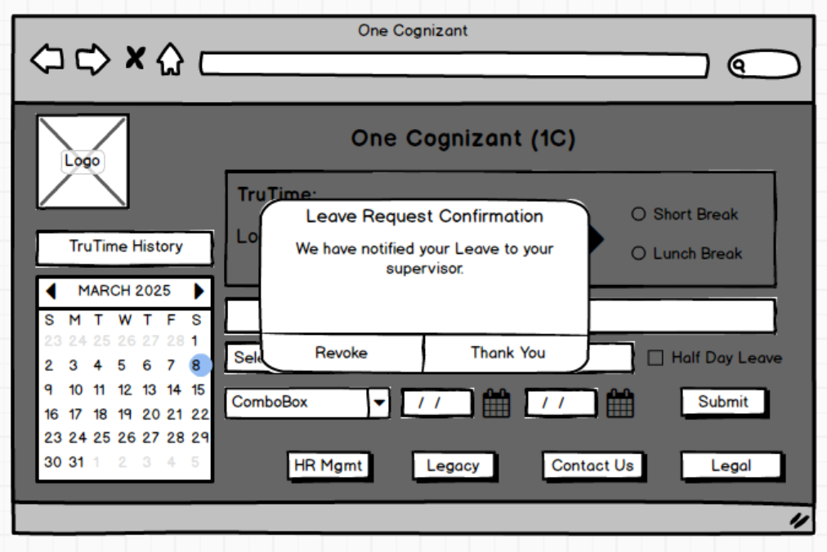

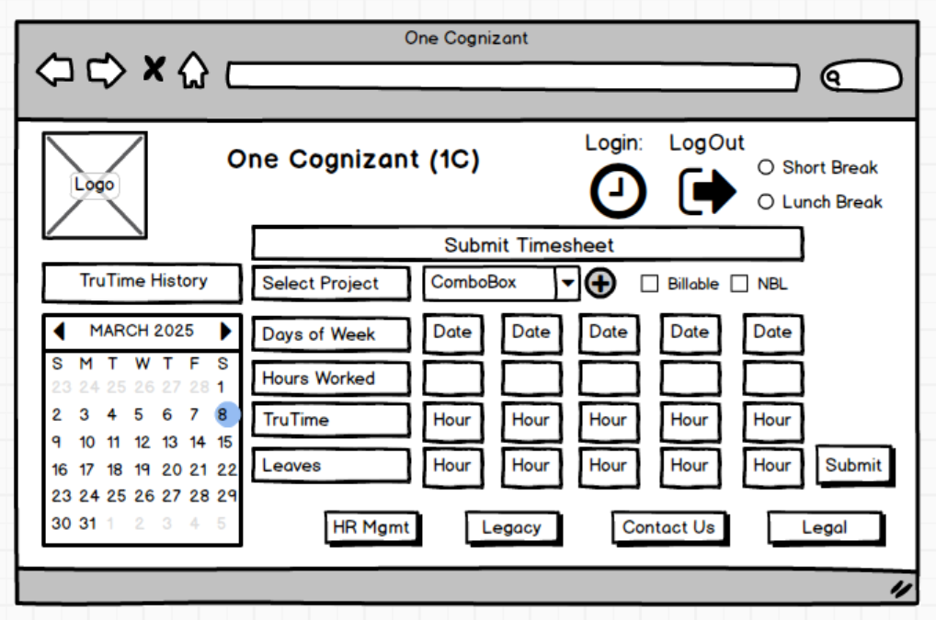

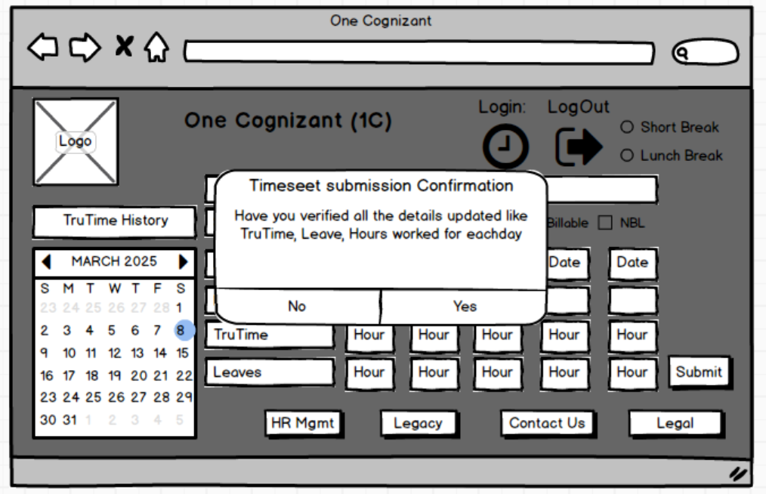

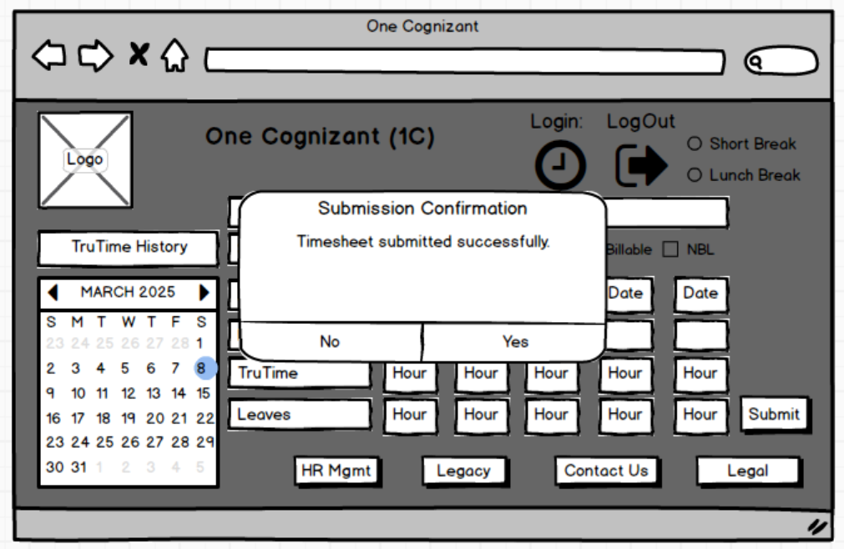

1. Reports Page

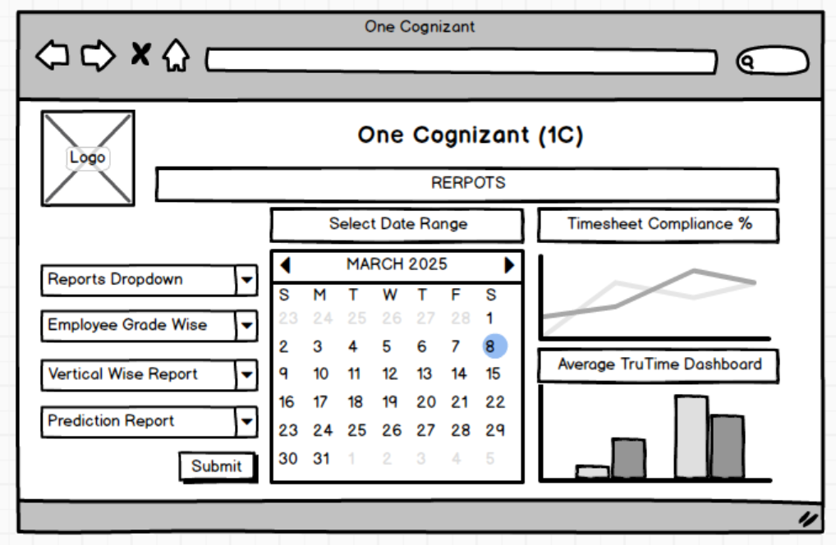

**Document 8** - Tools-Visio and Axure

|  |  |
| --- | --- |
| **Visio** | **Axure** |
| Best for creating static diagrams and flowcharts with ease of use and integration with Microsoft Office | Best for creating interactive prototypes and wireframes with advanced features for UX/UI design |
| Wide verities of widgets can be seen and used | Very limited when it comes to choosing of widgets |
| Cannot test with dummy data by inputting values | Can test with dummy data by inputting values |
| Ease of use and user friendly | Ease of use and yet non user friendly |
| Cannot prototype but can give only view on UI | Can prototype as per client requirement |

**Document 9** - BA experience

1. **Requirement gathering:**
   1. I certainly used few of the elicitation techniques to understand the core needs of the client. We used workshops, brainstorming, focus groups etc. This indeed helped us to achieve the objective of the project
   2. I also planned to assign a secondary POC from the stakeholder side that in case the primary stakeholder is unavailable, we could reach the other to get the inputs requested sooner as possible that there won’t be any delay due to unavailability
   3. I validated all the requirement and gathered one by one. This stage I removed all the duplicate requirement and made those unique
2. **Requirement Analysis:**
   1. We drew the UML diagram to understand better and neat in a visual way
   2. We also drew activity diagrams to understand the flow the client is required
   3. We then communicated the UMLs to the design and development team and took their concurrence if they have any other suggestion. I took their suggestions and implied if that were genuine and informed the client on any minor change or modification
   4. Then started preparing the BRS and SRS documents
3. **Design:** 
   1. I presented the requirements to the design team with the help of UMLs and we started preparing the test cases
   2. We prepared positive test cases and negative tests cases for all requirement to ensure system reacts to the user inputs correctly.
   3. Later, we communicated the client on the design documents for their view and signoff
   4. We got the signoff from the client after some modification in the testcases and prepared the new ones as per client inputs
   5. Later which we prepared test data for testing
   6. As we are doing all of these activities, we were updating the RTM to ensure smooth process and know where are we and what are we doing. This also came in handy when client asked for the status on the project
4. **Development:**
   1. At the initial of this stage, I conducted a session with the development team on the requirement, we included senior team members only. We made them understand the core requirement for the project
   2. I clarified all the questions that was raised in this session and ensured we are on right track.I was able to tackle some of the developers who were not agreeing on certain conditions of the requirement citing the criticality of the client and its importance. Requested to come up with alternatives that could satisfy the client
   3. Conducted reviews and meeting regularly to understand the project current status and ensure the timelines. Noted down actions points and recorded MoM of each of these meeting
   4. Any requirement the development team was in need, I went ahead with the respective stakeholder and ensured that are fulfilled within timelines
   5. Ensure unit tests are cleared with 100% accuracy
   6. Conducted client meeting as well in this stage so that we engage the client to know where we are doing in this project. While there were some challenges in conducting the meeting, we managed to go thru it by recording the meeting that whoever has missed could review the recordings later. This helps us in a way long
5. **Testing:**
   1. At first, I conducted a meeting with the testers and included some of the senior developers as well and explained the project strategy and goal
   2. Then prepared test cases of each and every senecios and documented well for all the testers to perform
   3. We then had rigours testing for all the coding developed. I also made some of the developers to be available at the ground level to clear tester clarification in case of anything that comes
   4. Prepared a document on the testing results. This has to be 100% of the efforts which is out ultimate to satisfy the client and sent the updated RTM to the client
   5. Once client has verified the reports, I requested all the team member to get ready for UAT and to prepare their UAT requirement
6. **Deployment:**
   1. I conducted a formal meeting with client and present the RTM that all the development/testing completed and so the UAT signoff document
   2. I have shared the project closure documents along with the user manuals prepared for client in case of any clarification
   3. I requested the client for a training session with all of their required members and conducted a formal training session and briefed the importance of it
   4. A formal project closure document was signed off by the client to deploy the new application that was developed for all the employees in the organization for TruTime, leave request and timesheet.
   5. This application was deployed to the client server/production server and that was also linked to all the client system for data analytics
   6. On the planned date, the application went live to all their employees.