**Vivek Kumar**

**Nurturing Process – Waterfall Deliverables – Part -2/2- V2D2 August 2024**

**Waterfall Model Documents**

**Waterfall Project – Part -2/2 – 100 Marks - Pass 60 %**

**Document 6- Please prepare a use case diagram, activity diagram and a use case specification document.  
  
Ans:**

**USE CASE DIAGRAM:**

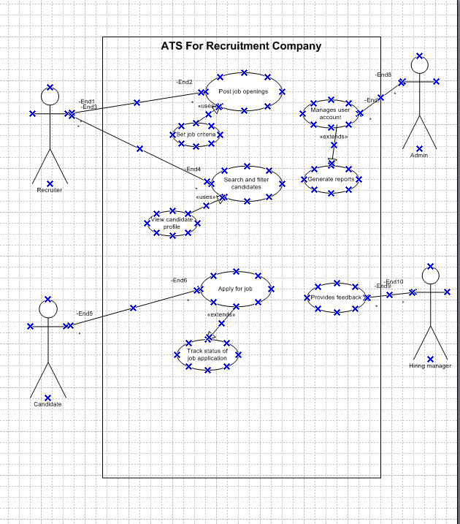

**ACTIVITY DIAGRAM:**



**Use Case Specification Document:**

|  |  |  |  |
| --- | --- | --- | --- |
| Use Case ID: | UIDOO1 | | |
| Use Case Name: | Candidate Application and Recruitment Process | | |
| Created By: | Vivek Kumar | Created By: | Vivek Kumar |
| Date Created: | 18/01/2024 | Date Created: | 18/01/2024 |

|  |  |
| --- | --- |
| Actor: | o HR Manager  o Recruiter  o Candidate  • Secondary Actors:  o Job Board Platforms (e.g., Monster, Indeed)  o Interview Panel |
| Description: | This use case describes the process of managing the candidate application lifecycle using an Applicant Tracking System (ATS). It includes job posting, candidate sourcing, application submission, resume screening, interview scheduling, feedback collection, and final decision-making. |
| Preconditions: | • Job description and requirements are finalized.  • ATS is configured and integrated with job boards.  • Candidate profiles are available. |
| Postconditions: | • Suitable candidates are hired and onboarded.  • Job posting is marked as closed. |
| Basic flow: | 1. Recruiter creates a job posting in the ATS. 2. Job is published on job boards and company portals. 3. Candidates submit applications. 4. ATS parses and stores resumes. 5. Recruiters review applications and shortlist candidates. 6. Recruiters contact shortlisted candidates. 7. Interviews are scheduled. 8. Feedback from the interview is collected. 9. HR extends an offer to selected candidates. 10. Job posting is closed. |
| Alternative Courses: | • A1: If a candidate is not reachable, the ATS notifies recruiters to try again later or mark as "Unable to Contact."  • A2: If no suitable applications are found, the job posting is updated or reposted to attract more candidates. |
| Exceptional flow: | • E1: Candidate withdraws application after shortlisting. Recruiters must move to the next best candidate.  • E2: Technical issues during resume parsing; ATS notifies the admin to rectify errors manually.  • E3: Interview panel member unavailable; reschedule interview with alternate members. |
| Input: | o Job descriptions  o Candidate applications  o Interview feedback |
| Output: | o Candidate shortlists  o Interview schedules  o Offer letters |
| Assumptions: | • Candidates actively check and apply for job postings.  • ATS is accessible by all actors without downtime.  • Job boards are integrated with the ATS. |
| Business rules: | • Only shortlisted candidates can be contacted.  • Automated rejection emails must be sent to unsuccessful candidates.  • Job postings expire after a predefined period unless renewed. |

**Document 7- Screens and pages:**

**1.Login page for ATS:**

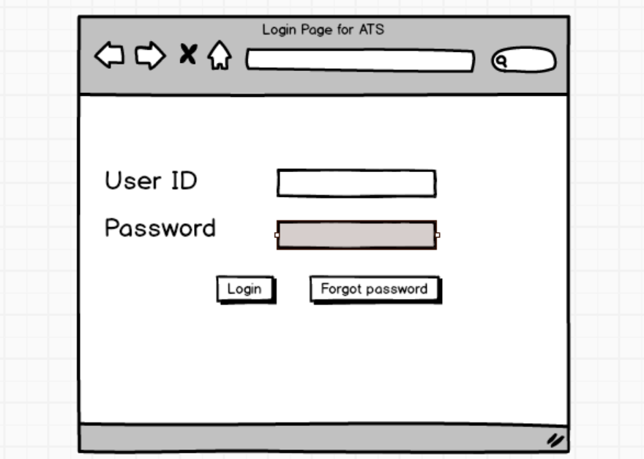

**2.Homepage for ATS:**

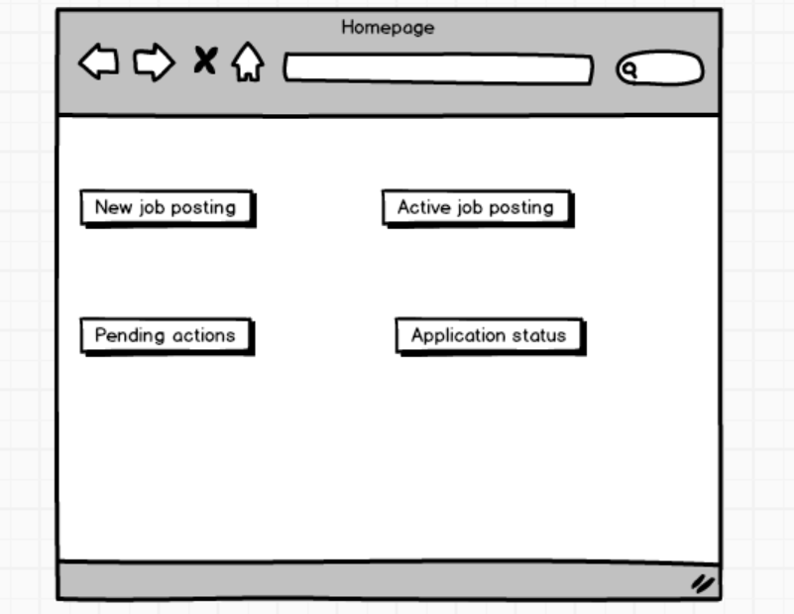

**3.Job posting screen:**

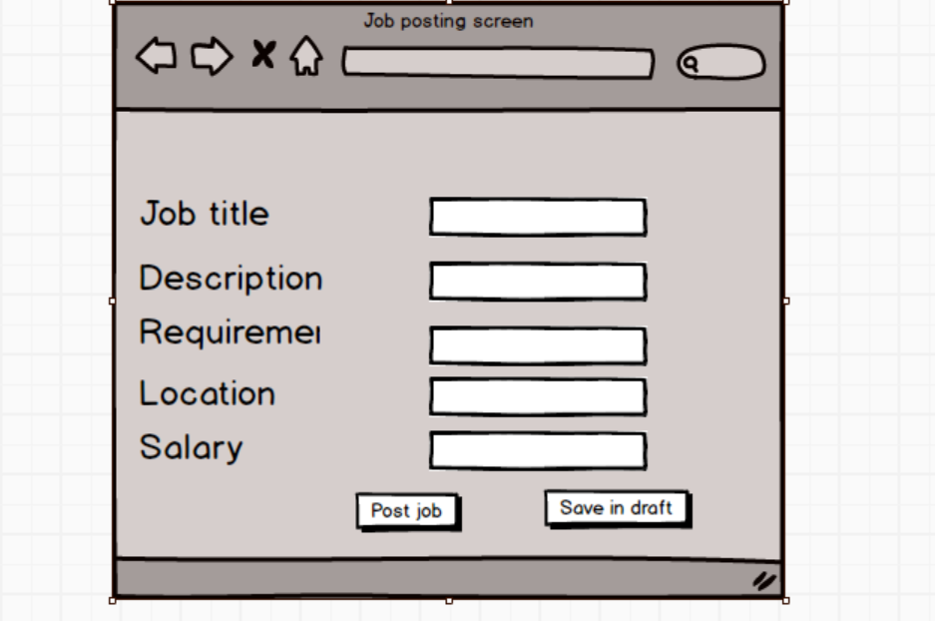

**4.Candidate management portal screen:**

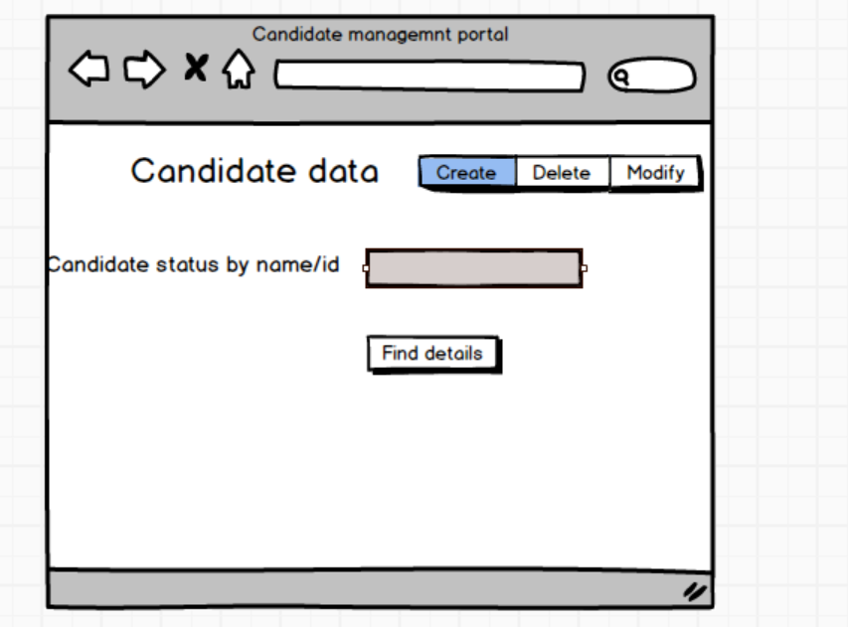

**5.Interview scheduling screen:**

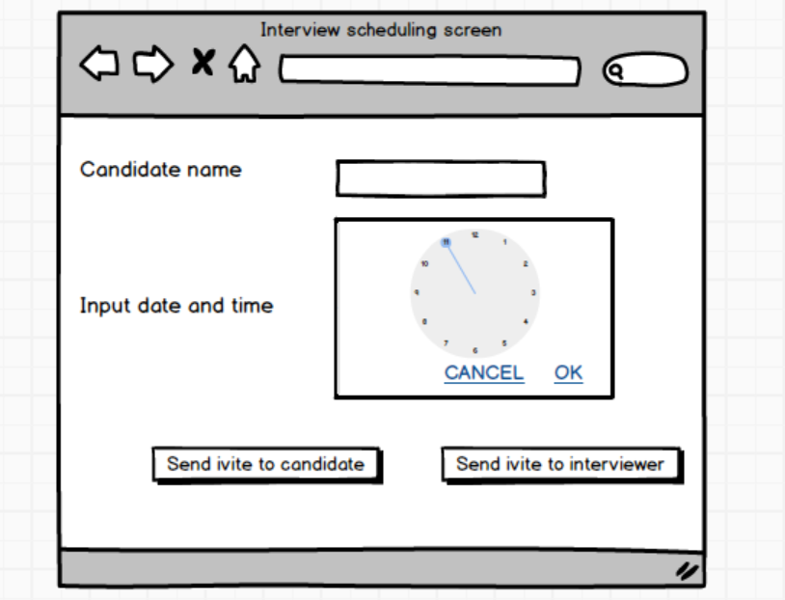

**Document 8- Tools-Visio and Axure Write a paragraph on your experience using Visio and Axure for the project.**

**Ans**: During the project, I had the opportunity to utilize both Visio and Axure as key tools for diagramming and prototyping. Microsoft Visio proved invaluable for creating clear and professional diagrams, such as use case diagrams and activity workflows, with its intuitive drag-and-drop interface and vast library of shapes. It enabled seamless communication of system processes to stakeholders and ensured alignment throughout the project lifecycle. On the other hand, Axure was instrumental in developing interactive mockups and prototypes of the ATS screens. Its robust features, such as dynamic panels and conditional logic, allowed for the simulation of real-world interactions, providing a tangible feel of the user interface and improving usability testing. Combining these tools significantly enhanced the documentation and visualization of the project, ensuring clarity and precision at every stage.

**__________________________________________________________________________________**

**Document 9- BA experience**

**Ans:  
  
My Experience as BA in the Following Phases:**

1. **Requirement Gathering:**
   * Conducted stakeholder interviews and workshops to gather detailed requirements.
   * Utilized the MOSCOW prioritization technique to categorize requirements.
   * Maintained open communication with the client despite limited availability, ensuring timely collection of information through alternate contacts.
   * Used prototyping to clarify and refine ambiguous requirements.
   * Validated requirements using FURPS (Functionality, Usability, Reliability, Performance, Supportability) criteria and eliminated redundancies to maintain clarity.
2. **Requirement Analysis:**
   * Developed detailed UML diagrams and process flows to provide a visual representation of requirements.
   * Created activity diagrams to outline key workflows and system interactions.
   * Collaborated with the team to review diagrams, addressing feedback and incorporating necessary revisions.
   * Documented all findings in the Business Requirement Specification (BRS) and Software Requirement Specification (SRS).
3. **Design:**
   * Converted use case diagrams into actionable test cases for QA teams.
   * Engaged with clients to review and approve design and solution documentation.
   * Created a comprehensive test case suite, ensuring inclusion of both positive and negative scenarios.
   * Prepared realistic test data and updated the Requirements Traceability Matrix (RTM) to align test cases with requirements.
4. **Development:**
   * Organized and facilitated Joint Application Development (JAD) sessions to align team efforts.
   * Provided ongoing clarification to developers regarding requirements and diagrams.
   * Addressed team conflicts through effective communication and one-on-one discussions, fostering a collaborative environment.
   * Ensured all sessions were recorded and shared with absent members, following up with individual discussions as needed.
5. **Testing:**
   * Collaborated with QA teams to create test cases based on use cases and business rules.
   * Performed initial high-level testing to verify core functionality.
   * Worked with clients to obtain test data and prepared for User Acceptance Testing (UAT).
   * Updated the RTM to ensure all requirements were covered in testing.
   * Secured client sign-off upon successful completion of UAT.
6. **Deployment:**
   * Compiled and forwarded the RTM as part of the project closure documentation.
   * Coordinated the creation and distribution of end-user manuals.
   * Planned and conducted training sessions for users, ensuring comprehensive participation.
   * Managed follow-up sessions to address user queries and ensure smooth system adoption.