# Capstone Project3– Part -1/2

**Q1.** Draw a Use Case Diagram - 4 Marks

**Answer:**

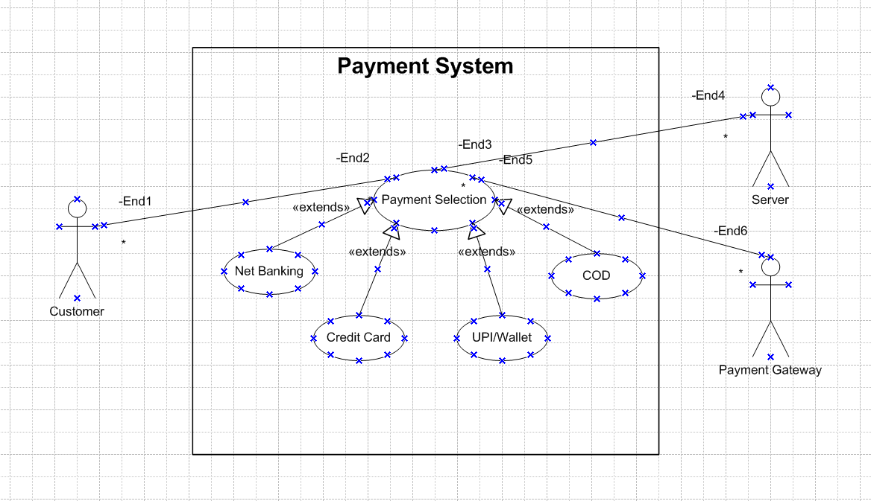

**Q2**. Derive Boundary Classes, Controller classes, Entity Classes. - 4 Marks

**Answer:**

**Boundary Class** – this is an interaction between the actor (customer) and system. This is a front-page system which an actor sees and does the operations. In this case study, customer interacts with the system for making the payment by selecting payment option as per the customer choice.

**Controller Class** – this is an intermediatory between the boundary class and the entity class which applies the business logic and act upon the decision made by an actor by retrieving data from the database. In this case study, when customer click any one method of payment, then controller class acts upon and route the webpage to the corresponding page. Like if customer chooses credit card, then it will display all input texts to update credit card credentials.

**Entity Class** – these are the database of objects and core data of almost all the information. Here we also have the core business logic calculation which controller class has to acts upon. In this case study, when a customer chooses the credit card payment method the entity class send the logic message to the controller class to get the card credentials to proceed further.

**Q3.** Place these classes on a three tier Architecture. - 4 Marks

**Answer:**

Boundary Class – Actor interacts with system – selecting payment like NetBanking, UPI, COD, CC

Application Layer

Controller Class – intermediate for application layer and database layer – applies business logic and represent the corresponding input text as per the customer selection.

Business Logic Layer

Entity Class – database layer – have data of customer, logical core value of the business, payment gateways as per the customer selection.

Database Layer

**Q4.** Explain Domain Model for Customer making payment through Net Banking - 4 Marks

**Answer:**

Domain modelling is a core data base modelling which is a conceptional method of identifying the core business logic, their structure and relationships. Here in this case study, we have illustrated with the net banking payment model.

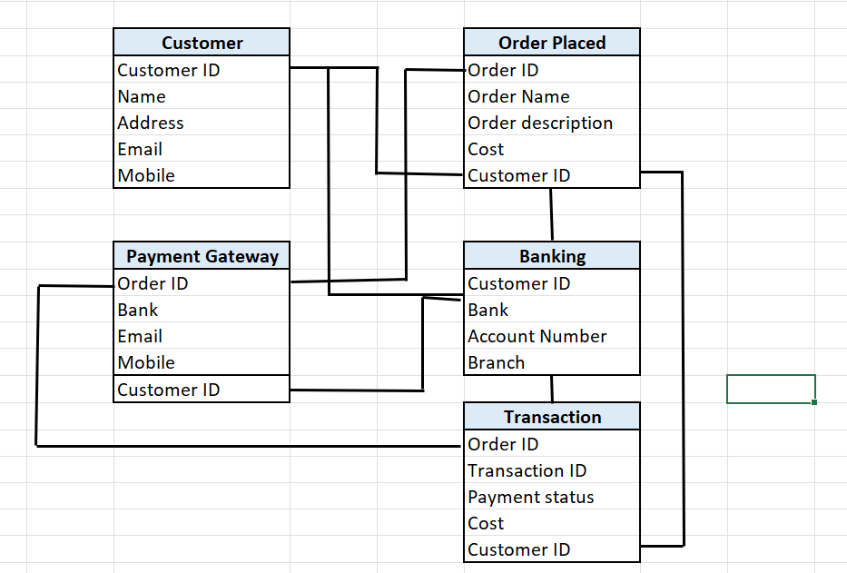

**Q5.** Draw a sequence diagram for payment done by Customer Net Banking - 4 Marks

**Answer:**

sequence diagram represents the interaction from an actor to the database with an intermediator.

Like in this case for making net banking payment as below.

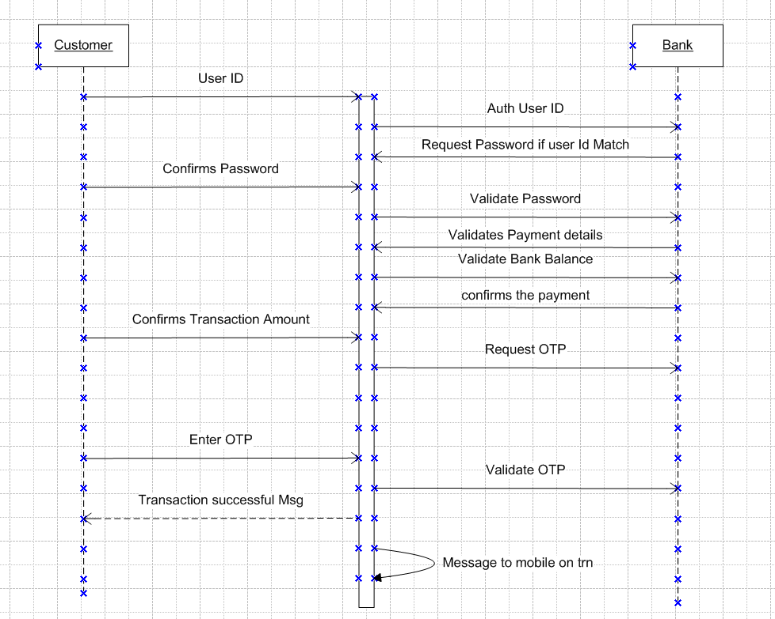

**Q6.** Explain Conceptual Model for this Case - 4 Marks

**Answer:**

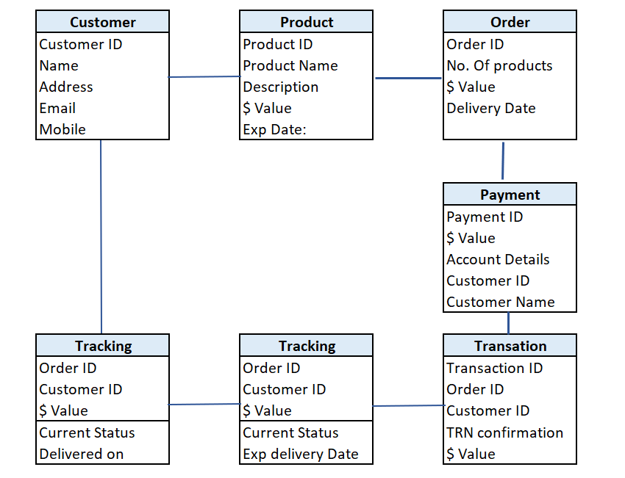

**Q7.** What is MVC architecture? Explain MVC rules to derive classes from use case diagram and guidelines to place classes in 3-tier architecture - 8 Marks

**Answer:**

MVC is Model View Controller. This is an architecture which represents system operation from user to the data base and its responses from data base to the user.

**Model** – this layer of architecture uses its business logic designed for gives desired output. Eg. If a user request to search for a product, model layer interacts with the controller layer from the database and display’s the product searched in the View layer.

**View** – in this layer, the user can look at the GUI of a web application for system interactions like giving inputs to the system. Eg., typing what we need for the system to show.

**Controller** – this layer of architecture has the core business logic built for all the operations that end user could do. It also has all the information of all the predicts, customer, etc. it acts as the intermediate between view and model. This is the brain of the application.

**In 3 tier architecture, we can place these MVC as follows;**

View layer can always be on application layer

Model layer can be in the business logic layer and

Controller can be on the database layer

**Some of the rules:**

1. Combination of One actor and a use case will have 1 boundary class
2. Use case will be part of controller class and
3. Actor inputs will be part of entity class

**Q8.** Explain BA contributions in project (Waterfall Model – all Stages) – 8 Marks

**Answer:**

We have multiple stages where BA involved in waterfall project.

|  |  |  |
| --- | --- | --- |
| **Stage** | **Activities** | **Resources** |
| Pre Project | Pre plan on the project which is recently initiated if the deal is nearing winning stage | BAs, PMs, Delivery head |
| Planning | look at the SOW to understand the client and their overall project documentation | BAs, PMs, Delivery head |
| Project Initiation | Initiate project based on the planning | BAs, PMs, Delivery head |
| Requirement Gathering | BA gather requirement fro the client with any of the best suitable requirement gathering method | BA, all Stakeholders |
| Requirement Analysis | Analyse the requirement and come up with the objective and the scope of the project | BAs, PMs, Delivery head, stakeholders |
| Design | Make the graphical representation of the objective | Designer, tech developer, PM, BA |
| Development | Develop the code to meet the objective | Tech developer, PM, Head, BA |
| Testing | testing the software functionality | Testers, BA, developers |
| UAT | Taking sign off from the client after successful User Acceptance Testing | Stakeholder, BA, Head, Developer, tester |

**Q9.** What is conflict management? Explain using Thomas – Kilmann technique – 6 Marks

**Answer:**

Conflicts management are simply known for it managing any conflicts that arise within the project in a constructive manner.

Thomas – kilmann technique is one of its best ways to manage conflicts within a project. These includes 5 steps and they are:

1. Identifying the conflicts
2. Discuss in detail
3. Accept the root cause of the conflicts
4. Come up with all the possible wat to resolve the conflicts in constructive manner
5. Also negotiate the solutions to avoid conflicts in future.

**Q10**. List down the reasons for project failure – 6 Marks

**Answer:**

There could be multiple reasons for the project failure and some of them could be;

1. Scope creep
2. Improper understanding on client objectives
3. Missing timeline – this could lead to penalty for the developing company
4. Team coordination/communication challenges
5. Lack of software availability to build the software
6. Shrinkage in the team often without back up
7. Lack of project documentation
8. Improper resource management
9. Less Stakeholder involvement
10. Avoiding possible risks and assuming thing will be handled

**Q11**. List the Challenges faced in projects for BA – 6 Marks

**Answer:**

Few of the challenges faced by BA are:

1. Unclear explanation of client requirement
2. Frequently having change requests
3. Meeting client expectation
4. Scope creep
5. Quality testing and assurance
6. Fixing meeting with all the stake holders
7. UAT sign off from client
8. Technology requirement and their issues
9. Managing team and its coordination
10. Keep all the communications up to date without any miss, Etc.,

**Q12.** Write about Document Naming Standards – 4 Marks

**Answer:**

For any documents we work upon has its own naming standards. Which includes name of the document, date, version number. This helps to identify the latest version also helps us to validate if we had to look back on initial requirement.

Example:

If we are working on a project ABCXX01 and if we had 3 different versions in different dates, then the document naming would look like:

Version1 : ABCXX01.01012025.V1.0

Version2 : ABCXX01.14012025.V2.0

Version3 : ABCXX01.27012025.V3.0

Sometimes if we have any minor change from the previous version to current version, the we can use the same version count of the file however the count in decimal can be used like below:

Version1 : ABCXX01.01012025.V1.0

Version1.1 : ABCXX01.01012025.V1.1

**Q13**. What are the Do’s and Don’ts of a Business analyst – 6 Marks

**Answer:**

|  |  |
| --- | --- |
| **Do's** | **Don't** |
| Get detailed inputs from the client for any requirement until you understand the objective fully | Never say NO to client and usage of words like by default. |
| Consult SMEs in case of any uncleared situation | Assuming things if we do not have clear understanding |
| Go with plain mind at the time of requirement gathering | Assuming as GUI when client explains his expectation |
| Ask multiple questions on existence until you are satisfied with the justification from client | Interrupting client when he explains the clarification or the expectation |
| Build relationship client and keep it professionally | Indulging with client for any personal requirement |
| Document everything and take client signoff | Coming to conclusion that client will agree without his signoff |
| Consult Head of delivery and discuss over meeting in case of any client escalation with the contract | reacting to client escalation and trying to give response without understand the root cause |

**Q14.** Write the difference between packages and sub-systems – 4 Marks

**Answer:**

|  |  |
| --- | --- |
| **Packages** | **Subsystem** |
| Collection of components which is not reuseable | Collection of components which is reuseable |
| For a specific kind of operation | For the larger group of operations |
| Application development uses packages | Product development uses subsystems |

**Q15.** What is camel-casing and explain where it will be used- 6 Marks

**Answer:**

These are mainly used in programming languages and used for naming the identifiers, variables and functions, etc. The 1st word of the camel casing would be in small letter and next all the words will have 1st letter as upper case and rest all smaller without any space. E.g., thisIsCamelCasing(), iPhone, eBay etc.

**Q16.** Illustrate Development server and what are the accesses does business analyst has? -6 Marks

**Answer:**

Development server is basically used at the time of project in development phase. System designer, developer, tester will have access to these servers and work on building the software, debug or test them. These all operations will be done within development servers. Once the software is fully completed and signed off, we move them to the production server.

As a BA, we may have limited access or read only access depending upon the client/company or compliance. As we oversee the process and monitor them not code them.

**Q17.** What is Data Mapping 6 Marks

**Answer:**

Data mapping is generally used to map one data from one system to the same data to the other systems without any data leakage. Example: if we need to map a list of customer data like customer name, mobile number, address from old system to the new system even if there are any slight name changes in the new system like customer first name, customer last name, Contact information, Billing address.

Here, the identifier name was address in the old system however, the new system has billing address. the data mapping will accurately map the corresponding values in each cell though we have slightly different identifiers.

**Q18.** What is API. Explain how you would use API integration in the case of your application Date format is dd-mm-yyyy and it is accepting some data from Other Application from US whose Date Format is mm-dd-yyyy 10 Marks

**Answer:**

API is Application Programming Interface. API will help a user to communicate to the system on any requirement and then it takes the requested system to the database or server and in turn, the server sends back the response to the APIs and API displays the response it gets from the server.

In India, the widely used date format is DD/MM/YYYY and hence the APIs can get the input text in the same format from the user and when the application is submitted the API can request the database and use data mapping logic to remap the DD/MM/YYYY to MM/DD/YYYY. The output will also be published as per the data mapping.

Or

The APIs itself can get the input text from the user in the MM/DD/YYYY format where we can mention the same in text field with a slight greyed text displaying the format it will accept/user to type. Like below:

|  |  |
| --- | --- |
| Date: | MM/DD/YYYY |