**Capstone Project Prep 1 Part 1**

**Decode the Project:**

**Project Idea:** To make online Agricultural Product Software to facilitate remote area Farmers to buy Agricultural Products

**Current Needs:** New Application should be able to accept the product (Fertilizers, Seeds and Pesticides) details from the manufacturers and should be able to display them to farmers.

**Overview of Project:** It’s an E-commerce based Project, Agricultural Products should display on website & farmers would buy the products online.

**Current Problem:** Facing difficulties in procuring fertilizers, seeds & pesticides, due to this problem crops production & type not as per expectations of farmers

**Question 1 – BPM - 5 Marks**

**Identify Business Process Model for Online Agriculture Store – (Goal, Inputs, Resources, Outputs,**

**Activities, Value created to the end Customer)**

**Answers:**

**Goals:** To facilitate farmers to buy seeds, pesticides and fertilizers from anywhere through internet connectivity.

**Inputs:** Requirement from farmers, online platform, product suppliers

**Resources:** Farm product supplier, farmers, online platform, Software, Laptop, Internet connectivity, Delivery methods

**Outputs:** Farmers satisfaction, Increase in Productivity, Time saving, Quick delivery of products

**Activities:** Services to Farmers, selling & buying products online

**Value:** Farmers satisfaction, Online delivery to Farmers

**Question 2 – SWOT - 5 Marks**

**Mr. Karthik is doing SWOT analysis before he accepts this project. What Aspects he should consider**

**as Strengths, as Weaknesses, as Opportunity and as Threats.**

**Answers:**

|  |  |
| --- | --- |
| **Strength:**  **-**Strong IT team  -Good knowledge about software development  -Budget is Good upto 2 Crors | **Weakness:**  **-**Less Time 18 months for entire SDLC  -Change in requirements  -Delivery to remote location |
| **Opportunities**  **-**Selling wide range of Farm Products  -Customer growth by satisfaction  -Product delivery to no. of different location | **Threats:**  **-**Improper Farmer technical expertise  -Lack of knowledge of products  -Change in delivery location  -Change in Farmers expectations |

**Question 3 – Feasibility study - 5 Marks**

**Mr. Karthik is trying to do feasibility study on doing this project in Technology (Java), Please help him**

**with points (HW SW Trained Resources Budget Time frame) to consider in feasibility Study.**

**Answer:**

**Feasibility Study of Following to be considered for implementation of Project:**

Technology:- Based on online platform, payment gateway, development of software & handover

Hardware:- Based on internet connection, products display, Delivery options

Software: Product information software , delivery management software & payment gateway

Resources: Software developments, product display team, manufacturing & marketing team, Business Analyst

Budget: Software development cost, team management costs, display & delivery cost

Time Frame: 18 Months budget timeframe, software & hardware trained resource time budget

For Feasibility study of **Technology, Budget & Time**

Feasibility study is Preliminary Analysis for solution alternatives or options to determine whether & how each option can provide on expected Business benefit to meet the Business need.

For Agricultural Product Store project following is the Initial Project Analysis:

1. Project Budget: 2 Crores
2. Project Time Frame: 18 Months
3. Trained Resources: 12 Resources

|  |  |  |  |
| --- | --- | --- | --- |
| A | Delivery Head | 1 | Mr. Karthik |
| B | Project Manager | 1 | Mr. Vandanam |
| C | Sr. JAVA Developer | 1 | Ms. Juhi |
| D | JAVA Developer | 4 | Mr. Teyson, Ms. Lucie, Mr. Tucker, Mr. Bravo |
| E | Network Admin | 1 | Mr. Mike |
| F | Database Admin | 1 | Mr. John |
| G | Testers | 2 | Ms. Alekya & Mr. Jason |
| H | Business Analyst | 1 | Me |

1. Hardware: 12 Laptops & chair/tables
2. Software: Licenses-12
3. **Technical Feasibility:**

For completion of Project , Software Developing Team is with sufficient support of

Hardware:12 Laptop for 12 Persons

Strong software team with Sr. Developer, Developer, Network Admin & Data base Admin

1. **Operational Feasibility:**

Budget Time is given 18 Months & time is divided into following activities as per Project Development Life cycle:

1. **Requirement Gathering: Business Analyst-2 Months**
2. **Project Planning: Project Manager, Sr. Developer-1 Month**

Project Development : It is opted as Waterfall Model so Project Developed & Tested after completion of all stages.

**Feasibility Study for Manufacturers: -5 Months**

1. Registration & Login Phase: 1 Month
2. Product Updating Phase in System: 2 Months
3. Billing & Payment: 1 Month
4. Delivery Phase: 1 Month

**Feasibility Study for Customers:-5 Months**

1. Registration & Login Phase: 2 Months
2. Product Selection Phase : 1 Months
3. Billing & Payment Phase: 1 Months
4. Delivery Phase: 1 Months
5. **Final Testing:-2 Months**

After Development Team implement codes as per requirement to Final Testing , these Testing should be conducted by Final Authoriser.

1. **Project Delivery & Training:-2 Months**

DH (Delivery Head) Mr. Karthik will work with development team for Delivery Testing & training.

1. **User Acceptance Testing:-1 Month**

Customer should ensure smooth running of software.

**Question 4 – Gap Analysis - 5 Marks**

Mr Karthik must submit Gap Analysis to Mr Henry to convince to initiate this project. What points

(compare AS-IS existing process with TO-BE future Process) to showcase in the GAP Analysis

Answer:

**As is Existing Process:**

-Difficulty in Farmers to buy products like Pesticides, Seeds & Fertilizers online

-No online platform to search for Farm products

-More loss in Farm production due to lack of farm products

-No communication with suppliers for purchase of products

**To be Future Process:**

-Sell & purchase of Farm products on line

-Product search by Farmers online & Purchase as per need

-Expansion in Business by adding no. of online delivery locations

-Increased investment in New Technologies to enhance farmers satisfaction

**Question 5 – Risk Analysis - 10 Marks**

List down different risk factors that may be involved (BA Risks And process/Project Risks)

**Internal Risks:**

-Dependancy on External suppliers from Product launches

-High cost of Agricultural products

-Remote location of Farmers

**External Risks:**

-Competition of online delivery to farmers

-changes in government regulations & policies that affect the E-commerce industry

**BA Risks:**

-BA not friendly with Domain

-Not understanding about the portal

-Continuous change in stakeholder requirements

**Project Based Risk:**

-Scope Risk

-Stakeholder Risk

**Question 6 – Stakeholder Analysis (RACI Matrix) - 8 Marks**

**Perform stakeholder analysis (RACI Matrix) to find out the key stakeholders who can take**

**Decisions and Who are the influencers**

Answer:

|  |  |  |  |  |  |  |  |  |
| --- | --- | --- | --- | --- | --- | --- | --- | --- |
| **RACI Matrix: R(Responsible), A(Accountable), C(Consulted), I(Informed)** | | | | | | | | |
| Tasks | **Project Sponsor/ Busi.**  **owner** | **Key Stake-holder** | **Project Manager** | **System Architecture** | **Development Lead** | **Testing** | **Implementation** | **BA** |
|  | Mr.Henry  Pandu/ Dooku | Mr.Peter/ Kevin/Ben | Mr.Vandanam | Java Develop. Mr.Teyson/ Lucie/Tucker | Sr. Java Develop.  Ms. Juhi | Mr.Jason/Alekya | Database Handler Mr.Karthik | Self |
| **Requirements Gathering** |  | C (Consulted) | A (Accountable) | A  (Accountable) | A  (Accountable) |  |  | R  (Responsible) |
| **Requirement Analysis** |  |  | I  (Informed) |  |  |  |  | R  (Responsible) |
| **Development (Software)** |  |  | R  (Responsible) | R  (Responsible) | A  (Accountable) |  |  | C  (Consulted) |
| **Testing (Initial)** |  |  | R  (Responsible) |  | I  (Informed) | R  (Responsible) |  | I  (Informed) |
| **Implementation** |  |  |  |  | I  (Informed) |  | R  (Responsible) | R  (Responsible) |
| **UAT (Final Testing)** | I(Informed) |  | R  (Responsible)/A |  |  |  |  | C  (Consulted) |

**Question 7 – Business Case Document - 8 Marks**

**Help Mr Karthik to prepare a business case document**

**Answer:**

Business Case Documents is prepared by Answering Following Questions:

1. Why is project initiated?
2. What are the current Problems?
3. With this project how many problems could be saved?
4. What are resources required?
5. How much organizational change is required to adopt this technology?
6. What is the time frame to recover ROI?
7. How to identify stakeholders?

**Business Case Document:**

|  |  |
| --- | --- |
| **Project Name:** | Online Agricultural Product Store |
| **Software Client:** | Soony Ltd. |
| **Project Manager:** | Mr. Vandanam |
| **Project Duration Time/Budget:** | 18 Months/ 2 Crores |
| **Business Owner:** | Mr. Henry |

1. **Project Initiated:**

Project Theme: To Build Online stores for Farmers to buy Farm products like Seeds, Pesticides and Fertilizers online

From different locations & Delivered to their Farm location.

**Project Definition:** The Online Agricultural products store is developed for Farmers to buy Farm Products online.

This Project Consists of Four Main Stages:

1. Registration & Login provided to Farmer
2. Product Display: Product from Manufactures will be displayed online to Farmers
3. Product Selection & Bill Payment simultaneously: Products will be selected by Farmers & Payment done online by UPI/Wallet/Card/COD
4. Delivery Phase: Products selected by Farmers will be delivered to directly at home of Farmers

Above Software will be developed by Client “Soony Ltd” within 18 Months.

1. **Current Problems:**
2. Farmers can not choose crops due to lack of particular seeds & they have to buy available stock nearby
3. Farmers can not increase productivity of crops due to lack of Fertilizers
4. Crops Quality not adequate due to lack of Pesticides
5. Products are buying with Higher Prices & Quality not ensured
6. Not Aware of New Pesticides , Type of Fertilizers & Good Quality Seeds
7. **Problems Resolution by Implementation of Project:**
8. Farmers can Buy Seeds as per their requirements for Crops
9. Farmers can buy Good Quality Fertilizers& Pesticides they want
10. Farmers can select Products according to their Budget, when Required, Types & Usages
11. Due to more comparison & availability of Products , Farmers can buy cost efficient products
12. Farmers come to know different types & New launch Farm Products
13. **Resources Required for Project:**
14. Hardware: Computer, Laptops, Mobiles
15. Software: Online Products Display Software to be developed by JAVA Developer
16. Internet Connectivity
17. Suppliers for Product Manufacturing
18. Bankers for Online Purchase Credit/Debit
19. Delivery System for Direct location of Farmers
20. **Organization Change Required for Project:**
21. No Organization change but New Organisation to form, New Suppliers, Database Platform , Software,

Banking, Delivery Organizations to add

1. Front End / Back End Software Developers to Work on New addition of Suppliers / Products / Bankers / Delivery

Companies

1. **Time Frame to Recover ROI:**
2. This Project Return On Investment (ROI) is Social & Economical

**Social ROI:** Large No. of Farmers will benefitted by Increasing Productivity, Quality & availability of Farm Product

At Rural locations.

**Economical ROI:**

By Considering Portals Total Operational Cost of 30-40 Lacks including Manpower, Banking, Delivery, Supplier payments we are getting Net Profit of 10 Lacks/ Annum, then ROI is as follows:

ROI=Net Profit in a Year/Total Project Investment Cost=10 Lacks/2 Crores=5%

So Project can be Debit Free in 20 Years by Considering ROI of 5%.

1. **Stakeholders for this Project:**

|  |  |
| --- | --- |
| **Business Stakeholders** | Mr. Pandu / Mr. Dooku |
| **Direct Stakeholder** | Mr. Henry |
| **Indirect/ Supporting Stakeholder** | Suppliers, Delivery, Banking Organization |
| **Key Stakeholder** | Farmers |
| **Internal Stakeholder** | PM: Mr. Vandanam, DM: Mr. Karthik, Sr. Java Developer: Ms. Juhi, Java Developer: Mr. Teyson /Tucker / Bravo / Ms. Lucie, Network Admin: Mr. Mike, DB Admin: John, Tester: Mr. Jason/Ms Alekya, BA-Self |
| **External Stakeholder** | Soony Ltd. |

**Question 8 – Four SDLC Methodologies - 8 Marks**

**The Committee of Mr. Henry , Mr Pandu , and Mr Dooku and Mr Karthik are having a discussion on**

**Project Development Approach.**

**Mr Karthik explained to Mr. Henry about SDLC. And four methodologies like Sequential Iterative**

**Evolutionary and Agile. Please share your thoughts and clarity on Methodologies**

1. **Sequential Methodology (Waterfall Model)**

It is most commonly used & old Methodology, It is also called Linear-Sequential as each phase must be completed before starting of next phase begin.

As it’s name, each stage is outcome of earlier stage & next stage comes after completion of previous step.

There are 7 Steps in Sequential Waterfall Model:

|  |  |  |
| --- | --- | --- |
| **Stage of Project** | **Documents prepared** | **Created By** |
| 1. Requirements Gathering | Business Requirements Documents | BA, PM |
| 1. Requirements Analysis | Functional Requirement Specif.,System Specif.Documents,System Req. Specification | BA, PM, Tech. Team |
| 1. Design | High Level Design Document / Architectural Design Document | Tech Team |
| 1. Development (Coding) | Low Level Design Document / Conceptual Design Document | Programmers, Developers |
| 1. Testing | Test Document | Testers |
| 1. UAT & System Integration | Test Results | PM |
| 1. Deployment & Implementation | User Manual, Training | PM, Release Engineers |

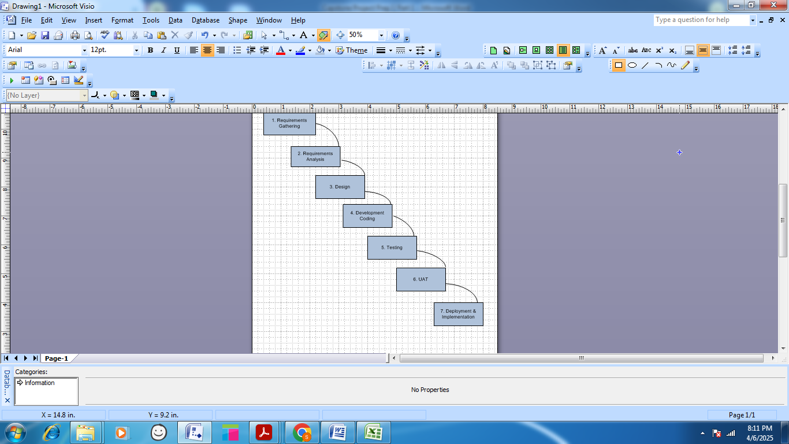

1. **Iterative Methodology-Rational Unified Process Model**

Rational Unified Process (RUP) is Iterative Software Development Process Framework.

It is based on set of Bulding Blocks or Content elements.

Contents Elements are categorized into:

1. Roles: Set of Related skills, competancies and Responcibilities
2. Work Products: Output of Tasks like documents, models,produced while working through process
3. Task: Unit of work assigned to Role that provides meaningful results

**Tasks in each Iterations are categorized into 9 disciplines:**

|  |  |  |
| --- | --- | --- |
| 1 | Business Modeling | Engineering Disciplines |
| 2 | Requirements Gathering |
| 3 | Analysis & Design |
| 4 | Implementation |
| 5 | Test |
| 6 | Deployment |
| 7 | Configuration & Change Management | Supporting Disciplines |
| 8 | Project Management |
| 9 | Environment |

**Four Project Life Cycles**

1. **Inception:**

Agreement among Team & Customer as what will be built

1. **Elaboration:**

To architecture & design needed to deliver agreed system behavior

1. **Construction:**

Iterative implementation of fully functional system

1. **Transition:**

Delivery, Defect correction & turning to ensure customer expectations

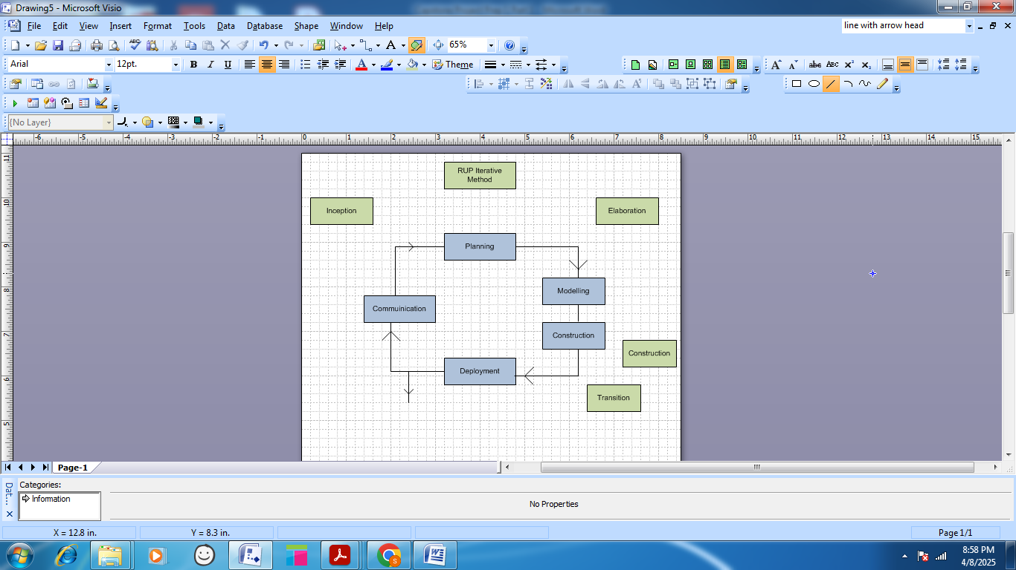

1. **Spiral Model:**

-Spiral Model combines both Iterative & Sequential Model.

-In Spiral Model initial Prototype is build & analyzed based on First Prototype Risk assessed & further actions taken to improve continuously.

-Every phase broke into Four Quadrants & each phase has requirement gathering, Risk Analysis, Build prototypes & Evaluation of Software performance.

-Radius of Spiral Model represents cost project

-Angular degree represents progress made in current phase

-Each Prototype phase is brocken into further small steps

Following steps are followed in Spiral Model Project Development:

1. New System requirements gathering

-Preliminary design is created for New System

-First Prototype is created from Preliminary design,

This prototype is evaluated & its weakness, strengths are identified.

2. These analysis of Ist prototype is considered improvement in 2nd Prototype

3. Next Prototype planned & designed

4. Testing is done to identify Risks

The Final Software is build from prototype & routine maintainence carried out to prevent large scale failures & reduce downtime.

1. **Agile (Scrum)**

-Agile methodology works on principle to break project into several small steps & review of each step properly implemented.

-Agile means ability of project to Quickly change project is continuously evaluated & improved throughout the life cycle.

Four Main Values of Agile:

1. Individuals & Interactions over processes & tools
2. Working software over comprehensive documentation
3. Customer collaboration over contract negotiation
4. Responding to change over following a plan

Twelve Principles of Agile Software:

Customer Satisfaction & Continuous Delivery

1. Agile’s highest priority is customer satisfaction through early & continuous delivery of valuable software.
2. Welcome changing requirements, even late in development is main advantage of Agile’s methodology
3. During completion of each sprint, software portion is delivered

Collaboration & communication:

1. Business people & developers must work together daily throughout the project
2. Motivate individuals & assign project to them & give support & trust the team members
3. Problems easily resolved due to Face to Face communication in each meeting
4. Working software is available for discussion & development

Simplicity:

1. Owners, Developers & Users are continuously able to see the project status & promote sustainable development.
2. Continuous attention to technical excellence & good design enhances agility.
3. To find the work not done & maximize efforts to get the workdone is simplicity

Flexibility & self organization:

1. The best architectures, requirements & design means self organization
2. At regular intervals , team reflects on how to become more effective then tunes and adjusts its behavior accordingly.

Description of Scrum:

Scrum can be implemented at beginning of project or when project is falling behind schedule.

Below are different stages of scrum:

1. Scrum Team:

Project resources are grouped as Scrum teams which comprises of BA’s , Developers & Testers

-Product Owner: Decides what to add in Scrum

-Scrum Master: Monitor performances of Team within sprint, issues will be raised & resolved by Scrum Master

B) Meeting:

-Sprint Planning Meeting: At beginning of each sprint

-Daily Scrum Meeting: Conduct each day for review status

-Sprint Review Meeting: Conduct at the End of sprint, team will demo completed stories to product owner & get it cleared

-Sprint Retrospective Meeting:At end of sprint & review about

What went well in Sprint?

What did not go well?

What are area’s of improvement to be taken in next sprint?

1. User Story Components:

-Epic: Epic is a set of user stories

-User Story: Epic breaks into themes & then to User Stories

During Sprint planning, User Stories are made in Jira Software which describes the requirement, action & acceptance criteria in software.

User stories are made by adding following information:

-As a (User/Customer) I want to (What is purpose) so that (What you can gain by this story)

Eg. As a Customer I want to Login to Net banking Site so that I can perform banking activities.

1. Product Backlog: Sprint Backlog

-It consists of all stories and all requirements User Stories that are parts of Sprint are called as Product Backlog.

E) Product Burndown Chart:

-A Product Burndown chart is graphical view of the remaining work left versus time in an iteration.

-A Burndown chart is often used to determine when work will be performed on a project or iteration.

**Question 9 – Waterfall RUP Spiral and Scrum Models – 8 Marks**

**They discussed models in SDLC like waterfall RUP Spiral and Scrum . You put forth your understanding on**

**these models**

Answer:

1. Waterfall (Sequential Model):

* Waterfall is sequential model & consists of 7 Steps:

Requirements Gathering

Requirement Analysis

Design

Development

Testing

User Acceptance Testing

Implementation

* This is the oldest & most systematic method of Project developments.

1. RUP (Rational Unified Process):

* Rational Unified Process is Iterative model & implementation of Final Software done by continued

Iterations on earlier small software by adding additional requirements.

This models consists of following phases:

1. Inception 2) Elaboration 3) Construction 4) Transition
2. Spiral:

Spiral model is beneficial for large projects where risks is key factor.

It consists of Building initial prototype by following 4 steps, Risk analysis is done to identify requirements & based on these requirements next prototype is build.

The model identify any small Risk that can affect failure of Big Project.

It is used in Defence / R&D of complicated devices.

1. Agile (Scrum) Model:

Scrum model is breaks into small sprints which have individual objective & final output.

After each sprint software element is tested.

Agile (Scrum) model works on identify & correct small issues in project & ability to change according to Risk identified during project.

Team can involve Business Stakeholder their feedback during development process.

1. V-Model:

This model is used where testing is necessary after each phase.

It is used in Mobile/App application where less budget is available & less complications.

**As Business Analyst which model do you think suit for this Farm product software development.**

**Case Study:**

1. The requirements are fixed in nature & each step requires detail documentation from Login, product addition, display, payment, delivery stages.

I would suggest waterfall model.

Decision to be taken based on no. of requirements added, available resources with in consideration expertise of project team & SME’s.

**Question 10 – Waterfall Vs V-Model - 5 Marks**

**20 Write down the differences between waterfall model and V model.**

**Answer:**

|  |  |  |
| --- | --- | --- |
|  | Waterfall Model | V-Model |
| Nature of Project | Big & Stable Project | Small & Low Risk Project |
| Steps | 7 Step that are come one after another  Application tested after all 7 steps implemented | Each step consists of testing after for Risk Analysis |
| Type | Linear sequential model as each step completed before next step | Development & testing happens sequential, each phase parallel done testing |
| Testing & Validation | Validation done after all development completed so if any need to change then implemented in first phase. | After each step, validation & testing done so no pending validation |
| Budget, time & cost | Waterfall less costly as due to linear development, one phase is operational at one time so less complex & low cost | V-Model, testing done after each phase so both development & testing operational so more costly & complex |
| Defects | Less defects in software as testing done after each phase completed | High defects & need to correct from Ist phase as testing done after development completed |

**Question 11 – Justify your choice - 3 Marks**

**As a BA, state your reason for choosing one model for this project**

**Answer:**

As a Business Analyst I will choose Waterfall model as

-Need for Farmers is defined & only No. of Products/Suppliers/Login Data of Farmers/Banking/Delivery options need to add

-I Waterfall after requirements gathering, analysis, design & development phase comes, this project requires more Design / development in portal.

-Testing can be done after each step completed & if any changes / improvements can be easily done in Ist phase.

On other side if I choose V-Model testing for each step is done on major time, so more emphasis given to testing & less to design & development.

Therefore considering both, I will choose Waterfall model for this project.

**Question 12 – Gantt Chart - 5 Marks**

**The Committee of Mr. Henry, Mr Pandu, and Mr Dooku discussed with Mr Karthik and finalised on**

**the V Model approach (RG, RA, Design, D1, T1, D2, T2, D3, T3, D4, T4 and UAT)**

**Mr Vandanam is mapped as a PM to this project. He studies this Project and Prepares a Gantt chart**

**with V Model (RG, RA, Design, D1, T1, D2, T2, D3, T3, D4, T4 and UAT) as development process and the**

**Resources are PM, BA, Java Developers, testers, DB Admin, NW Admin.**

**Answer:**

**Gantt Chart:**

|  |  |  |  |  |  |
| --- | --- | --- | --- | --- | --- |
| **Stages** | **Name** | **Position** | **Start Dt.** | **End Dt.** | **Days to complete** |
| **Requirements Gathering** | Self | BA | 1/6/2025 | 8/6/2025 | **7** |
| **Requirement Alalysis** | Self | BA | 9/6/2025 | 16/6/2025 | **7** |
| **Design Phase** | Vandanam  Self | PM BA | 17/6/2025 | 16/7/2025 | **30** |
| **Development Phase** |  |  |  |  |  |
| **Planning** | Ms. Juhi | Sr. Java Developer | 17/7/2025 | 24/7/2025 | **7** |
| **D1** | Mr. Teyson | Java Developer | 25/7/2025 | 2/8/2025 | **7** |
| **T1** | Mr. Alekya | Tester | 3/8/2025 | 6/8/2025 | **3** |
| **D2** | Ms. Lucie | Java Developer | 7/8/2025 | 14/8/2025 | **7** |
| **T2** | Mr. Jeson | Tester | 16/8/2025 | 19/8/2025 | **3** |
| **D3** | Mr. Tucker | Java Developer | 20/8/2025 | 27/8/2025 | **7** |
| **T3** | Mr. Alekya | Tester | 28/8/2025 | 1/9/2025 | **3** |
| **D4** | Mr. Bravo | Java Developer | 2/9/2025 | 9/9/2025 | **7** |
| **T4** | Mr. Jeson | Tester | 10/9/2025 | 13/9/2025 | **3** |
| **UAT** | Self | BA | 14/9/2025 | 21/9/2025 | **7** |
| **Implementation** | Karthik | DH | 22/9/2025 | 31/9/2025 | **7** |
| **Maintenance** | Vandanam  Self | PM | 1/10/2025 | 7/10/2025 | **7** |

**Question 13 – Fixed Bid Vs Billing - 5 Marks**

**Explain the difference between Fixed Bid and Billing projects**

**Answer:**

1. **Fixed Bid Projects:**

In Fixed Bid Projects Time & Scope is fixed.

For Bidding, Client provides all Data for Software development to Vendor such as Specification, Mockups, UAT, Users so that Vendor can easily Bid the estimated cost & time.

The Fixed Bid is less flexible & not easily adapt to changes as working time & Budget is fixed earlier.

The Model works with smaller projects, limited features & clear requirements.

1. **Billing Mode:**

In Billing Mode Vendor appoints Team members & SME for development of Project.

This Project has flexibility to change & New requirements can easily added.

Team Member/SME submits reports on Daily/Weekly basis so client can easily refer to work completed by vendor.

**Question 14 – Preparer Timesheets of a BA in various stages of SDLC - 20 marks**

1. **Design Timesheet of a BA**
2. **Development Timesheet of a BA**
3. **Testing Timesheet of a BA**
4. **UAT Timesheet of a BA**
5. **Deployment n Implementation Timesheet of a BA**
6. **Design Timesheet of a BA**

|  |  |  |  |  |  |  |
| --- | --- | --- | --- | --- | --- | --- |
| **Timesheet Made By** | | | **Business Analyst** | | | |
| **Project Manager** | | | **Mr. Vandanam** | | | |
| **Activity** | | | **Design Timesheet** | | | |
|  | | | | | | |
| **Day 1** | **Date:** | **Task** | | **Logging IN** | **Logging OUT** | **Hours** |
| 1 Day | 17.06.2025 | Prepare Use Case Diagram | | 8:00 | 9:00 | 1:00 |
|  |  | Allocating the Requirements | | 9:00 | 10:00 | 1:00 |
|  |  | Conduct Meeting With Stakeholders | | 10:00 | 11:00 | 1:00 |
|  |  | Collaborate with UI/UX Interface | | 11:00 | 12:00 | 2:00 |
|  |  | Analyze Data Required & Design DB Schema | | 13:00 | 14:00 | 1:00 |
|  |  | Meeting with Client for Design Solution | | 14:00 | 16:00 | 2:00 |
|  |  | Final SRS/SSD/FRS Software Solution Documents | | 16:00 | 18:00 | 2:00 |
|  | | | | Total Hours: | | 10:00 |
| Overtime Hours: | | 00:00 |
| Total Pay: | | $10000/- |

1. **Development Timesheet of a BA**

|  |  |  |  |  |  |
| --- | --- | --- | --- | --- | --- |
| **Day 1** | **Date:** | **Task** | **Logging IN** | **Logging OUT** | **Hours** |
| 1 Day | 18.06.2025 | Meeting With Development Team | 8:00 | 9:00 | 1:00 |
|  |  | Testing Each Stage after Developments | 9:00 | 11:00 | 2:00 |
|  |  | Discuss Requirements & clarifies with Technical Team-Conduct JAD/Brainstorming | 11:00 | 12:00 | 1:00 |
|  |  | Prepare MOM & finalize Software Solution as per Business Requirements | 13:00 | 15:00 | 2:00 |
|  |  | If any change required by Client add in Development Stage | 15:00 | 17:00 | 2:00 |
|  | | | Total Hours: | | 8:00 |
| Overtime Hours: | | 00:00 |
| Total Pay: | | $8000/- |

1. **Testing Timesheet of a BA**

|  |  |  |  |  |  |
| --- | --- | --- | --- | --- | --- |
| **Day 1** | **Date:** | **Task** | **Logging IN** | **Logging OUT** | **Hours** |
| 1 Day | 19.06.2025 | Review testing schedule done by testing team | 8:00 | 10:00 | 2:00 |
|  |  | Clarifies Requirements in Testing | 10:00 | 11:00 | 1:00 |
|  |  | Execute testing of Initial Software | 11:00 | 14:00 | 3:00 |
|  |  | Communicate & Sign off with client for Testing | 14:00 | 16:00 | 2:00 |
|  | | | Total Hours: | | 8:00 |
| Overtime Hours: | | 00:00 |
| Total Pay: | | $8000/- |

1. **UAT Timesheet of a BA**

|  |  |  |  |  |  |
| --- | --- | --- | --- | --- | --- |
| **Day 1** | **Date:** | **Task** | **Logging IN** | **Logging OUT** | **Hours** |
| 1 Day | 20.06.2025 | Prepare UAT Plan | 8:00 | 9:00 | 1:00 |
|  |  | Develop UAT test case scenario | 9:00 | 11:00 | 2:00 |
|  |  | Create UAT test case | 11:00 | 13:00 | 2:00 |
|  |  | Document & Review test case Results | 13:00 | 15:00 | 2:00 |
|  |  | Conduct Test Case (UAT) | 15:00 | 17:00 | 2:00 |
|  | | | Total Hours: | | 9:00 |
| Overtime Hours: | | 00:00 |
| Total Pay: | | $9000/- |

1. **Deployment n Implementation Timesheet of a BA**

|  |  |  |  |  |  |
| --- | --- | --- | --- | --- | --- |
| **Day 1** | **Date:** | **Task** | **Logging IN** | **Logging OUT** | **Hours** |
| 1 Day | 21.06.2025 | Prepare Requirements against fulfillment RTM matrix | 8:00 | 10:00 | 2:00 |
|  |  | Prepare complete user manual of software & testing | 10:00 | 12:00 | 2:00 |
|  |  | Conduct training to End user | 13:00 | 15:00 | 2:00 |
|  |  | Handover of complete project with sign off from client for completion | 15:00 | 17:00 | 2:00 |
|  | | | Total Hours: | | 8:00 |
| Overtime Hours: | | 00:00 |
| Total Pay: | | $8000/- |