**Detail information:**

Mr Hendry successful business person and one of the wealthiest persons

**Hendry’s friends:** Peter, Kevin, and Ben  
**occupation of Henry’s friends:** Farming

**Difficulties in farming:**

Peter told to Hendry that he is facing difficulties in procuring fertilizers and also   
Kevin said that he’s also facing the same while buying seeds for farming.   
Ben: Lack of pesticides, which helps in reducing the pests in crops

**Henry decided to build an online agricultural store, similar to an e-commerce platform.**

**Online web and mobile application:** To help many farmers to buy farming products

**Source:** Farmers and manufacturing companies to buy the products from companies sing internet

**Application Type:** user-friendly

**Requirements:** The products should be able to browse the products and display them to the farmers and buy and deliver to them farmers location   
**Application undertaken by:** Sonny Company to develop the application

**Financial Head:** Mr Pandu  
**Project coordinator:** Mr Dooku  
**Committee people:** Mr Pandu: Mr Dooku Mr Hendry  
**Project undertaken by** APT IT Solutions

**Project Budget:** 2 Crores  
**Duration:** 18 months under CSR initiative

**Stakeholders:** Peter, Kevin, and Ben  
Stakeholders share their requirements.

**Deliveries head in APT IT solutions:** Mr Karthik

**Project manager:** Mr. Vardaman

**Senior Java developer:** Ms Juhi

**Java developers:** Mr Teyson, Ms Lucie, Mr Tucker, Mr Bravo

**Network admin:** Mr Mike

**Database admin:** Mr John

**Tester**: Mr Jackson and Ms Alekhya

**Business** **Analyst:** You (Hari charan)

**1Q: Identify the Business process model for an online agricultural store.**

A**:** It is the process of steps and flow of project or work in business from start to end point to achieve a goal is known as business process model.

**Goal:** To facilitate remote area farmers to buy agriculture products and to let farmers and companies communicate directly with each other

**Inputs:** requirements gathered from the farmers like Peter Kevin and Ben and also other stakeholders and also the products information from the suppliers or manufacturers

**Resources:** project manager, business analyst, Developers, Testers, and Deployment Team.

**Output:** To facilitate farmers' access to agricultural products, such as seeds, fertilizers, and pesticides, from anywhere through the internet.

**Activities:** providing required documents, support, and information about the online agriculture store

**Value created for end customer:**

Easy access to agricultural products

Online access and purchasing

Product information

Customer assistance

Offers and pricing

Improves farming

Customer satisfaction

**2Q: Mr Karthik is doing Swot analysis before he accepts this project what aspects he should consider as strengths weakness opportunities and threats**

**A:** SWOT analysis is a tool used to identify and understand the Strengths, Weaknesses, Opportunities, and Threats related to a business, project, or decision.

**Strengths:** Strong Finance or budget in developing the project to an IT company

**Weakness:** Suppliers and manufacturers

**Opportunities:** Expanding the service or business throughout villages and cities

**Threats:** competitors, customer service, customer satisfaction, quality products, and delivering on Time

**3Q: Mr Karthik is trying to do feasibility study on doing this project in Technology (java) please help him with point’s (HW SW Trained resources Budget time frame) to consider in Feasibility study**

**A: Feasibility study:** This below consideration is for 18months

**Total Budget:** 2 Crores for 18 months

**Expected budget to create an application:** 1.35 Crores

**Hardware like database, devices or Gadgets, parallel servers’ cost**: 30 Lakhs

**Software:** e-commerce platform, payments gateway, security servers or software: 35 Lakhs

**Resources:** IT Team- 70Lakhs

**Project manager:**1(MR Vardaman)

**Business Analysts: 1**(Me)

**Developers:** 5(Mr Teyson, Ms Lucie Mr Tucker, Mr bravo, and Mr Juhi)

**Testers:**2(Mr Jackson and Ms Alekhya)

**Network Admin:** 1(Mr Mike)

**Data base admin:** 1(Mr John)

**4Q: Mr Karthik must submit Gap analysis to Mr henry to convince to initiate this project what points (As-IS existing process with To-BE future process) to showcase in the Gap analysis**

**A**: Gap analysis is a way to find the difference between where you are now (AS-IS) and where you want to be (TO-BE).

|  |  |
| --- | --- |
| **As-IS** | **TO-BE** |
| The initial stage of the online store is to sell only products like pesticides, seeds, and fertilizers. | In future they can also add a wide range of agricultural products and also spare parts of machines which are used in agriculture. |
| In the initial stage of the web or application, the farmers can buy the products and deliver them to their location. | As the users increases, the delivery of products within one day is possible. |
| The limited stock and products were sold for market price only | The limited offers and 1plus1 can be added in the future |
| Limited information about the order tracking | Detailed information about the order tracking |
| Limited logistics to supply the products | As users increases, the supply increases from more logistics. |
| Basic promotions and marketing are done at the beginning | In the future, marketing and promotions were done by offers and discounts |
| No discounts in the beginning stage | Get X discount on referring a friend. |

**5Q: List the different risk factors that may be involved (BA risks and process/project risks)**

**A:** The Things that might cause problems for the whole business are known as Business Risks, and things that might cause to a specific project are known as project risks

|  |  |
| --- | --- |
| **Business risks** | **Project Risk** |
| Stock maintenance | Lack of proper IT team |
| Handling customer feedback | Trained or experienced IT team |
| Good Customer assistance or helpline | Project updates to clients |
| Products delivered on time | Good hardware and software resources |
| Lack of limited delivery services  Promotions and marketing | Lack of client requirements |
| Maintaining proper staff | Lack of proper client requirements |
| Proper Financial backup | Multiple changes in project |

**6Q: Perform stakeholder analysis (RACI matrix) to find out the jet stakeholders who make decisions and who are influencers**

**A:** Stakeholder Analysis: It’s figuring out who is involved in a project and what they want or **need**

**Responsible:** Mr. Karthik

**Accountable:** Mr Pandu

**Supporting:** Mr. Vardaman

**Consulted:** ATI Solutions

**Informed:** Henry

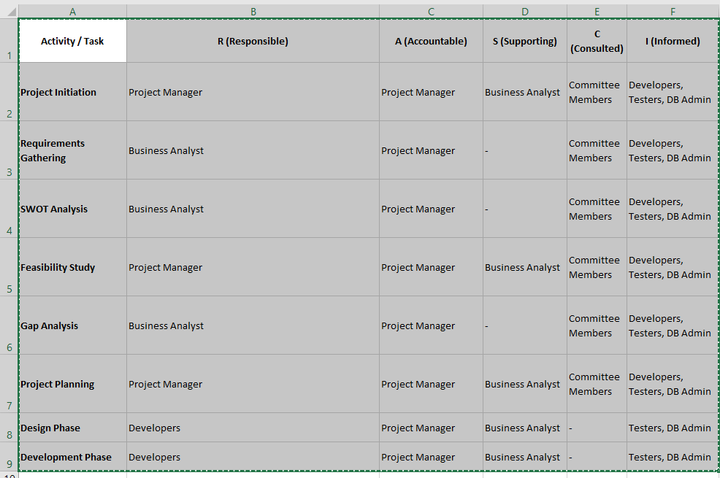

**7Q: Help Mr Karthik to prepare a business case document**

**A:**  **Business case document:**

**Summary:**

The online agricultural product store is a proposed solution to farmers' difficulties in obtaining fertilizers, seeds, and pesticides. The store will serve as a direct communication channel between farmers and product manufacturers, making the procurement process more efficient and straightforward. The proposed project has an estimated budget of 2 crore INR and a time frame of 18 months.

**Problem Statement:** Farmers in remote areas face numerous challenges in obtaining necessary agricultural products such as fertilizers, seeds, and pesticides. These difficulties cause a decrease in crop yield and a loss of income for farmers.

**Solution:** The proposed solution is to establish an online agricultural product store to make the procurement process easier and more efficient for farmers. This store will be accessible via internet connectivity and user-friendly.

**Business Requirements**: The solution should include the following features:

**Product listing:** The ability to provide detailed information for products such as fertilizers, seeds, and pesticides.

**Order placement:** Farmers must be able to order the products they require through the platform.

**Delivery:** The platform must be able to arrange for the delivery of products to farmers.

The platform must have a user-friendly interface that allows for easy navigation.

**Benefits:** The online agricultural product store will provide the following benefits

**Increased access to agricultural products:** The platform will provide farmers with a broader range of products, expanding their procurement options.

**Improved efficiency:** The procurement process will be more efficient, requiring less time and effort to purchase products.

**Increased income:** Improved access to essential agricultural products will result in higher crop yields, increasing farmers' income.

**Costs:** 2crore for 18 months

**Risks:**

**Technical Risks:** Risks related to the technology used for the platform.

**Delivery Risks:** Risks related to delivering the products to the farmers.

**Adoption Risks:** Risks related to the adoption of the platform by the farmers

**Conclusion:**

The online agriculture products store promises significant benefits for remote area farmers by improving access to essential supplies like seeds, pesticides, and fertilizers, thereby enhancing farming productivity. The project includes budget estimates, timelines, risk assessment, and stakeholder engagement, and will follow an appropriate methodology like Agile for efficient delivery and success.

**8Q:** **The Committee of Mr. Henry, Mr Pandu, and Mr Dooku, and Mr Karthik are discussing project development approach**

**Mr Karthik explained to Mr Henry about SDLC and four methodologies like sequential iterative evolutionary and agile. Please share your thoughts and give clarity on methodologies.**

**A: Thoughts on the sequential(waterfall) methodology:**

* The sequential methodology is also known as the waterfall model
* The sequential methodology is suitable for small-scale projects
* The sequential methodology is by step-by-step process; once a step is done, we cannot go back and make changes
* It’s just like water flowing in river
* It starts with requirements gathering, requirement analysis, design, development, and coding, and it ends with Testing
* The testing phase includes unit Testing, component Testing, system Testing, system integration Testing, and user acceptance Testing.
* It also includes deployment and implementation stages concerning the application.

**Thoughts on the Iterative(RUP) methodology:**

* The Iterative model is also known as the RUP model
* The RUP stands for Rational Unified Process
* It is suitable for software and application developments and research-based projects like qualitative research
* It starts with modelling of business, Requirements, analysis and design, implementation, Test and deployment
* It also has four phases like inception, Elaboration, Construction, and transition are called as four project life cycle processes
* Changing can be done continuously and cyclic process

**Thoughts on Evolutionary (Spiral) Methodology:**

* It is also known as the spiral model
* The process here is cyclic
* The spiral model has four phases or stages, starting with planning, Risk analysis, engineering, and evaluation
* Here, the phases are repeated continuously throughout the project
* Here, the business requirements are gathered during the project planning stage
* The risk is high in this modeling
* Suitable for large and tough projects, not for small projects.

**Thoughts on the Agile (Scrum) Methodology:**

* The agile is also known as scrum modelling
* Agile is the continuous change of projects
* Every phase is done at a time
* It is as same as the agile model, excluding the development and deployment stages
* User involvement and flexibility are more
* The testing stage is done continuously
* Cost of projects may vary on changes and needs
* Minimal documentation is required; the coding and development itself is the documentation
* Most software companies prefer this agile methodology.

**9Q: They discussed models in SDLC like waterfall, RUP Spiral, and Scrum. You put forth you’re understanding of these models**

**When APT IT SOLUTIONS got the project to make this online agriculture product store, there was a difference of opinion between a couple of SMEs and the project team regarding which methodology would be more suitable for this project. SMEs are stressing using the V model, and the project team is leaning more onto the side of the waterfall model. As a business analyst, which methodology do you think would be better for this project?**

**A:** As a Business analyst I would say that there is no difference between the v-model and water fall model where the stages of requirements gathering, requirement analysis, design are same but in v-model the coding ad deployment run at a time where as in water fall model it goes in order wise first coding and then deployment and coding in model done in parts.

Therefore, as a business analyst, I will go with the V-model.

* Changes can be done at any time
* Coding can be changed
* Code is stored in the form of database as layers
* Time will be saved when compared with the waterfall model

**10Q: Write down the** **differences between the waterfall model and the V model.**

|  |  |
| --- | --- |
| **Waterfall model** | **v-model** |
| The waterfall model is sequential. | The V-model is also a sequential model, but where the testing and deployment will be done at same time. |
| The stages of water waterfall model are requirement gathering, requirement analysis, coding, testing, and deployment. | The stages of the V model start with requirement gathering, requirement analysis, coding testing, and deployment. |
| In the waterfall model, the risk is high. | In the v-model risk is low or minimal. |
| Testing and deployment are done one after the other | Here the both testing and development are done at the same time or in parallel |
| It takes lots of time. | It saves time |
| In the waterfall model, changes cannot be done | In the v-model, changes can be easily done |

**11Q:** **As a BA, state your reason for choosing one model for this project.**

**A:**  As a business analyst I would choose only one model for this kind of project as a v-Model which saves the time when it is compared with waterfall model, with in the budget, low risk, easy deliverables can be updated to stakeholders and requirements can be changed at any point of time in v-model, every piece of code is stored in the form of layers.

**12Q: The Committee of Mr. Henry, Mr Pandu, and Mr Dooku discussed with Mr Karthik and finalised on the V Model approach (RG, RA, Design, D1, T1, D2, T2, D3, T3, D4, T4 and UAT)**

Mr Vardaman is mapped as a PM to this project. He studies this Project and prepares a Gantt chart with the V Model (RG, RA, Design, D1, T1, D2, T2, D3, T3, D4, T4 and UAT) as the development process and the Resources are PM, BA, Java Developers, testers, DB Admin, NW Admin.

|  |  |  |  |
| --- | --- | --- | --- |
| Tasks | Duration(months) | Responsibilities | Resources |
| Requirement Gathering | 2 | Business requirements | Project manager and business analyst |
| Requirement analysis | 2 | analysis | Project manager and business analyst |
| design | 2 | design | All Team members except testers |
| Development and Testing | 10 | Developing and Testing | Developers and testers |
| UAT | 2 | Acceptance testing | Testers and client |
|  |  |  |  |
|  | Total duration: 18 months |  |  |

**13Q: Explain the difference between Fixed Bid and Billing projects**

**A:**

|  |  |
| --- | --- |
| **Fixed Bills** | **Billing projects** |
| The cost of the project agreed at the start of the project | The cost of billing Projects depends upon hours and resources used in the project |
| The total cost of the project is provided to the client | The cost of the project may vary on requirement changes and hours |
| Fixed price | Bill varies on the man hours used for the project. |
| Less involvement of the client | Regular involvement of client to approve bills |
| Clear Timelines | Flexible Timelines |
| Suitable for well-defined requirement projects | Suitable for unclear requirements project |
| Fixed contract | Not a fixed contract |

**14Q: Prepare Timesheets of a BA in various stages of SDLC**

**Design Timesheet of a BA**

|  |  |  |  |  |
| --- | --- | --- | --- | --- |
| Date | Daily Task | Start Time | End Time | Total Hours |
| 15/03/2024 | Requirements Gathering | 10 Am | 12 pm | 2 |
| 15/03/2024 | Preparing Requirement gathering document | 12 pm | 1 pm | 1 |
| 15/03/2024 | Lunch | 1 Pm | 2 Pm | 1 |
| 15/03/2024 | Requirement analysis | 2 Pm | 4 Pm | 2 |
| 15/03/2024 | Designing workshop | 4 pm | 6 pm | 2 |

**Development Timesheet of a BA**

|  |  |  |  |  |
| --- | --- | --- | --- | --- |
| Date | Daily Task | Start Time | End Time | Total Hours |
| 16/03/2024 | Checking design documents | 10 am | 12 pm | 2 |
| 16/03/2024 | Team meeting | 12om | 1 pm | 1 |
| 16/03/2024 | Lunch | 1 PM | 2 Pm | 1 |
| 16/03/2024 | Support document | 2 Pm | 4 pm | 2 |
| 16/03/2024 | Updated based on Requirements | 4 Pm | 6 Pm | 2 |

**Testing Timesheet of a BA**

|  |  |  |  |  |
| --- | --- | --- | --- | --- |
| Date | Daily Task | Start Time | End Time | Total Hours |
| 17/03/2024 | Create Test documents | 10 am | 12 pm | 2 |
| 17/03/2024 | Meeting on Testing | 12 pm | 1 pm | 1 |
| 17/03/2024 | Lunch | 1 pm | 2 pm | 1 |
| 17/03/2024 | Testing | 2 pm | 4 pm | 2 |
| 17/03/2024 | Results and problems | 4 pm | 6 pm | 2 |

**UAT Timesheet of a BA**

|  |  |  |  |  |
| --- | --- | --- | --- | --- |
| Date | Daily Task | Start Time | End Time | Total Hours |
| 18/03/2024 | UAT preparation | 10 am | 12 pm | 2 |
| 18/03/2024 | UAT Training | 12 pm | 2 pm | 2 |
| 18/03/2024 | Lunch | 2 pm | 3 pm | 1 |
| 18/03/2024 | UAT | 3 pm | 5 pm | 2 |
| 18/03/2024 | Results | 5 pm | 6 pm | 1 |

**Deployment and Implementation Timesheet of a BA**

|  |  |  |  |  |
| --- | --- | --- | --- | --- |
| Date | Daily Task | Start Time | End Time | Total Hours |
| 19/03/2024 | Deployment meeting | 10 am | 12 pm | 2 |
| 19/03/2024 | Deployment document | 12 pm | 2 pm | 2 |
| 19/03/2024 | Lunch | 2 pm | 3 pm | 1 |
| 19/03/2024 | Deployment session | 4 pm | 5 pm | 1 |
| 19/03/2024 | Results | 5 pm | 7 pm | 2 |

**02 CAPSTONE PROJECT**

**PREP-1 PART-2**

Q1: 4 Quarterly Audits are planned for Q1, Q2, Q3, and Q4 for this Project. What is your understanding of how these audits will be conducted for a BA?

A: A quarterly audit is a periodic project review where the Business Analyst ensures that requirements, documentation, and processes align with business goals, compliance standards, and project timelines.

An internal audit assesses a company's operational efficiency and accounting processes, ensuring compliance with its established standards and regulations. Conducting audits from time to time ensures the firms are strict enough to follow the administrative fundamentals and stick to a maximum accuracy rate so far as financial reporting is concerned

* Business analyst internal audits will go through the
* Whether the project is going with the company objective or not
* Whether the process is followed properly by BA or not
* Process of project improvements is being followed

|  |  |
| --- | --- |
| Audit stage | **Requirement Gathering stage** |
| Audit status | Success (weeks 1 to 5)-5 weeks |
| checklist | Elicitation report, BRD copy, Features client signoffs, communication via email to cc and BC |

|  |  |
| --- | --- |
| Audit stage | **Requirement analysis stage** |
| Audit status | Success (week 6to 16)-10weeks |
| checklist | UML diagrams, client signoff documents, Business-to-functional requirements mapping, RTM documents, Email communication CC, and BC |

|  |  |
| --- | --- |
| Audit stage | **Design phase stage** |
| Audit status | Success (week 17-37)-20 weeks |
| checklist | Use of Tools, stakeholder collaborations, check with technical feasibility, Client communication documented evidence, Risk assessment, and email communication CC and BC. |

|  |  |
| --- | --- |
| Audit stage | **Development stage** |
| Audit status | Weeks (38 to 63)-25 weeks |
| checklist | Coding, Functional implementation, code document, security considerations, document of code change, and updates |

|  |  |
| --- | --- |
| Audit stage | **Testing phase** |
| Audit status | success |
| checklist | Review and validate test requirements, execute test cases and maintain test logs, collaborate with stakeholders for UAT and testing, generate test reports, prepare defect summary, and document lessons learned. |

Q2: Before the Project is going to Kick Start, The Committee asked Mr. Karthik to submit the BA Approach Strategy

Write BA Approach strategy (As a business analyst, what are the steps that you would need to follow to complete a project – What Elicitation Techniques to apply, how to do Stakeholder Analysis RACI/ILS, What Documents to Write, What process to follow to Sign off on the Documents, How to take Approvals from the Client, What Communication Channels to establish n implement, How to Handle Change Requests, How to update the progress of the project to the Stakeholders, How to take signoff on the UAT- Client Project Acceptance Form )

A: Our team Project Manager - Mr. Vardanam Senior Java Developer - Ms. Juhi Java Developers - Mr. Teyson, Ms. Lucie, Mr. Tucker, Mr. Bravo Network Admin - Mr Mike DB Admin - Mr John. Testers - Mr. Jason and Ms. Alekya BA – our technical Team has assembled to discuss the Project approach and has finalized the following 3-tier architecture for this project

1. **Elicitation Techniques**: I would employ various methods such as interviews, workshops, surveys, observations, and prototyping to gather and analyze requirements from stakeholders
2. **Stakeholder Analysis**: I would perform a stakeholder analysis to identify and prioritize stakeholders based on their interest, involvement, and influence in the project.
3. **RACI/ILS**: I would develop a RACI/ILS matrix to clearly define stakeholder roles and responsibilities, track issues, and ensure timely resolution.
4. **Documentation**: I would create key documents, including requirements specifications, functional and non-functional requirements, use cases, process flows, wireframes, and the test plan to communicate requirements to the development team.
5. **Document Sign-Off Process**: I would establish a formal review and sign-off process involving the development team, stakeholders, and project sponsors.
6. **Client Approvals**: I would seek client approvals at each project phase to ensure their requirements are met and avoid last-minute surprises.
7. **Communication Channels**: I would set up communication channels such as email, instant messaging, or project management tools to inform stakeholders about project progress and any changes.
8. **Change Requests**: I would implement a change management plan to document, track, prioritize, and gain approval for any change requests before implementing them.
9. **Progress Updates**: I would provide regular progress updates to stakeholders through reports, presentations, or status meetings, keeping them informed of the project status, risks, and issues
10. **UAT Sign-Off**: I would create a UAT plan and test cases, ensuring the client signs off on the UAT and project acceptance form before deployment.

Q3: Explain and illustrate 3-tier architecture.

A: A three-tier architecture is a client-server software design pattern in which the application is divided into three interconnected layers, each responsible for a specific aspect of the application's functionality. The layers are:

**Presentation Tier:** The user interface layer lets users view and enter data into the system using web, mobile, or desktop applications.

**Application Tier:** The Application Tier is the middle layer that manages business logic, processes user input from the presentation tier, and communicates with the data tier to retrieve or update data.

**Data Tier:** The Data Tier is the bottom layer responsible for managing and storing data in databases and for handling data retrieval and updates requested by the application tier.

Q4: Business Analysts should keep what points in their minds before they frame a Question to ask the Stakeholders.

(5W 1H – SMART – RACI – 3 Tier Architecture – Use Cases, Use case Specs, Activity Diagrams, Models, Page designs)

A: Step 1: Before framing some Questions, we should take 5W1H

* What is the product
* Why this project was initiated
* Who is getting benefits from this project
* Where the requirements are spotted
* When will the project be initiated
* How we should be doing this project

Step 2: We should check whether the requirements collected are SMART or not

S-specific

M-Measurable

A-Attenable

R- Realistic

T- Timebound

Step 3: While preparing the question, we need to figure out who comes under which category, so we use the RACI matrix, which is

* R-Responsible
* A-Accountable
* C-Consultant
* I-informed

Step4: Then we will prepare the 3tier architecture under 3 different categories

* Application layer
* Data layer
* Business layer

Step 5: We will identify the use cases to know how the external system is interacting with the system

5Q) As a Business Analyst, What Elicitation Techniques are you aware of? (BDRFOWJIPQU)

A:

* **Brainstorming**: This technique generates ideas and gathers input from stakeholders. It encourages creative thinking to explore solutions or identify requirements.
* **Document Analysis**: Review existing documents such as business plans, process flows, and user manuals to extract relevant information and identify gaps and areas for improvement.
* **Requirements Workshops**: Conduct group sessions with stakeholders to gather requirements, clarify doubts, resolve problems and ensure collaboration between the team.
* **Interviews**: one-on-one or group discussions with stakeholders to gather detailed information about their perspectives and uncover specific requirements.
* **Focus Groups**: gathering a selected group of stakeholders to discuss specific topics or areas of interest. The group dynamics encourage interaction and the exchange of ideas by providing valuable insights.
* **Observation**: Actively observing stakeholders' work environment processes and activities to gain a deep understanding of their needs, challenges, and workflows
* **Prototyping**: Creating a visual presentation or interactive model of the proposed solutions to gather feedback, validate requirements, and facilitate stakeholder understanding.
* **Questionnaires and surveys**: Structured questions or surveys to stakeholders to gather qualitative and quantitative data and opinions on specific topics or requirements.
* **Use cases**: Describing interactions between actors(users) and the system to illustrate how the system behaves and what actions it should support

6Q) Which Elicitation Techniques can be used in this Project and Justify your selection of Elicitation Techniques?

A: Based on the given project-based scenario, the following elicitation techniques will be used:

**Prototyping:** It can be utilized to gather feedback and validate the requirements for the online product store, as the application needs to be user-friendly. Creating a prototype can help visualize the user interface and functionalities. It allows stakeholders, including Mr. Henry Frind and other potential users, to provide feedback on the proposed solution and make necessary changes before development.

**Use case specs:** Use case specialization can be employed to capture the interactions and sequences of actions between the various actors (Farmers and manufacturers and the online store)and the system being developed by documenting use cases the project team can identify the specific functionalities and requirements needs to facilitate the communication and transactions between farmers and manufactures the use case will provide a structured approach to elicit validate and prioritize the requirements for the online store.

**Document analysis:** The document analysis can be useful for understanding the existing challenges faced by the farmers and the inquiries expressed by MR henry's friends Analyzing any available documentation such as reports on agricultural issues framing practices or market research can provide insights into the specific problems related to procuring fertilizers seeds and pesticides it helps in identifying the key points and requirements that the online store can be addressed

**Brainstorming**: It is a session conducted with the stakeholders including Mr henry, Peter Kevin, and Ben to gather their perspectives and insights The session can focus on discussing the challenges faced by the farmer's potential features and functionalities of the online store and any additional requirements that may arise during the discussion Brain storm encourage collaboration and creativity allowing for the exploration of innocence solutions and capturing comprehensive requirements.

**Justification:**

Through these elicitation techniques, the project team will gather a wide range of requirements, validate them through feedback and discussions, and make sure that the online agricultural store addresses the needs of the farmers.

Fertilizers, seeds, and pesticides are details from the manufacturers and should be able to be displayed to the Farmers. To gather the business requirements from the client, you went to SOONY and met Mr. Henry. When Mr. Henry was asked about the project and what they expecting from the project, Mr. Henry stated that he hoped to have a login for all its users (fertilizers, seeds, pesticide manufacturers, and Farmers), a product catalog of fertilizers, seeds, pesticides, a search option to search for products, payment process, and delivery tracking. After doing the stakeholder analysis, you discover that Peter, Kevin, and Ben are the key stakeholders, and you schedule an appointment to meet them. After meeting with them and trying to gather the stakeholder requirements, Kevin said that a Farmer should be able to browse through the product catalog once they visit the website and need to have a search option so that they can search for any product they need. Peter said that if a farmer wants to buy any product or add them to the buy-later list, they need to log in first using their email ID and password. If it is a new user, then they can create a new account by submitting their email ID and creating a secure password. Ben added that Farmers need to have an easy-to-use payment gateway, which should include cash-on-delivery (COD), Credit/Debit card, and UPI options so that the user’s experience is better. Kevin mentioned that a user gets an email confirmation regarding their order status. A delivery tracker to track the whereabouts of their order.

**Business Requirements**

**BR001 – Product Search and Catalog:**

* **Farmers** should be able to browse through a catalogue of products, including fertilizers, seeds, and pesticides, on the website.
* **Farmers** should have a search functionality to find specific products in the catalog.

**BR002 – User Authentication and Account Management:**

* **Farmers** must log in using their email ID and password to make purchases or add products to a buy-later list.
* **New users** (Farmers) should be able to create an account by submitting their email ID and creating a secure password.

**Stakeholder Requirements**

**Kevin’s Requirements:**

* **KR001:** Farmers need to browse the product catalog and use the search option to find products easily.

**Peter’s Requirements:**

* **KR002:** Farmers must log in to their accounts to buy products or add them to a buy-later list. New users should be able to create an account by submitting their email ID and setting a password.

7Q) Make suitable Assumptions and identify at least 10 Business Requirements

A: Assumptions:

- E-commerce platform for farmers to buy fertilizers, seeds, and pesticides.

- Product catalog with search functionality.

- Login system for farmers, manufacturers, and vendors.

- Account creation for new users with email and secure password.

- Payment options: COD, credit/debit cards, and UPI.

- Email confirmations for order status and delivery tracking.

- User-friendly interface for easy navigation and better user experience.

**Business requirements:**

* **BR001:** Product catalog with all fertilizers, seeds, and pesticides from various manufacturers and vendors.
* **BR002:** Search functionality for products by name, category, and brand.
* **BR003:** Login feature for farmers, manufacturers, and vendors.
* **BR004:** Account creation for new users via email and secure password.
* **BR005:** User-friendly interface with easy navigation.
* **BR006:** Payment gateway supporting COD, credit/debit cards, and UPI.
* **BR007:** Email confirmations for order status.
* **BR008:** Delivery tracking system for order whereabouts.
* **BR009:** Scalable platform for future growth and expansion.
* **BR010:** Secure infrastructure to protect user data and prevent breaches.

8Q) List your assumptions.

A:

* E-commerce platform for farmers to buy fertilizers, seeds, and pesticides.
* Product catalog with search functionality for items.
* Login system for farmers, manufacturers, and vendors; account creation with email and secure password.
* Payment options: COD, credit/debit cards, and UPI.
* Email confirmations for order status and delivery tracking.
* User-friendly interface with easy navigation.
* Secure infrastructure to protect user data and prevent breaches.

9Q) Give Priority 1 to 10 numbers (1 being low priority, 10 being high priority) to these Requirements after discussions with the stakeholders

A:

|  |  |  |  |
| --- | --- | --- | --- |
| Req ID | Req name | Req details | priority |
| **BR001** | Product Catalog | Product catalog with all fertilizers, seeds, and pesticides from various manufacturers and vendors. | 10 |
| **BR002** | Search option | Search functionality for products by name, category, and brand. | 10 |
| **BR003** | login | Login feature for farmers, manufacturers, and vendors. | 8 |
| **BR004** | Account creating | Account creation for new users via email and secure password | 9 |
| **BR005** | User interface | User-friendly interface with easy navigation | 8 |
| **BR006** | payments | Payment gateway supporting COD, credit/debit cards, and UPI | 10 |
| **BR007** | Order Status | Email confirmations for order status. | 10 |
| **BR008** | Delivery status | Delivery tracking system for order whereabouts. | 9 |
| **BR009** | Future growth | Scalable platform for future growth and expansion. | 5 |
| **BR010** | security | Secure infrastructure to protect user data and prevent breaches | 3 |

10Q) Draw a use case diagram

**A: Use case diagram**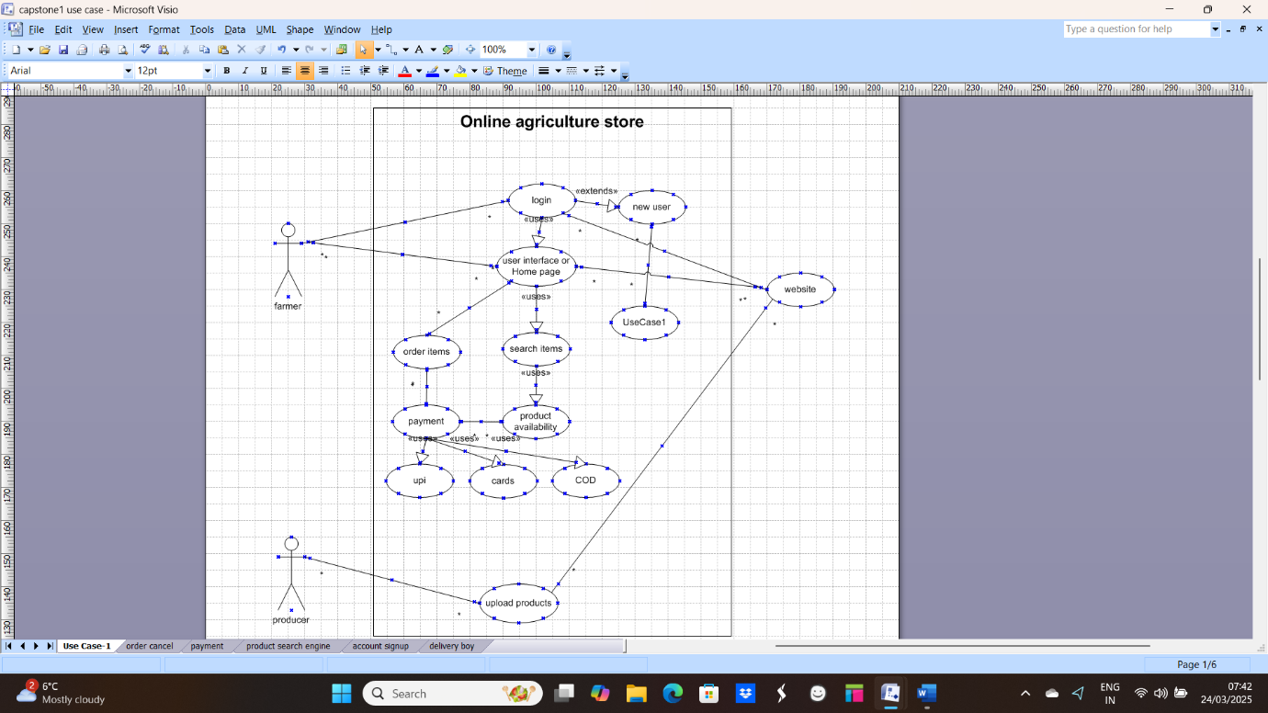

11Q) Prepare use case specs for all use cases

A:

|  |  |
| --- | --- |
| **Usecase ID: UCD_RECP_001** | **UCD_RECP_001** |
| **Use case name:** | Payment Use case |
| **Use case Description** | This use case of payment method is chosen by the farmer to purchase the products. |
| **Actors:** | A) Primary actor: Farmers  B) Secondary actor: Website |
| **Pre-conditions:** | * Active internet connection * Login should be successful * Delivery address should be updated * Select the products and add them to the cart |
| **Basic flow:** | * The user enters the correct username and password. * The system validates credentials. * The home page is displayed. * Display the payment amount. |
| **Alternate Flows:** | * The error message is displayed: "Incorrect password." * The error message is displayed: "Payment Failed." * The error message is displayed: "Invalid login credentials." |
| **Exceptional Flows:** | * Server down * Blocking of bank account |
| **Postconditions:** | * Sucessful Execution: Home page is displayed after successful login * Unsucess Execution: Payment gateway could unable to collect the payment |
| **Inputs** | * Username * Password |
| **Outputs:** | * Booking ID * Transaction ID |
| **Business Rules** | * The username must be a valid email address. * Payments are accepted through the card and wallet. |
| **Assumptions:** | * Users have basic internet knowledge. * Users understand English. |
| **constriants** | * Usernames cannot contain special characters. |
| **Key scenarios** | NA |
| **Dependencies:** | * The user must be registered in the online store. |
| **Special Requirments** | NA |
| **Wire frame** | NA |

**2) canceling an order**

|  |  |
| --- | --- |
| **Usecase ID: UCD_RECP_001** | **UCD_ORDRCNCL_001** |
| **Use case name:** | Canceling the ordered product |
| **Use case Description** | This use case describes the process of a customer canceling an online order before it is shipped. The system verifies the eligibility, updates the order status, and processes any applicable refunds. |
| **Actors:** | * Primary: Customer * Secondary: Website |
| **Pre-conditions:** | * Customer should be logged into their account * The order must be eligible for cancellation before shipping. |
| **Basic flow:** | * Go to my orders section * The customer will select the order that they want to cancel * The system checks whether the order is eligible for cancellation. * If eligible, the system allows for confirmation * Customers confirm the order * The system will update the order status to cancel * The system processes a refund if applicable and sends a notification to the customer |
| **Alternate Flows:** | * If the order is not eligible for cancellation, the system displays an appropriate message. * If the customer does not confirm the cancellation, the process is terminated. |
| **Exceptional Flows:** | * System error while cancelling the order * The refunding process may fail due to gateway errors * Customer may try to cancel after being shipped the order |
| **Postconditions:** | * Updated the cancelled order. * The Refund is initiated (If applicable). * A notification is sent to the customer. |
| **Inputs** | * Login credentials to access * Order ID cancellation * Customer confirmation for cancellation |
| **Outputs:** | * Order cancellation confirmation message * Refund processing status update (if applicable) * Email/SMS notification to the customer |
| **Business Rules** | * Orders can only be cancelled if they have not been shipped. * Some orders may have cancellation fees or restrictions |
| **Assumptions:** | * Order updates * Valid payment for refunds and payments |
| **constraints** | * Shipped orders cannot be cancelled * Refund may vary on the payment provider |
| **Key scenarios** | * Customer order cancellations are successful. * Refund processing is delayed. |
| **Dependencies:** | NA |
| **Special Requirements** | NA |
| **Wire frame** | NA |

**3. Product search**

|  |  |
| --- | --- |
| **Use case ID: UCD_RECP_001** | **UCD_PRDCT_001** |
| **Use case name:** | Product Search |
| **Use case Description** | |  | | --- | |  |  |  | | --- | | This use case describes how a customer searches for products using keywords, filters, or categories. The system retrieves and displays relevant product results. | |
| **Actors:** | * Primary: Customer * Secondary: Website |
| **Pre-conditions:** | * Customer to access into a web or application to buy products |
| **Basic flow:** | * Enters a keyword in the search bar * System gives a Relative products * Relative products are displayed with filters and sorting * Product will be selected for more details |
| **Alternate Flows:** | * Keywords of products * Filtering of products * Results are based on price and more sold |
| **Exceptional Flows:** | * No matching found system display with relavent message * System fetches with errors |
| **Postconditions:** | * Relavant product display * Customer can view the product details |
| **Inputs** | * Search query * Filter/sort selections |
| **Outputs:** | * List of matching products * Suggestions if no results are found |
| **Business Rules** | * Search results are based on most sold items popularity |
| **Assumptions:** | * Product catalog should be up-to-date |
| **constraints** | * NA |
| **Key scenarios** | * The product was found successfully. * No results found |
| **Dependencies:** | NA |
| **Special Requirements** | System updates should be updated along with the database. |
| **Wire frame** | NA |

4. Signup

|  |  |
| --- | --- |
| **Use case ID: UCD_RECP_001** | **UCD_SGNUP_001** |
| **Use case name:** | Online agricultural store signup |
| **Use case Description** | This use case describes how a new customer registers on the e-commerce platform by providing the required details and creating an account. |
| **Actors:** | * Primary: customer * Secondary: system |
| **Pre-conditions:** | * The customer must have access to the platform (website/app). * The Customer must have a valid email or phone number. |
| **Basic flow:** | * The customer clicks on the "Sign Up" button. * Customer enters required details (name, email/phone, password). * The system validates the details. * The system sends an OTP/email verification link. * The customer verifies via OTP/link. * The system creates the account and redirects to the homepage. |
| **Alternate Flows:** | * Customer signs up using a social media account. |
| **Exceptional Flows:** | * Invalid email/phone number; the system prompts for a valid input. * OTP not received; system provides a resend option. * Email already registered; system prompts to log in or reset the password. |
| **Postconditions:** | * Successful: Customer account is successfully created. * Unsuccessful: Invalid details with respective to system error |
| **Inputs** | * Name * Email/Phone * Password (Strong password) * OTP (If required) |
| **Outputs:** | * Account creation confirmation * Verification status update |
| **Business Rules** | * Password must meet security criteria. * Email/phone number must be unique. |
| **Assumptions:** | * Customer has access to email/phone for verification. |
| **constraints** | * The system should handle high signup traffic efficiently. |
| **Key scenarios** | * Successful signup with verification. * Sign up with a social media login. |
| **Dependencies:** | * Email/SMS service provider * User database |
| **Special Requirements** | NA |
| **Wire frame** | NA |

5) Delivery Boy

|  |  |
| --- | --- |
| **Use case ID: UCD_RECP_001** | **UCD_DLVRY_001** |
| **Use case name:** | |  | | --- | | Delivery Boy Registration & Order Handling |  |  | | --- | |  | |
| **Use case Description** | |  | | --- | | Enables delivery personnel to register, accept, and manage deliveries. |  |  | | --- | |  | |
| **Actors:** | * Primary: Delivery Boy * Secondary: System |
| **Pre-conditions:** | * Valid phone number, ID proof, and vehicle details |
| **Basic flow:** | * Delivery boy registers with details. * Admin verifies and approves. * Delivery boy logs in and views assigned orders. * Accepts, picks up, and delivers the package. * Updates delivery status. * The system notifies the customer. |
| **Alternate Flows:** | * The order will be reassigned if rejected. |
| **Exceptional Flows:** | * Incorrect details; system prompts corrections * delivery fails (wrong address, customer unavailable). |
| **Postconditions:** | * Delivery boy is registered and can accept orders * Successful: Order is marked as delivered. * Unsuccessful : Unsuccessful due to no response |
| **Inputs** | * Name, phone, ID proof, order acceptance. |
| **Outputs:** | * Registration confirmation, order notifications, and delivery updates. |
| **Business Rules** | * Only verified person can deliver |
| **Assumptions:** | * Delivery boy has a smartphone with GPS |
| **constraints** | * Deliveries must be within operating hours |
| **Key scenarios** | * Successful/failed delivery |
| **Dependencies:** | * Admin approval, order management system |
| **Special Requirements** | * Live tracking and status updates. |
| **Wire frame** | NA |

12Q) Activity diagrams

**A**

**1. Payment Diagram**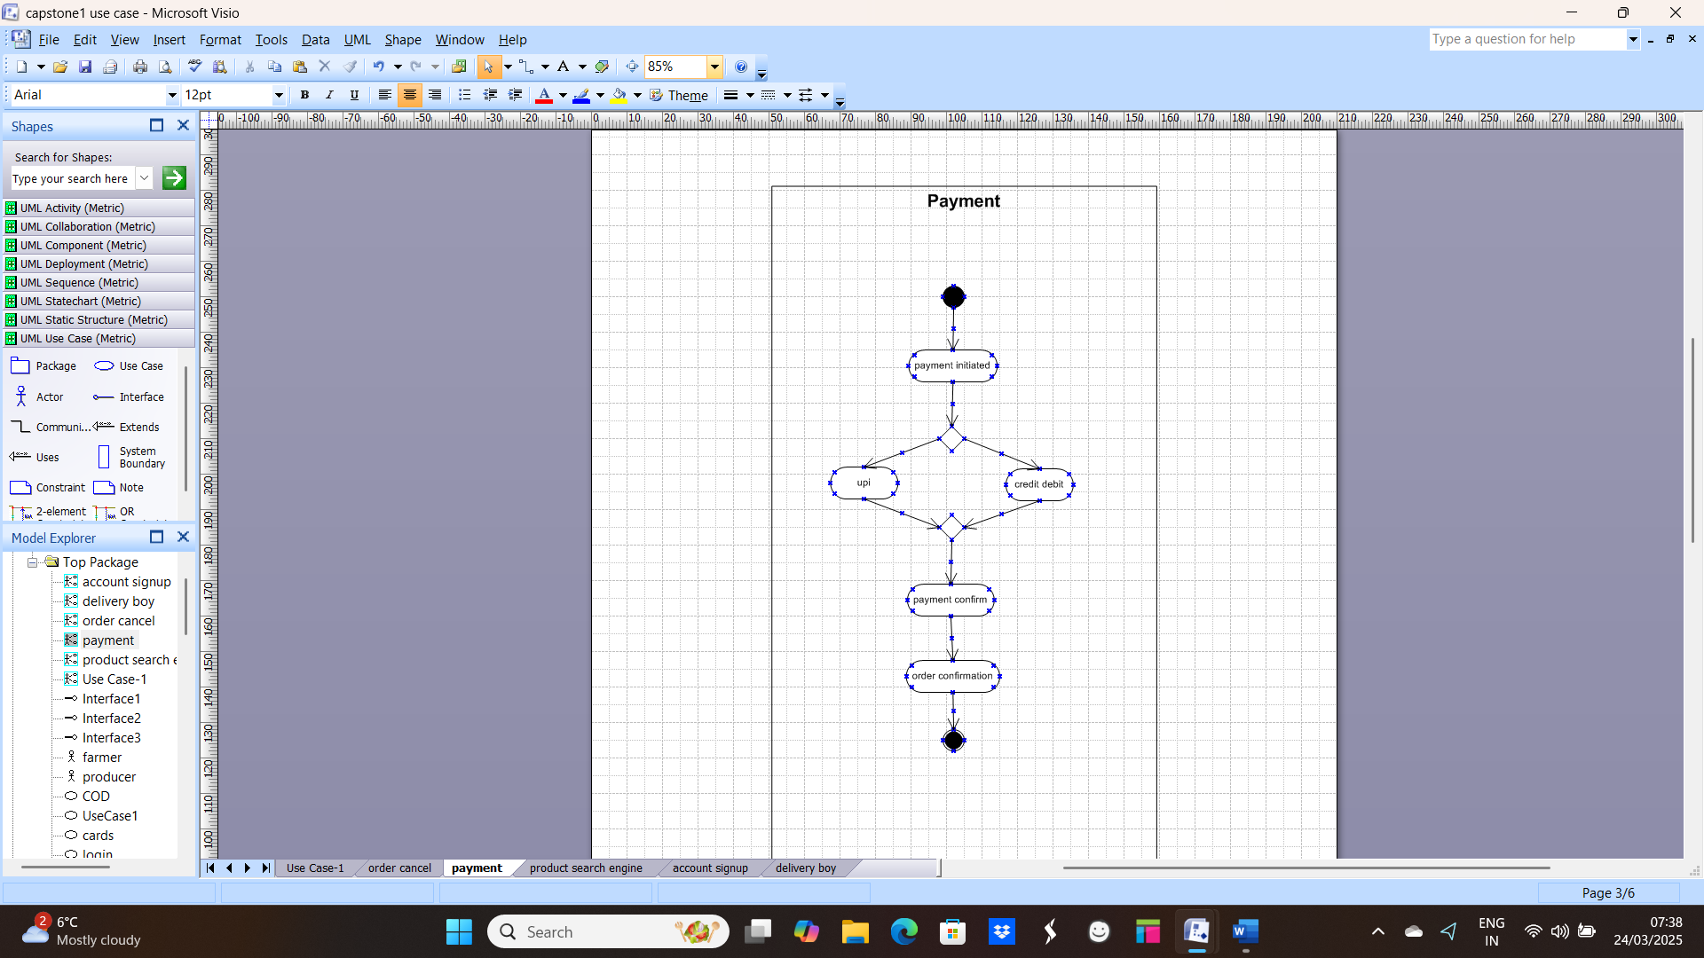

**2. Cancel ordered Item**

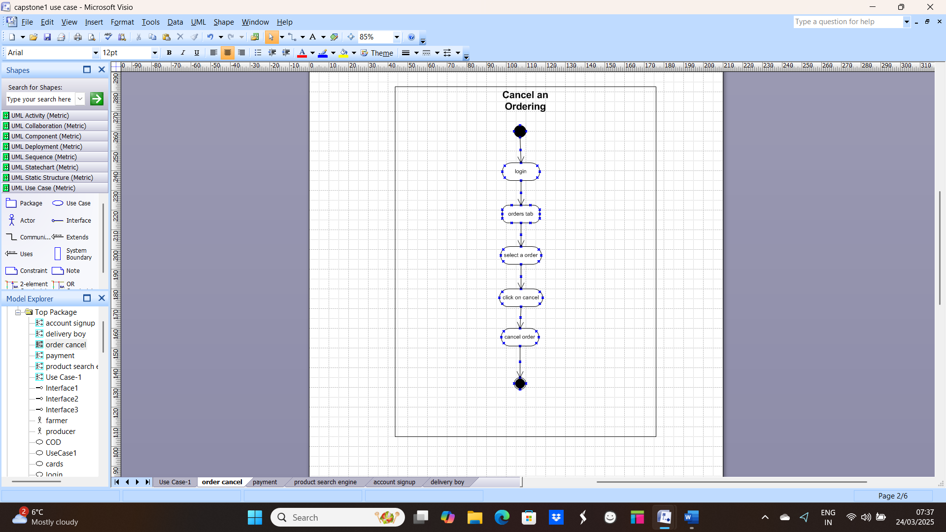

**3. Product search**

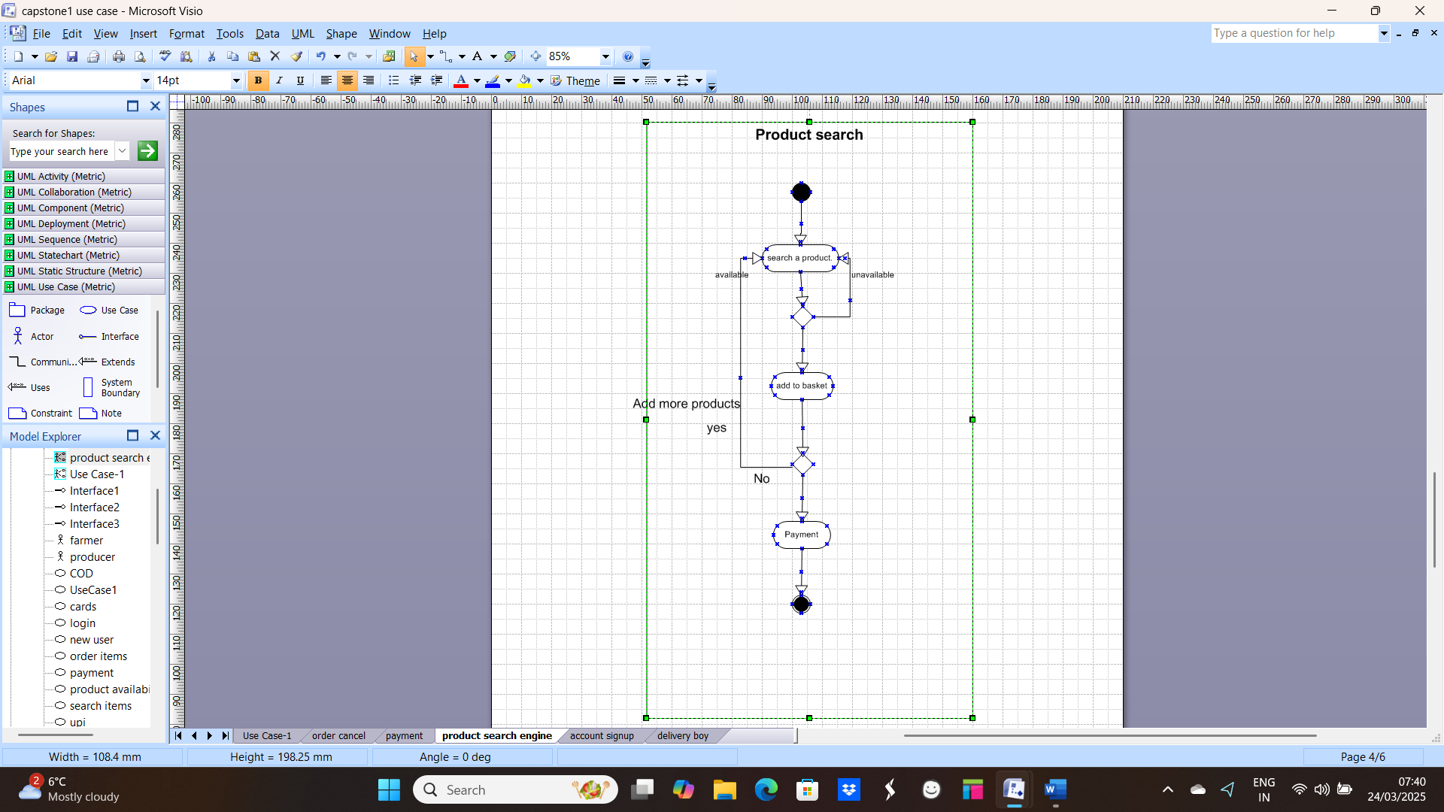

**4. Account signup**

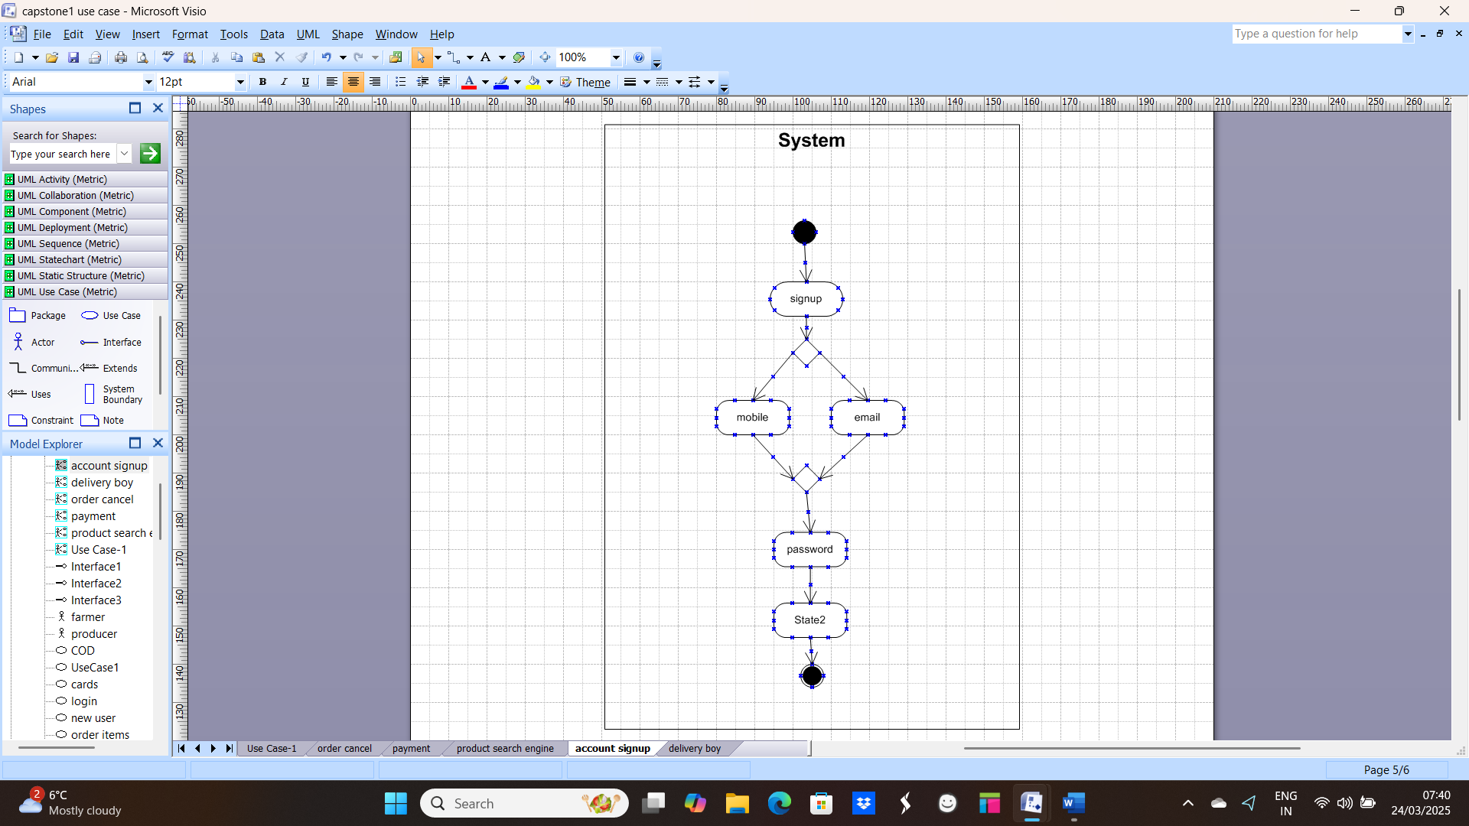

**5. Delivery Boy**

