Document 1: Definition of Done: -
Answer:
For Audit Ops Page –
Our Definition of Done List should include following points, you can also call it as Acceptance Criteria for the page –
- Audit Ops page should contain all the necessary information that is necessary to evaluate the file.
- The Design of the page should be dynamic – we should be able to filter data based on any of the column.
- Audit Ops page should contain two tabs -1. Audit Status 2. Audit History
- Audit Status should contain all the files which are currently available in our Active Coverage list.
- The File for which we have not done the audit yet should show blank entries/data.
- Audit History page contains all the files which have been audited in the past whether it is currently in our coverage or not.
- In Audit History Page For each file – Recent Audited date column should be available showcasing the date on which the recent audit is done. Let’s say 02/04/2024
- It should also contain a column called Audit count which will show the count of number of times the file is audited in the past. Let’s say 5,6 etc.
- It should show the Auditor Name, Analyst Name, Scenario for which we have done audit, Audit period etc
- In Audit History page the by default data should be shown for last 3 months.
- The Filtration should be based on Audit Month & Year.
- UAT should be performed and approved.
- All the issues should be resolved and again testing should be done.
- Page Design approval should also be taken.

Document 2- Product Vision
Answer:
Scrum Project Name | Audit Page Enhancements
Venue: | PUNE
Date: 24-04-2025 | Start time: 11:00 AM | End time: 06:00 PM | Duration: 06 Months
Client: | Global Flex Research Pvt Ltd.
Stakeholder list: | Audit Team | Research Team | Sector & Global Leads
 | Scrum Team
Scrum Master: | Sameer Rao
Product owner: | Parimal Waghmare
Scrum Developer 1: | Amit Kumar
Scrum Developer 2: | Umesh Patil
Scrum Developer 3: | Shrikant Singh
Vision: Our Vision here is to develop an Audit Ops Page which will be a single platform to access all the Audit related information, through which we can track analyst’s performances, focus of area of improvements, make the file error free, and to share feedback with the research team, etc.
Target Groups | Needs | Product | Value
Research Team,  Sector Heads,  Global Leads | This page will made access easy to the audited file and it will made our decision making easier.  Reduce errors, Improve & Track performance, improve Estimates. | This Audit Ops Page  Which will showcase all the audit files information belonging to our coverage List.  Yes, it is feasible to develop this page. | This page will provide benefits to the company because through this page we will reduce the errors in the files, improve the estimate accuracy of the files, which in return improve the valuation of the company & improve our Research Analysis.

Document 3: User stories
User Story No.1 | Tasks: | Priority: 10
Value statement:
As a Audit Manager
I want to view the Audited files for February 2025 Month
so that I can see the ratings and track the team’s performance

BV: 90 | CP: 10
Acceptance Criteria:
When applied the necessary filters - > data should display correctly
All the data such as Blog link, rated by, Analyst Name, Auditor Name, Audit Date etc should be displayed.

User Story No.2 | Tasks: | Priority: 9
Value statement:
As an Audit Manager
I want to have an option to build charts, graphs from the given set of data
so that I can visualise the data so that it will be easy to take decisions based on it.

BV: 70 | CP: 9
Acceptance Criteria:
At the end of Title column, user should have a button like option when clicked it should ask you the type of data visualization then user will select it and the visualised data should appear in the next page.
This new page can be downloaded in pdf, jpeg format.
The quality of the visualised images should be clear.

User Story No.3 | Tasks: | Priority: 8
Value statement:
As an Audit Manager
I want to view the Audit Ops where in which two tabs should be shown as Audit Status & Audit History
so that I can see the detailed report and do my analysis.

BV: 80 | CP: 8
Acceptance Criteria:
When we click on Audit Ops – Audit Ops page should be displayed in that page two sections should be shown as mentioned
They should be able to switch between the two tabs
It should not take much time loading the pages.

User Story No.4 | Tasks: | Priority: 6
Value statement:
As an Auditor
I want to view the Audit Ops where in which two tabs should be shown as Audit Status & Audit History
so that I can see the detailed report and do my analysis.

BV: 60 | CP: 6
Acceptance Criteria:
Auditor should also have access of these pages, and they should also view the same data as Audit manager.

User Story No.5 | Tasks: | Priority: 5
Value statement:
As an Audit Manager
I want to make sure that the data fetch is accurate
So that no file is missed.

BV: 50 | CP: 5
Acceptance Criteria:
On Stage platform we will test the count of the files getting fetched and then only we will release it to LIVE.

User Story No.6 | Tasks: | Priority: 4
Value statement:
As an Audit Manager
I want to make sure that the page gets load faster, UI looks dynamic and user friendly.
So that the pages are easy to handle.
BV: 40 | CP: 4
Acceptance Criteria:
Page should load faster.
Pages should be responsive, dynamic.
UI must be user-friendly.

Document 4: Agile PO Experience
Answer:
As a Product Owner, I recently led the Audit Page Enhancement Project, where the objective was to merge two separate audit modules — Audit Report and Audit Rating Report — into a single, streamlined page called Audit Ops. This project aimed to enhance user efficiency, improve data visibility, and simplify the audit process for stakeholders.
- Market and Enterprise Analysis:
At the outset, I conducted a market and enterprise analysis to understand the demand for a more unified audit experience. I evaluated existing tools internally and benchmarked against best practices to ensure our solution would offer a competitive edge by improving user navigation and reducing manual efforts.
- Defining the Product Vision and Roadmap:
Based on the findings, I developed a clear product vision: to provide a unified, user-friendly platform for audit tracking and rating, improving audit coverage and decision-making. I also created a roadmap outlining key milestones, including requirements finalization, development sprints, UAT, and rollout phases.

- Managing Product Features and Product Backlog:
I collaborated closely with stakeholders and business analysts to prioritize features that added the most value, focusing on critical functionalities like real-time audit data integration, dynamic filters, and enhanced reporting.
I managed the product backlog meticulously — creating, refining, and reprioritizing user stories based on stakeholder feedback and project evolution.
Each user story I crafted contained:
- Story ID and detailed tasks,
- Priority set based on business value,
- Clear Acceptance Criteria ensuring measurable outcomes,
- BV (Business Value) and CP (Complexity Points) for effort estimation.
- Active Participation in Agile Events:
Throughout the project, I was actively involved in all Agile ceremonies:
- Sprint Planning: Helped break down requirements into actionable tasks and set sprint goals.
- Daily Stand-ups: Monitored progress, clarified any doubts, and addressed blockers.
- Sprint Review: Presented completed Audit Ops features to stakeholders, gathering valuable feedback for future iterations.
- Sprint Retrospective: Participated in retrospectives with business analysts and developers, discussing what went well and identifying areas of improvement.
- Backlog Refinement Meetings: Continuously reviewed and updated backlog items to ensure development efforts remained aligned with changing priorities.
- Managing Iteration Progress:
I closely reviewed sprint progress through Jira boards, adjusted priorities if needed, and ensured that the team remained focused on delivering the highest-priority features. Whenever necessary, I reprioritized epics and user stories to meet evolving business needs.
Liaison Between Business and Development Teams:
One of my key roles was acting as the bridge between stakeholders and the Scrum team, ensuring that the vision for Audit Ops was consistently communicated and realized. I regularly conducted stakeholder demos and ensured transparency on deliverables.
Outcome and Learning:
The Audit Ops page was successfully deployed with a high user adoption rate. Consolidating two audit reports into one enhanced usability, reduced manual processing time, and improved audit coverage analysis.
This project strengthened my ability to drive a product vision, manage changing priorities, lead UAT sessions, and ensure successful iterative delivery within Agile frameworks.
Agile Meetings I Learned to Handle:
- Sprint Planning: Plan which user stories will be completed in the upcoming sprint.
- Daily Scrum (Stand-up): Quick daily updates on progress, obstacles, and plans.
- Sprint Review: Demonstrate completed work to stakeholders and gather feedback.
- Sprint Retrospective: Reflect on the sprint to find ways to improve processes.
- Backlog Refinement: Continuously review and update the backlog for upcoming sprints

Document 5: Product and sprint backlog and product and sprint burndown charts

Product backlog:
User story ID | User story | Tasks | Priority | BV Business Value | CP Complexity Points | Sprint
US-001 | Setup backend architecture | Database setup, server config | 10 | 10 | 5 | Sprint 1
US-002 | Develop API for Audit Report | API development, testing | 9 | 9 | 5 | Sprint 1
US-003 | Design Audit Ops UI prototype | Wireframe creation, UI tool usage | 8 | 9 | 4 | Sprint 2
US-004 | Integrate backend with frontend | API consumption, UI binding | 7 | 10 | 6 | Sprint 2
US-005 | Implement filtering in Audit Ops | Build filters, connect with API | 6 | 8 | 5 | Sprint 3
US-006 | Handle API error responses | Error management, validation | 5 | 7 | 4 | Sprint 4
US-007 | Develop Audit Ratings module | Ratings logic, UI integration | 8 | 9 | 6 | Sprint 5
US-008 | Create audit dashboard | KPI chart creation, data aggregation | 5 | 8 | 7 | Sprint 6
US-009 | Setup role-based access control (RBAC) | User roles setup, security testing | 4 | 6 | 4 | Sprint 7
US-010 | Implement notifications system | Alerts, email triggers, in-app messaging | 5 | 4 | 3 | Sprint 8
US-011 | Add Export to Excel feature | API update, Excel formatting | 9 | 8 | 6 | Sprint 9
US-012 | Perform UAT and Bug Fixes | UAT sessions, final defect fixes | 4 | 7 | 2 | Sprint 10

Sprint Backlog
User Story ID | User Story | Tasks | Owner | Status | Estimated Effort (Story Points)
US-001 | Setup backend architecture | Database setup, server config | Developer 1 (Backend) | Completed | 5
US-002 | Develop API for Audit Report | API development, testing | Developer 1 (Backend) | Completed | 5
US-003 | Design Audit Ops UI prototype | Wireframe creation, UI tool usage | Developer 2 (Frontend) | Completed | 4
US-004 | Integrate backend with frontend | API consumption, UI binding | Developer 2 (Frontend) | Completed | 6
US-005 | Implement filtering in Audit Ops | Build filters, connect with API | Developer 2 (Frontend) | Completed | 5
US-006 | Handle API error responses | Error management, validation | Developer 1 (Backend) | Completed | 4
US-007 | Develop Audit Ratings module | Ratings logic, UI integration | Developer 1 (Backend) + Developer 2 (Frontend) | Completed | 6
US-008 | Create audit dashboard | KPI chart creation, data aggregation | Developer 2 (Frontend) | Completed | 7
US-009 | Setup role-based access control (RBAC) | User roles setup, security testing | Developer 1 (Backend) | Completed | 6
US-010 | Implement notifications system | Alerts, email triggers, in-app messaging | Developer 1 (Backend) + Developer 2 (Frontend) | Completed | 5
US-011 | Make Audit Ops mobile responsive | UI responsiveness, cross-browser testing | Developer 2 (Frontend) | Completed | 4
US-012 | Add Export to Excel feature | API update, Excel formatting | Developer 1 (Backend) + Developer 2 (Frontend) | Completed | 3
US-013 | Perform UAT and Bug Fixes | UAT sessions, final defect fixes | Developer 3 (QA) | Completed | 5

Sprint Burndown Chart
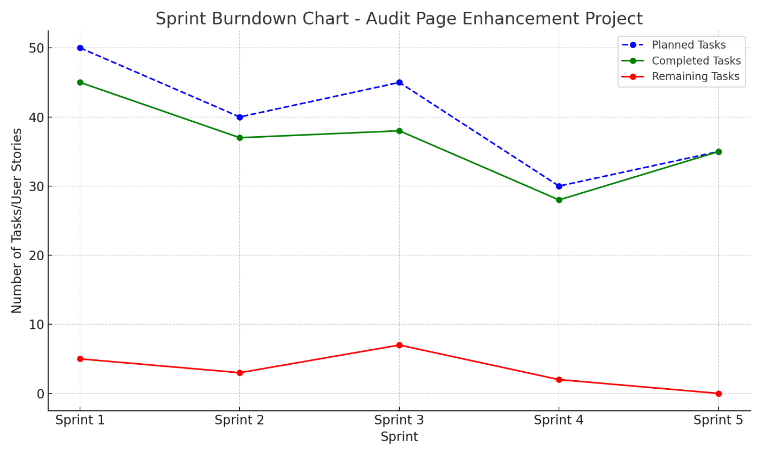

Product Burndown Chart

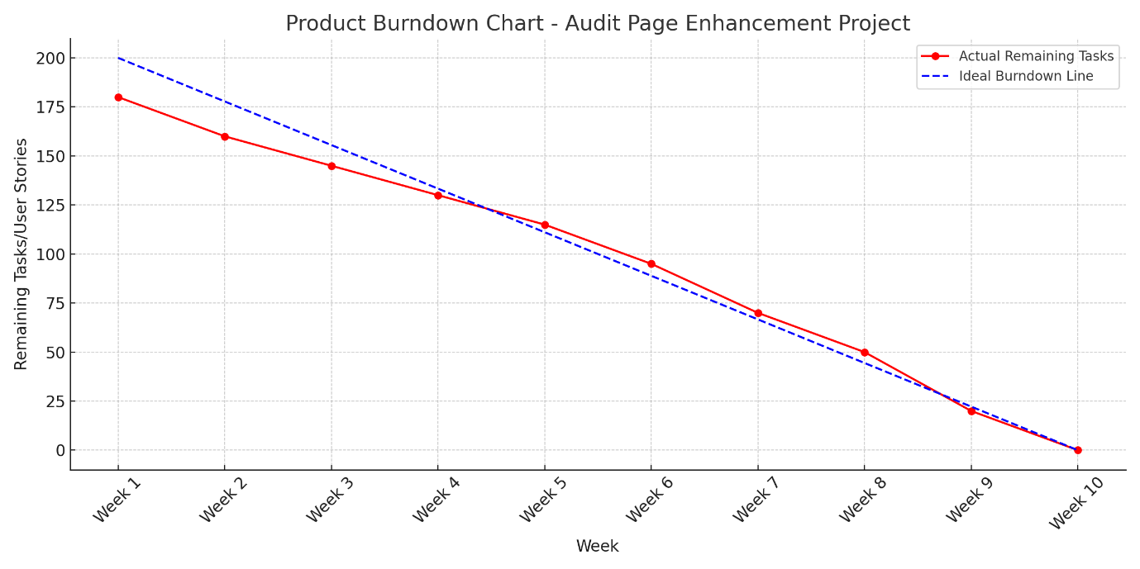

Document 6: Sprint meetings
Sprint 1 – Backend Foundation (15 Feb – 01 Mar 2025)
Meeting Type 1: Sprint Planning Meeting
- Date: 15 February 2025
- Time: 10:00 AM – 11:30 AM
- Location: Microsoft Teams
- Prepared By: Parimal Sanjay Waghmare (Product Owner)
- Attendees: Product Owner, Scrum Master, Developer 1, Developer 2, QA
- Agenda Topics:
  - Discuss and assign user stories: US-001 (Setup backend architecture) and US-002 (Develop API for Audit Report)
  - Define acceptance criteria
  - Review backend development dependencies
  - Estimate sprint capacity and effort
Meeting Type 2: Sprint Review Meeting
- Date: 01 March 2025
- Sprint Status: US-001 and US-002 completed
- Things to Demo:
  - Configured backend and server
  - Working API endpoints for Audit Report
- What's Next: Begin UI prototype and frontend structure
Meeting Type 3: Sprint Retrospective Meeting
- What Went Well:
  - Smooth coordination on backend setup
  - No blockers in API development
- What Didn’t Go Well:
  - Minor environment configuration delay
Daily Stand-ups
- Duration: 15 Feb – 01 Mar 2025
- Focus: Backend development progress, API integration, and blocker handling

Sprint 2 – UI Foundation (02 Mar – 16 Mar 2025)
Sprint Planning Meeting
- Date: 02 March 2025
- Agenda Topics:
  - US-003: Design Audit Ops UI prototype
  - US-004: Integrate backend with frontend
  - Finalize UI flow and user journey
  - Identify required API consumption points
Sprint Review
- Date: 16 March 2025
- Sprint Status: Both stories completed
- Things to Demo:
  - UI wireframes and clickable mock-ups
  - Real-time data display through integrated APIs
- What’s Next: Begin functional enhancements like filtering
Retrospective
- What Went Well:
  - Good UX alignment and design efficiency
- What Didn’t Go Well:
  - Small delays in finalizing button placement and user interaction flow
Daily Stand-ups
- UI design progress, integration fixes, team reviews

Sprint 3 – Functional Enhancements (17 Mar – 31 Mar 2025)
Sprint Planning
- Date: 17 March 2025
- Agenda Topics:
  - US-005: Implement filtering
  - US-006: Handle API error responses
Sprint Review
- Date: 31 March 2025
- Sprint Status: Stories completed
- Things to Demo:
  - Functional filters for Audit data
  - API response validation and fallback handling
Retrospective
- What Went Well: Error handling was robust and proactive
- What Didn’t Go Well: Filter logic had initial bugs with multi-criteria inputs
Daily Stand-ups
- Debugging, filter refinements, API logs review

Sprint 4 – Audit Ratings & Dashboard (01 Apr – 15 Apr 2025)
Sprint Planning
- Date: 01 April 2025
- Agenda Topics:
  - US-007: Develop Audit Ratings module
  - US-008: Create audit dashboard
Sprint Review
- Date: 15 April 2025
- Things to Demo:
  - Combined audit rating system
  - Visual dashboard with KPIs
Retrospective
- What Went Well: UI feedback was positive from stakeholders
- What Didn’t Go Well: Slight delay in chart rendering due to large datasets
Daily Stand-ups
- Audit logic testing, BI chart data accuracy

Sprint 5 – Access & Notifications (16 Apr – 30 Apr 2025)
Sprint Planning
- Date: 16 April 2025
- Agenda Topics:
  - US-009: Setup RBAC
  - US-010: Implement notifications
Sprint Review
- Date: 30 April 2025
- Things to Demo:
  - Role-based access management
  - In-app notifications with trigger alerts

Retrospective
- What Went Well: Authentication worked well
- What Didn’t Go Well: Notification delay on mobile devices
Daily Stand-ups
- Security testing, alert config troubleshooting

Sprint 6 – Final Touch & Deployment (01 May – 15 May 2025)
Sprint Planning
- Date: 01 May 2025
- Agenda Topics:
  - US-011: Mobile responsiveness
  - US-012: Export to Excel
  - US-013: UAT and bug fixes
Sprint Review
- Date: 15 May 2025
- Things to Demo:
  - Mobile-optimized interface
  - Export feature in action
  - UAT reports, final defect logs
Retrospective
- What Went Well: Full user acceptance
- What Didn’t Go Well: Minor bug surfaced late, resolved post-UAT
Daily Stand-ups
- UAT tracking, mobile layout checks, final deployment prep

Meeting Type 4: Daily Stand-up meeting:
Week 1: (17-02-2025 to 22-02-2025)
Sprint 1: Backend Foundation
Question | Name/Role | Monday | Tuesday | Wednesday | Thursday | Friday
What did you do yesterday? | Developer 1 | Set up server config | Designed DB schema | Created API structure | Tested endpoints | Debugged connection
 | Developer 2 | Wrote backend test cases | Executed API tests | Logged minor bugs | Retested fixed bugs | Updated QA checklist
What did you do today? | Developer 1 | Schema tuning | Write sample APIs | Handle error codes | Review integration | Final backend demo
 | Developer 2 | Test auth module | Validate endpoints | Add test data | Run regression | Prepare UAT list
What is blocking your progress? | Developer 1 | None | None | None | None | None
 | Developer 2 | None | None | None | None | None

Week 2: (26-02-2025 to 05-03-2025)

Question | Name/Role | Monday | Tuesday | Wednesday | Thursday | Friday
What did you do yesterday? | Developer 1 | Fixed endpoint errors | Finalized APIs | Synced with QA | Backend logs added | Backend sprint review
 | Developer 2 | Retested endpoints | Updated reports | Prepared UAT | Final QA checklist | Sprint demo executed
What did you do today? | Developer 1 | Review logs | Coordinate with PO | API walkthrough | Sprint wrap-up | Next sprint prep
 | Developer 2 | Report handoff | Review with PO | Test plan for next | Checklist sign-off | Retrospective notes
What is blocking your progress? | Developer 1 | None | None | None | None | None
 | Developer 2 | None | None | None | None | None

Week 3: (10-03-2025 to 14-03-2025)
UI Foundation
Question | Name/Role | Monday | Tuesday | Wednesday | Thursday | Friday
What did you do yesterday? | Developer 1 | Reviewed UI specs | Shared API mappings | Supported UI sync | Fixed backend response | Backend validation
 | Developer 2 | Drafted UI wireframes | Built mock-up screens | Created UI structure | API integration | Finalized UI layout
 | Developer 3 | Reviewed UI test cases | Tested static screens | Validated mock-ups | Logged frontend bugs | QA checklist updated
What did you do today? | Developer 1 | Backend clarifications | Support frontend dev | Response formatting | Error flow validation | Backend test wrap-up
 | Developer 2 | Field alignment tweaks | API response linking | Button functionality | UX enhancements | UI handoff for QA
 | Developer 3 | Review frontend logic | Validate data maps | Complete test cases | Prepare for review | Sprint 2 test summary
What is blocking your progress? | Developer 1 | None | API response delay | None | None | None
 | Developer 2 | Pending final mapping | None | UI loading lag | None | None
 | Developer 3 | Component crash | None | None | None | None

Week 4 (18-03-2025 to 24-03-2025)
Question | Name/Role | Monday | Tuesday | Wednesday | Thursday | Friday
What did you do yesterday? | Developer 1 | Clarified UI field issues | Fixed payload mapping | Validated API outputs | Supported QA | Backend demo walkthrough
 | Developer 2 | Fixed UI layout bugs | Finalized design flow | Retested mock-ups | Integrated all screens | Prepared UI demo
 | Developer 3 | Continued UI validations | Logged design defects | Retested mapped data | Closed critical issues | Shared sprint report
What did you do today? | Developer 1 | UAT preparation | UI-data syncing | Confirm API behaviour | Regression testing | Final sprint review
 | Developer 2 | Style updates | Final button validations | Help QA with rework | Walkthrough with PO | UI freeze
 | Developer 3 | Update test summary | Bug report collation | Prepare UAT checklist | Prepare UAT checklist | Share QA notes with PO
What is blocking your progress? | Developer 1 | None | None | None | None | None
 | Developer 2 | None | Minor CSS conflicts | None | None | None
 | Developer 3 | Inconsistent UI state | None | None | None | None

Week 5 (26-03-2025 to 01-04-2025)
Functional Enhancements:
Question | Name/Role | Monday | Tuesday | Wednesday | Thursday | Friday
What did you do yesterday? | Developer 1 | Started filter logic | Connected to DB filters | Handled date conditions | Debugged filter bugs | Tested API exceptions
 | Developer 2 | Designed filter dropdowns | Hooked filter to UI | Verified frontend logic | Refined UI controls | Fixed UI glitches
 | Developer 3 | Wrote test cases | Tested edge filter input | Validated error handling | Logged defects | Retested fixes
What did you do today? | Developer 1 | Validate filtering output | Test corner cases | Optimize queries | Review log accuracy | Retrospective prep
 | Developer 2 | Align filter UI properly | Apply final styles | Work with QA on testing | Polish interactions | Prepare demo
 | Developer 3 | Full regression pass | Test new filter cases | QA feedback integration | Final testing | QA sign-off
What is blocking your progress? | Developer 1 | None | Filter delay on UI side | None | None | None
 | Developer 2 | Data not binding correctly | None | CSS bug on IE browser | None | None
 | Developer 3 | Delayed response from API | None | None | None | None

Week 6 (03-04-2025 to 09-04-2025)
Question | Name/Role | Monday | Tuesday | Wednesday | Thursday | Friday
What did you do yesterday? | Developer 1 | Handled filter bug fix | Validated API logs | Optimized filter flow | Tested fallback flows | Sprint wrap-up
 | Developer 2 | UI fine-tuning | Helped QA walkthrough | CSS fixes | Final frontend tweaks | Demo slides update
 | Developer 3 | Completed test reports | Validated all test cases | Retested UI filters | UAT support | Closed QA checklist
What did you do today? | Developer 1 | Final sprint demo prep | Hand over to PO | Support QA post-demo | Analyse performance logs | Retrospective notes
 | Developer 2 | Review accessibility | UAT visual QA | UI test report | Code cleanup | Final review meeting
 | Developer 3 | Document test summary | Wrap-up defects | Archive test cases | QA retrospective | Final QA feedback
What is blocking your progress? | Developer 1 | None | None | None | None | None
 | Developer 2 | UAT delay | None | None | None | None
 | Developer 3 | Delayed frontend fixes | None | None | None | None

