**Question 1: Write Agile Manifesto**

Agile Manifesto has 4 values:

1. Individual and Interactions above process and tools.
2. Working software above comprehensive document.
3. Customer Collaboration over contract negotiation.
4. Responding to change over following a plan.

Agile Manifesto carries 12 principles:

1. Highest priority is to satisfy the customer through the early and continuous delivery of valuable software.
2. Welcome changing requirements, even late in development. Agile processes harness change for the customer’s competitive advantage.
3. Deliver working software frequently, from a couple of weeks to a couple of months, with a preference to the shorter timescale.
4. Business people and developers must work together daily throughout the project.
5. Build projects around motivated individuals. Give them the environment and support they need, and trust them to get the job done.
6. The most efficient and effective method of conveying information to and within a development team is face-to-face conversation.
7. Working software is the primary measure of progress.
8. Agile processes promote sustainable development. The sponsors, developers, and users should be able to maintain a constant pace indefinitely.
9. Continuous attention to technical excellence and good design enhances agility.
10. Simplicity–the art of maximizing the amount of work not done–is essential.
11. The best architectures, requirements, and designs emerge from self-organizing teams.
12. At regular intervals, the team reflects on how to become more effective, then tunes and adjusts its behavior accordingly.

**Question 2: Write minimum 40 User stories and their Acceptance Criteria along with their BV and CP.**

|  |  |  |  |
| --- | --- | --- | --- |
| User Story No: 1 | Task: 1 | | Priority: Very High |
| As a new user, I want to register an account so that I can order food. | | | |
| BV: 200 | | CP: 02 | |
| Acceptance Criteria:   * The user can access a registration form. * The registration form requires fields for name, email, password, and phone number. * The system validates the email format and password strength. * The system checks if the email is already registered. * Upon successful registration, the user receives a confirmation message and is redirected to the login page. * The password is securely stored. | | | |

|  |  |  |  |
| --- | --- | --- | --- |
| User Story No: 2 | Task: 1 | | Priority: Very High |
| As a registered user, I want to log in so that I can access my account | | | |
| BV: 500 | | CP: 02 | |
| Acceptance Criteria:   * The user can access a login form. * The login form requires fields for email and password. * The system verifies the entered email and password against the stored credentials. * Upon successful login, the user is redirected to the home page or a personalized dashboard. * The system handles incorrect login attempts with appropriate error messages. * The system should have a "forgot password" link that allows the user to reset their password. | | | |

|  |  |  |  |
| --- | --- | --- | --- |
| User Story No: 3 | Task: 1 | | Priority: High |
| As a user, I want to search for restaurants by name, cuisine, or location so that I can find suitable options. | | | |
| BV: 300 | | CP: 03 | |
| Acceptance Criteria:   * The user can enter search terms in a search bar. * The system filters restaurants based on name, cuisine, and location. * The search results display relevant restaurant information, such as name, cuisine, rating, and distance. * The search results are sorted by relevance or rating. * The user can filter the search results. | | | |

|  |  |  |  |
| --- | --- | --- | --- |
| User Story No:4 | Task: 1 | | Priority: High |
| As a user, I want to view a restaurant's menu so that I can decide what to order. | | | |
| BV: 400 | | CP: 04 | |
| Acceptance Criteria:   * The user can access a restaurant's menu from the restaurant's profile page. * The menu displays item names, descriptions, prices, and optionally, images. * The menu is organized into categories (e.g., appetizers, main courses, desserts). * The menu is easy to read and navigate. | | | |

|  |  |  |  |
| --- | --- | --- | --- |
| User Story No:5 | Task: 1 | | Priority: High |
| As a user, I want to add items to my order and place an order so that I can have food delivered. | | | |
| BV: 50 | | CP: 02 | |
| Acceptance Criteria:   * The user can add items from the menu to their order. * The user can adjust the quantity of items in their order. * The user can view a summary of their order, including the total price. * The user can provide delivery address and special instructions. * The user can confirm and place the order. | | | |

|  |  |  |  |
| --- | --- | --- | --- |
| User Story No:6 | Task: 1 | | Priority: High |
| As a user, I want to pay for my order using various payment methods so that I can complete the transaction. | | | |
| BV: 200 | | CP: 02 | |
| Acceptance Criteria:   * The system supports multiple payment methods (e.g., credit card, debit card, online wallets, cash on delivery). * The payment process is secure and complies with relevant security standards. * The user receives a payment confirmation. * The order is only placed after successful payment, unless cash on delivery is selected. | | | |

|  |  |  |  |
| --- | --- | --- | --- |
| User Story No:7 | Task: 1 | | Priority: High |
| As a user, I want to track my order status so that I know when to expect my food. | | | |
| BV: 200 | | CP: 02 | |
| Acceptance Criteria:   * The user can view the current status of their order (e.g., pending, confirmed, preparing, out for delivery, delivered). * The system provides estimated delivery time. * The user receives notifications about order status updates. * If possible, the user can see the location of the delivery driver on a map. | | | |

|  |  |  |  |
| --- | --- | --- | --- |
| User Story No:8 | Task: 1 | | Priority: High |
| As a user, I want to provide feedback and rate my order and restaurant so that I can share my experience. | | | |
| BV: 200 | | CP: 02 | |
| Acceptance Criteria:   * The user can rate the restaurant and individual items in their order. * The user can provide written feedback about their experience. * The feedback and ratings are stored and displayed on the restaurant's profile page. * The user can only leave a review after the order has been completed. | | | |

|  |  |  |  |
| --- | --- | --- | --- |
| User Story No:9 | Task: 1 | | Priority: High |
| As a new delivery boy, I want to register an account so that I can start accepting deliveries. | | | |
| BV: 200 | | CP: 02 | |
| Acceptance Criteria:   * The delivery boy can access a registration form. * The registration form requires fields for name, email, phone number, vehicle type, vehicle license number, and government issued ID. * The system validates the phone number format and email format. * The system checks if the phone number or email is already registered. * Upon successful registration, the delivery boy receives a confirmation message and is redirected to the login page. | | | |
| User Story No:10 | Task: 1 | | Priority: High |
| As a registered delivery boy, I want to log in so that I can access my delivery dashboard. | | | |
| BV: 200 | | CP: 02 | |
| Acceptance Criteria:   * The delivery boy can access a login form. * The login form requires fields for phone number or email and password. * The system verifies the entered credentials against the stored information. * Upon successful login, the delivery boy is redirected to the delivery dashboard. * The system handles incorrect login attempts with appropriate error messages. * The system includes a "forgot password" feature | | | |

|  |  |  |  |
| --- | --- | --- | --- |
| User Story No:11 | Task: 1 | | Priority: High |
| As a delivery boy, I want to view a list of available orders so that I can choose which orders to accept. | | | |
| BV: 200 | | CP: 02 | |
| Acceptance Criteria:   * The delivery boy can view a list of available orders, including order ID, pickup location, delivery location, and estimated delivery time. * The order list is sorted by proximity or estimated delivery time. * The delivery boy can filter the order list by location or order type. * The map shows the order pick up and drop off locations. | | | |

|  |  |  |  |
| --- | --- | --- | --- |
| User Story No:12 | Task: 1 | | Priority: High |
| As a delivery boy, I want to select and accept an order so that I can begin the delivery process. | | | |
| BV: 200 | | CP: 02 | |
| Acceptance Criteria:   * The delivery boy can select an order from the list of available orders. * The delivery boy can view detailed order information, including customer name, address, and items. * The delivery boy can accept the order, which changes the order status to "Accepted." * The system provides a confirmation message upon acceptance. | | | |

|  |  |  |  |
| --- | --- | --- | --- |
| User Story No:13 | Task: 1 | | Priority: High |
| As a delivery boy, I want to update the order status during pickup and delivery so that the customer and restaurant are informed. | | | |
| BV: 200 | | CP: 02 | |
| Acceptance Criteria:   * The delivery boy can update the order status to "Picked Up," "Out for Delivery," and "Delivered." * The system records the timestamp for each status update. * The customer and restaurant receive real-time notifications of status updates. * The delivery boy can add notes to the status update. | | | |

|  |  |  |  |
| --- | --- | --- | --- |
| User Story No:14 | Task: 1 | | Priority: High |
| As a delivery boy, I want to handle cash-on-delivery (COD) payments so that I can complete the transaction. | | | |
| BV: 200 | | CP: 02 | |
| Acceptance Criteria:   * The delivery boy can view the COD amount for the order. * The delivery boy can mark the order as "Paid" after receiving the cash from the customer. * The system records the payment transaction. * The delivery boy can view a history of collected COD amounts. | | | |

|  |  |  |  |
| --- | --- | --- | --- |
| User Story No:15 | Task: 1 | | Priority: High |
| As a delivery boy, I want to view my delivery reports and revenue generated so that I can track my earnings. | | | |
| BV: 200 | | CP: 02 | |
| Acceptance Criteria:   * The delivery boy can view a report of completed deliveries, including date, time, and earnings. * The delivery boy can filter the report by date range. * The delivery boy can view the total revenue generated within a specified period. * The report contains information about tips received. | | | |

|  |  |  |  |
| --- | --- | --- | --- |
| User Story No:16 | Task: 1 | | Priority: High |
| As a delivery boy, I want to raise issues or report problems so that I can get assistance. | | | |
| BV: 200 | | CP: 02 | |
| Acceptance Criteria:   * The delivery boy can report issues such as incorrect address, customer unavailability, or vehicle problems. * The delivery boy can provide details and attach images to the issue report. * The system sends the issue report to the support team. * The delivery boy receives a confirmation message and a tracking number for the issue. | | | |

|  |  |  |  |
| --- | --- | --- | --- |
| User Story No:17 | Task: 1 | | Priority: High |
| As a restaurant owner, I want to register my restaurant so that I can manage deliveries through the Scrum Food app. | | | |
| BV: 200 | | CP: 02 | |
| Acceptance Criteria:   * The restaurant owner can access a registration form. * The registration form requires fields for restaurant name, address, contact information, cuisine type, and banking details for payments. * The system validates the address and contact information. * The system checks if the restaurant name is already registered. * Upon successful registration, the restaurant owner receives a confirmation message and is redirected to the login page. * The bank information is stored securely. | | | |

|  |  |  |  |
| --- | --- | --- | --- |
| User Story No:18 | Task: 1 | | Priority: High |
| As a registered restaurant owner, I want to log in so that I can access my restaurant dashboard. | | | |
| BV: 200 | | CP: 02 | |
| Acceptance Criteria:   * The restaurant owner can access a login form. * The login form requires fields for email/username and password. * The system verifies the entered credentials against the stored information. * Upon successful login, the restaurant owner is redirected to the restaurant dashboard. * The system handles incorrect login attempts with appropriate error messages. * The system has a "forgot password" option. | | | |

|  |  |  |  |
| --- | --- | --- | --- |
| User Story No:19 | Task: 1 | | Priority: High |
| As a restaurant owner, I want to view incoming orders so that I can prepare them for delivery. | | | |
| BV: 200 | | CP: 02 | |
| Acceptance Criteria:   * The restaurant owner can view a list of incoming orders, including order ID, customer name, items ordered, delivery address, and estimated pickup time. * The order list is displayed in real-time. * The restaurant owner can view detailed order information. * The restaurant owner can print the order. | | | |

|  |  |  |  |
| --- | --- | --- | --- |
| User Story No:20 | Task: 1 | | Priority: High |
| As a restaurant owner, I want to verify the assigned delivery boy's information for security purposes. | | | |
| BV: 200 | | CP: 02 | |
| Acceptance Criteria:   * The restaurant owner can view the assigned delivery boy's name, photo, vehicle information, and rating. * The system verifies the delivery boy's identity and displays a verification status. * The restaurant owner can see the delivery boy's current location. | | | |

|  |  |  |  |
| --- | --- | --- | --- |
| User Story No:21 | Task: 1 | | Priority: High |
| As a restaurant owner, I want to receive payments for completed orders through the Scrum Food app. | | | |
| BV: 200 | | CP: 02 | |
| Acceptance Criteria:   * The system automatically calculates the restaurant's earnings based on completed orders. * The restaurant owner can view a payment history. * Payments are processed according to the agreed-upon schedule and deposited into the restaurant's bank account. * The restaurant owner receives a notification when a payment is sent. | | | |

|  |  |  |  |
| --- | --- | --- | --- |
| User Story No:22 | Task: 1 | | Priority: High |
| As a restaurant owner, I want to view customer feedback and ratings so that I can improve my service. | | | |
| BV: 200 | | CP: 02 | |
| Acceptance Criteria:   * The restaurant owner can view customer feedback and ratings for their restaurant and individual menu items. * The feedback and ratings are displayed in a clear and organized manner. * The restaurant owner can respond to customer feedback. | | | |

|  |  |  |  |
| --- | --- | --- | --- |
| User Story No:23 | Task: 1 | | Priority: High |
| As a restaurant owner, I want to raise issues or report problems with orders or delivery boys so that I can get assistance. | | | |
| BV: 200 | | CP: 02 | |
| Acceptance Criteria:   * The restaurant owner can report issues such as incorrect delivery, payment problems, or delivery boy misconduct. * The restaurant owner can provide details and attach images to the issue report. * The system sends the issue report to the support team. * The restaurant owner receives a confirmation and tracking number. | | | |

|  |  |  |  |
| --- | --- | --- | --- |
| User Story No:24 | Task: 1 | | Priority: High |
| As a restaurant owner, I want to view my revenue generated through the Scrum Food app so that I can track my business performance. | | | |
| BV: 200 | | CP: 02 | |
| Acceptance Criteria:   * The restaurant owner can view a report of revenue generated through the Scrum Food app, including total sales, commissions, and net earnings. * The restaurant owner can filter the report by date range. * The report can be downloaded. | | | |

|  |  |  |  |
| --- | --- | --- | --- |
| User Story No:25 | Task: 1 | | Priority: High |
| As an admin, I want to log in to the admin panel so that I can manage the system. | | | |
| BV: 200 | | CP: 02 | |
| Acceptance Criteria:   * The admin can access the admin login page. * The login form requires username/email and password. * The system verifies the credentials against the stored admin accounts. * Upon successful login, the admin is redirected to the admin dashboard. * The system handles incorrect login attempts with appropriate error messages. * The system has a "forgot password" option. | | | |

|  |  |  |  |
| --- | --- | --- | --- |
| User Story No:26 | Task: 1 | | Priority: High |
| As an admin, I want to track the status of orders and deliveries in real-time so that I can ensure smooth operations. | | | |
| BV: 200 | | CP: 02 | |
| Acceptance Criteria:   * The admin can view a real-time map displaying the location of delivery boys and the status of orders. * The admin can filter orders by region, status, and delivery boy. * The admin can view detailed order information, including customer details, restaurant details, and delivery details. * The admin can see historical order tracking. | | | |

|  |  |  |  |
| --- | --- | --- | --- |
| User Story No:27 | Task: 1 | | Priority: High |
| As an admin, I want to view customer feedback and ratings so that I can identify areas for improvement. | | | |
| BV: 200 | | CP: 02 | |
| Acceptance Criteria:   * The admin can view all customer feedback and ratings for restaurants and delivery boys. * The admin can filter feedback by region, restaurant, or delivery boy. * The admin can view aggregated ratings and feedback reports. * The admin can export feedback data. | | | |

|  |  |  |  |
| --- | --- | --- | --- |
| User Story No:28 | Task: 1 | | Priority: High |
| As an admin, I want to manage regional delivery boys and restaurants so that I can maintain quality and efficiency. | | | |
| BV: 200 | | CP: 02 | |
| Acceptance Criteria:   * The admin can view a list of all regional delivery boys and restaurants. * The admin can add, edit, and deactivate delivery boys and restaurants. * The admin can assign delivery boys to specific regions. * The admin can view delivery boy and restaurant performance metrics. | | | |

|  |  |  |  |
| --- | --- | --- | --- |
| User Story No:29 | Task: 1 | | Priority: High |
| As an admin, I want to view regional revenue reports so that I can track business performance. | | | |
| BV: 200 | | CP: 02 | |
| Acceptance Criteria:   * The admin can view revenue reports for each region. * The admin can filter revenue reports by date range. * The reports include total sales, commissions, and net earnings. * The admin can export revenue reports. | | | |

|  |  |  |  |
| --- | --- | --- | --- |
| User Story No:30 | Task: 1 | | Priority: High |
| As an admin, I want to manage and resolve reported issues so that I can ensure customer and restaurant satisfaction. | | | |
| BV: 200 | | CP: 02 | |
| Acceptance Criteria:   * The admin can view a list of reported issues from customers, restaurants, and delivery boys. * The admin can assign issues to specific support personnel. * The admin can update the status of issues and add notes. * The admin can view issue resolution reports. | | | |

|  |  |  |  |
| --- | --- | --- | --- |
| User Story No:31 | Task: 1 | | Priority: High |
| As an admin, I want to process refunds for customers so that I can handle disputes and ensure customer satisfaction. | | | |
| BV: 200 | | CP: 02 | |
| Acceptance Criteria:   * The admin can view refund requests and related order details. * The admin can approve or reject refund requests. * The system automatically processes approved refunds. * The admin can view refund reports. | | | |

|  |  |  |  |
| --- | --- | --- | --- |
| User Story No:32 | Task: 1 | | Priority: High |
| As an admin, I want to view payment records made to regional restaurants so that I can track financial transactions. | | | |
| BV: 200 | | CP: 02 | |
| Acceptance Criteria:   * The admin can view payment records to regional restaurants. * The admin can filter payment records by date range, and regional restaurant. * The payment records include payment date, amount, and order details. * The admin can export payment records. | | | |

|  |  |  |  |
| --- | --- | --- | --- |
| User Story No:33 | Task: 1 | | Priority: High |
| As a business owner, I want to log in to the system so that I can access my business dashboard. | | | |
| BV: 200 | | CP: 02 | |
| Acceptance Criteria:   * The business owner can access the login page. * The login form requires username/email and password. * The system verifies the entered credentials against the stored business owner accounts. * Upon successful login, the business owner is redirected to the business dashboard. * The system handles incorrect login attempts with appropriate error messages. * The system has a "forgot password" option. | | | |

|  |  |  |  |
| --- | --- | --- | --- |
| User Story No:34 | Task: 1 | | Priority: High |
| As a business owner, I want to view and manage reported issues so that I can ensure operational efficiency. | | | |
| BV: 200 | | CP: 02 | |
| Acceptance Criteria:   * The business owner can view a comprehensive list of all reported issues from customers, restaurants, delivery boys, and admins. * The business owner can filter issues by status, region, and type. * The business owner can assign issues to relevant personnel for resolution. * The business owner can track the progress of issue resolution. * The Business owner can add notes to the issues. | | | |

|  |  |  |  |
| --- | --- | --- | --- |
| User Story No:35 | Task: 1 | | Priority: High |
| As a business owner, I want to generate and view various reports so that I can analyze business performance. | | | |
| BV: 200 | | CP: 02 | |
| Acceptance Criteria:   * The business owner can generate reports on sales, revenue, delivery performance, customer feedback, and regional performance. * The business owner can customize report parameters, such as date range and region. * The reports are displayed in a clear and concise format, including charts and graphs. * The business owner can download reports in various formats (e.g., PDF, CSV). | | | |

|  |  |  |  |
| --- | --- | --- | --- |
| User Story No:36 | Task: 1 | | Priority: High |
| As a business owner, I want to view detailed financial reports so that I can monitor revenue and expenses. | | | |
| BV: 200 | | CP: 02 | |
| Acceptance Criteria:   * The business owner can view reports on total revenue, commissions, expenses, and net profit. * The business owner can filter financial reports by date range and region. * The reports provide a breakdown of income and expenses. * The business owner can export financial reports. | | | |

|  |  |  |  |
| --- | --- | --- | --- |
| User Story No:37 | Task: 1 | | Priority: High |
| As a business owner, I want to update payment status for restaurants so that I can manage financial transactions. | | | |
| BV: 200 | | CP: 02 | |
| Acceptance Criteria:   * The business owner can view a list of pending payments to restaurants. * The business owner can mark payments as "Paid" and record payment details. * The system generates payment records and receipts. * The business owner can filter restaurant payments by date. | | | |

|  |  |  |  |
| --- | --- | --- | --- |
| User Story No:38 | Task: 1 | | Priority: High |
| As a business owner, I want to update payment status for delivery boys so that I can manage their earnings. | | | |
| BV: 200 | | CP: 02 | |
| Acceptance Criteria:   * The business owner can view a list of pending payments to delivery boys. * The business owner can mark payments as "Paid" and record payment details. * The system generates payment records and receipts. * The business owner can filter delivery boy payments by date. | | | |

|  |  |  |  |
| --- | --- | --- | --- |
| User Story No:39 | Task: 1 | | Priority: High |
| As a business owner, I want to view an audit log of all payment updates so that I can track changes. | | | |
| BV: 200 | | CP: 02 | |
| Acceptance Criteria:   * The business owner can view a log of all payment updates made to restaurants and delivery boys. * The log includes the date, time, user, and details of the payment update. * The business owner can filter the audit log by date and user. | | | |

|  |  |  |  |
| --- | --- | --- | --- |
| User Story No:40 | Task: 1 | | Priority: High |
| As a business owner, I want to securely log out of the system so that my account is protected. | | | |
| BV: 200 | | CP: 02 | |
| Acceptance Criteria:   * The business owner can access a "Logout" button. * Upon clicking "Logout," the business owner is logged out of the system. * The system clears the session and redirects the business owner to the login page. | | | |

**Question 3: What is epic? Write 2 epics.**

An epic is a large body of work that can be broken down into smaller stories. It's essentially a high-level user story that's too big to be completed within a single sprint.

Epics serve as containers for related user stories and provide a broader context for the development effort.

2 Epics from this project are:

* Implement a Comprehensive Customer Ordering Experience: This epic includes all the features required to provide customers with a seamless and user-friendly ordering experience.
* Establish an Efficient Delivery Network: This epic focuses on building a robust and reliable delivery network that ensures timely and accurate order fulfillment.

**Question 4: Difference between BV and CP.**

|  |  |
| --- | --- |
| **BV (Business Value)** | **CP (Complexity Point)** |
| * It signifies the importance of a feature or user stories to the business and its customers. | * It estimates the effort required to implement a feature or user story. |
| * It helps in prioritizing the feature that will deliver the most significant benefits. | * It helps the team to plan their work and forecast how much they can achieve in a sprint. |
| * It is measured using relative scales. In this project the user story’s importance are estimated by scrum currency notes. (Rs 1000, Rs 500, Rs 100, Rs 50, Rs 20 and Rs 10) | * In this project we are measuring CP using poker card’s values. (? ,1,2,3,5,8,13,20,40,100 and BIG). |

**Question 5: Explain Sprint**

A Sprint is a short, time-boxed period during which a SCRUM team works on a complete, planned set of work. These time-periods are of specific duration, ranging from 12-14 days. By the end of each sprint, a scrum team should be able to deliver a functional product.

There are various scrum-events that takes place in a SPRINT.

* Sprint Planning: In this, the product owner, scrum-master and scrum development team collaborate to select product-backlog items for the SPRINT.
* Daily Scrum: It is a daily short meeting where the Scrum developers answer questions regarding ongoing sprint like –
  + What task did you work on?
  + What task will you work on next?
  + Any challenges/impediment faced?
* Sprint Review: This happens at the end of each sprint and the team reflects on what went well and what can be improved in future sprints.

**Question 6: Explain Product backlog and Sprint backlog.**

* **Product Backlog** is an ordered and dynamic list of everything that is needed in the product like user-stories, Bugs, knowledge acquisitions, technical work, etc. It is owned by Product Owner. It is a single source of requirement for any changes to made in the product.
* **Sprint Backlog** is a subset of product backlog. It contains the set of items from product backlog that a development team commits to complete in a particular sprint. It is owned and managed by the product development team.

**Question 7: What is impediments log? write 2 impediments.**

An impediment log is a tool used in Scrum to track and manage obstacles that hinder the progress of scrum development team. It is a repository where team records any issues or roadblocks that prevent them from completing the work efficiently.

The 2 impediments from this project can be:

* Glitches with real time delivery tracking. Navigation app integration issue.
* Payment Gateways integration delay.

|  |  |
| --- | --- |
| **Log Id** | 1 |
| **Description** | Glitches with real time delivery tracking. Navigation app integration issue. |
| **Impact** | Delay in deliveries, delivery person getting into wrong address and area. |
| **Priority** | Very High |
| **Assigned to** | Scrum Development Team |
| **Status** | Open |
| **Action Taken** | The team is making changes in the integration code blocks and looking for bugs. |
| **Resolution** | WIP. Team is providing regular updates. An application update will be launched for delivery drivers and customers. |

|  |  |
| --- | --- |
| **Log Id** | 2 |
| **Description** | Payment Gateways integration delay. |
| **Impact** | Delay in online payments and sometime failed payments. |
| **Priority** | High |
| **Assigned to** | Scrum Development Team |
| **Status** | Open |
| **Action Taken** | The team is making changes in the integration code blocks and are in touch with payment providers to resolve this issue. |
| **Resolution** | WIP. Team is in regular contact with payment portals. An application update will be launched for delivery drivers and customers. |

**Question 8: Explain Velocity of the Team.**

In Scrum “Velocity of a team” is a measure of the amount of work a team can complete during a single sprint. It is typically measured in story points. It is calculated by Scrum Master.

It is calculated using:

* Story point estimations.
* Tracking completed work.
* Summing story points.
* Calculating average velocity.

**Question 9: Draw Sprint Burn Charts and Product Burn Down Charts.**

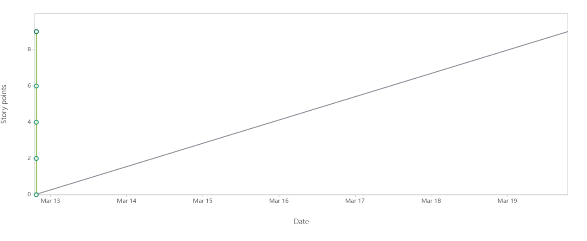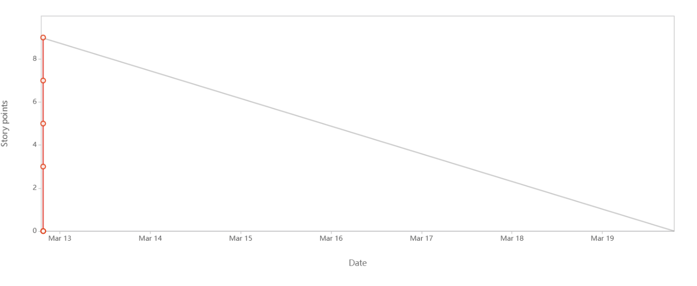

**Question 10: Explain about product grooming.**

Product Grooming is an ongoing process with agile development where the product is regularly refined.

It is regularly reviewing and refining the product backlog to ensure that it is organized, up to date and ready for future sprints.

The key activities in Product Grooming are:

* Reviewing and updating backlog items.
* Breaking down large items to smaller tasks so that it can be completed in a single sprint.
* Estimating effort.
* Adding details such as acceptance criteria, descriptions, etc. to provide clarity.
* Removing irrelevant items from backlog.
* Reprioritizing the backlog items.

**Question 11: Explain the roles of Scrum Master and Product Owner.**

* **Scrum Master** – A Scrum Master facilitates the Scrum process and ensures that the team is following scrum principles. Scrum Master facilitates the scrum events like: Scrum Planning, Daily Scrums, Sprint reviews and Scrum Retrospectives. Some of the main responsibilities of scrum master is to coach the team on scrum practices and values, Impediment removal and process improvements.
* **Product Owner** – A Product owner is responsible for defining the product vision and strategy. Product Owners create and maintain product backlog and prioritize backlog items to maximize the value of product. The product owner is also a person in contact for the stakeholders and gather requirements and feedback from the stakeholders.

**Question 12: Explain all Meetings Conducted in Scrum Project.**

* **Mandatory meetings**
  + **Sprint Planning:** The sprint planning meeting is scheduled to plan the work to be done in upcoming sprint. The entire scrum team participates in this meeting. In this, product owner presents the prioritized product backlog, the development team selects items from product backlog and a sprint backlog is created.
  + **Daily Stand-up (Daily Scrum):** It is scheduled every day for 15 – 20 mins where each team member answers 3 questions: What they did yesterday? What will they do today? Any impediments faced?
  + **Sprint Review:** It is done at the end of each sprint to inspect the increment and update the product backlog if needed. The Scrum team and stakeholders participate in this meeting. The stakeholders are informed on what items from the backlog has been done and what has not been done. The stakeholder and product owner collaborate based on stakeholder’s feedback and update the product backlog if required.
  + **Sprint Retrospective:** This is done at the end of each sprint to discuss on what went well in a sprint and identify areas of improvement.
* **Optional Meetings**
  + **Backlog Grooming:** The purpose of this meeting is to refine and maintain the product backlog. Everyone from the Scrum team and stakeholders participate in this meeting before the sprint starts.
  + **Release Planning:** It is scheduled to create high level plan for releasing the product. Everyone from the scrum team and stakeholders participate in this meeting.
  + **Ad-hoc meetings:** These are unplanned meetings and are scheduled according to the scenarios.

**Question 13: Explain Sprint Size and Scrum Size.**

* Sprint size refers to the duration of a sprint. It has a fixed duration of 10 days to 2 weeks.
* Scrum Size refers to the number of people in a Scrum team. The team size is generally 8 – 10 members in it.

**Question 14: Explain DOR and DOD.**

* **DOR (Definition of Ready):** It defines the criteria that a Product backlog item (PBI), must meet before the development team considers it ready to be included in a Sprint. It ensures that the team understands the requirements and has all the necessary information to begin work.
* **DOD (Definition of Done):** The DoD is a checklist of criteria that must be met for a PBI or a Sprint Increment to be considered complete. It ensures that everyone on the team has a shared understanding of what "done" means.

**Question 15: Explain Prioritization Techniques and MVP.**

**Prioritization** is a process of determining the order in which, items in the backlog should be addressed. Items are ranked according to the value they deliver to the customer. High-Value, Low effort items are prioritized first.

One of the most common prioritization techniques is MoSCoW (Must Have, Should Have, Could Have, Won’t Have).

* Must Have: These are critical requirements that are essential for the project to be considered a success. If these are not met, the project fails.
* Should Have: These are important requirements that are highly desirable but not absolutely essential. They add significant value but are not critical for the project's core functionality.
* Could Have: These are desirable requirements that would be nice to have if time and resources permit. They add value but are not crucial for the project's success.
* Won't Have: These are requirements that have been agreed upon as being the lowest priority or not necessary for the current delivery cycle. They may be considered for future releases.

**MVP (Minimum Viable Product)** is the version of new planned product which has minimum enough features to be used by early customers. These customers provide feedback and these are used to implement features in future development of the product. Its purpose is to validate the product idea with minimal investment.

**Question 16. Difference between Business Analyst and Product Owner.**

|  |  |
| --- | --- |
| **Business Analyst** | **Product Owner** |
| BAs analyze the business, gather requirements and creates functional requirements. | Product Owner defines the product vision, strategy and Roadmap. |
| Facilitate conversations b/w stakeholders and developers. | They are responsible to maximize the value of the product. |
| BA focuses on detailed requirement and not on overall product. | Managing Product backlog and prioritizing items. |
| The BA provides analysis and recommendations to support decision-making. | Make decisions about product features and functionalities. |
|  |  |

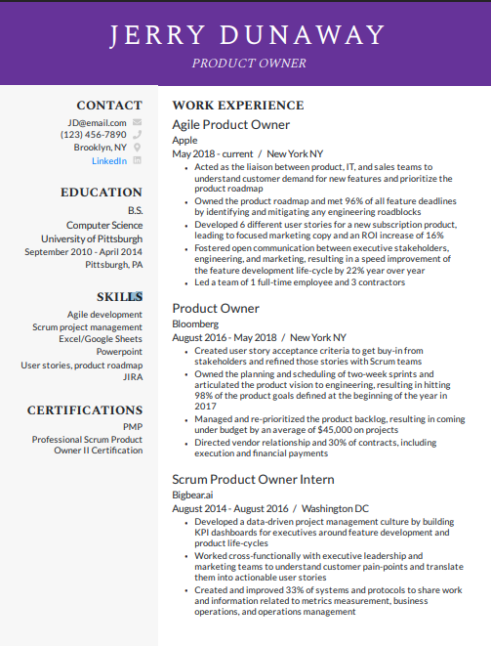**Question 17. Prepare a sample Resume of 3yrs exp Product Owner.**