Assignment 1

Business Requirement Document (BRD)

1. Project Title:
Inventory Management and Quick Delivery Software for Ice-cream & Milk Products Company

2. Purpose:
The purpose of this project is to build an integrated system that:
- Efficiently manages inventory across manufacturing plants and warehouses.
- Ensures quickest delivery of products to customers using intelligent logistics and routing.

3. Background:
The client operates multiple manufacturing plants and warehouses across the country. Their business heavily depends on:
- Maintaining optimal inventory levels to meet demand without overstocking or wastage.
- Ensuring timely deliveries of perishable goods to retain customer satisfaction and brand value.

4. Goals and Objectives:

Goals | Objectives
1. Manage Inventory | Real-time stock monitoring at plants and warehouses. Track batches and expiry dates for perishable goods. Stock alerts for low and overstock.
2. Quickest Delivery | Auto-assign orders to the nearest warehouse. Optimize delivery routes. Track shipments in real-time. Allow customers to track their orders.

5. Scope of Work:

5.1 In-Scope:
- Inventory management system with stock tracking, stock movement, reorder alerts.
- Order management system.
- Customer order portal (Web + Mobile responsive).
- Warehouse and logistics management.
- Integration with GPS and map services for delivery routing.
- Admin dashboard and reporting.

5.2 Out-of-Scope:
- Manufacturing process automation (e.g., plant production machines).
- Third-party logistics services integration initially (can be phased later).

6. Functional Requirements:

Feature | Description
Inventory Module | Stock In/Out, Transfers, Batch Tracking, Expiry Tracking, Reorder Levels
Order Management | Customer orders placement, processing, allocation
Delivery Routing | Auto-suggest optimal route and warehouse based on customer address
Admin Dashboard | KPIs: Stock levels, Order status, Delivery status, Warehouse performance
Notifications | Low stock, expired products, new orders, delayed deliveries
Customer Portal | Order placing, order tracking, support chat
Reports | Inventory reports, Sales reports, Delivery time analysis

7. Non-Functional Requirements:
- High Availability: 99.9% uptime
- Mobile Responsive Design
- Data Security: SSL encryption, role-based access
- Scalability: Handle increasing plants, warehouses, customers
- Performance: <2 seconds page load time

8. Stakeholders:
Stakeholder | Role
Client Leadership | Approvals, Strategy
Warehouse Managers | Daily stock and dispatch operations
Logistics Team | Delivery planning and execution
IT Team | System maintenance post-launch
Customers | End users for order placing

9. Assumptions:
- GPS tracking devices or mobile apps will be available with delivery agents.

- Real-time internet connectivity is available at warehouses and delivery points.

10. Timeline and Milestones:
Milestone | Timeframe
Requirement Gathering | Week 1-2
UI/UX Designing | Week 3-4
Core Development (Inventory + Orders) | Week 5-9
Delivery & Routing Module | Week 10-12
Integration and Testing | Week 13-14
User Acceptance Testing (UAT) | Week 15
Deployment and Go Live | Week 16
Total Duration: 4 months
  - Development Plan

Phase | Activities | Tools/Technologies
Planning | BRD Finalization, Tech Stack Selection | Figma (UI), Confluence (documentation)
Design | Wireframes, UI/UX | Figma, Adobe XD
Development | Backend APIs, Frontend Screens | Backend: Node.js / Python Django  Frontend: ReactJS / Angular  Database: PostgreSQL/MySQL
Delivery Optimization | GPS Integration, Route Algorithms | Google Maps API, Open Route Service
Testing | Unit Testing, Integration Testing, UAT | Selenium, Postman
Deployment | Cloud Hosting, Database Setup | AWS/Azure

  - Resource Plan

Role | Resource Count | Key Responsibilities
Project Manager | 1 | Project oversight, communication with client
Business Analyst | 1 | Requirements gathering, documentation
UI/UX Designer | 1 | Design screens and customer portal
Backend Developer | 2 | API development, inventory logic, database management
Frontend Developer | 2 | Customer portal, Admin portal development
Mobile Developer | 1 | Mobile responsive optimization or light app
QA Tester | 1 | Manual + automation testing
DevOps Engineer | 1 | Deployment, server management

Process Flow Diagram

Start
Customer Places Order
System Receives Order
Check Inventory Levels
Stock Available?
Assign Nearest Warehouse
Generate Pick List

Notify Admin / Suggest Alternative

Dispatch Team Picks & Packs Items

Delivery Routing System Finds Best Route
Assign Delivery Agent
Update Customer with Tracking Info
Real-Time Delivery Tracking
Customer Receives Order
System Auto-Updates Inventory
Send Feedback Request to Customer
End

Assignment 2

Introduction letter

Dear [Client's Name],
I hope this message finds you well. My name is Tanisha, and I will be your dedicated Business Analyst working closely with you and your team as we embark on this exciting journey together.
In my role, I will serve as the key point of contact for understanding your business needs, aligning our goals, and ensuring smooth communication between all stakeholders. I am here to guide you through the process of identifying requirements, analysing your existing systems and processes, and helping to shape the solutions that will best support your business objectives.
My goal is to facilitate the business understanding process and make sure we’re all aligned from the very start. I look forward to collaborating with you and your team, gathering valuable insights, and providing actionable recommendations to drive success for your business.
Please feel free to reach out if you have any questions or if there is anything you'd like to discuss ahead of our upcoming meetings. I am eager to get started and contribute to our mutual success.
Warm regards,
Tanisha
Business Analyst
[ Contact Information]

Horoscope BRD AND SRS

  - Business Requirements Document (BRD) – Horoscope Project

1. Project Overview
The Horoscope Project aims to develop a web and/or mobile application that provides users with daily, weekly, monthly, and yearly horoscopes based on their zodiac sign. The application will also offer personalized astrology reports, compatibility analysis, and daily notifications.
2. Business Objective
- Enhance user engagement by offering personalized horoscope readings.
- Generate revenue through ads, subscriptions, and premium astrology reports.
- Build a loyal user base interested in astrology-related content.
3. Scope
- Display horoscopes for 12 zodiac signs.
- Personalized daily horoscope feed.
- Zodiac compatibility matching.
- Optional: Detailed astrology reports (paid feature).
- Notifications/reminders for daily horoscope updates.
- Admin Panel for horoscope content management.
4. Key Stakeholders
- Product Owner
- Development Team
- Marketing Team
- End Users (general public interested in astrology)
5. Business Requirements
- Users should be able to select their zodiac sign and view predictions.
- The app should send daily horoscope notifications.
- Users should be able to check zodiac compatibility with others.
- Admins should be able to update horoscope content regularly.
- Paid users should access exclusive, detailed astrology reports.

  - Software Requirements Specification (SRS) – Horoscope Project
1. Introduction
This document defines the functional and non-functional requirements for the Horoscope application.
2. Functional Requirements
- User Registration/Login (Optional): Allow users to create an account (for premium features).
- Zodiac Selection: Users can select their zodiac sign manually or by entering their birthdate.
- Horoscope Display: Show daily, weekly, monthly, and yearly horoscopes.
- Push Notifications: Send daily horoscope notifications.
- Compatibility Check: Allow users to check compatibility between two zodiac signs.
- Content Management (Admin Panel): Admin can add, edit, or delete horoscope content.
- Subscription Management: Manage subscription plans for detailed reports.
3. Non-Functional Requirements
- Performance: The app should load horoscope content within 2 seconds.
- Scalability: Should handle up to 10,000 concurrent users in phase 1.
- Security: Secure user data with encryption and secure authentication.
- Availability: 99.5% uptime guarantee.
4. System Requirements
- Frontend: Web (ReactJS) / Mobile (Flutter/React Native)
- Backend: Node.js/Python (Django/Flask) with RESTful APIs
- Database: MySQL or MongoDB
- Hosting: AWS, Azure, or GCP
5. Constraints
- Horoscope content must be updated daily without fail.
- Push notifications should respect user time zone preferences.
- Premium reports require payment gateway integration (e.g., Stripe, Razorpay).

ERD -Support Ticket /Ticketing Life cycle

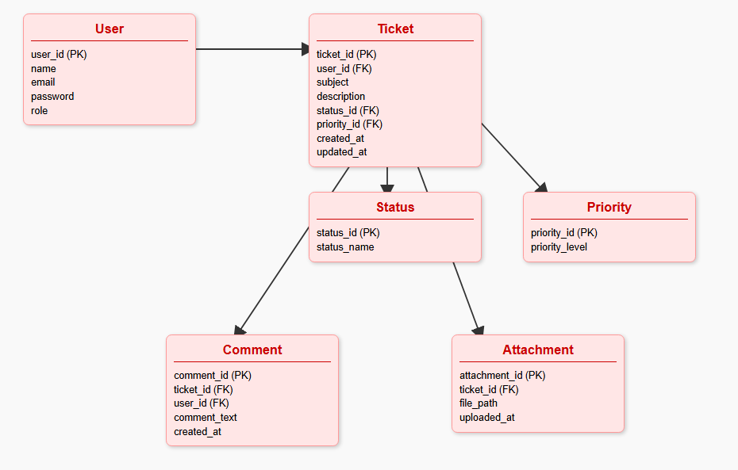

User story -Shopping from E commerce

Title: Shopping on E-commerce Platform
As a customer,
I want to browse products, add them to my cart, apply discounts, and complete my purchase,
so that I can buy the items I need in a simple, convenient, and secure manner.
Acceptance Criteria:
- Product Browsing:
  - I can search for products by category, brand, or keyword.
  - I can filter search results based on price, ratings, or other product attributes.
- Product Details:
  - I can view detailed information about a product, including price, description, images, and customer reviews.
  - I can check the product's availability and shipping options.
- Shopping Cart:
  - I can add multiple products to my cart.
  - I can view the cart and update the quantities or remove items.
  - I can see the total price of my cart, including taxes and shipping fees.
- Discounts and Offers:
  - I can apply discount codes or promotional offers to my order.
  - I can see the updated price after the discount is applied.
- Checkout Process:
  - I can review my order before proceeding to payment.
  - I can provide shipping details and select a payment method (credit card, PayPal, etc.).
  - I can review my payment details and complete the purchase.
- Order Confirmation:
  - I receive an order confirmation email or notification.
  - I can track my order status (processing, shipped, delivered) from the platform.
- Security:
  - My personal and payment information is encrypted and securely stored.

