Waterfall Model Documents

Document No 6

# Use Case Diagram

# Activity Diagram

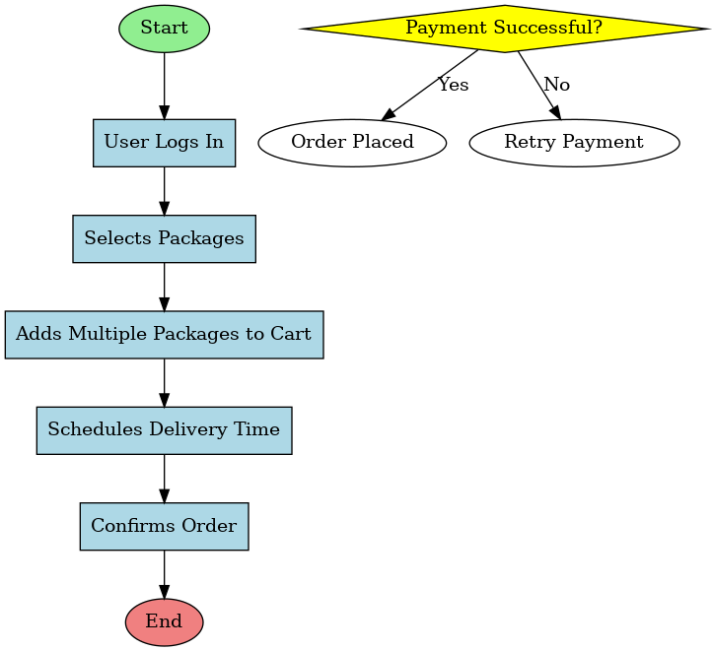 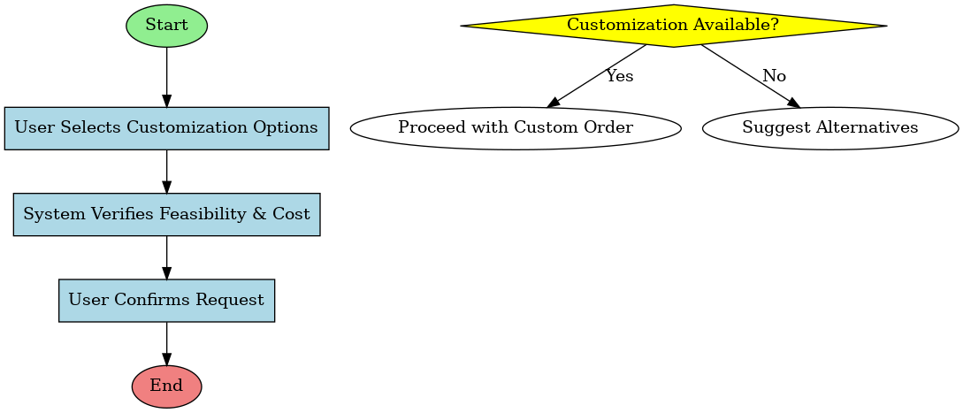

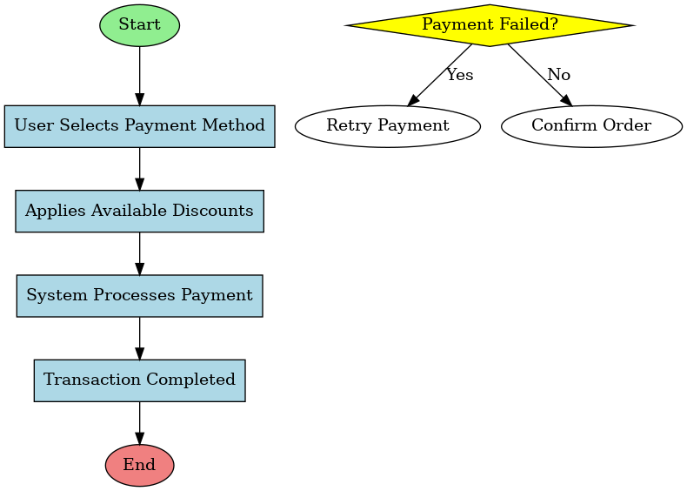

# Use case Specification Document

## Use case Name

Order Placement and Route Optimization

## Use Case Description:

This use case defines the process of order placement and AI-powered route optimization for efficient delivery.

## Actors:

Customer, System (AI-based Route Optimizer), Delivery Personnel, Payment Gateway

## Basic Flow:

* Customer logs into the app.
* Customer enters pickup and drop-off locations.
* AI suggests the best route and estimated delivery time.
* Customer confirms the order.
* Customer completes the payment.
* System assigns a delivery person.
* Order processing starts.

## Alternate Flow:

* If the AI suggests an unavailable route, an alternate route is provided.
* If the customer cancels before pickup, the system refunds the payment.

## Exceptional Flows:

* If payment fails, the customer is prompted to retry or select a different method.
* If AI cannot suggest a route due to system failure, manual intervention is required.

## Pre-Conditions:

* The customer must be a registered user.
* Pickup and drop-off locations must be serviceable.

## Post-Conditions:

* The order is successfully placed, and delivery is scheduled.
* The system records the order details for tracking.

## Assumptions:

* Customers provide accurate pickup/drop-off details.
* Delivery personnel follow AI-recommended routes.
* AI predictions are based on real-time data and are accurate.

## Constraints:

* AI optimization depends on internet connectivity.
* Limited delivery slots for high-demand areas.

## Dependencies:

* Payment gateway for processing transactions.
* AI route optimizer for efficient delivery.

## Inputs and Outputs:

* Inputs: Pickup and drop-off locations, package details, payment details.
* Outputs: Estimated delivery time, real-time tracking, notifications.

## Business Rules:

* Orders cannot be placed without payment confirmation.
* Customers can cancel an order within 2 minutes of placement.
* AI assigns delivery personnel based on proximity and availability

## Miscellaneous Information:

* Customers receive an AI-generated estimated time of arrival (ETA).
* AI dynamically reroutes deliveries based on real-time traffic.

## Use case Name

Real-Time Delivery Tracking

## Use Case Description:

This use case explains how the customer can track their delivery in real-time

## Actors:

Customer, System, Delivery Personnel

## Basic Flow:

* Customer logs into the app.
* Customer selects an active order.
* System displays real-time tracking updates.
* AI updates the route dynamically based on traffic and weather.
* Customer receives notifications for delivery status changes.

## Alternate Flow:

* If GPS tracking fails, the system provides last known location.
* If delivery is delayed, customer support is notified automatically.

## Exceptional Flows:

* If the tracking system fails, fallback notifications are sent.
* If the delivery personnel deviates from the route, a security alert is triggered.

## Pre-Conditions:

* The customer must have an active order.
* GPS tracking must be enabled on the delivery personnel’s device.

## Post-Conditions:

* Customer receives accurate, real-time updates on the delivery status.
* System logs the delivery journey for future reference.

## Assumptions:

* Delivery personnel follow AI-recommended routes.
* Customers check tracking details periodically.

## Constraints:

* Tracking accuracy depends on GPS and internet connectivity.

## Dependencies:

* GPS tracking system.
* AI route optimizer for dynamic updates.

## Inputs and Outputs:

* Inputs: Delivery personnel location data, AI route updates.
* Outputs: Live tracking updates, delivery status notifications.

## Business Rules:

* Customers can view tracking details only for their own orders.
* System updates tracking status every few minutes.

## Miscellaneous Information:

* AI reroutes deliveries dynamically based on real-time conditions.

## Use Case Name

Payment and Refund Processing

## Description:

This use case details how payments and refunds are handled.

## Actors:

Customer, System, Payment Gateway

## Basic Flow:

* Customer selects a delivery service.
* Customer chooses a payment method.
* Payment is processed through the gateway.
* System confirms payment and starts the order.

## Alternate Flows:

* If payment fails, the customer retries or selects another method.
* If order is canceled within a grace period, a full refund is processed.

## Exceptional Flows:

* If payment gateway experiences downtime, customers are notified to retry later.
* If unauthorized payment is detected, security alerts are triggered.

## Pre-Conditions:

* The customer must have a valid payment method linked.
* The payment gateway must be operational.

## Post-Conditions:

* Payment is successfully processed and recorded.
* Refunds are issued for canceled or failed orders.

## Constraints:

* Some payment methods may have processing delays.

## Dependencies:

* Payment gateway for transaction processing.
* Customer’s bank or financial service provider.

## Inputs and Outputs:

* Inputs: Payment details, transaction ID.
* Outputs: Payment confirmation, refund status.

## Business Rules:

* Orders cannot be placed without successful payment confirmation.
* Refunds are processed within a specified timeframe.

## Assumptions:

* Customers use secure and valid payment methods.
* The payment gateway is reliable and secure.

## Miscellaneous Information:

* Customers receive transaction confirmation via email and in-app notification.

## Use Case Name

Delivery Personnel Assignment and Reassignment

## Description:

AI assigns or reassigns delivery personnel for order fulfillment.

## Actors:

System, Delivery Personnel, Customer

## Basic Flow:

* System selects the nearest available delivery person.
* Delivery personnel accept the order.
* Customer receives delivery personnel details.
* Order pickup and delivery begin.

## Alternate Flows:

* If delivery personnel is unavailable, the system automatically assigns another.
* If a customer requests a change, the system evaluates the feasibility.

## Exceptional Flows:

* If no delivery personnel are available, the order is temporarily put on hold.
* If delivery personnel cancel midway, a reassignment is triggered.

## Pre-Conditions:

* Delivery personnel must have an active status.
* Customer’s order must be confirmed.

## Post-Conditions:

* Delivery personnel are successfully assigned.
* Customer is notified of the assignment.

## Constraints:

* Assignments are based on personnel availability and location.

## Dependencies:

* AI system for personnel assignment.
* Delivery personnel’s device connectivity.

## Inputs and Outputs:

* Inputs: Delivery personnel location, order details.
* Outputs: Assignment confirmation, customer notification.

## Business Rules:

* Personnel are assigned based on proximity and availability.
* Customers cannot manually select delivery personnel.

## Assumptions:

* Delivery personnel are available in the serviceable area.
* AI system can process real-time assignments efficiently.

## Miscellaneous Information:

* The system reassigns personnel dynamically based on real-time data.

## Use Case Name

Customer Support and Issue Resolution

## Description:

This use case handles customer issues related to deliveries.

## Actors:

Customer, Customer Support, System

## Basic Flow:

* Customer reports an issue via the app.
* System categorizes the issue.
* Automated AI-assisted support provides potential solutions.
* If unresolved, customer support intervenes.
* Resolution is provided to the customer.

## Alternate Flows:

* If the issue is technical, a support ticket is generated.
* If compensation is required, a refund or discount is applied.

## Exceptional Flows:

* If customer support is unavailable, an automated response is sent.
* If an issue remains unresolved beyond a set timeframe, escalation occurs.

## Pre-Conditions:

* Customer must have an order-related concern.
* Support system must be operational.

## Post-Conditions:

* Customer receives a resolution or next steps.
* System logs issue details for reference.

## Constraints:

Support response time may vary based on issue complexity.

## Dependencies:

* AI-assisted support system.
* Human customer support agents.

## Inputs and Outputs:

* Inputs: Customer complaint details, order ID.
* Outputs: Resolution response, compensation details if applicable.

## Business Rules:

* Customers can escalate issues if not resolved within a timeframe.
* Refunds or compensations follow predefined policies.

## Assumptions:

* Customers provide accurate issue descriptions.
* AI-assisted solutions can handle most minor issues.

## Miscellaneous Information:

Customers receive updates on issue progress via notifications.

Document No 7

# Screens and pages

Document No 8

# Tools-Visio and Axure

For this project, Microsoft Visio was instrumental in creating clear and structured use case diagrams and activity diagrams. Its intuitive drag-and-drop interface helped in designing UML-based representations, ensuring that workflows and interactions were well-documented. The ability to use pre-defined shapes and templates made it efficient to map out complex processes.

Axure RP was used for developing high-fidelity wireframes and interactive prototypes. It provided an excellent platform to visualize user flows and refine the UI/UX for the customizable delivery app. The ability to create clickable prototypes allowed for better demonstration and validation of the application’s functionalities before actual development. The combination of Visio for system diagrams and Axure for wireframes helped create a seamless and structured approach to designing the app.

Document No 09

# BA experience

## Requirement Gathering:

* Gathered business requirements from stakeholders through discussions.
* Documented all necessary features for the customizable delivery app.
* Ensured clarity in scope to align with the project objectives.

## Requirement Analysis:

* Analyzed the gathered requirements and structured them for development.
* Created use case diagrams and workflows to represent the system behavior.
* Reviewed the feasibility of features based on business and technical constraints.

## Design:

* Developed wireframes and UI layouts using Axure to visualize the app’s functionality.
* Ensured a user-friendly and intuitive design aligned with business needs.
* Reviewed the designs with stakeholders and refined them based on feedback.

## Development:

* Worked closely with developers to ensure the implementation of requirements.
* Provided necessary clarifications regarding functionality and expected outcomes.
* Ensured that the development followed the structured approach of the Waterfall Model.

## Testing:

* Assisted in validating the app's functionality by reviewing test cases.
* Ensured that all features worked as intended before deployment.
* Identified and addressed any usability or functionality gaps before release.

## Deployment:

* Verified that the final version of the application met all requirements.
* Supported documentation and user training to ensure smooth adoption.
* Coordinated with stakeholders to facilitate a seamless launch.