**Waterfall Model Documents**

**Part 2/2 Evaluation**

Document 6- Please prepare a use case diagram, activity diagram and a use case specification document.

Document 7- Screens and pages

Document 8- Tools-Visio and Axure

Document 9- BA experience

My experience as BA in following phases:

1. Requirement gathering:
2. Requirement Analysis:
3. Design:
4. Development:
5. Testing:
6. Deployment:

**Document 6- Please prepare a use case diagram, activity diagram and a use case specification document.**

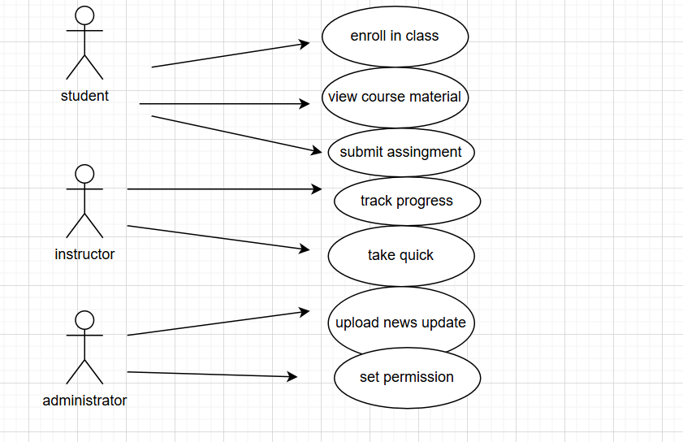

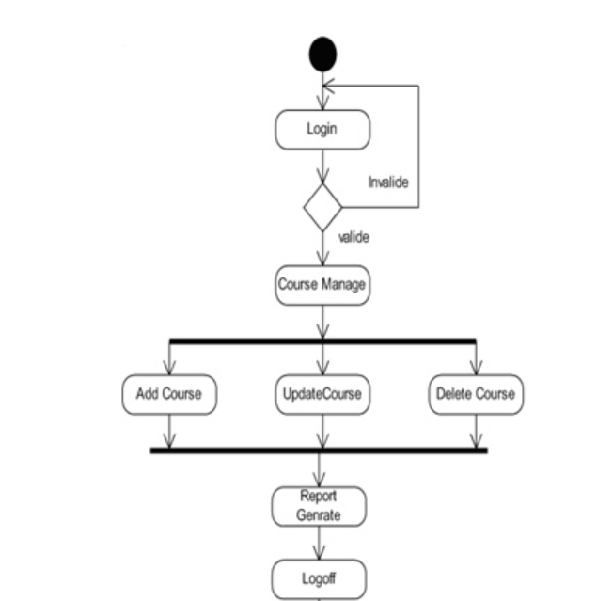

**Use case specification**

### Use Case Name

User Registration and Enrollment

### 2. Use Case Description

This use case describes the process by which a new user registers for an account on the Learning Management System (LMS) and enrolls in courses.

### 3. Actors

* **Primary Actors:**
  + User (Student)
  + System Administrator
* **Secondary Actors:**
  + Course Instructor

### 4. Basic Flow

1. The user navigates to the LMS registration page.
2. The user fills out the registration form with required details (name, email, password).
3. The user submits the registration form.
4. The system validates the information and creates a new user account.
5. The user receives a confirmation email with an account activation link.
6. The user clicks on the activation link to activate their account.
7. The user logs into the LMS using their credentials.

### 5. Alternate Flow

User Registration with google account

* 1. The user opts to register using a google account.
  2. The system redirects the user to the google authentication page.
  3. The user grants the LMS permission to access their google information.

### 6. Exceptional Flows

Invalid Registration Details

* 1. The system detects invalid or incomplete registration details.
  2. The system prompts the user to correct the information and resubmit the form.

Email Already Registered

* 1. The system identifies that the email is already registered.
  2. The system prompts the user to login or recover their password.

### 7. Pre-Conditions

* The user has access to the LMS registration page.
* The LMS system is online and operational.

### 8. Post-Conditions

* The user has a registered and activated account on the LMS.
* The user is enrolled in the selected course.

### 9. Assumptions

* Users have a valid email address.
* Users have internet access to register and enroll in courses.

### 10. Constraints

* Registration forms must comply with data privacy regulations.
* System should handle a high volume of concurrent registrations.

### 11. Dependencies

* Email service for sending confirmation and activation emails.
* Social media authentication services if registering through social media.

### 12. Inputs and Outputs

* **Inputs:**
  + User registration details (name, email, password)
  + Course selection for enrollment
* **Outputs:**
  + Confirmation emails
  + Account activation link
  + Updated user course list

### 13. Business Rules

* Users must provide a unique email address for registration.
* Password must meet security criteria (e.g., minimum length, complexity).
* Users can enroll in multiple courses.

### 14. Miscellaneous Information

* System should support multiple languages for the registration process.
* System should provide accessibility options for users with disabilities.

# Document 7- Screens and pages

Please follow the following steps to create the mock-ups

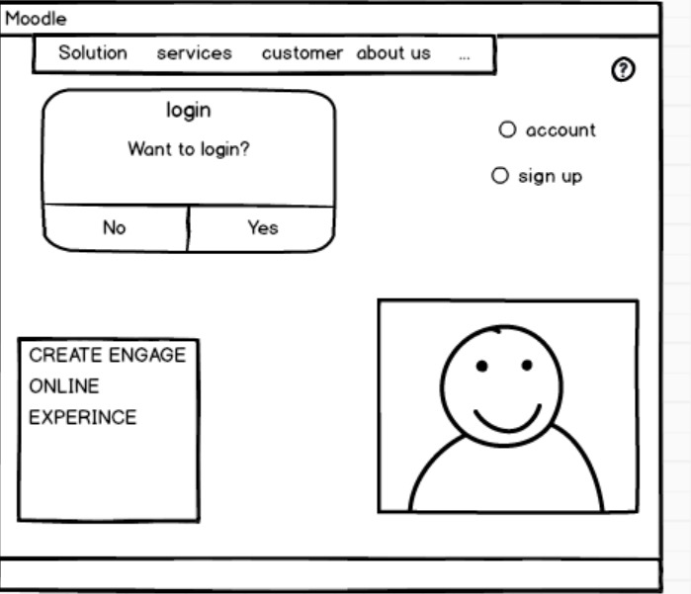

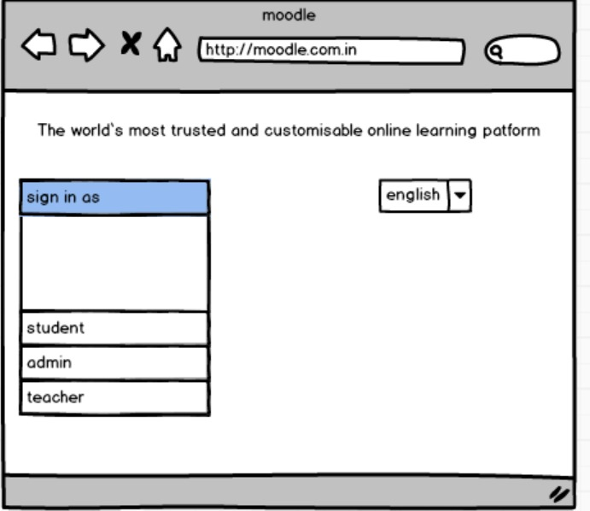

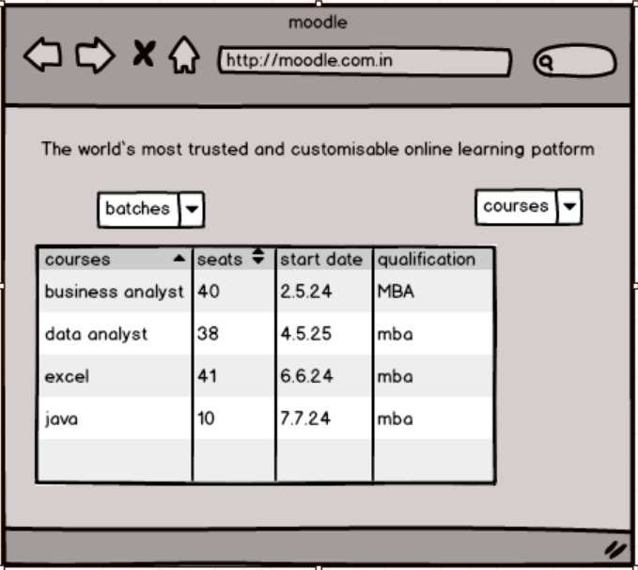

**Document 8- Tools-Visio and Axure**

Write a paragraph on your experience using Visio and Axure for the project.

**Visio**- To prepare a practical, flexible, easy to make, easy to understand flow chart or organizational chart the ultimate choice, in most cases, will be Microsoft Visio, an innovative way to visualize a business process. Visio enables you to learn about organizational setup, flow of documentation, and procedures along with cause and effect diagrams, the more important is that the diagram is self explanatory for presentation purpose.

**Azure**- Microsoft Azure is the perfect public cloud platform.. Microsoft Azure keeps adding features/products according to the need and business requirements. The virtual machines are the most advanced feature from Azure, we are using this most of the time and I can say this is fully scalable and provide great flexibility to our cloud infrastructure and the applications. The deployment of this platform was really quick unlike the other cloud platforms and on the

infrastructure and the applications. The deployment of this platform was really quick unlike the other cloud platforms and on the other hand, this also comes with seamless integration options with the third-party platforms and applications

# Document 9- BA experience

**My experience as BA in following phases:**

**1. Requirement Gathering**

* Conducting interviews and workshops with stakeholders to elicit requirements.
* Using techniques like brainstorming, surveys, and focus groups to gather comprehensive information.
* Documenting detailed requirements in the form of user stories and use case diagrams.
* Ensuring all requirements were captured accurately and reviewed with stakeholders for validation.

**2. Requirement Analysis**

* Analyzing and modeling requirements using tools like UML diagrams, flowcharts, and data models.
* Prioritizing requirements based on business value, feasibility, and impact.
* Collaborating with technical teams to ensure requirements were technically viable and aligned with project scope.
* Creating requirement traceability matrices to track requirements throughout the project lifecycle.

**3. Design**

* Contributing to the creation of high-level design documents that outline system architecture and data flow.
* Ensuring the design met business needs and adhered to industry best practices.
* Participating in design review meetings to provide input from a business perspective.
* Documenting detailed functional specifications and user interface designs.

**4. Development**

* Acting as a liaison between the development team and stakeholders to clarify requirements.
* Reviewing development progress and providing feedback to ensure alignment with requirements.
* Updating requirement documents to reflect any changes or new insights gained during development.
* Assisting in creating test plans and test cases based on the requirements.

**5. Testing**

* Reviewing and validating test plans and test cases to ensure comprehensive coverage of requirements.
* Participating in various testing activities such as unit testing, integration testing, and user acceptance testing (UAT).
* Identifying and documenting defects, and working with the development team to resolve them.
* Ensuring all requirements were tested and met before the system went live.

**6. Deployment**

* Preparing deployment plans and coordinating with various teams for a successful rollout.
* Conducting training sessions and creating user manuals to help users understand the new system.
* Monitoring the deployment process to quickly address any issues or concerns.
* Gathering feedback post-deployment to identify areas for improvement and ensure user satisfaction.