**Agile Documents Part 2**

**Document 1 : Definition Of Done**

**Definition Of Done (DoD)** is a shared agreement among all team members on the criteria that must be met before a backlog item is considered complete. This ensures transparency, quality, and alignment with business requirements.

The DoD is structured as a checklist that ensures :

* **Customer acceptance criteria** are satisfied.
* **Quality criteria** are met to ensure a reliable and maintainable product.
* **Team alignment** on what constitutes “done” at different project levels ( user story, sprint, release ).

***Checklist for Definition of Done***

1. **Development Criteria :**

* **Product code** for all required functionalities.
* **User Story assumptions met** as per business requirements.
* **Project builds without errors** and compiles successfully.
* **Unit tests written and passing** for all developed features.

1. **Testing & Quality Assurance :**

* **Project deployed** on a test environment identical to production.
* **Tests passed** on all required devices, browsers, and platforms.
* **Features validated by UX designer** to ensure usability.
* **QA performed & issues resolved,** including functional, integration, and performance testing.
* **Features tested against acceptance criteria** and meets all defined requirements.

1. **Product Validation & Approval :**

* **Features approved by Product Owner** and aligns with business needs.
* **Refactoring completed,** ensuring clean and maintainable code.
* **Any configuration or build changes documented** for future reference.

1. **Documentation & Deployment Readiness :**

* **End-user documentation updated** for training and support.
* **Technical documentation updated** for developers and IT teams.
* **Peer code review performed** to ensure coding standards and best practices.

By adhering to this **Definition of Done**, Volkswagen Financial Services ensures that each completed feature is high-quality, fully functional, and ready for deployment.

**Document 2 : Product Vision**

|  |  |  |  |
| --- | --- | --- | --- |
| **Scrum Project**  **Name :** | VWFS ( Volkswagen Financial Services ) | | |
| Venue : | Pune |  |  |
| Date : | Start time : 07/08/2022 | End time : 07/08/2023 | Duration : 12 months |
| Client : | Volkswagen |  |  |
| Stakeholder list : | Volkswagen Financial Services Management | Volkswagen Dealerships | Finance & Compliance Teams |
|  | IT & Development Teams | Customers ( Car Buyers Seeking Financing ) |  |
|  |  |  |  |
| Scrum Team | | | |
| Scrum Master : | Mr. Krishna |  |  |
| Product Owner : | Mr. Shivanand |  |  |
| Scrum Developer 1: | Mr. Vaibhav |  |  |
| Scrum Developer 2: | Mr. Daulat |  |  |
| Scrum Developer 3: | Mr. Vinayak |  |  |
| Scrum Developer 4: | Ms. Deepika |  |  |
| Scrum Developer 5: | Ms. Madhuri |  |  |

|  |  |  |  |
| --- | --- | --- | --- |
| ***Vision :***  The Volkswagen Financial Services POS Application aims to **generate quotations & Contracts, maintain inventory data, service records, customer information, and streamline the vehicle financing process** for Volkswagen dealership and customers by providing a **flat, transparent, and user-friendly digital solution.** This application will integrate seamlessly with dealership systems, enabling **real-time loan approvals, compliance checks, and enhanced customer experience,** ultimately driving business efficiency and sales growth. | | | |
| **Target group**  **Market Segment :**    ***Automotive financing industry***, specially Volkswagen dealerships and their customers.  ***Digital financial services*** for faster, paperless loan processing.  **Target Audience :**  *Primary Users (B2B -Volkswagen Dealerships & Finance Teams )*  *End Customers (B2C – Car Buyers seeking for Financing )* | **Needs**  **Seamless integration** with Volkswagen’s CRM, ERP, and financial systems.  ***Reduced system downtime***, transaction failures, and technical issues.  Easiest way to ***generate quotations*** and save customer’s details.  ***Automated and real-time credit approvals*** to speed up financing.  ***User-friendly customer interface*** for easy loan tracking and approvals. | **Product**  A **user-friendly, digital POS solution** integrated with Volkswagen dealership systems to generate quotations, save customer data, offer real-time credit checks, loan approvals, service records , inventory management, and compliance validation. | **Value**  **Value :**    **Speed –** Reduces financing processing time.  **Integration –** Seamlessly connects with existing systems.  **Transparency –** Provides real-time loan status updates to customers.  **Business Growth –** Boosts sales conversions by reducing loan approval delays.  **Business goals :**   * Accelerate financing approvals. * Enhance dealership efficiency. * Ensure compliance with financial regulations. * Reduce operational costs by automating manual loan processes.   **Business Model :**   * **Service fees** from dealerships using the POS system. * **Transaction-based commission** on approved loans. * **Premium API integrations** for financial institutions. |

**Document 3 : User Stories**

|  |  |  |  |
| --- | --- | --- | --- |
| **User Story No: US-001** | | **Tasks :01** | **Priority : High** |
| As a Admin  I want to login to the application to view the available showroom stock  So that I can maintain inventory. | | | |
| **BV : 500 INR** | **CP : 8** | | |
| **Acceptance Criteria :**  User can enter login Id and password.  System validates entered credentials.  User is logged in system. | | | |

|  |  |  |
| --- | --- | --- |
| **User Story : US-002** | **Tasks : 3** | **Priority : High** |
| As a sales Manager  I want to generate quotation which include all necessary required information of customer and customer’s requirement.  So that I can save the customer’s data and I can understand the requirement. | | |
| **BV : 300 INR** | **CP : 8** | |
| **Acceptance Criteria :**  User can able to generate quotation  Text box to enter the information  Click on submit  Information saved and quotation generated | | |

|  |  |  |
| --- | --- | --- |
| **User Story No: US-003** | **Tasks : 04** | **Priority : High** |
| As a cur buyer,  I want to submit s financing application through the POS system  So that I can get quick approval for my car purchase. | | |
| **BV : 350 INR** | **CP: 13** | |
| **Acceptance Criteria :**  User can enter personal and financial details  System validates all required fields.  Application is submitted successfully.  Confirmation message is displayed. | | |

|  |  |  |
| --- | --- | --- |
| **User Story : US-004** | **Tasks : 02** | **Priority : Medium** |
| As a dealership finance manager,  I want to perform an instant credit check for a customer,  So that I can determine their loan eligibility immediately. | | |
| **BV : 300 INR** | **CP : 8** | |
| **Acceptance Criteria :**  Dealership manager can enter customer’s CIBIL score and financial details.  System checks and validates the details.  As per credit score loan should be approved or rejected. | | |

|  |  |  |
| --- | --- | --- |
| **User Story : US-005** | **Tasks : 03** | **Priority : Medium** |
| As a showroom owner  I want to view the showroom’s revenue report  So that I can view the revenue and profits. | | |
| **BV : 200 INR** | **CP : 5** | |
| **Acceptance Criteria :**  Select reports  Select Revenue Reports  Select month and year  Generate Report  Download report in EXCEL | | |

|  |  |
| --- | --- |
| **User Story : US-006** | **Priority : High** |
| As an admin  I want to add/update car inventory details. |  |
| **BV: 250 INR** | **CP: 8** |
| **Acceptance Criteria :**  New cars can be added, and existing details updated without errors. |  |

|  |  |
| --- | --- |
| **User Story : US-007** | **Priority : critical** |
| As a customer  I want to select financing options. |  |
| **BV : 500 INR** | **CP: 13** |
| **Acceptance Criteria :**  Users can select financing plans and see accurate can details. |  |
| **User Story : US-008** | **Priority :High** |
| As a finance officer  I want to approve/reject loan applications. |  |
| **BV: 450 INR** | **CP: 8** |
| **Acceptance Criteria :**  Loans can be approved/ rejected based on credit score and internal rules. |  |

|  |  |
| --- | --- |
| **User Story : US-009** | **Priority : Medium** |
| As a customer  I want to track my loan application status. |  |
| **BV : 250 INR** | **CP: 5** |
| **Acceptance Criteria :**  Customers can view real-time status updates of their loan applications. |  |

|  |  |
| --- | --- |
| **User Story : US-010** | **Priority : Medium** |
| As a sales agent  I want to schedule test drive. |  |
| **BV : 150 INR** | **CP: 3** |
| **Acceptance Criteria :**  Test drive requests can be booked and confirmed through the system. |  |

|  |  |
| --- | --- |
| **User Story : US-011** | **Priority : High** |
| As an accountant  I want to generate invoice. |  |
| **BV : 350 INR** | **CP: 8** |
| **Acceptance Criteria :**  Invoice data is correct and exportable in PDF format. |  |

|  |  |
| --- | --- |
| **User Story : US-012** | **Priority : Medium** |
| As a customer  I want to receive payment reminders. |  |
| **BV : 100 INR** | **CP : 3** |
| **Acceptance Criteria :**  Reminders are sent before due dates through SMS and email. |  |

|  |  |
| --- | --- |
| **User Story : US-013** | **Priority : High** |
| As a showroom manager  I want analyze customer buying trends. |  |
| **BV : 300 INR** | **CP : 8** |
| **Acceptance Criteria :**  Reports correctly show customer buying patterns with filtering options. |  |

|  |  |
| --- | --- |
| **User Story : US-014** | **Priority : Medium** |
| As an admin  I want to manage user roles and permissions. |  |
| **BV : 300 INR** | **CP : 5** |
| **Acceptance Criteria :**  Users can only access authorized features based on roles. |  |

|  |  |
| --- | --- |
| **User Story : US-015** | **Priority : High** |
| As a loan officer  I want to generate credit reports |  |
| **BV : 400 INR** | **CP : 8** |
| **Acceptance Criteria :**  Credit report data is correctly pulled and displayed for review. |  |

|  |  |
| --- | --- |
| **User Story : US-016** | **Priority : High** |
| As a customer  I want to upload necessary documents |  |
| **BV : 350 INR** | **CP : 5** |
| **Acceptance Criteria :**  Users can upload files securely, and files are stored successfully. |  |

|  |  |
| --- | --- |
| **User Story : US-017** | **Priority : High** |
| As a dealership owner  I want to generate business performance reports. |  |
| **BV : 450 INR** | **CP : 8** |
| **Acceptance Criteria :**  Reports accurately display dealership performance data |  |

|  |  |
| --- | --- |
| **User Story : US-018** | **Priority : Critical** |
| As a customer  I want to digitally sign loan agreements. |  |
| **BV : 450 INR** | **CP : 13** |
| **Acceptance Criteria :**  Customers can sign agreements electronically without errors. |  |

|  |  |
| --- | --- |
| **User Story : US-019** | **Priority : High** |
| As a finance manager  I want to track pending loan repayments. |  |
| **BV : 450 INR** | **CP : 8** |
| **Acceptance Criteria :**  Dashboard shows overdue and upcoming loan payments. |  |

|  |  |
| --- | --- |
| **User story : US-020** | **Priority : High** |
| As an auditor  I want to verify financial transactions. |  |
| **BV : 400 INR** | **CP : 8** |
| **Acceptance Criteria :**  Transactions are traceable and audit logs can be exported. |  |

|  |  |
| --- | --- |
| **User Story : US-021** | **Priority : High** |
| As a customer  I want to compare different loan options |  |
| **BV : 400 INR** | **CP : 5** |
| **Acceptance Criteria :**  Customers can see side-by-side comparisons of loan options. |  |

|  |  |
| --- | --- |
| **User Story : US-022** | **Priority : Low** |
| As an admin  I want to reset forgotten passwords. |  |
| **BV : 100 INR** | **CP : 2** |
| **Acceptance Criteria :**  Users receive password reset links via email. |  |

|  |  |
| --- | --- |
| **User Story : US-023** | **Priority : Medium** |
| As a sales agent  I want to view customer purchase history |  |
| **BV : 200 INR** | **CP : 5** |
| **Acceptance Criteria :**  Customer history is displayed correctly when searched. |  |
| **User Story : US-024** | **Priority : High** |
| As an admin  I want to generate detailed audit logs |  |
| **BV : 300 INR** | **CP : 8** |
| **Acceptance Criteria :**  Logs are generated and downloadable. |  |

|  |  |
| --- | --- |
| **User Story : US-025** | **Priority : Medium** |
| As a customer  I want to receive instant approval notifications. |  |
| **BV : 300 INR** | **CP : 3** |
| **Acceptance Criteria :**  Instant notifications are triggered upon approval. |  |

|  |  |
| --- | --- |
| **User Story : US-026** | **Priority : Medium** |
| As a manager  I want to filter reports by date range |  |
| **BV : 250 INR** | **CP : 5** |
| **Acceptance Criteria :**  Reports update dynamically based on the date range filter. |  |

|  |  |
| --- | --- |
| **User Story : US-027** | **Priority : Low** |
| As a sales manager  I want to export customer data |  |
| **BV : 150 INR** | **CP : 3** |
| **Acceptance Criteria :**  Data exports properly in CSV and PDF format. |  |

|  |  |
| --- | --- |
| **User Story : US-028** | **Priority : High** |
| As a customer  I want to set up autopay for my EMI |  |
| **BV : 350 INR** | **CP : 8** |
| **Acceptance Criteria :**  Customers can successfully enroll in autopay. |  |

|  |  |
| --- | --- |
| **User Story : US-029** | **Priority : High** |
| As a dealer  I want to view real-time stock availability |  |
| **BV : 400 INR** | **CP : 8** |
| **Acceptance Criteria :**  Inventory data updates in real-time. |  |

|  |  |
| --- | --- |
| **User Story : US-030** | **Priority : High** |
| As a showroom manager  I want to view service history of cars |  |
| **BV : 350 INR** | **CP : 5** |
| **Acceptance Criteria :**  Service history is displayed correctly. |  |

|  |  |
| --- | --- |
| **User Story : US-031** | **Priority : High** |
| As a finance officer  I want to apply promotional discounts on loans. |  |
| **BV : 450 INR** | **CP : 8** |
| **Acceptance Criteria :**  Discounts reflect correctly in loan calculations. |  |

|  |  |
| --- | --- |
| **User Story : US-032** | **Priority : Low** |
| As an admin  I want to automate system backups. |  |
| **BV : 100 INR** | **CP : 2** |
| **Acceptance Criteria :**  System backups data at scheduled intervals. |  |

|  |  |
| --- | --- |
| **User Story : US-033** | **Priority : Medium** |
| As a sales agent  I want to generate car comparison reports |  |
| **BV : 200 INR** | **CP : 5** |
| **Acceptance Criteria :**  Report data loads correctly without errors. |  |

|  |  |
| --- | --- |
| **User Story : US-034** | **Priority : Critical** |
| As a finance manager  I want to integrate credit scoring APIs |  |
| **BV : 500 INR** | **CP : 13** |
| **Acceptance Criteria :**  Credit scoring API should be integrate correctly. |  |

|  |  |
| --- | --- |
| **User Story : US-035** | **Priority : High** |
| As an admin  I want to monitor system performance in real-time |  |
| **BV : 350 INR** | **CP : 8** |
| **Acceptance Criteria :**  System should track and show performance in real-time. |  |

|  |  |
| --- | --- |
| **User Story : US-036** | **Priority : 13** |
| As a loan officer  I want to get instant fraud detection alerts. |  |
| **BV : 500 INR** | **CP : 13** |
| **Acceptance Criteria :**  System detect fraud activities and send instant alerts. |  |

|  |  |
| --- | --- |
| **User Story : US-037** | **Priority : High** |
| As a dealer  I want to manage commissions for sales agents |  |
| **BV : 300 INR** | **CP : 5** |
| **Acceptance Criteria :**  System should track and calculate the commissions for the sales agents depending upon their sales. |  |

|  |  |
| --- | --- |
| **User Story : US-038** | **Priority : Medium** |
| As an admin  I want to set up approval workflows |  |
| **BV : 300 INR** | **CP : 5** |
| **Acceptance Criteria :**  Workflow engine should set workflow of approvals. |  |

|  |  |
| --- | --- |
| **User Story : US-039** | **Priority : High** |
| As a customer  I want to apply trade-in value for down payment. |  |
| **BV : 450 INR** | **CP : 8** |
| **Acceptance Criteria :**  Trade-in calculator should calculate value of down payment. |  |

|  |  |
| --- | --- |
| **User Story : US-040** | **Priority : Low** |
| As an admin  I want to enable multilingual support |  |
| **BV : 150 INR** | **CP : 3** |
| **Acceptance Criteria :**  System should support multi languages and translate. |  |

**Document 4 : Agile PO Experience**

Role of the Product Owner (PO) in the Volkswagen Financial Services POS Application Project :

1. **Product Vision & Market Experience :**

The Product Owner (PO) plays a crucial role in defining the **vision, strategy, and execution** of the Volkswagen Financial Services POS Application by leveraging **industry experience and market needs.**

1. **Responsibilities of the Product Owner :**

* Market Analysis :
* Conducts **market research** to identify the demand for a digital POS financing solution.
* Evaluates **existing similar products** in the financial services and automotive industry.
* Analyzes **competitor solutions** and identifies unique value propositions.
* Enterprise Analysis :
* Performs **due diligence** on market opportunities and potential challenges.
* Assesses **business feasibility and ROI** for the Volkswagen Financial Services POS system.
* Product Vision and Roadmap :
* Defines a **clear product vision** aligned with market needs.
* Develops a **high-level product roadmap** with key features and timeline.
* Managing Product Features :
* Engages with stakeholders to gather business and technical requirements.
* **Prioritizes epics, stories, and features** based on business impact and ROI.
* Manages **stakeholder expectations**  and ensures alignment with business objectives.
* Managing the Product Backlog :
* **Prioritizes user stories** based on business and customer needs.
* Continuously **refines the backlog** by reprioritizing tasks based on changing requirements.
* Ensures proper **epic planning and sprint alignment.**
* Managing Overall Iteration Process
* Reviews **sprint process** to ensure alignment with project goals.
* Conducts **reprioritization of sprints and epics** based on business needs.
* Leads **sprint retrospectives** with the Business Analyst to refine processes.

1. **Sprint Meetings & Agile Execution :**

From this project, I have gained experience in handling the following **Agile Scrum meetings :**

* **Sprint Planning Meeting –** Defining sprint scope, backlog items, and goals.
* **Daily Scrum Meetings –** Monitoring progress, addressing blockers, and aligning team efforts.
* **Sprint Review Meeting –** Showcasing completed work and gathering stakeholder feedback.
* **Sprint Retrospective Meeting –** Reviewing sprint performance and identifying improvements.
* **Backlog Refinement Meeting –** Adjusting user stories, reprioritizing, and ensuring clarity.

1. **User Story Creation & Key Elements :**

In this project I have worked on **user story creation,** ensuring they include the following details :

* **Story Number –** Unique ID for tracking.
* **Tasks –** Breakdown of development and testing work.
* **Priority –** Categorization ( High, Medium, Low ) based on business impact.
* **Acceptance Criteria –** Clear conditions that must be met for the story to be considered “done”.
* **BV & CP value ( Business Value & Customer Priority ) –** Ensuring alignment with business goals.

1. **Product Owner as the Communication Bridge :**

As a **Product Owner,** I acted as a **liaison** between different areas of the organization, ensuring :

* **Effective communication with business stakeholders** to align product goals.
* **Collaboration with Scrum teams** to guide development priorities.
* **Regular updates to all teams** on project progress and changes.

The **Product Owner’s vision** for the Volkswagen Financial Services POS application helped define the product’s **features, priorities, and backlog items,** ensuring smooth execution and successful delivery.

**Document 5: Product and sprint backlog and product and sprint burn down charts**

**Product Backlog :**

The Product Backlog is a prioritizes list of all features, enhancements, and bug fixes required for the Volkswagen Financial Services POS application.

|  |  |  |  |  |  |  |
| --- | --- | --- | --- | --- | --- | --- |
| User Story ID | User Story | Tasks | Priority | BV | CP | Sprint |
| US-001 | As a Admin  I want to login to the application to view the available showroom stock  So that I can maintain inventory. | UI Design,  Database setup | High | $10K | 3 | Sprint 1 |
| US-002 | As a sales Manager  I want to generate quotation which include all necessary required information of customer and customer’s requirement.  So that I can save the customer’s data and I can understand the requirement. | UI Form, PDF Generation, Data storage | High | $50k | 5 | Sprint 1 |
| US-003 | As a cur buyer,  I want to submit s financing application through the POS system  So that I can get quick approval for my car purchase. | UI Form, API Integration, Data validation | High | $100k | 13 | Sprint 2 |
| US-004 | As a dealership finance manager,  I want to perform an instant credit check for a customer,  So that I can determine their loan eligibility immediately. | Credit Check API, UI Update | Medium | $75k | 8 | Sprint 2 |
| US-005 | As a showroom Manager  I want to view the showroom’s revenue report  So that I can view the revenue and profits. | Report Generation, Database Queries, UI Design | Medium | $25k | 5 | Sprint 3 |
| US-006 | As a showroom manager  I want to check the latest vehicle stock came from company  So that I can put them into display on showroom. | UI design,  Inventory data, API integration with database | medium | $50k | 8 | Sprint 2 |
| US-007 | As a customer  I want to select financing options  So that I can finance on vehicle. | UI development, Loan calculator, API Integration | Critical | $90K | 13 | Sprint 2 |
| US-008 | As a finance officer  I want to approve/reject loan applications. | Decision workflow, UI Updates, Database Update | High | $80k | 8 | Sprint 2 |
| US-009 | As a customer  I want to track my loan application status | Status UI, Database Query, Notification Setup | Medium | $30k | 5 | Sprint 2 |
| US-010 | As a sales agent  I want to schedule test drives. | Booking UI, Calendar Integration, Reminders | Medium | $20k | 3 | Sprint 2 |
| US-011 | As an accountant  I want to generate invoices. | Invoice UI, PDF Export, Payment Integration | High | $50K | 8 | Sprint 2 |
| US-012 | As a customer,  I want to receive payment reminders. | SMS/Email Notifications, Scheduler Setup | Medium | $15k | 3 | Sprint 3 |
| US-013 | As a showroom manager  I want to analyze customer buying trends. | Data Analytics, Graphs, Filters | High | $40k | 8 | Sprint 3 |
| US-014 | As an admin  I want to manage user roles and permissions. | Role-based access control (RBAC), UI Setup | Medium | $35k | 5 | Sprint 3 |
| US-015 | As a loan officer  I want to generate credit reports. | Report UI, API calls, data processing | High | $60K | 8 | Sprint 3 |
| US-016 | As a customer  I want to upload necessary documents. | File upload UI, storage, security measures | High | $45k | 5 | Sprint 3 |
| US-017 | As a dealership owner  I want to generate business performance reports. | BI tools integration, dashboard UI | High | $70k | 8 | Sprint 3 |
| US-018 | As a customer  I want to digitally sign loan agreements. | Digital signature API, UI, security compliance | Critical | $85K | 13 | Sprint 3 |
| US-019 | As a finance manager  I want to track pending loan repayments. | Payment tracker UI, reminder system | High | $55k | 8 | Sprint 3 |
| US-020 | As an auditor  I want to verify financial transactions. | Audit logs, report export | High | $65k | 8 | Sprint 3 |
| US-021 | As a customer  I want to compare different loan options. | Loan comparisons UI, database queries | High | $85k | 5 | Sprint 3 |
| US-022 | As an admin  I want to reset forgotten passwords. | Password reset UI, email OTP | Low | $10k | 2 | Sprint 3 |
| US-023 | As a sales agent  I want to view customer purchase history. | Search UI, customer purchase API | Medium | $30k | 5 | Sprint 3 |
| US-024 | As an admin  I want to generate detailed audit logs. | Logging system, security compliance | High | $40k | 8 | Sprint 3 |
| US-025 | As a customer  I want to receive instant approval notifications. | Real-time notification setup, UI update | Medium | $35k | 3 | Sprint 3 |
| US-026 | As a manager  I want to filter reports by date range. | Filter UI, database queries | Medium | $25k | 5 | Sprint 3 |
| US-027 | As a sales manager  I want to export customer data. | CSV?PDF export feature | Low | $20k | 3 | Sprint 3 |
| US-028 | As a customer  I want to setup auto pay for my EMI | Payment gateway integration, UI update | High | $50k | 8 | Sprint 3 |
| US-029 | As a dealer  I want to view real-time stock availability. | Live data fetching, UI dashboard | High | $60k | 8 | Sprint 3 |
| US-030 | As a showroom manager  I want to view service history of cars. | Service record UI, API fetch | High | $40k | 5 | Sprint 3 |
| US-031 | As a finance officer  I want to apply promotional discounts on loans. | Discount calculation, UI update | High | $75k | 8 | Sprint 3 |
| US-032 | As an admin  I want to automate system backups. | Database backup scripts, scheduling | Low | $10k | 2 | Sprint 3 |
| US-033 | As a sales agent  I want to generate detailed car comparison reports. | Comparison tool UI, data fetch | Medium | $30k | 5 | Sprint 3 |
| US-034 | As a finance manager  I want to integrate credit scoring APIs | API integration, UI update | Critical | $80k | 13 | Sprint 3 |
| US-035 | As an admin  I want to monitor system performance in real-time. | System monitoring dashboard | High | $50k | 8 | Sprint 3 |
| US-036 | As a loan officer I want to get instant fraud detection alerts. | Fraud detection API, UI notifications | Critical | $90k | 13 | Sprint 3 |
| US-037 | As a dealer  I want to manage commissions for sales agents. | Commission tracker UI, calculation module | High | $40k | 5 | Sprint 3 |
| US-038 | As an admin  I want to set up approval workflows. | Workflow engine, UI setup | Medium | $35k | 5 | Sprint 3 |
| US-039 | As a customer  I want to apply trade-in value for down payment. | Trade-in calculator, UI update | High | $75k | 8 | Sprint 3 |
| US-040 | As an admin  I want to enable multilingual support. | Translation API, UI updates | Low | $20k | 3 | Sprint 3 |

**Sprint Backlog :**

|  |  |  |  |  |  |
| --- | --- | --- | --- | --- | --- |
| User Story ID | User Story | Tasks | Owner | Status | Estimated Effort |
| US-001 | Admin login & showroom stock view | UI Design | Developer A | In Progress | 6 hrs |
| US-001 | Admin login & showroom stock view | Database Setup | Developer B | Not Started | 8 hrs |
| US-002 | Generate customer quotation | UI Form | Developer C | Completed | 5 hrs |
| US-002 | Generate customer quotation | PDF Generation | Developer D | In Progress | 6 hrs |
| US-003 | Submit financing application | UI Form & API Integration | Developer A | Not Started | 10 hrs |
| US-003 | Submit financing application | Data Validation | Developer B | Not Started | 5 hrs |
| US-004 | Perform instant credit check | Credit Check API Integration | Developer C | Completed | 7 hrs |
| US-004 | Perform instant credit check | UI Update | Developer D | In Progress | 4 hrs |
| US-005 | View revenue report | Report Generation | Developer A | Not Started | 9 hrs |
| US-005 | View revenue report | Database Queries | Developer B | Not Started | 6 hrs |

**Product Burn down :**

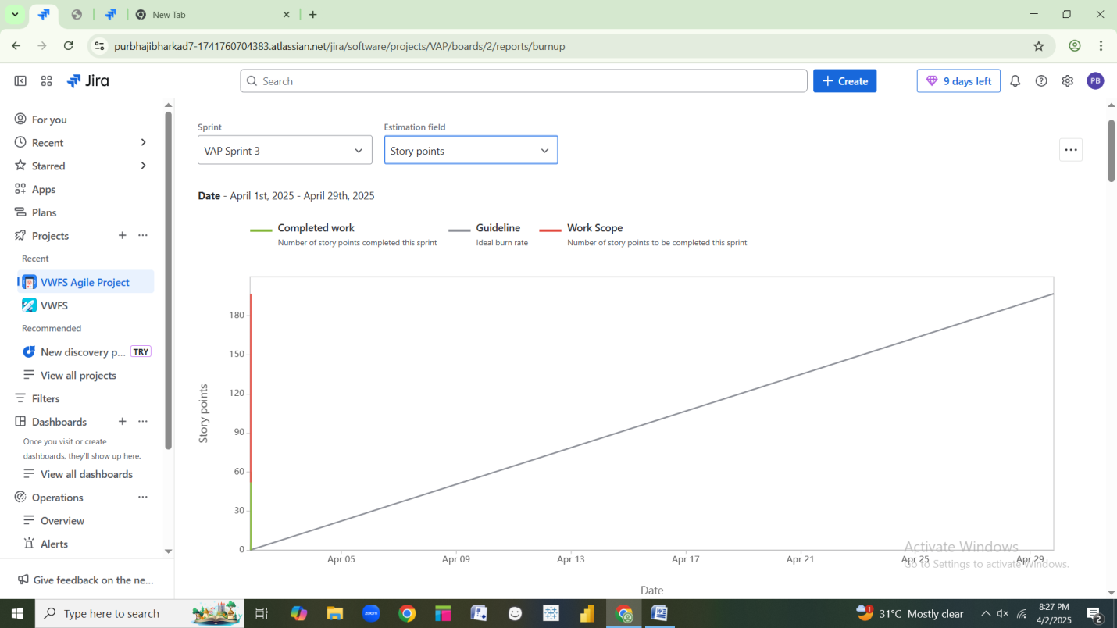

Explanation :

* **X-axis :** Represents **Sprint Days** ( 1 to 10 ).
* **Y-axis** : Shows **Story Points Remaining** ( starting at 50 ).
* **Blur Line :** Indicates the actual progress of completed work.
* **Dashed Line ( Sprint Goal ) :** Represents the goal to complete all work by the end of the sprint.

As seen in the chart, work is being completed consistently, leading to a successful sprint.

**Sprint Burn down :**

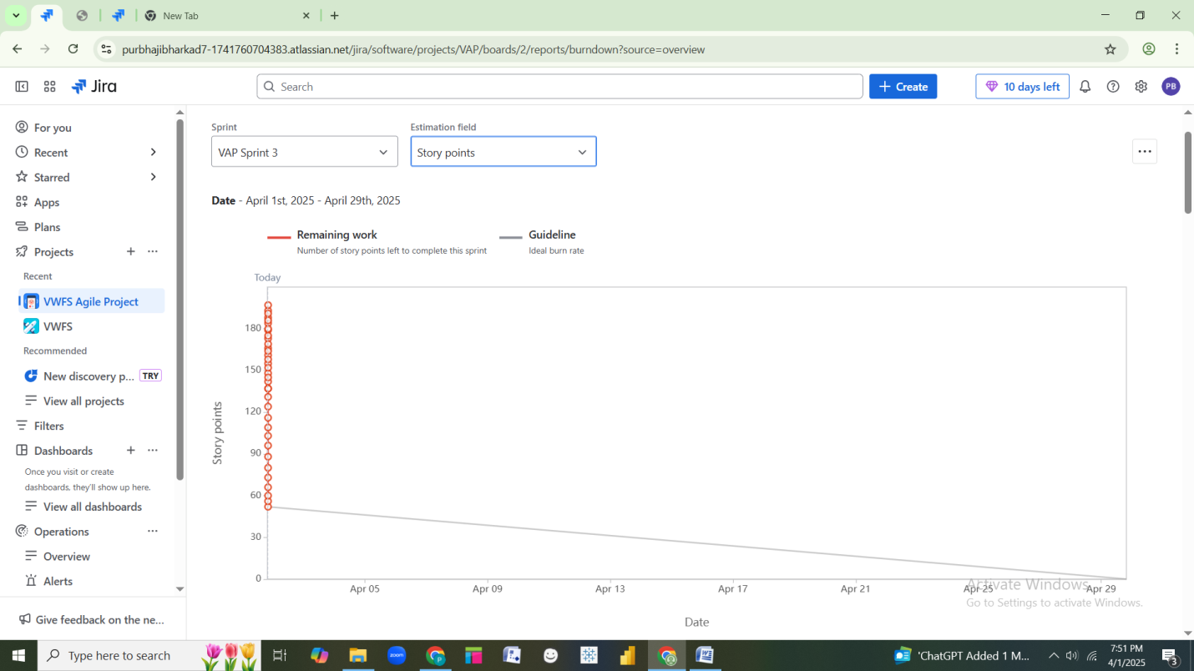

Explanation :

* **X-axis :** Sprint Days (1 to 10)
* **Y-axis :** Story points Remaining (starting at 55)
* **Red Line :** Represents actual work completed each day.
* **Dashed Line :** Sprint goal (target to complete all work by day 10)

This chart shows a steady **decrease in remaining work,** ensuring successful sprint completion.

**Document 6 : Sprint Meetings**

**Meeting type 1 : Sprint Planning Meeting**

|  |  |
| --- | --- |
| **Date** | 16/08/2022 |
| **Time** | 10:00 AM |
| **Location** | Pune |
| **Prepared By** | Purbhaji Bharkad |
| **Attendees** | Stakeholders, Project Managers, Development Team, QA Team, Database Administrator, Scrum Master, Product Owner. |

**Agenda Topics**

|  |  |  |
| --- | --- | --- |
| **Topic** | **Presenter** | **Time Allotted** |
| Sprint Goal Discussion | Scrum Master | 10 mins |
| Reviewing Product Backlog Items | Product Owner | 15 mins |
| Prioritizing User Stories for Sprint | Product Owner | 10 mins |
| Task Breakdown & Estimations | Development Team | 20 mins |
| Identifying Dependencies & Risks | Scrum Master | 10 mins |
| Sprint commitment & Scope Finalization | Entire Team | 10 mins |
| Q&A and Next Steps | Scrum Master | 10 mins |

**Other Information**

|  |  |
| --- | --- |
| Observers | All Team Members |
| Resources | Sprint Backlog, JIRA, Required Documents, Burndown Chart. |
| Special Notes |  |

**Meeting Type 2 : Sprint review meeting**

|  |  |
| --- | --- |
| **Date** | 08/09/2022 |
| **Time** | 4:00 Pm |
| **Location** | Pune |
| **Prepared By** | Purbhaji Bharkad |
| **Attendees** | Scrum Team, Product Owner, Stakeholders, Business Analysts |

|  |  |  |  |
| --- | --- | --- | --- |
| **Sprint Status** | **Things to Demo** | **Quick Updates** | **What’s Next** |
| **Sprint Goal**: Implement and test core POS functionalities, including financing applications and credit checks. | Admin login & Stock Management  (US-001) | **Stakeholder Feedback:**  Positive response to the credit check functionality.  Suggested UI improvements for the quotation generation screen. | **Carry Forward Work:**  Complete showroom revenue report feature (US-005).  Finalize API integration for financial reporting. |
| **Completed User Stories :**  US-001: Admin login & showroom stock view.  US-002: Generate customer quotation.  US-003: Submit financing application through POS  US-004: Perform instant credit check | Quotation Generation (US-002) | **Challenges Faced :**  API integration issues caused delays in the revenue report feature.  Initial issues with from validation for financing applications | **Upcoming Sprint Goals:**  Implement payment processing for financing applications.  Enhance reporting & analytics features.  Conduct performance testing on POS application. |
| **Pending User Stories :**  US-005: Perform instant credit check | Financing Application (US-003) | **Fixes Implemented :**  Enhanced from validation for financing applications.  Minor UI changes implemented in the quotation section. | **Testing Focus :**  Validate different financing scenarios.  Ensure smooth POS integration with external credit check providers. |
| **Burndown Chart Analysis:**  Initial estimated effort: 55 hours  Work completed: 48 hours  Remaining effort: 7 hours | Instant Credit Check (US-004) |  | **Next Sprint Planning :**  Schedule backlog refinement meeting.  Prioritize new feature requests from stakeholders. |

**Meeting Type 3: Sprint retrospective meeting**

|  |  |
| --- | --- |
| **Date** | 20/09/2022 |
| **Time** | 10:00 AM |
| **Location** | Pune |
| **Prepared By** | Purbhaji Bharkad |
| **Attendees** | Scrum Team, Product Owner, Scrum Master |

|  |  |  |  |  |
| --- | --- | --- | --- | --- |
| **Agenda** | **What went well** | **What didn’t go well** | **Questions** | **Reference** |
| Review the sprint’s successes and challenges. | Successful implementation of core functionalities (Admin login, financing application, credit check). | API integration issues delayed the revenue report feature. | How can we improve AP integration timelines? | Sprint Backlog & Burndown Chart |
| Identify areas for improvement. | Positive stakeholder feedback on financing application and credit check. | Initial difficulties in financing from validation. | What strategies can we use to prevent last-minute UI changes? | Stakeholder feedback from sprint review |
| Discuss actionable steps for the next sprint. | Collaboration between development and testing teams improved efficiency. | Some last-minute UI changes caused minor delays. | How can we ensure daily stand-ups remain time-efficient? | Issue tracker & Bug reports |
|  | Burndown chart showed steady progress with minimal scope creep. | Daily stand-up sometimes ran longer than scheduled. | Are there any blockers that need immediate attention for the next sprint? |  |

**Meeting Type 4: Daily Stand-up meeting**

|  |  |  |  |  |  |  |  |  |
| --- | --- | --- | --- | --- | --- | --- | --- | --- |
| **Question** | **Name/Role** | **Week “X” (from dd-mm-yyyy to dd-mm-yyyy)** | | | | | | |
| Monday | Tuesday | Wednesday | Thursday | Friday | Saturday | Sunday |
| What did you do yesterday? | Ganesh | Project Alpha’s deliverables | Project Alpha’s deliverables | Project Alpha’s deliverables | Presentation A | Presentation B |  |  |
| Vaibhav |
| Daulat |
| What will you do today ? | Ganesh | Project Beta’s deliverables | Project Beta’s deliverables | Project Beta’s deliverables | Presentation A | Presentation B |  |  |
| Vaibhav |
| Daulat |
| What (if any) is blocking your progress ? | Ganesh | Need to connect with development team |  |  |  |  |  |  |
| Vaibhav |
| Daulat |