# CAPSTONE PROJECT – PART 2/3

**Question 1:** 4 Quarterly Audits are planned Q1, Q2, Q3, Q4 for this Project What is your knowledge on how these Audits will happen for a BA?

**Answer:**

Q1 Audit:

* What did BA Understand about company goals?
* Is work is planned and tracked?
* Did BA perform the GAP analysis?
* What is the Elicitation technique used by BA to gather the requirements?
* How did BA do the BRD?

Q2 Audit:

* Reviewing the documents prepared by BA
* Review the Activity diagrams which are done by BA
* Before the development phase, every document is approved by the stakeholders?

Q3 Audit:

* Did BA explain the requirements to the technical team?
* Is BA following up the development?
* All the Timesheets are being sent to manager?
* BA posting all the necessary updates to stakeholders?
* If any clarifications are needed, does BA is helping to development team?

Q4 Audit:

* BA tracking the testing process?
* BA sending the prepared test data to client?
* BA prepared the End user manual?
* BA helping the client in UAT process?
* Has BA taken the signoff from the client?

**Question 2**: BA Approach Strategy

**Answer:**

1. **Elicitation Techniques:** For this project I would go with the below mentioned elicitation techniques.

**Brainstorming:** I will gather a small group of participants and clearly explain the project goal to ensure everyone understands the purpose. I will encourage open discussion and creativity by creating a comfortable environment and asking thought-provoking questions. Ideas will be documented, and participants will build on each other's suggestions to refine concepts collaboratively.

**Interviews**: I will prepare a list of questions related to the project and invite participants to join at a scheduled time. Each interview will last around 20–30 minutes, focusing on gathering insights and opinions relevant to the project goals. I'll ensure a comfortable and open environment so participants can share their thoughts freely.

**Workshops**: I will conduct a workshop session by starting with a brief introduction to the topic and outlining the key objectives. The session will include interactive activities, hands-on exercises, and group discussions to keep participants engaged. I will conclude with a Q&A segment to clarify doubts and summarize the main points covered.

**Surveys or Questionnaires**: I will first prepare a set of clear and concise questions relevant to the project's goals. During the session, participants will be guided to answer these questions either online or on paper. I will ensure the process is easy to understand, confidential, and encourage honest responses. After the session, I will analyze the data to derive useful insights.

1. **Stakeholder Analysis**: This involves identifying all individuals or groups affected by a project, understanding their interests, and assessing their influence or impact. This helps in planning effective communication and engagement strategies to ensure project success. They are divided into internal and external stakeholders.

Internal Stakeholders :

* Project Manager: Mr. Vandanam
* Senior Java Dev: Ms. Juhi
* Java Developers: Mr. Teyson, Ms Lucie, Mr Tucker
* Network Admin- Mike
* DB Admin- Jhon
* Testers - Mr Jason and Ms Alekya
* BA- Srikar

External Stakeholders:

* Project Sponsor: Mr. Henry
* Financial Head: Mr. Pandu
* Project Coordinator: Mr. Dooku
* Key Stakeholders: Peter, Kevin and Ben

|  |  |  |  |  |  |  |  |  |  |
| --- | --- | --- | --- | --- | --- | --- | --- | --- | --- |
|  | Srikar | Jason & Alekya | | Teyson, Lucie, Tucker, Bravo | Juhi | Vandanam | Peter, Kevin, Ben | Karthik | Henry |
| Requirement Gathering | R | |  |  |  | A/I | C |  |  |
| Analysis | R | |  |  |  | I |  |  |  |
| Development |  | |  | R | A/C | R/A |  |  |  |
| Testing | I | | R | R (Unit Testing) | I | I |  |  |  |
| Implementation | R | |  |  |  | I |  | R |  |
| UAT | I | |  |  |  | R/A |  |  | I |

1. **What Documents to Write:** Business Requirements Document(BRD), System Requirements Document (SRD), Functional Requirement Document (FRD), Use Case Document, Process Flow Document, Project Report, Test Cases, Stakeholder Analysis Document.
2. **What process to follow to Sign off on the Documents:** Once all the required documents are prepared. I will review with respective teams or stakeholders and sign them via emails and try to get physical sign off as well.
3. **How to take Approvals from the Client:** I will review with respective teams or stakeholders and get their approval via emails and try to get physical sign off as well.
4. **What Communication Channels to establish n implement**: Meetings, Email Communication, Collaborative platforms (Like Jira, Share point, miro etc), Messaging tools (Slack, Microsoft Teams), Face-to-Face discussions.
5. **How to Handle Change Requests**:

- Receive and Document the Request  
- Analyze the Impact  
- Prioritize and Evaluate Alternatives  
- Seek Approval  
- Implement and Communicate

1. **How to update the progress of the project to the Stakeholders:**
2. Stakeholder Meetings or Check-Ins
3. Email Updates and Summaries
4. Collaborative Platforms (e.g., Jira, Confluence)
5. Milestone and Deliverable Updates
6. Progress Tracking Against Key Performance Indicators (KPIs)
7. **How to take signoff on the UAT- Client Project Acceptance Form:** To take signoff on the UAT (User Acceptance Testing) - Client Project Acceptance Form, you should first ensure that all testing requirements and client expectations have been met. Then, schedule a meeting or share the UAT report with the client to review the outcomes. Once the client confirms that the project meets their needs and no further changes are required, have them sign the acceptance form, formally documenting their approval of the project.

**Question 3: Explain and illustrate 3-tier architecture?**

**Answer :** The 3-tier architecture is a software architecture pattern that divides an application into three distinct layers, each with specific responsibilities:

1. Presentation Layer (User Interface):
   * This is the topmost layer that interacts with the user. It displays the information to the user and collects input. Essentially, it’s the "front-end" of the application (e.g., web pages or mobile apps).
2. Business Logic Layer (Application Layer):
   * The middle layer, where the core business rules, logic, and computations are executed. It processes the input received from the presentation layer and makes decisions or calculations based on that input.
3. Data Layer (Database Layer):
   * The bottom layer stores the application's data. This layer communicates with databases or other data storage systems to retrieve, store, or modify data as required by the business logic layer.

In simple terms, the 3-tier architecture organizes software into three layers to keep the system modular, scalable, and easier to manage. Each layer has a specific role, which helps improve maintenance and ensures that changes in one layer (like UI updates) do not affect the others (like data storage or business logic).

**Question 4: Questions to Stake holders**

**5W 1H:**

* What specific functionalities should the application have to cater to farmers’ needs?
* What types of fertilizers, seeds, and pesticides should be included in the platform’s catalog?
* Why is an online platform the best solution to address farmers' procurement challenges?
* Why is it essential to enable direct communication between farmers and manufacturers?
* When should the application be launched to align with the farming calendar or crop cycles?
* When will manufacturers start onboarding their products onto the platform?
* Where will the products be sourced and delivered from, and who will manage the logistics?
* Where will the application initially be launched (specific regions or all across the country)?
* Who will handle customer support for farmers and manufacturers using the platform?
* Who will be responsible for managing and updating product details on the platform?
* How will the platform ensure trust in product quality and reliability of manufacturers?
* How will the application handle transactions and payments for farmers in remote areas?

**SMART**

1. **Specific:**

* Focused on understanding the exact needs of farmers and manufacturers.
* Example: "What specific challenges do farmers face while using existing methods to procure agricultural products?"

1. **Measurable:**
   * Aim to gather quantifiable data.
   * Example: "How often do farmers require fertilizers or seeds, and in what quantities?"
2. **Achievable:**

* Ensure the solutions derived from the questions can be implemented within the project’s scope and budget.
* Example: "What are the minimum features required in the application to address these issues effectively?"

1. **Relevant:**

* Align with the project's goal to support farmers in remote areas.
* Example: "How important is offline access or multilingual support for the target farmers?"

1. **Time-Bound:**

* Address the timeline constraints and priorities.
* Example: "Which features should be prioritized in the initial 6 months of development?"

**RACI**

* **Responsible:** Those who do the work or provide the input. Peter, Kevin, Ben (providing requirements and user insights), Manufacturers (providing product details).
* **Accountable:** The person ultimately answerable for the project or task's success or failure. Mr. Henry, SOONY Committee (final decisions and project approval).
* **Consulted**: Those whose opinions are sought, typically subject-matter experts. Mr. Dooku (project coordination), APT IT SOLUTIONS team (technical feasibility).
* **Informed:** Those who are kept updated on progress or outcomes. Mr. Pandu (financial updates), Delivery Head (project progress).

**3-Tier Architecture:**

**Presentation Layer (User Interface)**:

* **Usability**: How user-friendly should the application be for farmers with limited technical knowledge?
* **Access**: What devices will farmers use (smartphones, computers)?
* **Design**: Any preferences for layout or language?

**Business Logic Layer (Application Layer)**:

* **Product Management**: How will product details (fertilizers, seeds, pesticides) be entered by manufacturers?
* **Transactions**: What should the buying process look like for farmers?
* **Notifications**: How should farmers be notified about product availability or delivery status?

**Data Layer (Database)**:

* **Data Storage**: What data needs to be stored (user profiles, product details, transaction history)?
* **Integration**: What external systems (e.g., payment gateways, logistics) need to be integrated?
* **Security**: What security measures should be in place to protect sensitive information?

**Use Cases:**

1. Who are the primary users of the system, and what are their specific roles and needs?
2. What key features and functionalities should the system have to meet the business objectives?
3. What are the common pain points or challenges faced by farmers and manufacturers in the current process, and how can the system address them?
4. What are the expected workflows for farmers, manufacturers, and admins, and how should they interact with the system?
5. What are the performance, security, and usability expectations for the system, particularly regarding accessibility for farmers in remote areas?

**Use Case Specs:**

1. What are the primary goals and expectations for the app from both farmers and manufacturers?
2. What product details should be included and how should they be organized?
3. What key features should make the purchasing process simple and intuitive for farmers?
4. How should communication between farmers and manufacturers be handled within the app?
5. What is the process for managing and tracking orders, payments, and deliveries?

**Activity Diagrams:**

1. **Key Activities**: Understand the main steps (product submission, browsing, selection, delivery).
2. **Flow of Information**: Clarify how data flows between stakeholders (farmers, manufacturers, delivery).
3. **User Interactions**: Define how farmers will interact with the platform (mobile/web).
4. **Parallel/Sequential Activities**: Identify if some activities can happen simultaneously.
5. **Decision Points**: Determine key decision points (e.g., product availability, purchase success).
6. **End Conditions**: Clarify when activities are complete (e.g., successful delivery).

**Models:**

* Conceptual Model: Conceptual models represent abstract, high-level structures that define how various system components interact and communicate. They provide a simplified view of complex processes, helping stakeholders understand the overall functionality and relationships within a system.
* Data Model: Data models define the structure and organization of data within a system, outlining how data is stored, related, and accessed. They ensure efficient data management and support system functionality, such as search, filtering, and reporting.
* Physical Model: Physical models represent the tangible, real-world elements of a system, such as hardware, devices, or infrastructure, used to support the application or service. They help visualize and plan physical aspects like server setups, network infrastructure, or the user interface's physical layout.

**Page Design:** A page design model outlines the visual and functional layout of a web or mobile application’s user interface, focusing on elements like navigation, content arrangement, and user interaction. It ensures a user-friendly, intuitive experience by defining how information is presented and how users interact with the application.

**Question 5: Elicitation techniques**

**Brainstorming (B):** Brainstorming is a group creativity technique where participants generate ideas or solutions in a collaborative setting. It encourages free thinking and helps uncover a wide range of possibilities in a short time.

**Document Analysis (D):** Document analysis involves reviewing existing documentation (e.g., reports, user manuals, contracts) to gather relevant information. This technique helps identify gaps, inconsistencies, and areas that require further clarification.

**Requirements Workshops (R):** Requirements workshops are structured meetings where stakeholders collaborate to define and refine project requirements. This interactive approach promotes alignment and ensures that all perspectives are considered.

**Focus Groups (F**): Focus groups involve gathering a small group of stakeholders or end-users to discuss specific issues, needs, or ideas. It provides qualitative insights into user opinions, experiences, and preferences.

**Observation (O):** Observation involves watching stakeholders or end-users perform their daily tasks or processes to understand their needs and challenges. It helps uncover implicit requirements that may not be captured through interviews or surveys.

**JAD (Joint Application Development) (J):** JAD is a facilitated workshop involving business users, IT staff, and stakeholders to define and refine system requirements. It aims to streamline the requirements gathering process and ensure everyone’s input is considered.

**Interviews (I**): Interviews are one-on-one discussions with stakeholders to gather detailed, in-depth information. They provide a personal, direct way to understand needs, expectations, and challenges.

**Prototyping (P):** Prototyping involves creating an early version (prototype) of the system or product to allow stakeholders to interact with and provide feedback. This iterative process helps clarify requirements and refine the final solution.

**Questionnaires (Q):** Questionnaires are structured forms with predefined questions sent to a large group of stakeholders to gather quantitative or qualitative data. They are useful for collecting broad insights in a short time.

**Use Cases (U):** Use cases describe how users interact with a system to achieve specific goals. They help clarify functional requirements by focusing on user actions and system responses.

**Question 6: Which Elicitation Techniques can be used in this Project and Justify your selection of Elicitation Techniques?**

**Answer:** I would go with **Prototyping**

* Visual Representation of Requirements: Prototyping allows stakeholders like Mr. Henry, Peter, Kevin, and Ben to visualize the system functionalities such as product catalog, search option, login functionality, payment process, and delivery tracking. This ensures alignment with their expectations.
* Clarifies Ambiguous Requirements: By creating mockups or interactive prototypes, it becomes easier to address ambiguous requirements such as the design of the payment gateway or delivery tracker functionality.
* Stakeholder Feedback: Farmers and manufacturers can provide direct feedback on the usability and user-friendliness of the interface, ensuring the system meets the needs of all users.
* Iterative Refinement: Prototyping supports iterative improvements based on stakeholder input, reducing the risk of missed requirements or misunderstandings.

This technique ensures clear communication of the proposed solution and aligns all stakeholders on the expected output.

**Question 7: Business and Stakeholder Requirements:**

**BR001** – Farmers should be able to search for available products in fertilizers, seeds, and pesticides using a search bar.  
**BR002** – Manufacturers should be able to upload and manage their product details, including images, descriptions, prices, and availability, on the platform.  
**BR003** – The platform should provide a product catalog to display all products for browsing by farmers.  
**BR004** – Farmers should be able to create a new account by submitting their email ID and creating a secure password.  
**BR005** – Farmers should be able to log in using their email ID and password to access their account.  
**BR006** – Farmers should be able to add products to a "buy-later" list for future purchases.  
**BR007** – Farmers should be able to add products to a shopping cart and place orders.  
**BR008** – The system should include a secure and user-friendly payment gateway that supports COD, credit/debit card, and UPI payment options.  
**BR009** – Farmers should receive an email confirmation for their order status, including successful payment and shipping updates.  
**BR010** – Farmers should be able to track their orders in real time using a delivery tracker feature.  
**BR011** – The application should support secure authentication mechanisms to protect user accounts.  
**BR012** – The platform should ensure a simple and intuitive user interface for ease of use, especially for non-technical users.  
**BR013** – The system should allow manufacturers to view feedback or ratings provided by farmers for their products.  
**BR014** – Farmers should have the ability to filter products by categories, such as fertilizers, seeds, and pesticides, or by attributes like price range and ratings.  
**BR015** – The application should ensure data security and compliance with data protection regulations to safeguard user information.

**Question 8: Assumptions:**

1. The application will have two primary user groups: farmers and manufacturers.
2. Farmers and manufacturers will have basic internet connectivity.
3. The platform will be available on both web and mobile devices.
4. The application will support a multilingual interface.
5. The platform will be designed with a simple and intuitive interface for non-technical users.
6. All products listed by manufacturers will have complete details (descriptions, prices, availability).
7. Farmers will be able to search and filter products by categories and attributes.
8. The payment process will support COD, UPI, and credit/debit cards.
9. The payment process will be secure and comply with industry standards.
10. Delivery services will be integrated into the system with real-time tracking.
11. Farmers will receive email notifications about their order status.
12. New users (farmers and manufacturers) can create accounts using email and secure passwords.
13. Secure authentication mechanisms will be implemented for login and data access.
14. Farmers can provide feedback and ratings for products.
15. The system will comply with data protection regulations (e.g., GDPR or local laws).
16. Customer support will be available for farmers and manufacturers.
17. The application will initially target rural regions.
18. Delivery services will operate within predefined geographic areas.
19. The project will adhere to the budget (2 Crores INR) and time frame (18 months).
20. Key stakeholders (Mr. Henry, Peter, Kevin, Ben) will be available for ongoing discussions.

Question 9:

|  |  |  |  |
| --- | --- | --- | --- |
| Req ID | Req Name | Req Description | Priority |
| BR001 | Farmer Search for Products | Farmers should be able to search for available products in fertilizers, seeds, pesticides | 10 |
| BR002 | Manufacturers upload their Products | Manufacturers should be able to upload and display their products in the application | 9 |
| BR003 | Product Catalog | The platform should provide a product catalog to display all products for browsing by farmers. | 8 |
| BR004 | Account Creation for Farmers | |  | | --- | | Farmers should be able to create a new account by submitting their email ID and creating a secure password. |  |  | | --- | |  | | 7 |
| BR005 | User Login | Farmers should be able to log in using their email ID and password to access their account. | 10 |
| BR006 | Buy-later List | Farmers should be able to add products to a "buy-later" list for future purchases. | 6 |
| BR007 | Shopping Cart | Farmers should be able to add products to a shopping cart and place orders. | 9 |
| BR008 | Payment Gateway | The system should include a secure and user-friendly payment gateway that supports COD, credit/debit cards, and UPI payment options. | 10 |
| BR009 | Email Notifications | Farmers should receive email notifications for order status, including successful payment and shipping updates. | 8 |
| BR010 | Order Tracking | Farmers should be able to track their orders in real time using a delivery tracker feature. | 9 |
| BR011 | Secure Authentication | The application should use secure authentication mechanisms to protect user accounts. | 9 |
| BR012 | User Interface | The platform should ensure a simple and intuitive user interface for ease of use, especially for non-technical users. | 7 |
| BR013 | Product Feedback and Reviews | Farmers should be able to provide feedback and ratings for products after purchase. Manufacturers should be able to view and respond to feedback. | 6 |
| BR014 | Product Filtering | The system should allow farmers to filter products by categories, price range, and ratings. | 7 |
| BR015 | Data Security | The platform should ensure data security and comply with relevant data protection regulations to safeguard user information. | 10 |

**Question 10: Use Case Diagram**

**Answer:  
  
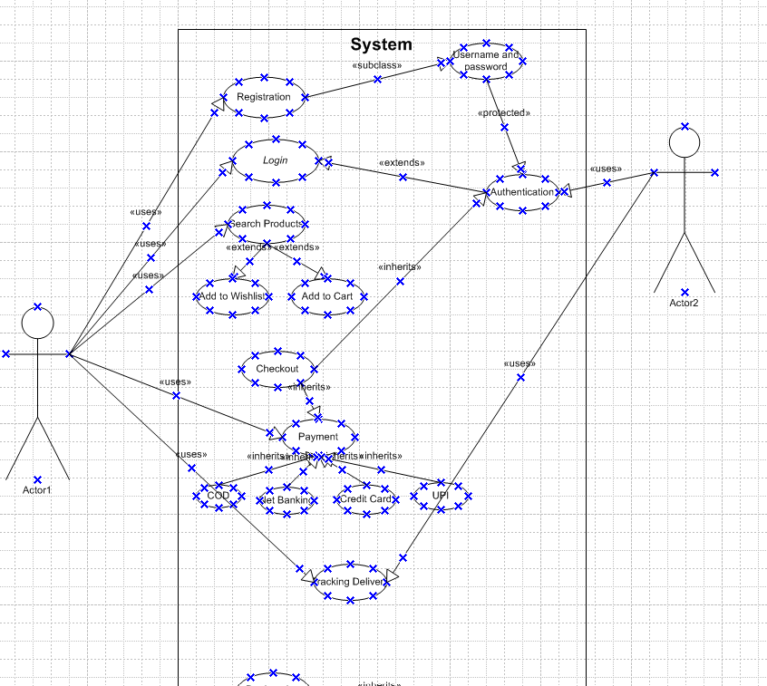**

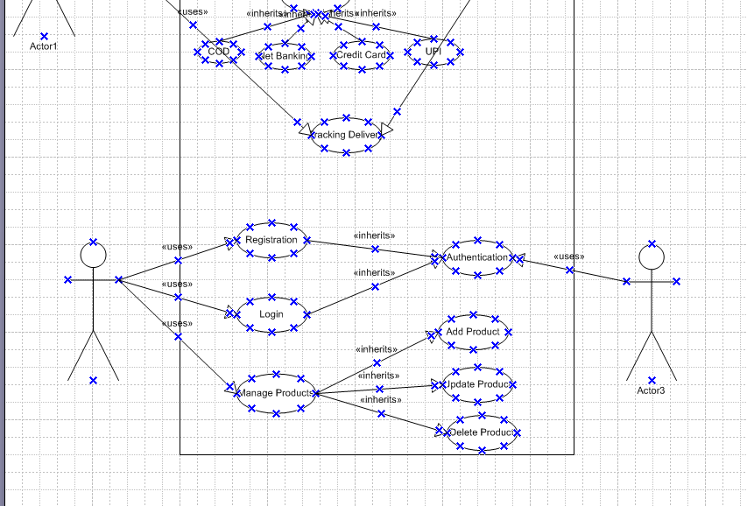

**Question 11: Use Case Specs**

**Answer:**

|  |  |
| --- | --- |
| **Use Case Spec 1 – User buying fertilizer from store** | |
| **Description** | This Use Case explains how Farmers uses the online agriculture product store which helps farmers to buy the products. |
| **Actors** | Farmers  Data Base Admin |
| **Conditions** | Internet and a smart phone |
| **User Flow** | 1. Users login into their respective account  2. User validation will be done  3. Customer will use the search box and find their product which they want to purchase.  4. Application will display the searched products to user and also show relevant products.  5. User will add the product to their cart.  6. User selects the delivery address. 7. User selects the payment method and does the check out. 8. Once order is placed user will get a SMS stating that order has been placed successfully.  9. Use case is completed |
| **Alternate Flow** | 1. While logging in if the username and password does not match then the authentication will be a failure and use case ends here.  2. If the searched product is out of stock/does not deliver to the location of the user then user can not proceed with the buying of product but instead can choose similar range of products. Use case ends here. 3. While selecting the payment method and user selects the Card/UPI or any other option and authentication fails then the use case ends. |
| **Post Conditions** | 1. Success: If user gets the fertilizer product delivered. 2. Failure: If user did not get the desired product due to any technical/financial unforeseen issues. |
| **Additional requirements** | 1. All the products should be aligned by govt rules and policies. 2. All the incomplete transactions of the customer should be stored. |

|  |  |
| --- | --- |
| **Use case 2: Registration of New User** | |
| **Description** | This use case explains how a new user will register in the application. |
| **Actors** | Farmers  Data Base Admin |
| **Conditions** | Internet, smart phone, Email id, mobile number |
| **User Flow** | 1. User will get onto the login page.  2. User will click on ‘New User’ button. 3. User will enter all their primary details along with phone number, email id and any other mandatory fields which would be required and then click on ‘Submit Application’. 4. User would be receiving an OTP to the given phone number/email and enter the OTP. 5. Once authentication is successful, a profile would be created on the name of the user. Use case will be completed |
| **Alternative flow** | 1. If user has entered incorrect OTP then the authentication would be failed and user would be displayed a message which states enter the correct OTP. 2. If the mobile number is already in use then user will be displayed a message stating that this mobile number already exists. 3. If the email id is already in use then user will be displayed a message stating that this email id is already in use. 4. If there is an existing user id then user will be showed with a message stating that this user id already exists. 5. If there are any server issues then account will not be created. |
| **Post Conditions** | 1. Successful Completion: User account would be created. 2. Failure: User will not be able to create any account. |
| **Additional requirements** | All the failure logs should be stored. |

|  |  |
| --- | --- |
| **Use Case 3: Payment processing** | |
| **Description** | This use case explains how the user process a payment. |
| **Actors** | Farmers  Data Base Admin 3rd party payment integration gateways. |
| **Conditions** | Internet, smart phone, Email id, mobile number, active bank account. |
| **User Flow** | After user adds the product to the cart and proceeds to checkout: 1. Application displays different modes of payments.  2. If user selects Cash on delivery, then system will check weather COD option is available to the deliver address or not. 3. If user selects the Net banking or UPI or credit/debit cards then system will integrate with 3rd party system (i.e bank) and banks sends a OTP for the user, then user should enter the OTP in the application. 4. System checks the OTP and if it is correct then money would be debited from the user’s bank. 5. Success message of the order would be displayed and an email will also be sent. |
| **Alternate flow** | 1. Server Error: If there is any application server error, user cannot continue with purchase of product.  2. Incorrect Card details: If user has given any incorrect details of the card, then system will stop the user in order to proceed with the process of payment. 3. Incorrect OTP: If user has entered incorrect OTP then, system will stop the user to proceed with the payment. 4. Insufficient funds: If user has entered correct OTP and the server reaches the bank to collect the payments and observe that user has insufficient funds, then the payment fails and system will not proceed with the payment for the product. |
| **Post Conditions** | 1. Success : User completes the payment process and gets confirmation through SMS and email stating the product is successfully purchased and will be delivered soon. 2. Failure: Payments gets failed and user should check where the mistake has been done and payment re-initiation should be done. |
| **Additional Requirements** | The Application will store all the successful and failure transactions. |

|  |  |
| --- | --- |
| **Use Case 4: Addition/Updating of products into the application by the seller/manufacturer** | |
| **Description** | This Use case describes how a seller/manufacturer adds the new products or updates the existing products. |
| **Actors** | Seller/manufacturer Data Base Admin |
| **Conditions** | Seller/Manufacturer should have laptop/mobile phone and active internet. |
| **User Flow** | When seller wants to add/update the products in application 1. Seller logins into the application. 2. Selects the product category  3. Adds the new product by giving all the mandatory fields like, Name of the product, description, price, features, Ingredients and pictures of the product. 4. After completion of setting up of the product, seller clicks on add the product and once added into the application, seller gets a message and mail stating that product has been added successfully. |
| **Alternate flow** | 1. If seller selects inappropriate category and tries to upload the product, then system will throw an alert stating that product cannot be added. 2. If seller tries to increase the price and the price do not sets between the government rules then seller will not be able to add the product. |
| **Post Conditions** | Success: Seller completes all the steps then system will accept the product and displays the product to the customer. Failure: If any steps misses and seller uploads a wrong information, then product will not be displayed in the application. |
| **Additional Requirements** | The application will store all the passed/failed logs of the seller. |

|  |  |
| --- | --- |
| **Use Case 5: User Cancelling the product** | |
| **Description** | This use case describes what happens to a product if user cancels the order/returns the order. |
| **Actors** | User Database Admin Seller |
| **Conditions** | Smart phone, Internet |
| **User Flow** | When user returns/cancels the product. 1. User logins into the application  2. User goes to their cart and tries to cancel the delivering product or want to return the product which has been delivered. 3. When user cancels the product then application will ask the reason why they are cancelling the ordered product. 4. When user wants to return the product then user should select the product which they would like to return and application asks the user what is the reason they want to return the product. 5. When user cancels/returns the product then a notification would be sent to the seller/manufacturer stating that the user would be returning/cancelled the ordered product.  6. Then seller would be sending an agent to pickup the ordered product. 7. Database admin will initiate the refund. 8. User would be getting the refund. |
| **Alternate flow** | User will not be able to return/cancel the product if the no of days has been expired. |
| **Post Conditions** | Success: When product cancellation or return is done. Failure: If the product returning date is crossed then user will not have the ability to return the product. |
| **Additional Requirements** | The application will store all the passed/failed logs of the user and seller. |

**Question 12: Activity Diagrams:**  
1. [Login Page.vsd](https://1drv.ms/u/c/63c858940af7e992/EfxGl88YA61CqZkJ4r1zLgMBZk8I17GI3tn3fmxBJZTpJg?e=IZiJvv) :   
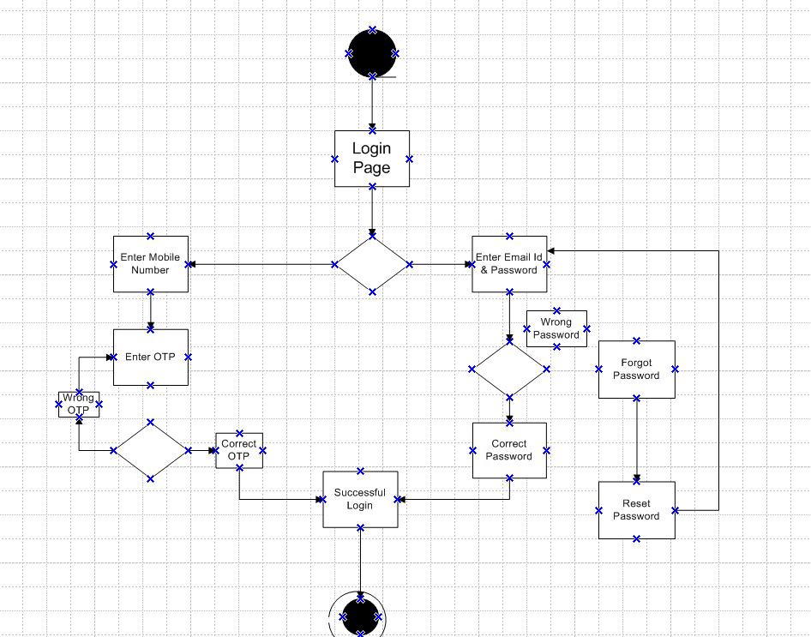

2. [Creating the user.vsd](https://1drv.ms/u/c/63c858940af7e992/EYvlCm_3qOlHjk19xA5myuUByJpG0aDNmSoORWAI1rNrkw?e=7QtFek)  
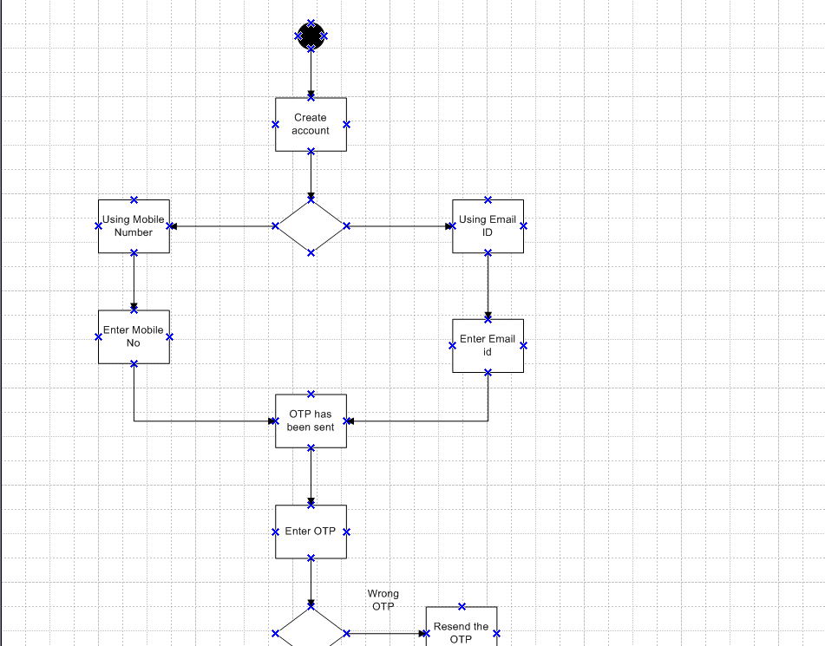

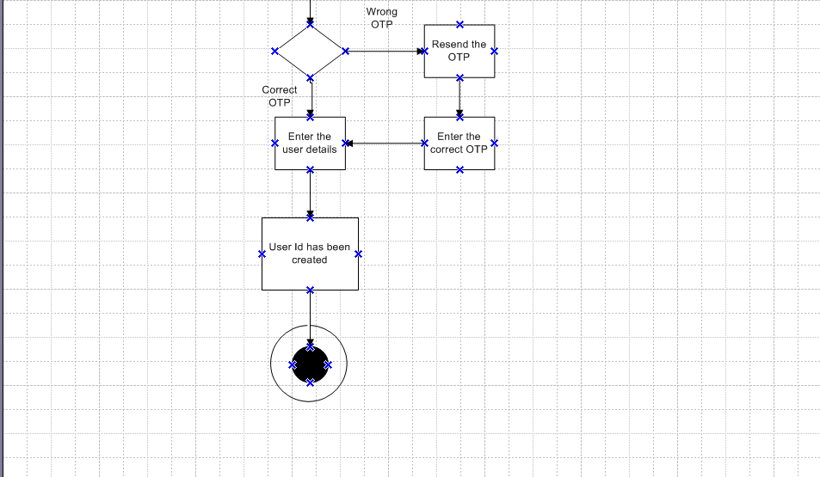

3. [Placing order.vsd](https://1drv.ms/u/c/63c858940af7e992/Ebgx6SE0zs1Fp637tcpgElkBr6CJvq8h0Ip05xhdIBHj4A?e=WWO9sf)  
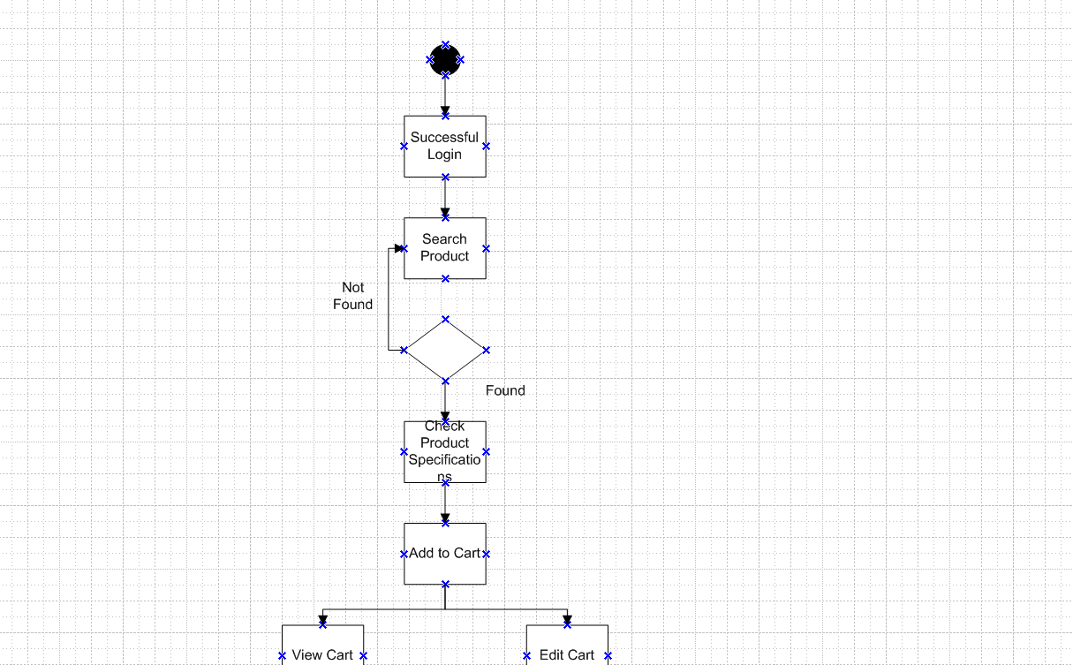

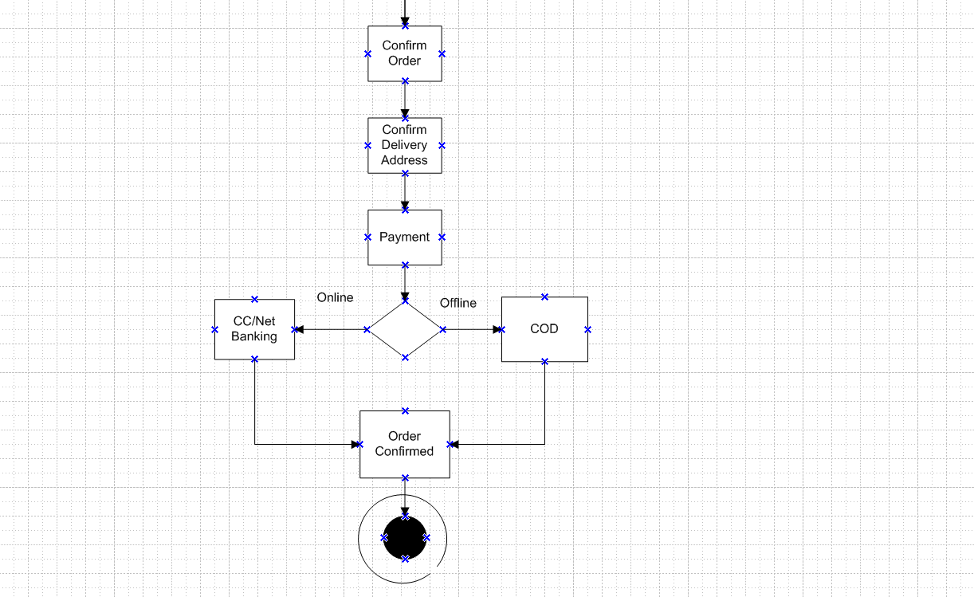  
4. [Cancellation of Product.vsd](https://1drv.ms/u/c/63c858940af7e992/EcTrGFOq6DVPtNqQ54yHyFkBx45GSIuOLAjBS84NIDCkqA?e=JjK8nE)  
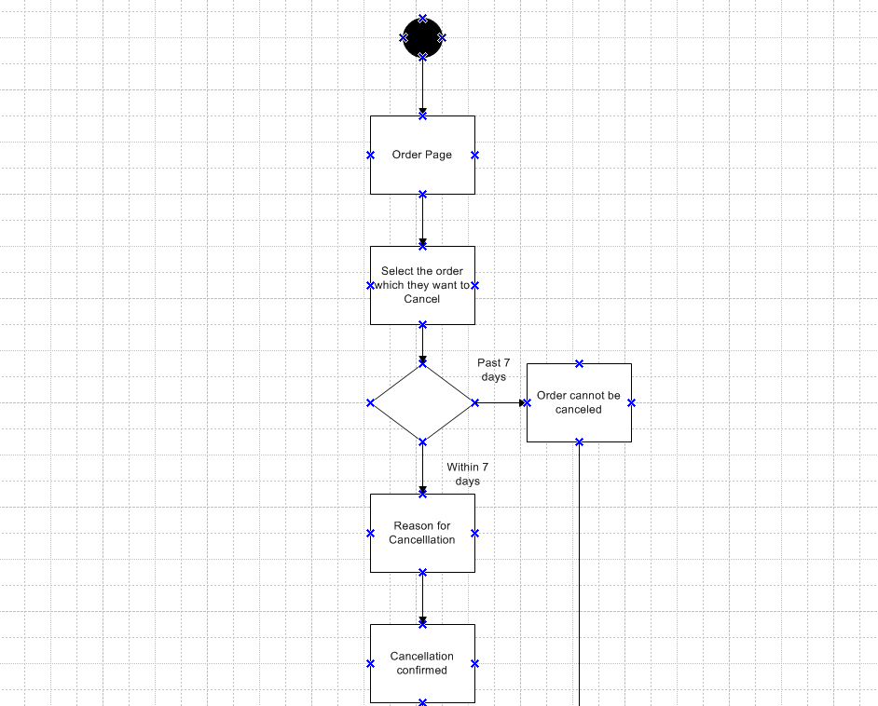

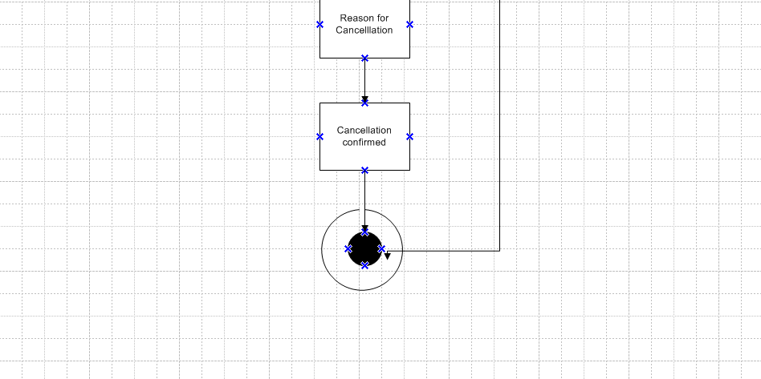

5. [Adding a product.vsd](https://1drv.ms/u/c/63c858940af7e992/EQlHLLMfw55PivLSW3G4S7kBPOFz8pui8VIivxpirFdVnQ?e=gicbSg)  
