# **AGILE DOCUMENTS**

**Document 1:** Definition of Done

1. Workflow automation on repetitive tasks is designed and implemented according to the agreed-upon business requirements.
2. A unified template on hiring approval has been generated across all verticals to improve data accuracy and has been agreed upon all the stakeholders.
3. Email approval template and respective approver details has been tagged vertical wise. Along with the cc.
4. A mail box has been created for the automation to ensure seamless operation without disturbing user’s email.
5. The hiring approval automation flow has been well defined to ensure seamless operation.
6. Approval rules and logic are configured for all demand types (e.g., project requests, procurement demands) including the slot availability.
7. Notifications and alerts for approvals (email or system-based) are set up and tested.
8. The database on all the request flowing thru automation has been established for auditing purposes.
9. End-to-end testing ensures the workflow processes demands from submission to final approval.
10. User roles and permissions for approvers are correctly assigned and validated.
11. Performance is optimized to handle peak demand volume without delays.
12. Key stakeholders, including end-users and approvers, have validated the automation in user acceptance testing (UAT).
13. Documentation for the automated process (e.g., process flow, troubleshooting guide) is completed and shared with relevant teams.
14. Training sessions for the staff who interact with the system have been conducted.
15. The solution is successfully deployed in production with no critical issues.

**Document 2:** Product Vision

|  |  |  |  |  |  |  |  |
| --- | --- | --- | --- | --- | --- | --- | --- |
| **Project Name** | Demand Automation | | | | | | |
| **Venue** | MEPZ SEZ, Tambaram, Chennai - 600045 | | | | | | |
| **Date** | 22-03-2025 | **Start Time** | 11:00AM | **End Time** | 09:00PM | **Duration** | 4 Hours |
| **Client** | Internal | | | | | | |
| **Stakeholder Lists** | COO - Sameer | | AVP - Pradeep K | | Sr. Dir - Sharat | |  |
|  | Sr. BA - Arihant | |  | | | | |
| **Scrum Team** | | | | | | | |
| **Scrum Master:** | Sheila Ranjini (Sr. Manager) | | | | | | |
| **Product owner:** | Pavittar Singh (Dir) | | | | | | |
| **Scrum Developer 1:** | Sai Prasad (Sr. Ui Path Developer) | | | | | | |
| **Scrum Developer 2:** | Naveen Kumar (Sr. Ui Path Developer) | | | | | | |
| **Scrum Developer 3:** | Sri Ganesh (Jr. Ui Path Developer) | | | | | | |
| **Scrum Developer 4:** | Arthi Kumari (Power Automate) | | | | | | |
| **Scrum Developer 5:** | Tara (Training & Support) | | | | | | |

|  |  |  |  |
| --- | --- | --- | --- |
| **Vision:** End to end demand approval automation | | | |
| **Target Group** | **Needs** | **Product** | **Value** |
| It targets the hiring demand generated by delivery projects and bring revenue for the organization  Hiring Manager/Delivery Manager and PMOs are the target users | This resolves tedious manual work and minimises time consumption   Will benefit the delivery with the quicker hiring approvals and improve timely hiring | The product for Hiring Demand Approval is thru UiPath Technology  This enables end to end automation for all repetitive excel and email templates for approval related tasks  This is easily available software with just a licence key | This product helps to align with long time organization aspiration of automation  The Goal is to get quick approval for demand raised by delivery from 1 week to 1 day and increase stakeholder experience  Cost saving, Transparency, compliance are the business model |
|  |
|  |
|  |
|  |
|  |
|  |
|  |
|  |
|  |
|  |
|  |

**Document 3:** User stories

|  |  |  |  |
| --- | --- | --- | --- |
| User Story : 01 | Task : 01 | | Priority: High |
| AS A USER | | | |
| I WANT TO TRIGGER BOT FOR THE DEMAND CREATED BY DELIVERY | | | |
| SO THAT USER CAN UNDERSTAND THEIR REQUIREMENT AND GET THE APPROVAL | | | |
| BV : 200 | | CP : 5 | |
| **Acceptance Criteria:** | | | |
| Demand Created in the system, BOT with Specific template to get the desired inputs, separate mail box to send and receive email | | | |

|  |  |  |  |
| --- | --- | --- | --- |
| User Story : 02 | Task : 02 | | Priority: Medium |
| AS A USER | | | |
| I WANT TO TRIGGER BOT FOR THE RESPONSE RECEIVED FROM DELIVERY FOR APPROVAL | | | |
| SO THAT USER CAN CONSOLIDATE THE TEMPLATE , VALIDATE WITH BUSINESS RULES AND COMPLIANCE TO PROCEED WITH THE APPROVAL | | | |
| BV : 400 | | CP : 9 | |
| **Acceptance Criteria:** | | | |
| Delivery responses for initial BOT that was triggered, have prefilled valid template, specified all the business rules for validation in UiPath for compliance checks, Slot availability to approve | | | |

|  |  |  |  |
| --- | --- | --- | --- |
| User Story : 03 | Task : 03 | | Priority: Medium |
| AS A USER | | | |
| I WANT TO SEND EMAIL TO LEADER FOR HIRING APPROVAL ALONG WITH THE SUMMARY | | | |
| SO THAT USER CAN GET THE APPROVAL FOR THE DEMAND RAISED IN THE SYSTEM | | | |
| BV : 100 | | CP : 2 | |
| **Acceptance Criteria:** | | | |
| Delivery responses for initial BOT that was triggered, have prefilled valid template, validated all the business rules thru UiPath, compliance checks, Slot availability to approve | | | |

|  |  |  |  |
| --- | --- | --- | --- |
| User Story : 04 | Task : 04 | | Priority: Low |
| AS A USER | | | |
| I WANT TO PULL OUT THE REPORT FOR AUDITING PURPOSE | | | |
| SO THAT USER VALIDATE ALL THE APPROVAL AND SUMMARIZE THE ANALYTICS | | | |
| BV : 50 | | CP : 1 | |
| **Acceptance Criteria:** | | | |
| delivery lead approved hiring only, date range on the reports, excel sheet | | | |

|  |  |  |  |
| --- | --- | --- | --- |
| User Story : 05 | Task : 05 | | Priority: Low |
| AS A USER | | | |
| I WANT TO GET THE DELIVERY UPDATED UPON APPROVAL OF DEMAND | | | |
| SO THAT USER CAN UPDATE THE TRACKER ON NUMBER OF APPROVED DEMAND AND INFORM DELIVERY TO HIRE | | | |
| BV : 50 | | CP : 1 | |
| **Acceptance Criteria:** | | | |
| delivery lead approval on hiring, email box to send email on approval | | | |

**Document 4:** Agile PO Experience

**Market analysis -** As a PO, I analysed the hiring demand automation requirement. This automation will rejuvenate the way hiring manger and PMOs sees. This automation will be a game changer for delivery leads satisfaction and improve the quality on clean demand approvals.

**Enterprise Analysis –** we are one of the first organization to make the process fully automated on hiring demand requirement. This is one of a setting example of being a tech company.

**Product Vision and Roadmap -** It targets the hiring demand generated by delivery projects and bring timely revenue for the organization. The product for Hiring Demand Approval is thru UiPath Technology. This enables end to end automation for all repetitive excel and email templates for approval related tasks. This is easily available software with just a licence key. For now, this will take a maximum of 1-1.5 months to complete the agile project with the working condition of the entire process.

The organization has just started the hiring approvals via automation, as this matures, we have plan to automate the process in such a way that it gets approved as it is raised.

**Generating PBI -** Stakeholder expectation was very much clear about the process. their expectation was to delivery at least user story within a gap of 3 days until the project get over. So, we broke the epics into stories and then prepared the user stories. The max ROI we expect is within 3 months and this is 1 month before than expected.

As and when the user stories were created, we have given each of these user stories to stake holder to confirm their expectation along with the business values in 10s,20s,50s,100s,200s etc. We also received their responses within time. As we received their responses, we gave these stories to our developers to check their complexity points. Eventually, this was done within 5 hours of time approx.

Based on the CP and BV points, we created the number of sprints based on the prioritisation stakeholder provided.

We also set the clear expectation on acceptance criteria. Any dependencies that had to be resolved and the task is prioritized and aligned with the sprint goal. This was the DOR!

**Sprints -** We had ensured to us through process that we need to have Sprint plan and review meet, daily standups and retrospective meeting with PO and BA. And this is key to our successful project.

We planned sprint wisely and the work was defined with roles and responsibility of each of the resources in the scrum. All were on their top notch to plan the scrum and started sprint by coding. Every day morning, we started the day with daily stand ups checking on the status of the sprints and nay help that was required. Through these meeting, we have overcome few of the impediments in the scrum and able to complete within the time frame.

At the time of review meeting, we completed the coding, testing as well as live test a case to ensure the code handles exceptions. This went really well and upon the stakeholder’s concurrence, we delivered their product as per their expectation.

We also have retrospective meet after delivery of the project and discuss about what was best and what was worst. Just an experience documents which will help us in the coming days.

We had one instance where we had a backlog due to a clarification on mail box ID. This took a while for the stakeholder to confirm the email ID. Yet, we did not pause there. We created temp email and used that in our coding and testing. We ensured that the email ID can be replaced simply by a small coding. And when client gave us, we just replaced it and reran the testing and it was successful in 1st go. This helped us to complete the sprint within time frame or we would have got delayed by 2 days.

Upon all the PBIs, we ensured the acceptance criteria matches 100% to what is given. This was done through rigorous testing with dummy data to the excel template.

As a PO, I was also tracking the sprint burndown and product burndown charts to ensure we aren’t behind. The velocity of the project was well ahead than planned from the starting of the project. Finally the DOD was prepared and they were sent to take stakeholders for signoffs.

**Document 5:** Product and sprint backlog and product and sprint burndown charts

**Product Backlog Items:**

|  |  |  |  |  |  |  |
| --- | --- | --- | --- | --- | --- | --- |
| **USER STORY ID** | **USER STORY** | **TASKS** | **PRIORITY** | **BV** | **CP** | **SPRINT** |
| 1 | BOT 1 Trigger for Demand Creation acknowledgement | Trigger Email to respective Hiring manager | High | 200 | 5 | 1 |
| 2 | BOT 2 Trigger on consolidating the responses received | Consolidate the template to a master excel | Medium | 400 | 9 | 1 |
| 3 | BOT 3 Trigger on sending email to all the leaders for approval | Desired template vertical wise along with all the compliance check and slot availability to be attached in excel | Medium | 100 | 2 | 2 |
| 4 | Reports from Approved tracker | Reports to be pull out as and when required on auditing purpose | Low | 50 | 1 | 2 |
| 5 | Power Automate to notify Delivery leads on hiring approved | Once the leaders approve hiring request, a power automate will be placed to notify the delivery leads on approval | Low | 50 | 1 | 2 |

**Sprint Backlog:**

|  |  |  |  |  |  |
| --- | --- | --- | --- | --- | --- |
| **USER STORY ID** | **USER STORY** | **TASKS** | **Owner** | **Status** | **Estimated Effort** |
| 1 | BOT 1 Trigger for Demand Creation acknowledgement | Trigger Email to respective Hiring manager | Pavittar | Completed | 2 weeks |
| 2 | BOT 2 Trigger on consolidating the responses received | Consolidate the template to a master excel | Pavittar | Development stage |
| 3 | BOT 3 Trigger on sending email to all the leaders for approval | Desired template vertical wise along with all the compliance check and slot availability to be attached in excel | Sheila | Completed | 1 week |
| 4 | Reports from Approved tracker | Reports to be pull out as and when required on auditing purpose | Sheila | InProgress |
| 5 | Power Automate to notify Delivery leads on hiring approved | Once the leaders approve hiring request, a power automate will be placed to notify the delivery leads on approval | Sheila | Not Started |

**Product Burndown Chart**

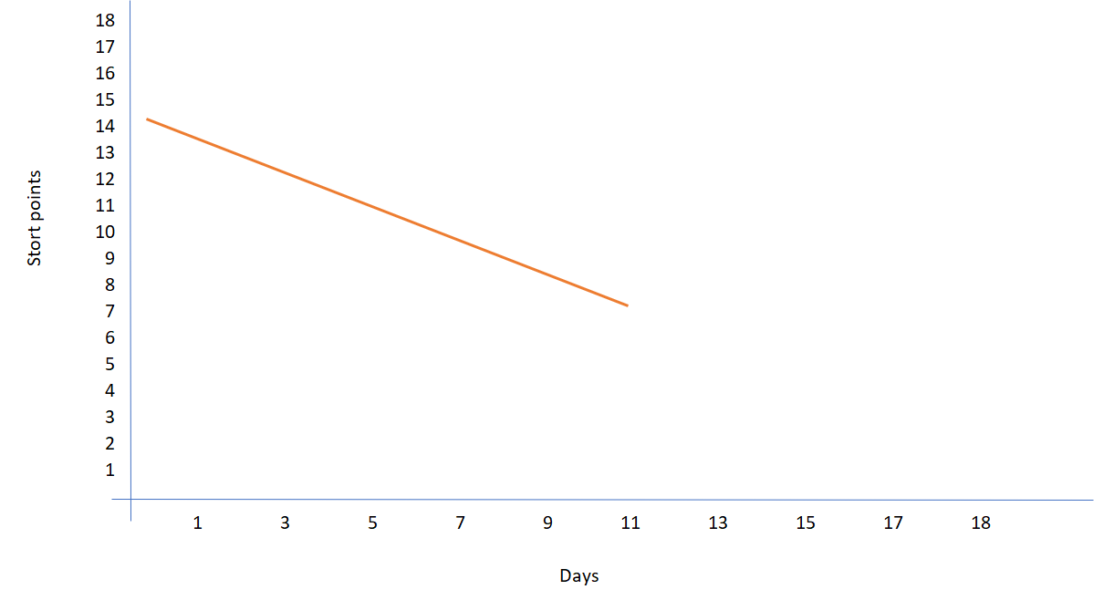

**Sprint 1 Burndown chart**

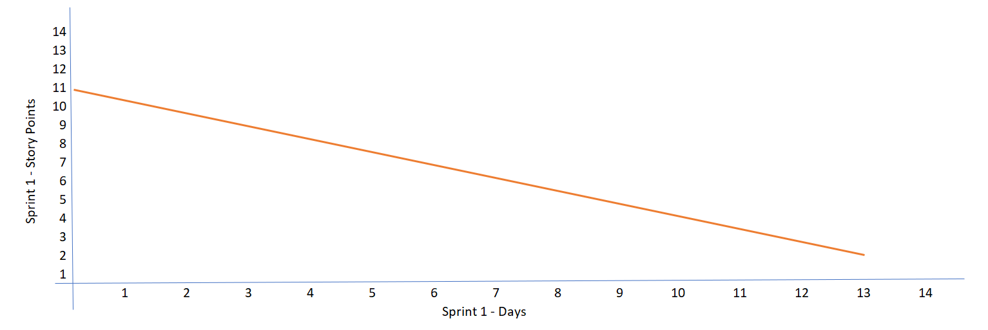

**Sprint 2 Burndown chart**

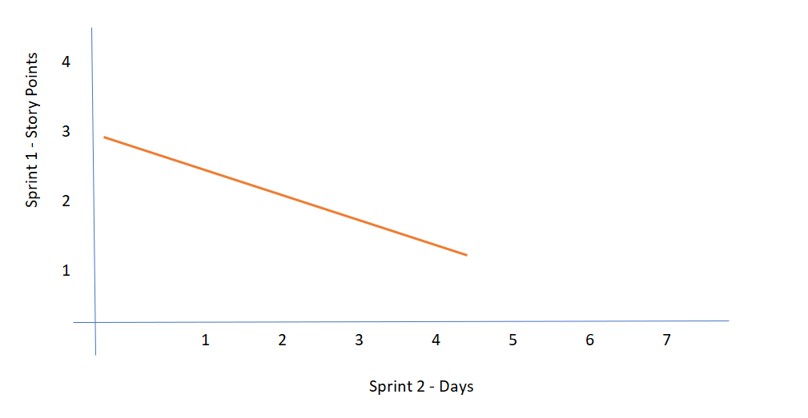

**Document 6:** Sprint meetings

**Meeting Type 1**: Sprint Planning meeting

|  |  |
| --- | --- |
| **Date** | 23-03-2025 |
| **Time** | 9:45 AM |
| **Location** | Mepz - SDB 1 - 4th Floor - Opulence Meeting Room |
| **Prepared By** | Arihant |
| **Attendees** | Pavittar, Sheila, Sai Prasad, Naveen, Arthi, Sri Ganesh, Tara |

**Agenda Topics**

|  |  |  |
| --- | --- | --- |
| **Topics** | **Presenter** | **Time allotted** |
| UiPath | Sai Prasad | 20 Min |
| Power automates | Arthi Kumari | 10 Min |
| Mail Box Creation | Tara | 5 Min |
| System UiPath Flow | Sheila Ranjini | 20 Min |
| Wrap-up | Pavittar Singh | 5 Min |

**Other Information**

|  |  |
| --- | --- |
| **Observers** | Arihant, Naveen, Sri Ganesh |
| **Resources** | All |
| **Special Notes** | Licence key approval to be taken from COO for UiPath |

**Meeting Type 2:** Sprint review meeting

|  |  |
| --- | --- |
| **Date** | 26-03-2025 |
| **Time** | 5:00 PM |
| **Location** | Mepz - SDB 3 - 11th Floor - Space Meeting Room |
| **Prepared By** | Sheila Ranjini and Naveen |
| **Attendees** | Pavittar, Arihant, Sai Prasad, Arthi, Sri Ganesh, Tara |

|  |  |  |  |
| --- | --- | --- | --- |
| **Sprint Status** | **Things to Demo** | **Quick Updates** | **What’s Next** |
| User story 1 - Completed | UiPath Trigger | Email successful triggered as per the user story design | Successfully completed and delivered |
| User story 2 - WIP | Email Consolidation demo | Multiple email to be checked with few incorrect templates mapping to see if that rejects as per the plan | Once the valid template is accepted and noncompliance is rejected and send email upon the same, this user story will be successfully completed. |

**Meeting Type 3:** Sprint retrospective meeting

|  |  |
| --- | --- |
| **Date** | 06-04-2025 |
| **Time** | 5:00 PM |
| **Location** | Mepz - SDB 3 - 11th Floor - Space Meeting Room |
| **Prepared By** | Sheila Ranjini, Pavittar |
| **Attendees** | Arihant, Sai Prasad, Arthi, Sri Ganesh, Tara, Naveen |

|  |  |  |  |  |
| --- | --- | --- | --- | --- |
| **Agenda** | **What Went Well** | **What Didn't go well** | **Questions** | **Reference** |
| UiPath | UiPath coding was quick and easy as we had most of sr. developers. | Licence Key mapping was challenging despite of approval from COO for few users | None Raised | Document v12 is the final go to for the UiPath coding and setup |
| Email Flow | Email Flow was smooth and instant as per the client requirement | Mapping of new mailbox to multiple user as each user had to raise different tickets. This delayed 1 day | Can we Raise bulk tickets for all the users at once? | Document v1.1.2 is the final go to for the email mapping setup |
| Template Adherence | Designated template was key for success of sprint 1 as this has literally eliminated the manual intervention | Template finalization from stakeholder. Stakeholder were not available as only 1 POC was assigned. | It would be great if we have 2 POCs | Document v4.1 is the final go to reference for demand template requirement |

**Meeting Type 4:** Daily Stand-up meeting

|  |  |  |  |  |  |  |
| --- | --- | --- | --- | --- | --- | --- |
| **Question** | **Name / Role** | **Week 1 - 23/3/2025 to 27/3/2025** | | | | |
| **Monday** | **Tuesday** | **Wednesday** | **Thursday** | **Friday** |
| **What did you do yesterday?** | Sai Prasad (Sr.Devp) | Reviewed the User Stories | Meeting fixed with COO to explain the need for Licence Key | UiPath coding to Trigger BOT 1 | UiPath coding to Trigger BOT 1 | UiPath coding to Trigger BOT 1 |
| Naveen Kumar (Sr. Devp) | Reviewed the User Stories | Getting the documents ready for the process to start | Mail Box creation | Mail box testing | Integrating mail box to the BOT 1 Trigger |
| Sri Ganesh (Jr. Devp) | Reaching out for the approval of UiPath Licence Key | Helping Naveen for on the document | Getting the excel template ready that BOT will trigger | Creating a share path to store all the details at one place | On Leave yesterday |
| **What will you do today?** | Sai Prasad (Sr.Devp) | Meeting fixed with COO to explain the need for Licence Key | UiPath coding to Trigger BOT 1 | UiPath coding to Trigger BOT 1 | UiPath coding to Trigger BOT 1 | Testing of BOT 1 with dummy email trigger |
| Naveen Kumar (Sr. Devp) | Getting the documents ready for the process to start | Mail Box creation | Mail box testing | Integrating mail box to the BOT 1 Trigger | Testing of BOT 1 with multiple exception handing |
| Sri Ganesh (Jr. Devp) | Helping Naveen for on the document | Getting the excel template ready that BOT will trigger | Creating a sharepath to store all the details at one place | On Leave today | Testing of BOT 1 with dummy email trigger |
| **what is blocking the progress?** | Sai Prasad (Sr.Devp) | None | Licence key was not mapped properly to the designated user | Few undefined errors occurred and there were no documents to refer such errors | None | None |
| Naveen Kumar (Sr. Devp) | None | None | Mail box inactive on automation related email. Took couple of hours to active for BOT to send email | Had to edit few codes and made the BOT to handle exceptions |
| Sri Ganesh (Jr. Devp) | None | None | Cloud down due to MS office update | None as Sai & Naveen managed shrinkage | None |