**Question 1 – BPM**

Business Process Model

A [business process](https://www.techtarget.com/searchcio/definition/business-process)is an activity or set of activities that helps accomplish an organization's goals, such as increasing profits or promoting workforce diversity. BPM uses various methods to improve a business process by analysing it, what’s the desired outcome? What’s the goal? What’s the thing that happens at the end of this process?

* **Goal:** To Develop an online agriculture store for remote area farmers to purchase seeds, pesticides, and fertilizers
* **Input:** Product details from manufacturers, farmer requirements, Order Requests
* **Resources:** Online platforms, Internet connectivity, Warehouses
* **Output:** Orders, Product Delivery, Improving Forming efficiency
* **Activities:** Registration, selecting products, placing orders, Payment, delivery tracking
* **Value Created:** Increased accessibility to farmers, enhanced farming productivity, ease of farming

**Question 2 – SWOT**

SWOT Analysis is a strategic planning framework used to evaluate the Strengths, Weaknesses, Opportunities, and Threats related to a business, project, product, or process. It helps organizations and individuals identify internal factors (strengths & weaknesses) and external factors (opportunities & threats) to make informed decisions and develop strategies for growth and risk management.

Weakness:

* Internet connectivity
* farmers digital literacy

Strengths:

* Direct manufacturer-to-farmer model
* Accessibility for remote farmers digitally

Opportunities:

* Expansion to other regions
* Include advisory services to farmers

Threats:

* Competition from established Agro-businesses.
* Logistical and delivery challenges in remote areas.

**Question 3 – Feasibility study**

A Feasibility Study is an analysis that helps determine whether a project, business idea, or plan is practical, achievable, and worth pursuing. It considers factors like cost, technology, market demand, legal requirements, and risks to decide whether the project should proceed.

* **Hardware:** Server infrastructure for hosting the platform.
* **Software:** Java-based mobile and web application.
* **Resources:** Java developers, Network admin, DB admin, Testers
* **Budget:** 2CR
* **Timeframe:** 18Months

**Question 4 – Gap Analysis**

Gap Analysis is a business assessment tool used to identify the difference (gap) between the current state and the desired future state of a process, system, or business performance. It helps organizations understand what needs improvement and what actions are required to close the gap.

**AS-IS Process:**

* Rely only on physical markets
* Limited access to a variety of quality seeds, fertilizers, and pesticides.
* Unavailability of products.
* Higher costs due to intermediaries and transportation.

**TO-BE Process:**

* Farmers can directly purchase products from manufacturers via an online platform.
* Wide range of high-quality seeds, fertilizers, and pesticides available in one place
* Transparency in pricing, availability, and quality

**Question 5 – Risk Analysis**

Risk Analysis is the process of identifying, assessing, and prioritizing potential risks that could negatively impact a business, project, or decision. It helps organizations prepare for uncertainties by evaluating the likelihood and impact of risks and developing strategies to mitigate them.

**Internal Risks:**

* Dependence on external vendors for product supply and inventory management
* Logistic issues in delivering remote areas
* Technical issues and system downtime can affect the farmer’s experience

**External Risks:**

* Intense competition from other Agro-business in India
* Changes in government regulations and policies that affect industry

**BA Risks:**

* Incomplete requirements
* Domain
* Change in requirements

**Project-based risks:**

* Scope risks
* Stakeholder risks

**Question 6 – Stakeholder Analysis (RACI Matrix)**

A RACI Matrix is a project management tool used to define and clarify the roles and responsibilities of team members for specific tasks, processes, or deliverables. It ensures accountability and avoids confusion in projects.

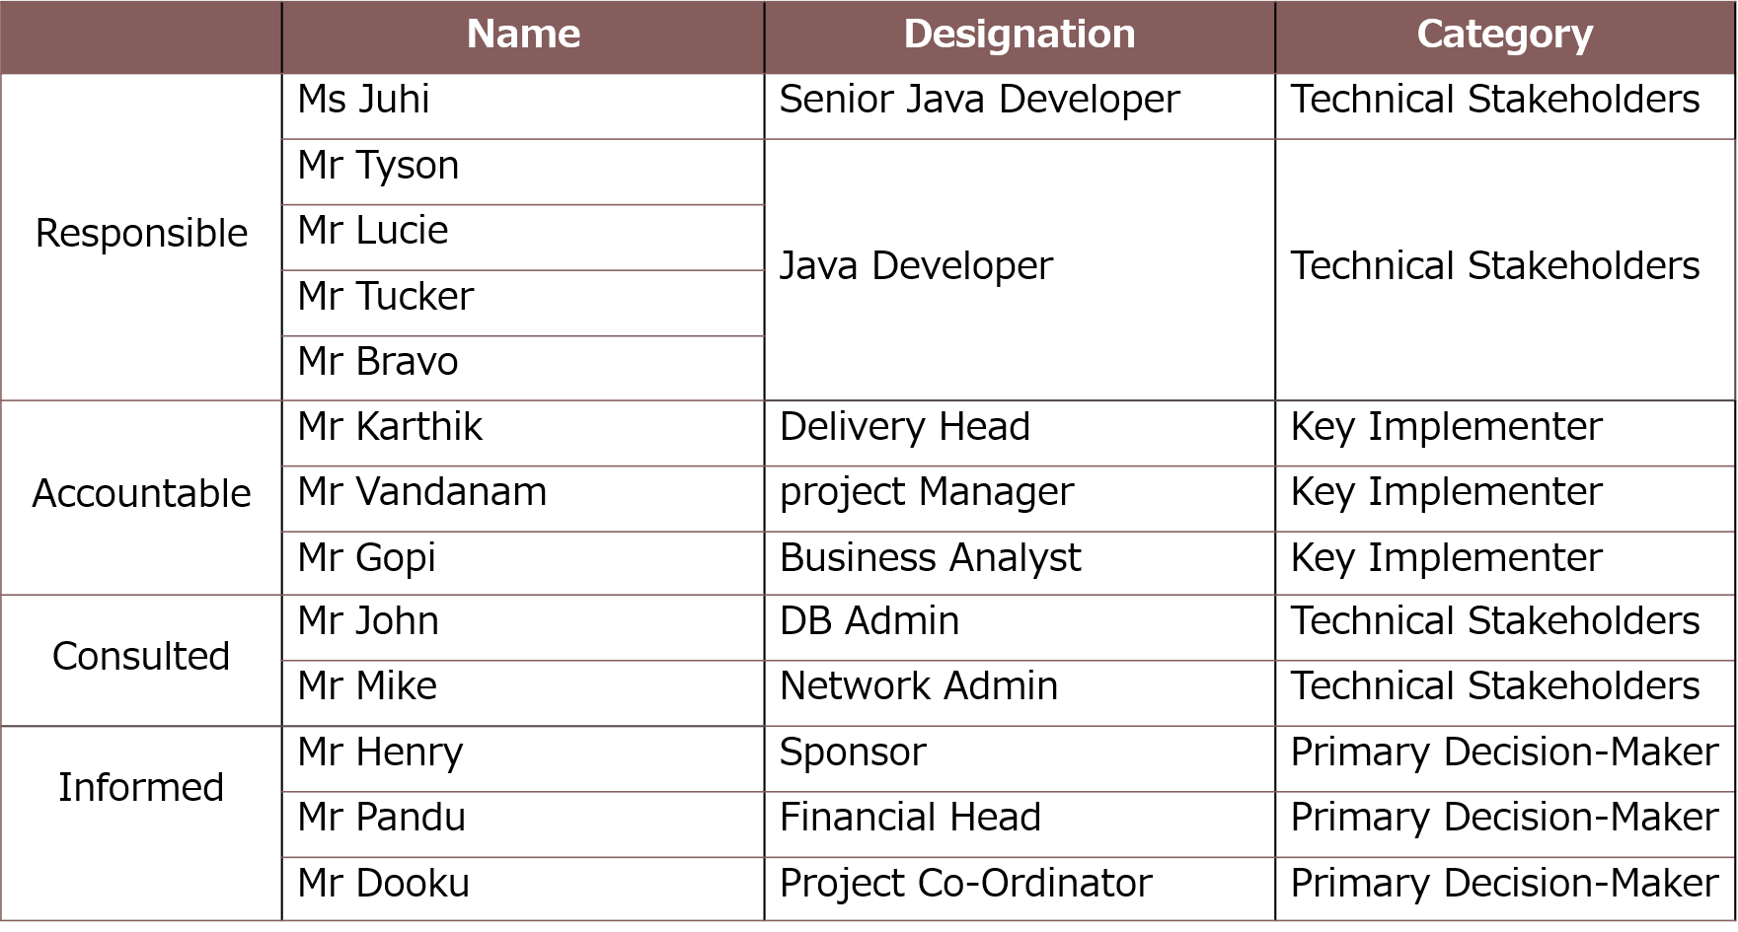

**Question 7 – Business Case Document**

A Business Case Document (BCD) is a formal document that justifies the need for a project, investment, or business initiative. It outlines the problem, solution, benefits, costs, risks, and expected outcomes, helping stakeholders decide whether to approve the project.

**Objective**:

Improve accessibility of agricultural products for remote farmers.

**Scope:**

Development of an online store accessible via web and mobile.

**Benefits:**

Reduced cost to the farmers because of direct manufacturer-to-farmer transactions, improved agricultural output.

**Risks:**

Internet connectivity in rural areas, Low digital literacy in farmers

**Resource:**

**Hardware:** Server infrastructure for hosting the platform.

**Software:** Java-based mobile and web application.

**Resources:** Java developers, Network admin, DB admin, Testers

**Question 8 – Four SDLC Methodologies**

**1.Sequential Methodology (Waterfall Model)**

**Definition**: A **linear and step-by-step** approach where each phase is completed before moving to the next.

**Key Characteristics**

* Fixed requirements from the beginning.
* No overlap between phases.
* Suitable for well-defined, stable projects.

**2. Iterative Methodology (Incremental Model)**

**Definition**: The project is broken down into **small parts (increments)**, and each increment adds functionality.

**Key Characteristics**

* Partial implementations are developed and improved over time.
* Customer feedback is incorporated in each iteration.
* Testing is conducted after each increment.

**3.Evolutionary Methodology (Spiral Model, Prototyping)**

**Definition**: A **risk-driven** model where a system is developed **in cycles**, refining the solution at each step.

**Key Characteristics**

* Prototypes or working versions are built and improved in iterations.
* Risk assessment is a key part of the process.
* Focuses on feedback and gradual system evolution.

**4.Agile Methodology (Scrum, Kanban, XP, SAFe, etc.)**

**Definition**: A **highly flexible, adaptive** approach where development happens in short cycles (**Sprints** or iterations).

**Key Characteristics**

* Rapid development and continuous feedback.
* Prioritizes working software over documentation.
* Teams work in small, cross-functional groups.

**Question 9 – Waterfall RUP Spiral and Scrum Models**

**Waterfall Model (Sequential Approach)**

**Definition**: A linear, step-by-step approach where each phase is completed before moving to the next.

**Key Characteristics**

* **Phases:** Requirement → Design → Implementation → Testing → Deployment → Maintenance
* **No going back:** Once a phase is completed, you cannot return to it.
* **Best for:** Well-defined projects with stable requirements.

**RUP (Rational Unified Process) Model**

**Definition**: An **iterative** software development model designed by **IBM Rational**, focusing on object-oriented and UML-based design.

**Key Characteristics**

* **Phases:** Inception → Elaboration → Construction → Transition
* **Iterative:** Each phase allows feedback and improvement.
* **Use of UML:** Heavy emphasis on modeling using **Unified Modeling Language (UML)**.
* **Roles & Artifacts:** Defines clear roles, workflows, and deliverables.

**Spiral Model (Evolutionary & Risk-Driven Approach)**

**Definition**: A **risk-focused iterative** development model that combines **Waterfall and Prototyping**.

**Key Characteristics**

* **Phases:** Planning → Risk Analysis → Engineering → Evaluation (repeats in a loop).
* **Risk management:** High emphasis on assessing and mitigating risks early.
* **Iterative refinements:** Continuous improvements in each cycle.

**Scrum Model (Agile Approach)**

**Definition**: A lightweight, **Agile-based methodology** that delivers **working software in small iterations (Sprints)**.

**Key Characteristics**

* **Short cycles (Sprints):** Typically,2-4 weeks.
* **Roles:** Product Owner, Scrum Master, Development Team.
* **Daily Standups:** 15-minute meetings to track progress.
* **Continuous Feedback:** From stakeholders & users.

**Question 10 – Waterfall Vs V-Model**

|  |  |
| --- | --- |
| Waterfall Model | V-Model |
| A sequential development model with distinct phases. | A sequential development model with distinct phases. |
| Sequential, phase-by-phase execution | Verification and validation run in parallel |
| Testing Begins after the development phase is completed | Testing occurs at each development stage. |
| Rigid, changes are difficult to incorporate. | More flexible, as defects are detected early. |
| Higher risk, as issues are found later. | Lower risk, as defects are identified early. |
| Late-stage feedback after full development. | Early feedback due to continuous testing. |
| Extensive documentation required at each stage. | Well-documented with a strong focus on testing documentation. |
| Heavy documentation is required before proceeding. | Comprehensive documentation at each phase. |
| Well-defined projects with stable requirements. | Projects where quality and early defect detection are crucial. |
| Longer, as testing is at the end. | Shorter, as testing runs parallel to development. |
| Higher risk, as issues are found later. | Lower risk, as defects are identified early. |
| Late-stage feedback after full development. | Early feedback due to continuous testing. |
| The cost of Fixing Bugs is High, as bugs are found late in the cycle. | Lower, as defects are caught in earlier stages. |
| Easier maintenance due to early defect resolution | Easier maintenance due to early defect resolution |
| No iterations; once a phase is completed, it cannot be revisited. | Iterative at testing stages, allowing verification at every step |
| Suitable for small to medium-sized projects. | Suitable for medium to large-scale projects. |
| The client is only involved at the beginning (requirement phase) and at the end (final delivery). If the final product does not meet expectations, changes are costly. | The client is involved in multiple stages, especially in the validation phases. This helps in early feedback and ensures the product aligns with expectations. |
| Not suitable for complex and evolving projects. | More efficient for handling complex requirements. |
| Development Cost Can be higher due to late error discovery. | Generally lower as defects are caught early. |
| Not suitable for complex and evolving projects. | More efficient for handling complex requirements. |
|  |  |

**Question 11 – Justify your choice**

* Chosen Model: V-Model.
* Justification: Since testing is integrated at each development stage, it ensures a higher-quality product, reduces rework, and aligns well with project requirements.

**Question 12 – Gantt Chart**

A Gantt chart is a visual project management tool that represents tasks or activities along a timeline. It helps in planning, scheduling, and tracking project progress.

|  |  |  |  |  |  |  |  |
| --- | --- | --- | --- | --- | --- | --- | --- |
| **Week1** | **Week10** | **Week20** | **Wwek30** | **Week40** | **Week50** | **Week60** | **Week72** |
| RG | RA |  |  |  |  |  |  |
|  |  | Design |  |  |  |  |  |
|  |  |  | T1  D1 |  |  |  |  |
|  |  |  |  | D2 | T2 |  |  |
|  |  |  |  |  |  | D3 |  |
|  |  |  |  |  |  | T3 | UAT |

|  |  |  |  |  |  |  |  |  |
| --- | --- | --- | --- | --- | --- | --- | --- | --- |
| Resource | WEEK1 | **Week10** | **Week20** | **Week30** | **Week40** | **Week50** | **Week60** | **Week72** |
| Project Manager |  |  |  | 1 |  |  |  |  |
| Business Analyst |  |  |  |  |  |  |  |  |
| **Java Developers** |  |  |  | 1 |  |  |  |  |
| **Testers** |  |  |  | 2  4 |  |  |  |  |
| **DB Admin** |  |  |  |  |  |  |  |  |
| **NW Admin** |  |  |  | 1 |  |  |  |  |

1

**Question 13 – Fixed Bid Vs Billing**

* A fixed bid project is one in which the service provider agrees to deliver a specific scope of work for a fixed price. The scope of work, deliverables, and timeline are agreed upon upfront, and the service provider assumes the risk for any cost overruns or delays.
* A billing project is one in which the service provider bills the client for the actual times and materials expended on the project. The client pays for the service provider's time and expenses, and the scope of work can be adjusted as needed throughout the project

**Question 14 – Preparer Timesheets of a BA in various stages of SDLC**

**Design Timesheet of a BA**

|  |  |  |
| --- | --- | --- |
| **Task Description** | **Hours Spent** | **Comments** |
| Requirements gathering | 4 | Met with stakeholders |
| Creating use cases | 3 | Drafted initial use cases |
| Reviewing design documents | 2 | Provided feedback |
| Meeting with the design team | 3 | Discussed design issues |

**Development Timesheet of a BA**

|  |  |  |
| --- | --- | --- |
| **Task Description** | **Hours Spent** | **Comments** |
| Assisting developers with requirements | 3 | Clarified user stories |
| Reviewing development progress | 2 | Provided feedback |
| Updating documentation | 3 | Made updates based on feedback |

**Testing Timesheet of a BA**

|  |  |  |
| --- | --- | --- |
| **Task Description** | **Hours Spent** | **Comments** |
| Creating test cases | 4 | Drafted test cases |
| Conducting initial testing | 3 | Tested critical features |
| Logging defects | 2 | Recorded defects in system |

**UAT Timesheet of a BA**

|  |  |  |
| --- | --- | --- |
| **Task Description** | **Hours Spent** | **Comments** |
| Preparing UAT test plans | 3 | Prepared UAT documentation |
| Conducting UAT with users | 4 | Guided users in testing |
| Reviewing UAT feedback | 2 | Analyzed user feedback |

**Deployment and Implementation Timesheet of a BA**

|  |  |  |
| --- | --- | --- |
| **Task Description** | **Hours Spent** | **Comments** |
| Preparing deployment documentation | 3 | Finalized deployment docs |
| Supporting deployment activities | 4 | Assisted with deployment |
| Post-deployment review | 2 | Conducted review meetings |