**COEPD Live Project - Waterfall Deliverables -Part 2**

Document 6: Use Case Diagram, Activity Diagram, and Use Case Specification Document

Use Case Diagram

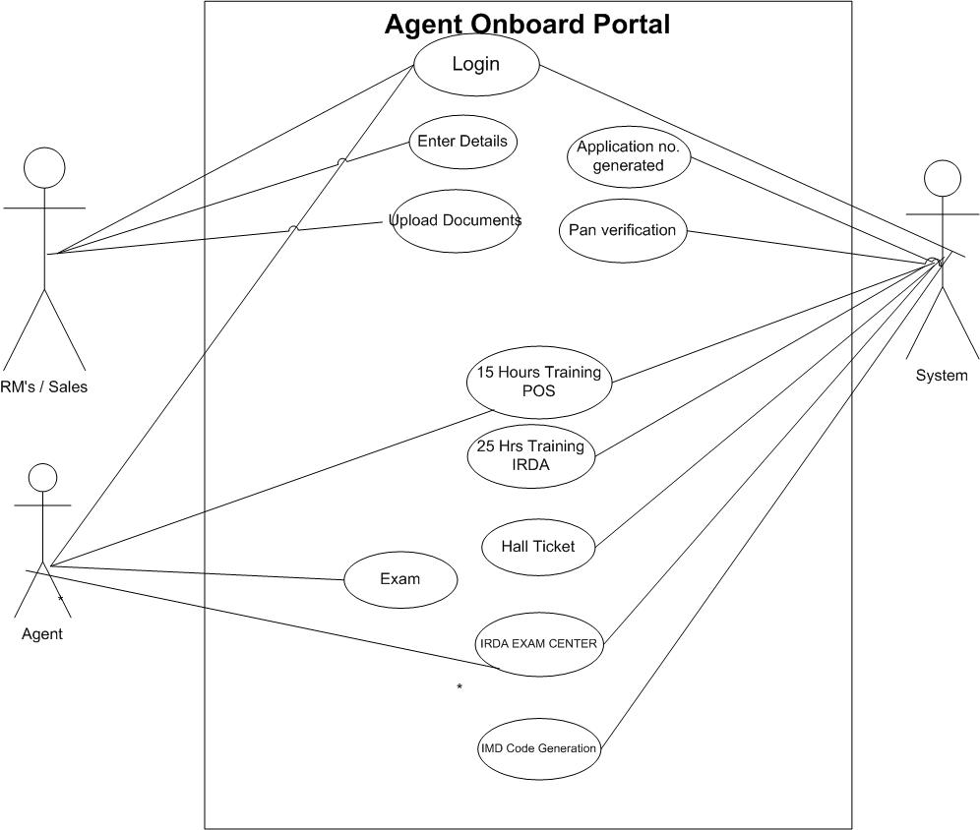

**Activity Diagram**

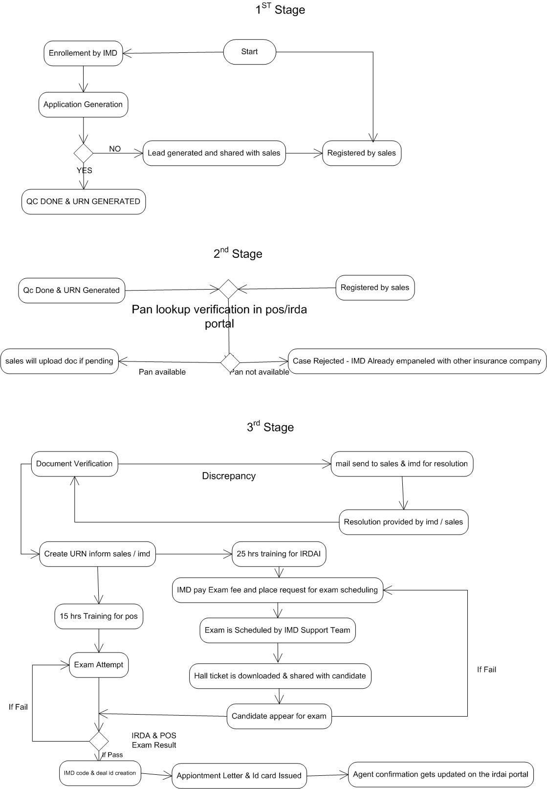



Use Case Specification Document

1. **Use Case Name: Login**

Use Case Description: Allows users to log in to the Agency onboarding portal.

**Actors:**

Primary Actors: RM’S, System Administrator

Secondary Actors: Database

**Basic Flow:**

1.User navigates to the login page.

2.User enters username and password.

3.System validates credentials.

4.System displays the dashboard upon successful login.

**Alternate Flow:** Invalid credentials:

• System displays an error message.

• User retries login or resets password.

**Exceptional Flows:** System downtime:

* User is unable to log in.
* System displays maintenance message.

**Pre-Conditions:**

• User must be registered in the system.

• System must be online.

**Post-Conditions:**

• User is logged in and directed to the dashboard.

**Assumptions:**

• Users have valid credentials.

**Constraints:**

•High load times during peak hours.

**Dependencies:**

•User database authentication service.

**Inputs and Outputs:**

* Inputs: Username, password

• Outputs: Dashboard, error messages

**Business Rules:**

• Passwords must meet security requirements.

• Account lockout after multiple failed attempts.

**Miscellaneous Information:**

• Ensure password reset functionality is available.

1. **Use Case Name: Upload Agent Data**

**Use Case Description:** Allows RM’s to upload Agent Data.

Actors: Primary Actors: RM’s

Secondary Actors: Database

Basic Flow:

1. RM’s logs into the AOB portal.

2. RM’s navigates to the "Upload Documents" section.

3. RM’s selects the field to upload specified documents.

4. RM’s enters or uploads Agent Details

5. System validates the data

6. System saves the data to the database.

Alternate Flow: Invalid data format:

* System displays an error message.
* RM’s corrects and re-submits details.

Exceptional Flows: Database error:

* System displays an error message.
* RM’s retries uploading details later.

**Pre-Conditions:**

* + RM’s must be logged into the system.
  + The selected field must be predefined in the system.

**Post-Conditions:**

* Data are successfully saved in the system.

**Assumptions:**

* RM’s have the correct data.

**Constraints:**

* System performance during high usage times.

**Dependencies:**

* Database service

**Inputs and Outputs:**

* + - Inputs: Agent data
    - Outputs: Confirmation message, error messages

**Business Rules:**

* + - Data must be in the correct format.
    - Data entry should follow the correct format.

**Miscellaneous Information:**

* Provide a template for data upload.

1. **Use Case Name: View login status.**

**Use Case Description:** Allows Agents to view status of data entered.

**Actors:**

Primary Actors: Rm’s/ Agent

Secondary Actors: Database

**Basic Flow:**

1. Rm’s/Agent logs into the Agency portal.
2. Rm’s Agent navigates to the "View details section.
3. Rm’s/Agent selects the name and password.
4. System retrieves and displays the record.

**Alternate Flow: No Data available:**

• System displays a message indicating no details is available for the selected column

**Exceptional Flows:** Database error:

• System displays an error message.

• Agents retries later.

**Pre-Conditions:**

• Rm’s/Agent must be logged into the system.

• Agent data must be available.

**Post-Conditions:**

* Data is viewed or downloaded.

**Assumptions:**

* Agents have valid login credentials.

**Constraints:**

* Data generation performance.

**Dependencies:**

* Database service

**Inputs and Outputs:**

* Inputs: Agent name
* Outputs: error messages

**Business Rules:**

* + - Details must be finalized before viewing.
    - Access permissions for Agents must be verified.

**Miscellaneous Information:**

* Upload data format is user-friendly.

2. **Functional Requirements Specification (FRS)**

* Use Case Documents
* RTM
* Test Plan
* User Acceptance Testing (UAT) Plan
* Training Materials
* Project Management Plan

**5. Document Sign-off Process:**

* Share draft documents with stakeholders for review and feedback.
  + Incorporate feedback and revisions as necessary.
  + Obtain formal sign-off from stakeholders indicating their acceptance of the documents.
  + Maintain version control to track changes and updates

**6 Client Approvals:**

* Present finalized documents to the client for approval.
* Provide explanations and clarifications as needed to ensure understanding.
* Obtain formal approval from the client through signed agreements or email confirmation.

1. **Communication Channels:**

* Establish regular meetings with stakeholders to discuss project progress, issues, and updates.
* Utilize email, project management software, and collaboration tools for asynchronous communication.
* Maintain an open-door policy for stakeholders to raise concerns or provide feedback.

1. **Change Request Handling:**

* Establish a formal change management process to capture, assess, and prioritize change requests.
* Evaluate the impact of proposed changes on scope, timeline, and budget.
* Obtain approval from the Change Control Board before implementing changes.

1. **Progress Reporting to Stakeholders:**

* Provide regular updates on project milestones, deliverables, and risks.
* Use status reports, dashboards, and presentations to communicate progress effectively.
* Highlight achievements, challenges, and upcoming tasks to keep stakeholders informed.

**10. UAT - Client Project Acceptance:**

* Coordinate User Acceptance Testing (UAT) with the client to validate that the software meets requirements.
* Provide clear instructions and test cases for the client to execute during UAT.
* Obtain sign-off on the UAT - Client Project Acceptance Form once the client confirms satisfaction with the software functionality.

**4 . Use Case Name: Training Management**

Use Case Description: Tracks training completed by employees.

**Actors:**

Primary Actors: RM’s

Secondary Actors: Trainer, Database

**Basic Flow:**

1. Trainer assigns training modules.

2. RM’s/Agents completes assigned training.

3. System updates training records.

**Alternate Flow:**

Incomplete training:

- System reminds the RM’s of pending training.

**Exceptional Flows:**

System downtime:

- Training cannot be recorded.

- System displays maintenance message.

**Pre-Conditions:**

- Training modules are available.

- System must be online.

**Post-Conditions:**

- Training records are updated.

**Assumptions:**

- RM’s/Agents have access to training materials.

**Constraints:**

- Training must be completed within deadlines.

**Dependencies:**

- Training management system, employee database.

**Inputs and Outputs:**

- Inputs: Training module completion

- Outputs: Updated training records

**Business Rules:**

- RM’s/Agents must complete mandatory training.

**Miscellaneous Information:**

- Include notifications for upcoming training.

**5. Use Case Name: Technical Support**

**Use Case Description**: Provides technical support for employees.

**Actors:**

Primary Actors: Employee

Secondary Actors: IT_Admin

Basic Flow:

1. Employee submits a technical support request.

2. IT_Admin reviews and addresses the issue.

3. System updates the status of the support request.

**Alternate Flow:**

Unresolved issue:

- IT_Admin escalates the issue.

- System updates escalation status.

**Exceptional Flows:**

System downtime:

- Support request cannot be submitted.

- System displays maintenance message.

**Pre-Conditions:**

- Technical issues must be reported.

- System must be online.

**Post-Conditions:**

- Updated status of the support request.

**Assumptions:**

- IT_Admin is available to provide support.

- System updates escalation status.

**Exceptional Flows:**

System downtime:

- Support request cannot be submitted.

- System displays maintenance message.

**Pre-Conditions:**

- Technical issues must be reported.

- System must be online.

**Post-Conditions:**

- Updated status of the support request.

**Assumptions:**

- IT_Admin is available to provide support.

**Constraints:**

- Support must be provided within SLA.

**Dependencies:**

- IT support system, employee database.

**Inputs and Outputs:**

- Inputs: Support request details

- Outputs: Updated support request status

**Business Rules:**

- Support requests must be logged and tracked.

**Miscellaneous Information:**

- Provide feedback mechanism for support provided.

**Document 7- Screens and pages**

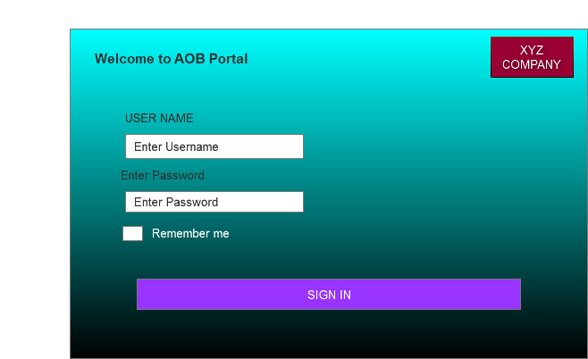

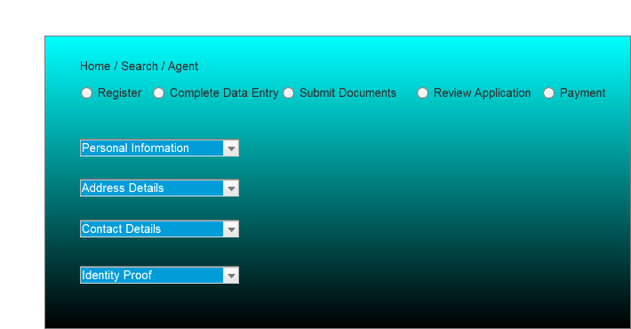

**Document 8: Tools - Visio and Axure**

**Experience with Visio and Axure**

In this project, I effectively utilized Visio and Axure to enhance the design and development process. Visio was instrumental in creating detailed technical diagrams, including flowcharts, UML diagrams, and network layouts, which facilitated clear communication and planning. Axure was used to design intuitive user interfaces and interactive prototypes, ensuring a seamless user experience. The real-time collaboration features of both tools allowed for efficient teamwork and iterative feedback, leading to a well-organized and visually appealing AOB portal.

**Document 9: BA Experience**

1. **Requirement gathering:**

* In this project, I leveraged my expertise as a Business Analyst to gather comprehensive requirements by using MOSCOW technique for the AOB portal.
* Through a combination of stakeholder interviews, workshops, and surveys, I meticulously documented the needs and expectations of RM’s, administrators, and IT staff.
* I validate the requirements using FURPS technique
* Utilizing elicitation techniques such as use case analysis and process mapping, I ensured a thorough understanding of the functional and non-functional requirements.
* My experience in requirement gathering helped create a detailed and precise requirements document, which served as a solid foundation for the successful development and implementation of the AOB portal.
* Prototyping is used to give more specific requirements

1. **Requirement Analysis:**

* In this project, I utilized my skills as a Business Analyst to perform a thorough requirements analysis for the AOB portal.
* I started by organizing and categorizing the gathered requirements, ensuring clarity and removing any ambiguities.
* Using detailed analysis techniques, I identified and consolidated duplicate requirements, ensuring a streamlined and coherent set of needs.
* I shared diagrams with the team for feedback. The team suggestions were incorporated and made necessary modifications.
* I conducted regular validation sessions with stakeholders to confirm the accuracy and completeness of the requirements.
* By developing and sharing prototypes, I facilitated stakeholder engagement, refining the requirements to align perfectly with user expectations. This meticulous approach ensured a solid foundation for the project's successful implementation.
* Prepare BRS and SRS

1. **Design:**

* From the use case diagrams, we prepare test cases
* Communicate with client on design and solution documents
* Write negative test cases as well along with positive test cases.
* Do not miss a single test case. It might have huge impact on project development in later stages
* Prepare test data for testing
* Update RTM. This is just as we need to make sure that all the requirements are met

1. **Development:**

* Organized JAD sessions
* Clarifying queries of tech team during coding
* There might be some team members who does not agree with the concept or who does not cooperate during JAD sessions. As a BA i handle the situation gently and had one on one discussion with them. Explained how their actions are going to affect the project. Setup healthy environment within the team.
* Referred diagrams to code the Unit
* Conduct regular meetings with technical team and client which is challenging. Some team members might not be available for the meeting. Recording the session and providing that to missed one and having one to one discussion later with that missed person is all i need to do

1. **Testing:**

* Prepare test cases from use cases
* Perform high level testing
* Test data is requested by BA from client
* Updated RTM
* Take signoff from client
* Prepare client for UAT

1. **Deployment:**

* Forwarded RTM to client which should be attached to project closure document Coordinates to complete and share end user manuals
* Plans and organizes training sessions
* Make sure all the candidates attend the meeting

**Adding some more experience points based on my Experience for this project**

1. **Requirement Gathering:**

**Techniques:**

- Interviews with RM’s and management

- Surveys to collect feedback on current processes

- Review of existing documentation and systems

- Observations of IT/RM’s' workflows and procedures

**Activities:**

- Conducting one-on-one interviews with stakeholders to understand pain points and requirements

- Distributing surveys to gather quantitative data on entry processes

- Analysing existing documents such as data entry system and procedures manuals

- Shadowing management/higher authority to observe current workflows and identify areas for improvement

**Challenges:**

- Gathering comprehensive requirements from diverse stakeholders

- Ensuring alignment between business needs and technical capabilities

- Managing expectations of stakeholders with varying priorities

- Dealing with resistance to change from online process to existing processes

**Steps to Overcome Challenges:**

- Establishing a clear communication plan to engage stakeholders throughout the requirement gathering process

- Prioritizing requirements based on business impact and feasibility

- Facilitating workshops to resolve conflicting requirements and build consensus

- Providing training and support to help stakeholders adapt to new processes

2. **Requirement Analysis: Techniques:**

- Use Case Analysis to identify user interactions with the system

- Business Process Modelling to visualize RM’s' workflows

- Data Modelling to define data entities and relationships

- Requirement Prioritization to determine critical features

**Activities:**

- Creating use cases to capture system interactions for different user roles

- Modelling current data entry processes to identify inefficiencies and bottlenecks

- Prioritizing requirements based on business value and dependencies

**Challenges:**

- Managing complexity in data entry processes - Balancing conflicting requirements from different stakeholders

- Ensuring scalability and flexibility of the system architecture

- Addressing regulatory compliance and data privacy requirements

**Steps to Overcome Challenges:**

- Collaborating closely with RM’s & subject matter experts to understand detailed requirements

- Facilitating workshops and discussions to resolve conflicts and reach consensus

- Designing a modular and extensible system architecture to accommodate future changes

- Conducting thorough analysis of regulatory requirements and incorporating them into the system design

1. **Design:**

**Techniques:**

- System Design to define system components and interactions

- User Interface Design to create intuitive interfaces for users

- Data Design to design databases and data storage mechanisms

- Architecture Design to define the overall system structure

**Activities:**

- Designing the system architecture with modules for employee management functions

- Creating wireframes and mockups for user interfaces

- Defining database schemas and data storage mechanisms

- Documenting design decisions and rationale for future reference

**Challenges:**

- Balancing usability with functionality in the user interface design

- Integrating with existing HR systems and databases

- Ensuring security and privacy of employee data

- Managing design changes and maintaining consistency

**Steps to Overcome Challenges:**

- Conducting user testing and feedback sessions to iterate on interface designs

- Collaborating with IT teams to integrate with existing systems using standardized protocols

- Implementing robust security measures such as encryption and access controls

- Using version control and documentation tools to track design changes and ensure consistency

**4. Development**

**Techniques:**

- Coding according to design specifications

- Code reviews and unit testing

- Prototyping to validate design concepts

- Continuous Integration to integrate code changes

**Activities:**

- Writing code for backend and frontend components of the software

- Conducting code reviews and unit tests to ensure quality

- Building prototypes to validate key features with stakeholders

- Integrating code changes into the main codebase and deploying to test environments

**Challenges:**

- Meeting deadlines and milestones set in the project plan

- Addressing technical debt and maintaining code quality

- Ensuring compatibility and interoperability with other systems

- Managing dependencies and third-party integrations

**Steps to Overcome Challenges:**

- Breaking down development tasks into smaller, manageable units

- Prioritizing high-impact features and functionalities for early delivery

- Allocating time for refactoring and addressing technical debt

- Implementing automated testing and continuous integration practices to detect and fix issues early

**5. Testing:**

**Techniques:**

- Unit Testing to test individual components

- Integration Testing to test interactions between components

- System Testing to test the entire system

- User Acceptance Testing to validate against user requirements

**Activities:**

- Writing and executing test cases for different levels of testing

- Identifying and reporting bugs and issues

- Conducting regression testing to ensure new features do not break existing functionality

- Facilitating user acceptance testing with stakeholders

**Challenges:**

- Limited test coverage and resources

- Reproducing and fixing complex bugs reported by testers

- Coordinating testing efforts across different teams and environments

- Balancing time and resources allocated for testing with other project activities

**Steps to Overcome Challenges:**

- Prioritizing test cases based on risk and criticality

- Implementing test automation for repetitive and time-consuming tests

- Establishing clear communication channels between development and testing teams

- Continuously monitoring and adjusting testing efforts based on project priorities and timelines

1. **Project Live/Implementation/Deployment:**

**Techniques:**

- Deployment Planning to ensure smooth transition to the new system

- User Training to familiarize users with the new software

- Change Management to address resistance and facilitate adoption

- Post-Implementation Review to evaluate project success and identify areas for improvement

**Activities:**

- Planning and coordinating deployment activities with IT and business teams - Conducting training sessions for Rm’s and end-users

- Communicating changes and benefits of the new system to stakeholders

- Reviewing project outcomes and gathering feedback for future enhancements

**Challenges:**

- Disruption to RM’s and Agents during system rollout

- Resistance to change from employees accustomed to old processes

- Ensuring user adoption and proficiency with the new software

- Evaluating project success and identifying lessons learned for future projects

**Steps to Overcome Challenges:**

- Developing a detailed deployment plan with contingencies for potential issues

- Providing comprehensive training and support to address user concerns and build confidence

- Engaging stakeholders early and often throughout the implementation process

- Conducting post-implementation reviews to gather feedback and identify opportunities for improvement

**Activity Diagram**

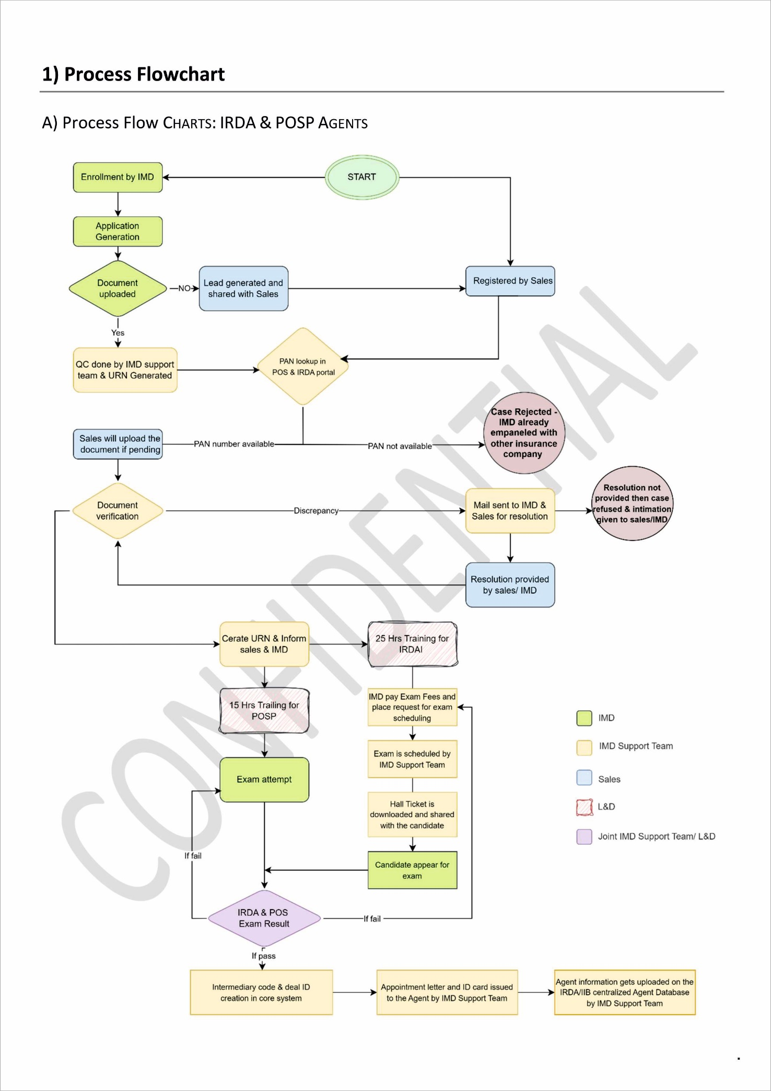

**Use Case Specification Document**

1. **Use Case Name: Login**

**Use Case Description:** Allows users to log in to the Agent onboard portal.

**Actors: Primary Actors:** Teacher, System Administrator

**Secondary Actors: Database**

**Basic Flow:**

**1.User navigates to the login page.**

**2.User enters username and password.**

**3.System validates credentials.**

**4.System displays the dashboard upon successful login.**

**Alternate Flow:Invalid credentials:**

* **System displays an error message.**
* **User retries login or resets password.**

**Exceptional Flows: System downtime:**

* **User is unable to log in.**
* **System displays mainten**
* **ance message**

**Pre-Conditions:**

* **User must be registered in the system.**
* **System must be online**

**Post-Conditions:**

**User is logged in and directed to the dashboard.**

**Assumptions:**

**Users have valid credentials.**

**Constraints:**

**High load times during peak hours.**

**Dependencies:**

User database authentication service.