**Q1. What is the difference between Brainstorming and JAD Sessions? 3 Marks**

**Answer**

**Key Differences between Brainstorming and JAD sessions are as below:**

1. **Goal-Oriented**: Brainstorming is focused on generating many ideas quickly, while JAD sessions aim to gather detailed and agreed-upon system requirements.
2. **Level of Structure**: Brainstorming is informal and open-ended, whereas JAD sessions follow a structured approach.
3. **Participant Involvement**: JAD sessions involve multiple stakeholders and decision-makers, while brainstorming is usually limited to a small group.
4. **Outcome**: Brainstorming results in a pool of ideas, while JAD sessions result in formalized system requirements and specifications.

**Brainstorming** is generally conducted when there is a challenge in identifying functional requirements from the given Business Requirement and when you are new to some domain. We need to plan in advance, identify the problem take approval from PM, identify the domain experts and SME’s, send invite with venue details and problem areas so that they come prepared and start giving ideas when discussion is initiated.

**JAD Sessions** are conducted generally when you feel problem in some technical concept and technical team is involved while discussing the requirements with client. If you face any challenge, JAD Sessions can be conducted during middle of the project. JAD sessions is intended to solve the problem as all participant’s comes with common mind-set.

**Q2. Why Document Analysis is one of the compulsory technique we use in a Project? Justify – 3 Marks**

**Answer:**

Document Analysis is an essential technique in business analysis and project management because it helps extract valuable information from existing documentation. Below are some key points which makes it compulsory elicitation technique:

1. Understanding Business Processes and Requirements
2. Reducing Requirements Gaps and Ambiguities
3. Supporting Stakeholder Communication
4. Risk Identification and Mitigation
5. Saving Time and Resources
6. Ensuring Compliance and Standardization
7. Supporting Decision-Making

Document analysis is one of the compulsory elicitation technique for any project as they serve as the document for our current system which could provide some of the input for the new system requirement.

Document Analysis is compulsory in a project because it **enhances requirement accuracy, minimizes risks, improves efficiency, ensures compliance, and supports better decision-making.** It acts as a foundation for requirement elicitation, reducing misunderstandings and project failures.

**Q3. In Which Context we will use Reverse Engineering? - 3 Marks**

**Answer: Reverse Engineering (RE)** is the process of analysing a system to extract design information from an existing product, software, or structure. It is widely used in different industries for various purposes, generally used in migration projects.

In situations where the software for an existing system has little or outdated documentation and it is necessary to understand what the system actually does reverse engineering is an elicitation technique that can extract implemented requirements from the software code.

**Q4. What is the difference between Brainstorming and Focus Groups? - 3 Marks**

**Answer:** Below are the key differences between Brainstorming and Focus Groups:

* **Objective**: Brainstorming is about **idea creation**, while Focus Groups are about **opinion gathering**.
* **Structure**: Brainstorming is more informal and open-ended, while Focus Groups are structured and guided.
* **Participants**: Brainstorming involves **internal team members**, whereas Focus Groups consist of **target users or stakeholders**.
* **Outcome**: Brainstorming results in **many possible solutions**, while Focus Groups provide **valuable user insights and preferences**.

**Focus group are of two types: Homogenous and Heterogeneous**

**Q5. Observation Technique – Explain both Active and Passive approaches - 3 Marks**

**Answer:**

Observing, shadowing users or doing a part of their job, can provide information of existing processes, inputs and outputs.

There are 2 basic approaches for the observation techniques:

1) **Passive / Invisible**: It is the way in which BA will only observe the SME working through the business routine without asking any questions. He will be preparing the notes in this process only by seeing as if he is invisible and Questions will be asked at the end of any process. BA will observe the process multiple times to ensure he understands how the process works today and why it was different on the other day.

2) **Active/Visible**: in this approach while BA observes the process and making notes at the same time he may also ask question to the worker. BA can even participate in the ongoing work to gain more on how the actual system works.

**Q6. How do you conduct the Requirements Workshop- 3 Marks**

**Answer:**

A requirement workshop is a structured approach where all stakeholders collaborate to capturing requirements. A workshop may be used to scope, discover, define, prioritize and reach closure on requirements for the target system. It helps ensure a shared understanding of business needs and minimizes gaps in requirements gathering.

**Requirements workshop can be conducted in following ways-**

1. Define the Objectives
2. Identify and Invite Key Stakeholders
3. Prepare the Workshop Agenda
4. Gather and Distribute Pre-Workshop Materials
5. Facilitate the Workshop
6. Document Requirements in Real-Time
7. Validate and Prioritize Requirements
8. Review and Confirm Next Steps
9. Post-Workshop Documentation and Follow-Up

**Q7. In which context, Interview Technique can be conducted by a BA? How may approaches are there in conducting Interviews? (Structured – Unstructured) Explain them.**

**Explain the difference between Open Ended Questions and Closed Ended Questions – 6 Marks**

**Answer:**

Interview of a user and stakeholders are important in creating software. An interview is a systematic approach where the interviewee is going to ask relevant questions related to software and documenting the responses.

There are 2 approaches while conducting an interview

**1) Structured Approach** – In structured approach we write down all the question before hand and we start asking them one after the other.

**2) Unstructured approach** – In unstructured approach we know the concept and we will start questioning, on the basis of 1st answer 2nd question will be asked and so on.

While asking questions we can ask them in the form of :

**1) Open ended questions:** In open ended questions generally answers will be in the form of detailed explanation.

**2) Close ended questions:** In close ended questions answer needs to be in the form of Yes or no.

**Q8. Questionnaire Technique – Where we will use? Give one example - 6 Marks**

**Answer:**

The questionnaire can be useful for obtaining limited system requirements details form the users/stakeholders, who have minor input or are geographically remote. It is generally used to interact with more number of stakeholders in a single flow.

**Example:**

Suppose If there are 1000 stakeholders from whom we need to collect requirements. So in this case we will be using a questionnaire or survey form technique (which is like a feedback form).

Mostly questions in this survey will be of multiple-choice questions or pre-defined values where stakeholders just need to select the option.

**Q9. How to Sort the Requirements – Where we will use? Give one example - 5 Marks**

**Answer:**

It is the process in which scattered requirements are put together and redundancy is removed and the inter related requirements are linked.

**Key tasks:**

1) Define stakeholder needs.

2) identify business needs and divide them into functional & non-functional requirements.

3) Create group of similar requirements.

4) Create supporting artefacts-BRD&FRD

**Methods to Sort Requirements:**

**MoSCoW Method** (Must-have, Should-have, Could-have, Won’t-have) – Used to prioritize based on necessity.  
 **Kano Model** – Categorizes requirements based on customer satisfaction.  
 **Business Value Ranking** – Orders requirements based on ROI and impact.  
 **Risk-Based Prioritization** – Sorts based on risks associated with delays.  
 **Cost-Benefit Analysis** – Compares development effort versus business value.

**Example:** it can be used where all the requirements are gathered and we need to sort the same.

**Q10. Prioritise the Requirements –Where we will use? Give one example - 5 Marks**

**Answer:**

Technique of queuing the requirements for the development process is called as prioritizing the requirements.

In this requirement prioritizing technique we prioritize the top few requirements as per inputs from client and enter them into our product backlog considering importance of each requirement.

For Prioritizing requirements following 2 techniques can be used.

1) 100 $ test

2) MOSCOW - MoSCoW prioritization, also known as the MoSCoW method or MoSCoW analysis, is a popular prioritization technique for managing requirements.

The acronym MoSCoW represents four categories of initiatives: must-have, should-have, could-have, and won’t-have, or will not have right now.

**Example**: In a project we got 1000 requirements and after sorting the same have left with 800 requirements. So out of these 800 requirements we will prioritize which are top 100 requirements those client wants to get delivered in 1st Lot.

**Q11. Weekly status reporting – How we will drive? 5 Mark**

**Answer:** Weekly status reporting is crucial for tracking progress, identifying risks, and ensuring alignment among stakeholders. A Weekly Status Report is a team's summary of the tasks completed, in progress or upcoming during the week. It can also include updates alerting teams to changes in schedules or timelines, deliverables, resources or risks.

A weekly report includes:

* A summary of objectives
* Weekly task statuses - upcoming, in progress or complete
* Action Items for the following week
* New or unforeseen challenges

**Schedule a Weekly Reporting Meeting** – Keep it short (30 minutes).  
 **Use a Standard Template** – Ensure consistency across reports.  
 **Collaboration Tools** – Use tools like **JIRA, Confluence, Excel, Trello, or MS Teams**.  
 **Encourage Team Participation** – Get input from team members on their progress.  
 **Highlight Critical Issues** – Focus on blockers and resolution strategies.  
 **Ensure Timely Distribution** – Send reports to stakeholders **before the deadline**.

**Q12. Meeting Minutes Document – prepare one Sample -5 Mark**

**Answer:**

MOM are the written records of meeting which can be noted down during meeting and can be distributed with the team for future reference or further actions.

Key points to be included in the MOM:

1 Date and time of the meeting.

2 Names of the participants.

3 Purpose of the meeting.

4 Agenda items and topics discussed.

5 Action items.

6 Next meeting date and place.

**Minutes of Meeting (MOM) Sample**

**Date:** February 20, 2025  
**Time:** 10:00 AM – 11:00 AM (EST)  
**Venue:** Zoom Meeting  
**Meeting Title:** Weekly Project Status Update  
**Attendees:**

**A** (Project Manager)  
**B** (Business Analyst)  
**C** (Developer)  
**D** (QA Lead)  
**E** (Product Owner)

**Agenda Items:**

Project Progress Updates

Current Issues & Risks

Next Steps & Action Items

**Meeting Discussions & Key Decisions:**

**Project Progress Updates**

**Development:**

ZIP code search feature successfully integrated.  
UI enhancements completed as per feedback.  
API response time optimized by **20%**.

**Testing:**

Functional testing completed for core features.  
Performance testing in progress.

**Deployment:**  
Beta version deployed for internal testing.

**Q13. Change Tracker – Document - – prepare one Sample -4 Mark**

**Answer:** Whenever a change comes to us and even before deciding whether to go ahead with the change or not we document the incoming change request and the document where we maintain the record of all the change received is called as change tracker document.

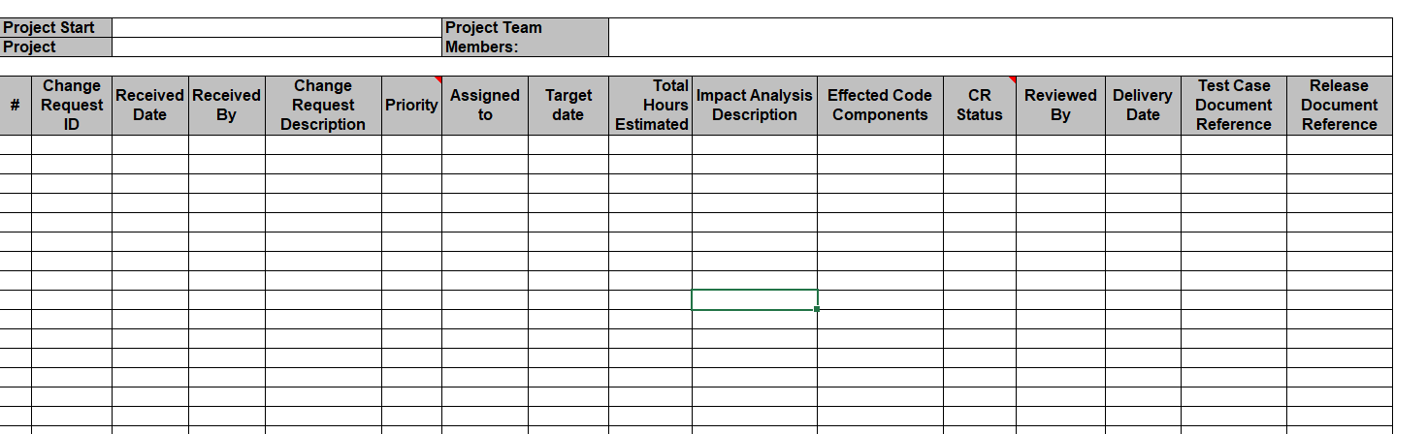

**Q14. Difference between Traditional Development Model and Agile Development Models – 8 Marks**

**Answer:**

**Traditional Development Model**

Traditional software development methodologies are based on pre-organized phases/stages of the software development lifecycle. Here the flow of development is unidirectional, from requirements to design and then to development, then to testing and maintenance. In classical approaches like the Waterfall model, each phase has specific deliverables and detailed documentation that have undergone a thorough review process.

**Agile Development Models**

Unlike the traditional approaches of SDLC, Agile approaches are precise and customer friendly. Users/Customers have the opportunity to make modifications throughout project development phases.

Agile proposes an incremental and iterative approach to development. Consider Agile Scrum Methodology to get good understanding of how Agile processes work. Scrum Master plays an important role in Agile Scrum Methodology. A Scrum Master interacts daily with the development team as well as the product owner to make sure that the product development is in sync with the customer’s expectations.

The main difference between traditional and agile approaches is the sequence of project phases – requirements gathering, planning, design, development, testing and UAT. In traditional development methodologies, the sequence of the phases in which the project is developed is linear where as in Agile, it is iterative.

**Q15. Explain Brainstorming Technique – Where to use? 5 Marks**

**Answer:**

Brainstorming can be done either individually or in groups. The ideas collected during the brainstorming session are reviewed or analyzed. Brainstorming is an effective way to generate lots of ideas on a specific issue and then determine which idea is the best solution.

Brainstorming is most effective with group of 8-12 people and should be performed in a relaxed environment. It is utilized in requirement elicitation to gather good number of ideas from a group of people.

Usually brainstorming is used in identifying all possible solutions to problems and simplifies the detail of opportunities.

Suppose client wants to build a platform for online ordering and and client has an existing team of say around 10 people working in various departments. So we can conduct a brainstorming sessions with the complete team to generate lot of ideas and their views on what the application be like.

**Case study (Q16 – Q20 - 33 Marks)**

**Q16. What reports Accounts Departments will generate (minimum 5 reports) – 10 Marks**

**Answer:**

1) Loan approval report

2) load rejection report.

3) T&C report in case of Loan approval

4) Loan repayment schedule report.

5) Loan offer report.

6) Pending or ongoing loan report

**Q17. What is the structure of the message/mail communicated from the HR department to the employee in case the Loan is rejected? – 5 marks**

**Answer:**

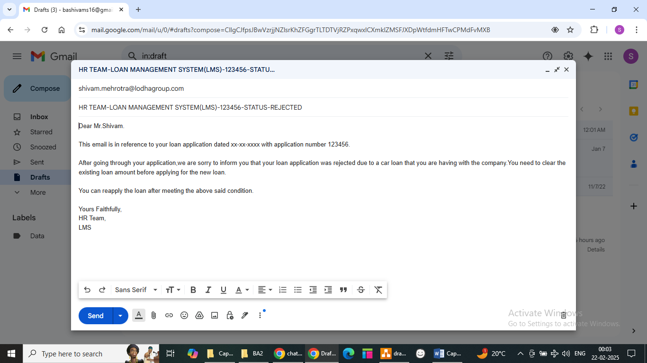

**Q18. What is the structure of the message/mail communicated from the HR department to the employee in case the Loan is approved? – 5 marks**

**Answer:**

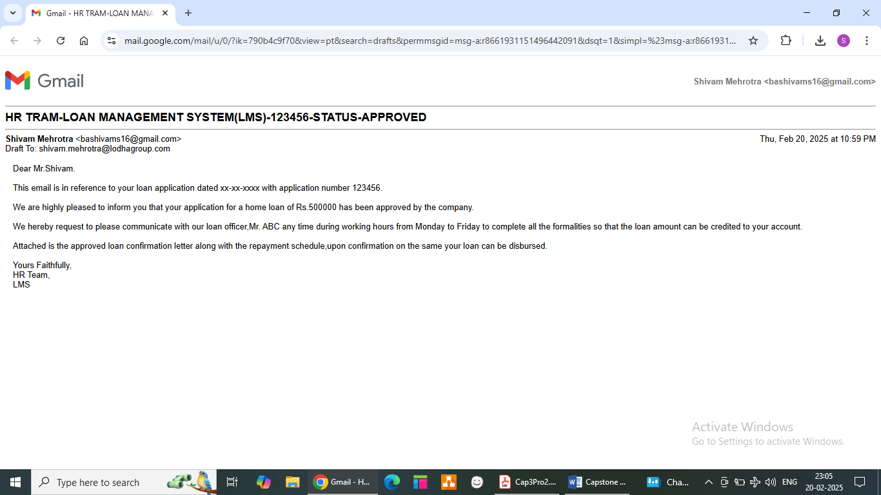

**Q19. Design a sample report on the Loans Applications Received by the accounts department – 8 Marks**

**Answer:**



**Q20. Which reporting Tools we will use for generating reports. – 5 Marks**

**Answer:**

For generating reports we can use Tableau and Power BI.

Tableau: It is data visualization tool used for data analysis and business intelligence and handle large amount of data.

Power BI: Microsoft Power BI is a data and analytics reporting tool that helps organizations bring together disparate data sets into reporting dashboards.

We can upload the raw data in any of the above tool and generate interactive reports and dashboards.

* Like which type of loan is the most common requirement of the staff.
* What is the most frequent age group applying for loans.
* What are the existing loan amount that company needs to recover from the employees.