**Answers –**

**Question no 1)**

Goal: Creating an application/ website to assist the farmers to buy fertilizers, seeds, and pesticides.

Inputs: Details of products i.e. fertilizers, seeds, pesticides available from manufacturers and list of products required by farmers.

Resources: Internet, Website/ Application, Data.

Activities:

1. Upload product details (manufacturers),
2. Farmers Browse products,
3. Farmers select products,
4. Place orders and Payment process,
5. Delivery of products to the farmers.

Outputs: Delivered agricultural products to the farmers and payment received.

Value created to the End Customers: Wide range of agricultural products, Farmer’s satisfaction through smooth delivery of products, advisory solutions to farmers.

Question no 2:

SWOT Analysis:

Mr. Kartik’s SWOT Analysis will be as follows:

1. **Strengths**:
2. Wide range of Products available to the local farmers in remote areas via online platform.
3. Multiple Payment Options.
4. Description/ feedback available for different products.
5. Comparison of products as per consumer requirements.
6. **Weaknesses**:
7. Difficult delivery to reach remote locations.
8. Lack of Knowledge of the Application/ Website.
9. Limitation on internet accessibility in remote locations.
10. Lack of adaptation to modern techniques.
11. **Opportunities**:
12. Expansion of services to other agricultural products.
13. Increase revenue in Agricultural Market.
14. Government support for rural development projects.
15. **Threats**:
16. Competitors offering similar products.
17. Risk of product delivery delays or damaged goods.
18. Changing regulations regarding agricultural products and e-commerce.

**Question 3 – Feasibility Study**

**Mr. Karthik’s Feasibility Study (Technology - Java)**

**Hardware (HW):**

1. Infrastructure for network (e.g. routers, servers).
2. Mobile devices or laptops for accessing.
3. Computers/ Devices for data.

**Software (SW):**

* + 1. Java Software.
    2. Database management system.
    3. Web/mobile application frameworks.
    4. Payment gateway e.g. Bill desk etc.
    5. GPS.

**Trained Resources:**

1. Java developers (Ms. Juhi, Mr. Teyson, Ms. Lucie, Mr. Tucker, Mr. Bravo).
2. Database administrator (John).
3. Network administrator (Mr. Mike).
4. Testers (Mr. Jason, Ms. Alekya).
5. Project manager (Mr. Vandanam).
6. Business analyst (Myself).

**Budget:**

* + 1. 2 Crores INR (allocated for development, infrastructure, and operational costs).

**Time Frame:**

* + 1. 18 months (for development, testing, and deployment).

**Question 4 – Gap Analysis**

**AS-IS (Existing Process):**

* 1. Communication gap between the farmers and manufacturers.
  2. Availability of the product is limited.
  3. Old delivery process (to buy from shop and bring to the farm)

**TO-BE (Future Process):**

* 1. Direct communication with manufacturers.
  2. Accessibility to a wide range of products online.
  3. Detailed product information available on website.
  4. Smooth online ordering and delivery.

**Gap:**

* 1. Fulfilling difficulties of day to day problems of Framers of buying fertilisers, pesticides etc.
  2. Establishing a reliable online platform.
  3. Encouraging farmers to use online platforms.

**Question 5 – Risk Analysis**

**BA Risks:**

1. Wrong or incomplete requirements gathering.
2. Scope creep.
3. Communication problems.
4. Fluctuating stakeholder expectations.
5. Lack of domain knowledge.

**Project/ Process Risks:**

1. Internet connectivity issues in rural areas.
2. Technical challenges.
3. Delivery issues.
4. Payment process errors.

**Question 6 – Stakeholder Analysis (RACI Matrix)**

**For decisions and influencers**

|  |  |  |  |  |  |
| --- | --- | --- | --- | --- | --- |
| Stakeholder | Role | Responsible | Accountable | Consulted | Informed |
| Mr. Henry | Sponsor |  | X |  | X |
| Mr. Pandu | Financial Head |  | X |  | X |
| Mr. Dooku | Project Coordinator | X |  |  | X |
| Peter, Kevin, Ben | Stakeholders (Farmers) |  |  | X | X |
| Mr. Karthik | Delivery Head | X |  | X | X |
| Mr. Vandanam | Project Manager |  | X | X | X |
| Ms. Juhi Developer and others | Development Team | X |  | X |  |
| Manufacturers | Product providers | X |  | X | X |

**Key Decision Makers**: Mr. Henry, Mr. Pandu, Mr. Dooku, Mr. Karthik.

**Influencers**: Peter, Kevin, Ben, Manufacturers.

**Question 7 – Business Case Document**

**Executive Summary:**

1. Introduction to the online agriculture product store project.
2. The Business opportunity for the manufacturers.

**Mission Statement:**

1. To face challenges by farmers in remote areas.
2. To improved accessibility to agricultural supplies.

**Proposed Solution:**

1. Create an online platform.
2. Address the problems faced by the farmers.

**Benefits:**

1. Direct communication with manufacturers.
2. Improved farmer access to essential products.

**Costs:**

1. Development costs (2 Crores INR).

**Timeline:**

1. 18-month project timeline.

**Question 8 – Four SDLC Methodologies**

**Sequential (Waterfall):**

1. Linear, sequential phases (requirements, design, development, testing, deployment).
2. Suitable for well-defined projects with stable requirements.
3. Rigid and hard to change.
4. Good for large projects.

**Iterative:**

1. Develops the system in iterations, refining it with each cycle.
2. Allows for feedback and adjustments throughout the process.
3. Early feedback.

**Evolutionary (Spiral):**

1. Combines iterative development with risk management.
2. Suitable for complex projects with evolving requirements.
3. Risk driven.

**Agile:**

1. Emphasizes flexibility, collaboration, and rapid iterations.
2. Suitable for projects with changing requirements.
3. Customer focused.

According to me the Agile methodology is the most appropriate one as it is customer focused, flexible, and it helps in evolving requirements.

**Question 9 – Waterfall, RUP, Spiral, and Scrum Models**

According to me the following are the key points of respective models

**Waterfall:**

1. Linear, sequential phases.
2. Suitable for well-defined projects.

**RUP (Rational Unified Process):**

1. Iterative and incremental, with phases (inception, elaboration, construction, transition).
2. Focuses on risk management and quality.

**Spiral Model:**

1. It's a model that incorporates risk analysis.
2. It's suitable for large, complex projects with high risks.

**Scrum:**

1. It's an agile framework that emphasizes short, iterative development cycles (sprints).
2. It involves daily meetings (daily scrum), sprint planning, and sprint reviews.
3. It promotes collaboration and self-organization.

Due to the difference in opinion between the SME and the project Team,

the SMEs' preference for the V-model is very wise. And as a Business analyst I would opt the V model

Because,

The V-model's parallel testing approach aligns with the need for a reliable and accurate platform for farmers. The V-model's focus on verifying and validating requirements at each stage helps ensure that the platform meets the user’s needs. It provides clear traceability between requirements and test cases, ensuring comprehensive testing.   The V model finds issues within each phase, instead of finding all the issues at the end of the project cycle.

While the waterfall model offers simplicity, the V-model's structure and emphasis on quality make it a better fit for this project's objectives.

**Question 10:**

**Differences:**

**Waterfall Model:**

* + 1. Linear, sequential flow of phases
    2. Testing occurs primarily at the end of the development phase.
    3. Less emphasis on early verification and validation.
    4. Difficult to accommodate changes after the requirements phase.

**V-Model:**

* + 1. Emphasizes verification and validation at each stage of development.
    2. Development and testing phases are planned in parallel.
    3. Each development phase has a corresponding testing phase (e.g., unit testing for detailed design, integration testing for architectural design).
    4. Provides a structured approach to quality assurance.

**As a BA, Reasons for Choosing the V-Model:**

As earlier mentioned,

* 1. The V-model's focus on early verification and validation ensures that defects are detected and addressed earlier, reducing the risk of costly rework later.
  2. The V-model facilitates clear traceability between requirements and test cases, ensuring that all requirements are adequately tested.
  3. The parallel testing approach helps mitigate risks associated with late defect detection.
  4. The V model gives clear understanding of the project life cycle, and the relation between development and testing.
  5. In the case of this project, where accuracy and reliability are critical, the V-model provides a more robust framework for ensuring quality.

**V-Model Phases for this Project:**

* 1. RG (Requirements Gathering)
  2. RA (Requirements Analysis)
  3. Design (Architectural and Detailed Design)
  4. D1, D2, D3, D4 (Development Phases)
  5. T1, T2, T3, T4 (Testing Phases, corresponding to D1-D4)
  6. UAT (User Acceptance Testing)

**Question 11 – Justify Your Choice**

1. I chose the V-model for this project due to its emphasis on early testing and validation, which aligns with the project's goal of delivering a reliable and user-friendly online platform for farmers.
2. The V model provides clear structure and enhances project quality. Since this project is a CSR initiative, and needs to be delivered with high quality, V model is the best choice.

**Question 12 – Gantt Chart**

Here's a simplified representation of a Gantt chart for the V-model, with estimated durations (adjust as needed):

|  |  |  |
| --- | --- | --- |
| TASK | DURATION (Weeks) | RESOURCES |
| RG (Requirements Gathering) | 4 | PM, BA |
| RA (Requirements Analysis) | 4 | PM, BA |
| Design (Architectural) | 6 | PM, BA, Java Devs, DB Admin, NW Admin |
| Design (Detailed) | 6 | PM, BA, Java Devs, Admin |
| D1 (Development 1) | 8 | Java Devs, DB Admin |
| T1 (Testing 1) | 4 | Testers |
| D2 (Development 2) | 8 | Java Devs, DB Admin |
| T2 (Testing 2) | 4 | Testers |
| D3 (Development 3) | 8 | Java Devs, DB Admin |
| T3 (Testing 3) | 4 | Testers |
| D4 (Development 4) | 8 | Java Devs, DB Admin |
| T4 (Testing 4) | 4 | Testers |
| UAT (User Acceptance Testing) | 6 | PM, BA, Testers, Stakeholders |

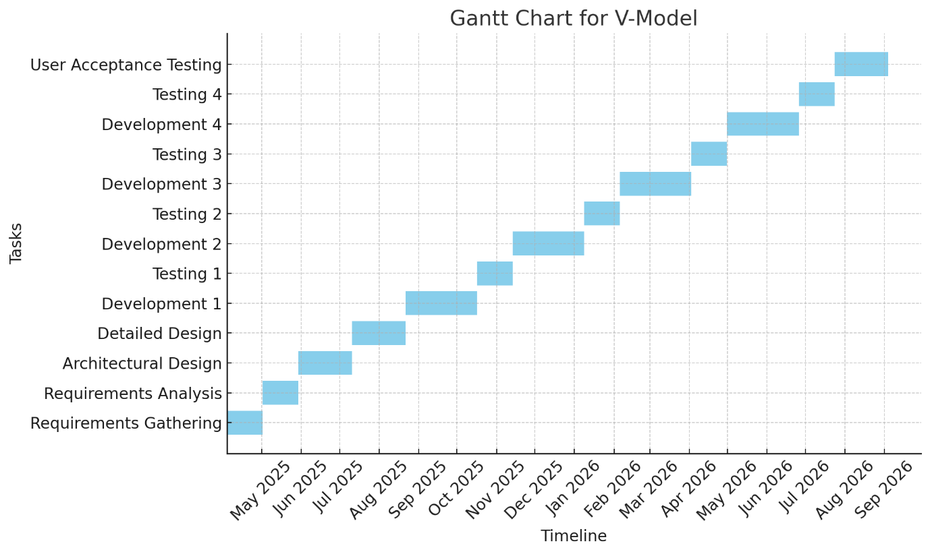

**Question 13 – Fixed Bid Vs. Billing Projects**

**Fixed Bid Projects:**

* 1. The project cost is determined and agreed upon before the project begins.
  2. The vendor is responsible for delivering the project within the agreed-upon budget.
  3. Risk is primarily borne by the vendor.
  4. Scope changes can lead to disputes.
  5. Client knows the total cost upfront.

**Billing Projects (Time and Materials):**

* 1. The client is billed for the actual time and materials used on the project.
  2. The project cost is variable and depends on the project's progress.
  3. Risk is shared between the client and the vendor.
  4. Scope changes are easier to accommodate.
  5. Can lead to costs exceeding initial estimates if not carefully controlled.

**Question 14 – BA Timesheets**

The below are the estimated time and this can vary while making the actual project

**Design Timesheet of a BA:**

* 1. Requirements Review and Clarification: 20 hours
  2. Use Case/User Story Development: 30 hours
  3. Data Flow Diagram Creation: 15 hours
  4. UI/UX Wireframing Collaboration: 25 hours
  5. Design Document Preparation: 20 hours

Total: 110 Hours.

**Development Timesheet of a BA:**

* 1. Requirements Clarification for Developers: 20 hours
  2. Functional Questions Answering: 15 Hours
  3. Participating in Scrum/Agile meetings: 10 Hours.
  4. Reviewing implemented code for functionality. 10 hours

Total 55 Hours.

**Testing Timesheet of a BA:**

* 1. Test Case Review: 15 hours
  2. Test Data Preparation: 10 hours
  3. Defect Reporting and Tracking: 20 hours
  4. Test case creation. 20 hours.

Total: 65 Hours.

**UAT Timesheet of a BA:**

* 1. UAT Planning and Preparation: 15 hours
  2. UAT Support and Coordination: 20 hours
  3. Feedback Gathering and Documentation: 15 Hours
  4. User support during UAT. 10 hours.

Total: 60 Hours.

**Deployment and Implementation Timesheet of a BA:**

* 1. User Training Material Creation: 20 hours
  2. Deployment Support: 15 hours
  3. Post-Deployment Monitoring: 10 hours
  4. Documentation of any deployment related issues. 10 hours.

Total: 55 Hours.