Capstone Project 3 Part 1

**Case Study- A customer can make a payment either by Card or by Wallet or by Cash or by Net banking.**

**Question 1-** Draw the Use case diagram

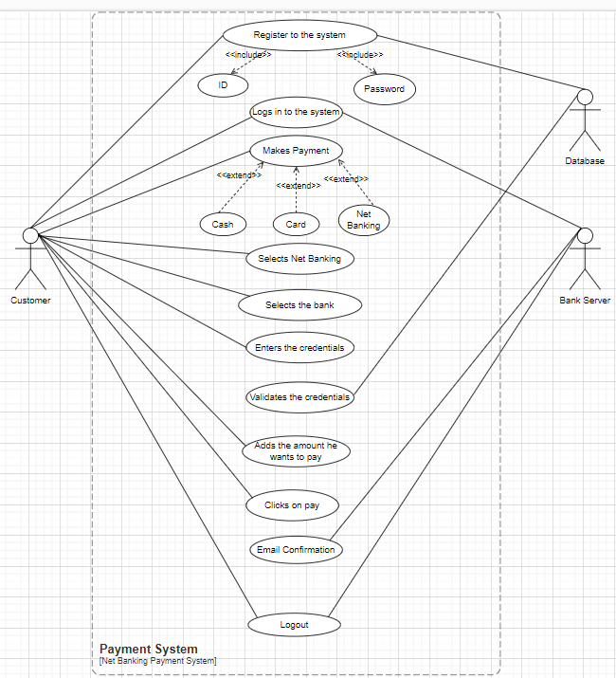

**Question 2-** **Derive Boundary Classes, Controller classes, Entity Classes.**

|  |  |
| --- | --- |
| Boundary class (All use cases)  [combination of 1 actor and a use case is one boundary class]  [combination of 2 actors and a use case is two boundary class]  [combination of 3 actors and a use case is three boundary class] and so on  And those actors should be primary actors.  Primary actors means the actors who initiate the use case and interact with the system. | CustomerRegistration  CustomerLogin  BankServerLogin  CustomerLogout  BankServerLogout |
|  |  |
| Controller class(handles user input and process the data)  Use case will be considered as the controller classes | RegistrationController  LoginController  PaymentController  CredentialsController  NetBankingController  EmailController  LogoutController |
|  |  |
| Entity Class (All actors)  Each Actor will be considered as one entity. | Customer  Bank Server  Cash  Card  Net banking |

**Question 3-** **Place these classes on a three tier Architecture.**

**Answer-**

|  |  |
| --- | --- |
| **Application Layer** | CustomerRegistration  CustomerLogin  BankServerLogin |
|  |  |
| **Business Logic Layer**  **(Primary actors associated with the Boundary class)** | Customer  Bank Server |
|  |  |
| **Data Layer**  **(All the entity classes)** | Customer  Bank Server  Cash  Card  Net banking |
|  |  |

In this three-tier architecture, the application tier handles the user interface,

the Business Logic Layer manages the Business logic and coordinates between the other tiers,

the data tier handles data storage and retrieval.

**Question 4- Explain Domain Model for Customer making payment through Net Banking**

**Answer-** Domain model is similar to the entity relationship model.

The tables are connected to each other.

In the below diagram,

The customer table is connected to bank table, which is why the customer is able to make payment.

Customer table is also connected to payment table, bcoz he should make the payment.

Now the payment is done by netbanking, so payment table is connected to netbanking table.

The account is in the bank, so the account table is connected to the bank table.

The authentication table is connected to both net banking table and bank table, bocz authencation is to performed there.

Also the authentication table is connected to transaction table, becoz authentication will be done while transaction.

**Difference between ER diagram and domain model-**

ER Model – do not have attributes inside the box

Domain Model- do have attributes mentioned inside the box

ER Model – it is a data modelling technique used in database design to represent tables.

Domain Model- it is a conceptual model that represents real world entities.

ER Model – focuses on relationships required for storing and retrieving the data

Domain Model- It focuses on capturing the behaviour of application

ER Model – primarily used in database design

Domain Model- used throughout the software development lifecycle

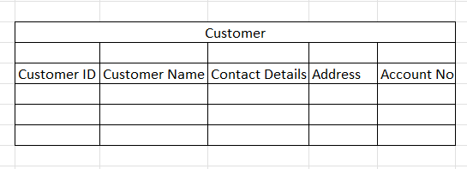 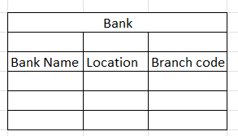

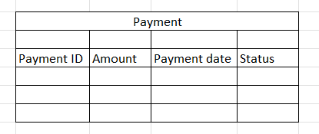 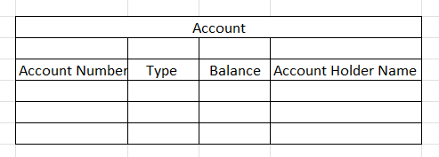

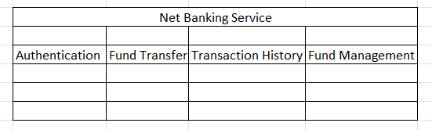 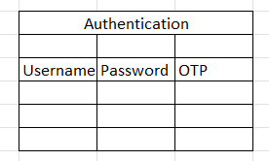

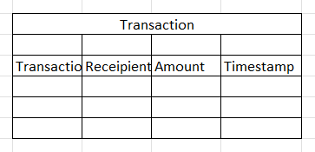

-------------------------------------------------------

**Question 5- Draw a sequence diagram for payment done by Customer Net Banking**

**Answer-** this diagram shows how the objects in the system interact and communicate with each other with time to achieve specific task.

Developer will draw this.

It is used to show the flow of messages, events or actions between the objects of the system.

This diagram helps to visualize the behaviour of the system .

This diagram shows the process in detail.

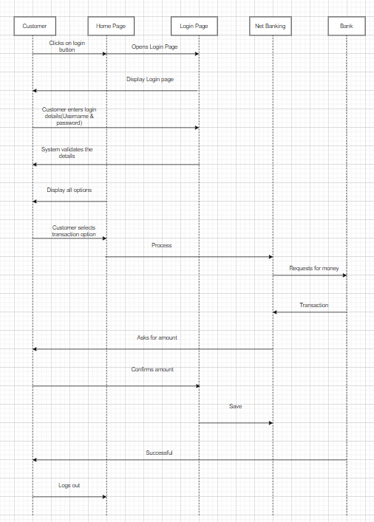

**Question 6- Explain Conceptual Model for this Case**

**Answer-** The conceptual model helps in understanding the key concepts, their relationships, and the overall structure of the net banking payment system.

It serves as a foundation for designing the database schema, defining the application architecture, and implementing the necessary functionalities within the system.

The relationships between these entities can be described as follows:

1. Customer: This node represents the customers or users of net banking services.
2. Service awareness: customers should be aware of the available net banking services and their features.
3. Privacy of data: the importance/significance of this node is to protect the privacy and confidentiality of customer data in the context of net banking.
4. Technology awareness: the significance of this node is that customers' should be aware and comfortable with the underlying technology used in net banking services.
5. Trust & Support: This node indicates that the bank provide such good services that it will help to enhance the customers trust.
6. Bank: This node represents a service provider responsible for offering net banking services.
7. Online information: This aspect highlights the importance of providing accurate and up-to-date online information about net banking services to customers.
8. Security & Privacy: the bank should adapt the security policies which will help the customers to keep their data related to their transaction secure and private.
9. Infrastructure: This component suggests that the underlying technological infrastructure, including hardware and software systems, plays a important role in enabling net banking services.
10. Policies: This node represents the various policies and regulations that govern the implementation and operation of net banking services, ensuring compliance and customer protection.

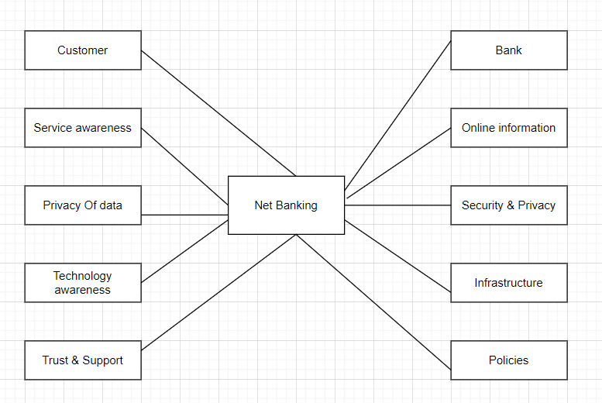

-------------------------------------------------------

**Question 7- What is MVC architecture? Explain MVC rules to derive classes from use case diagram and guidelines to place classes in 3-tier architecture**

**Answer-**

MVC is a design pattern where, the application is divided into 3 logical parts- Model, View and Controller.

Each of these parts will have specific responsibility.

Model-

The Model represents the data and the business logic of the application.

Model is responsible for multiple tasks like managing the application's data, performing data validation, implementing business rules, and handling data access operations.

Model does not depend on how the data is presented or how the user interacts with the application

The model class is known about all the data that is needed to be displayed.

This layer corresponds to the data-related logic that the user works with.

It represents the data that is being transferred between View and Controller.

It can add or retrieve the data from the database.

It responds to the controller’s request because the controller cannot interact with the database by itself.

The model interacts with the database and give the requested data.

All the model classes are nothing but the entities.

Model classes are represented as entity class.

View-

The View is responsible -for presenting the data to the user

for handling the user interface.

The View can be a web page, a desktop application window, or any other form of user interface.

It receives input from the user and passes it to the Controller for processing.

It represents the presentation of the application.

View refers to the model.

It takes the data from the Model and renders it in a way that is suitable for the user's display or interaction.

For rendering the data, it uses query method.

View does not depend upon application logic.

View class are represented as boundary class.

Controller-

The Controller acts as an intermediary between the Model and the View.

It receives input from the user (via the View), processes the input by invoking the appropriate methods in the Model, and then updates the View with the new data or state.

The Controller handles user interactions, interprets user input, and translates it into instructions for the Model or the View.

It coordinates the flow of data between the Model and the View, ensuring that they remain separated and independent of each other.

Whenever the user requests for anything, that request first goes to the controller.

Controller works on the users request.

Takes input from the user/ client.

It interacts with the model and view.

Controller class represents as use case.

Controller acts as a mediator between model and database.

Controller cannot directly get the data from the database.

So controller interacts with the model.

**Advantages of MVC-**

MVC has the feature of scalability, which in turn helps the growth of application.

The components are easy to maintain.

A model can be used by multiple views that provide reusability of code.

By using MVC, the application becomes more manageable.

As all the three layers are different and independent, they are maintained separately.

**\*Rules to derive the classes from use case diagram-**

1. Combination of one actor and one use case results in one boundary class.

Combination of two actor and one use case results in two boundary class.

Combination of three actor and one use case results in three boundary class.

2. Use case will result in controller class.

3. Each actor will result in one entity class.

**Consider the example of Online shopping application with the following usecase:**

Model Classes-

Customer, Payment, Net Banking, Card, Cash

View Classes-

Login View, PaymentOptionView, NetBankingView, BankSelectionView, CredentialsView, PaymentAmountView, PaymentConfirmationView, LogoutView

Controller Classes-

LoginController, PaymentOptionController, NetBankingController, BankSelectionController, CredentialsController, PaymentAmountController, PaymentConfirmationController, LogoutController

**\*Guidelines to place classes in 3-tier architecture-**

Presentation Layer-

This layer is nothing but a user interface.

View is inside this layer.

These classes interact directly with the user.

Presentation layer is responsible for displaying information and also receiving the input from the user.

Application Layer-

This layer is nothing but business logic.

Model and controller are inside this layer.

Controller handles the user input, process the request and co-ordinates interaction between the model and view.

Data Layer-

Classes which are responsible for data access and storage are in this layer.

It contains the classes which interacts with the database, files and other data sources.

-------------------------------------------------------

**Question 8- Explain BA contributions in project**

**Answer-**

* Waterfall model is useful in the situation where the project requirements are well defined and the project goals are clear.
* Waterfall model follows sequential approach.
* In this model each phase is completed entirely and then only moved to the next phase.
* Waterfall model relies on documentation to ensure that the project is well defined and project team is working toward clear goals.
* Ones that particular phase has been completed and ones we move to the next phase , we cannot go back to the previous phase to make changes.
* This model is stable for the projects when the requirements are clear.

Requirements Gathering-

First, the stakeholders are identified.

In this phase, all the requirements are gathered from the stakeholder.

BA and Project Manager participates in this phase.

After completing this phase, BRD will be generated.

Requirements Analysis-

The requirements are analysed to understand the scope of the project.

Analysing means the BA will check all the requirements, if he founds conflicting requirements then the BA will talk to the concerned stakeholder to clear it, remove the ambiguous requirements.

BA will prepare functional requirement.

The document which contains the functional requirements is called (FRS).[Functional Requirement Specifications]

Technical team will prepare non-functional requirement.

The document which contains the non-functional requirements is called (SSD).[Supplementary Support Document ]

BA will combine FRS and SSD to form SRS.[ Software Requirement Specifications]

BA will prepare RTM by referring SRS.

Design-

After the requirements are cleared, Design phase starts.

This has a detailed design document that outlines the software architecture, user interface, and system components.

HDD, ADD and solution document will be generated here.

[Highlevel Design Doc.]

BA Collaborate with designers, architects, and developers to translate requirements into system design.

BA Ensure that the design aligns with the documented requirements and addresses stakeholder needs.

Development-

The Development phase include implementation.

It involves coding the software based on the design specifications.

Programmers or developer are involved in this phase.

Here BA acts as a mediator between the development team and the stakeholders.

BA clarifies the requirements, check if the development is going on right track or not.

BA also participates in scrum meetings.

Testing-

In the testing phase, the software is tested as a whole to ensure that it meets the requirements and is free from defects.

Testers are involved in this phase.

Test documents are generated here.

BA works with the testing team to ensure that the solution meets the requirements.

BA facilitate UAT.

BA helps the users to know the functionality of the system and also helps them to use the system.

Deployment-

Once the software has been tested and approved, it is deployed to the production environment.

BA ensures that there is smooth transition from development phase to the production phase.

Implementation-

This is the final stage of waterfall model.

It involves running the code for the very first time in production phase.

Release manager handles this phase.

BA will Update documentation and requirements specifications to reflect changes in the system over time

Maintenance-

Running the code for second time in the production phase is called maintenance.

This is done by support team.

-------------------------------------------------------

**Question 9- What is conflict management? Explain using Thomas – Kilmann technique**

Conflicts can occur due to various reasons, such as differences in goals, values, personalities, resources, or communication breakdowns.

Conflict is an inevitable part of any workplace.

So it is important to resolve it to promote learning and growth.

Conflict management is nothing but the process of identifying and addressing conflicts in a healthy and constructive manner.

It consists of strategies and techniques aimed at resolving disputes, disagreements, or differing perspectives among individuals or groups.

By identifying the conflicts efficiently, it will in turn be helpful to reduce negative impact and increase positive impact.

It is a process or skill to find creative ways to handle the disagreement.

Thomas – Kilmann approach is widely used to recognize the approaches for conflict management.

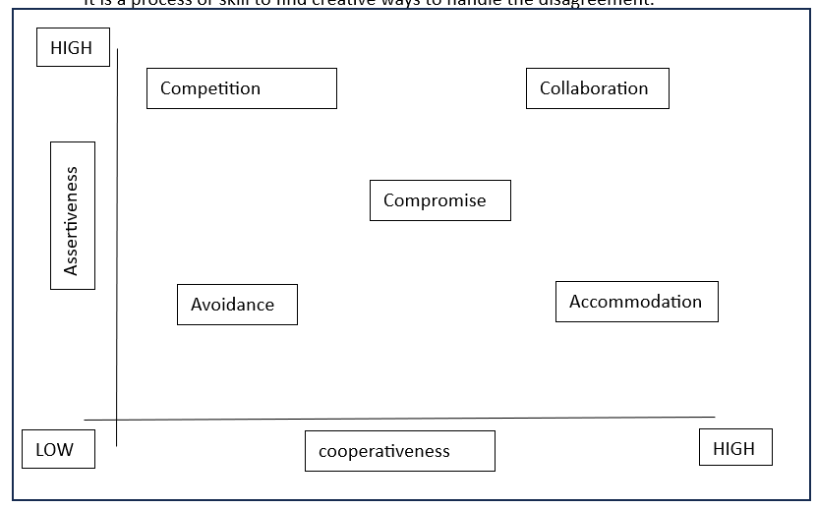

Y axis- assertiveness x axis- co-operativeness

**High Assertiveness and High Cooperativeness** – Collaboration- means working together to find solution

**High Assertiveness and Low Cooperativeness** – Competition- means defensive, that is standing for your individual beliefs and trying to win.

**Low Assertiveness and High Cooperativeness** – Accommodation- stakeholder will prioritize their needs over others.

**Low Assertiveness and Low Cooperativeness** – Avoidance- means ignoring the conflict

Assertiveness- the extent to which the person attempts to satisfy his own concerns.

Cooperativeness- the extent to which the person attempts to satisfy the other persons concerns.

-------------------------------------------------------

**Question 10- List down the reasons for project failure**

Reasons for project failure are:

**Improper requirement gathering-**

If the requirements of the project are not gathered correctly, then this can lead to project failure.

**Lack of stakeholder involvement-**

A project can fail if the stakeholders are not participating in the process.

The stakeholders input and feedback plays very important role to meet the goals.

**Ineffective or less communication-**

If there are communication issues between stakeholders, team members then this can lead to misunderstandings or delays in project or even can lead to project failure.

**Continuous change in the requirement-**

if the requirements keep on changing frequently, this can also lead to project failure.

Because the scope of the project will also keep on changing which will lead to project failure.

**Poor risk management-**

Poor risk management can also lead to project failure.

The team fails to identify the risks and do the risk mitigation, which can lead to unexpected challenges or delays in project.

Lack of user involvement.

Lack of executive support.

**Unrealistic expectations-**

means the goals that cannot be achieved or the goals that are out of scope

**Improper planning-**

The project can fail if the planning is not done properly.

The milestones , goals should be discussed.

If there is no proper planning, then team may face difficulties in addressing the issues or to track the progress.

**Insufficient resources-**

Insufficient resources can also lead to project failure.

The project may fail due to lack of technology knowledge or lack of finances

-------------------------------------------------------

**Question 11- List the Challenges faced in projects for BA**

Lack of training.

Obtaining sign-off on the requirement.

Change management.

Co-ordination between developers and testers.

Conducting meeting.

Making sure status report is effective.

Driving clients for UAT completion.

Making sure that the project is going on right track and delivered as per the timelines without any issues.

Gathering clear and unambiguous requirements can be challenging.

Unable to understand what stakeholder is trying to convey.

Scope creep- change in requirement or scope of the project during the project lifecycle can lead to scope creep.

Managing the stakeholder with conflicting interest can be a difficult task for BA.

BA may face difficulties in understanding the requirements if the domain is not familiar to him.

Poor communication between stakeholder and BA can affect the process of gathering the information.

Technical complexity

-------------------------------------------------------

**Question 12- Write about Document Naming Standards**

[ProjectID][Document Type]V[x]D[y].extention

Example- [PQ777FRDV1D1.docx] or [PQ777FRD1.1.docx]

-------------------------------------------------------

**Question 13- What are the Do’s and Don’ts of a Business analyst**

Never say “NO” to the client.

There is no word called as “BY DEFAULT”.

Never imagine anything in terms of GUI.

Question everything in the world.

Go to the client with plain mind i.e. with no assumptions.

Listen to the client very carefully and after he is done, then ask question.

Don’t interrupt the client.

Never try to give solutions to the client right away.

Try to concentrate only on important and required things.

Be like a lotus in mud- if a client comes with a fancy requirement, then talk to the project manager first.

Requirement hurried-project buried.

Never criticize the stakeholder.

Always appreciate the stakeholder even for small efforts.

-------------------------------------------------------

**Question 14- Write the difference between packages and sub-systems**

Packages- it is a group of classes or use cases that are used to organize model elements.

Packages can be nested within other packages.

These are used as containers to organize elements.

It is very useful to represent system architecture.

package

Subsystems- it is logical grouping of related components.

It is collection of classes, packages, libraries and other sub systems that work together to deliver a specific set of functionalities.

-------------------------------------------------------

**Question 15- What is camel-casing and explain where it will be used**

Camel-casing refers to the naming convention of variable, parameters or properties.

Here, multiple words are combined together.

In camel-casing, the starting letter of first word starts with small letter and other words first letter starts with capital letters.

Ex- firstName, lastName

In BA, camel-casing is used in requirements documentation.

In requirement documentation, BA often use camel-casing to name the entities like use case, features, user stories like validateCustomerDetails, calculateInterestRate, etc

Business rules, which should be satisfied by the system use camel-casing.

While documenting business process or workflows, camel-casing can be used to individual in steps. This will help maintain consistency in the document.

The database tables name also uses camel-casing.

Requirement naming- camel casing is used in requirement document also, to name the functional and non-functional requirements.

By using camel casing in the documents, it helps to maintain consistency in the entire document and also increases readability.

**Question 16- Illustrate Development server and what are the accesses does business analyst has?**

**Answer-**

A development server refers to a dedicated environment that is used during the software development process.

It provides platform for the developers and the testers to build, test, develop and debug the application.

The accesses a BA has are-

ReadOnly- BA’s may be granted with the readonly access to the development server.

This will allow them to view the user interface of the application, navigate through the features and also they will be able to observe the behavior of the application.

Limited Access-

Depending upon the project needs, the BA’s will be granted limited access to the specific modules in the application.

Limited Configuration Access- Means BA have the authority to make changes in certain areas of application where they have the access.

**Question 17- What is Data Mapping.**

The database contains multiple tables in it.

There may come a scenario, where we need to map the data from one table to another.

Data mapping is necessary in cases where we want quick manner.

Data mapping is nothing but a process to establish connection between multiple data sources.

The purpose of data mapping is to ensure that the data is accurately transferred or converted into different format.

The main purpose of data mapping is-

Data integration-

While combining the data from different sources, it ensures that the data is properly matched.

Data Migration-

While migrating the data from legacy system(source) to the new system(destination), the data elements are mapped accurately into the new system.

Required techniques are applied to covert the data into the format that is required by the new system.

Data Transformation-

Data transformation means converting the data from one format to other.

In data mapping, data transformation plays very important role which ensures that the data of legacy system(source) is mapped correctly to the data in new system(destination).

-------------------------------------------------------

**Question 18- What is API. Explain how you would use API integration in the case of your application Date format is dd-mm-yyyy and it is accepting some data from Other Application from US whose Date Format is mm-dd-yyyy.**

API stands for Application Programming Interface.

It is a software intermediary that allows the two applications to communicate with each other.

It is the set of rules, protocols and tools that define how different software application should interact with each other.

API allows sharing of only necessary information and keeps the internal system details hidden, which helps the system security.

For the above scenario,

Establish API communication- set up API communication between your application and other application to exchange data.

Do Data formatting- while sending the data from one application to other, convert the date format from dd-mm-yyyy to mm-dd-yyyy.

While receiving the data from other application, parse the data and extract the date, month and year and re-arrange them accordingly.

Perform Data Validation and ensure that the converted date remains in a valid format.